

Submission

**To: Australian Energy Regulator**

Topic: ElectraNet Electricity Transmission Draft Revenue Decision

(released 6th October 2017)

& Revised Revenue Proposal (lodged 22nd December 2017)

**Date: January 2018**

**Contact:**

**Mark Henley**

**E:** [**MarkH@unitingcommunities.org**](mailto:MarkH@unitingcommunities.org)

**P: (08) 82020 5135**

***Uniting Communities is South Australia’s first accredited Carbon Neutral organisation/business.***

**Uniting Communities Experience in Working With ElectraNet**

In our response to the initial ElectraNet regulatory proposal for 2018-23, we said:

“Uniting Communities was invited to be a member of the ElectraNet consumer advisory panel in July - August 2015, and we were pleased to accept the invitation. We advised ElectraNet of our willingness to participate and also informed them of the recently released, at the time, report dealing with network regulatory reform that has just been released through UnitingCare Australia. The report was titled “the DNA approach to network regulation,” where DNA was an acronym for deliberation, negotiation and agreement. We told ElectraNet that we were keen to explore some of the ideas raised in this paper. They also signalled an interest in developing the regulatory proposal in a manner that gave it a high likelihood of being accepted by stakeholders, including the Regulator.

The collegiality demonstrated by ElectraNet in developing their regulatory proposal has been deeply appreciated by Uniting Communities and we are accepting of their regulatory proposal as reasonable and certainly developed in good faith with significant efforts being made to engage consumer and stakeholder views. We certainly feel that we been taken seriously over the nearly 2 years since we first talked about this particular regulatory proposal.”

The “journey” that we had taken with ElectraNet, up to that point of time was also described as important context to our subsequent consideration of specific issues relating to their revenue proposal. We ended the description of our expereince by saying:

“We conclude by again commending ElectraNet on what we regard as an outstanding effort to engage with consumers, to hear what a range of consumer interests and stakeholders had to say and most importantly to incorporate these to a significant extent, in the final regulatory proposal.”

In making this submission responding to the draft decision and revised regulatory proposal, we observe that nothing has changed. We remain very supportive of the ElectraNet revised revenue proposal and are very satisfied with the engagement that ElectraNet has maintained with us since the initial regulatory proposal was lodged.

Since their proposal was lodged on 28th March 2017, we have been directly involved with ongoing engagement activities, specifically:

* June 2017: Public forum in Adelaide re: Contingent Project – Eyre Peninsula (Forum also held in Port Lincoln)
* 18th July: CAP (Consumer Advisory Panel) meeting including review of the submissions received by AER on Revenue Proposal i
* October 2017: Written notification on October 2017 regarding emerging cost pressures from new obligations expected to impact on our operating expenditure forecast.
* 6th November: AER Pre-determination Conference re draft decision.
* 8th November: CAP (Consumer Advisory Panel), focus on likely changes to be made in revised revenue proposal, these discussions and associated consumer advice is included in revised revenue proposal.
* 27th November: Public forum Contingent Project – Eyre Peninsula Adelaide 27th, Port Lincoln 20th
* 23rd January 2018: CAP meeting (for which we were an apology)

We suggest that this range of consumer and consumer related engagement indicates a continuing commitment to informed and proactive engagement with consumer interests and other stakeholders.

It is also our observation that recent engagement activities involving ElectraNet have attracted a significant range of stakeholder and consumer interest. There has also been a high level of goodwill. While it is not standard regulatory practice to consider ‘the vibe’ at a public meeting, we suggest that the AER hosted pre-determination conference held on 6 November 2017 displayed a very high level of goodwill towards ElectraNet by all stakeholders present and a high level of acceptance across those present for ElectraNet’s proposal. We observe this because there have been other predetermination conferences which have been quite confrontational with much less ‘bonhomie’ evident from consumer interests and stakeholders. This degree of support, the level of respect for ElectraNet and the relatively high level of acceptance of the regulatory proposal are good indicators of the calibre of engagement that had been undertaken in the lead up to lodging the regulatory proposal, and now revised proposal

We are also aware that on 29th of November 2017 ElectraNet received the inaugural Energy Network’s Australia (ENA) and Energy Consumers Australia (ECA) Consumer Engagement award which recognises industry leading consumer engagement practice. This is a significant result in what we understand was a keenly contested award in recognition by peers and consumer interests that ElectraNet’s consumer engagement has been carefully considered well delivered and most importantly, responded to.

Our perspective on the quality of ElectraNet’s ongoing consumer engagement is also supported by the Consumer Challenge Panel who presented the following slide as part of their presentation at 6 November pre-determination conference.

CCP said

“Customer engagement & prudent expenditure in a time of change

* ElectraNet has faced unprecedented level of policy changes and operational challenges over the last 18 months
* **CCP9 acknowledges ElectraNet’s approach to these challenges** 
  + **Supported by an effective approach to consumer engagement in the past**
  + **Keeping consumers and regulators updated going forward**
* **ElectraNet has not used this uncertainty to justify an excessive capex program in their revenue proposal** *(our emphasis)*
* CCP9 therefore supports the AER’s DD to approve ElectraNet’s capex and opex; but going forward:
  + close scrutiny of the contingent projects by the AER
  + enhance co-ordination between SAPN and ElectraNet
  + enhance investigation of non-network options
* Many challenges remain:
* –ElectraNet has demonstrated its ability to adopt prudent solutions to many of these problems
  + Rigorous assessment and innovative thinking to manage cost impacts and establish expenditure priorities
  + Continued customer engagement to assist making these tough decisions.”

As an organisation with a strong interest in the development of consumer engagement by Australian energy businesses, we note that ElectraNet:

1. Was one of the first NSP’s to release a costed preliminary Revenue Proposal, well before lodgement and took feedback into account in adjusting their eventual regulatory proposal
2. Was also one of the first NSP’s to apply a ‘deep dive’ approach to exploring more difficult issues.
3. Brought consumer interests and the AER together with their own staff to undertake ‘deep dives.’
4. Specifically detailed changes that they had made in response to consumer and other stakeholder input.

We observe that other NSP’s are now utilising these approaches.

Uniting Communities remains convinced that ElectraNet has undertaken high quality consumer engagement in the lead up to lodging their regulatory proposal and that this has continued since lodgement. EelctraNet has communicated regularly with consumer interests and has demonstrated their willingness to adjust their thinking in response to consumer engagement.

**Policy Changes and Operational Challenges**

The challenges confronted by ElectraNet during this regulatory process have been recognised, including by the Consumer Challenge Panel who said “ElectraNet has faced unprecedented level of policy changes and operational challenges over the last 18 months.” In responding to their initial proposal, we highlighted the substantial impact of storm activity during a period in which the regulatory proposal was being developed and the amount of reviews that arose from these events in particular 28 September 2016 cyclonic storms.

The following figure from the revised revenue proposal usefully highlights a significant operational challenge for ElectraNet in integrating on synchronous, renewable generation into the South Australian transmission network.

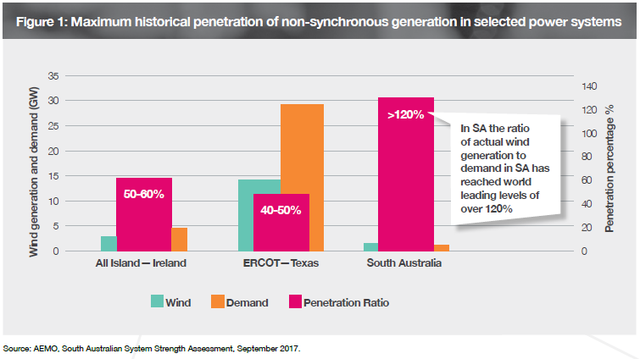

The high ratio of actual wind generation to demand in South Australia is significant and provides opportunities as well as challenges for ElectraNet. At the same time South Australia has high levels of rooftop photovoltaic generation and a highly politicised energy market. Since the original proposal was lodged, South Australia has seen the “world’s largest battery” installed and State government releasing a state energy plan[1] to shore up energy supply particularly for the current summer. The Liberal opposition released its pre-election energy plan in October 2017[2] with a significant emphasis on network focused solutions.

The uncertainty about future energy markets that ElectraNet is dealing with is part of a global phenomenon. While there have been many papers and conferences dealing with the future of energy markets, we just mention one presentation from Dr Philip Lewis from VaasaETT[3], who gave a future looking presentation to the Citizens Energy Forum, in London during 2017.

The Helsinki based company, VaasaETT describes themselves as “*a research and advisory consultancy guiding future-focused energy markets globally. We monitor and analyse energy markets, companies and consumers around the world to help our clients enter markets, develop offerings, models and policy, as well as identify future visions and take advantage of evolving opportunities and trends applying 20 years of unmatched global experience*.”

Dr Lewis spoke at the Citizens Energy Forum on the topic of “key principles for the next energy markets,” he made the following comments as part of a broader set of observations:

* the new market is not here yet, it will appear in 4 to 6 years’ time
* new market models will garner greater flexibility
* all succeeding models will be global and will bypass the country if it’s market doesn’t fit the model
* regulation will determine the extent of pickup by succeeding models
* simpler well-regulated markets will thrive
* access to data will be crucial

He concluded his presentation by saying “massive, amazing things will happen in the future”

We consider Dr Lewis’ observations to be in line with perspectives of other observers considering future energy markets and highlight the views that any sort of ‘synthesis’ associated with what more settled future markets will look is at least four years away and probably more.

We observe that even since the revised revenue proposal was lodged there have been significant announcements by the SA Government and that “energy policy” will be a hotly contested matter in the lead up to the South Australian election on March 17th, 2018. We observe that ElectraNet has quietly gone about their business through the politics and new developments, including the “world’s biggest battery” becoming operational. They talk regularly with relevant stakeholders at technical level as well, now including Tesla and other grid scale energy storage providers, AEMO and SAPN.

This is in line with our observation that ElectraNet is using future uncertainty to be a better business rather than to become richer.

ElectraNet continue to be at the forefront of rapid change in energy markets and to their credit have used this opportunity to engage with stakeholders including government and consumer interests and has not sought to over claim for future uncertainty in this regulatory proposal. This against our general observation that too much future uncertainty has been passed onto consumers, by some parts of Australian energy markets

**AER's draft decision and ElectraNet's proposed average building block costs ($million, 2017–18)**

The following chart from the AER’s Draft decision shows changes from the proposal.



Source: AER analysis. Table 2.1 shows our draft decision on ElectraNet's revenues including the building block components.

We note that opex expenditure is marginally higher than the ElectraNet proposal, which suggests to us that the proposal was reasonable and reinforces the value of frank and respectful engagement in the first place. Opex reductions have been significant in some other AER draft decisions.

The three areas of major change from the initial proposal are “Return on Capital,” “Regulatory Depreciation” and “Net Tax Allowance” which are generally subject to external factors including guidelines and decisions by the Federal Court (gamma and tax allowance implications). Therefore we suggest that the AER has largely accepted aspects of the proposal over which ElectraNet has most control.

The following figure summarises the differences between the initial and the revised revenue proposals

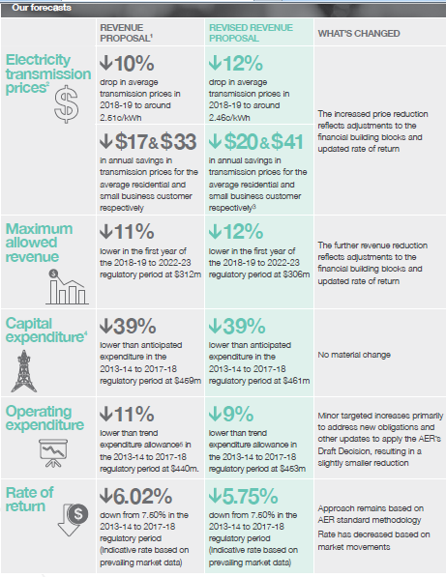

This shows that there have only been minor adjustments from initial to revised revenue proposals, with consumers a little better off under the revised proposal.

We are satisfied that ElectraNet’s revised revenue proposal is reasonable and in line with the AER’s draft decision.

Other matters.

1. Contingent projects

There is an issue for ElectraNet and other network business about the relationships between the regulatory proposal and contingent projects – this is a broader than ElectraNet matter, however there are potentially 5 contingent projects for ElectraNet over the course of this regulatory period, we understand. We are not in a position to comment on ElectraNet’s contingent projects at this stage, though we have been kept informed about their development. We think that contingent projects should be subject to the sort of consumer engagement that has been demonstrated in the development of this proposal. The impact of contingent projects on revenue determinations is an important regulatory question, particularly in a rapidly changing world. We do not want to see consumers required to pay higher future prices because return on Regulated Asset Bases has escalated due to contingent projects.

1. Energy Security Board

We recognise that the creation of the Energy Security Board and their decisions may have implications for ElectraNet, including opex for compliance with new requirements including the emergent National Energy Guarantee.

1. SA’s circumstances

South Australia is ahead of much of the rest of the world in implementing the challenges of new markets, particularly the shifting mix of renewables. Government initiatives are regular occurrences at the moment, many with implications for ElectraNet. We remain optimistic that with further embedding consumer and other stakeholder engagement, ElectraNet will be able to meet the challenges of an extremely dynamic market over the next 5 years, providing national and even international leadership.

**Definitions of Terms**

We clarify some terms that we have used in this submission and terms used in broader aspects of approaches to consumer engagement. This is our understanding of some important terms.

1. Deliberation: a process spanning over at least a couple of weeks where a group of people from a range of consumer perspectives are brought together at least twice and take in to facilitate a process, not from the network business, to consider an important topic of some complexity. Citizen juries are one form of such deliberative processes.
2. Negotiated agreement: documentation about the negotiation undertaken to reach areas of agreement, between the network business and relevant stakeholders
3. Agreement: some form of documentation of areas of agreement between accepted consumer interests and network business, which is presented to the regulator with lodgement of a regulatory proposal.

We have described these 3 terms as the “DNA approach to network regulation”

1. Deliberative forum: a gathering of at least 50 people from a range of consumer perspectives were guided through a process of open questions and discussion for at least four hours. We observe that some network businesses are utilising this approach now, though it was not a formal part of the ElectraNet process. (this is not a criticism, purely an observation)
2. Deep dive. Detailed consideration of a more complex or contentious issue that is part of a regulatory proposal. In the ElectraNet context, this has been a part of the “Front ended” approach that has been applied.
3. No surprises proposal: regulatory proposal lodged under the rules where no stakeholder, including the Regulator, finds any aspect that they were not expecting. Note that ‘no surprises’ does not mean agreement, it means that where there are points of disagreement between any parties, these have been identified and fully explored.
4. Fast track: consideration of a regulatory proposal by the Regulator, that takes less time than a standard process. The decision making being fast tracked due to extensive engagement with stakeholders, including consumers, prior to lodgement. We note that fast tracking is currently not possible under the electricity rules in Australia, but is an option for Ofgem, in the UK. We also note that there is movement away from using this term in Australia at time of writing, but the term was important in this ElectraNet journey
5. Front loaded: this is an emerging term for a process whereby a network business releases details of their intended regulatory proposal four - six months before lodgement, in order to engage with stakeholder interests and the Regulator, including ‘deep dive’ sessions for ElectraNet, to lead to a ‘no surprises’ proposal on lodgement. ElectraNet talked about the Preliminary revenue Proposal (PRP) as their ‘front loaded’ process. We have also used the term “early reveal’ to describe the same process.
6. Consumer Engagement: The term ‘consumer engagement’ is widely used and has many interpretations.

The Canadian Tamarack Centre for Community Engagement[4] is recognised as a leader in developing and documenting community engagement practice. They define community engagement as:

*“people working collaboratively, through inspired action and learning, to create and realize bold visions for their common future.”*

This is what we mean by the term “Consumer engagement” as applied to energy markets. Using this definition we further understand consumer engagement in energy markets to be **“end consumers and network businesses working collaboratively, through inspired action and learning, to create and realise bold visions for their common future.”**

Stakeholder Engagement: While stakeholder engagement means “all relevant parties and network businesses working collaboratively, through inspired action and learning, to create and realize bold visions for their common future.” Note that we understand retailers to be a significant stakeholder.

1. http://ourenergyplan.sa.gov.au/
2. http://www.liberalenergysolution.com.au/
3. http://www.vaasaett.com/#main
4. See Tamarack Centre for Community Engagement at http://tamarackcommunity.ca/