Submission to

**Australian Energy Regulator**

**Re: AGN SA Access Arrangement**

**2016-21, Draft Decision**

From UnitingCare Australia

March 2016

**About UnitingCare Australia**

UnitingCare Australia is the Uniting Church’s national body supporting community services and advocacy for children, young people, families, people with disabilities and older people.

The UnitingCare network is one of the largest providers of community services in Australia, providing services and supports to more than 2 million Australians each year in urban, rural and remote communities. The network employs 35,000 staff and 24,000 volunteers.

UnitingCare Australia works with and on behalf of the UnitingCare network to advocate for policies and programs that will improve people’s quality of life. UnitingCare Australia is committed to speaking with and on behalf of those who are the most vulnerable and disadvantaged for the common good.

Stewardship of our environment is a fundamental responsibility of societies both in the short-term and for the benefit of future generations. We strongly support the notion of the triple bottom line for government community and business organisations whereby economic stewardship, environmental stewardship and the nurture of citizens (social stewardship) are equally valued and reported on publicly.

UnitingCare Australia’s principle interest in energy regulation arises because energy is an essential service with rising costs that are putting inordinate financial pressure on growing numbers of households in Australia.

**AGN SA Access Arrangement 2016-21**

UnitingCare Australia wishes to commence with our observation that AGN has made quite reasonable efforts over recent months to engage with consumers in South Australia, and to be responsive to issues raised and questions asked. We observe that a consumer reference group has been established and is, from our experience, being taken seriously by AGN, including by its senior management. We think this bodes well for ongoing future engagement between consumers and AGN. (Note that UnitingCare Australia network agency, Uniting Communities is represent on the AGN consumer reference group in SA.)

**Context for AGN SA Access Arrangement 2016-21**

As an organisation with particular focus on affordability of energy for low and modest income consumers, we note that significant numbers of South Australian households continue to struggle with energy costs.

We note that whilst gas is not an essential service in quite the same way that electricity is, in that electricity is a substitute for gas but gas is not always a substitute for electricity, it is a very important energy source for many households, for heating, hot water and cooking. We still maintain that gas is a near essential service and that affordable gas improves quality of life for low and modest income households, as well as other households through efficiency in household use, gas is a crucial input for some small businesses, and so has employment impacts which are particularly pertinent at a time of low employment. Also moderate gas prices help to moderate electricity prices so that the two stay relatively in step with each other. For these reasons UnitingCare Australia has decided to respond to the access arrangement proposal from AGN.

In considering the impact on consumers of gas prices we note the reality that gas prices are continuing to rise across the country including in South Australia. This is shown chart 1 below which is taken from the AER’s Annual Report on the Performance of the Retail Energy Market.

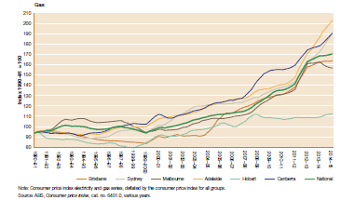

Chart 1 Gas price index, Capital Cities, Source AER, 2014–15 Annual Report on the Performance of the Retail Energy Market

The data in this chart shows that South Australian consumers currently have the highest cost for gas, compared to other jurisdictions and that the rate of increase in gas prices for SA has grown faster than all other Australian jurisdictions over the last 3 years.

While there are many reasons for the high and rapidly increasing gas process in SA, the situation in important context for the AGN access arrangement proposal, 2016-21

One of the implications of high and rising gas process in SA is the trend for residential gas disconnections for non-payment. Figure 2 shows residential gas disconnections for non-payment for South Australia 2009-10 to 20014-15. Regrettably residential gas disconnections for non-payment were at their highest level ever in 2014 with significant increases over the previous two years, although we note that disconnections were particularly high during 2011-12.

Figure 2: Gas disconnections, SA. Source AER, 2014–15 Annual Report on the Performance of the Retail Energy Market

(Trend line added by UnitingCare Australia)

Disconnections for non-payment as a very strong indicator of energy stress and of the consequent inability of some customers to be able to afford to pay their gas bills. We also observe through Financial Counselling and other services that many more customers than those disconnected struggle to pay their utility bills and go without other necessities in order to remain connected.

The volatility of gas markets in understood with major LGN exports from Australia ramping up amid world parity price uncertainty and associated uncertainty about domestic gas supply and wholesale prices. We recognise that COAG has earmarked the East Coast Gas market as a priority for work and that AEMC and ACCC are both currently undertaking reviews of this market. This uncertainly however, must not be unreasonably be passed onto end consumers.

This context of rising gas prices and rising customer hardship as a result of the prices rises is of continuing concern to UnitingCare Australia. All players in the gas industry need to be focussed on reducing their costs so that the end bill paid by customers is reduced to levels that are more affordable and manageable for an increased number of households.

**AER Draft Decision and AGN Revised Proposal**

It is understood that there is significant discussion between the AER and AGN regarding specific aspects of the draft decision and revised proposal. For example, on the substantial issue of ‘main replacement’, the AER draft determination states “Much of this reduction is because we did not have sufficient information to find the proposed expenditure to be prudent or efficient. We have identified where further information needs to be provided …” AGN will, no doubt, provide further information. As an organisation representing consumer interests, we have very limited capacity to comment meaningfully on matters like this that are the basis of regular and on-going bilateral interchange between AER and AGN.

In striving to make some useful input into this process, we have copied below a table produced by Australian Gas Networks which summarises components of the access arrangement, the AER’s draft determination and then the AGN response. This table has been presented to the AGN consumer reference group in January 2016.

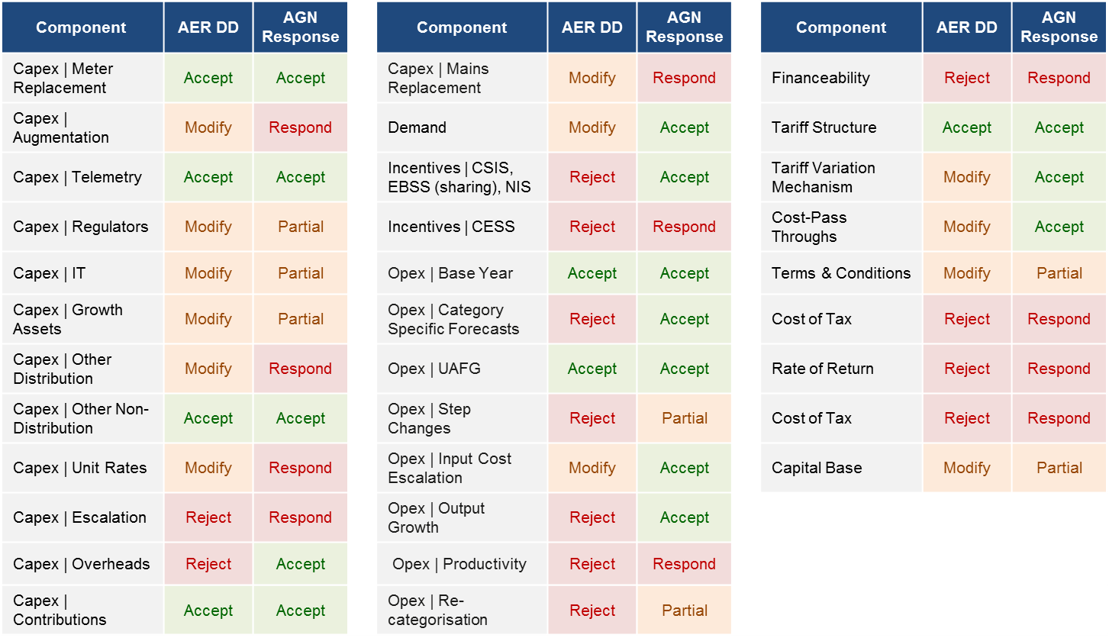

Figure 3 What we Have Accepted. Source: AGN, presented to SA Reference Group, 18th January 2016

This is a substantial list of topics and we observe that AGN has accepted nearly half of the AER’s decisions regarding topics disputed / challenged by AGN. We believe that AGN has demonstrated good faith in seeking to accept a significant number of these draft determinations.

This short submission therefore seeks to focus on a handful of issues that remain important particularly focussing on the issues that AGN has rejected and intends to respond too. These issues being:

* CAPEX escalation
* Incentive schemes
* Incentives / CESS
* OPEX productivity
* Financeability
* Rate of return
* Cost of tax

**CAPEX**The strong reductions in proposed CAPEX, signalled by the AER in the Draft Decision are supported.

The single largest proposed CAPEX item, mains replacement, is important and ongoing work, but consumer benefit from an ambitious, in the short term, replacement program is unclear. We also support reducing the proposed IT CAPEX spending as IT is an ongoing cost to any business and we struggle to see the consumer benefit from nearly $60 million in net IT capital spending.

We support CAPEX spending on research and development that has high potential for assisting in identification of growing risk in mains, to optimise replacement and preventative maintenance and believe that in-line camera technology, for example, is likely to be cost effective. It is also our understanding that AGN in SA has some higher use of HDPE (High Density Poly Ethylene) mains than some other gas networks and that HDPE has not proved to be as ‘failure proof’ as initial research hypothesised. Prioritisation of addressing deteriorating mains is important and we understand is the subject of on-going AER / AGN discussion

UnitingCare Australia and other consumer groups have mixed views about the expansion of the gas network, into Mt Barker and Two Wells in the case of this Access Arrangement. We recognise the advantages of consumers in newer developments having the choice of gas and the benefits to all consumers of spreading fixed costs over a larger customer base, so that each consumer pays less. At the same time, for new houses, paying two supply changes to be due fuel, may not be cost effective.

We recognise that AGN has undertaken substantial research re Mt Barker, in particular, and that Mt Barker is a fast growing residential and SME location. This coupled with AGN recognising that gas connection through Murray Bridge, rather than from Adelaide would be cheaper, leads us to the opinion that establishing gas supply to Mt Barker is likely to be in the net longer term interest of Mt Barker business and households and for existing SA gas customers. From what we understand, we support the extension of gas supply to Mt Barker as proposed by AGN.

**Incentive Schemes**

The AER response to the proposed incentive schemes is supported for this Access Arrangement, mainly because there has not been adequate time for informed engagement between AGN, consumer interests and other stakeholders. However, the argument for Capital Expenditure Sharing Scheme (CESS) incentives to apply to gas as well as electricity networks is sound and should be the focus of debate amongst interested stakeholders in the near future.

Similarly, debate about a broader suite of gas network incentives is warranted, but to attempt to introduce new incentives into the 2016-21 access arrangement is too hasty. UnitingCare Australia is keen to be a part of discussions about future incentive schemes that both provide incentive for gas network businesses and which fairly share benefits of greater efficiency with consumers. We are aware that AGN’s CEO has recently participated in a series of very constructive forums, hosted by Frontier Economics, where incentive options have been discussed and we welcome AGN’s leadership is seeing more effective, outcome based incentive arrangements.

**OPEX productivity**

AER has proposed modest reductions in AGN’s proposed OPEX and has rejected ‘step change’ proposals. We support the rejection of all proposed ‘step changes’ because we regard them to be a part of OPEX for a prudent business, which AGN is.

AGN is concerned about the AER’s proposed ‘productivity adjustment’, but we suggest that the notion of such an adjustment is the basis of incentive based regulation and current sluggish economic conditions, we suggest, mean that real reductions in operating cost can be achieved without reducing service quality, reliability or safety.

**Financeability**

Along with Incentive arrangements, Financeability is the other issue raised by AGN in it’s access arrangement proposal that deserves further informed policy and regulatory practice debate. The relatively late commencement of consumer engagement by AGN in preparing their proposal mitigated against such informed debate making any resolution in time for application over the 2016-21 control period.

While financeability is not part of the current Australian regulatory environment and so does not need to be considered for 2016-21, we note that Ofgem in the UK now regards this as a parameter to which they have regard in making regulatory decisions, under the moderately new RIIO (Revenue = Incentive + Innovation + outputs) model.

Considering AGN, Moodys state of AGN (previously Envestra)

“On the other hand, the rating could face downward pressure if the company's financial profile weakens materially as a result of weaker than expected operating performance or an unexpected change in its financial policy following the change in ownership. Financial metrics we would look for include FFO to interest falling consistently below 2.3x, its FFO to debt dropping below 9%, or its Debt/RAB ratio increasing above 85% on a consistent basis.”

We understand that the critical metric for maintaining BBB+ (Moody’s Baa1) is:

(Funds from Operations) FFO/debt > 9%

This appears to us to be an important metric.

As with the Incentives regime for gas networks, we regard the question of financeability to be an important policy issue for debate, now and into the near future, but note that current rules do not require AER to consider this parameter for the current determination.

**Rate of return and Cost of tax**

We note that these are issues that AGN has said that they will contest in their revised proposal, which was required to be released prior to the recent Competition Tribunal decision being released for the NSW / ACT electricity distribution business appeals. The Tribunal has now released its findings which we understand will be applied to the AGN determination.

**Final Comment**

We have proposed that AGN and stakeholders undertake shared work and negotiation focussed on incentives and financeability. There are also important CAPEX elements that would benefit from broad consumer dialogue and negotiation. We have considerable faith in the willingness and ability of AGN to promote, lead and be informed by such debates. We observe that their consumer engagement has improved markedly since their access arrangement proposal was first lodged in mid 2015.