**IN THE DISPUTE RESOLUTION PANEL AT MELBOURNE**

(Constituted for a determination as to compensation under Rule 3.16.2 of the National Electricity Rules)

**JOINT SUBMISSION TO THE DISPUTE RESOLUTION PANEL**

|  |  |
| --- | --- |
| **AGL Hydro Partnership** (ABN 86 076 691 481) | (**AGL Hydro**) |
| **EnergyAustralia Pty Ltd** (ABN 99 086 014 968) | (**EA**) |
| **Lake Bonney Wind Power Pty Ltd** (ABN 48 104 654 837) and **Woodlawn Wind Pty Ltd** (ABN 38139 165 610) | (**Infigen**) |
| **Pacific Hydro Clements Gap Pty Ltd** (ABN 87 109 911 097) | (**Pacific Hydro**) |
| **Snowtown Wind Farm Pty Ltd** (ABN 76 109 468 804) | (**Trustpower**) |

and

|  |  |
| --- | --- |
| **Australian Energy Market Operator Limited** (ABN 94 072 010 327) | (**AEMO**) |

**A. Glossary**

1. AGL Hydro, EA, Infigen, Pacific Hydro and Trustpower are together referred to as the **Affected Generators**, each of whom owns or operates one or more **Wind Farms** listed in Schedule 2.
2. The italicised terms used in this submission and its attachments are defined in the National Electricity Rules (***Rules***).[1] ‘Rule’ followed by a number refers to a provision of the *Rules*.
3. Other terms and acronyms are defined in bold where they are first used in this submission. For convenience, they are also listed here:

|  |  |
| --- | --- |
| **AWEFS** | Australian Wind Energy Forecasting System |
| **Dispatch Procedure** | AEMO’s 'Power System Operating Procedure – Dispatch', version 74, dated 1 July 2012 |
| **DRP** | *dispute resolution panel* |
| **ECM** | *energy conversion model* |
| **MW / MWh** | megawatt / megawatt hour |
| **NEL** | National Electricity Law |
| **NEMDE** | *NEM* dispatch engine |
| **NSP** | *Network Service Provider* |
| **SCADA** | Supervisory Control and Data Acquisition |
| **TNSP** | *Transmission Network Service Provider* |
| **UIGF** | *unconstrained intermittent generation forecast* |
| **“what-if” dispatch level** | See paragraph 67 |
| **“what-if” UIGF** | See paragraph 67 |

**B. Application**

1. Each Affected Generator is, and was at all material times, registered as a *Market Generator* and a *Semi-Scheduled Generator* for the Wind Farm(s) listed in Schedule 2.
2. On 7 June 2012, AEMO declared under Rule 3.8.24(a)(2) that a *scheduling error* had occurred which affected the Wind Farms.
3. Rule 3.16.2(a) permitsthe Affected Generators to apply to the *dispute resolution panel* (**DRP**) for a determination as to compensation in respect of the *scheduling error*. The matters to be determined by the DRP are:
   * 1. whether compensation is payable;
     2. the amount of compensation to be paid to each Affected Generator from the *Participant compensation fund*;[2] and
     3. the manner and timing of that payment.[3]

**C. Rules**

1. The current version of the *Rules* (version 52) came into effect on 1 November 2012. Previous versions of the National Electricity Rules are applicable to periods during which the Affected Generators were impacted by the *scheduling error*.
2. The applicable versions of the National Electricity Rules and the dates during which each version was in effect, are set out in the table below.

|  |  |  |
| --- | --- | --- |
| **Version** | **Start Date** | **End Date** |
| 27 | 31 March 2009 | 15 April 2009 |
| 28 | 16 April 2009 | 27 May 2009 |
| 29 | 28 May 2009 | 30 June 2009 |
| 30 | 1 July 2009 | 31 August 2009 |
| 31 | 1 September 2009 | 14 October 2009 |
| 32 | 15 October 2009 | 11 November 2009 |
| 33 | 12 November 2009 | 11 March 2010 |
| 34 | 12 March 2010 | 24 March 2010 |
| 35 | 25 March 2010 | 12 May 2010 |
| 36 | 13 May 2010 | 21 June 2010 |
| 37 | 22 June 2010 | 1 August 2010 |
| 38 | 2 August 2010 | 15 September 2010 |
| 39 | 16 September 2010 | 5 January 2011 |
| 40 | 6 January 2011 | 19 January 2011 |
| 41 | 15 March 2011 | 23 March 2011 |
| 42 | 24 March 2011 | 20 April 2011 |
| 43 | 21 April 2011 | 30 June 2011 |
| 44 | 1 July 2011 | 13 July 2011 |
| 45 | 14 July 2011 | 9 November 2011 |
| 46 | 10 November 2011 | 21 December 2011 |
| 47 | 22 December 2011 | 14 March 2012 |
| 48 | 15 March 2012 | 4 April 2012 |
| 49 | 5 April 2012 | 1 July 2012 |
| 50 | 2 July 2012 | 1 August 2012 |
| 51 | 2 August 2012 | 31 October 2012 |
| 52 | 1 November 2012 | N/A |

1. The amendments to the Rules that have been made since Version 27 came into force do not alter the effect of the provisions cited in these submissions in a manner which is material to the matters relevant to the DRP's determination in respect of the *scheduling error*.[4]

**D. AEMO and the National Electricity Market (NEM)**

1. Sections C to F set out background information regarding the operation of the *NEM* and how *Semi-Scheduled Generators* operate in the *NEM*. This is included to provide context to the DRP.
2. AEMO operates and manages the *NEM*. The *NEM* is essentially two things: the physical infrastructure that keeps electricity flowing from producers to consumers, and a notional wholesale pool (or spot market) to which producers sell, and from which purchasers buy, electricity.
3. Electricity cannot be stored economically; it must be dynamically produced to satisfy demand that varies instantaneously. The *NEM* facilitates the instantaneous matching of supply and demand through a centrally coordinated process managed by AEMO, called *central dispatch*.
4. Figure 1 depicts the relationships between different participants in the *NEM*.

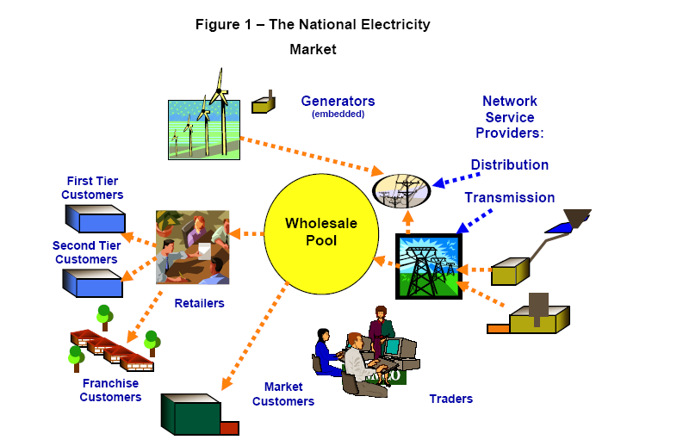

1. The *NEM* is a gross pool. This means that all *Generators* whose power output enters the grid must 'sell' their output via the market conducted by AEMO, unless they are embedded in a *distribution network* and they have already sold their output to the local retailer for that network or to a Customer located at the same *connection point*.
2. In geographic terms, the *NEM* covers the supply of electricity to southern and eastern Australia. It operates on one of the world’s longest *interconnected power systems*, a distance of more than 4,000 kilometres.
3. The *NEM* is divided into five *regions* for *market* pricing purposes:
   * 1. Queensland;
     2. New South Wales (incorporating the Australian Capital Territory);
     3. Victoria;
     4. South Australia; and
     5. Tasmania.
4. Each *region* is connected to its adjacent *regions* by *interconnectors*, which are a series of *transmission lines* that facilitate the flow of electricity between *regions*. Figure 2 shows the *interconnectors*:

**Figure 2 – Interconnectors in the NEM**

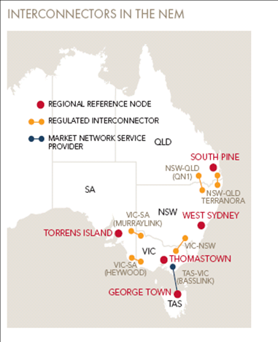

1. A number of different types of organisations can participate in the *NEM*. These are called *Registered Participants*. Some are registered in their capacity as providers of infrastructure, such as *Network Service Providers* (**NSPs**) while others participate in the wholesale electricity exchange as *Market Participants*, buying and selling electricity.
2. The *Rules* allow producers of electricity in the *NEM* to register in a number of different categories. For example:
   * 1. *Scheduled Generators* participate in the *central dispatch* process. Generally, these are *Generators* with *generating units* whose *nameplate rating* is greater than 30 MW.
     2. *Non-Scheduled Generators* are typically *Generators* with *generating units* whose *nameplate rating* is less than 30 MW and do not participate in the *central dispatch* process.
     3. *Semi-Scheduled Generators* are *Generators* in respect of which a *generating unit* is classified as a *semi-scheduled generating* unit. Typically, this occurs where:
        1. a *generating unit* has a *nameplate rating* greater than 30 MW, or a group of generating units *connected* at a common *connection point* have a combined *nameplate rating* greater than 30 MW; and
        2. the output of the relevant *generating unit* is *intermittent* (such as for wind farms);
     4. *Generators* that sell all of their electricity into the *spot market* are registered as *Market Generators*. *Market Generators* are paid the *spot price* applicable at their *network connection* for each *trading interval* during which they supply electricity to the *market*. A *Generator* that sells its entire output to either a *Local Retailer* or consumer located at the same *connection point* is classified as a *Non-Market Generator*.

**E. The regulatory framework**

1. The *NEM* is regulated by the National Electricity Law (**NEL**), a schedule to the *National Electricity (South Australia) Act 1996* (SA) that applies in each of the *participating jurisdictions* through a co-operative legislative scheme. The *Rules* are made and enforced under the NEL.
2. Under the NEL, AEMO has two core functions: power system operator, and wholesale market operator.
3. As power system operator, AEMO is concerned primarily with meeting standards of security and reliability. *Power system security* refers to the *power system's* capacity to continue operating within defined technical limits even in the event of the *disconnection* of a major *power system* element, such as an *interconnector* or large *generating* *unit*. *Power system* reliability refers to the *power system's* capacity to supply sufficient energy to meet consumer demand.
4. As wholesale market operator, AEMO facilitates the wholesale trading of electricity through a centrally co-ordinated *dispatch* process.

**F. Central dispatch**

1. *Central dispatch* refers to the AEMO-managed process of *dispatching* electricity to meet demand, in accordance with Chapter 3 of the *Rules*.
2. *Central dispatch* should aim to maximise the value of *spot market* trading on the basis of *dispatch offers* and *dispatch bids* (that is, the lowest cost *generating units* needed for electricity supply to meet demand are *dispatched*) subject to a number of matters, such as *network* *constraints* and *power system security* requirements.[5]
3. To participate in *central dispatch*, *Scheduled Generators* must submit *dispatch offers* to AEMO to generate electricity[6]. In each *dispatch offer*, *Scheduled Generators* must make an offer to provide a certain number of megawatts (**MW**) of electricity for each of the 48 *trading intervals* in the *trading day* and may make offers for up to ten *price bands* for each *generating unit*.[7] All prices in *price bands* are locked in at 12:30 EST on the day before trading commences, but MW quantities associated with those *price bands* can be modified at any time prior to dispatch.
4. A *Generator* can own one or more *generating units*. Unless AEMO approves an application to aggregate these into a single entity for bidding purposes, AEMO receives bids for, and then determines loading levels (*dispatch instructions*) on an individual *generating unit* basis. The basis upon which two or more *generating units* may be registered as a single *semi-scheduled generating unit* is described in section G below.
5. *Dispatch offers* are processed by a computer system called the National Electricity Market Dispatch Engine (**NEMDE**).
6. NEMDE is based on a constrained optimisation program that uses linear programming techniques that represent the *power system* as reflected in Figure 3:

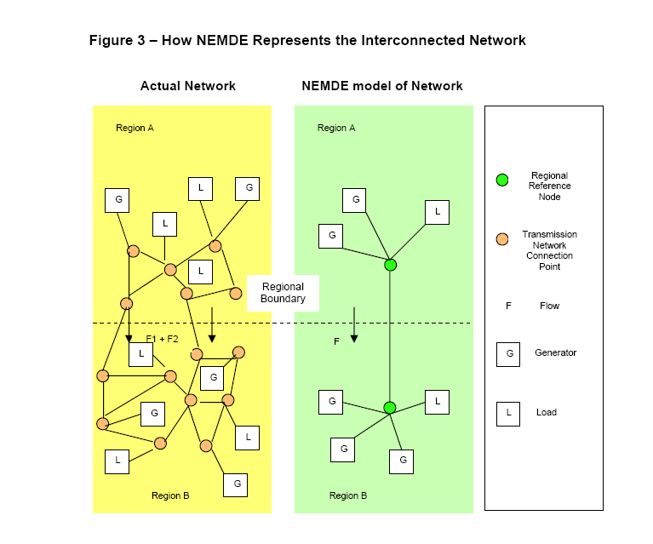

1. AEMO forecasts electricity consumption in each *region*, identifies the capability of the *transmission network* to transmit electricity, and captures the present state of the *power system* from information provided by *Transmission Network Service Providers* (**TNSPs**). AEMO then determines the *generation* outputs for each *Generator* according to an overall optimisation process that is specified in the *Rules* and, in practice, performed by NEMDE. This process is repeated for every 5 minute *dispatch interval*. A simplified form of this optimisation process, as it applies at a general level, is depicted in Figure 4. Further details of the *dispatch process* as it applies to *semi-scheduled generating units*, including how AEMO takes into account the *available capacity* of a *semi-scheduled generating unit* as part of that process, is set out in Section G.

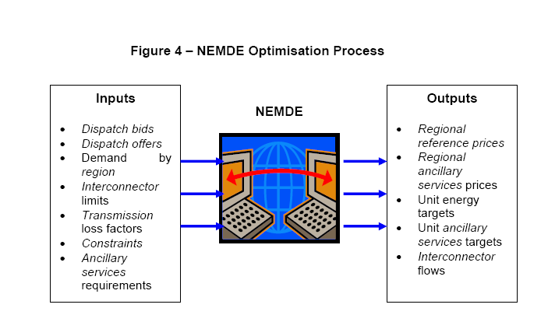

1. The *dispatch* process attempts to maximise the value of electricity traded and produces a *dispatch* *price* in each *region* that represents the marginal price of producing the next increment of electricity at that location.
2. The highest price *Scheduled Generators* can offer is $12,500 per MWh[8] (*market price cap*) and the lowest is -$1,000 per MWh (*market floor price*).[9] *Scheduled Generators* must specify other technical matters in their *dispatch offers*, such as their rate of change for increasing or decreasing their output in MW/minute (*ramp rate*).
3. AEMO sends *Scheduled Generators* a *pre-dispatch schedule* every 30 minutes. A *pre-dispatch schedule* is essentially a forecast that gives *Scheduled Generators* an indication of when they will be *dispatched*, and for what level of output they will be *dispatched* for the *trading intervals* in the next two days. *Scheduled Generators* have the opportunity to *rebid* the MW capacity that they can produce and other technical aspects of their capacity right up to five minutes before the event, but cannot change the prices for the *price bands* they have offered.
4. NEMDE sends the *Scheduled Generators* electronic *dispatch instructions* to increase or reduce the quantity of electricity they produce for each *dispatch interval*.
5. NEMDE will process all the data it has available to achieve the lowest cost and most efficient outcome taking into account *power system* limitations. In general, and without considering the impact of *constraints*, *ramp rate* and other limitations for each *dispatch interval, Scheduled Generators* will be *dispatched* in ascending *price band* order until enough electricity has been produced to meet demand in that *dispatch interval*.
6. The *spot price* for a *trading interval* is the average of the six *dispatch interval* prices within that *trading interval*.
7. All of the *Generators* *dispatched* during that *trading interval* will be paid the *spot price* times their *loss factor* for the energy they produced in that *trading interval*, even if their *dispatch offers* were for a lower price. Any *Generators* whose offers were too expensive and were not needed to meet the demand were not *dispatched* and, consequently, do not get paid. In this way, the wholesale exchange encourages competition between *Generators*.

**G. Semi-Scheduled Generation**

The *Rules* introduced a new category of *Generator*, the *Semi-Scheduled Generator*, on 31 March 2009.

***Classification of semi-scheduled generating units***

1. The process by which a *generating unit* is classified as a *semi-scheduled generating unit* is set out in Rule 2.2.7. As a general rule, a *generating unit* with a *nameplate rating* of 30 MW or greater, or which is part of a group of *generating units connected* at a common *connection point* with a combined *nameplate rating* of 30 MW or greater, must be classified as a *semi-scheduled generating unit* where the output of the *generating unit* is *intermittent*. [10] AEMO may approve this classification for smaller *intermittent generating units* on such terms and conditions as AEMO considers appropriate.[11]
2. A person must not classify a *generating unit* as a *semi-scheduled generating unit* unless it has obtained AEMO's approval to do so.[12] AEMO must approve a request for classification of a *generating unit* as a *semi-scheduled generating unit* if it is satisfied of the following matters:[13]
   * 1. the output of the *generating unit* is *intermittent*; [14]
     2. the person has submitted data in accordance with the requirements to provide *bid and offer validation data* in Schedule 3.1 of the Rules;
     3. the person has submitted an *energy conversion model* (**ECM**) which contains the information described in guidelines *published* by AEMO for that purpose under Rule 2.2.7(d); and
     4. the person has adequate communications and telemetry to support the issuing of *dispatch instructions* and the audit of responses.
3. The ECMs provided *by* *semi-scheduled generators* are in the form of a data template, with the data used as an input into a mathematical model that defines how an *intermittent* energy source, such as wind, is converted by a *semi-scheduled generating unit* into electrical output (ie to forecast the electrical power output from a wind turbine based on the forecast of wind speed).
4. The date upon which each of the relevant *generating units* or groups of *generating units* of the Affected Generators were registered as *semi-scheduled generating units* is set out in the final column of the table in Schedule 2.

***Dispatch of semi-scheduled generating units***

1. A *Semi-Scheduled Generator* must operate a *semi-scheduled generating unit* in accordance with the *central dispatch* process under Chapter 3 of the Rules (described generally in section E above).[15]
2. The Rules distinguish between two different forms of *dispatch interval* for *semi-scheduled generating units,* which are treated differently in AEMO's *central dispatch* process:
   * 1. *semi-dispatch intervals*; and
     2. *dispatch intervals* that are not *semi-dispatch intervals*.
3. Under the Rules, a *semi-dispatch interval* is a *dispatch interval* for which either:
   * 1. a *network constraint* would be violated if the *semi-scheduled generating unit*'s *generation* were to exceed the *dispatch level* specified in the related *dispatch instruction* at the end of the *dispatch interval*; or
     2. the *dispatch level* specified in that *dispatch instruction* is less than the UIGF at the end of the *dispatch interval*,

and which is notified by AEMO in that *dispatch instruction* to be a *semi-dispatch interval*.

1. Semi*-Scheduled Generators* participate in the *central dispatch* process by submitting offers, but effectively operate as though they were *Non-Scheduled Generators* unless AEMO declares a *semi-dispatch interval* for a *semi-scheduled generating unit*. During a *semi-dispatch interval* the output for that *semi-scheduled generating unit* must not exceed a *dispatch level* specified by NEMDE.
2. In operating the *central dispatch process* under Rule 3.8, the specific matters to which AEMO's obligation in Rule 3.8.1(b) to aim to maximise the value of *spot market trading* is subject include, in respect of *semi-scheduled generating units*, *constraints* identified by the *unconstrained intermittent generation forecast* (**UIGF**).[16]
3. The requirement for AEMO to develop a UIGF is established in Rule 3.7B, which provides that AEMO must prepare a forecast of the *available capacity* of each *semi-scheduled generating unit* (to be known as the UIGF) for the purposes of, amongst other things, *dispatch*.[17]
4. In preparing a UIGF under Rule 3.7B, AEMO must take into account the following matters:[18]
   * 1. the maximum *generation* of the *semi-scheduled generating unit* provided by the *Semi-Scheduled Generator* as part of its *bid and offer validation data*;[19]
     2. the *plant availability* of the *semi-scheduled generating unit* submitted by the *Semi-Scheduled Generator* under Rule 3.7B(b);
     3. the information obtained for the *semi-scheduled generating unit* from the *remote monitoring equipment* in Rule S5.2.6.1;
     4. the forecasts of the energy available for input into the electrical power conversion process for each *semi-scheduled generating unit*;
     5. the ECM for each *semi-scheduled generating unit*;
     6. the assumption that there are no *network constraints* otherwise affecting the *generation* from that *semi-scheduled generating unit*; and
     7. the timeframes of, amongst other things, *dispatch.*
5. A UIGF should therefore forecast the total electrical *power* output from available *semi-scheduled generating uni*ts, based solely on the forecast *power* input to its *intermittent* energy conversion process and ignoring any *constraints* on its electrical *power* output, such as *network* limitations.
6. The data that is used to produce *dispatch* *instructions* for *semi-scheduled generation* is processed by a number of systems. The UIGF data for wind generators is determined by the Australian Wind Energy Forecasting System (**AWEFS**).
7. The manner in which AEMO *dispatches* *semi-scheduled generating units,* and its use of AWEFS in preparing a UIGF, is set out in the 'Power System Operating Procedure – Dispatch', version 74, dated 1 July 2012, made for the purposes of Rule 4.10 (**Dispatch Procedure**).[20]
8. The Dispatch Procedure provides that specified SCADA inputs are to be used by AWEFS in preparing a UIGF, including MW output, wind speed, wind direction, number of turbines in service, and the 'control system set-point' (the latter of which is stated to be 'desirable but not mandatory' for a *Semi-Scheduled Generator* to provide).[21] This SCADA data is the 'primary input' for preparing a UIGF, but the Dispatch Procedure also provides that where these inputs fail, AWEFS will not use this data, and will revert to using forecast weather and turbine availability information to produce a five minute ahead dispatch forecast. The forecast information specified in the Dispatch Procedure for this purpose is the 'number of turbines available' and the 'upper MW limit'.[22]
9. AEMO is required under Rule 2.2.7(d) to develop and *publish* guidelines setting out the information to be contained in ECMs. AEMO *published* the ECM initial guidelines (which remain current) on 28 April 2009. During the consultation on these guidelines as part of the implementation process for the *Semi-Scheduled Generator* arrangements*,* and in response to submissions by potential *Semi-Scheduled Generators*, AEMO made the provision of the ‘control set-point’ information as part of the ECM optional (as is now reflected in the Dispatch Procedure). In hindsight, this decision appears to be the cause of an unintended impact on the manner in which *semi-scheduled generating units* are *dispatched*.
10. AWEFS uses the control set-point sent in real-time to AEMO to determine whether actual output has been reduced by a *constraint* equation.[23] Where that control set point data is provided, AWEFS will revert to using forecast weather and turbine availability information to determine the UIGF where a output has been effected by a *constraint* equation. However, in the absence of a control set-point, AWEFS effectively assumes the output reduction is due to a reduction in wind, and fails to revert to using forecast weather and turbine availability information in determining the UIGF.As noted, AEMO is required under Rule 3.7B(c)(6) to create a UIGF for each *semi-scheduled generating unit* on the assumption that there are no *network* *constraints* otherwise affecting *generation.*
11. The lack of a control set-point has resulted in AWEFS ignoring this assumption.[24]

**H. The scheduling error**

1. Rule 3.8.24(a) provides that a *scheduling error* is any one of the following circumstances:
   * 1. the DRP determines under Rule 8.2 that AEMO has failed to follow the *central dispatch* process set out in Rule 3.8;[25]
     2. AEMO declares that it failed to follow the *central dispatch* process set out in Rule 3.8;[26] or
     3. AEMO determines under Rule 3.9.2B(d) that a *dispatch interval* contained a manifestly incorrect input.[27]
2. On 7 June 2012, AEMO declared in accordance with Rule 3.8.24(a)(2) that it failed to follow the *central dispatch* process set out in Rule 3.8 with respect to the *dispatch* of the Wind Farms, and that a *scheduling error* had therefore occurred.
3. The *scheduling error* is constituted by AEMO having incorrectly determined UIGFs for *Semi-Scheduled Generators* during certain *dispatch intervals*.
4. AEMO considers that, following the introduction of semi-scheduled generation on 31 March 2009, it is required to apply the UIGF in *central dispatch* by virtue of Rule 3.8.1(b)(2)(ii) and that the UIGF is a key input to *central dispatch*. *Central dispatch* applies the UIGF as an upper limit on NEMDE’s calculation of *dispatch level* for the relevant *semi-scheduled generating unit*.
5. Where a *semi-scheduled generating unit* is affected by a *network* *constraint* and the next *dispatch interval* is a *semi-dispatch interval* for that *semi-scheduled generating unit* for the same reason, AWEFS incorrectly determined the UIGF, as it would not have ignored the reduction in output from the previous *dispatch interval*. Hence, the UIGF did not ignore *constraints* on electrical *power* output, such as *network* limitations. At times, this error results in a lower UIGF (and hence *dispatch level*), than would otherwise be calculated based on prevailing wind conditions.
6. AEMO has prepared a Market Event Report titled 'Scheduling Error Report Incorrect Unconstrained Intermittent Generation Forecasts for Semi-Scheduled Generators’. The report describes the occurrence of the *scheduling error* and is provided in Schedule 1 to this submission.

**I. Dispatch intervals affected by the scheduling error**

1. In any given *dispatch interval*, the output of a Wind Farm will only have been potentially affected by the *scheduling error* in certain circumstances. Other operational and economic conditions that applied to that Wind Farm will determine whether the Wind Farm would have been able to generate at a higher level than the limit imposed by the incorrect UIGF.
2. The following principles are agreed by the parties for the purposes of determining the affected dispatch intervals:

(a) The earliest date on which the *scheduling error* could have occurred for a Wind Farm is when it was classified as a *semi-scheduled generating unit*.

(b) The *scheduling error* could no longer occur for a Wind Farm from the date and time at which AEMO applied the control set-point for that Wind Farm to AWEFS for the calculation of a correct UIGF.

(c) The *scheduling error* only occurred in *semi-dispatch intervals* where a Wind Farm was affected by a *network constraint*, excluding the first in a series of *semi-dispatch intervals* where that *network constraint* applied. This is because the Wind Farm’s UIGF for the first *semi-dispatch interval* is correctly based on initial output which is not yet affected by the network constraint*.*

(d) The *scheduling error* only occurred in *semi-dispatch intervals* where the UIGF was less than the Wind Farm’s actual generating capacity. That is, if the UIGF did not act to limit a Wind Farm’s output, the *scheduling error* does not affect the Wind Farm.

(e) The *scheduling error* only occurred in *semi-dispatch intervals* where some of the Wind Farm’s capacity was offered at *dispatch offer* prices lower than the *spot price*, otherwise the Wind Farm would not have been *dispatched* by reason of its uneconomic bid, not by reason of the *scheduling error*.

**J. Calculation of compensation – overview**

1. Rule 3.16.2 provides that where a *scheduling error* occurs:
   * 1. a Market Participant may apply to the DRP for a determination as to compensation;[28] and
     2. the DRP may determine that compensation is payable to *Market Participants* and the amount of any such compensation payable from the *Participant compensation fund*.[29]
2. A *Semi-Scheduled Generator* who receives an instruction in respect of a *semi-scheduled generating* unit to operate at a lower level than the level at which it would have been instructed to operate had the *scheduling error* not occurred is entitled to receive in compensation an amount determined by the DRP.[30]
3. The DRPmust therefore determine the compensation payable in respect of a Wind Farmthat, as a result of the *scheduling error*, was *dispatched* at a lower level than it would have been had the *scheduling error* not occurred*.*[31]
4. In order to determine the amount of this compensation payable to each Affected Generator,it is necessary to establish the following values for each affected *semi-dispatch interval*:

(a) the actual output of the Wind Farm;

(b) the UIGF that would have applied if *network constraints* had not been taken into account – referred to as the **“what-if” UIGF**;

(c) the level at which the Wind Farm would have been *dispatched* if the “what-if” UIGF had been applied in *central dispatch*, with all conditions not impacted by the *scheduling error* remaining unchanged – referred to as the **“what-if” *dispatch* *level***;

(d) the applicable *intra-regional loss factor* for the Wind Farm; and

(e) the applicable *spot price*.[32]

1. Part J of this submission sets out the principles which the parties have agreed should be applied in determining those values in relation to this *scheduling error*.

**K. Calculation of compensation – principles for determining inputs**

1. The following compensation principles have been agreed by the parties for the purposes of quantifying an Affected Generator's spot market losses for this particular *scheduling error*:

(a) The calculation of the “what-if” UIGF must be based on the data actually available for each 5-minute *semi-dispatch interval*, using:

* + - 1. SCADA inputs actually received for the purposes of determining wind speed and wind turbine availability (subject to paragraph (b)); and
      2. AWEFS standing data actually used, which includes information from the ECM.[33]

(b) If SCADA data for turbines available (as required under the ECM) was not provided for a Wind Farm, the SCADA data for turbines in operation will be used instead. For the Lake Bonney 2 and 3 Wind Farms, the calculation of turbines available will be based on the sum of turbines in operation and additional ‘turbines paused’ SCADA data actually provided to AEMO, which can be aggregated to derive turbine availability.

(c) The “what-if” UIGF for a Wind Farm cannot exceed its actual capacity (assuming unlimited wind) based on the number of wind turbines available[34] for *dispatch* during the relevant *semi-dispatch intervals*.

(d) For reasons of practicality, the impact of the *scheduling error* on a Wind Farm’s output during a period after a *constraint* has been lifted will not be included for the purpose of calculating an Affected Generator's loss.

(e) The “what-if” dispatch level is taken to equal the “what-if” UIGF unless the Wind Farm would not have achieved the “what-if” UIGF due to the relative economics of the Wind Farm compared to other generators within the network constraint. Other *Generators* competing for access to the *constrained* transmission linemay have displaced the output of the Wind Farm because they were cheaper within the constraint. However, it is not possible to re-create with certainty the exact conditions that would have occurred absent the *scheduling error*, nor is it practical to attempt this for many thousands of affected *dispatch intervals* over 3 years. The parties have therefore agreed for the purposes of this claim to assume that the “what-if” dispatch level is:

1. for each affected *semi-dispatch interval* in which the *regional spot price* was $300/MWh or more, the maximum *dispatch level* of the Wind Farm resulting from a re-run of the original NEMDE *dispatch* calculation with only the following changes:
   * + - 1. substitute the UIGF with the “what-if” UIGF for each affected Wind Farm; and
         2. substitute the initial MW with the “what-if” dispatch level calculated by the NEMDE re-run for the previous *dispatch interval*, for the Wind Farm and for all other *scheduled generating units*, *semi-scheduled generating units* and *interconnectors* within the *network constraint* which caused the *semi-dispatch interval* to be set; and
2. for all otheraffected *semi-dispatch intervals*, the same as the “what-if” UIGF (determined in accordance with the principles in paragraph 69(a) to (c).

(f) Compensation is payable based on the difference between the “what-if” dispatch level determined under paragraph (e) and the actual UIGF that applied to the Wind Farm in the affected *semi-dispatch interval*.

(g) The quantity calculated under paragraph (f) is multiplied by the *intra-regional loss factor* to give the compensable quantity (in MWh).

(h) The spot market loss for each Wind Farm for each affected *semi-dispatch interval* is the compensable quantity calculated under paragraph (g) multiplied by the *spot price*.

(i) If the *spot price* for an affected *semi-dispatch interval* is negative, the calculation under paragraph (h) will result in a payment to the market (that is, a credit in the overall compensation calculation).

**L. Compensation amounts**

1. AEMO has calculated the amount of compensation that would be payable to each Affected Generator in respect of its spot market losses, based on the principles in Part J. The calculations are agreed by the Affected Generators and are set out in separate confidential claim schedules submitted by each of them. The aggregate amount claimed by all Affected Generators is $1,314,670. Infigen has also sought compensation for certain non-spot market losses in respect of the same scheduling error. As this aspect of compensation has not been agreed with AEMO it will be the subject of separate submissions.

**M. Participant compensation fund**

1. AEMO is required by Rule 3.16.1 to 'maintain, in the books of the corporation, a fund called the *Participant compensation fund* for the purpose of paying compensation to *Scheduled Generators* ... as determined by the *dispute resolution panel* for *scheduling error*s…'.
2. AEMO is required to pay to the *Participant compensation fund* the component of *Participant fees* attributable to the *Participant compensation fund*. The overall funding requirement for each financial year is the lesser of:
   * 1. $1,000,000; and
     2. $5,000,000 minus the amount that AEMO reasonably estimates will be the balance of the *Participant compensation fund* at the end of the financial year.[35]
3. Any interest paid on money held in the *Participant compensation fund* also accrues to and forms part of the *Participant compensation fund*.[36]
4. AEMO must prepare and *publish* before the beginning of each financial year a budget of the revenue requirements for AEMO for that financial year.[37] The budget must take into account and separately identify projected revenue requirements in respect of the funding requirements of the *Participant compensation fund* in accordance with Rule 3.16.[38] The projected revenue requirements in respect of the funding requirements of the *Participant compensation fund* must only be recovered from *Scheduled Generators*, *Semi-Scheduled Generators* and *Scheduled Network Services Providers*.[39]
5. AEMO must also develop, review and *publish* the structure (including the introduction and determination) of *Participant fees* for such periods as AEMO considers appropriate.[40] The *Participant fees* should recover the budgeted revenue requirements for AEMO determined under Rule 2.11.3.[41]
6. AEMO has determined the structure of *Participant fees* for the period 1 July 2011 to 30 June 2016.[42] AEMO determined that the budgeted revenue requirements in respect of the *Participant compensation fund* will be allocated to *Scheduled Generators, Semi-Scheduled Generators* and *Scheduled Network Service Providers* and levied using a combination of historical capacity and historical energy scheduled, where:
   * 1. 50% will be collected on the basis of MWh of energy scheduled or *metered* in the previous calendar year; and
     2. 50% will be collected on the basis of the higher of the greatest registered capacity and highest notified maximum capacity in the previous calendar year.
7. AEMO may charge a *Registered Participant* the relevant components of *Participant fees* by giving the *Registered Participant* a statement setting out the amount payable by that *Registered Participant* and the date for payment.[43] In the case of *Market Participants*, AEMO may, alternatively, include the relevant amount in the final statements described in Rule 3.15.15.[44] A *Registered Participant* must pay to AEMO the net amount stated in the relevant statement by the date specified by AEMO.[45]
8. In making its determination, the DRP must:
   * 1. consider the claim for compensation by reference to the reduction in the *loading level* at which a *generating unit* operated due to the *scheduling error*;
     2. use the *spot price* determined under Rule 3.9;[46]
     3. take into account the current balance of the *Participant compensation fund* and the potential for further liabilities to arise during the year;[47] and
     4. recognise that the aggregate liability in any year in respect of *scheduling errors* cannot exceed the balance of the *Participant compensation fund* that would have been available at the end of the year if no compensation payments for *scheduling errors* had been made during that year.[48]
9. In a decision of the DRPdated 24 April 2008in a claim for compensation from the *Participant compensation fund* by Macquarie Generation, it was held that the reference to 'liabilities' in Rule 3.16.2(h)(4) is a reference to actual liabilities that will have created a clear balance in the *Participant compensation fund*.[49] The DRP also accepted that the reference to 'year' in Rule 3.16.2(h) is a reference to a financial year.[50]
10. The *Participant compensation fund* currently has a balance of $5,450,565.
11. Since the commencement of the market there have been four payments made from the *Participant compensation fund*. These are as follows:
    * 1. $438,892.00 to Snowy Hydro Limited as compensation for a *scheduling error* that occurred on 31 October 2005;
      2. $4,544,638.00 to Macquarie Generation as compensation for a *scheduling error* that occurred on 22 October 2007; and
      3. $571,935.06 to AGL Hydro as compensation for a *scheduling error* that occurred on 19 & 20 November 2009.
      4. $246,858.78 to Synergen Power Pty Ltd as compensation for a *scheduling error* that occurred between 19 May 2009 and 14 January 2010.
12. Since the last payment a *scheduling error* under Rule 3.8.24(a)(2) or (3) has occurred on six other occasions, but no claims for compensation have been made except as referred to in paragraph 70.
13. The *Adviser* contacted each *Semi-Scheduled Generator* in the *NEM* on 19 July 2012 regarding a potential claim against the *Participant compensation fund* in respect of this *scheduling error*. A claim notice was received from AGL Hydro on 23 July 2012. The Adviser held a teleconference with the DMS contacts of all *Semi-Scheduled Generators* on 22 August 2012. All but one of them has made a claim for compensation and these are the Affected Generators. The Adviser gave notice to all DMS contacts of the referral of this matter to the DRP on 31 October 2012. No other person has elected to join the proceedings.
14. If the compensation was paid for the full amount claimed in aggregate by the Affected Generators), the balance in the *Participant compensation fund* would be $4,135,895.
15. Accordingly, there is no reason why full payment of the loss of the Affected Generators should not be made.

**N. Costs**

1. For the purposes of this claim, AEMO and the Affected Generators have agreed that the costs of these proceedings (other than the legal costs of the parties) should be allocated on a basis that reflects both their relative involvement in the dispute resolution process and their expected compensation entitlement, as set out in the DRP agreement for this matter entered into on or about 12 November 2012. Each party will bear its own legal costs.
2. It is submitted that the DRP should allocate costs as agreed by the parties in accordance with Rule 8.2.8(a)(ii). The parties agree that none of the parties has unreasonably prolonged or escalated a dispute or otherwise increased the costs of these proceedings.

**DATED: [7] November 2012**

SCHEDULE 1

MARKET EVENT REPORT

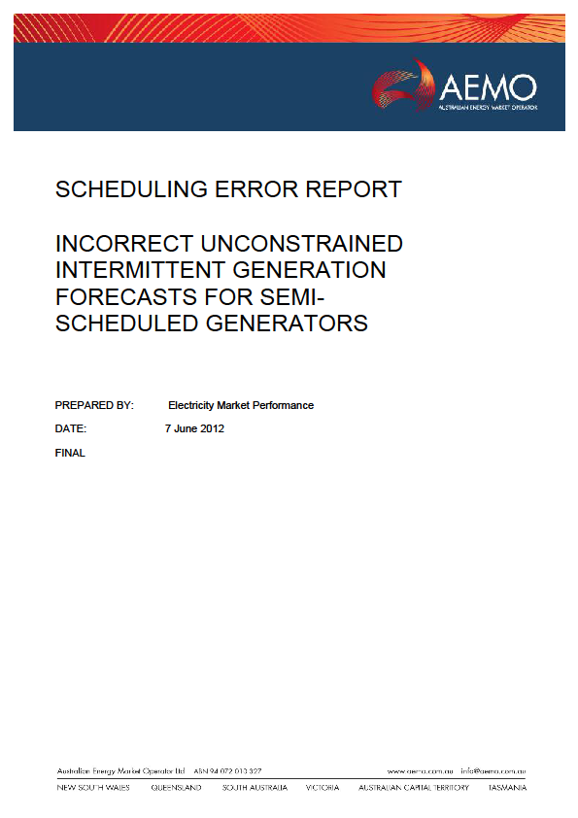

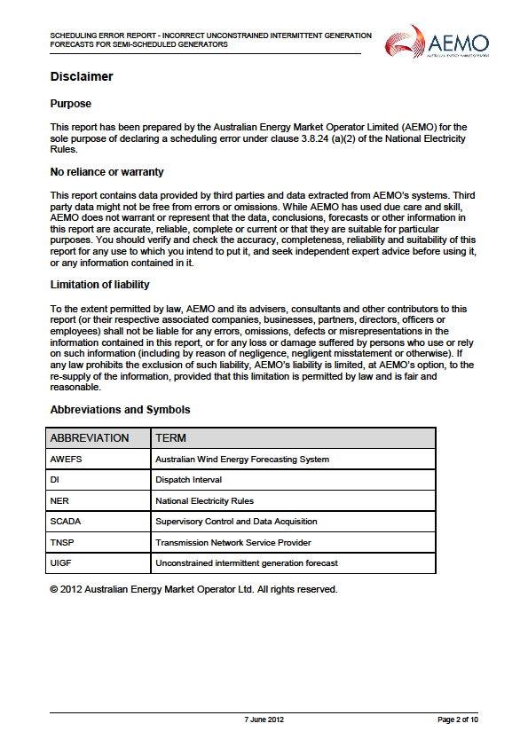

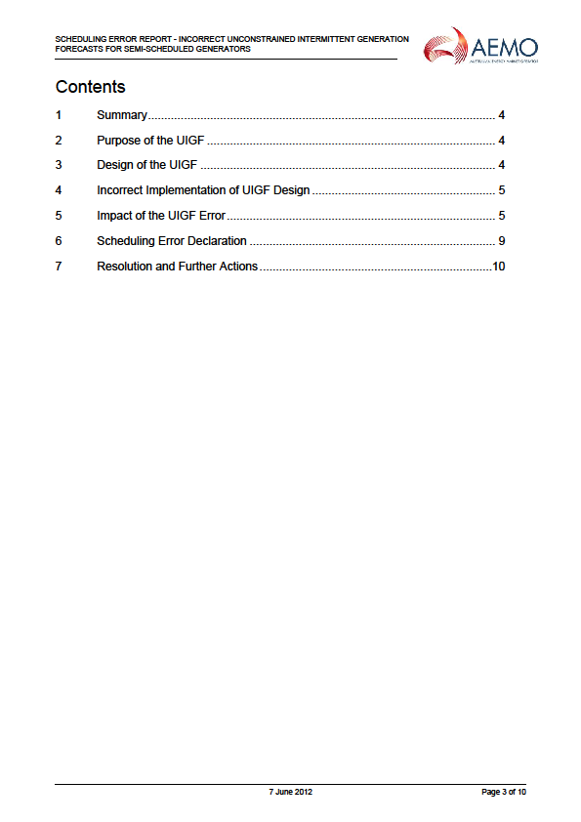

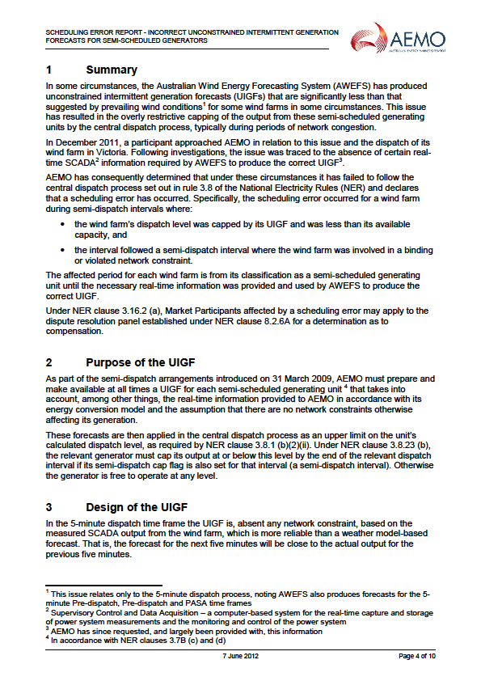

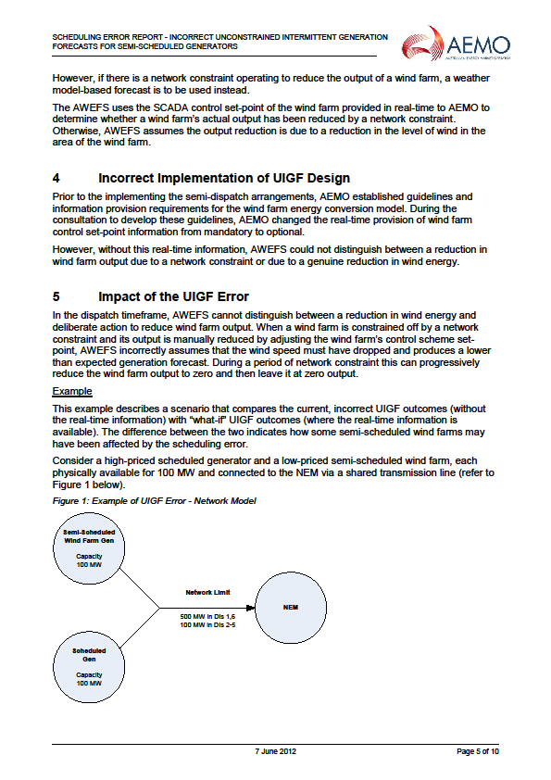

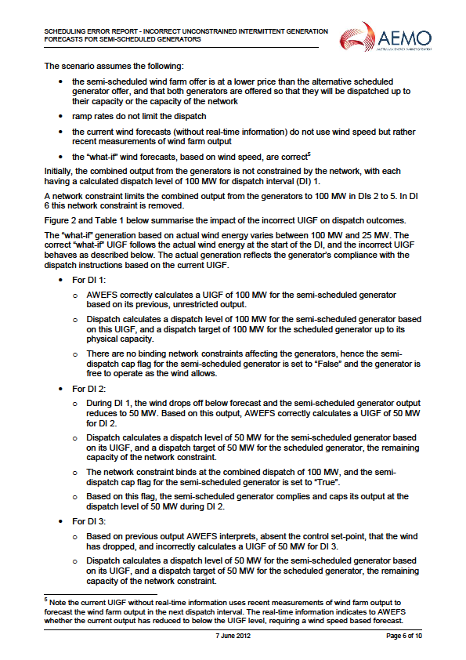

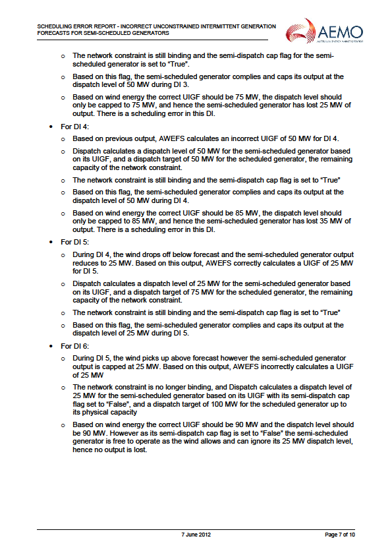

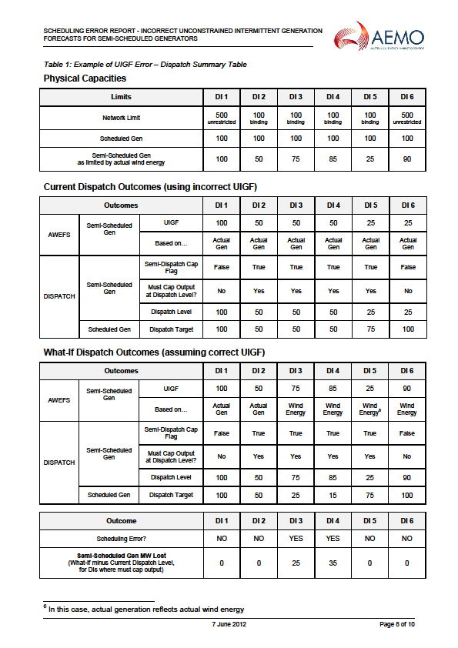

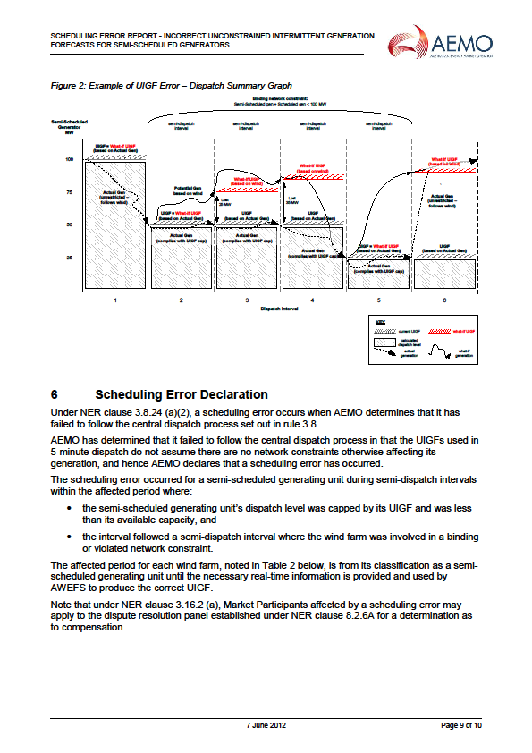

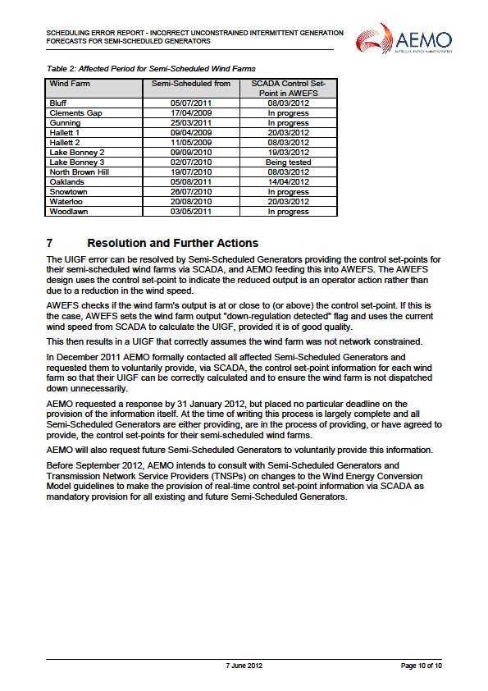

SCHEDULE 2

AFFECTED GENERATORS AND WIND FARMS

|  |  |  |  |  |
| --- | --- | --- | --- | --- |
| **Affected Generator** | **Wind Farm** | **Region** | **MW** | **Semi-Scheduled from** |
| AGL Hydro | Bluff | SA | 53 | 5 July 2011 |
| Hallett 1 | SA | 95 | 9 April 2009 |
| Hallett 2 | SA | 71 | 11 May 2009 |
| North Brown Hill | SA | 132 | 19 July 2010 |
| Oaklands Hill | VIC | 63 | 5 August 2011 |
| EA | Waterloo | SA | 111 | 20 August 2010 |
| Infigen | Lake Bonney 2 | SA | 159 | 9 September 2010 |
| Lake Bonney 3 | SA | 39 | 2 July 2010 |
| Woodlawn | NSW | 48 | 3 May 2011 |
| Pacific Hydro | Clements Gap | SA | 57 | 17 April 2009 |
| Trustpower | Snowtown | SA | 99 | 26 July 2010 |

1. Section C addresses the question of which versions of the Rules are relevant to the period during which the *scheduling error* impacted the Affected Generators.
2. Rule 3.16.2 (b) and (d)
3. Rule 3.16.2(i).
4. Rule 8.2.6C(e), which provides that the DRP must determine the real questions in controversy between the parties, and is not bound by the parties' formulation of those questions, was inserted into the National Electricity Rules in Version 30.
5. Rule 3.8.1(b).
6. Rule 3.8.2(a).
7. Rule 3.8.6(a).
8. Increased to $12,900 per MWh from 1 July 2012
9. Rules 3.9.4(b) and 3.9.6(b).
10. Rule 2.2.7(a).
11. Rule 2.2.7(e)
12. Rule 2.2.7(b).
13. Rule 2.2.7(c).
14. '*Intermittent*' is defined in Chapter 10 of the Rules to refer to a *generating unit* whose output is not readily predictable, including, without limitation, solar generators, wave turbine generators, wind turbine generators and hydro-generators without any material storage capability.
15. Rule 2.2.7(h).
16. Rule 3.8.1(b)(2)(ii).
17. Rule 3.7B(a)(2).
18. Rule 3.7B(c).
19. Rule 3.7B(c)(1), which was inserted in version 42 of the Rules, effective from 24 March 2011.
20. Dispatch Procedure, section 25 (Attachment 3). This section was added to version 70 of the Dispatch Procedure on 6 October 2011 and there have been no material amendments since that date.
21. Dispatch Procedure, section 25.1 (Attachment 3).
22. Dispatch Procedure, section 25.1.
23. Limitations on the *power system* are represented in NEMDE as a series of mathematical constraint equations.
24. Had the Wind Farm control set-point been provided, this would allow AWEFS to ignore the Wind Farm’s output in the previous *dispatch interval* (if approximately equal to the control set-point value) and provide an UIGF based on actual wind speed and the number of turbines available.
25. Rule 3.8.24(a)(1).
26. Rule 3.8.24(a)(2).
27. Rule 3.8.24(a)(3).
28. Rule 3.16.2(a).
29. Rule 3.16.2(b).
30. Rule 3.16.2(d).
31. Rule 3.16.2(d)
32. Rule 3.16.2(h)(3) requires the *dispute resolution panel* to use the *spot price* determined under Rule 3.9 in determining compensation.
33. The data used by AWEFS in the *dispatch* process for *semi-scheduled generating units* is discussed in Section G, at paragraph 52.
34. Or turbines in operation where turbines available SCADA data is either not provided or cannot be derived from data provided to AEMO (see paragraphs (a) and (b)).
35. See Rule 3.16.1(c).
36. Rule 3.16.1(e).
37. Rule 2.11.3(a).
38. Rule 2.11.3(b)(8).
39. Rule 2.11.3(b)(8).
40. Rule 2.11.1(a).
41. Rule 2.11.1(b)(2).
42. See <http://www.aemo.com.au/en/About-AEMO/Energy-Market-Registration/Current-Energy-Market-Budget-and-Fees/Structure-of-Participant-Fees-in-the-National-Electricity-Market-July-to-June>
43. Rule 2.11.2(a).
44. Rule 2.11.2(b).
45. Rule 2.11.2(c).
46. Rule 3.16.2(h)(3)
47. Rule 3.16.2(h)(4).
48. Rule 3.16.2(h)(5).
49. See paragraph 24 of the decision.
50. See paragraph 15 of the decision. A 'financial year' is defined in Chapter 10 of the *Rules* as the period commencing on 1 July in one calendar year and terminating on 30 June in the following calendar year.