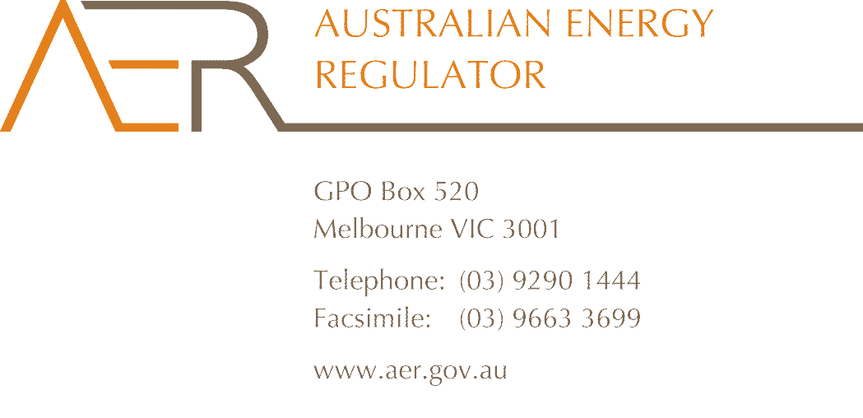

Contact Officer: Dale Johansen

Contact Phone: 07 3835 4679

21 March 2013

Mr Richard Khoe

Australian Energy Market Commission

PO Box A2449

Sydney South NSW 1235

Dear Mr Khoe

**Rule change proposal – Changes to cost allocation method (ERC0150)**

I refer to the AEMC’s consultation paper on proposed changes to National Electricity Rule (the Rules) provisions for cost allocation methods (CAMs) and negotiated service pricing.

I understand the rule change proponent hopes the proposed revised Rules would provide greater insight into negotiated service prices offered by electricity distribution network service providers (DNSPs). If approved by the AEMC, the rule changes would require:

* adoption of the distribution consultation procedures for changes to CAMs
* inclusion of numeric values for each cost allocator, and
* negotiated service prices having to be (‘must be’) based on the cost of supplying those services.

At the outset, it is worth noting the intended outcome of improving or facilitating the provision of negotiated services can more directly and effectively be achieved by looking at the adequacy of the negotiated services framework itself rather than the CAMs. This appears therefore a somewhat round-about way to address such a concern.

More particularly, the first two proposed changes represent a significant departure from the current approach to CAMs. We have no concerns with the rule change paraphrased in the third dot point, although it’s not considered this will make significant difference to negotiations.

The AER’s approval of proposed CAMs is based on an assessment against the requirements of the AER’s cost allocation guidelines (guidelines) and relevant provisions of the Rules. If compliant, CAMs are approved. While the AER is strongly supportive of greater levels of consumer engagement in regulatory processes, it is also important that such engagement be effective and meaningful. In the case of CAMs, it is reasonable that a DNSP should have discretion to construct its CAM in light of its own business characteristics and practices. Critical aspects of a CAM are that a business applies it robustly and consistently, and that any changes to it or its application are minimised. These issues relate to CAM application, however, not the approval process.

The Rules already provide for customer consultation on the guidelines. To the extent that any CAM must comply with certain minimum obligations, it is the purpose of the guidelines to set out such requirements. Consultation on the guidelines provides the opportunity for stakeholders to meaningfully input into the requirements of a CAM, as sought by the rule change proponent

The proponent further submits that, by seeing numeric values for all CAM cost allocators, service applicants may verify negotiated service prices offered by DNSPs. However, CAMs operate at the principle level and guide cost allocation to service categories, not to individual services. They do not set out cost allocations themselves. The benefits sought for service applicants are, therefore, unlikely to be realised. Mandating numeric values for all allocators would, however, add to regulatory costs. Allocator values often vary from year to year, so mandating numeric values implies more frequent, if not annual, CAM submission and approval. This is impractical, implying almost ongoing preparation and approval of revised CAMs. Publication of separate cost allocator schedules is more workable, but would still incur additional costs for little identifiable benefit.

The proposal that negotiated service prices ‘must’ be cost based rather than the current ‘should’, is a marginal change. Either way, prices are only based on costs. I suspect the rule change proponent is seeking a more deterministic outcome. The framework for negotiated prices may become somewhat irrelevant if the approach to price setting was entirely deterministic.

To conclude, I appreciate the rule change proponent’s intent to clarify the cost of supplying negotiated services for service applicants. The Rules, however, already establish a negotiation framework under which DNSPs must provide cost information and demonstrate how proposed prices reflect those costs. Also, service prices ultimately agreed by the parties need only be based on supply costs, leaving some scope for negotiation. Proposed CAM related Rule changes are therefore unlikely to assist service applicants beyond that already provided by the existing negotiation framework. The consequential costs of the proposed changes do not appear justified.

Attachment A to this letter provides further detail on these points.

Yours sincerely

Chris Pattas

General Manager – Network Operations and Development

**Attachment A**

**Applying the distribution consultation procedures to CAM approval**

The consultation procedures provide a formalised stakeholder consultation process and must be followed for changes to the cost allocation guidelines. The AER’s approval of proposed CAMs is, however, a relatively mechanistic process with the DNSPs having broad discretion to propose CAMs appropriate to their business. The potential benefits to customers from consultation on CAM approval are not clear.

The guidelines detail the process and approach for CAM preparation by service providers and the AER’s approval, amendment or rejection. Customer engagement with the guidelines is already mandated and is an effective way of incorporating customer views, by influencing the provisions against which the AER assesses proposed CAMs.

The Rules’ negotiated service provisions provide greater scope for information sharing than would customer involvement in assessment of proposed CAMs. The rule change proponent has not shown how the distribution consultation procedures would improve either approved CAMs, or negotiated service outcomes.

**Cost allocators in all cases must include numeric values**

CAMs provide a high level ‘map’ of principles and policies used to determine and allocate regulatory costs for the supply of distribution services to their respective service classes. This accounts for the underlying cost information generated by a business’ accounting and journal system. CAMs are not intended to provide specific formulae used by DNSPs to generate a particular regulatory proposal. Rather, CAMs operate at a principle level and are intended to remain in place for several years, if not multiple regulatory periods (usually five years). Such stability promotes consistent regulatory reporting, facilitates cost comparisons, minimises the regulatory burden and minimises the AER’s administrative costs.

Specific cost allocators are metrics such as dollar values or percentages, used to link, or allocate, indirect costs to service categories. An example is the total staff hours dedicated by a DNSP to respective service categories over a regulatory year. The cost of that DNSP’s corporate human resources team may be allocated to service categories on this basis. Such cost allocators may vary frequently. Where this is the case, the Rules currently require only that cost allocators be clearly described rather than specified numerically. The guidelines are more prescriptive and require CAMs include numeric values for individual allocators when they will not change over the regulatory period. The current approach balances detail, regulatory burden and administrative cost.

While CAMs can inform prospective customers of the principles used to allocate costs to service categories, they are not intended to provide detailed allocation formulae. As noted above, the Rules’ existing negotiated service provisions provide a more direct way of accessing relevant information and to check on the veracity of proposed prices.

Mandating numeric values for all cost allocators implies more frequent CAM revision, further implying almost constant updating, submission, assessment and approval. This would be an undue burden on the AER and DNSPs, likely to outweigh any associated benefits. Establishment of separate cost allocator schedules is more workable, but would still add to the regulatory burden and, ultimately, electricity costs. Proposed rule changes should more clearly contribute to the national electricity objective to justify such consequent cost increases.

**Negotiated distribution service prices must be based on the cost of supply**

It is proposed that the Rules be amended to mandate that negotiated service prices ‘must’, rather than the current ‘should’, be based on costs incurred by DNSPs in providing those services. This proposal initially appears to further constrain DNSPs in their negotiations with service applicants. However, the requirement relates only to prices being based on, or having some relationship to, supply costs. This is less restrictive than were the proposed revised Rules to require that prices must reflect only the cost of service provision.

The Rules currently require DNSPs to inform service applicants of the reasonable costs of supplying negotiated services. DNSPs must also demonstrate how prices reflect those costs. The proposed change seems not to establish a new requirement or restriction, but to reflect an existing requirement. To the extent that the Rules’ current use of ‘should’ is ambiguous, the proposed substitution of ‘must’ would reduce such uncertainty. While a marginal change, the AER supports this proposal.