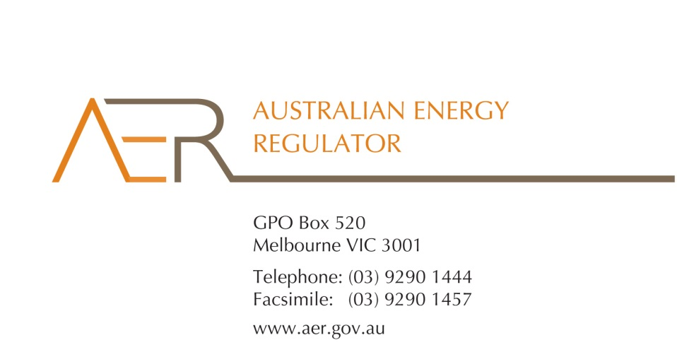

Our Ref: 58992

Contact Officer: Susan Faulbaum

Contact Phone: 08 8213 3463

20 May 2016

Mr Craig Parr

National Embedded Network Operations Manager Scentre Group

85 Castlereagh Street

Sydney NSW 2000

Dear Mr Parr

**Scentre Group** **applications for an electricity individual exemption**

I refer to your applications of 18 December 2015 for individual exemptions under the National Energy Retail Law (Retail Law) to sell electricity under the following legal entities at the following commercial premises in NSW:

* Westfield Burwood, 100 Burwood Road, Burwood NSW 2134 - P.T. Limited ACN 004 454 666, Scentre Management Limited ACN 001 670 579, RE1 Limited ACN 145 743 862.
* Westfield Liverpool, Macquarie Street, Liverpool NSW 2170 - P.T. Limited ACN 004 454 666, Scentre Management Limited ACN 001 670 579, RE1 Limited ACN 145 743 862, Kent Street Pty Limited ACN 006 794 654.
* Westfield Parramatta, 159-175 Church Street, Parramatta NSW 2150 - P.T. Limited ACN 004 454 666, RE1 Limited ACN 145 743 862, The Trust Company (Australia) Limited ACN 000 000 993.
* Westfield Penrith, 585 High Street, Penrith NSW 2750 - Scentre Management Limited ACN 001 670 579, RE1 Limited ACN 145 743 862, GPT RE Limited ACN 107 426 504.
* Westfield Warringah Mall, Corner Old Pittwater Road and Condamine Street, Brookvale NSW 2100 - Scentre Management Limited ACN 001 670 579, AMP Warringah Mall Pty Limited ACN 108 254 100.

I am writing to inform you that that the Australian Energy Regulator (AER) has considered Scentre Group’s applications for an individual exemption and that it decided, on 20 May 2016, to grant all five individual exemptions in accordance with s.110 of the Retail Law.

In accordance with the National Energy Retail Rules, the AER has published the applications on its website, and sought submissions from interested parties.[1]

The AER has considered the policy principles relating to exempt selling in s. 114 of the Retail Law, being:

1. regulatory arrangements for exempt sellers should not unnecessarily diverge from those applying to retailers,
2. exempt customers, should, as far as practicable, be afforded the right to a choice of retailer in the same way comparable retail customers in the same jurisdiction have that right,
3. exempt customers, should, as far as practicable, not be denied customer protections afforded to retail customers under this Law and Rules.

In making its decision, the AER is guided by the objective of the Retail Law[2], the exempt seller factors,[3] the customer related factors,[4] and the assessment approach outlined in the AER’s *Exempt Selling Guideline*.

The AER is satisfied that Scentre Group should be exempt from the requirement to hold a national retailer authorisation, having regard to the considerations outlined above. Each of these individual exemptions is subject to the conditions set out at Appendix A of the attached Instruments of Exemption and subject to your acceptance of those conditions.[5] Scentre Group must advise the AER in writing, by **17 June 2016**, whether it accepts these conditions.

Please note, the exemptions will not take effect until then.

We also note that for these applications you have stated you are unlikely to obtain the consent of every existing market connected tenant for the conversion of the existing network to a private embedded network. Subject to your acceptance of the conditions set out in Appendix A, the AER will not seek to enforce the requirement of condition 4.1.12 of the AER’s *Electricity Network Service Provider Registration Exemption Guideline* that every tenant consent to the conversion to this application.

If you have any further queries, or would like to discuss this further, please contact Susan Faulbaum on 08 8213 3463.

Yours sincerely

Sarah Proudfoot

General Manager

Retail Markets

**Schedule 1: Instrument of Exemption**

**INDIVIDUAL EXEMPTION FROM THE REQUIREMENT TO HOLD A RETAILER AUTHORISATION**

**DATE OF ISSUE: 20 May 2016**

**FORM OF ENERGY: Electricity**

Pursuant to section 110 of the National Energy Retail Law, the Australian Energy Regulator on 20 May 2016 decided to grant P.T. Limited (ACN 004 454 666), Scentre Management Limited (ACN 001 670 579) and RE1 Limited (ACN 145 743 862) an exemption from the requirement to hold a retailer authorisation under section 88 of the National Energy Retail Law, subject to the conditions set out Appendix A. This exemption applies to the premises at Westfield Burwood, 100 Burwood Road, Burwood NSW 2134 (see map at below).

Westfield Burwood – 100 Burwood Road, Burwood NSW 2134

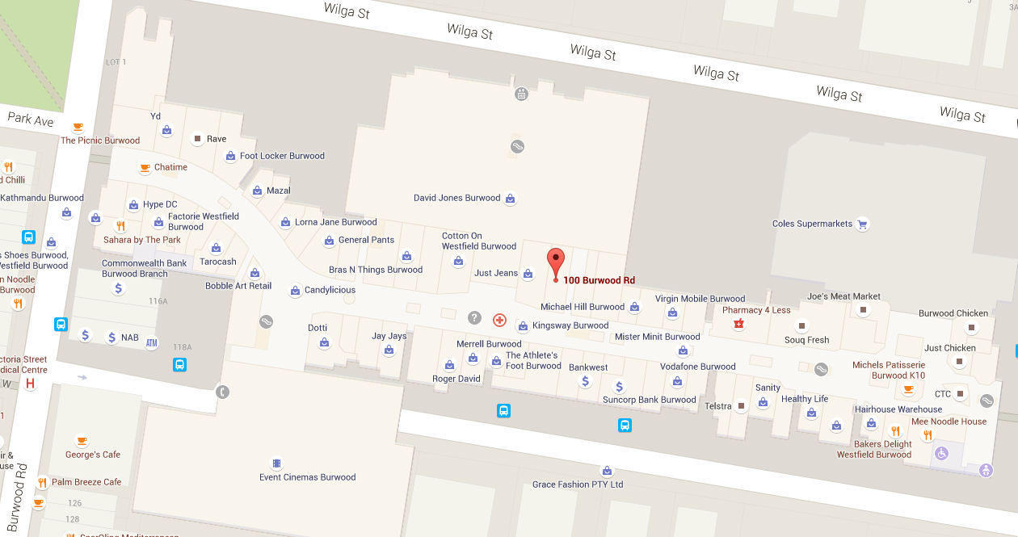

**Schedule 2: Instrument of Exemption**

**INDIVIDUAL EXEMPTION FROM THE REQUIREMENT TO HOLD A RETAILER AUTHORISATION**

**DATE OF ISSUE: 20 May 2016**

**FORM OF ENERGY: Electricity**

Pursuant to section 110 of the National Energy Retail Law, the Australian Energy Regulator on 20 May 2016 decided to grant P.T. Limited (ACN 004 454 666), Scentre Management Limited (ACN 001 670 579), RE1 Limited (ACN 145 743 862) and Kent Street Pty Limited (ACN 006 794 654) an exemption from the requirement to hold a retailer authorisation under section 88 of the National Energy Retail Law, subject to the conditions set out Appendix A. This exemption applies to the premises at Westfield Liverpool – Macquarie St, Liverpool NSW 2170 (see map at below).

Westfield Liverpool – Macquarie St, Liverpool NSW 2170

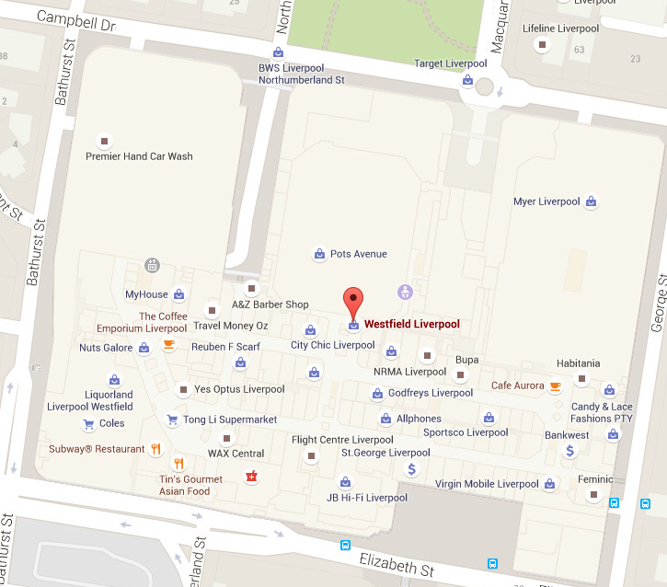

**Schedule 3: Instrument of Exemption**

**INDIVIDUAL EXEMPTION FROM THE REQUIREMENT TO HOLD A RETAILER AUTHORISATION**

**DATE OF ISSUE: 20 May 2016**

**FORM OF ENERGY: Electricity**

Pursuant to section 110 of the National Energy Retail Law, the Australian Energy Regulator on 20 May 2016 decided to grant P.T. Limited (ACN 004 454 666), RE1 Limited (ACN 145 743 862), The Trust Company (Australia) Limited (ACN 000 000 993) an exemption from the requirement to hold a retailer authorisation under section 88 of the National Energy Retail Law, subject to the conditions set out Appendix A. This exemption applies to the premises at Westfield Parramatta – 159-175 Church St, Parramatta NSW 2150 (see map at below).

Westfield Parramatta – 159-175 Church St, Parramatta NSW 2150

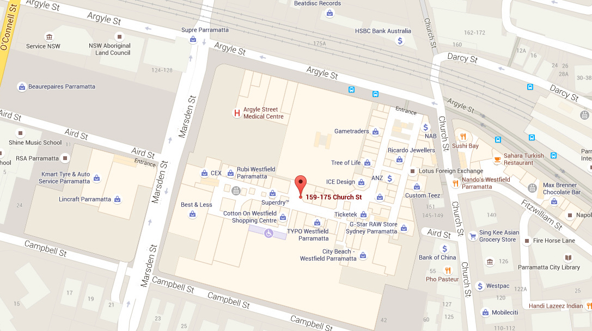

**Schedule 4: Instrument of Exemption**

**INDIVIDUAL EXEMPTION FROM THE REQUIREMENT TO HOLD A RETAILER AUTHORISATION**

**DATE OF ISSUE: 20 May 2016**

**FORM OF ENERGY: Electricity**

Pursuant to section 110 of the National Energy Retail Law, the Australian Energy Regulator on 20 May 2016 decided to grant Scentre Management Limited (ACN 001 670 579), RE1 Limited (ACN 145 743 862), GPT RE Limited (ACN 107 426 504) an exemption from the requirement to hold a retailer authorisation under section 88 of the National Energy Retail Law, subject to the conditions set out Appendix A. This exemption applies to the premises at Westfield Penrith – 585 High St, Penrith NSW 2750 (see map at below).

Westfield Penrith – 585 High St, Penrith NSW 2750

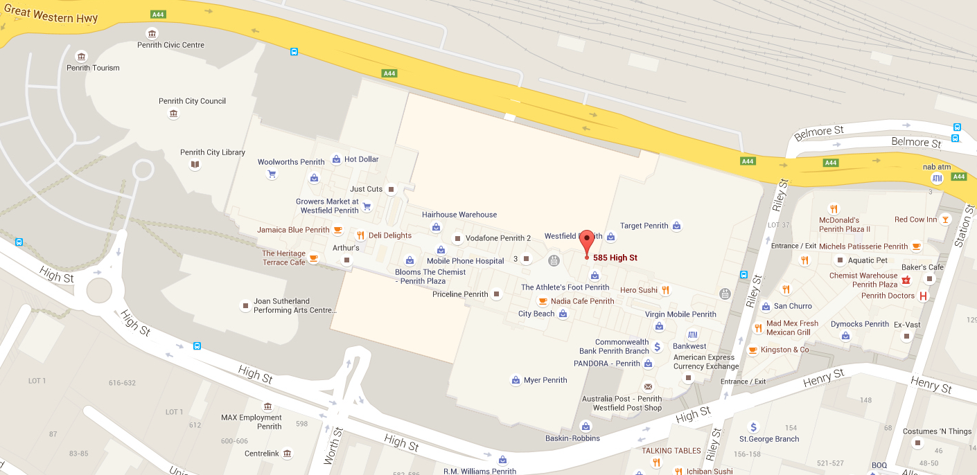

**Schedule 5: Instrument of Exemption**

**INDIVIDUAL EXEMPTION FROM THE REQUIREMENT TO HOLD A RETAILER AUTHORISATION**

**DATE OF ISSUE: 20 May 2016**

**FORM OF ENERGY: Electricity**

Pursuant to section 110 of the National Energy Retail Law, the Australian Energy Regulator on 20 May 2016 decided to grant Scentre Management Limited (ACN 001 670 579), AMP Warringah Mall Pty Limited (ACN 108 254 100) an exemption from the requirement to hold a retailer authorisation under section 88 of the National Energy Retail Law, subject to the conditions set out Appendix A. This exemption applies to the premises at Westfield Warringah Mall – Corner Old Pittwater Road and Condamine Street, Brookvale NSW 2100

(see map at below).

Westfield Warringah Mall – Corner Old Pittwater Road and Condamine Street, Brookvale NSW 2100

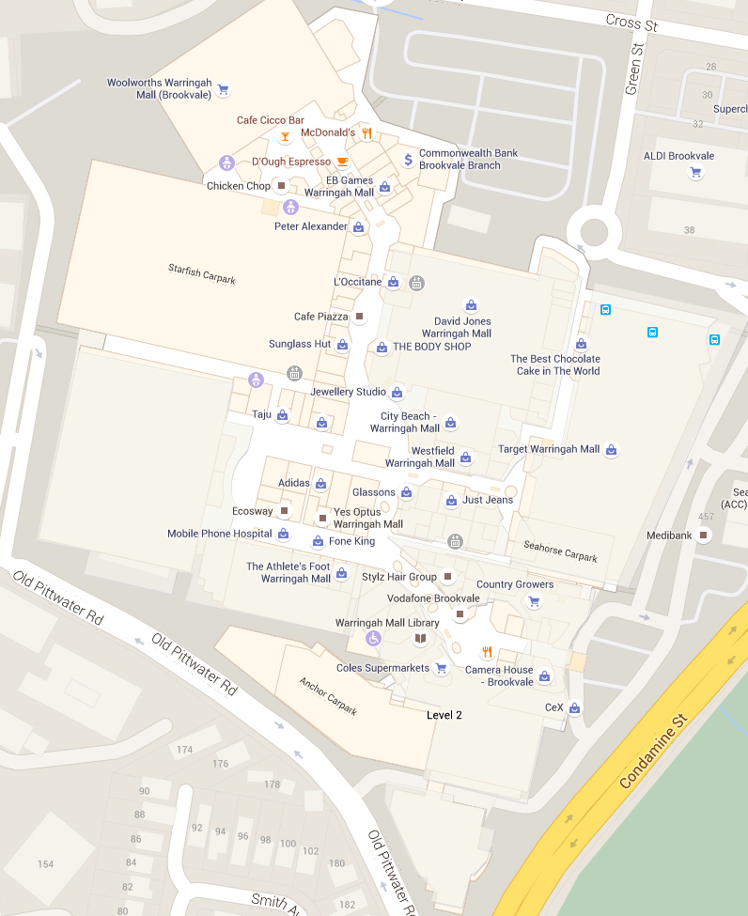

**Appendix A**

**Retrofitting of an embedded network**

**Condition 1 – Provision of information to tenants regarding embedded network retrofit**

1. The exempt person must provide notice, by letter, to all tenants of the plan to install an embedded network at the site.
2. The exempt person must provide each tenant with the following information regarding the installation of the embedded network:
   1. a written notice which provides the tenant with information concerning:
      1. the tenant’s right to choose their own retailer, even within an embedded network
      2. the tenant’s ability to enter into an energy only contract[6] with an authorised electricity retailer
      3. the obligations regarding electricity offer matching, as set out in conditions 3 and 4
      4. the obligations regarding duplication of network fees, as set out in condition 5.
   2. a copy of the electricity sales agreement to be offered by the exempt person
   3. the contact details of a representative of the exempt person who will address any concerns and queries relating to the planned retrofit.
3. The exempt person must ensure that information regarding the proposed retrofit is clearly, fully and adequately disclosed, and that it has regard to a person’s capacity to provide consent.

**Condition 2 – Collecting and recording explicit informed consent**

1. The exempt person must provide the tenant with the information set out in Condition 1, prior to seeking the tenant’s explicit informed consent to the retrofitting of the embedded network.
2. The exempt person must keep records of the consent obtained. These records must:
   1. include copies of the information provided to tenants
   2. include records of consultations and meetings held with tenants
   3. identify and record which tenants have not consented and the reasons for non-consent
   4. record the outcome of any negotiation and/or dispute resolution with tenants
   5. be kept for a period of two years
   6. be provided to the AER on request .
3. The exempt person must engage with tenants who do not consent, and take steps to address any detriment the tenant may suffer as a result of the retrofit.
4. The exempt person must obtain the tenant’s consent for the retrofit in a separate document, that is, the document recording the tenant’s consent to the retrofit must be separate to a document acknowledging that the tenant is selecting the exempt person as its electricity supplier.

**Condition 3 –Offer matching for large customers**

***This condition applies only if the large customer was a tenant at the time of the creation of the embedded network.***

1. If a tenant, who is categorised as a large electricity customer,[7] does not consent to becoming part of the embedded network, the exempt person must:
   1. facilitate, within the embedded network, the continuation of the tenant’s electricity contract with their current retailer,[8] or
   2. maintain the tenant’s direct connection to a registered distributor[9], or
   3. fulfil a request made by the tenant that the exempt person match any genuine electricity offer that would be available to the particular tenant if they were still a grid connected customer.
2. The exempt person must fulfil any subsequent request made by a tenant to match an electricity offer if the request is made 12 months or more after a previous request.
3. In the absence of a subsequent request to match an electricity offer, the exempt person need only apply the matched offer for a period of 12 months.
4. The exempt person’s obligation to match an electricity offer expires upon termination or renewal of the large customer’s tenancy/lease.

**Condition 4 –Offer matching for small customers**

***This condition applies only if the small customer was a tenant at the time of the creation of the embedded network.***

1. If a tenant, who would be categorised as a small electricity customer, does not consent to becoming part of the embedded network, the exempt person must fulfil a request made by the tenant that the exempt person match any genuine electricity offer that would be available to the particular tenant if they were still a grid connected customer.
2. The exempt person must fulfil any subsequent request by a tenant to match an electricity offer if the request is made 12 months or more after a previous request.
3. In the absence of a subsequent request to match an electricity offer, the exempt person need only apply the matched offer for a period of 12 months.
4. The exempt person’s obligation to match an electricity offer expires upon termination or renewal of the customer’s tenancy/lease.

**Condition 5 – Duplication of network charges**

1. The exempt person must take steps to remedy any duplication of network charges experienced by tenants who have entered into an energy only contract with an authorised retailer.

***Condition 5.1 applies only if the customer was a tenant at the time of the creation of the embedded network.***

1. The exempt person must not charge a connection charge to any tenant who enters into an energy contract with an authorised retailer in accordance with conditions 5.1.

**Condition 6 – Metering arrangements**

1. The exempt person must not charge tenants the cost of any changes to metering and other network alterations that take place in the course of retrofitting the embedded network.
2. The exempt person must ensure that metering arrangements within the embedded network allow for exempt customers to access retail competition.

**Electricity selling within an embedded network**

**Condition 7 – Obligation to supply**

1. The exempt person cannot refuse to sell electricity to a tenant except in accordance with relevant disconnection provisions.
2. Subject to condition 15, the exempt person can refuse to sell energy to an exempt customer where:
3. outstanding amounts are owed under the exempt customer’s ongoing energy account
4. the exempt customer’s premises have been disconnected by the exempt person for a reason other than the failure to pay a bill and the exempt customer has not within 10 business days of disconnection rectified the matter that gave rise to the disconnection. The exempt person must reconnect the premises and offer to sell energy once the matter is rectified.

**Condition 8 – Provision of exempt selling information to exempt customers**

1. The exempt person must advise an exempt customer, in writing, at the start of their electricity sale agreement of the following:
2. any right of the exempt customer, under state or territory laws, to elect to purchase energy from a retailer of their choice and information on the options for metering that would allow this choice
3. that the exempt person is not subject to all the obligations of an authorised retailer, and the exempt customer will not receive the same protections as it would if it were purchasing from an authorised retailer
4. the exempt customer’s rights in relation to dispute resolution including:
5. the exempt person’s procedures for handling disputes and complaints
6. any right that the exempt customer has to access the energy Ombudsman scheme or any other relevant external dispute resolution body in the state or territory in which the exempt customer is located.
7. the conditions applicable to the exemption that the exempt person is operating under
8. the energy tariffs and all associated fees and charges that will apply to the exempt customer in relation to the sale of energy
9. contact numbers in the event of an electricity fault or emergency, including the number for a 24-hour emergency contact line.
10. In addition to the requirement to provide the information at the commencement of the exempt customer’s electricity sale agreement, the information set out in paragraph 1 of this condition must be provided by the exempt person at any time on request by the exempt customer or the AER.

**Condition 9 - Billing and payment arrangements**

1. The exempt person must ensure that bills are issued to each exempt customer at least once every three months.
2. The exempt person must offer at least two payment methods to an exempt customer. However, if an exempt person offers direct debit as one payment method, they must also offer at least two other payment methods to an exempt customer (that is, at least three methods in total). In each case, at least one of the payment methods offered must be able to be effected without internet access. For example:
3. in person;
4. by telephone;
5. by mail;
6. by direct deposit into a bank account.

**Condition 10 - Estimation as basis for bills**

1. The exempt person must use best endeavours to ensure that the meter for each exempt customer is read and used as the basis, or apportioned, for any bill issued.
2. The exempt person cannot rely on an estimation of the meter value at the start of an energy supply arrangement with an exempt customer, or for the purpose of issuing a final bill to an exempt customer.
3. The exempt person may base an exempt customer’s bill on an estimation of the exempt customer’s consumption of energy where the exempt person is not able to reasonably or reliably base the bill on an actual meter reading.
4. Where an estimation is used as the basis for an exempt customer’s bill, the estimation must be based on:
5. historical metering data for the exempt customer reasonably available to the exempt person, or
6. where this is not available, the average usage of energy by a comparable customer over the corresponding period.
7. If a customer’s bill is based on an estimation, this must be clearly stated on the exempt customer’s bill.

**Condition 11 - Pay-by date**

1. The pay-by date for a bill must not be less than 13 business days from the date on which the exempt person issues the bill.

**Condition 12 - Receipts**

1. The exempt person must provide each exempt customer with a receipt for any amount paid for energy, except where payment has been made by:
2. direct debit, or
3. credit card over the phone and the customer is provided with a receipt number.
4. The exempt person must provide the exempt customer with a separate receipt if a payment for energy was made together with a rent payment but has not been separately identified on the rent receipt.

**Condition 13 - Pricing**

1. Subject to conditions 3 and 4, the exempt person must not charge the exempt customer tariffs higher than the standing offer price that would be charged by the relevant local area retailer for new connections, if the local area retailer were to supply that quantity, or estimated quantity, of energy directly to the premises of the exempt customer.
2. The exempt person must provide notice to the exempt customer of any change in the exempt customer tariff as soon as practicable, and no later than the exempt customer’s next bill.
3. The exempt person must not impose any charge on an exempt customer that could not be charged by the relevant local area retailer for new connections under a standard retail contract.[10]
4. The exempt person must limit any fee charged to a customer for late payment to a recovery of reasonably incurred costs by the exempt person as a result of the customer’s late payment.[11]

**Condition 14 – Undercharging and overcharging**

1. Where an exempt customer has been undercharged, the exempt person can recover the amount undercharged subject to the following:
2. where the undercharging was not the result of the exempt customer’s fault or unlawful act or omission, the exempt person is limited to recovering the amount undercharged in the 9 months before the date on which the customer is notified of the undercharging.
3. the exempt person cannot charge interest on the undercharged amount.
4. the exempt person must offer the exempt customer time to pay the undercharged amount by instalments, over a period nominated by the customer (up to12 months, but no longer than the period of the undercharging).
5. Where an exempt customer has been overcharged, the exempt person must inform the customer within 10 business days after becoming aware of the overcharging and repay the amount overcharged subject to the following:
6. where the amount overcharged is $25 or more, the exempt person must refund the amount to the exempt customer if requested, or if no such request is made, credit the amount to the exempt customer’s next bill. Where the exempt customer no longer purchases energy from the exempt person, the exempt person must use best endeavours to refund the amount within 10 business days.
7. where the amount overcharged is less than $25, the exempt person must credit that amount to the exempt customer’s next bill.
8. no interest is payable on the overcharged amount.
9. where the overcharging was the result of the exempt customer’s fault or unlawful act or omission, the exempt person is limited to repaying the amount overcharged in the 12 months before the date on which the error was discovered.

**Condition 15 - Disconnection or cessation of supply**

1. Subject to Condition 16, the exempt person must not proceed with disconnection or cessation of energy supply to an exempt customer unless the following requirements have been met:
2. the exempt customer has requested disconnection, or
3. continuity of supply to the premises would be unsafe, or
4. the exempt customer’s tenancy/ agreement has ended and the exempt customer is vacating the premises, or
5. the exempt customer has not paid a bill by the pay-by date or has not adhered to the terms of a payment plan, and:
6. following non-payment by the pay-by date, the exempt person has given the exempt customer a reminder notice requesting payment by a date at least 6 business days from the date of issue of the reminder notice, and
7. following non-payment by the date specified in the reminder notice the exempt person has given the exempt customer a disconnection warning notice informing the exempt customer that disconnection may occur if payment of the outstanding bill is not made by a date at least 6 business days from the date of issue of the warning notice, and
8. the exempt person has, after issuing the disconnection warning notice, used its best endeavours to contact the customer in person or by telephone in connection with the failure to pay, and
9. the exempt customer has, by the date specified in the disconnection warning notice, refused or failed to take any reasonable action towards settling the debt.
10. Where an exempt customer is disconnected in accordance with paragraph 2(b) of this condition, the exempt person must use its best endeavours to notify the exempt customer in person or by telephone prior to the disconnection, and must arrange for reconnection of the premises as soon as practicable.
11. This condition does not apply where state or territory tenancy legislation sets out the process and requirements for the disconnection or cessation of energy supply by the exempt person on the basis that they are a landlord.

**Condition 16 - When disconnection or cessation of supply is prohibited**

1. The exempt person must not disconnect or cease energy supply to an exempt customer’s premises where:
2. the exempt customer has made a complaint directly related to the proposed reason for disconnection or cessation of supply, to the exempt person, the energy Ombudsman or another relevant external dispute resolution body and the complaint remains unresolved, or
3. the disconnection or cessation of supply would occur on:
4. a business day before 8am or after 3pm, or
5. a Friday or the day before a public holiday, or
6. a weekend or a public holiday, or
7. the days between 20 December and 31 December (inclusive) in any year.
8. The exempt person must contact its distributor to ask whether disconnection of a retail customer in the relevant jurisdiction would be prohibited on that day due to extreme weather conditions. Where the distributor confirms that the disconnection of a retail customer would be prohibited on that day, the exempt person must not disconnect the exempt customer’s premises.
9. This condition does not apply where:
   1. the exempt customer has requested disconnection, or
   2. continuity of supply to the exempt customer’s premises would be unsafe, or
   3. there is a planned or unplanned interruption to supply, or
   4. the energy supply agreement between the exempt person and exempt customer has been terminated.

**Condition 17 - Reconnection of supply**

1. Where the exempt person has arranged for the disconnection of an exempt customer’s premises and the exempt customer has within 10 business days of the disconnection:
2. if relevant, rectified the matter that led to the disconnection, and
3. made a request for reconnection, and
4. paid any charge for reconnection,

the exempt person must reconnect the premises (or, where required, arrange with the network operator to reconnect the premises) as soon as practicable, and no later than two days from when the request was made.

**Condition 18 – Planned interruption to supply**

1. In the case of a planned interruption, the exempt person must notify each affected exempt customer by any appropriate means of the interruption at least 4 business days before the date of the interruption.
2. The notification must:
   1. specify the expected date, time and duration of the interruption; and
   2. include a telephone number for enquiries (the charge for which is no more than the cost of a local call); and
   3. include a statement that any enquiries regarding planned interruptions are to be directed to the exempt seller.
3. The exempt person must use its best endeavours to restore the exempt customer’s supply as soon as possible.

**Condition 19 – Unplanned interruptions to supply**

1. In the case of an unplanned interruption, the exempt person must:
   1. within 30 minutes of being advised of the *interruption*, or otherwise as soon as practicable, make available, by way of a 24 hour telephone service (the charge for which is no more than the cost of a local call), information on the nature of the *interruption* and an estimate of the time when supply will be restored or when reliable information on restoration of supply will be available; and
   2. if the telephone service is automated—provide options for exempt customers who call the service to be directly connected to a telephone operator if required; and
   3. use its best endeavours to restore supply to affected exempt customers as soon as possible

**Condition 20 - Choice of retailer**

1. Where an exempt customer is eligible under state or territory legislation to purchase energy from a retailer of their choice, the exempt person must not do anything to discourage or prevent them from exercising this choice, whether by:
2. requiring the exempt customer to waive their ability to choose a retailer;
3. hindering their efforts to find another retailer.

**Condition 21 - Contact details**

1. The exempt person must provide a means of contact for account inquiries and complaints that can be readily accessed by exempt customers. Where a telephone number is provided, the charge for this call must be no more than the cost of a local call.

**Condition 22 – Dispute resolution**

1. In the event of a dispute concerning the sale of energy to an exempt customer, and in the absence of a determination of the relevant tenancy tribunal if the customer is a tenant, the exempt person must:
2. make reasonable endeavours to resolve the dispute, and
3. advise the exempt customer of any right that the exempt customer has to access the energy Ombudsman scheme or any other relevant external dispute resolution body in the state or territory in which the exempt customer is located, if applicable.
4. The exempt person’s dispute resolution process must meet, at a minimum, Australian Standards: AS/NZS 10002:2014 Customer Satisfaction – Guidelines for complaints handling in organisations.

**Condition 23 – Continuity of supply**

1. The exempt person must notify the exempt customers immediately if they are (or expect to be) disconnected, or there is any likelihood that they will be unable to continue selling energy.

**Condition 24– Termination of energy supply agreement**

1. An energy supply agreement between the exempt person and an exempt customer will terminate:
2. on a date agreed by the exempt person and exempt customer, or
3. five business days (or a different time agreed by the exempt person and exempt customer) from the date when the exempt customer gives the exempt person a termination notice, or
4. at the conclusion of the exempt customer’s lease for, or occupancy of, the premises to which the energy is supplied, or
5. when the exempt customer starts receiving energy retail services from a different retailer or exempt person, or
6. when a different exempt customer moves in and starts receiving customer retail services for the premises, or
7. at the end of a period of 10 business days commencing on the day the exempt customer’s premises are disconnected, where the conditions for reconnection have not been met.
8. Termination of an arrangement to supply energy does not affect any rights or obligations that have already accrued under the agreement.

**Condition 25 - Maintaining records**

1. The exempt person must maintain records of the following for each of its exempt customers:
2. The name of the exempt customer.
3. The address of the exempt customer’s premises.
4. The identifier of the meter for the exempt customer’s premises (if applicable).
5. The date that the customer account was created.
6. Copies of any bills issued for the previous 12 months.
7. The date of the most recent meter read for the customer (if applicable).
8. The basis for determining any estimates of consumption for the purpose of billing where a meter read could not be obtained.

1. r. 155(3) and 156, National Energy Retail Rules.
2. The national energy retail objective is to “promote efficient investment in and efficient operation and use of energy services for the long term interests of energy consumers with respect to price, quality, safety, reliability and security of supply of energy”. (s. 13, Retail Law)
3. s. 115, Retail Law.
4. s. 116, Retail Law.
5. r. 158(1), Retail Rules.
6. ‘Energy only contract’ means a contract that charges customers for their energy consumption only and does not include a supply charge.
7. A “large” customer is a customer that consumes 100 MWh or more of electricity per annum.
8. Where a separate account is rendered for network charges, the exempt person must also meet the large customer’s reasonable cost of a bill validation service in relation to that account.
9. A “registered distributor” is an electricity network distributor that is registered with AEMO.
10. For clarification, a “charge” includes, but is not limited to, account establishment fees, late payment fees, debt collection fees, service charges, and security deposits. The fees and charges allowable under a standard retail contract are governed by Division 6 of the National Energy Retail Rules (which sets out the requirements for charging a security deposit under a standard retail contract) and may also be governed by jurisdictional legislation.
11. For clarification, a late payment fee can only be charged where it has not been excluded by jurisdictional legislation.