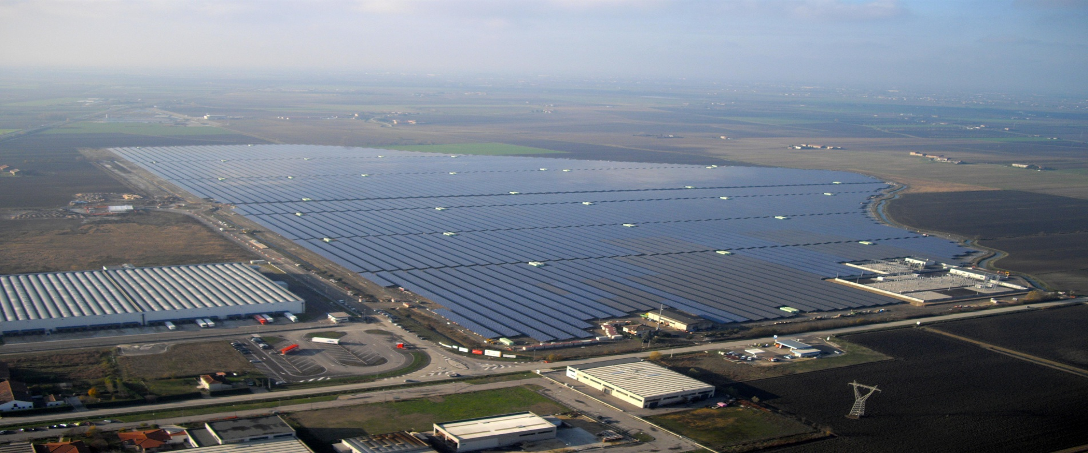

**SunEdison’s 70 MW power plant at Rovigo, Italy**

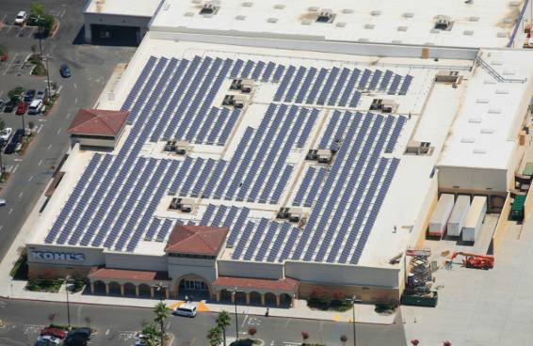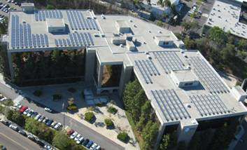

**SunEdison’s AT&T Installation, USA**

**SunEdison’s Kohls Department Store Installation, USA**

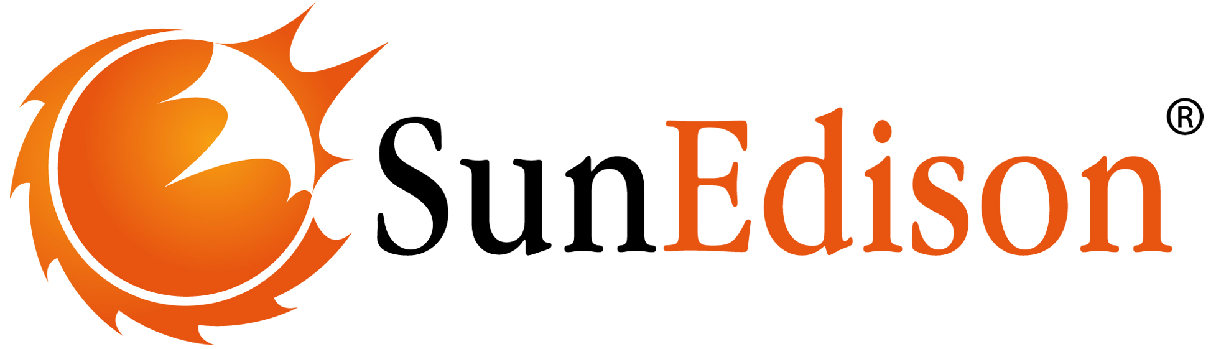

Application for Individual Retail Exemption

May 2014

Table of Contents

SunEdison Overview 2

Application for Individual Retail Exemption 3

APPENDIX

APPENDIX 1……………………………………...……………………………………………...REDACTED

APPENDIX 2….…………………………………………………………………………………..REDACTED

# SunEdison Overview

SunEdison, Inc. is a global leader in solar development, semiconductors and solar technology. SunEdison's common stock is listed on the New York Stock Exchange under the symbol "SUNE" as of June 3, 2013. SunEdison and its affiliates (“SunEdison Group”) deliver more energy from its systems than any other solar company. SunEdison is a trusted partner for innovative, intelligent energy solutions around the globe. We have built our business by putting our customers first, and focusing on addressing each customer’s unique solar energy needs. Through our integrated service approach, we partner with you, help you navigate your way through the solar landscape and offer uniquely tailored solutions and flexible financing.

From Fortune 500 businesses to the house down the street, our customers trust us to provide solar energy services to meet their needs. We use only proven technologies, and we pride ourselves on delivering timely installations and long-term financial benefits to homeowners, businesses, power companies, and public sector institutions. It's the reason why more than 40% of our commercial and utility customers have more than one SunEdison system installed and over 90% of customers are repeat customers.

Headquartered at St. Peters, Missouri, USA, SunEdison has manufacturing locations around the world. SunEdison operates in the U.S., Canada, India, Spain, Italy, France, Germany, Thailand and South Africa. Our headquarters is located in Belmont, California, USA and we have regional offices across four continents. We are fast expanding into new geographies like Indonesia, Philppines, Taiwan, Japan, Australia and other international locations.

Please provide the following information in your application for the grant of an individual exemption:

1. **Your legal name. If you are a body corporate or community corporation, please indicate this.**

SE SOLAR 1 PTY LTD (ACN 166 080 244)

SE SOLAR 2 PTY LTD (ACN 166 080 486)

SunEdison expects to use one entity to sell energy to residential customers (SE SOLAR 1 PTY LTD (ACN 166 080 244)) and a different legal entity to sell energy to business / commercial customers (SE SOLAR 2 PTY LTD (ACN 166 080 486)). Hence, we have consolidated both vehicles into a single application, but each entity shall be treated as if it had submitted its own, separate application.

1. **Your trading name if different to your legal name.**

To be determined.

1. **Australian Business Number (ABN) or Australian Company Number (ACN).**

SE SOLAR 1 PTY LTD (ACN 166 080 244)

SE SOLAR 2 PTY LTD (ACN 166 080 486)

1. **Registered postal address for correspondence. We may verify this information with the Australian Securities and Investments Commission (ASIC) or other relevant agency.**

Level 5, Deutsche Bank Place, 126 Philip Street, Sydney, NSW 2000

1. **Nominated contact person, including their position in the organisation and contact details.**

Anthony Stocken (Country Head of Australia)

astocken@memc.com

+61 4 1047 9294

Mark Sandy (Regional General Counsel)

[msandy@sunedison.com](mailto:rsankhe@sunedison.com)

+65 9382 2275

Radhe Adidam (Manager, Business Development)

[radidam@sunedison.com](mailto:asubramanian@sunedison.com)

+91 87 5450 9457

+61 4 7022 1923

1. **Why you are seeking an individual exemption, and why you believe that an exemption (rather than a retailer authorisation) is appropriate to your circumstances.**

SunEdison intends to introduce its innovative solar energy-sale model to the Australian market. Our model does not fit under the existing Retailer Energy Legislation or its exemption categories. Our approach contemplates the sale of solar electricity to consumers under a solar Power Purchase Agreement (or its substantive equivalent (including equipment leases that enjoy output-related performance guarantees or hire-purchase arrangements that are priced based on energy produced by those systems)) (“**SPPA**”) with a pre-agreed tariff structure for a specified tenor. Tenors of our SPPAs with residential customers will range between 7 and 15 years; tenors of SPPAs with commercial customers may extend up to 20 years. Our approach will include both ground-mount and roof-top sites. The terms and conditions of the SPPA will fall within the guidelines for seeking an individual exemption for the following reasons:

* SunEdison does not intend to be the primary supplier of electricity to its consumers. It will be a condition in our SPPA model that the customer retains a relationship with an “authorised retailer” under the National Energy Retail Law and the customer retains the ability to change authorised retailers without consequence during the term of the SPPA.
* SunEdison’s solution will serve as a supplementary source of electricity to consumers, who are currently being serviced by an authorised electricity retailer.
* SunEdison intends to operate across all States and Territories in Australia including New South Wales, South Australia, Australian Capital Territory, Victoria and Queensland. In this context, SunEdison would like to seek a multi‐site individual retail exemption to include each of the aforementioned States and Territories.   SunEdison seeks this multi-­site individual retail exemption to include Victoria and Queensland once those states accede to National Energy Customer Framework (‘**Customer Framework**’). In the interim SunEdison will ensure that it has appropriate approvals and exemptions in those two states and is presently in consultation with the relevant regulators regarding the same.
* Our SPPA will take into account the requirements of the Retail Energy Legislation as it pertains to consumer protection including billing, metering, cooling off-period and dispute resolution.

1. **The address of the site at which you intend to sell energy, including a map of the site and a brief description of this site and its current and future use/s.**

Not Applicable - SunEdison intends to operate across all States and Territories in Australia including New South Wales, South Australia, Australian Capital Territory, Victoria and Queensland. In this context, SunEdison is seeking a multi‐site individual retail exemption to include each of the aforementioned States above.   SunEdison is seeking this multi-­site individual retail exemption to include Victoria and Queensland once those States accede to the Customer Framework. In the interim, SunEdison will ensure it has appropriate approvals and exemptions in those two States and is presently in consultation with the relevant regulators.

1. **The primary activity of your business (for example, managing a shopping centre).**

* SunEdison is a leading global solar PV integrator with a market capitalisation in excess of US$ 4.41 billion (NYSE:SUNE) and an asset portfolio of over 1.5GW of PV plant under management.
* SunEdison was, in fact, among the first to offer solar PPAs in the USA (circa 2003).
* As well as being a manufacturer of solar modules, SunEdison develops, designs, builds, finances and operates solar PV plants globally. In Australia, SunEdison is well advanced in establishing its footprint in the utility, commercial, residential and off-grid PV sectors. For the residential and commercial PV market sectors, SunEdison, as an alternative energy seller, will deliver supplementary electricity under a SPPA from solar systems installed on the premises of the customers.
* SunEdison will be the owner of such solar systems and will be responsible for their Installation, operation & maintenance (O&M), directly or through our accredited partners.

1. **The form of energy for which you are seeking the individual exemption (electricity or gas). For electricity, please state whether the network you propose to sell is directly or indirectly connected to the main grid or is (or will be) an off-grid network.**

* SunEdison will sell supplementary electricity generated from solar photovoltaic (PV) systems installed on its customers’ premises, such customers being currently connected to the grid through existing contracts with authorised electricity retailers.

1. **Are you establishing, or have you established, energy supply in an area where there are no other viable energy supply arrangements available.**

* SunEdison has established off-grid projects elsewhere in the world, but it is not our intention to do so in Australia using the entities that are seeking the present exemption.
* For purpose of this application, we are only seeking to sell “supplementary”, “non-essential”, “ancillary” power, a condition precedent to any such sale being that our customers have in place existing contractual arrangements for the supply of power with licensed electricity retailers. We will interface with the existing retail and network system.

1. **The date from which you intend to commence selling energy.**

* Immediately, subject to approval of this exemption request.

1. **Mailing addresses for premises at the site (where applicable). We may use this information to ensure that potential customers are able to participate in our consultation process.**

* Not applicable given the nature of this request.

1. **Details of any experience in selling energy, for example:**

* Please refer to Question 8 above. Some additional notable facts include:
  + - Developed more than 1.4 GW of solar energy capacity
    - Over 1000 operational sites
    - Delivered over 800,000 MWh of electricity
    - First solar energy provider to raise more than US$3 billion in project financing
    - First solar energy services provider to commercialize the solar Power Purchase Agreement (SPPA), eliminating capital outlay from customers
* Based upon its experience and track record of supplying similar products in the US and Europe, SunEdison is well advanced in developing its SPPA and lease offerings to meet the requirements of customers and regulators in Australia.
* Additional general information about our global reach and experience in the development, construction and operation of solar power systems and the sale of power therefrom can be found at our website ([www.sunedison.com](http://www.sunedison.com)). As a publicly listed company on the New York Stock Exchange, information on our global operations can also be found in our periodic filings with the US Securities and Exchange Commission, which can also be found on our website.
* Should AER require any further information regarding our experience, SunEdison would be pleased to provide the same upon request.

1. **Whether you currently hold, or have previously held or been subject to, an energy selling exemption or a retail licence (retailer authorisation) in any state or territory. If so, please provide details.**

* No – SunEdison does not hold, nor has it ever held, an energy selling exemption or a retailer license in any State or Territory.

1. **What arrangements you have made in the event that you can no longer continue supplying energy (e.g., has the retailer that sells to you agreed that they will service the customers).**

* SunEdison will provide an ancillary/supplementary supply of electricity only. Primary supply, along with all of its related obligations, will continue to be provided by the customer’s authorised primary electricity Retailer.
* In the unlikely event that supply from the SunEdison‐owned solar system is compromised, the full electricity needs to the property would continue to be fulfilled by the primary Electricity Retailer.

***Particulars relating to the nature and scope of the proposed operations***

To determine whether it is appropriate to exempt you from the requirement to hold a retailer authorisation, we need information on the nature and scope of the operations you propose to conduct. Please answer the following questions:

1. **Will your customers be your tenants? If so, are they residential or commercial/retail? Are they covered by residential or retail tenancy, or other legislation governing accommodation that is a person’s principal place of residence (for example, retirement village legislation, residential parks or manufactured home estates legislation) in your state or territory?**

* Not Applicable. While we do not presently anticipate selling energy under a SPPA model directly to residential or retail tenants, we may introduce this in the future, pending further assessment of regulatory requirements and satisfactory tripartite arrangements.

1. **Are you providing other services (for example, accommodation/leasing of property) to persons on the site who you intend to sell energy to? Or will your only commercial relationship to persons on the site be the sale of energy? If you are providing other services, please specify what these services are, and the contractual or leasing arrangements under which these services are being provided.**

* SunEdison’s scope of services will be limited to the installation and operation and maintenance of its solar systems and the sale of energy therefrom. Such services will be offered to both residential and business/commercial customers.

1. **What is the total number of dwellings/premises at the site? Please provide a breakdown between residential and business customers (and whether they are small or large as defined for the jurisdiction in which you intend to operate).[1]**

* Not applicable - as SunEdison’s application is not site-specific.
* It is SunEdison’s expectation that its customer base will be comprised of both residential (small) and business/commercial (medium - large) customers. At this stage, the exact breakdown between residential and business/commercial customers is not known.
* SunEdison intends to operate across all States and Territories in Australia including New South Wales, South Australia and Australian Capital Territory, Victoria and Queensland.

1. **Will you be onselling energy (that is, selling energy purchased from an authorised retailer) or purchasing it directly from the wholesale market?**

* Not Applicable

1. **If purchasing from an authorised retailer, have you formed, or do you intend to form, a bulk purchase contract with the energy retailer, and how far into the future does this, or will this, contract apply? If you have formed, or intend to form, a contract, please provide a brief summary of this arrangement.**

* Not applicable - The customers will continue to have an existing separate contract with their primary electricity retailer. SunEdison will purely be providing electricity to the customer on a supplementary basis. SunEdison’s business model does not anticipate, at this point in time, providing conventional electricity generation from a traditional electricity Retailer

1. **What is the estimated aggregate annual amount of energy you are likely to sell (kilowatt hours or megawatt hours for electricity and mega joules or gigajoules for gas) and the average expected consumption of customers for each type of customer you service (that is, residential customers and retail or commercial customers)?**

* This is commercially sensitive information – redacted in large measure.
* In general, the aggregated annual amount of energy that SunEdison is expecting to sell will depend on the size of the solar system, solar insolation and its efficiency. Each of these parameters will be site-specific and will vary for every customer.
* The average size of the solar system is expected to be in the range of 4-5 kilowatts for residential clients and commercial customers in the range of 50 kilowatts and above.

1. **Will your customers be wholly contained within a site owned, controlled or operated by you? (For the purposes of this question, a body corporate may be taken to ‘operate’ premises it oversees).**

* Not applicable. SunEdison is seeking an exemption to install systems at, and sell electricity from, multiple sites, none of which will be owned by SunEdison.

1. **Will each premises/dwelling be separately metered? If the application is for a new development or a redevelopment and customers will not be separately metered, please explain why not.**

* Yes, each site will be separately metered for electricity supplied by the network / grid and our solar systems.

1. **What types of meters will be used? For example, basic/accumulation meters, manually read interval meters or remotely read interval meters? Will these meters allow your customers to change retailers (i.e. not source their energy from you)?**

* We expect a range of metering solutions depending on the jurisdiction and the type/availability of existing metering at each customer’s switchbox. The preferred solution will employ a remotely read interval metering solution independent of the primary electricity meter located for the site's grid connection. In addition, SunEdison is developing proprietary discrete integrated metering solutions that will measure gross solar generation, customer usage as well as export kWh’s. These solutions will meet the necessary/relevant Australian standards.

1. **What accuracy standards apply to the meters? Do the meters comply with Australian Standards? If so, specify which Standard or Standards. For electricity meters, will the meters comply with National Measurement Act 1960 (Cth) requirements for electricity meters installed from 1 January 2013?[2]**

* In general, the electricity metering equipment will comply with the necessary accuracy standards relevant to this type of metering, as well as the relevant Australian standards. We expect a range of metering solutions depending on the jurisdiction and the type/availability of metering at the customer’s switchbox. All installed metering solutions will be of Class 1 accuracy standard or above. The meters will comply with Australian Standards AS3000 'Wiring rules', AS3100 'General requirements for electrical equipment' and AS3820 'Essential safety requirements for low voltage electrical equipment'.
* In addition, SunEdison is developing proprietary discrete integrated metering solutions that will measure gross solar generation, customer usage as well as export kWh’s. These solutions will meet the necessary/relevant Australian standards.

1. **If customer dwellings/premises are separately metered, how often do you propose the meters to be read and by whom?**

* SunEdison will constantly monitor the meters for its residential and business customers through the appropriate proprietary technology which will be compliant with the relevant standards for recording electricity. Depending on the customer, such data will be used to bill the customers on either a monthly or quarterly basis.

1. **How will you determine energy charges if customers are not separately metered?**

* Not applicable. All customers will be separately metered for their grid and SPPA consumption with each energy supplier being separately responsible for their respective charges and billing processes.

1. **In what form and how often will customers be billed? Will you be issuing bills yourself or through a billing agent?**

* Customers will be billed in accordance with their SPPA contracts. It is expected that residential and commercial customers will be invoiced either monthly or quarterly. We expect to outsource billing, receivables management and other related administration functions to a reputable and experienced provider of such services in the consumer finance industry.

1. **What dispute resolution procedures do you intend to put in place to deal with energy related complaints and issues?**

* SunEdison’s SPPA contracts will include robust dispute resolution protocols that reflect “best practices” in the industry. Our SPPA contracts will include a mechanism by which a customer may raise a complaint directly with us, which complaint will be addressed within 20-40 Business Days depending on the nature of the complaint. In furtherance of the same, SunEdison anticipates unveiling a dedicated customer care centre that will permit customers to submit questions / concerns by phone and/or email, which questions / concerns will be handled by appropriately trained staff for expeditious resolution. If a customer does not find our resolution of the matter to be satisfactory, we will meet with such customer within 10 Business Days of being notified by such customer that it is not satisfied. If matters remain unresolved after such consultation, such customer will be free to refer the complaint to the relevant fair trading office or ombudsman in its respective State or Territory or pursue the matter in the civil courts. Our SPPA contracts will also provide for a mechanism by which disputes in relation to Building Work-related statutory warranties will be resolved.

1. **What energy rebates or concessions are available for your customers and, if applicable, how can customers claim these?**

* SunEdison will not be offering its customer any rebates or concessions. Any financial incentives or rebates that are derived from our solar systems will be retained by us as the systems will continue to be our property. As such, any and all ‘green’ energy certificates and rebates (eg. STC’s, LGC’s) generated by our solar systems will remain our property for our exclusive benefit unless otherwise agreed with the end customer. That being said, our retention of such incentives / rebates will permit us to offer a fully maintained solar system at no upfront cost to the customer and at more competitive tariffs under our SPPAs. In addition, any income derived from sales of exported electricity will normally be paid directly to the end customer via their traditional retailer except in certain exceptional instances.

1. **Will you make energy efficiency options available to your customers? Will your network incorporate solar or other generation options for sustainability purposes? If so, will you use gross or net metering?**

* Our SPPAs will reflect a “state of the art” renewable solar energy service. SunEdison will work with our customers at the outset to maximise the benefit of the electricity generated by solar so that it best matches their load profile. While we do not presently anticipate making additional energy efficient options available, we may introduce them in the future, including, but not limited to, the introduction of new products and services that reflect the rapid pace of technological change in the solar industry (e.g., storage systems, more efficient panels, integrated solar panels and micro-inverters, and expansion of current systems, etc.).

**EXTRA INFORMATION ON BUSINESS MODEL**

Below is commercially sensitive information – redacted in large measure.

1. **Please provide an overview of the business model and business plan**

* SunEdison’s long-term business goal is to market and sell SPPAs to a range of Residential and Business/Commercial customers based upon the company’s proven products, experience and global track record in this area. .

1. **Please provide projected annual aggregate energy sales (in kilowatt hours or megawatt hours)?**

* Redacted.

1. **Are you intending to sell to business customers, residential customers, or both?**

* Yes, SunEdison’s business model is based upon selling to both residential and business or commercial clients.
* SunEdison expects to use one entity to sell energy to residential customers (SE SOLAR 1 PTY LTD (ACN 166 080 244)) and a different legal entity to sell energy to business / commercial customers (SE SOLAR 2 PTY LTD (ACN 166 080 486)). Hence, we have consolidated both vehicles into a single application, but each entity should be treated as having submitted its own individual application.

1. **Pricing structures (for example, is the customer charged only for their consumption or are there other fees, who retains the right to access any feed-in tariffs, etc).**

* Redacted.

1. **Under what circumstances can the customer contract be terminated (for example, what happens if the customer moves house or wishes to exit the contract)?**

* Redacted.

1. **What happens to the solar panels at the end of the contract? Who owns them?**

Although terms of the SPPA may vary by customer, a customer will generally have a number of options at end of term. These include (1) having the panels removed upon request, (2) entering into a new SPPA at a new tariff, (3) buying out the solar system at its residual value, or (4) taking ownership of the solar system at no additional cost.

1. For electricity, large customers are customers who consume 100 MWh pa or more in New South Wales, the ACT, Queensland and Victoria, and 160MWh pa in South Australia; and for gas, customers who consume 1TJ pa or more.
2. For further information, see [www.measurement.gov.au](http://www.measurement.gov.au).