

4 February 2015

Mr Sebastian Roberts

General Manager

Australian Energy Regulator

GPO Box 520

Melbourne Vic 3001

**Re: SA Power Networks Regulatory Proposal 2015-20**

The Renmark Irrigation Trust is an Irrigation Infrastructure Operator supplying irrigation water pumped from the Murray River to around 550 irrigators in the Renmark district horticultural industry located within the larger Riverland region of South Australia. Crops grown in the region predominantly consist of vines, citrus and nuts. The irrigated horticulture industry underpins the whole of the region’s economy.

As pumping irrigation water is the Trust’s primary function, the cost of electricity to drive pumps is a very large part of our operating expenditure that is largely impacted by network charges. Electricity prices that allow irrigators to remain viable and keep rises to sustainable levels are critical to the Trust, its member irrigators and the community they support. The Trust thanks the AER for the opportunity to make this submission regarding the SA Power Networks (SAPN) regulatory proposal.

SAPN’s proposal is suggesting increases of around CPI for the period. This would normally be pleasing but instead provides only resentment when considering the extremely harsh rises in network charges by SAPN over the last 5 years.

In 2009-2010 network charges for the Trust at our main pumping station totalled near $113k, in 2013-2014 it was near $216k. This is a rise of over 91%! CPI in the same period went from 95.8 to 105.9 (sourced from ABS) rising by just over 10.5%.

**Main Pumping Station Electricity Use and Cost**

|  |  |  |  |  |  |  |  |
| --- | --- | --- | --- | --- | --- | --- | --- |
| **Year** | **Water pumped (ML)** | **Electricity Use (kWh)** | **Total Electricity Cost ($)** | **Electricity Cost ($/ML)** | **Total Network Charges ($)** | **Network Cost**  **% of Total** | **CPI** |
| **2009-2010** | 25,377 | 1,967,820 | $269,181 | 11.17 | $112,736 | 42% | 95.8 |
| **2013-2014** | 29,470 | 2,298,531 | $404,595 (+50.3%) | 14.61 (+30.8%) | $215,852 (+91.1%) | 53% | 105.9 (+10.5%) |

Operating as a not-for-profit organisation, these network charge rises have put price pressures on the Trust that must be subsequently passed on to irrigators. Irrigators using efficient irrigation systems are also required to operate their own pumps and therefore face associated additional electricity costs. Incentives for irrigators to install water efficient systems have therefore been significantly eroded by the cost of electricity required to operate such systems. The growing number of irrigators struggling to pay Trust bills is indicative of the reduced viability caused by rising costs, especially those like SAPN that have been continually above CPI by large amounts.

**CAPEX & OPEX**

SAPN have tried to justify the recent price hikes suggesting a need for CAPEX and OPEX increases in the coming regulatory period of over 50% and 33% respectively. They have used a flawed consumer engagement process that asked questions about road safety, bushfire prevention, and reliability during storms (that everybody desires) to further justify these expenses but did not indicate to consumers what costs are incurred and what profits SAPN is already making from price rises. Many consumers are complaining about the increasing cost of electricity but are not aware of the part played by SAPN in those increases.

Page 6 of SAPN’s proposal overview document shows the outcomes achieved in the last 5 years and a chart (Figure 8) that shows revenue, capex and opex. SAPN have achieved quite notable outcomes in asset replacement, reliability and operationally without noticeable increases in either capex or opex. In the same period revenue appears to have risen by around $200m (28%).

Also from the document and at their presentation, SAPN have indicated that reliability of their network is very high by performance indicators. The Trust has not experienced any issues with reliability and is not aware of any in our region. There appears to be no real justification for a substantial increase in the rate of asset replacement programs.

As with all business, any capex should be subject to a cost benefit analysis. SAPN should make significant savings in future opex for any enhancements or ‘hardening’ of the network. For instance, a network more resistant to storm damage will reduce repair, insurance and compensation costs whereby any capex should be easily recovered over the long life expectancy of network infrastructure.

The Regulated Asset Base method of calculating ‘appropriate’ charges for distribution network service providers appears to provide incentive for large capex which will in turn be used to justify future increases.

**Rate of Return**

The Trust is pleased to see that the AER is investigating the proposed rate of return. Based on their previous 5 year return it seems likely that SAPN will achieve better than their proposal. A monopoly provider supplying an essential service should not be expecting or allowed to achieve excessive rates of return. The proposed figure appears to be very high in the current economy compared to average business models and allowing for the high rate of return in recent years. The rate of return should be compared to similar businesses overseas rather than interstate where similar high rates are occurring.

**Alternative Tariffs**

The Trust is pleased that SAPN are considering other tariff options. Irrigators throughout Australia have been asking for a “Food & Fibre” tariff that provides discounted tariffs to an industry struggling to remain viable against high levels of international competition. However, SAPN must ensure that tariffs are simplified and allow consumers to easily select the most appropriate.

**Conclusion**

The Trust is convinced that the proposal by SAPN is not acceptable in the light of excessive price rises over the last 5 years. SAPN network charges need to be heavily reduced to help irrigators and many other businesses in our region remain viable for the future and in addition provide confidence for new investments.

The Trust would also like to draw the attention of the AER to the submissions of related organisations including:

* Central Irrigation Trust which is also an Irrigation Infrastructure Operator in the Riverland of South Australia
* National Irrigators Council which represents irrigators throughout Australia

Thank you for your consideration of this submission.

Yours Faithfully

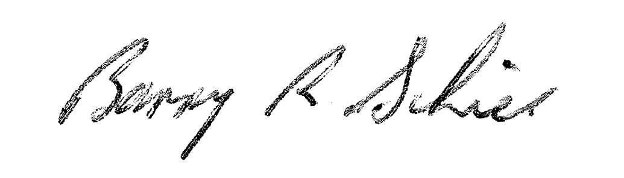

Barry Schier

General Manager