10 July 2015

Mr Sebastian Roberts

General Manager, Network Regulation

Australian Energy Regulator

GPO Box 520

Melbourne 3001

Sent by email to [SAelectricity2015@aer.gov.au](mailto:SAelectricity2015@aer.gov.au)

**QFMP Submission to SA Power Networks Revised Regulatory Proposal (2015 – 2020)**

As an energy consumer spending around $200k per year in South Australia I would like to thank the Australian Energy Regulator for allowing us to respond the submission by SA Power networks to the SA Power Networks Revised Regulatory Proposal 2015-2020.

SA Power Networks revised proposal shows their cavalier approach to its customers. There is little change to its original proposal demonstrating the distinct lack of interest they have in the long term interests of their customers. This is vastly different to attitude of Tas Networks who accepted AER’s decision, significantly reduced expenditure and subsequent prices to its customers.

There is no justification to reinstate the programs from the original SA Power Networks’ proposal that were rejected by the AER and were predicated on a flawed “push” consultation process.

Table 16.3 epitomises the distain that SA Power Networks have for their customers. This table demonstrates that in a time of static or declining demand their proposed expenditure over the period was as follows:

* Return on capital increasing by 28% (nominal)
* Regulatory depreciation increasing by 64% (nominal)
* Operating Expenditure increasing by 19% (nominal)
* Tax allowance increasing by 15% (nominal)
* Revenue increasing by 31 % (unsmoothed nominal)

Price increases of 23% in 2016/2017 and 12% in 2017/2018 as proposed by SA Power Networks are unacceptable to customers. I am sure a survey of customers would support this assertion.

The network cost share of our energy costs almost doubled over the previous 5 years which is demonstrably more than CIP or wage growth in that period. It is predicted CIP and wage growth without the mining boom will be far less in the next 5 years and some cases wages will decline because of the removal of competition from the mining industry for similarly skilled labour. Basically over the last 5 years SA Power networks would have had to replace two thirds of the distribution network to justify the cost increases. Unless SA Power Networks intends to fully replace the remaining network their operating costs should decline not increase.

Their greed and rudeness to their customers is unbelievable by requesting such an increase following the previous five years and SA industry require a strong regulator to stand up to the bully that SA Power Networks is by presuming we are fools. We ask you give the time this submission deserves, a simple NO will suffice and do not waste ink.

Finally SA Power Networks is prepared to use the UK as a model for consultation. We would also like to see SA Power Networks being benchmarked against networks in the UK and others internationally to ensure they are the most efficient provider in the world.

Regards

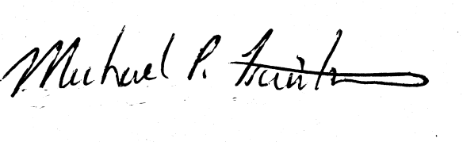

Michael Trautwein

QFM Production