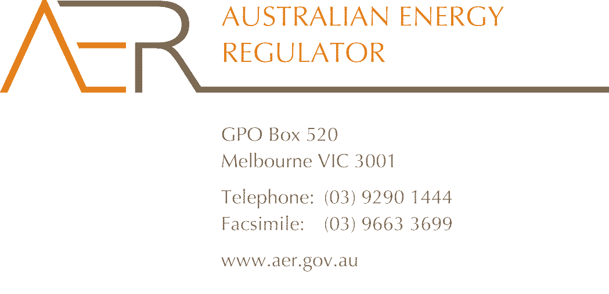

Our Ref: D12/64012
Your Ref: ERC0140
Contact Officer: Mark Wilson
Contact Phone: 08 8213 3419

1 May 2012

Mr John Pierce
Chairman
Australian Energy Market Commission
PO Box A2449
SYDNEY SOUTH NSW 1235

Dear Mr Pierce

Negative offers from scheduled network service providers

The AER welcomes the opportunity to comment on the consultation paper for the Rule change proposal from International Power-GDF Suez Australia (IPRA) and Loy Yang Market Management Company (LYMMCo) to make offers from scheduled network service providers subject to a price floor of zero.

As you are aware, the AER monitors the wholesale electricity market and is responsible for compliance with and enforcement of the National Electricity Rules (the Electricity Rules).

As described in the consultation paper, at present if Hydro Tasmania and Basslink each bid at -$1000/MWh, then, assuming no losses, the effective offer price at the Loy Yang connection point is -$2000/MWh. This gives Hydro Tasmania dispatch priority over Victorian generators to meet demand in the Victorian region, which represents an unfair advantage for Hydro Tasmania, and appears to create significant efficiency issues. While not a breach of the Electricity Rules, such an arrangement does not appear to be consistent with the NEM objective of promoting “efficient investment in, and efficient use of, electricity services for the long term interests of consumers of electricity.”

In most circumstances the proposed Rule change should deal with the significant efficiency issues created by the current arrangements. However, as highlighted in the consultation paper, because of the complexities involved in the treatment of losses across Basslink, under certain limited conditions, the proposed solution may not improve on the status quo. Notwithstanding this, however, on balance, the proposed Rule change would be an acceptable short term solution.

The AER considers that an enduring solution to the problem highlighted by the Rule change proposal should be considered as part of the Transmission Frameworks Review. Consistent with its submission to this review, the AER considers the modified Shared Access Congestion Pricing regime has the potential to provide a solution to the congestion problems associated with bidding across Basslink.

Should you have any queries on the above, please don’t hesitate to contact Mark Wilson, Director, Wholesale Markets on 08 8213 3419.

Yours sincerely

Tom Leuner
General Manager Wholesale Markets

