## Limited disclosure process

## Overview

1. The Australian Energy Regulator has the power to disclose confidential information it has received, where it considers the disclosure would not cause detriment or the public benefit in disclosing the information would outweigh the detriment.[1]
2. This document has been developed to assist stakeholders who have been engaging with the AER about the disclosure of confidential supplier information provided in the NSW electricity distribution businesses' public lighting proposals for the 2014–15 and 2015–19 regulatory control periods. It sets out the steps the AER will take when it has determined that confidential information should be provided to specific persons. That is, the information should be subject to 'limited disclosure'.

## Our approach

1. The AER board has made a decision for a form of limited disclosure of the confidential public lighting information. This would involve disclosing the information only to public lighting consultants who are engaged by Regional Organisation of Councils (ROCs) or by councils directly. The consultant must be engaged to perform work on a particular determination or other regulatory process.
2. To facilitate the limited disclosure of confidential information, we consider that a staged approach is appropriate. The figure below sets out the three steps the AER will follow. This process is in line with the AER’s confidentiality guidelines and the associated explanatory statement available on our website: <https://www.aer.gov.au/node/18888>.

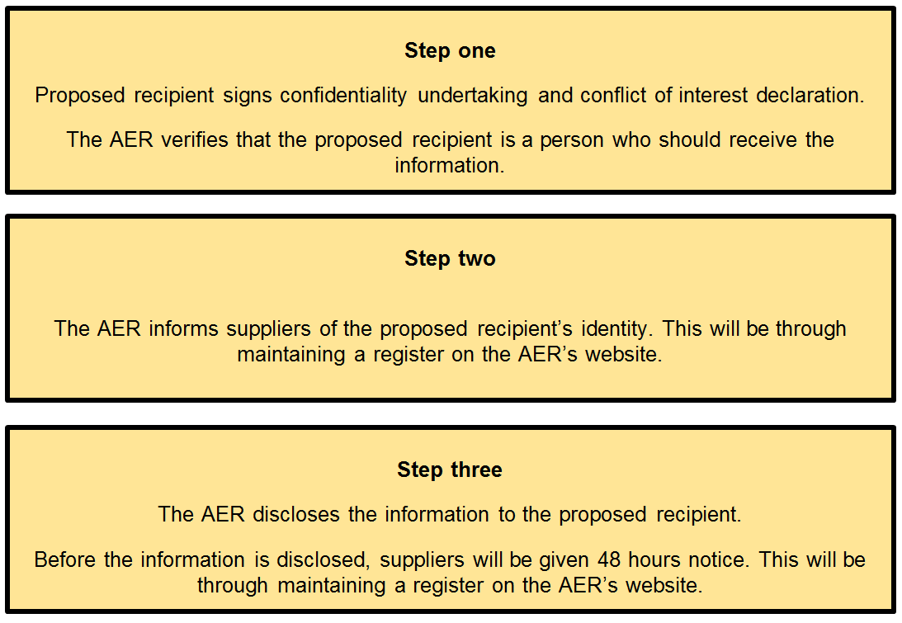

Step 1

The public benefit associated with the disclosure of the confidential information will not be realised if the information is provided to an unauthorised person. Therefore, on receiving a request for information we will verify that the proposed recipient has been engaged by a local council, or councils, to review an electricity distribution business’ public lighting proposal. A written assurance from a council executive officer will offer sufficient verification.

We will not seek this written assurance until we have received a signed confidentiality undertaking and conflict of interest declaration from the individual requesting access to the information. Those documents must be in the form stipulated by the AER and made out in favour of the AER, the relevant distribution business(es), and the public lighting suppliers. The pro forma undertaking and conflict of interest declaration will be available on the AER’s website.

Step 2

On verifying the authenticity of the proposed recipient, we will inform the suppliers of the proposed recipient. We consider the most effective way to do this would be through maintaining a register on our website ([www.aer.gov.au](http://www.aer.gov.au)).

The register will identify the name of the person receiving the information, their organisation, and the Regional Organisation of Councils (ROCs) or Council(s) that the individual represents.

Step 3

The final step will be to disclose the information to the recipient. In this instance, the information to be provided to the recipient will be those documents outlined in the revised disclosure notices and listed on the AER’s website: <https://www.aer.gov.au/node/26494>.

To avoid any doubt, only the persons who have accepted the undertaking and signed the conflict of interest declaration would be able to receive the information. The AER would give suppliers 48 hours notice that it is about to disclose information. It will publish the consultant’s name in a register on the AER’s website.

1. National Electricity Law, section 28ZB.