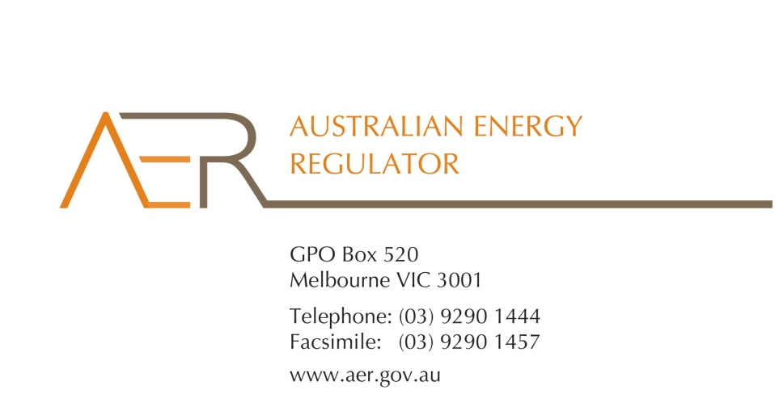

Our Ref: D14/111026

Your Ref:

Contact Officer: Susan Faulbaum

Contact Phone: (08) 8213 3643

2 September 2014

Mr Glenn Melton

8 Stead Street

Wodonga VIC 3690

Dear Mr Melton

**Applications for an individual exemption from the requirement to hold an electricity retailer authorisation**

I refer to your applications from 10 July 2014, for an individual exemption under the National Energy Retail Law (Retail Law) for the eight businesses listed below:

* Green Urban Group Pty Ltd (ACN 158 643 175)
* PPA Direct Pty Ltd (ABN 67 163 029 187)
* PPA Now Pty Ltd (ACN 600 298 486)
* PPA Green Pty Ltd (ABN 38 165 973 893)
* PPA Solar Pty Ltd (ABN 57 165 479 489)
* PPA Electrical Pty Ltd (ACN 169 208 093)
* PPA Energy Pty Ltd (ACN 169 208 119)
* PPA Farm Pty Ltd (ACN 169 208 146)

I am writing to inform you that the Australian Energy Regulator (AER) has considered the eight applications from the businesses listed above for individual exemption, and that it decided, on 2 September 2014, to grant the individual exemptions in accordance with s.110 of the Retail Law.

In accordance with the National Electricity Retail Rules (Retail Rules), the AER has published the applications on its website, and sought submissions from interested parties.[1] The AER did not receive any submissions in response to the applications.

The AER has considered the policy principles relating to exempt selling in s. 114 of the Retail Law, being:

1. regulatory arrangements for exempt sellers should not unnecessarily diverge from those applying to retailers,
2. exempt customers, should, as far as practicable, be afforded the right to a choice of retailer in the same way comparable retail customers in the same jurisdiction have that right,
3. exempt customers, should, as far as practicable, not be denied customer protections afforded to retail customers under this Law and Rules.

In making its decision the AER is also guided by the objective of the Retail Law[2], the exempt seller factors,[3] and the customer related factors.[4]

The AER is satisfied that the eight businesses listed above should be exempt from the requirement to hold a national retailer authorisation, having regard to the above considerations. If any of these businesses wish to change the way they sell electricity they should contact the AER as they may need to apply for an authorisation or another exemption. If these activities are not covered by these exemptions the business(es) may be in breach of s. 88 of the Retail Law and we may take enforcement action or otherwise seek to ensure compliance.

These individual exemptions are subject to acceptance of the conditions[5] set out at Schedules 1- 8 to this letter. One of these conditions relates to information disclosure. Specifically, this condition is intended to ensure that customers understand the nature of the service that the businesses are providing and the protections they are entitled to (as opposed to the service and protections your customers would receive from their energy retailer).

You must advise the AER in writing, by **30 September 2014,** whether each of these eight businesses accepts the attached conditions. Please be aware that the AER may vary conditions attached to an individual exemption at any time in accordance with rule 158 of the Retail Rules.

If you have any further queries, or would like to discuss this further, please contact Susan Faulbaum on (08) 8213 3463.

Yours sincerely

Sarah Proudfoot

General Manager

Retail Markets

Australian Energy Regulator

**Schedule 1: Instrument of exemption**

**INDIVIDUAL EXEMPTION FROM THE REQUIREMENT TO HOLD A RETAILER AUTHORISATION**

The Australian Energy Regulator on 2 September 2014, decided pursuant to section 110 of the National Energy Retail Law, to grant an exemption from the requirement to hold a retailer authorisation under section 88 of the National Energy Retail Law, subject to the following conditions, to PPA Direct Pty Ltd (ABN 67 163 029 187).

**Condition 1 - Information provision**

The exempt seller must provide the customer in writing a plain English notice explaining that the contract is covered by Australian consumer protection laws and is separate to the customer’s contract with their retailer and distributor which are covered under the National Energy Retail Law.

**Condition 2 – Exemption limited to the sale of electricity through solar power purchase agreements**

This exemption is conditional upon the exempt seller:

* refraining from registering in the wholesale market for the purposes of purchasing energy, and
* not being the financially responsible retailer for the premises (rather, this must be an authorised retailer).

**Schedule 2: Instrument of exemption**

**INDIVIDUAL EXEMPTION FROM THE REQUIREMENT TO HOLD A RETAILER AUTHORISATION**

The Australian Energy Regulator on 2 September 2014, decided pursuant to section 110 of the National Energy Retail Law, to grant an exemption from the requirement to hold a retailer authorisation under section 88 of the National Energy Retail Law, subject to the following conditions, to PPA Now Pty Ltd (ACN 600 298 486).

**Condition 1 - Information provision**

The exempt seller must provide the customer in writing a plain English notice explaining that the contract is covered by Australian consumer protection laws and is separate to the customer’s contract with their retailer and distributor which are covered under the National Energy Retail Law.

**Condition 2 – Exemption limited to the sale of electricity through solar power purchase agreements**

This exemption is conditional upon the exempt seller:

* refraining from registering in the wholesale market for the purposes of purchasing energy, and
* not being the financially responsible retailer for the premises (rather, this must be an authorised retailer).

**Schedule 3: Instrument of exemption**

**INDIVIDUAL EXEMPTION FROM THE REQUIREMENT TO HOLD A RETAILER AUTHORISATION**

The Australian Energy Regulator on 2 September 2014, decided pursuant to section 110 of the National Energy Retail Law, to grant an exemption from the requirement to hold a retailer authorisation under section 88 of the National Energy Retail Law, subject to the following conditions, to PPA Green Pty Ltd (ABN 38 165 973 893).

**Condition 1 - Information provision**

The exempt seller must provide the customer in writing a plain English notice explaining that the contract is covered by Australian consumer protection laws and is separate to the customer’s contract with their retailer and distributor which are covered under the National Energy Retail Law.

**Condition 2 – Exemption limited to the sale of electricity through solar power purchase agreements**

This exemption is conditional upon the exempt seller:

* refraining from registering in the wholesale market for the purposes of purchasing energy, and
* not being the financially responsible retailer for the premises (rather, this must be an authorised retailer).

**Schedule 4: Instrument of exemption**

**INDIVIDUAL EXEMPTION FROM THE REQUIREMENT TO HOLD A RETAILER AUTHORISATION**

The Australian Energy Regulator on 2 September 2014, decided pursuant to section 110 of the National Energy Retail Law, to grant an exemption from the requirement to hold a retailer authorisation under section 88 of the National Energy Retail Law, subject to the following conditions, to PPA Solar Pty Ltd (ABN 57 165 479 489).

**Condition 1 - Information provision**

The exempt seller must provide the customer in writing a plain English notice explaining that the contract is covered by Australian consumer protection laws and is separate to the customer’s contract with their retailer and distributor which are covered under the National Energy Retail Law.

**Condition 2 – Exemption limited to the sale of electricity through solar power purchase agreements**

This exemption is conditional upon the exempt seller:

* refraining from registering in the wholesale market for the purposes of purchasing energy, and
* not being the financially responsible retailer for the premises (rather, this must be an authorised retailer).

**Schedule 5: Instrument of exemption**

**INDIVIDUAL EXEMPTION FROM THE REQUIREMENT TO HOLD A RETAILER AUTHORISATION**

The Australian Energy Regulator on 2 September 2014, decided pursuant to section 110 of the National Energy Retail Law, to grant an exemption from the requirement to hold a retailer authorisation under section 88 of the National Energy Retail Law, subject to the following conditions, to Green Urban Group Pty Ltd (ACN 158 643 175).

**Condition 1 - Information provision**

The exempt seller must provide the customer in writing a plain English notice explaining that the contract is covered by Australian consumer protection laws and is separate to the customer’s contract with their retailer and distributor which are covered under the National Energy Retail Law.

**Condition 2 – Exemption limited to the sale of electricity through solar power purchase agreements**

This exemption is conditional upon the exempt seller:

* refraining from registering in the wholesale market for the purposes of purchasing energy, and
* not being the financially responsible retailer for the premises (rather, this must be an authorised retailer).

**Schedule 6: Instrument of exemption**

**INDIVIDUAL EXEMPTION FROM THE REQUIREMENT TO HOLD A RETAILER AUTHORISATION**

The Australian Energy Regulator on 2 September 2014, decided pursuant to section 110 of the National Energy Retail Law, to grant an exemption from the requirement to hold a retailer authorisation under section 88 of the National Energy Retail Law, subject to the following conditions, to PPA Electrical Pty Ltd (ACN 169 208 093).

**Condition 1 - Information provision**

The exempt seller must provide the customer in writing a plain English notice explaining that the contract is covered by Australian consumer protection laws and is separate to the customer’s contract with their retailer and distributor which are covered under the National Energy Retail Law.

**Condition 2 – Exemption limited to the sale of electricity through solar power purchase agreements**

This exemption is conditional upon the exempt seller:

* refraining from registering in the wholesale market for the purposes of purchasing energy, and
* not being the financially responsible retailer for the premises (rather, this must be an authorised retailer).

**Schedule 7: Instrument of exemption**

**INDIVIDUAL EXEMPTION FROM THE REQUIREMENT TO HOLD A RETAILER AUTHORISATION**

The Australian Energy Regulator on 2 September 2014, decided pursuant to section 110 of the National Energy Retail Law, to grant an exemption from the requirement to hold a retailer authorisation under section 88 of the National Energy Retail Law, subject to the following conditions, to PPA Energy Pty Ltd (ACN 169 208 119).

**Condition 1 - Information provision**

The exempt seller must provide the customer in writing a plain English notice explaining that the contract is covered by Australian consumer protection laws and is separate to the customer’s contract with their retailer and distributor which are covered under the National Energy Retail Law.

**Condition 2 – Exemption limited to the sale of electricity through solar power purchase agreements**

This exemption is conditional upon the exempt seller:

* refraining from registering in the wholesale market for the purposes of purchasing energy, and
* not being the financially responsible retailer for the premises (rather, this must be an authorised retailer).

**Schedule 8: Instrument of exemption**

**INDIVIDUAL EXEMPTION FROM THE REQUIREMENT TO HOLD A RETAILER AUTHORISATION**

The Australian Energy Regulator on 2 September 2014, decided pursuant to section 110 of the National Energy Retail Law, to grant an exemption from the requirement to hold a retailer authorisation under section 88 of the National Energy Retail Law, subject to the following conditions, to PPA Farm Pty Ltd (ACN 169 208 146).

**Condition 1 - Information provision**

The exempt seller must provide the customer in writing a plain English notice explaining that the contract is covered by Australian consumer protection laws and is separate to the customer’s contract with their retailer and distributor which are covered under the National Energy Retail Law.

**Condition 2 – Exemption limited to the sale of electricity through solar power purchase agreements**

This exemption is conditional upon the exempt seller:

* refraining from registering in the wholesale market for the purposes of purchasing energy, and
* not being the financially responsible retailer for the premises (rather, this must be an authorised retailer).

1. r. 155(3) and 156, National Energy Retail Rules.
2. The National Energy Retail Law objective is to “promote efficient investment in and efficient operation and use of energy services for the long term interests of energy consumers with respect to price, quality, safety, reliability and security of supply of energy”. (s. 13, Retail Law)
3. s. 115, Retail Law.
4. s. 116, Retail Law.
5. r. 158 (1), Retail Rules.