

Generator Performance Standards

Information Booklet

August 2013

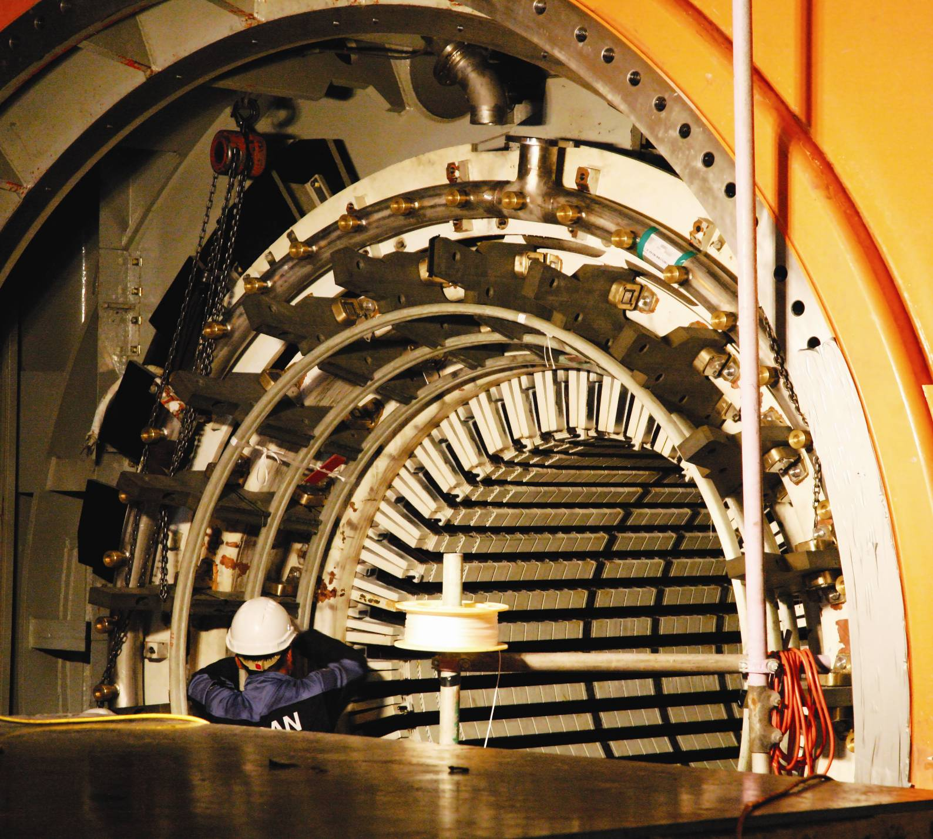

Background

The Australian Energy Regulator (**AER**) is responsible for monitoring compliance and enforcement under legislation and rules governing Australia’s wholesale energy markets, including those applying to Network Service Providers (**NSP**). Section 15 of the National Electricity Law and section 27 of the National Gas Law set out the functions and powers of the AER, including:

* monitoring compliance by energy industry participants[1] and other persons
* investigating breaches, or possible breaches, of provisions of the legislative instruments under the AER’s jurisdiction.

We undertake a continuous compliance risk assessment of the National Electricity Rules (**Electricity Rules**) and National Gas Rules (**Gas Rules**) to identify appropriate focus areas and monitoring mechanisms. These mechanisms include audits, the imposition of reporting requirements, market monitoring and targeted compliance reviews.

Consistent with our [*Statement of Approach*](http://www.aer.gov.au/sites/default/files/AER%20compliance%20and%20enforcement%C3%A2%E2%82%AC%E2%80%9Dstatement%20of%20approach%20%28December%202010%29.pdf), we aim to promote high levels of compliance, and seek to build a culture of compliance in the energy industry. A compliance culture will:

* reduce the risk of industry participants breaching their regulatory obligations
* ensure industry participants can engage confidently in commercial decisions and negotiations.

In the event of a breach, we will take into account the participant’s compliance framework when determining what action to take. In assessing compliance culture, we consider whether compliance programs and related processes are effectively applied,   
up-to-date and tested regularly.

One area of focus for the AER has been the technical performance requirements for generators which require them to implement and maintain specific compliance programs pursuant to clause 4.15 of the Electricity Rules. A similar obligation exists on NSPs under clause 5.7.4 with respect to their protection and control schemes.

About this booklet

The purpose of this booklet is to provide generators with an overview of the AER’s compliance monitoring approach specific to the performance standards regime established under clause 4.15 of the Electricity Rules.

We outline:

* the process that a participant must follow in the event of a performance standards breach
* the approach a participant should take when one of its generators is shut down and placed in ‘dry-storage’ for an extended period of time
* how our technical compliance audits examine generators’ compliance programs.

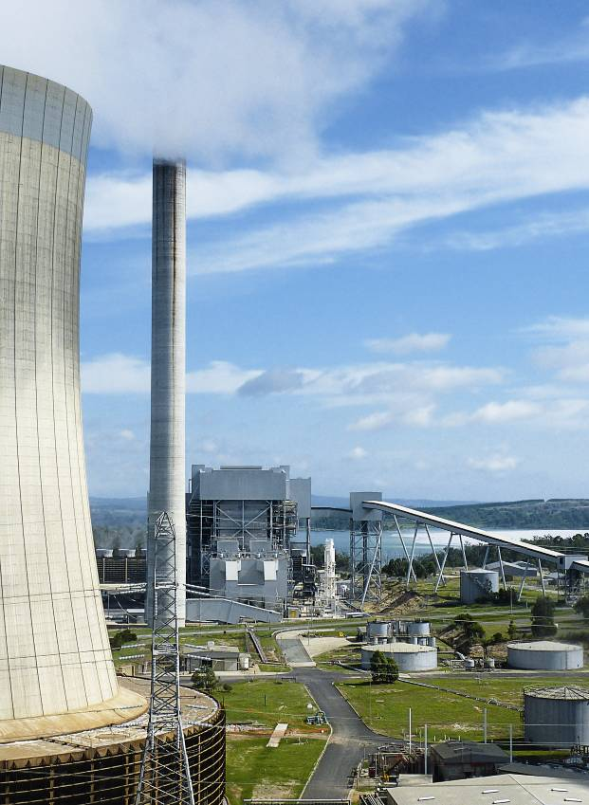

Good Energy Industry Practice

‘Good Electricity Industry Practice’ is a defined term under the Electricity Rules, and is the threshold against which performance standards compliance is measured. A similar definition exists under the Gas Rules. When assessing compliance against this threshold, we have adopted the concept of ‘Good Energy Industry Practice’ (**GEIP**) to cover both electricity and gas.

We consider the key components of GEIP to include effective:

**Governance**—internal arrangements encompassing reporting lines and supporting systems, including the level of involvement and commitment of senior management and committees as well as the overall compliance culture of the business.

**Expertise**—the human resources dedicated to technical compliance including the allocation of responsibilities, the underlying knowledge systems and the nature and extent of the technical understanding of applicable obligations

**Implementation**—the means by which, at a practical level, participants drive and promote compliance through internal procedures and processes, encompassing staff training, technical testing and reporting of compliance matters

**Performance**—the overall compliance status of each participant with reference to how effectively compliance programs and arrangements operate, including the ongoing evaluation and updating of such programs and arrangements to reflect lessons learnt.

GEIP is the foundation of our technical audit program outlined on page 5 of this booklet. We will assess participants’ compliance taking into account the above criteria and those outlined in our [*Statement of Approach*](http://www.aer.gov.au/sites/default/files/AER%20compliance%20and%20enforcement%C3%A2%E2%82%AC%E2%80%9Dstatement%20of%20approach%20%28December%202010%29.pdf).

Generator performance standards

Generator performance standards (**GPS**) are:

* the specific performance standards established for each registered generator in accordance with clause 5.3.4.A(i) of the Electricity Rules, or
* included in the register of performance standards established and maintained by the Australian Energy Market Operator (**AEMO**) under clause 4.14(n) of the Electricity Rules.

The Electricity Rules establish up to 18 separate technical requirements.[2] Compliance with performance standards is fundamental to ensure AEMO can safely and reliably operate the power system. Non-compliance with certain performance standards may materially increase the risk of major power system incidents.

The Electricity Rules require generators to plan and design their facilities to ensure that, among other things, they operate in a manner that complies with the applicable performance standards (clause 5.2.5(a)). The Electricity Rules also provide that a registered participant who plans, owns, controls or operates a plant to which a performance standard applies must:

* institute and maintain a compliance program, within a prescribed timeframe and in accordance with certain criteria (clause 4.15(b) and (c))
* maintain compliance program records and other prescribed records[3] for 7 years and, if requested, deliver such records to the AER within 5 business days or other specified period (clause 4.15(e))
* immediately notify AEMO if the plant is breaching a performance standard or is likely to breach (clause 4.15(f))
* immediately notify AEMO and the relevant NSP when the plant has returned to compliance with the relevant performance standard (clause 4.15(h)).

The above clauses are civil penalty provisions. This means that if the provisions are breached, the AER can issue a $20 000 infringement notice or institute court proceedings which may result in a fine of up to $100 000 and/or other appropriate court orders.

With the advent of a carbon price and unfavourable economic conditions, there have been numerous cases of generators going offline or being put in ‘dry-storage’. If generating plants that are placed in   
dry-storage allow their technical compliance programs to lapse, there may be a heightened risk to power system security upon those plants’ return to service.

For this reason, we expect generators that are offline for any period of time to continue to comply with all applicable obligations under the Electricity Rules for as long as they remain registered in the National Electricity Market (**NEM**). Continuing appropriate testing and maintenance of the plant should avoid   
non-compliance that may materially affect power system security if the generator was to return to service.

AEMO holds a consistent view regarding testing and maintenance and has released a guideline on what might constitute Good Electricity Industry Practice in relation to   
long-term storage of generating facilities in the NEM. This guideline is available on [AEMO’s website](http://www.aemo.com.au/).

Non-compliance with performance standards

AEMO has developed and published a [*Notice of Non-compliance with Registered Performance Standards*](http://www.aemo.com.au/Electricity/Market-Operations/Generator-Performance-Standards). When a registered participant breaches or identifies a possible breach of one if its performance standards, it must fill in and submit this notice to AEMO immediately.

The immediate notification allows AEMO to assess the implications of the non-compliance on the operation of the power system and, where necessary, make adjustments to the technical envelope to ensure power system security can be maintained. Under most circumstances, and subject to the type of   
non-compliance, if the participant submits the a plan to rectify the non-compliance within a reasonable period along with the relevant notice, AEMO will provide its endorsement and close off the matter as soon as the technical problem is resolved.

The process followed by AEMO in determining a reasonable period to rectify a performance standards breach is set out in the Electricity Rules clauses 4.15(i) and (j). There is also a mechanism involving the AER in the event of the participant and AEMO cannot agree on the rectification period (clause 4.15(n-p)).

AEMO forwards a copy of all non-compliance notices to the AER and the relevant NSP. We liaise closely with the Generator Performance Standards team at AEMO who also provide us with regular updates, including formal quarterly updates, on all outstanding compliance matters.

We have established a process to record and assess each notice received based on the risk associated with each non-compliance. This information is cross referenced with any related Power System Operating Incident Reports published by AEMO or other information available to us, to assist in determining what action, if any, to take directly with the registered participant.

We may request further information from a participant to better understand the circumstances surrounding the   
non-compliance. In the most serious cases, we may then seek an undertaking from a participant to address the matter urgently and/or take enforcement action such as issuing an infringement notice or instituting proceedings. In all instances we keep AEMO informed of our GPS activities.

Our technical compliance audit process is continually refined to cover systemic compliance issues.

In general:

* provided that a breach is of minor impact and the generator in breach fulfils its obligations and addresses any   
  non-compliance in a timely and effective matter, we will not take action other than assessing and monitoring the situation to ensure the existence of no systemic issues.
* the fact that a generator may be offline or in dry-storage will not result in any GPS non-compliance being automatically closed off by AEMO or the AER while the generator remains registered in the NEM.

Technical compliance audits

The AER developed its compliance audit program relating to the technical performance requirements of generators in 2007. This followed an investigation into the events of 16 January 2007, when bushfires in north east Victoria caused transmission lines between Victoria, South Australia and New South Wales to trip, resulting in the separation of the national power system into three electrical islands.[4] A number of generators who failed to meet their performance standards and to ride through this event, contributed to the   
system-wide disturbance.

We have since conducted regular audits to ensure participants have developed and are maintaining robust and effective compliance programs. This is achieved by ascertaining whether—as required clause 4.15(c)—these compliance programs:

* are consistent with the template for generator compliance programs published by the Reliability Panel of the Australian Energy Market Commission (**AEMC**)[5]
* include procedures to monitor the performance of the participant’s generating plant in a manner that is consistent with good electricity industry practice
* are modified to be consistent with any mandated amendments to the above template by the Reliability Panel
* provide reasonable assurance of ongoing compliance with each applicable performance standard.

Purpose of our audits

As part of each audit we explore with the participant, in detail:

* whether the business understands the nature of each obligation and the resulting performance expectations
* whether appropriate people and resources are available to monitor and test the facilities
* how feedback mechanisms are built into the business’s processes when issues are identified and problems rectified, including when issues are identified by other participants who have similar equipment
* how procedures and testing processes are continually evaluated and improved
* how appropriate reporting lines are established through each level of the business to ensure the full range of people responsible for compliance are aware of GPS issues—from maintenance personnel to senior management.

The key criteria we use as part of the technical compliance audit program are set out in terms of GEIP, as outlined on page 3 this booklet.

Broadly speaking, our program involves the following five steps:

* issue of a questionnaire, posing a series of questions of a general (section A) and technical (section B) nature—the participant’s response would allow us to examine the compliance management arrangements it has across the organisation and its understanding of the specific requirements of clause 4.15
* detailed review by AER staff of the completed questionnaire and supporting documentation received from the participant under review
* an on-site meeting between AER staff and the participant’s key personnel responsible for GPS compliance—this is to discuss general corporate governance arrangements and responsibilities within the organisation and focus on how, in practice, the participant has implemented its GPS compliance program
* the issue of a confidential report for the AER Board and the participant, which sets out our key findings and identifies areas of the participant’s operations where there may be scope for improvement
* a summary of the outcomes from the audit is published in our [*Quarterly Compliance Report*](http://www.aer.gov.au/node/454) (**QCR**).

An outline of the questionnaire and the particular areas of interest to the AER as part of the audit are presented in **Appendix A**.

Details of our findings are shared with AEMO and, depending on the nature of the findings, they may result in further action by the AER (e.g. monitoring to ensure that follow-up actions are taken and completed; escalation to enforcement action).

For the reasons highlighted above, the fact that a generator may be offline or in dry‑storage will not preclude the AER from conducting a technical compliance audit of that generator, for as long as it remains registered in the NEM.



Appendix A: Overview of AER technical compliance audit questionnaire

This questionnaire is divided into sections A (General) and B (Technical). Its structure and content may vary over time.

|  |  |  |  |
| --- | --- | --- | --- |
| Section | Part | Question | Description |
| A | 1 |  | **Organisational structure** |
|  |  | 1.1 | Organisational chart setting out responsibility roles and communication links |
|  |  | 1.2 | Mechanism by which Board (or equivalent) is informed of GPS compliance matters |
|  |  | 1.3 | Details of any compliance committee (or equivalent) |
| A | 2 |  | **Technical compliance management** |
|  |  | 2.1 | Details of who specifically is responsible for GPS compliance matters |
|  |  | 2.2 | Details of any training program specific to Electricity Rules |
| A | 3 |  | **Compliance issues and information** |
|  |  | 3.1 | Process to monitor changes to Electricity Rules |
|  |  | 3.2 | Process of monitoring compliance with Electricity Rules and how they are handled |
|  |  | 3.3 | Details of any procedures to monitor, collect and disseminate non-compliance information |
|  |  | 3.4 | Process to report non-compliance matters within the organisation |
| B | 1 |  | **Performance standards and compliance program** |
|  |  | 1.1 | Copy of current registered performance standards |
|  |  | 1.2 | Copy of the compliance program in place for each generating unit |
| B | 2 |  | **Development of a compliance program** |
|  |  | 2.1 | With respect to each technical requirement outlined in the applicable GPS: |
|  |  | 2.1.1 | Participant’s understanding of what each requirement entails |
|  |  | 2.1.2 | How the participant has identified the appropriate systems and subsystems related to applicable GPS |
|  |  | 2.1.3 | Details of the relevant systems and subsystems |
|  |  | 2.1.4 | How the participant identified appropriate compliance monitoring mechanisms |
|  |  | 2.1.5 | Details of the compliance monitoring mechanisms in place |
|  |  | 2.1.6 | Characterisation of the elements of the compliance monitoring mechanisms in place by reference to the categories set out in questionnaire (benchmarking, testing, calculation, modelling, monitoring) |
|  |  | 2.1.7 | Whether the compliance monitoring mechanisms cover all GPS-related systems and subsystems |
|  |  | 2.1.8 | How the participant has identified the appropriate frequency of testing |
|  |  | 2.1.9 | Factors considered in determining the most appropriate compliance monitoring mechanisms |
|  |  | 2.1.10 | Risks or factors identified as obstacles to developing compliance monitoring mechanisms |
|  |  | 2.1.11 | Participant’s grounds for believing that its compliance monitoring is consistent with GEIP |
| B | 3 |  | **Evaluation and testing** |
|  |  | 3.1 | Monitoring and recording systems in place for plant performance and system conditions |
|  |  | 3.2 | With respect to evaluating and testing each applicable GPS |
|  |  | 3.2.1 | Assessment criteria for determining whether technical requirement is satisfied |
|  |  | 3.2.2 | Process and equipment used |
|  |  | 3.2.3 | How results are captured, analysed, disseminated and maintained |
|  |  | 3.2.4 | Whether evaluation and test reports are controlled documents |
|  |  | 3.2.5 | Results of most recent evaluations and tests |
|  |  | 3.3 | How the effectiveness of the evaluation and testing process is verified and improved on |
| B | 4 |  | **Ongoing compliance monitoring** |
|  |  | 4.1 | Details of the resources (e.g. technical, human) available for ongoing compliance |
|  |  | 4.2 | With respect to applicable technical requirement outlined in the applicable GPS |
|  |  | 4.2.1 | Details of the internal reporting arrangements |
|  |  | 4.2.2 | Details of the process to address any non-compliance |
|  |  | 4.2.3 | Details of the process to notify AEMO pursuant to clause 4.15(f) of the Electricity Rules |
|  |  | 4.2.4 | Details of how the participant determines whether a plant alteration will affect any applicable GPS |
|  |  | 4.2.5 | Process in place to amend any GPS |
|  |  | 4.2.6 | How related matters arising from questions 4.2.4 and 4.2.5 above are managed |
|  |  | 4.3 | Details of any training program specific to GPS and related technical matters |
| B | 5 |  | **External factors** |
|  |  | 5.1 | Involvement of AEMO and relevant NSP in the development of GPS and compliance program |
|  |  | 5.2 | Extent to which any other party involved in the development of GPS and compliance program |
|  |  | 5.3 | Details of any external or mitigating factors that may have compromised the above development |
|  |  | 5.4 | Details of any further issues relating to compliance with applicable GPS |

1. Entities registered by AEMO under Chapter 2 of the Electricity Rules or in accordance with Part 15A of the Gas Rules.
2. These technical requirements are set out in Schedule 5.2.5 and will vary for each generator depending on when the performance standard was registered with AEMO.
3. Relating to tests to demonstrate compliance with connection requirements under clause 5.7.3.
4. For further details, see our website.
5. More information is available on the [AEMC website](http://www.aemc.gov.au/market-reviews/completed/review-of-template-for-generator-compliance-programs.html).