

Annual Benchmarking Report

Electricity distribution network service providers

November 2016

© Commonwealth of Australia 2016

This work is copyright. In addition to any use permitted under the Copyright Act 1968, all material contained within this work is provided under a Creative Commons Attributions 3.0 Australia licence, with the exception of:

* the Commonwealth Coat of Arms
* the ACCC and AER logos
* any illustration, diagram, photograph or graphic over which the Australian Competition and Consumer Commission does not hold copyright, but which may be part of or contained within this publication. The details of the relevant licence conditions are available on the Creative Commons website, as is the full legal code for the CC BY 3.0 AU licence.

Requests and inquiries concerning reproduction and rights should be addressed to the:

Director, Corporate Communications  
Australian Competition and Consumer Commission   
GPO Box 4141, Canberra ACT 2601

or publishing.unit@accc.gov.au.

Inquiries about this publication should be addressed to:

Australian Energy Regulator  
GPO Box 520  
Melbourne Vic 3001

Tel: (03) 9290 1444  
Fax: (03) 9290 1457

Email: [AERInquiry@aer.gov.au](mailto:AERInquiry@aer.gov.au)

Contents

Shortened forms 3

Glossary 4

Overview 5

1 Introduction 8

1.1 Who the report compares 8

1.2 Benchmarking techniques 9

1.3 Inputs and outputs 10

1.4 Data 11

1.5 Measuring productivity and efficiency 12

2 Benchmarking results 14

2.1 Multilateral total factor productivity results 14

2.1.1 Industry MTFP 14

2.1.2 MTFP by State 15

2.1.3 MTFP by DNSP 15

2.1.4 Observations for 2014–15 16

2.2 Results from supporting benchmarking techniques 18

2.2.1 Multilateral partial factor productivity 18

2.2.2 Econometric opex modelling 19

2.2.3 Partial performance indicators 21

3 Interpreting the benchmarking results 26

3.1 Variations in recent productivity performance 26

3.2 Differences in operating environment 29

A References and further reading 31

B Inputs and outputs 33

B.1 Outputs 33

B.1.1 Customer numbers 33

B.1.2 Line length 34

B.1.3 Maximum demand and energy throughput 35

B.1.4 Reliability 36

B.2 Inputs 38

C Partial performance indicator trends 40

D Map of the National Electricity Market 44

E List of submissions 45

Shortened forms

|  |  |
| --- | --- |
| Shortened form | Description |
| AEMC | Australian Energy Market Commission |
| AER | Australian Energy Regulator |
| ACT | ActewAGL |
| AGD | Ausgrid |
| AND | AusNet Services (distribution) |
| Capex | Capital expenditure |
| CIT | CitiPower |
| DNSP | Distribution network service provider |
| END | Endeavour Energy |
| ENX | Energex |
| ERG | Ergon Energy |
| ESS | Essential Energy |
| IEEE | Institute of Electrical and Electronics Engineers |
| JEN | Jemena Electricity Networks |
| MW | Megawatt |
| NEL | National Electricity Law |
| NEM | National Electricity Market |
| NER | National Electricity Rules |
| Opex | Operating expenditure |
| PCR | Powercor |
| RAB | Regulatory asset base |
| SAPN | SA Power Networks |
| TND | TasNetworks (Distribution) |
| UED | United Energy Distribution |

Glossary

|  |  |
| --- | --- |
| Term | Description |
| Inputs | Inputs are the resources DNSPs use to provide services. |
| LSE | Least squares econometrics. LSE is an econometric modelling technique that uses 'line of best fit' statistical regression methods to estimate the relationship between inputs and outputs. Because they are statistical models, LSE models with firm dummies allow for economies and diseconomies of scale and can distinguish between random variations in the data and systematic differences between DNSPs. |
| MPFP | Multilateral partial factor productivity. MPFP is a PIN technique that measures the relationship between total output and one input. It allows partial productivity levels as well as growth rates to be compared. |
| MTFP | Multilateral total factor productivity. MTFP is a PIN technique that measures the relationship between total output and total input. It allows total productivity levels as well as growth rates to be compared. |
| Network services opex | Opex for network services excludes amounts associated with metering, customer connections, street lighting, ancillary services and solar feed-in tariff payments. |
| OEFs | Operating environment factors. OEFs are factors beyond a DNSP’s control that can affect its costs and benchmarking performance. |
| Outputs | Outputs are quantitative or qualitative measures that represent the services DNSPs provide. |
| PIN | Productivity index number. PIN techniques determine the relationship between inputs and outputs using a mathematical index. |
| PPI | Partial performance indicator. PPIs are simple techniques that measure the relationship between one input and one output. |
| Ratcheted maximum demand | Ratcheted maximum demand is the highest value of maximum demand for each DNSP, observed in the time period up to the year in question. It recognises capacity that has been used to satisfy demand and gives the DNSP credit for this capacity in subsequent years, even though annual maximum demand may be lower in subsequent years. |
| SFA | Stochastic frontier analysis. SFA is an econometric modelling technique that uses advanced statistical methods to estimate the frontier relationship between inputs and outputs. SFA models allow for economies and diseconomies of scale and directly estimates efficiency for each DNSP relative to estimated best performance. |

Overview

This benchmarking report sets out our findings on the overall efficiency of each distribution network service provider (DNSP) in the National Electricity Market (NEM).

This is the third annual benchmarking report. As with the previous reports, the benchmarking models presented in this report are the culmination of a substantial work program. This program commenced in 2012 after changes to the electricity rules removed impediments to the use of benchmarking in making regulatory determinations. We worked with leading economic experts, Economic Insights, and consulted extensively with the DNSPs and electricity consumers to establish benchmarking data requirements, model specifications and a guideline setting out how benchmarking would be used in determinations.

Benchmarking enables us to compare the performance of DNSPs relative to each other and over time. This is important in an industry where the service providers are natural monopolies because they may not face the same pressures to operate efficiently as firms in a competitive market. By reporting comparative performance, we create an incentive for DNSPs to learn from each other and improve their performance and provide meaningful information to consumers and other stakeholders for better engagement in our regulatory processes. There has been a long history of benchmarking by international regulators for electricity distribution networks. This has been detailed in the ACCC/AER working paper on benchmarking opex and capex in electricity networks (see Appendix A).

We have regard to the annual benchmarking report in our determinations for the DNSPs. We consider that our benchmarking models are the most robust measures of overall efficiency available. At the same time, we recognise that there is no perfect benchmarking model, and have been cautious in our application of benchmarking in recent distribution determinations. Benchmarking is a critical exercise in assessing the efficiency of the DNSPs’ regulatory proposals and we will continue to invest in refining our benchmarking techniques into the future.

The benchmarking techniques in this report are consistent with those presented in previous reports, but updated by Economic Insights with data for 2015. We have focused on an economic benchmarking technique—multilateral total factor productivity (MTFP)—as the primary technique to compare efficiency. MTFP is a sophisticated ‘top down’ technique that enables us to measure each DNSP’s overall efficiency at providing electricity services.

Key messages

The long term industry trend of declining productivity continued in the twelve months between 2014 and 2015. This can be seen in figure 1, which shows the combined industry inputs have increased at a greater rate than outputs since 2007.

Figure 1 Industry input, output and productivity indices, 2006 to 2015



Despite the downward trend at the industry level, there are promising results in 2015 at the individual network level. Figure 2 shows that in 2015, over half of the networks go against the declining productivity trend. TasNetworks, ActewAGL, CitiPower, United Energy, Powercor and SA Power Networks all improved their productivity in 2015. However, these productivity gains were offset by productivity declines in networks operating in New South Wales and Queensland. A number if the New South Wales and Queensland networks are currently undertaking restructuring programs.  Given their relatively large size, their decline drove down the overall industry productivity.

Figure 2 suggests that while the productivity gap between the DNSPs had narrowed in recent years, in 2015 the gap has started to widen again. In 2015, the four most productive DNSPs are CitiPower, United Energy, SA Power Networks and Jemena and the four least productive DNSPs are Ausgrid, Essential Energy, ActewAGL and Ergon Energy. These DNSPs have consistently been among the best and worst performers, respectively, over the period.

Figure 2 Multilateral total factor productivity by DNSP for 2006–15



In addition to MTFP, this report presents several supporting metrics, which provide alternative measures of comparative performance. These metrics include partial productivity indices, econometric opex modelling and partial performance indicators. While the best and worst performers on a supporting metric may rank similarly to those on MTFP, the supporting techniques do not reflect overall efficiency. They either examine relative efficiency of total output to one input or provide a general indication of comparative performance. Nevertheless, the supporting metrics are useful for assessing opex and/or capital efficiency in conjunction with the MTFP and other assessments of efficiency.

# Introduction

Electricity networks are 'natural monopolies' which, without regulation, could increase their prices above efficient levels and would face limited pressure to operate or invest efficiently. The AER regulates all electricity networks in the NEM. We regulate network prices with the goal of ensuring that energy consumers pay no more than necessary for the safe and reliable delivery of electricity services. Benchmarking underpins this by enabling us to identify the relative efficiency of electricity networks, and to track changes in efficiency over time.

This report uses 'top down' benchmarking techniques to measure each DNSP’s efficiency in delivering network services to consumers. We rank the DNSPs according to their relative efficiency based on their costs of providing network services. We present three different types of techniques to do this, drawing on data provided by the DNSPs.

Many benefits flow from reporting the comparative performance of electricity networks. It provides meaningful information to consumers and other stakeholders and encourages participation and engagement in our regulatory processes. Also, by comparing the performance of DNSPs, we create an incentive for DNSPs to learn from each other and improve their performance.

This report is informed by expert advice provided by Economic Insights.[1] We consider that the benchmarking models presented in it are the most robust measures of overall efficiency available to us. At the same time, however, we recognise that no model is perfect, and have been cautious in our initial application of these results in recent distribution determinations. Benchmarking is a critical exercise in assessing the efficiency of the DNSPs’ regulatory proposals and we will continue to invest in refining our benchmarking techniques into the future.

The benchmarking presented in this report is one of a number of factors we consider when making our revenue determinations. In our determinations, we examine the efficiency of an individual DNSP's forecast opex and capex. In this report we primarily examine the efficiency of distribution networks overall. Though the efficiency of networks as a whole is relevant to our determinations, we also undertake further analysis when reviewing opex and capex forecasts.

## Who the report compares

The electricity industry in Australia is divided into four distinct parts, with a specific role for each stage of the supply chain—generation, transmission, distribution and retail.

Electricity generators are usually located near fuel sources, and often long distances from most electricity customers. The supply chain, therefore, requires networks to transport power from generators to customers:

1. High voltage transmission lines transport electricity from generators to distribution networks in metropolitan and regional areas.
2. Distribution networks convert electricity from the high voltage transmission network into medium and low voltages and transport electricity from points along the transmission lines to residential and business customers.

This report focuses on the distribution sector. Thirteen DNSPs operate in the NEM. Appendix D presents a map of the NEM showing the service area for each DNSP.

## Benchmarking techniques

Benchmarking approaches may be broadly classified into ‘top down’ and ‘bottom up’ techniques:

* Top down techniques measure a business’s efficiency overall, taking into account efficiency trade-offs between components that make up the total.
* Bottom up techniques separately examine the components that make up the total, which are then built up to form the total. Bottom up techniques generally do not take into account efficiency trade-offs between all of the different components of a DNSP’s operations.[2] They are also quite resource intensive to implement. Most regulators overseas use top down economic benchmarking techniques rather than bottom up benchmarking techniques.[3]

For more information on regulatory application of benchmarking, see the ACCC/AER reports that provide a comprehensive overview of the benchmarking approaches used by overseas regulators (see Appendix A).

In this report we present the results of top down benchmarking which use an inputs and outputs framework. The report presents three types of top down benchmarking techniques. Each uses different methods for relating outputs to inputs (further information is at Appendix A):

* Productivity index number (PIN) techniques. These use a mathematical index to determine the relationship between outputs and inputs. The PIN analysis techniques used in this report include:
* Multilateral total factor productivity (MTFP). This relates total inputs to total outputs. The ‘multilateral’ method enables comparison of both productivity levels and productivity trends.
* Multilateral partial factor productivity (MPFP). MPFP uses the same output specification as MTFP but examines the productivity of either opex or capital in isolation rather than both.
* Econometric opex modelling techniques. These model the relationship between opex (as the input) and total output, so they measure partial efficiency. The report presents two types of econometric opex models—least squares econometrics (LSE) and stochastic frontier analysis (SFA).
* Partial performance indicators (PPIs). These techniques relate one input to one output (contrasting with the above techniques that relate inputs to multiple outputs). They measure the average amount of input that is used to produce one unit of the chosen output.

MTFP is the primary technique we use to compare relative efficiency in this report. The supporting metrics provide alternative measures of comparative performance. While, in some cases, the best and worst performers on a supporting metric rank similarly to those on MTFP, the supporting techniques do not measure overall efficiency. MPFP and the econometric opex modelling examine relative efficiency of total output to one input and PPIs examine the relationship between inputs and only one output. Therefore, the results of the supporting metrics, while useful for assessing some aspects of efficiency, will not be the same as they are for MTFP.

## Inputs and outputs

The benchmarking in this report examines the combination of inputs the DNSPs use to deliver their outputs. Inputs are the resources (such as capital and labour) a DNSP uses to provide services. Outputs are measures that represent those services (such as the number of customers and how much electricity they consume).

Since DNSPs use multiple inputs to provide multiple outputs, we aggregate them to produce a top down efficiency measure. On the input side, DNSPs use a mix of assets and operating expenditure to deliver services:

* Operating expenditure (opex) is expenditure on operating and maintaining their network. Opex is an immediate and short term input into providing services.
* Capital stock (assets) is the physical assets DNSPs invest in to replace, upgrade or expand their networks. Electricity distribution assets provide useful service over a number of years or even several decades. We split capital into overhead distribution (below 33kV) lines, overhead subtransmission (33kV and above) lines, underground distribution cables, underground subtransmission cables, and transformers and other capital.

Outputs are measures that represent the services the DNSPs provide. DNSPs exist to provide customers with access to a safe and reliable supply of electricity. The outputs we have selected reflect this. The outputs we use are:

* Customer numbers. The number of customers is a significant driver of the services a DNSP must provide. We measure the number of customers as the number of active connections on a network, represented by each energised national metering identifier.
* Circuit line length. Line length reflects the distances over which DNSPs deliver electricity to their customers.
* Maximum demand. DNSPs endeavour to meet the demand for energy from their customers when that demand is greatest. This means that they must build and operate their networks with sufficient capacity to meet the expected peak demand for electricity.[4]
* Energy delivered. Energy throughput is a measure of the amount of electricity that DNSPs deliver to their customers.
* Reliability. Reliability measures the extent to which networks are able to maintain a continuous supply of electricity.

The November 2014 Economic Insights referenced in Appendix A details the input and output weights applied to constructing the productivity index numbers.

## Data

The benchmarking techniques in this report use data provided by the DNSPs in response to our economic benchmarking regulatory information notices (EB RINs). The EB RINs require all DNSPs to provide consistent data and is verified by the DNSP’s chief executive officer and independently audited. We have tested and validated this data and it, along with the Basis of Preparation provided by each DNSP, is published on our website.[5] As Economic Insights states: While no dataset will likely ever be perfect, the AER’s economic benchmarking RIN data provides the most consistent and thoroughly examined DNSP dataset yet assembled in Australia.[6]

For the econometric modelling techniques, we also use overseas data. The data intensive nature of these techniques means that robust results cannot be produced with only the Australian DNSP data. As such, Economic Insights supplemented the Australian data with comparable data from Ontario and New Zealand. This significantly increases the size of the dataset, enabling robust estimation of the opex cost function. Appendix A contains references to further reading on how Economic Insights incorporated overseas data into the econometric models.

## Measuring productivity and efficiency

Our benchmarking report considers the efficiency and productivity of individual network service providers. We focus on the productive efficiency of the DNSPs.[7] DNSPs are productively efficient when they produce their goods and services at least possible cost given their operating environments and prevailing input prices.

The efficiency and productivity measurement techniques we use are discussed in section 1.2. MTFP shows the relative productivity of DNSPs, where productivity is measured as the ratio of the quantity of total outputs produced to the quantity of total inputs used. The relative productivity of the DNSPs reflects their efficiency. MPFP examines the productivity of either opex or capital in isolation.

The econometric cost modelling measures opex efficiency by modelling the technology, input prices, output quantities and some operating environment factors. The efficiency scores derived from these models are representative of individual DNSPs' ability to efficiently provide network services given their operating environment.

Each benchmarking technique cannot readily incorporate every possible exogenous factor that may affect a DNSP's costs. Therefore, the performance measures are reflective of, but do not precisely represent, the underlying efficiency of DNSPs. For this benchmarking report, our approach is to derive raw efficiency and productivity results and where possible, explain drivers for the performance differences and changes. These include those factors that may not have been accounted for in the benchmarking modelling.

# Benchmarking results

## Multilateral total factor productivity results

This section presents the benchmarking results for MTFP, the primary technique used to measure overall relative efficiency. Results are presented over a ten year period, from 2006 to 2015.

### Industry MTFP

Productivity across the industry has been declining since 2007 and has continued to decline in the twelve months between 2014 and 2015. Figure 3 displays the output and input indices and the resultant MTFP index at the industry level (all DNSPs).

Figure 3 Industry input, output and TFP indices for 2006–15



Figure 3 shows that since 2007, inputs have increased at a greater rate than outputs. In other words, the resources used to maintain, replace and augment the networks are increasing at a greater rate than electricity network services delivered (measured in terms of customer numbers, line length, energy throughput, maximum demand, and reliability). As such the measure of productivity is declining across the sector, with the exception of 2013 which showed small positive productivity growth. We discuss the drivers of declining industry productivity further in section 3.1.

### MTFP by State

Figure 4 shows the MTFP results above, grouped by state. It shows that the declines in the productivity of New South Wales and Queensland DNSPs in 2015 are driving the decline in industry wide productivity, given their relatively large size. Distributors in all the other states have improved their productivity in 2015. The Tasmanian and the Australian Capital Territory DNSPs have made significant productivity improvements.

Figure 4 MTFP by state for 2006–15



### MTFP by DNSP

Despite the downward trend at the industry level, there are promising results in 2015 at the individual network level. Figure 5 shows that in 2015 over half of the networks go against the declining productivity trend. TasNetworks, ActewAGL, CitiPower, United Energy, Powercor and SA Power Networks all improved their productivity from 2014. Figure 5 also shows some considerable shifts in productivity in 2015 as the productivity of Ergon Energy, Ausgrid, Essential Energy, Energex and Endeavour Energy declined from 2014.

Figure 5 Multilateral total factor productivity by DNSP for 2006–15



The productivity gap between the DNSPs has narrowed in more recent years, however, in 2015, the gap has started to widen again. In 2015, the four most productive DNSPs are CitiPower, United Energy, SA Power Networks and Jemena and the four least productive DNSPs are Ausgrid, Essential Energy, ActewAGL and Ergon Energy. These DNSPs have consistently been among the best and worst performers, respectively, over the 2006–15 period. The earlier reduction in the efficiency gap was the result of general declines in productivity from the more productive DNSPs, combined with opex improvements from TasNetworks.[8]

We discuss variations in recent productivity performance further in section 3.1.

### Observations for 2014–15

Consistent with the rules, this report describes the relative efficiency of each distribution network service provider in 2015.[9] Table 1 presents the MTFP score of each network in 2015. However, it also presents the average performance from 2006 to 2015. This is because one off factors in a particular year can influence the results.[10]

Table 1 also shows, for each DNSP, the percentage change in its 2015 score from its average performance, and from own performance in 2014. This shows how the DNSPs' performance in 2015 compares to its performance in the previous year and over the longer term.

The rankings in this table are only indicative of the DNSPs' relative performance because there may be operating environment factors (OEFs) not captured in the MTFP model. OEFs are factors beyond a DNSP’s control that can affect its costs and benchmarking performance.

Table 1 DNSP MTFP scores and rankings

|  |  |  |  |  |  |  |
| --- | --- | --- | --- | --- | --- | --- |
| DNSP | Average Rank | 2015 Rank | Average Score | 2015 Score | % change between average and 2015 | % change between 2014 and 2015 |
| CitiPower | 1 | 1 | 1.576 | 1.491 | -5% | 3% |
| SA Power Networks | 2 | 3 | 1.386 | 1.267 | -9% | 2% |
| United Energy | 3 | 2 | 1.367 | 1.321 | -3% | 4% |
| Jemena | 4 | 4 | 1.261 | 1.204 | -4% | 0% |
| Powercor | 5 | 5 | 1.174 | 1.118 | -5% | 2% |
| Energex | 6 | 6 | 1.164 | 1.085 | -7% | -3% |
| Endeavour Energy | 7 | 7 | 1.125 | 1.039 | -8% | -2% |
| AusNet Services | 8 | 8 | 1.120 | 1.017 | -9% | 0% |
| TasNetworks | 9 | 9 | 0.996 | 1.008 | 1% | 10% |
| Ergon Energy | 10 | 10 | 0.935 | 0.911 | -3% | -10% |
| ActewAGL | 11 | 11 | 0.932 | 0.862 | -7% | 3% |
| Essential Energy | 12 | 12 | 0.913 | 0.855 | -6% | -4% |
| Ausgrid | 13 | 13 | 0.907 | 0.813 | -10% | -6% |

Note: 1. Period average is for 2006–15. This reviews performance in the longer term.

2. All scores are calibrated relative to the 2006 ActewAGL score which is set equal to one.

3. Since last year's benchmarking report, we have amended ActewAGL's historic data to be consistent with the cost allocation method (CAM) we approved in 2013. The CAM put in place since June 2013 brings ActewAGL more in line with other DNSPs' capitalisation policy. To provide a consistent time series, ActewAGL back cast its historical data consistent with the approved CAM. This has resulted in lower opex reported for ActewAGL in the years 2006 to 2014. Therefore, ActewAGL's 2006 to 2014 performance improves relative to what it was previously and to other DNSPs.

4. We continue to set ActewAGL's new score for 2006 equal to one. Because all other DNSPs’ scores are calibrated relative to this observation, they now receive lower scores. Importantly, the relativities between all other DNSPs remain the same. It is only the relationship between each of the other distributors and ActewAGL that has changed.

## Results from supporting benchmarking techniques

### Multilateral partial factor productivity

The MPFP techniques use the same output specification but examine the productivity of either opex or capital in isolation rather than both together. This is why they are ‘partial’ factor productivity metrics.

Figure 6 displays capital MPFP for all DNSPs over the 2006–15 period. The input specification is the same as the capital index in the MTFP model so it considers the productivity of each DNSP’s use of overhead lines and underground cables (split into distribution and subtransmission voltages) and transformers and other capital at the same time.

Figure 6 Capital partial factor productivity for 2006–15



Figure 6 shows that while there has been a general downward trend in capital productivity since 2006, the capital productivity of around half of the DNSPs improved in 2015. Specifically, the capital productivity of CitiPower, United Energy, SA Power Networks, Powercor and TasNetworks improved in 2015. For several DNSPs, the rate of capital productivity decline is more modest than observed for MTFP in figure 5.

Figure 7 displays the opex MPFP for all DNSPs over the same period. It shows that while the opex productivity measure significantly declined for some DNSPs over the first half of the period, in the last few years the general rate of decline has reduced and even reversed for some DNSPs. A number of DNSPs improved their opex performance in 2015. TasNetworks has a sizable improvement and is the second best performer in 2015. CitiPower, United Energy and ActewAGL also improved their opex partial factor productivity in 2015. Figure 7 also shows that the opex productivity gap between the DNSPs has narrowed over time but may be starting to widen again in 2015.

Figure 7 Opex partial factor productivity for 2006–15



The ranking of the DNSPs changes somewhat under the two MPFP results, which reflects differing input combinations. For example Powercor and TasNetworks both have relatively low scores on capital MPFP, but are among the top five highest for opex MPFP. In contrast, CitiPower and United Energy perform well both on the opex and capital MPFP measures.

### Econometric opex modelling

This section presents the results of the three econometric models:

* Cobb-Douglas stochastic frontier analysis (SFA)
* Translog least squares econometrics (LSE)
* Cobb-Douglas LSE.

These models provide a measure of the efficiency of opex and were developed as part of our assessment of the efficiency of DNSPs’ opex proposals in recent distribution determinations. Each model uses the same specification. It compares opex as the input to multiple outputs (customer numbers, circuit length and ratcheted maximum demand). This output specification differs from that used in MTFP and MPFP in that it does not include energy delivered or reliability. However, the econometric model specification includes the proportion of network underground as an operating environment factor. The three models differ in functional form or estimation method. Cobb-Douglas and translog are different functional forms. SFA and LSE are different estimation methods.

The econometric modelling results are presented in the Economic Insights memo.[11]

Figure 8 presents the results from the three econometric models and the opex MPFP model from section 2.2.1. The results are the average efficiency scores for the 2006–15 period.[12] A score of 1.0 is the highest possible score. CitiPower, Powercor, SA Power Networks and United Energy have the highest efficiency scores on the majority of metrics. ActewAGL, Ausgrid, and Ergon Energy have the lowest scores.

Figure 8 Econometric modelling and opex MPFP results (2006–15 average)

Figure 8 shows the results for each model are broadly comparable, despite their differing functional forms and estimation methods. In particular, the similarity in results between the opex MPFP model and the econometric models is noteworthy. Opex MPFP is a productivity index number (PIN) technique[13] that uses Australian data only whereas the three econometric models use Australian data and overseas data.

In recent distribution determinations, we have used the Cobb-Douglas SFA model as our preferred technique for forming a view about efficient total opex. When we do this, we make three adjustments to the above ‘raw’ score of the DNSP we are assessing by:

* applying an adjustment for operating environment factors (OEFs) that are beyond the DNSP’s control and not already accounted for in the model
* comparing the DNSP’s efficiency score to a target efficiency score (previously we have used the top quartile of possible scores) to provide an error margin for potential data or modelling issues
* conducting a ‘roll forward’ process to transform the period average efficiency results to an opex amount for a particular year.

Appendix A contains references to determinations where we have used the Cobb-Douglas SFA model to form a view on efficient total opex.

### Partial performance indicators

PPIs provide a simple visual representation of input costs relative to a particular output. The PPIs we use support the MTFP analysis because they provide a general indication of comparative performance of the DNSPs in delivering one type of output. However, PPIs do not take interrelationships between outputs into account. Therefore, PPIs are most useful when used in conjunction with other benchmarking techniques (such as MTFP).

The inputs we use are the DNSPs’ total cost, made up of opex and asset cost.[14] The outputs we use are customer numbers, maximum demand and circuit line length. We also use unplanned minutes off supply per customer to provide a 'per customer' reliability metric.[15]

We note that on 'per customer' metrics, large rural DNSPs will perform more poorly. The longer and sparser a DNSP’s network, the more assets it must operate and maintain per customer because of the need to connect the few customers in such a sparse area. A similar pattern is expected on 'per MW' metrics. Conversely, on 'per km' metrics, large rural DNSPs will perform better because their costs are spread over a longer network. Therefore, we plot the PPIs against customer density where possible, so readers can visualise and account for these effects when interpreting the results.[16]

All the PPIs in this report measure average costs over a five year period (from 2011 to 2015). We use an average to mitigate the effect of one-off changes in opex or assets in a particular year. Five years is the length of a typical regulatory period.

Total cost per customer

Figure 9 shows total cost per customer on the vertical axis and customer density on the horizontal axis. Customer numbers are arguably the most significant output DNSPs provide because the number of customers connected to the network drives the demand and the infrastructure required to meet that demand.[17] As expected, this measure favours DNSPs with higher customer density.

Figure 9 Total cost per customer ($2015) against customer density (average 2011–15)

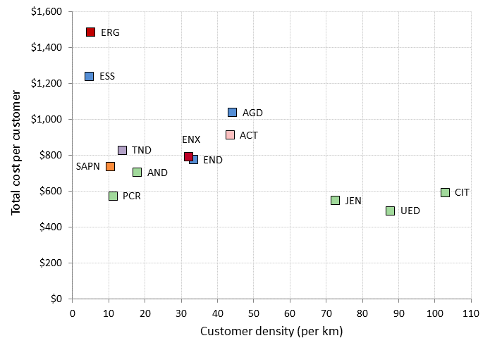

Under this measure, the Victorian and South Australian DNSPs perform the best in their combined use of opex and assets. They have the lowest ratio of cost to customers, despite their differing customer densities, of between approximately $400 and $800 per customer.

Ergon Energy and Essential Energy have the highest cost per customer, spending approximately double the cost per customer than many DNSPs including SA Power Networks and Powercor which are also low density networks. This may be partially explained by their relatively low customer density as discussed earlier. Ausgrid, ActewAGL, Endeavour Energy, Energex and TasNetworks have either higher or comparable costs per customer than SA Power Networks and Powercor. We would expect them to be positioned lower on the chart given their comparatively higher customer densities.

Total cost per MW of maximum demand

Figure 10 shows total cost per MW of maximum demand on the vertical axis and customer density on the horizontal axis. DNSPs aim to ensure that they meet demand when it is at its peak. Thus they will install assets to meet maximum demand. Maximum demand is also an indirect driver of opex because the assets installed to meet demand will ultimately require maintenance (opex). As expected, this measure favours DNSPs with higher customer density. However, the spread of results is narrower than for some other metrics.

Figure 10 Total cost per MW of maximum demand ($2015) against customer density (average 2011–15)

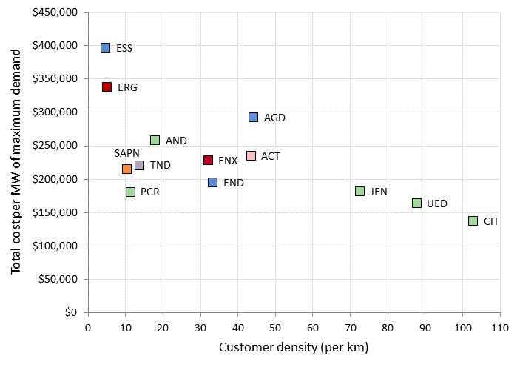

Under this measure, the Victorian DNSPs (excluding AusNet Services) perform the best in their combined use of opex and assets. They spend the least per MW of maximum demand, despite their differing customer densities. TasNetworks and Endeavour Energy spend comparable amounts to SA Power Networks. However, AusNet Services, Energex, Ausgrid and ActewAGL spend more than these DNSPs, despite having similar or higher customer densities.

Total cost per km of circuit line length

Figure 11 presents total cost per km of circuit line length against customer density. Circuit line length is a driver of costs because it reflects the distances over which DNSPs must deliver electricity to their customers. As expected, this measure favours DNSPs with lower customer density.

Figure 11 Total cost per km of circuit line length ($2015) against customer density (average 2011–2015)

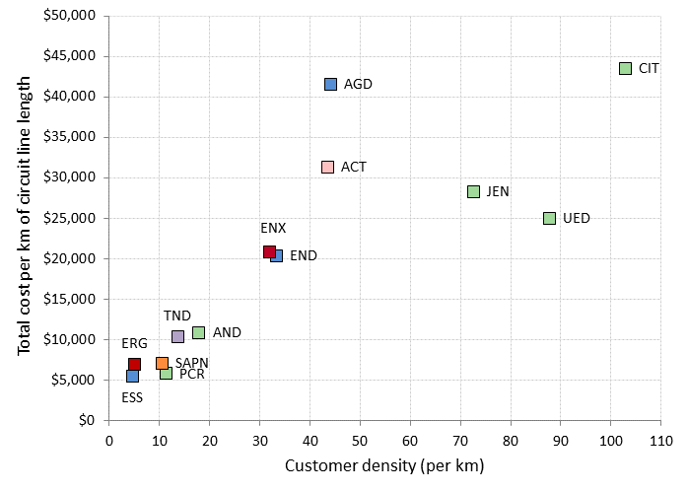

Figure 11 shows Ausgrid and ActewAGL spend more per km of circuit line length than Jemena and United Energy, who both have a higher customer density. Also, Ergon Energy and Essential Energy have comparable costs per kilometre to SA Power Networks and Powercor, despite their lower customer density.

Total cost per customer and reliability

Figure 12 is a ‘per customer’ reliability metric. It compares the total cost per customer against unplanned minutes off supply per customer. This reliability measure excludes the effect of large, abnormal outage events (known as major event days, or MEDs). MEDs can be unforeseeable, uncontrollable and may affect measured performance. Reliability is an important service DNSPs provide to their customers and is a significant driver of DNSPs' costs.

Figure 12 Total cost per customer ($2015) against unplanned minutes off supply per customer (excluding MEDs, average 2011–15)

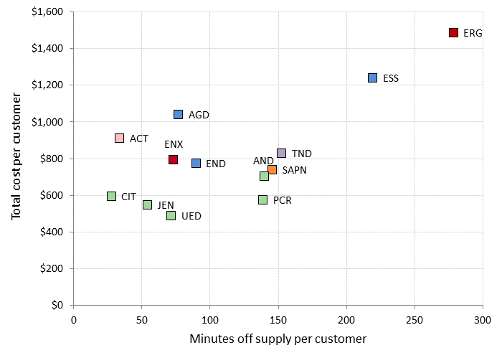

We would generally expect those DNSPs with longer networks (such as Essential Energy and Ergon Energy) to incur higher minutes off supply per customer, as they may need to travel further distances when responding to outages. However, Ergon Energy's minutes off supply (and its costs) are much greater than its peers, including Essential Energy, Powercor, AusNet Services and SA Power Networks, who also operate rural networks.

# Interpreting the benchmarking results

In this section we consider the variations in recent productivity performance across the DNSPs, as well as the importance of considering operating environment factors.

## Variations in recent productivity performance

Productivity at the industry level has been declining since 2007. There are a number of drivers of this, which include:

* demand for network services only increased moderately or remained relatively flat
* changes to jurisdictional regulatory obligations required some DNSPs to increase inputs but without a corresponding increase in outputs
* inefficient use of inputs by some DNSPs.

Despite the declining industry productivity trend, there have been some considerable variations in recent productivity performance across the DNSPs. As part of our ongoing benchmarking work, we intend to investigate the drivers of the declining productivity trend. In particular, we are interested in how exogenous drivers of costs affect productivity. For example, in our recent Victorian DNSP determinations we considered the reasons for increasing opex and the decline in opex MPFP for the Victorian DNSPs.[18]

We found there were three main drivers of the increase in opex:

1. More stringent vegetation clearance requirements put in place under the Electricity Safety (Electric Line Clearance) Regulations 2010 had led to higher vegetation management opex. These regulations were introduced in June 2010 following the Black Saturday Bushfires.
2. Increases in vegetation management opex across the Victorian DNSPs were probably affected by heavy rainfall during the period.
3. Other additions to regulatory obligations following the Black Saturday bushfires increased maintenance expenditure.[19]

Figure 13 shows the effect of these drivers on opex.

Figure 13 Change in Victorian DNSP opex ($2015) relative to 2009 – index measure



Source: AER, Powercor distribution determination final decision 2016–20, Attachment 7 – Operating expenditure, AER, May 2016,, p. 7-35.

Going forward we do not expect these drivers will contribute to further productivity declines. This is borne out by our benchmarking which indicates that productivity of the Victorian DNSPs improved in 2015.

Another observation from our benchmarking analysis is the improvement in TasNetworks’ performance. Compared to other DNSPs, TasNetworks has improved its productivity in recent years and now is one of the leading performers on opex MPFP. In 2010, TasNetworks was one of the five least productive networks under our opex MPFP measure. By 2015 TasNetworks was the second most productive DNSP. TasNetworks achieved these efficiencies by reducing its overhead costs when it merged with the Tasmanian transmission network service provider.

Figure 14 shows that TasNetworks' maintenance has remained relatively steady, however, its overheads have fallen since 2012.

Figure 14 TasNetworks maintenance and overheads opex 2006–2015 ($million, 2015)

Source: AER analysis

The networks operating in New South Wales, Queensland, and the Australian Capital Territory continue to benchmark poorly, though we expect recent cost cutting initiatives will improve their performance. ActewAGL managed to improve its opex efficiency from 2014 and Essential Energy also made a marginal improvement. However, Ergon showed a sizable decline in both opex and capex productivity. It attributed its opex increase in 2015 to a number of reasons, including lower than normal preventative maintenance costs in 2014, higher opex due to weather and storm events in 2015, and writing off non-proceeding capital works in 2015.

Ausgrid increased opex significantly from 2014, in large part due to exit costs for long term employees, higher rent expenses, and higher expenses relating to storms in April 2015.[20] The effect of the exit costs is significant as Ausgrid has reduced its staff numbers by 29 per cent between 2011 and 2015.[21] If we were to simply adjust Ausgrid's opex to exclude voluntary redundancy costs and pass through cost relating to the April 2015 storm, its MTFP and opex MPFP scores in 2015 increase by 9 per cent and 27 per cent respectively relative to unadjusted scores (as reported in section 2).[22] We have not done this, however, because other DNSPs have also incurred storm and redundancy costs and we do not currently have the data to make consistent adjustments across all DNSPs.[23] Further, careful consideration must be given to if, and when, costs are excluded from the benchmarking analysis.

We consider these significant downsizing of labour force and restructuring programs currently undertaken by the New South Wales networks will ultimately flow through to productivity improvements in the future. It may not be evident in the productivity performance results in 2015 in part because of the high transitional costs these DNSPs have incurred in reforming their businesses.

## Differences in operating environment

The networks we compare operate in different environments. The differences in operating environment can affect the relative expenditures of networks and hence their performance under benchmarking. However, differences in operating environment do not preclude us from measuring the efficiency of networks. This is because DNSPs are inherently comparable. They use a similar set of assets, such as poles, wires, transformers and cables, to provide their services to customers. Because of their similarity, distribution networks are commonly the subject of benchmarking studies and energy regulators commonly use benchmarking.[24]

Our economic benchmarking accounts for the most significant operating environment factors (OEFs). In economic benchmarking, we have adjusted the inputs to ensure similar coverage of DNSP activities. We have chosen to benchmark only the core 'poles and wires' component of distribution services by excluding opex and assets associated with other services that distributors sometimes provide including metering and public lighting. We have also excluded the costs of solar feed in tariffs and accounted for differences in the boundary between transmission and distribution that affect some DNSPs.[25]

By including customer numbers, network length, energy throughput and ratcheted peak demand as outputs we account for the relative size of the networks. The inclusion of these variables also allows for differences in density such as customer density (customers per line/cable kilometre), energy density (energy delivered per customer) and demand densities (peak demand per customer and peak demand per line/cable kilometre) in the analysis.[26] The econometric modelling also allows for the impact of undergrounding on opex by including a variable for the proportion of undergrounding.

1. Like other economic models, our benchmarking models are simplifications of reality. As such, they cannot directly account for every possible difference in operating environment between service providers. Further, we practically cannot consider all differences in operating environment for the purposes of this report. That said, in our determinations we consider operating environments in further detail where necessary.

1. References and further reading

This benchmarking report is informed by several sources. These include ACCC/AER research and expert advice provided by Economic Insights.

Economic Insights publications

The following publications explain in detail how Economic Insights developed and applied the economic benchmarking techniques used by the AER.

* Economic Insights, Memorandum – DNSP Economic Benchmarking Results Report, November 2016
* Economic Insights, Memorandum – DNSP MTFP and Opex Cost Function Results, 13 November 2015
* Economic Insights, Economic Benchmarking Assessment of Operating Expenditure for NSW and ACT Electricity DNSPs, 17 November 2014 ([link](https://www.aer.gov.au/system/files/Economic%20Insights%20%E2%80%93%20%20Economic%20benchmarking%20assessment%20of%20operating%20expenditure%20for%20NSW%20and%20ACT%20Electricity%20DNSPs%20%E2%80%93%2017%20November%202014_1.PDF)).
* Economic Insights, Response to Consultants’ Reports on Economic Benchmarking of Electricity DNSPs, 22 April 2015 ([link](https://www.aer.gov.au/system/files/Economic%20Insights%20-%20Response%20to%20consultants%20%20reports%20on%20AER%20economic%20benchmarking%20-%20April%202015_1.PDF)).

ACCC/AER publications

These publications provide a comprehensive overview of the benchmarking approaches used by overseas regulators.

* ACCC/AER, Benchmarking Opex and Capex in Energy Networks – Working Paper no. 6, May 2012 ([link](https://www.accc.gov.au/system/files/Working%20paper%20no.%206%20%20-%20Benchmarking%20energy%20networks.pdf)).
* ACCC/AER, Regulatory Practices in Other Countries – Benchmarking opex and capex in energy networks, May 2012 ([link](https://www.accc.gov.au/system/files/Regulatory%20practices%20in%20other%20countries%20-%20Benchmarking%20opex%20and%20capex%20in%20energy%20networks.pdf)).
* WIK Consult, Cost Benchmarking in Energy Regulation in European Countries, December 2011 ([link](https://www.accc.gov.au/system/files/Cost%20benchmarking%20in%20energy%20regulation%20in%20European%20countries%20-%20WIK-Consult.pdf)).

AER distribution determinations

In each of the following determinations, the AER applied economic benchmarking to determine efficient total forecast opex.

* AER, Jemena distribution determination 2016 to 2020, Attachment 7 – Operating Expenditure, May 2016, p. 7-22 ([link](https://www.aer.gov.au/system/files/AER%20-%20Final%20decision%20Jemena%20distribution%20determination%20-%20Attachment%207%20-%20Operating%20expenditure%20-%20May%202016.pdf)).
* AER, SA Power Networks distribution determination 2015–16 to 2019–20, Attachment 7 – Operating Expenditure, October 2015 ([link](https://www.aer.gov.au/system/files/AER%20-%20Final%20decision%20SA%20Power%20Networks%20distribution%20determination%20-%20Attachment%207%20-%20Operating%20expenditure%20-%20October%202015.pdf)).
* AER, Final decision, Endeavour Energy distribution determination 2015–16 to 2018–19, Attachment 7 – Operating Expenditure, April 2015 ([link](https://www.aer.gov.au/system/files/AER%20-%20Final%20decision%20Endeavour%20Energy%20distribution%20determination%20-%20Attachment%207%20-%20Operating%20expenditure%20-%20April%202015.pdf)).
* AER, Draft decision, Endeavour Energy distribution determination 2015–16 to 2018–19, Attachment 7 – Operating Expenditure, November 2014 ([link](https://www.aer.gov.au/system/files/AER%20%E2%80%93%20Draft%20decision%20Endeavour%20Energy%20distribution%20determination%20%E2%80%93%20Attachment%207%20%E2%80%93%20%20Operating%20expenditure%20%E2%80%93%20November%202014.pdf)).
* AER, Preliminary decision, Energex determination 2015–16 to 2019–20, Attachment 7 – Operating Expenditure, April 2015 ([link](https://www.aer.gov.au/system/files/AER%20-%20Preliminary%20decision%20Energex%20distribution%20determination%20-%20Attachment%207%20-%20Opex%20-%20April%202015.pdf)).
* AER, Preliminary decision, Ergon Energy determination 2015–16 to 2019–20, Attachment 7 – Operating Expenditure, April 2015 ([link](https://www.aer.gov.au/system/files/AER%20-%20Preliminary%20decision%20Ergon%20Energy%20-%20Attachment%207%20-%20Opex%20-%20April%202015_0.pdf)).

1. Inputs and outputs

This appendix contains further information on the outputs and inputs used in the benchmarking techniques. The November 2014 Economic Insights report referenced in Appendix A explains and justifies the input and output specifications used in this report.

* 1. Outputs

The techniques in the report measure output using some or all of customer numbers, circuit line length, maximum demand, energy throughput and reliability.

* + 1. Customer numbers

The primary function of a distribution network is providing its customers with access to electricity. Regardless of how much electricity a customer consumes, infrastructure is required to connect every customer to the network. The number of customers, therefore, reflects a significant driver of the services a DNSP provides. We measure the number of customers as the number of active connections on a network, represented by each energised national metering identifier.

Figure 15 shows the average customer numbers of each DNSP over the five year period from 2011 to 2015.

Figure 15 Five year average customer numbers by DNSP (2011–15)

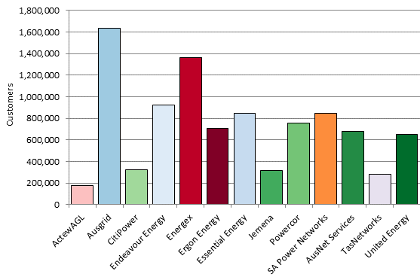

* + 1. Line length

Line length reflects the distances over which DNSPs deliver electricity to their customers. To provide their customers with access to electricity, DNSPs must transport electricity from the transmission network to their customers' premises. DNSPs will typically operate networks that transport electricity over thousands of kilometres.

In this report, line length is measured in terms of the length of 'circuit' or the length of 'route’. Route length is the distance between a DNSP’s poles. Circuit length is the length of lines in service, where a double circuit line counts as twice the length. Circuit and route length can differ because distributors may run multiple lines on the same route.

In economic benchmarking metrics and PPI metrics, we use circuit length because, in addition to measuring network size, it also approximates the line length dimension of system capacity. System capacity represents the amount of network a DNSP must install and maintain to supply consumers with the quantity of electricity demanded at the places where they are located. Figure 16 shows each DNSP’s circuit length, on average, over the five years from 2011 to 2015.

Figure 16 Five year average circuit length by DNSP (2011–15)

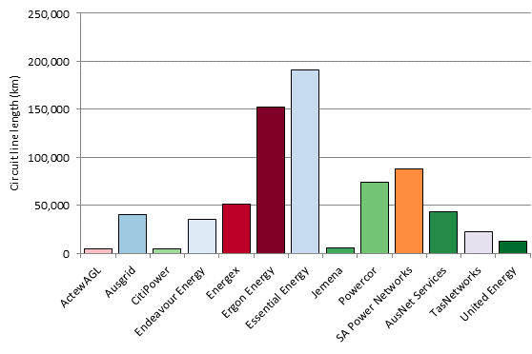

For PPI metrics, we use route length to calculate customer density (measured as customers per km of line length) because it is a measure of network size. For this purpose, route length is a measure of a DNSP’s physical network footprint because it does not count multiple circuits on the same route. Figure 17 demonstrates that, for all DNSPs, route length is shorter than circuit length but there is no change in DNSP ranking between the two line length measures.

Figure 17 Five year average route line length by DNSP (2011–15)

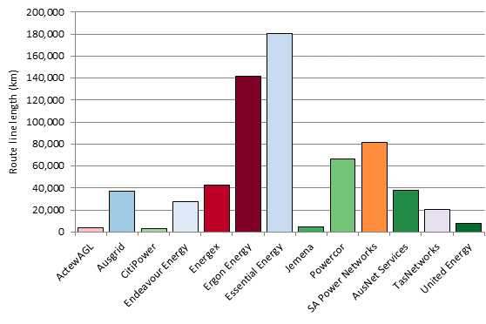

* + 1. Maximum demand and energy throughput

DNSPs are required to meet and manage the demand of their customers. This means that they must build and operate their networks with sufficient capacity to meet the expected peak demand for electricity. Maximum demand is a measure of the overall peak in demand experienced by the network. The maximum demand measure we use is non-coincident summated raw system annual maximum demand, at the transmission connection point.

The economic benchmarking techniques use 'ratcheted' maximum demand as an output rather than observed maximum demand. Ratcheted maximum demand is the highest value of peak demand observed in the time period up to the year in question for each DNSP. It thus recognises capacity that has actually been used to satisfy demand and gives the DNSP credit for this capacity in subsequent years, even though annual peak demand may be lower in subsequent years. For PPI analysis, we choose to use observed maximum demand.

Energy throughput is a measure of the amount of electricity that DNSPs deliver to their customers. While energy throughput is not considered a significant driver of costs (distribution networks are typically engineered to manage maximum demand rather than throughput) energy throughput reflects a service provided directly to customers.

Table 2 presents maximum demand and energy delivered for each of the DNSPs, on average, for the five years between 2011 and 2015.

Table 2 Maximum demand and energy throughput (2011–15 average)

|  |  |  |
| --- | --- | --- |
|  | Maximum demand (MW) | Energy throughput (MWh) |
| ActewAGL (ACT) | 683 | 2,878,157 |
| Ausgrid (AGD) | 5,810 | 27,481,192 |
| AusNet Services (AND) | 1,855 | 7,571,841 |
| CitiPower (CIT) | 1,385 | 6,007,022 |
| Endeavour Energy (END) | 3,664 | 16,354,449 |
| Energex (ENX) | 4,726 | 21,142,308 |
| Ergon Energy (ERG) | 3,123 | 13,557,356 |
| Essential Energy (ESS) | 2,652 | 12,077,640 |
| Jemena (JEN) | 955 | 4,276,308 |
| Powercor (PCR) | 2,387 | 10,563,196 |
| SA Power Networks (SAP) | 2,912 | 10,846,268 |
| TasNetworks (TND) | 1,049 | 4,261,589 |
| United Energy (UED) | 1,959 | 7,859,951 |

* + 1. Reliability

Another dimension of the outputs of DNSPs is the reliability of their electricity supply. This is commonly measured as the average number of minutes off supply per customer (per annum) or the average number of interruptions per customer. Figure 18 presents the average number of minutes off supply per customer, excluding the effects of major events, planned outages and transmission outages.

Figure 18 Average minutes off supply per customer (2011–2015)

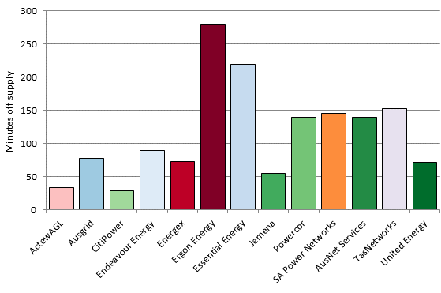

Figure 19 presents the average number of interruptions to supply per customer, excluding the effects of major events, planned outages and transmission outages. There are other measurements of reliability but the frequency and duration of interruptions to supply per customer are the Institute of Electrical and Electronics Engineers (IEEE) standard measures for DNSPs.

Figure 19 Average number of interruptions per customer (2011–2015)

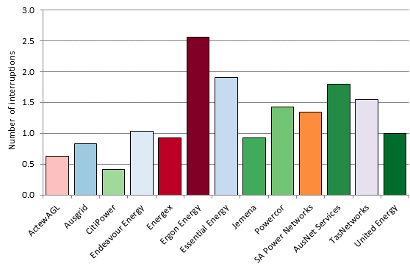

* 1. Inputs

The inputs used in this report are assets and opex. DNSPs use a mix of assets and opex to deliver services. Electricity assets can provide useful service over several decades. However, benchmarking studies typically focus on a shorter period of time.

For our MTFP analysis we use physical measures of capital inputs. Using physical values for capital inputs has the advantage of best reflecting the physical depreciation profile of DNSP assets. Our MTFP analysis uses five physical measures of capital inputs: the capacity of transformers, overhead lines above 33kV, overhead lines below 33kV, underground cables above 33kV and underground cables below 33kV. The MTFP analysis also uses constant dollar opex as an input. The November 2014 Economic Insights report referred to in Appendix A provides further detail on the capital inputs for MTFP.

For the purpose of PPI analysis we use the real value of the regulatory asset base as the proxy for assets as the starting point in deriving the real cost of using those assets. To be consistent with Economic Insights' MTFP analysis, and in response to a submission by Ausgrid,[27] we have adjusted the PPI analysis to remove assets associated with the first-stage of the two-step transformation at the zone substation level for those DNSPs with more complex system structures. This allows better like-with-like comparisons to be made across DNSPs.

Asset cost is the sum of annual depreciation and return on investment. [28] This measure has the advantage of reflecting the total cost of assets for which customers are billed on an annual basis, using the average return on capital over the period. This accounts for variations in the return on capital across DNSPs and over time.

Table 3 presents measures of the cost of network inputs relevant to opex and assets for all DNSPs. We have presented the average annual network costs over five years in this table to moderate the effect of any one-off fluctuations in cost.

Table 3 Average annual costs for network inputs for 2011–15 ($m, 2015)

|  |  |  |  |  |
| --- | --- | --- | --- | --- |
|  | Opex | RAB | Depreciation | Asset cost |
| ActewAGL (ACT) | 69.73 | 824.51 | 44.98 | 90.90 |
| Ausgrid (AGD) | 582.23 | 12,305.34 | 434.55 | 1,119.76 |
| AusNet Services (AND) | 184.90 | 2,859.89 | 133.98 | 293.23 |
| CitiPower (CIT) | 55.26 | 1,301.76 | 63.18 | 135.67 |
| Endeavour Energy (END) | 259.55 | 4,416.33 | 210.76 | 456.67 |
| Energex (ENX) | 382.99 | 7,127.86 | 300.24 | 697.14 |
| Ergon Energy (ERG) | 357.24 | 7,011.37 | 307.59 | 698.01 |
| Essential Energy (ESS) | 414.26 | 6,226.92 | 290.63 | 637.37 |
| Jemena (JEN) | 71.86 | 881.17 | 53.12 | 102.19 |
| Powercor (PCR) | 181.55 | 2,373.69 | 118.76 | 250.93 |
| SA Power Networks (SAP) | 233.19 | 3,346.40 | 206.07 | 392.41 |
| TasNetworks (TND) | 78.47 | 1,422.51 | 74.09 | 153.30 |
| United Energy (UED) | 127.17 | 1,742.51 | 96.66 | 193.69 |

Note: Data for the Victorian distributors is for calendar years whereas the data for the other DNSPs is for financial years. RAB values are the average of opening and closing values.

1. Partial performance indicator trends

The partial performance indicators that we present in section 2.2.3 are average results for 2011–15. These metrics provide insight into the relative performance of the networks over the most recent five years. However, they do not show the change in performance over time. In this appendix, we present trends in PPI performance over the period 2006 to 2015.

In this appendix, we present PPI results on a state by state basis. This is because there is less variability in customer density across states than across DNSPs. As we note in section 2.2.3, customer density differences should be taken into account when comparing PPIs. Figure 20 presents customer density by state.

Figure customer density by state (customers/km route line length)



Figure 21 shows the trend in total cost per customer by state. This figure shows that total cost per customer has increased between 2006­ and 2015 in every state. This means that the growth in total cost has outpaced the growth in customer numbers. In recent years, TasNetworks has reduced its total cost per customer.

States with relatively low density network will be disadvantaged under this PPI measure. The longer and sparser a network, the more assets it must operate and maintain per customer because of the need to connect the few customers in such a sparse area. Given their relatively high densities, the Australian Capital Territory and Victoria should be at an advantage under this PPI. However, total cost per customer in the Australian Capital Territory is comparable to New South Wales in 2006 and 2015, but the path diverges in the intervening years. Despite having similar customer density at the state level, Queensland and New South Wales have much higher costs per customer than South Australia and Tasmania.

Figure 21 Trend in total costs per customer ($2015)



Figure 22 shows the trend in total costs per MW of maximum demand. This time series is much more volatile than the trend in total cost per customer, which reflects the volatility in annual maximum demand. New South Wales and Queensland also have the highest costs per MW of maximum demand. Again, given their relatively high density, the Australian Capital Territory and Victoria should be at an advantage under this PPI measure. However, total cost per MW of maximum demand in the Australian Capital Territory is comparable to South Australia in 2006, 2012 and 2015, but higher in other years.

Figure 22 Trend in total cost ($2015) per MW maximum demand



Figure 23 shows the trend in total cost per km of circuit line length. South Australia has the lowest cost per km of circuit line length. In 2006, New South Wales, Queensland, Tasmania and Victoria all had very similar costs per circuit km. Since then, New South Wales and Victoria have increased their costs per km at a greater rate than Queensland and Tasmania.

On 'per km' metrics, states with relatively low density network will perform better because their costs are spread over a longer network. Victoria and the Australian Capital Territory are at a disadvantage under this measure given their relatively high customer density.

Figure 23 Trend in total cost per km of circuit line length ($2015)



1. Map of the National Electricity Market

This benchmarking report examines the efficiency of the 13 DNSPs in the National Electricity Market (NEM). The NEM connects electricity generators and customers from Queensland through to New South Wales, the Australian Capital Territory, Victoria, South Australia and Tasmania. Figure 24 illustrates the network areas for which the DNSPs are responsible.

Figure 24 Electricity distribution networks within the NEM

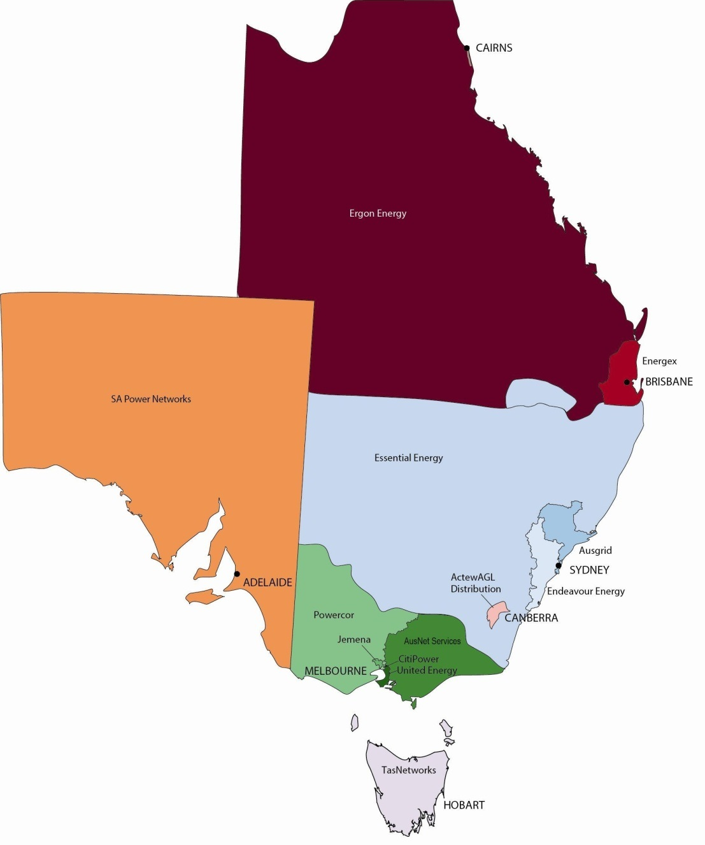

1. List of submissions

We sought comment from DNSPs on a draft version of this report. We received submissions from:

* ActewAGL
* Ausgrid
* AusNet Services distribution
* Endeavour Energy
* Ergon Energy
* Essential Energy
* TasNetworks.

All submissions are available on our website.

Submissions on the benchmarking modelling undertaken by Economic Insights have been addressed in its memo which is also available on our website. Where specifically relevant to PPI analysis, issues raised in the submissions are addressed in the relevant parts of this report, including this appendix.

Essential Energy submitted that trend lines and correlation coefficients (R2) for the current year and the prior year should be added to the PPI figures. We consider that data-driven statistical analysis should not be adopted. We also note that deriving trend lines from the 13 DNSP data points could potentially be misleading.

Essential Energy suggested we should use route line length instead of circuit line length in the PPI analysis, given the cost per km cost of circuit line length was plotted against customer density.   We use circuit line length because it is considered as a key output for delivering electricity to customers. It approximates the line length dimension of system capacity. Whereas, customer density is measured as customer numbers relative to route line length and is a key operating environmental factor effecting cost.  We therefore plot the PPI measures against customer density to visually account for this important operating environmental factor.  We expect that ‘per customer’ and ‘per MW of maximum demand’ metrics favour DNSPs with higher customer density and ‘per km’ metrics favour DNSPs with lower customer density.  We are not convinced by Essential Energy’s argument for extending the two-dimensional PPI plots to illustrate each PPI measure against customer number and line length respectively.

Essential Energy submitted we should highlight the size differences (measured in square kilometres) covered by each DNSP. It submitted we should consider customer density as a function of square kilometres serviced as well as a function of line length. We acknowledge there are multiple dimensions of network density, but disagree with Essential Energy that we should compare DNSPs based on the number of customers per square kilometre. Based on Economic Insights advice, the difficulty with specifying customer density in terms of customers per square kilometre in Australia is the arbitrariness involved in specifying exactly what constitutes the area ‘serviced’ given the sparseness with which outback areas are populated.[29]

1. Appendix A lists the Economic Insights publications which explain how it developed and applied the economic benchmarking techniques we used.
2. This is particularly the case with opex. However, it is should be recognised that for capex, in some cases, a bottom up assessment is useful in circumstances where a discrete number of projects to be undertaken can be clearly identified.
3. Bottom up techniques are not commonly used. One example, however, is in Spain where the regulator constructs a network reference model. This model designs large scale electricity distribution networks optimally, considering all technical features imposed on the actual distribution networks. The WIK Consult report referenced in Appendix A provides more detail on the Spanish bottom up model.
4. The economic benchmarking techniques use 'ratcheted' maximum demand as an output rather than observed maximum demand. Ratcheted maximum demand is the highest value of peak demand observed in the time period up to the year in question for each DNSP. It recognises capacity that has been used to satisfy demand and gives the DNSP credit for this capacity in subsequent years, even though annual maximum demand may be lower in subsequent years.
5. This dataset is available at: <https://www.aer.gov.au/node/483>.
6. Economic Insights, Economic Benchmarking Assessment of Operating Expenditure for NSW and ACT Electricity DNSPs, November 2014, p. 3.
7. Other aspects of efficiency include allocative efficiency and dynamic efficiency. Allocative efficiency is achieved where resources used to produce a set of goods or services are allocated to their highest valued uses (i.e., those that provide the greatest benefit relative to costs). To achieve this, prices of the goods and services must reflect the productively efficient costs of providing those goods and services by distributors. Dynamic efficiency is achieved when distributors are productively and allocatively efficient over time. Measuring productive efficiency will assist us in assessing whether distributors are allocatively and dynamically efficient. Measuring productive efficiency helps us determine efficient prices/revenues for services promoting allocative efficiency. Measuring productive efficiency over time provides an insight into the dynamic efficiency of distributors.
8. TasNetworks, however, could be considered an outlier compared to its peers in terms of system structure, which influences its MTFP score to some extent. Compared to other DNSPs, TasNetworks operates substantially less high voltage subtransmission assets and has a comparatively high proportion of lower voltage lines. Therefore, Economic Insights advises that some caution is required in interpreting TasNetworks’ MTFP score, given its comparatively unusual system structure. The Economic Insights 2015 memorandum referred to in Appendix A contains further detail on TasNetworks’ system structure.
9. NER, cl. 6.27.
10. Economic Insights, Economic Benchmarking Assessment of Operating Expenditure for NSW and ACT Electricity DNSPs, November 2014, pp. 5–6.
11. Economic Insights, Memorandum – DNSP Economic Benchmarking Results Report, November 2016, pp. 5-15.
12. This reviews performance in the longer term and facilitates the estimation of the impact of technological change.
13. PIN techniques determine the relationship between inputs and outputs using an index.
14. Asset cost is the sum of annual depreciation and return on investment. This measure has the advantage of reflecting the total cost of assets for which customers are billed on an annual basis, using the average return on capital over the period.
15. The outputs we consider are similar to those used in the MTFP and MPFP benchmarking techniques. However, we do not specifically consider energy delivered as it is likely to be highly correlated with customer numbers and maximum demand, and is a less significant driver of the DNSPs' costs.
16. We measure customer density as the number of customers per km of route line length (see Appendix B).
17. The customer numbers output carries the largest weight (in terms of per cent share of gross revenue) in the MTFP and MPFP indices. It also carries the largest weight (in terms of the magnitude of coefficient estimates) in the opex cost function models. See Economic Insights, Economic benchmarking assessment of operating expenditure for NSW and ACT electricity DNSPs, November 2014, pp. 16, 21, 33-36.
18. See for example, AER, Final Decision, CitiPower distribution determination 2016 to 2020, Attachment 7 – Operating expenditure, May 2016, pp. 7-32 to 7-38. Available at: https://www.aer.gov.au/networks-pipelines/determinations-access-arrangements/citipower-determination-2011-15.
19. For instance, one of the requirements is regular inspection of single wire earth return lines and 22KV feeders in high bushfire risk areas at interval of no longer than 37 months. This has contributed to the increase in pole inspection expenditure.
20. Ausgrid, AER 2015 EBRIN questions - Ausgrid, June 2016, p. 1.
21. Ausgrid, Submission on draft DNSP annual benchmarking report 2016, 14 October 2016, p. 5.
22. Ausgrid reported $107 million in voluntary redundancies costs in 2015 associated with its ongoing reforms to improve its operational efficiencies. The cost pass through relating to the April 2015 storm is $33.9 million on opex. Ausgrid, Letter from Ausgrid - Comments on the AER's Draft Annual Benchmarking Report, Email to the AER, 28 October 2016.
23. We are cautious about excluding abnormal costs from benchmarking because it creates an opportunity for gaming the results. Netting out abnormal costs should be consistently made to both reviewing historical performance and setting forward-looking costs. If abnormal costs are to be excluded from opex benchmarking because they are not part of the costs normally incurred to provide network services, then these costs should also be excluded from the base opex for forecasting efficient costs going forward.
24. We have published some papers that consider the use of benchmarking by other regulators. These include: ACCC/AER, Benchmarking Opex and Capex in Energy Networks, Working Paper no. 6, May 2012; ACCC/AER, Regulatory Practices in Other Countries: Benchmarking Opex and Capex in Energy Networks, May 2012 and Schweinsberg, Stronzik, and Wissner, Cost Benchmarking in Energy Regulation in European Countries, December 2011.
25. To account for the distribution and transmission boundary differences, we have excluded the assets associated with the first stage of two stage transformation at the zone substation level from our analysis.
26. Economic Insights, Response to Consultants’ Reports on Economic Benchmarking of Electricity DNSPs, 22 April 2015, p. 11.
27. Ausgrid, Submission on the DNSP annual benchmarking report 2016, 14 October 2016, p. 3.
28. To calculate asset costs relevant to PPIs, MTFP and Capital MPFP, where possible we have applied annual weighted average cost of capital values calculated in accordance with the AER's approach to setting rate of return in the most recent determination. See: AER, Final decision, Jemena distribution determination 2016 to 2020 Attachment 3 – Rate of return, May 2016 and AER, Final decision, Jemena distribution determination 2016 to 2020 Attachment 4 – value of imputation credits, May 2016. These include a market risk premium of 6.5 per cent, and a risk free rate based on the yield of ten year CGS (noting we use a 365 day averaging period for each year in the benchmarking report). For this benchmarking report, we choose to continue to use our the previous approach used in previous benchmarking reports that use the Bloomberg BBB fair value curve (365 day averaging period) to calculate the debt risk premium. The AER's present approach averages ten year maturity BBB yields from the RBA and Bloomberg (appropriately extrapolated out to ten years where necessary). However, historical data going back to 2006 is not available for the RBA curve. Given this, we have continued to rely solely on estimates based on the Bloomberg fair value curve data. Where relevant, the tax component uses gamma of 0.4.
29. Economic Insights, Response to Consultants’ Reports on Economic Benchmarking of Electricity DNSPs, 22 April 2015, p. 15.