Our ref: 4283/4621310

30 January 2015

Mr Sebastian Roberts
General Manager
Australian Energy Regulator
GPO Box 520
MELBOURNE VIC 3001 Email: QLDelectricity2015@aer.gov.au

Dear Sir

AER Issues Paper
Queensland Electricity Distribution Regulatory Proposals 2015-16 to 2019-20

The Far North Queensland Regional Organisation of Councils (FNQROC) membership includes Cairns, Cassowary and Tablelands Regional Councils, Cook, Croydon, Douglas, Hinchinbrook and Mareeba Shire Councils and Yarrabah and Wujal Wujal Aboriginal Shire Councils. Member Councils cover more than 250,000 square kilometres in Far North Queensland.

FNQROC would like to thank the Australian Energy Regulator (AER) for its time, effort and patience to help us to understand the role of the AER and the complexities of energy distribution.

Our submission while touching on various components has been developed with Local Governments and particularly street lighting in mind. As such, we also support the submission made by the Far North Queensland Electricity Users Group (of which we are a member) coordinated by Cummings Economics.

As a disclaimer to our submission, many of our comments include questions. FNQROC like many Local Governments is resource poor and does not have a thorough understanding of all the components related to energy distribution. However, our knowledge today is significantly greater than it was one year ago and this issue, like many others, is important to comment on.

We are aware there may be some comments which the AER is unable to consider as part of its determination, however from our novel point of view there is perceived to be a linkage to the determination.

Our interest in the distribution determination process:
We have a keen interest in the cost and distribution of energy to this region as it is not only a significant cost to councils but it also plays a major role in economic development. In terms of energy costs and attracting new investments we are not only competing nationally but internationally as well. While we only have anecdotal evidence we believe we are losing businesses due to the cost of energy. What we cannot measure at this stage but we are concerned with is potential businesses/investment which is not coming to the region due to energy costs or availability.

There is also a social impact associated in electricity distribution and pricing. These impacts are not only related to business decisions for new potential/new residents and their employees but also on our existing residents. Before we even start there is a substantial service fee which is a result of network utilisation or share of costs across customers. Solar energy and any associated rebate is a contributor to this. Our most at risk residents potentially impacted the greatest, meaning those who can least afford investment in alternative technologies to manage their costs bear a greater burden than those equipped to do so. An example is our pensioners and particularly those who rely on energy for their health equipment or cooling during summer months.

The submission from the North Queensland Electricity Users Group will focus more depth on these issues.

Comments related to the Issues Paper – December 2014

Infrastructure financing:
As acknowledged within the paper, the cost of infrastructure financing is falling however there still remains the issue that Ergon Energy can only be funded by the Queensland Treasury Corporation (QTC), which charges a ‘market rate’ and not the rate the State receives. It is understood this is to manage the market competitively; however there is no competition and restrictions on Ergon Energy to only borrow from the State affects their ability to seek competitive rates. Ergon Energy is unable to go to the market to seek a more competitive rate which was identified as an initiative within the paper. As the sole shareholder of Ergon Energy it is perceived this allows the State to benefit from the interest revenue. Arguably, this revenue benefits the people of Queensland but there is little the general public can do to ascertain if this ‘market rate’ is competitive or rather a loop hole in which the State can increase revenue ‘quietly’ rather than through public tax increases.

Capital Expenditure
AER Question: Do you think the distributors’ capital expenditure proposals are adequately justified?

It is difficult to understand if Ergon Energy’s capital expenditure is adequately justified with any confidence.

Ergon Energy’s REPEX is shown as 33% of CAPEX and 10% higher than the previous determination. Concern is raised, as identified within the issues paper, as to how CAPEX can be lower but RAB increasing (27%) it could be assumed, they are extending the life of assets (rightly or wrongly) which in turn will increase the Regulatory Asset Base (RAB).

Extending the life of an asset in turn may allow Ergon Energy to count on incentives for underspend on approved CAPEX as its assets did not need to be replaced or could not be replaced as they had not reached the end of their ‘financial life’.

Issues with extending the financial life of assets
This could have the effect of limiting Council’s ability to manage their energy costs. As an example; within the FNQROC region we have 4,500 Mercury Vapour (MV) luminaires near (within three years) or past their ‘financial life’ of 20 years. We have been pushing for some time to have these replaced (ideally with LEDs but in the absence of a ‘suitable’ replacement in the Australian Energy Market Operator (AEMO) National Electricity Market Load Table for unmetered connection points – Public Lighting Load (NEM table)) we have undertaken a cost assessment on Compact Fluorescent (CFL). This shows the non-replacement of these ‘end of financial life’ luminaires is costing our Councils an additional $200,000 per year in additional energy use. If the nominal ‘financial life’ is extended we will not only have to contribute to replacing these luminaires (despite previous contribution to return of capital) but also risk higher replacement rates (due to failure) on an adhoc basis which could limit the ability to negotiate bulk change outs and increased costs to Councils through a ‘contribution’ for the remaining life of those assets replaced due to previous failures. While these amounts may seem minor in the scheme of this determination, this has only been done for out of date MV, and there are a number of other types past their ‘financial date’. For Local Governments in this region every dollar counts.

Financial and operational life
It is understood there is a need to line up ‘financial life’ with ‘operational life’ for more robust asset management. However, perhaps a line in the sand could be drawn and any ‘new’ assets are applied with the ‘new’ financial life. If not, there also is the risk that Ergon Energy could be ‘double dipping’ on the return on capital for older assets.

Connections
With the continual rise in electricity prices and the residential and small/medium enterprises being significant contributors to Ergon Energy’s revenue, the question needs to be asked: “has technology been factored into these estimates?” During the last period we saw demand significantly less then estimated. The reasons for this are discussed under Demand Management. With the introduction of retail energy storage solutions and the ‘customers’ willingness and ability to accept lessor reliability’ it could be assumed that the connection forecasts could be over stated.

Demand Management
As identified within the issues paper “Demand management refers to any strategy to mitigate growth in consumption volumes or peak demand”. As it is understood, one of the current issues is that the network is built around peak needs which results in a network utilisation rate of just over 40%. As prices increase consumers will find ways to reduce consumption – reference is made to the previous period where there was a higher updake than expected of solar power combined with a reduction of usage arguably related to cost of energy. With increasing costs, further uptake of solar (with the capacity for battery storage) will occur. Consumers also will look to further reduce their usage via investment in alternative energy sources and an increase in uptake of efficient appliances. It is envisaged this will result in higher ‘service fees’ to cover the network costs. Incentives should be offered to manage utilisation of the existing network to limit or reduce peak demand growth and transfer this usage to other times.

Operating Expenditure
There appears some information does not add up - on page 25 of the Issues Paper it advises that “forecast overheads account for $480.5mil (14-15) of Ergon Energy’s total OPEX forecast”. However, figure 12 on page 22 shows 14-15 OPEX to be under $450mil.

Solar Bonus Scheme
It is believed the Solar Bonus Scheme should not be subsidised by those who can least afford it. The rebate initiative and amounts was a product of the State, and as such it should be funded by the State from the taxes and dividends/revenues it receives.

It is also noted the Issues Paper identifies Ergon Energy’s saving of 4% if the Feed in Tariff (FiT) was removed. However, in Ergon Energy’s presentation to the AER Public Forum for Queensland distributors on 9 December 2014 it said the FiT made up 8% of the price.

OPEX efficiency
We are not in a position to effectively comment on OPEX forecasts and the AER has developed its own guidelines. The only comment we would like to stress is that shareholders, not the consumers, should bear the cost of any transition. Reasoning:
- As the only shareholder they should be keeping Ergon Energy accountable for efficiency.
- The shareholder of Ergon Energy has been reaping the benefits of:
  - Dividends
  - Revenue from interest charged on borrowings
- The benefits of revenue from interest have arguably gone to the State as a whole.
- If the benefits have gone to the State and it has not held Ergon Energy accountable for efficiency, why should the customer (who is predominately regional, rural or remote with least density) pay?
- This will be a further economic deterrent for investment into the regions. All levels of government have a role to play in helping to develop northern Australia.

Rate of Return
“In the current regulatory control period, the return on capital made up more than half of Ergon Energy’s total revenue requirement. The methods used to calculate the return on capital is therefore also one of the more contentious issues when establishing future revenue allowances.”

This is difficult to comment on without relevant qualifications or resources to substantiate an argument. For this reason we are reliant on the advice of members on the Consumer Challenge Panel (CCP) who, in simple terms, are there to represent consumers to critically assess AER which is in turn assessing submissions by energy providers.

Ergon Energy is proposing 8.02%. Hugh Grant’s (CCP member) presentation identifies an overall WACC of below 6% (assuming the current risk free rate) and with reference to the CCP papers to the AER on the AER’s approach to determining the Rate of Return (RoR). Given our lack of resources, the contentious issues, hindsight generosity of the previous RoR and the CCP being there to support consumers, we are inclined to support Hugh Grant’s assessment.

In the case of street lighting, or other assets for that matter, how are ‘donated’ assets managed to ensure they do not slip into the asset base used for the Rate of Return?

STREET LIGHTING

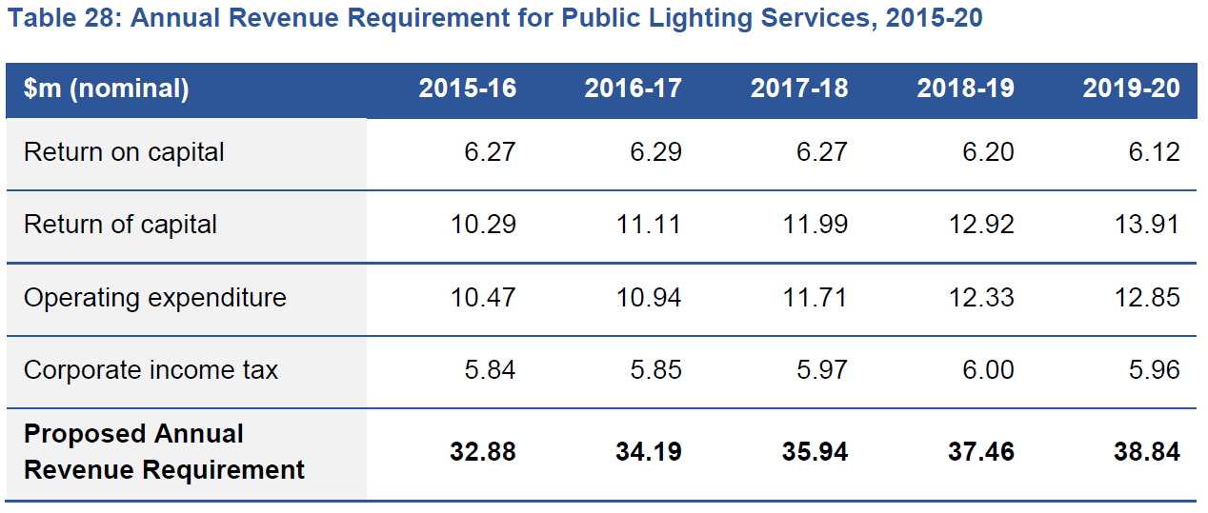
Source: Ergon Energy Regulatory Proposal 2015 to 2020

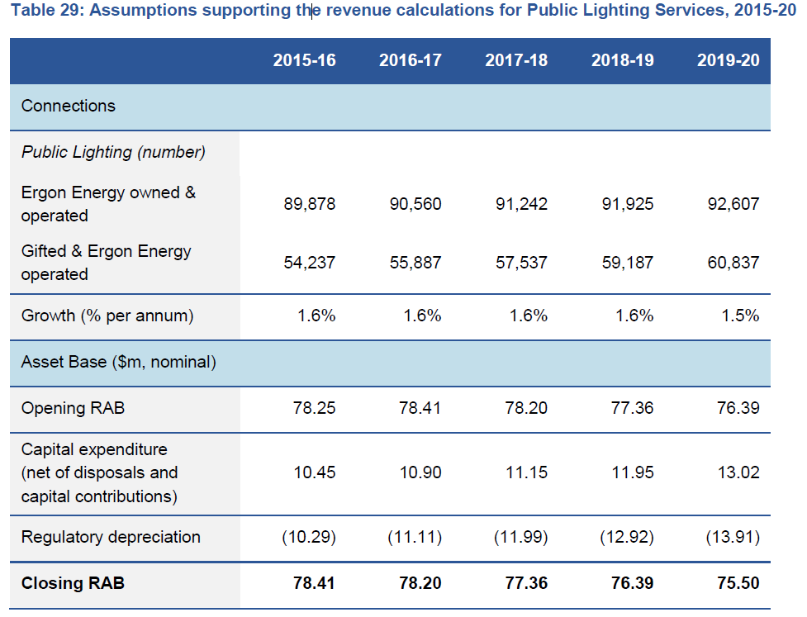
Source: Ergon Energy Regulatory Proposal 2015 to 2020

Table 28 shows ‘Return of Capital’ which in Table 29 is ‘regulated depreciation’. With a focus on LED transition program and based on LEDs having a longer life, has this been factored into depreciation going forward?

There is a sharp and steady increase in the regulatory depreciation which on the surface looks high – simple calculations show 13% regulatory depreciation rising to 18.4% in 2019-2020. Again, we do not have the resources to delve further into this but on the surface it looks high and may suggest ageing infrastructure with proposed CAPEX and OPEX unable to manage the assets. How can there be 57.47 in CAPEX with a closing RAB of 75.5 and increasing regulatory depreciation? Again this may be linked to historic capital expenditure not being adequate with many assets not having a remaining financial life. It is noted in the issues paper on page 44 that increasing the asset base will increase the distributors’ depreciation allowance; however the asset base is decreasing over the five years. It is also noted more assets require more maintenance however the move to LEDs is expected to reduce maintenance costs.

The question asked is: with the move towards LEDs in new subdivisions and with the LED transition program, has this been appropriately costed into the OPEX and depreciation calculation for street lighting? It is also acknowledged that luminaires are not the only components related to the RAB.

I am unsure if there is an impact from the statement within Ergon Energy’s proposal which identifies Ergon Energy has having more than 155,000 public lights. Yet Table 29 identifies 144,115 with expected growth to 153,444 in 2019-2020. Could the discrepancy in numbers have come from the recently completed audit? If there is in fact more than 155,000 public lights, which is close to the estimation for 2019-2020, have the assumptions in table 29 been updated?

Table 29 – Assumptions supporting the revenue calculations for Public Lighting Services.
While the ratio between capital expenditure and depreciation is within sustainable limits the question needs to be raised - is the CAPEX appropriate looking at historic CAPEX actuals? The last period saw a significant underspend in CAPEX in comparison to the AER approved amount. I have not identified (due to resource constraints) where the under spend for approved sits; however, our case study rings some alarm bells for future investment. As identified earlier, we have 4,500 MV which are near (within three years) or past their financial life. A rough estimate on the cost of replacing these with CFL (preference is for LED) is $6.75 million. We know our region is not alone in this scenario. Again, delaying replacement of these costs Councils additional energy use – for FNQROC Councils this amount is in the order of $200,000 per year.

LED Transition and Exit Fee’s
We support rapid transition to allow LED to be introduced for new public lighting installations. It is something local governments and this region’s development industry has argued for, for a number of years now.

In principle, we support provision for the conversion of targeted existing public lighting to LED technology, with the sunk cost of assets spread across all public lighting customers through the daily charge. This support is in principle as to date we have no specific details to make an informed comment.

We support the flexibility for customers to adopt LED technology above and beyond the funded LED conversion program. However, we do not support customers having to pay an exit fee on assets past their financial life. The reasoning for this is that these customers have paid the return on capital for these assets and are now paying considerably more for energy than current approved technology. For the FNQROC region and on MV only when compared to CFL (LED is preferred) it is costing us and additional $200,000 per year.

With regard to the exit fees:

- The term ‘end of useful operational life’ has been used. This should be ‘end of useful financial life’ as Ergon Energy has already received the capital on investment or regulated depreciation amount for these assets.

- The fee table should be on a sliding scale dependent on the age of the asset for EO&O major and minor. This will allow Ergon Energy to recoup the outstanding return on capital or regulated depreciation. For G&EO Major and Minor a fee for refurbishment capital expenditure is questioned. On this note, is there a figure related to refurbishment capital expenditure within the CAPEX identified in table 29?

Consumer Engagement

Do you consider Ergon Energy has adopted practices set out in the Consumer Engagement Guideline to build consumer engagement across all business activities?

Do you consider the proposals from Ergon Energy reflect the engagement they had with you and issues you raised with them? If they did not agree with consumer views, did they explain why?

Did Ergon Energy provide you with options and scenarios for service and price trade-offs?

Ergon Energy has worked proactively with Councils to undertake a tariff review of our highest use assets. This has resulted in significant savings to Councils and is very much appreciated. Ergon Energy has offered to conduct this review on an annual basis and provide us with the information for Councils to make an informed decision going forward. Again this is very much appreciated.

In relation to street lighting, traditionally, it had been difficult to work with Ergon Energy With the release of the Federal Government’s Consumer Energy Efficiency Program (CEEP) we saw an opportunity to work with Ergon Energy to obtain funding to exchange our older luminaries with LEDs as they had in other parts of Australia. When we were able to engage them there were a lot of words and promises which were not fulfilled which caused a great amount of frustration and wasted time and energy from our side.

Over the past year Ergon Energy has increased its active engagement and transfer of information. The street lighting audit and hopefully imminent release of light maps has been a positive direction forward. There are a few outstanding issues including a Service Level Agreement (SLA) which we have been seeking for some time. At the request of Ergon Energy, in about December 2013 we put forward the types of things we believe should be included in a SLA and despite promises, we are yet to see a draft of this. From here-say, we believe a draft has been completed with options for increased/decreased service with associated price trade-offs. Our concern is this draft will not be a negotiated draft with the Councils on the ground, but rather ‘here is the final’.

As mentioned earlier we are yet to see details on the LED transition program as are keen to engage with Ergon on this with cluster sites already identified.

Cost Pass Throughs
Regarding additional cost pass throughs for Ergon Energy related to a retail separation event it is argued this should be managed through existing resources rather than an additional cost passed on to the consumer. This type of event is a business decision of the shareholder and as such, the shareholder should decide if the benefits to the business/businesses have an effective return on investment and therefore wear the risk or benefit of that decision.

Incentives
Whilst we are not across all the incentives and disincentives, some of the thoughts include:

- Penalty for incorrect demand forecast

Reasoning:
  - Demand feeds OPEX estimation.
  - Demand feeds CAPEX estimation.
  - There are incentives for reduced OPEX and CAPEX which is a benefit to Ergon Energy. Over-estimating demand provides more opportunities to benefit Ergon Energy, however this is a cost to the consumer.

- Perhaps incentives for managing demand during peak times

Reasoning:
  - Limit pressure on CAPEX related to infrastructure upgrades due to peak demand needs. This in turn will have a positive impact on the Rate of Return.
  - Provides opportunity to increase utilisation rate of existing infrastructure.

Should you require any further details please contact me on 07 4044 3038 or 0403 808 680.

Yours sincerely

Darlene Irvine
Executive Officer

AER Issues Paper – Qld electricity distribution regulatory proposals 2015-16 to 2019-20 page 18
Hugh Grant presentation at the AER Public Forum 9 December 2014
Ergon Energy Regulatory Proposal 2015 to 2020 page 117
Preliminary Perspectives Energex & Ergon Revenue Proposals – presentation at the AER Public Forum 9 December 2014
Ergon Energy Regulatory Proposal 2015 to 2020 page 51

