Attachment 1

PLEASE NOTE: While tables 1 to 5 have been amended to reflect correspondence with the ACCC, the tables have not been amended to reflect the increased ORC and DORC amounts shown elsewhere in this consolidated access arrangement information document

Attachment 1

Attachment 1

Attachment 1

Attachment 2

ORC Paper

MOOMBA TO ADELAIDE

NATURAL GAS PIPELINE

ANALYSIS
OF
OPTIMISED REPLACEMENT COST

For

Pipeline System and Facilities

Prepared By
EPIC ENERGY

September 1998

Consolidated 11 September 2000

Moomba-Adelaide Pipeline

Optimized Replacement Cost

The Service Provider has costed the Optimized Replacement Cost (ORC) for the Pipeline System on the following premises:

- A maximum Capacity of 393 TJ per day. This capacity is supported by separate flow studies and is the contracted capacity under the existing gas haulage agreements;
- The best available applicable technology in use in the area today has been utilized. That standard is a "fit for purpose" and not “gold plated” or substandard;
- Each line segment and facility is optimized for the flow at today’s current contracted capacities, using standard sizing;
- Includes and allowance for costs associated with:
  - A "brownfields" construction rather than "greenfields". That is, the pipeline would be constructed in the existing route but recognizing that the route conditions of today rather than at the time of the original construction would apply;
  - Settling possible native title compensation (see later); and
  - Interest on capital during construction.
- Does not include any allowance for facilities to provide the Service Provider with greater control over customers' actions.

Optimum Configuration
In order to determine the ORC, four alternative design options were designed and costed. The details of these pipeline configuration options are provided in the Attachment. In summary they were as follows:

- Option A the direct replacement of the existing 558mm (22 inch) diameter pipeline and configuration | $673m
- Option B a 558mm (22 inch) diameter pipeline but operating at a pressure of 15MPa | $600m
- Option C a 863mm (34 inch) diameter free flow pipeline | $758m
- Option D a 610mm (24 inch) diameter pipeline operating at 10MPa | $626m

The least cost option (Option B) is based on ANSI Class 900 standard. This would give a system Maximum Allowable Operating Pressure (MAOP) of 15 MPa versus the 7.3 MPa which was actually used. This configuration requires the utilization of a 22” pipeline and two turbine-driven compressor stations. The compressor stations are required to compress the gas from the pressure available from the Moomba Plant to 15 MPa and to keep the required gas flow and pressure required for the Torrens Island Power Station and other gas-fired power generation facilities. As the laterals are fully contracted the existing design of the laterals and meter stations is deemed to be optimal.

System Design and Costing Issues

Redundancy
The optimum configuration includes a level of compression redundancy similar to that which now exists on the Pipeline System. It should be noted that since there are less compressor units in the optimized system, a higher level of redundancy is required to give a similar capacity in a “one unit out" situation. The existing system is equipped with 14 units and loss of one of these units reduces the capacity of the pipeline by approximately 10%. For the optimized design, without the installation of the redundant units there is likely to be a significantly greater (and unacceptable) impact on pipeline capacity should a unit be lost. The approach taken has been to allow an additional compressor unit at the Moomba Compressor Station.

Costing of Smaller Meter Stations
Small meter stations are classed into two groups - farm taps and small industrial commercial. Farm taps are valued at $20,000 regardless of size due to the SCADA and communications requirements. Small industrial/commercial meter stations are valued at $20,000/TJ/day due to the SCADA, communications and redundancy requirements.

Pipeline Costing
The cost of pipelines is $22,000 and $20,000 per diameter inch per kilometre for the mainline/loop line and laterals respectively. For this costing exercise it has been assumed that the laterals are constructed at the same time as the mainline. If the laterals are constructed separately the cost of contractor mobilization and demobilization increases this cost considerably. However, it should be noted that, most of the laterals and the loop line were added at various times after the main pipeline was built. For water crossing pipelines, $100,000 per diameter inch per kilometre has been assumed.

Other Facilities
Maintenance depots include land, buildings, furnishings, computers, test equipment, tools and vehicles. Head office/gas control includes land, building, furnishings, computers, tools and vehicles.

Exchange Rate
Due to the overseas sourcing of pipeline and major components, the costings are significantly impacted by exchange rate variation. The exchange rate used for the purpose of this valuation was A$1.00:US$0.65.

Native Title
The only un-quantifiable amount is the cost of settling native title compensation issues. In the recent past the cost of settling native title issues has ranged from $2,500/km to $100,000/km. This would add from $2,635,000 to $105,400,000 to the replacement value. It is suggested that a figure of $5,000/km would be appropriate for this Pipeline System. That would add $5,270,000 to the Optimized Replacement Cost.

ORC ATTACHMENT

MAP OPTIMISED REPLACEMENT VALUE

Option Descriptions
Four design/configuration replacement options where considered in the determination of an Optimized Replacement Cost (ORC), for the Pipeline System. Those options are described as follows:

Option A (Existing)
This option is generally replacing "like with like". In this regard the system consists of the following major elements:
1. One (1) mainline - 781.045km of 558.8 mm (22 inch) OD pipe.
2. One (1) loopline - 42 km of 508 mm (20 inch) OD pipe
3. Seven (7) lateral lines - totaling 244.480km of various OD pipes
5. Eight (8) compressor stations
6. One (1) reducing station
7. Three (3) regulator stations
8. Pigging facilities:
- mainline - 9 locations
- loopline - 2 locations
- lateral lines - 6 locations
9. Mainline valve assemblies:
- mainline - 30
- loopline - 4
- lateral lines - 2
10. Meter stations - 23

Option B (High Pressure – 15 MPa)
This option considers the utilization of a "high" pressure pipeline with a Maximum Allowable Operating Pressure of 15 Mpa. This pressure is considered to be the maximum practical operating pressure for pipeline constructed in Australia currently. With this pressure it is considered that the following would provide the optimal configuration. A 22-inch diameter pipeline, 10.55 mm wall thickness X70 ERW grade steel pipe coated with FBE. It assumes 12 class 900 MLVs and 6 pig launcher and receiver sites. The meter stations would be similar to existing except for an additional cost for some items that will have to be rated at class 900.
The optimal configuration requires 2 compressor stations. One at the Moomba receipt point, comprising 3 x 6,000 kW compressor units. This station would have fittings rated at class 600 on the inlet and class 900 on the outlet. The second compressor station would be located near the current compressor station 4, comprising 2 x 2,000 kW units. It has been assumed that 2 x 570 kW units similar to the single unit currently installed at Whyte Yarcowie, are needed to provide the necessary pressure and reliability in the lateral to Port Pirie and Whyalla.

Option C (Free Flow)
This option considers the utilization of a free flow pipeline, i.e. without compression. The Service Provider's flow studies indicate that a 34 inch diameter pipeline with 9 mm wall thickness is required for supply pressure of 6,500 kPa at Moomba, using 12 MLV and 6 pig launcher and receiver sites.

Option D (Mid Pressure – 10 MPa)

The fourth option that was considered was a "mid-pressure" system. This system assumed a Class 600 system with a Maximum Allowable Operating Pressure of 10,000 kPa. This option comprised a 24 inch diameter 5.6 mm wall X70 ERW pipe coated with FBE, using 12 MLVs and 6 pig launcher and receiver sites. In this configuration, two compressor stations are required with 3 x 3,000 kW units at each site.

ORC ATTACHMENT

COMMON COMPONENTS OF AN OPTIMISED REPLACEMENT FOR THE MOOMBA TO ADELAIDE NATURAL GAS PIPELINE SYSTEM

- Laterals for Options A, C and D

Laterals – 600# | Length | Diameter | Unit Cost | Cost
 | Km | inch | $/inch.km | $
Peterborough | 1.931 | 3 | 20,000 | 115,860
Port Pirie | 77.971 | 6 | 20,000 | 9,356,520
Whyalla | 76.2 | 8 | 20,000 | 12,192,000
Gulf Crossing | 11.57 | 8 | 100,000 | 9,256,000
Gulf Crossing | 11.57 | 4 | 100,000 | 4,628,000
Port Bonython | 5.47 | 4 | 20,000 | 437,600
Burra | 15.022 | 3 | 20,000 | 901,320
Mintaro | .315 | 8 | 20,000 | 50,400
Angaston | 38.724 | 8 | 20,000 | 6,195,840
Nuriootpa | 1.605 | 4 | 20,000 | 128,400
Tarac | 0.35 | 3 | 20,000 | 21,000
Dry Creek | 1.262 | 12 | 20,000 | 302,880
Taperoo | 1.2 | 12 | 100,000 | 1,440,000
Osborne | 1.3 | 10 | 100,000 | 1,300,000
TOTAL | 244.480 |  |  | $46,325,820

Note - For Option B, which is 900 # system the cost is $55,590,984

- SCADA & Communications

SCADA/Communications |  |  |  | $7,000,000

- Operations & Maintenance Services

Maintenance Depots |  |  |  | 6,000,000
Spares |  |  |  | 3,500,000
Head Office/Gas Control |  |  |  | 3,000,000
 |  |  | Total | $12,500,000

- Remote Shut Off (For future control purposes – not included in initial ORC)

Remote Shut Off at 24 outlets and one inlet station |  | Unit Cost  $/site |  | Cost
 |  | 50,000 |  | $1,250,000

- Gas Quality Monitoring (for measuring out of specification gas at the pipeline inlet at a location north of Adelaide for another warning and at the major gas delivery point) (For future control purposes – not included in initial ORC)

Additional gas quality monitoring at 3 locations |  | Unit Cost  $/site |  | Cost
 |  | $200,000 |  | $600,000

- Meter Stations / Regulation Stations

Meter Stations | Maximum  Capacity |  |  |  | Unit Cost |  | Cost
 | TJ/day |  |  |  | $/TJ/day |  | $
BORAL | SEE NOTE (1)
Angaston | 13.3
Angaston Riverland | 12
Angaston Township | 0.92
Burra | 1.64
Elizabeth | 69.6
Freeling | 0.92
Gepps Cross | 129
Nuriootpa | 5.45
Pacific Salt | 3.7
Penfield Roses | 0.32
Peterborough | 1.01
Port Bonython | 10.1
Port Pirie | 6.57
Sheoak Log | 0.1
Sloan Sands | 0.23
Taperoo | 76
Virginia |  | 0.92
Wasleys Metro Farms |  | 0.24
Whyalla BHP |  | 29
Whyalla Township |  | 1.29
TOTAL |  | 362.31
TERRA GAS TRADER |  | SEE NOTE (1)
Dry Creek |  | 77
Mintaro |  | 32.3
Osborne |  | 40
Torrens Island |  | 303
TOTAL |  | 412.3
 |  |  | GRAND TOTAL |  |  | $16,400,400

Note 1:This information is confidential.

6. Interest on Capital During Construction Phase

Based on capital costs in ORC ATTACHMENT table

- Initial design and other costs funded by debt

- Debt funded at 7.2%:

Equal drawdowns over 24 months construction period.

Using a debt to equity split of 60:40, the following amounts have been determined for each of the ORC Options:

CAPEX* | 60:40 D/E
Option Amount | 13.08% Equity | 16.84% Equity
A $613 million | $54.3 million | $62.4 million
B $545 million | $48.3 million | $55.5 million
C $690 million | $61.2 million | $70.2 million
D $569 million | $50.5 million | $57.9 million

* Refer SUB-TOTAL in ORC ATTACHMENT table, less Linepack

(Refer worked example in Attachment 6)

ORC ATTACHMENT
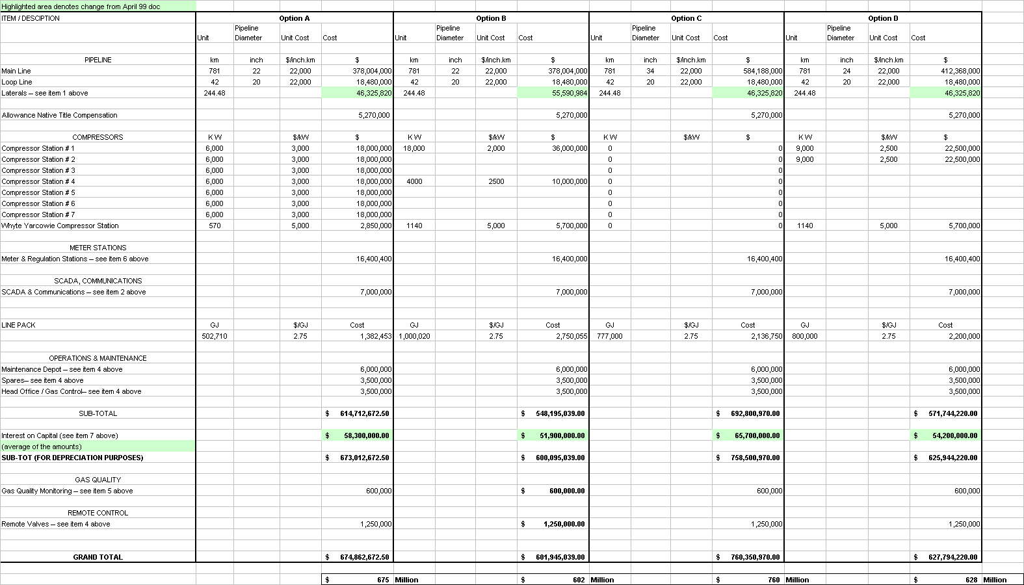

Attachment 3

WACC Paper

Rate of Return
The Regulator has recently handed down its ruling regarding the allowed rate of return for Transmission Pipelines Australia Pty Ltd ('TPA'). It seems appropriate that this decision serves as the starting point in the establishment of the required rate of return for the Pipeline System owned by the Service Provider.

With the Regulator having established the Victorian decision as the starting point (hence the low end of the range) the Service Provider believes that it is appropriate to stress that each asset has its own unique risk characteristics. In reaching a final determination for the Pipeline System some of the following characteristics of the system should be factored into the calculation:

- The South Australian market growth is static, with limited opportunities being available;
- The pipeline is dependent on two customers and is exposed to volatile electricity generation load;
- Pipeline sales to electricity generators must compete with imported and coal-fired electricity generation;
- Long term gas resources are uncertain;
- It is more likely that the system could be bypassed; and
- No annual revenue adjustment for material changes in operating costs is being requested.

The Service Provider believes that these differences are extremely significant and as such the required rate of return for equity investment to be undertaken in the Pipeline System versus TPA would be substantially greater. This in turn would result in a required WACC of greater than the 7.75% arising from the final TPA decision.

WACC Input Parameters
The Service Provider believes that strict adoption of the WACC inputs used by the Regulator in the Victorian decision would be the absolute low point for the Pipeline System. Simply adjusting some of the input parameters in line with the many plausible arguments presented during the debate process means that a far greater WACC can be arrived at. Outlined below are the considered acceptable ranges. It should be noted that the additional risks associated with the Pipeline System have not been factored into the ranges.

High End Values
Asset Beta – In the British Gas Transco price formula review before the Monopolies and Mergers commission in 1997, the asset beta for the transmission business was calculated as 0.70. Given the similar regulatory regime and competitive environments the Service Provider considers the 0.70 asset beta is the most appropriate comparison available. To derive an asset beta from other companies that have implicitly different characteristics has little justification. The Service Provider shares the view expressed by Bob Officer “estimating a beta for a company yet to list and for which there are no comparable companies which might be used as a benchmark, increases the chance of error”.

Equity Beta – The Monkhouse formula has been adopted by the Service Provider in the conversion. This is consistent with the recommendation by the Regulator in its final decision for the Victorian transmission arrangements.

β_{e} = β_{a} + (β_{a} - β_{d})(1 – r_{d}/(1 + r_{d})T)D/E

Where:
β_{e} = Equity Beta
β_{a} = Asset Beta
β_{d} = Debt Beta
r_{d} = Cost of Debt
T = Tax Rate
D/E = Likely debt to Equity Funding.
The figure used for the debt beta was 0.12 as originally proposed in the TPA application and accepted by the Regulator in its final decision.

Applying this formula to the recommended Asset beta of 0.70 an Equity beta of 1.55 is reached.

Risk Free Rate – the level recommended by the Regulator was 6%. This was reached by taking the average of Indexed Bonds for the preceding 8 weeks and then interpolating an estimated 5-year rate (considered as the appropriate term as it would then coincide with the next review). An inflation rate of 2.5% was then applied to gross this real rate up to a nominal figure. The Service Provider in both the low and high level ranges has accepted the 6% level as the average rate for the eight weeks to March 1 1999 for August 2005 Indexed Bonds was 3.39% (compared with the Regulator's figure of 3.42%).

Market Risk Premium – While the Regulator has decided that 6% is the level for the market risk premium, it has been generally accepted that periods have existed when the premium has been greater than this level. As such, a 7% premium has been used by the Service Provider in the high-end analysis.

Imputation Level - The Regulator primarily accepted the dividend drop off studies that were undertaken by Davis who came up with a range of 0.40 to 0.70. Taking other tax concessions into considerations the Regulator reached a range of 0.40 to 0.60. The Regulator took the midpoint of this range of 0.50. The Service Provider in the high-end range feels that a level of 0.25 is justifiable given the supporting comments from Bob Officer “the measurement of gamma is difficult and subject to considerable error and the end result of adopting a gamma equal to 0.25 is quite within the bounds of a reasonable estimate given the subjective nature of judgements about the appropriate shareholder class, their rate and dividend payout rate that will apply”.

Debt Margins - Margins are an empirical matter. They are dependent on issues such as the credit rating of the company and its chosen level of gearing. They may also depend on the aggressiveness of lenders. The Regulator settled on a margin of 1.20%. The Service Provider is of the view that a margin of 1.50% is also supportable. This level was presented by AMP and was a composite of margin, swap spread and upfront costs. Deutsche Bank commentary on this issue as part of the Texas Utilities submission derived a range of 1.20% to 1.55% albeit that their analysis was based on 10-year debt.

Calculation of WACC Ranges
Using the above inputs and a common inflation rate of 2.5% the following outputs are derived. The Pre Tax real range arrived at by first adjusting for tax and then for inflation is 8% to 10.95%. By applying the Macquarie Risk Advisory reverse transformation method, that is, to adjust for inflation first and gross up for tax second, provides a range of 6.63% to 9.58%

CAPM Parameter | Low Range | High Range
Nominal Cost of Equity r_{e}=r_{f}+β_{e} (rm-rf)% | 13.08% | 16.84%
Post-Tax Nominal WACC (r₀)%  r_{e}[(1-Te)/1-Te(1-ϒ))]. E/V+r_{d}(1-T).D/V | 6.85% | 8.78%
Post-Tax Real WACC (rr₀)%  (1+r₀)/(1+f)-1 | 4.24% | 6.13%
Pre-Tax Nominal WACC(pr₀)%  =r_{e}/(1-Te(1-ϒ)).E/V +r_{d}.D/V | 10.70% | 13.73%
Pre-Tax Real WACC (prr₀)%=(1+pr₀)/1+f)-1  (application transformation) | 8.00% | 10.95%
Pre-Tax Real WACC (prr₀)%=rr₀/(1-T)  (reverse transformation) | 6.63% | 9.58%

The Regulator settled on a level of 7.75%, which was between the values suggested by the two transformation methods (6.63% to 8%).

Recommended WACC for MAP
In reaching the recommended WACC range, the Service Provider has used the methodology adopted by the Regulator for the Victorian Access Arrangement. As a starting point (Low range) the input parameters that the Regulator used were utilized. As an alternative the Service Provider has presented what it believes to be justifiable parameters to arrive at a high end of an acceptable range. The final Pre Tax real numbers are then dependent on which method of transformation is used.

Transformation Method | Low Range | High Range
EPD Transformation | 8.00% | 10.95%
Macquarie Risk Advisory Transformation | 6.63% | 9.58%

Conclusion
In reaching these levels the substantial differences between the Pipeline System and the Victorian system as noted above have not been factored into the calculation. Given the additional risk characteristics of the Pipeline System, a significantly greater WACC will be required than granted in the Victorian decision. Taking these risk factors into consideration and the ranges arrived at above, the Service Provider recommends that the appropriate Pre Tax Real WACC be in the range of 9% to 10%.

Attachment 4

Main Natural Gas Transmission Pipelines in Australia 1996

(including those approved or under construction as at 30 June 1996)

Route | Year  Commissioned |  | Length | External  Diameter | Maximum  Continuous  Capacity
 |  |  | km | mm | PJ pa
New South Wales
Moomba (SA) to Wilton (NSW) | 1976 |  | 1300 | 864 | 152
Young to Wagga Wagga | 1981 |  | 130 | 324 | 32
Junee to Narrandera/Leeton/Griffith | 1993 |  | 177 | 160 | 5
Dalton to Canberra/Queanbeyan | 1981 |  | 58 | 273 | 22
Young to Lithgow & Oberon | 1987 |  | 270 | 168 | 5
Wilton to Sydney | 1976 |  | 51 | 864 | na
Sydney to Northcoast/Newcastle | 1982 |  | 214 | 508 | na
Sydney to Wollongong | 1979 |  | 33 | 508 | na
Victoria
Longford to Melbourne (Dandenong) | 1969 |  | 173 | 762 | na
Pakenham to Wollert | 1984 |  | 91 | 762 | na
Wollert to Wodonga | 1977 |  | 269 | 324 | na
Brooklyn to Corio (Geelong) | 1973 |  | 52 | 355 | na
Brooklyn to Ballarat/Bendigo | 1973 |  | 197 | 324/220/170 | na
Wandong to Bendigo | 1984 |  | 136 | 324 | na
Euroa to Sheparton/Kyabram/Echuca | 1975-1991 |  | 80 | 200/150 | na
North Paaratte to Portland/Hamilton | 1986-1995 |  | 193 | 150 | na
Queensland
Roma to Brisbane | 1969 |  | 440 | 237/400 | 28
Roma to Gladstone | 1989 |  | 530 | 324 | 27
Gladstone to Rockhampton | 1991 |  | 96 | 219 | 6
Ballera (Qld) to Moomba (SA) | 1994 |  | 180 | 406 | na
Gilmore to Blackall/Barcaldine | 1995 |  | 240 | 168 | 4
Ballera to Wallumbilla | 1996 |  | 756 | 406 | 110
Western Australia
Dongara to Perth/Pinjarra | 1971 |  | 415 | 355 | 38
Dampier to Perth/Kwinana | 1984 |  | 1398 | 660 | 161
Dampier to Cape Lambert | 1984 |  | 57 | 273 | 35
Mungarra to Geraldton | 1985 |  | 58 | 168 | 5
Kwinana to Wagerup/Bunbury | 1985 |  | 125 | 508/219 | 68/9
Gascoyne Junction to Carnarvon | 1988 |  | 171 | 168 | 4
Onslow (Tubridji) to Dampier/Perth main | 1991 |  | 87 | 150 | 40
Varanus Island to Dampier/Perth main | 1993 |  | 100 | 324 | 73
Griffin/Onslow to Dampier/Perth main | 1993 |  | 100 | 324 | 73
Karratha to Port Hedland | 1995 |  | 213 | 457 | na
Dampier/Perth main to Kalgoorlie | 1996 |  | 1380 | 450/350 | 35
South Australia
Moomba to Adelaide | 1969 | 781 |  | 559 | 95
Whyte Yarcowie to Port Pirie | 1976 | 78 |  | 168 | 79
Port Pirie to Whyalla | 1989 | 88 |  | 219 | 79
Wasleys to Angaston/Berri/Murray Bridge | 1969-1994 | 270 |  | 219/114 | 6/1.59
Wasleys to Adelaide (loop) | 1986 | 42 |  | 508 | 959
Katnook to Snuggery/Mt Gambier | 1991 | 67 |  | 168 | 49
Northern Territory
Palm Valley to Alice Springs | 1983 | 146 |  | 219 | 11
Palm Valley to Mataranka/Darwin | 1987 | 1577 |  | 356/324 | 20/15
Daly Water to McArthur River Mine | 1995 | 330 |  | 150 | NA

Attachment 5

Future Demand for Gas Haulage Services

The following provides a commentary on the influences on the demand for gas haulage services on the Pipeline System and the significant uncertainty as to the forecast level of demand both within the initial Access Arrangement Period and beyond.

Forecasts of deliveries for gas within the Adelaide and Iron Triangle regions, together with the actual deliveries for 1997 and 1998, are shown in Figure 1 below. The current forecast demand for gas is expected to continue to lie substantially below the ABARE (1997) forecast as shown at Figure 1 due to:

- A continuation of relatively lower electricity prices in Victoria and NSW and therefore the continuation of current maximum levels of electricity imports from Victoria.
- The staged construction of new more efficient gas fired generation plant between 2001 and 2005. The construction of a 500MW power station at Pelican Point in Adelaide is now almost certain. This plant is expected to have an efficiency of approx. 50% and will be dispatched ahead of the Torrens Island power station, which has an efficiency of about 30 to 33%. Subject to an unlikely major failure of plant in eastern Australia, the Pelican Point plant is expected to produce a net reduction in gas demand over the forecast period.
- The addition of new electricity generation plant, which is either not fired on gas or not supplied with gas via the Pipeline System. For example the construction of new generation plant alongside the Katnook gas plant in the South East of SA will reduce the dispatch opportunities for Torrens Island power station. It is noted that Boral Energy has recently announced a likely increase in their SouthEast plant capacity from 40MW to 80MW. In addition, the return to service of generation units at the coal fired Playford power station at Port Augusta can also have a depressing effect on demand for gas fired plant in Adelaide.
- Demand levels significantly lower than those forecasted could arise if new electricity interconnections were built within the next few years. Transgrid have indicated they are working to a year 2000 timetable for the completion of the SANI interconnector.
- The demand for gas by the top two or three industrial gas users is also not certain. There has been much speculation that the Port Stanvac oil refinery may be closed as part of a rationalization of Australian refinery capacity and the continuation of soft demand for cement and steel may see significant reductions in the demand from Adelaide Brighton Cement and BHP Whyalla respectively.
- On the upside there is the prospect of a magnesium plant being located in Port Augusta (2PJs) expected post 2002 and the potential substitution of LPG and distillate at Olympic Dam (2PJ). The latter will require a pipeline from Compressor Station 2 on the Pipeline System or directly from Moomba.
Current demand for pipeline capacity (as distinct from throughput) is being driven by requirements to meet peak electricity generation demands. Over the last few years peak electricity demand in SA has increased at the rate of 4% pa due to increasing air-conditioning loads. The recently completed Pipeline System Upgrade project created an additional 40 TJ/day capacity, which has all been contracted to Terra Gas Trader. However considerable risk of uncontracted capacity exists in the medium term when current contracts terminate at the end of 2005. This risk arises from a continuation of the downward demand effects indicated above and in particular:

- new electricity imports from the possible construction of the SANI and a reinforcement of the existing Heywood interconnector (see following);
- Conversion by existing users from firm Service to interruptible services utilizing alternative fuel capabilities;
- Reduced access to competitively priced gas ex Moomba (see following);
- Possibility of bypass/competition from new pipelines and the possibility of the conversion of other product pipelines to gas.

Potential New Electricity Imports Into SA
As indicated above, one of the major determinants of demand for gas haulage services will be the level of electricity imports from the eastern states (at the expense of local gas fired generation in SA). The existing interconnector with Victoria operates at maximum capacity and construction of new electricity transmission links with NSW or Victoria would increase imports. The current major prospects for new transmission links are the 250MW NSW to SA SANI interconnector and the 250MW enhancement to the existing Interconnector from Victoria. The NSW Government/Transgrid is currently seeking an alteration to the National Electricity Code that would permit SANI to be built as a regulated transmission asset. Last year NEMMCO rejected a submission on the basis of a “customer benefits test”. However the ACCC and NEMCO are examining a change to the Code criteria. Transgrid are moving ahead with environmental and route studies.

Availability of competitively priced gas supplies into SA
The availability of competitive/contractible gas supplies to meet aggregate demand in SA ex Moomba will depend on:
- Exploration success in the SA and Qld Cooper Basin. In recent times the success of the existing Cooper Basin JV has been only very modest despite a significant acceleration in exploration prior to the expiration of current PELs. The exploration success of new entrant producers taking part in the competitive tender of SA Cooper Basin acreage post the 1999 expiration of the PELs 5 and 6 is also uncertain.
- The availability of competitively priced gas from new remote supply sources, especially Timor Sea and PNG. Construction of new pipelines to transport Timor Sea or PNG gas to Moomba/Ballera will add considerably to the cost of delivering remote sources of gas to Moomba. Consideration will need to be given to building critical loads for pipelines from Palm Valley to Moomba/CS2/CS6 or from Ballera to Moomba.

- The share of the NSW market captured by the Cooper Basin producer JV beyond the AGL contract relative to market in SA. At this time it is noteworthy that the Gippsland Producers are targeting a maximum export to NSW of 70PJ. This quantity is likely to simply part fill the AGL/Cooper Basin contract shortfalls as they arise from 2001 to 2006 and may leave a shortfall in supply over demand.
- Facilitation of gas swaps to bring Gippsland Basin gas to Moomba needs the strong cooperation of a number of players in the SA/VIC/NSW gas chains and indications to date provide some pessimism.

Figure 1

Calendar Years

Attachment 6

Example Calculation of

Interest on Capital

A range of outcomes can be determined, depending upon the debt/equity split, debt and equity rates of return, etc. The example is based upon a 60:40 debt/equity split and 16.84% return on Equity

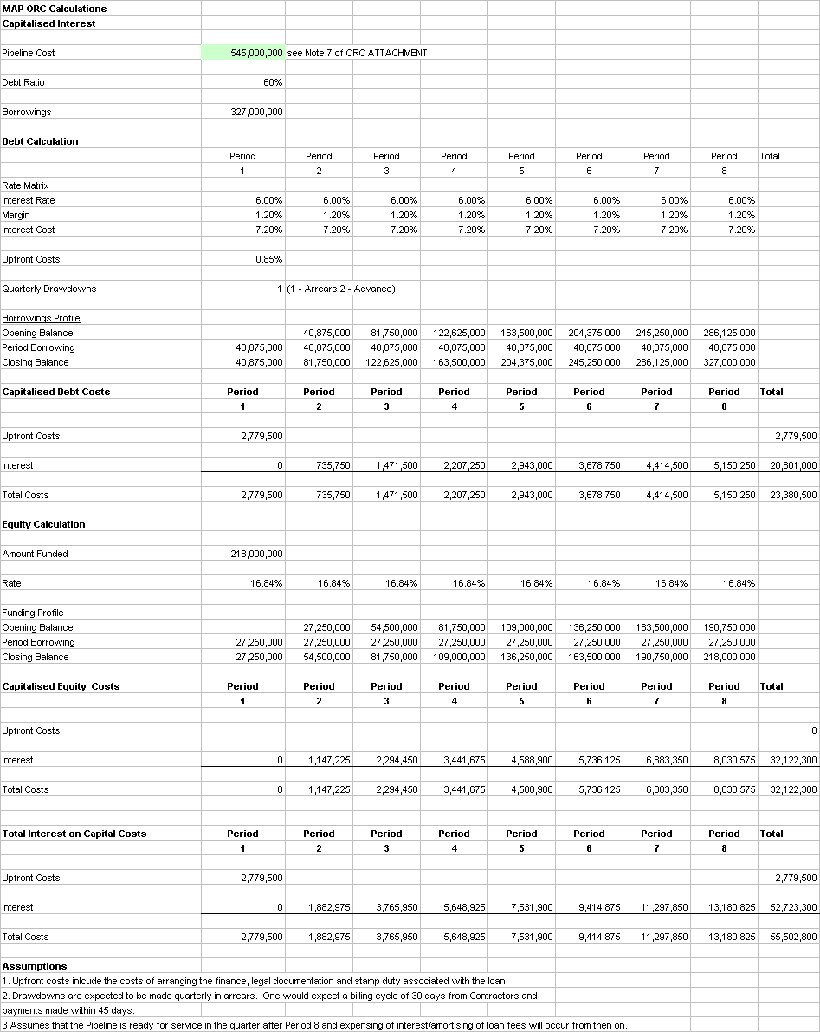

ORG Weighted Average Cost of Capital for Revenue Determination Gas Distribution Staff Paper Number 1, 28 May 1998 page 32.
A Note on the ACCC’s and Office of the regulator General’s Cost of Capital for the Gas Industry. R.R. Officer, 1 July 1998
AMP Asset Management Submission to the Office of the Regulator General regarding the Draft Determination of May 1998 on Victorian Gas Distribution Access Arrangements. 29 June 1998
Deutsche Bank, Utility Company Gearing and Cost of Debt, 15 June 1998.
Duplicated between Longford and Morwell and between Longwarry and Pakenham
Partially duplicated
Expected completion date
Initially capacity will be 45PJ pa
Partially duplicated. Maximum nominal annual throughput assuming current load factors.
9
9
9
9
9

