

Final decision

Amendment

Electricity distribution network service providers

Post-tax revenue model handbook

29 January 2015

© Commonwealth of Australia 2015

This work is copyright. In addition to any use permitted under the Copyright Act 1968, all material contained within this work is provided under a Creative Commons Attribution 3.0 Australia licence, with the exception of:

* the Commonwealth Coat of Arms
* the ACCC and AER logos
* any illustration, diagram, photograph or graphic over which the Australian Competition and Consumer Commission does not hold copyright, but which may be part of or contained within this publication.

The details of the relevant licence conditions are available on the Creative Commons website, as is the full legal code for the CC BY 3.0 AU licence.

Requests and inquiries concerning reproduction and rights should be addressed to the Director, Corporate Communications, ACCC, GPO Box 3131, Canberra ACT 2601, or [publishing.unit@accc.gov.au](mailto:publishing.unit@accc.gov.au).

1. Inquiries about this decision should be addressed to:

Australian Energy Regulator

GPO Box 520

Melbourne Vic 3001

Tel: (03) 9290 1444

Fax: (03) 9290 1457

Email: [AERInquiry@aer.gov.au](mailto:AERInquiry@aer.gov.au)

1. AER reference: 55444
2. Amendment record

|  |  |  |  |
| --- | --- | --- | --- |
| Handbook version | Model version | Date | Pages |
| 1 | 1, 2 | 26 June 2008 | 22 |
| 2 | 3 | 30 January 2015 | 40 |

Contents

Contents 3   
  
Shortened forms 5

1 Nature and authority 6

1.1 Introduction 6

1.2 Authority 6

1.3 Role of the model 6

1.4 Confidentiality 6

1.5 Process for revision 6

1.6 Version history and effective date 6

2 The model 7

2.1 Overview of the PTRM 7

2.2 DMS input sheet 8

2.3 PTRM input sheet 9

2.3.1 Opening regulatory asset base and opening tax asset base 12

2.3.2 Forecast real capital expenditure—as-incurred 14

2.3.3 Forecast real asset disposals—as-incurred 14

2.3.4 Forecast real customer contributions—as-incurred 14

2.3.5 Forecast net real capital expenditure—as-incurred 14

2.3.6 Forecast real operating and maintenance expenditure 14

2.3.7 Revenue adjustments 15

2.3.8 Tax 15

2.3.9 Cost of capital 15

2.3.10 Debt and equity raising costs—transaction costs 15

2.3.11 Price/revenue constraint for the current regulatory year 16

2.3.12 Energy delivered forecast 16

2.3.13 Current prices by tariff component 16

2.3.14 Forecast sales quantities by tariff component 16

2.4 WACC sheet 16

2.5 Assets sheet 17

2.5.1 Rolling forward the RAB and depreciation 18

2.6 Analysis sheet 19

2.6.1 Building block approach to deriving cash flows 22

2.6.2 Taxation and related costs and benefits 23

2.6.3 Cash flow analysis 23

2.7 Forecast revenues sheet 25

2.8 X factors sheet 27

2.9 Revenue summary sheet 31

2.10 Equity raising costs sheet 33

2.11 Chart 1—Revenue sheet 35

2.12 Chart 2—Price path sheet 36

2.13 Chart 3—Building blocks sheet 37

3 Process for annual return on debt update 39

3.1 Setting X factors for the final decision before the start of the regulatory control period 39

[3.2 Updating X factors to incorporate the annual update to the trailing average portfolio return ....   
 on debt..………………………………………………………………………………………………40](#_Toc410224099)

1. Shortened forms

|  |  |
| --- | --- |
| Shortened form | Extended form |
| ARR | annual revenue requirement |
| AER | Australian Energy Regulator |
| ATO | Australian Tax Office |
| capex | capital expenditure |
| CPI | consumer price index |
| DMS | data management system |
| DNSP | distribution network service provider |
| IRR | internal rate of return |
| NEL | National Electricity Law |
| NER | National Electricity Rules |
| NPV | net present value |
| opex | operating expenditure |
| PTRM | post-tax revenue model |
| PV | present value |
| RAB | regulatory asset base |
| RFM | roll forward model |
| TAB | tax asset base |
| WACC | weighted average cost of capital |
| WAPC | weighted average price cap |

# Nature and authority

## Introduction

1. This handbook sets out the Australian Energy Regulator’s (AER) post-tax revenue model (PTRM) to be used as part of the building block determinations for standard control services of electricity distribution network service providers (DNSPs). The PTRM is a series of Microsoft Excel spreadsheets developed in accordance with clause 6.4.1 of the National Electricity Rules (NER).

## Authority

1. Clause 6.4.1(a)(c) of the NER requires the AER to develop and publish the PTRM, in accordance with the distribution consultation procedures.

## Role of the model

1. DNSPs are required to submit a completed PTRM to the AER as part of their regulatory proposals. However, the AER recognises that there may be a need for some flexibility in applying the PTRM in order to account for the particular circumstances a DNSP may face. A number of elements of the PTRM where this may be the case have been identified in this handbook. A DNSP will need to propose and justify a departure from any element of the PTRM for the purposes of addressing its specific circumstances as part of its regulatory proposal, which will be considered and assessed by the AER on a case-by-case basis in making its distribution determination.
2. The PTRM is used by the AER to determine the DNSP’s annual revenue requirement (ARR) using the building block approach as specified in clause 6.4.3 of the NER. The PTRM’s purpose is to perform calculations of building block revenue requirements to derive X factors that form part of the control mechanisms for direct control services under clause 6.2.6 of the NER. The PTRM has not been developed with respect to alternative direct control services. Where a DNSP intends to propose multiple control mechanisms, it should consult with the AER on how the PTRM will apply.

## Confidentiality

1. The AER’s obligations regarding confidentiality and the disclosure of information provided to it by a DNSP are governed by the Competition and Consumer Act 2010 (Cth), the National Electricity Law (NEL) and the NER.

## Process for revision

1. The AER may amend or replace the PTRM from time to time in accordance with clause 6.4.1(b) of the NER and the distribution consultation procedures in clause 6.16 of the NER. The AER will publish a revised version of this handbook to accompany each new version of the PTRM it amends or replaces in the future.

## Version history and effective date

1. A version number and an effective date of issue will identify each version of this handbook.

# The model

## Overview of the PTRM

1. The PTRM is used to calculate the allowed revenue for a given regulatory control period. Specifically, the PTRM is a set of Microsoft Excel spreadsheets (combined into one file, often referred to as a singular spreadsheet) that perform iterative calculations to derive the ARR, expected revenue and X factors for each regulatory year of the regulatory control period from a given set of inputs.[1] The PTRM allows the user to enter these inputs and then displays the outputs. Figure 1 provides an overview of this process.

Figure 1 Overview of the PTRM spreadsheets

**CALCULATIONS**

**OUTPUTS**

**INPUTS**

User enters all data required by the PTRM on this sheet. This includes:

• Opening RAB values and lives

• Opening TAB values and lives

• Forecast capex

• Forecast customer contributions and asset disposals

• Forecast Opex

• Revenue adjustments

• Tax rates

• Return on equity

• Return on debt (varies year by year)

• Forecast inflation

• Capital raising costs

• Forecast demand

• Current revenue and price

• Tariff schedule

**PTRM input**

Calculates the weighted average cost of capital for each year of the period.

**WACC**

Calculates the values of the RAB and TAB across the period, and regulatory depreciation (return of capital) for each year.

**Assets**

Cash flow analysis for each year of the period, shows all building blocks and calculates tax payable.

**Analysis**

Tables showing building blocks, unsmoothed revenue, smoothed revenue, X factors, demand and indicative price paths.

**Revenue summary**

Graphs of key data including revenue and price path.

**Graphs**

Calculates benchmark equity raising costs, from building blocks and smoothed revenue.

**Equity raising costs**

Metadata that controls the automatic import of the PTRM into the AER system.

**DMS input**

Converts unsmoothed revenues to smoothed revenues, using the relevant form of control. User sets the profile of the X factors via an iterative smoothing process.

**X factors**

Under a weighted average price cap, calculates smoothed revenues from tariff schedule and X factors.

**Forecast revenues**

1. In Figure 1, each box represents a spreadsheet within the PTRM. Sheets are classified as primarily about inputs (left column), calculations (centre column) or outputs (right column). The flow of data is therefore from left to right, and simplified links between the sheets are shown with grey arrows.
2. To operate the PTRM, the user enters all the required data on the **PTRM input** sheet—for example, forecast capital expenditure (capex) across the regulatory control period, or the rate of return on equity. Determination of these inputs often requires considerable analysis, but this occurs outside the PTRM. In this sense, the input to the PTRM will be the output from all the other parts of the regulatory proposal (or final decision).
3. The PTRM then uses this data to undertake the building block derivation of total revenue, consistent with the requirements of the NER. Under this approach, total revenue is set to equal the total costs of the benchmark network service provider. Total costs are derived by adding up a number of different types of costs, labelled building blocks. The **Analysis** sheet sets out each of these building blocks, and calculates the tax building block (since the PTRM explicitly models the effect of corporate taxes). This gives total unsmoothed revenue (the ARR) for the service provider.
4. The **X factors** sheet is where smoothed revenue (expected revenue) is derived from unsmoothed revenue. This process will require user input, as they choose the relevant form of control (weighted average price cap, revenue cap or revenue yield cap) and numerically define the percentage change from year to year within the period (these values are labelled ‘X factors’).[2] This process is known as ‘smoothing’ and makes use of the inbuilt Excel programming language (macros).[3]
5. Finally, there are a number of presentation sheets which include summary output tables and graphs.
6. The PTRM is configured:

* to perform the interim calculations automatically whenever an input is recorded
* to perform revenue smoothing calculations and equity raising cost updates manually via buttons that will trigger built in macros.

1. The user should not alter the names of any sheets or defined name ranges within the PTRM. These PTRM components are used by macros and when automatically importing into the AER’s data management system (DMS). If these elements are changed, errors may occur.

## DMS input sheet

1. The **DMS input** sheet captures business specific, non-financial information that is required for the AER to import the PTRM into its DMS. To allow this automatic import to take place, this sheet has been locked (using the Excel ‘Protect sheet’ command) so that the layout of this sheet cannot be changed.
2. Contact details for those responsible for preparing and submitting the PTRM are recorded in rows 14:31. These will be stored in the DMS. These inputs also control the headings displayed at the top of other sheets in the PTRM.
3. Context details for the PTRM are recorded in the lower section. Many of these details (such as the dates of the regulatory control period) are automatically populated from the **PTRM input** sheet and so the cells here are hidden. The stage of the regulatory process is set in cell D46 using a drop down menu.[4] If this is not enough description to uniquely identify the PTRM submission, a description should be placed in cell C53 (for example, a resubmission of the Regulatory proposal PTRM with revised data values after an error was corrected).
4. The form of control (weighted average price cap, revenue cap, revenue yield cap) is also specified here in cell C56. This determines which smoothed revenue amounts are imported into the DMS from the **X factors** and **Revenue Summary** sheets. Note that the user will still have to select the relevant smoothing operation (using the macro buttons provided) on those sheets.
5. Figure 2 provides an example of the **DMS input** sheet.

Figure 2 DMS input sheet

1. 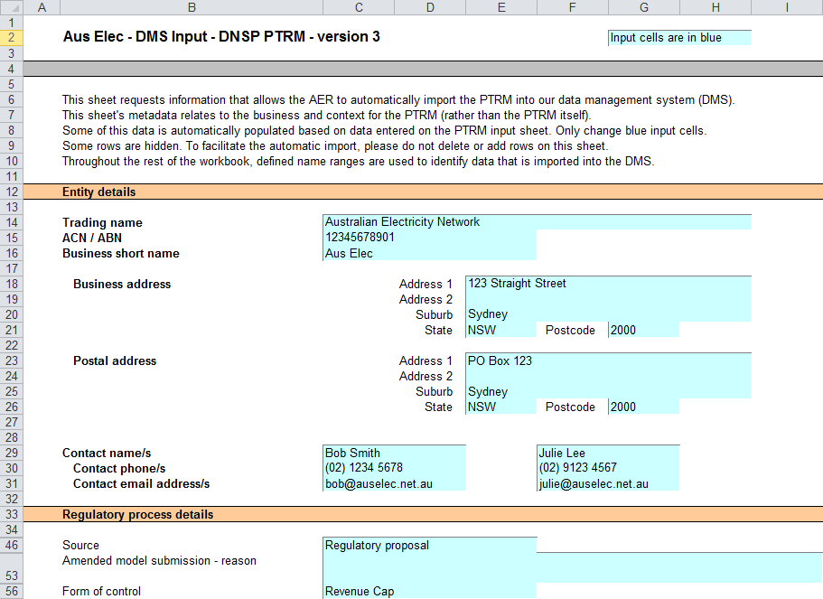

## PTRM input sheet

1. The **PTRM** input sheet provides for key input variables to be entered in the PTRM. These are automatically linked to corresponding cells in the relevant sheets. Values should be entered into each cell that has light blue shading. This sheet comprises of the following sections:

* opening regulatory asset base (RAB) and opening tax asset base (TAB)
* forecast real capex—as incurred
* forecast real asset disposals—as-incurred
* forecast real customer contributions—as incurred
* forecast real net capex—as incurred
* forecast operating expenditure (opex)
* revenue adjustments from previous regulatory control period
* revenue adjustments from other use of standard control services assets
* expected taxation rate
* cost of capital
* debt and equity raising costs—transaction costs
* price/revenue constraint for the current year
* energy delivered forecast
* current prices by tariff component
* current and forecast quantities by tariff component.

1. The only inputs specified outside of the **PTRM input** sheet are:

* inputs related to the automatic import into the DMS (on the **DMS input** sheet)
* inputs used when deriving smoothed revenue (on the **X factors** sheet)
* input of the form of control for equity raising costs purposes (on the **Equity raising costs** sheet).

1. These cells are also marked with light blue shading and are addressed when they arise.
2. Figure 3, Figure 4 and Figure 5 provide examples of the **PTRM** input sheet.

Figure 3 PTRM input sheet–first screenshot

1. 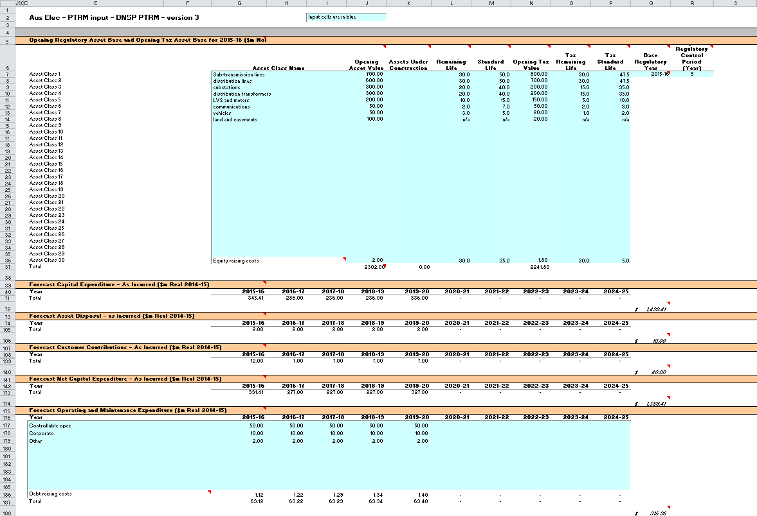

Figure 4 PTRM input sheet–second screenshot

1. 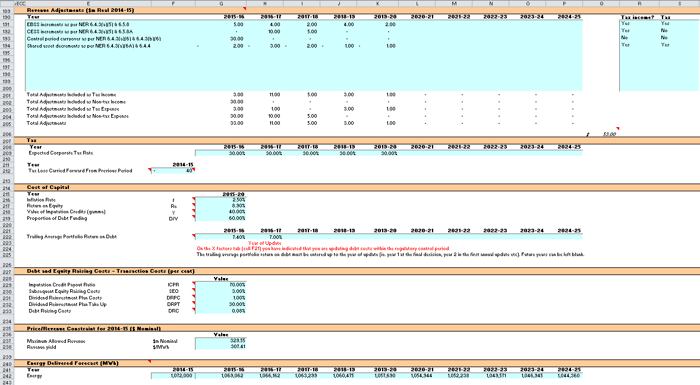

Figure 5 PTRM input sheet–third screenshot

1. 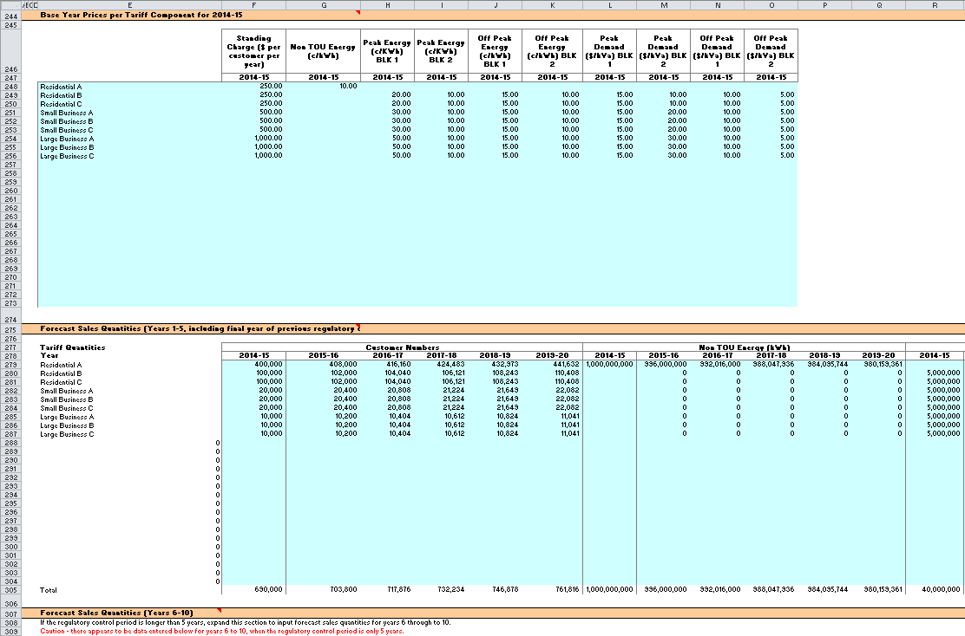
2. The PTRM can accommodate input data for up to a 10-year regulatory control period. Input cells outside of the relevant regulatory control period should be left blank.
3. The PTRM is configured to use the straight-line method as the default position for calculating depreciation for regulatory and tax purposes. If DNSPs intend to propose using other depreciation profiles, it is recommended that they raise this as part of pre-lodgement discussions.[5] For example, this could take place during the framework and approach process for a determination.[6]

### Opening regulatory asset base and opening tax asset base

1. The opening RAB is the value of assets on which a return will be earned. The opening TAB is used to calculate depreciation for tax purposes. The **PTRM** input sheet requires a value for the opening RAB (broken into asset classes in rows 7 to 36) and opening TAB at the start of the first regulatory year of the next regulatory control period. The RAB and TAB will differ each regulatory year to reflect forecast capex, asset disposals, customer contributions and regulatory depreciation (for the RAB) or tax depreciation (for the TAB).
2. The recorded input values are linked to the Assets sheet, which also calculates depreciation for the next regulatory control period. Notes have also been included for various cells with specific comments and explanations about the relevance of the inputs.
3. Asset class name
4. The asset classes/names are recorded in column G. It is important that the asset classes recorded in the RAB section match the asset classes for which capex, disposals and capital contributions are reported in other input sections. This allows the PTRM to model depreciation consistently across the asset classes.
5. The PTRM is configured to accommodate up to 30 asset classes.[7] The number of asset classes used in the PTRM will vary between businesses.[8] However, for each business the asset classes used in the PTRM must be consistent with that used in the AER’s roll forward model (RFM). This allows the closing RAB values determined in the RFM to be used as inputs to the opening RAB values in the PTRM. RAB values by asset class derived from the RFM may be aggregated or disaggregated when forming inputs for the PTRM where this demonstrably improves the accuracy or administrative convenience of asset calculations.
6. Opening asset value
7. The opening asset values for each asset class are recorded in column J and are manually sourced from the closing asset value for each asset class as determined in the RFM.
8. Assets under construction
9. The value of assets under construction for each asset class, where relevant, is recorded in column K.[9] The total value of assets under construction as at the start of the first regulatory year of the next regulatory control period (cell K37) is rolled into the opening RAB value (cell J37).
10. Average remaining life
11. The average remaining life of the asset classes is recorded in column L, based on the economic life of the assets.[10]
12. Standard life
13. The standard life of the asset classes is recorded in column M and measures how long the infrastructure would physically last had it just been built.
14. Opening tax value
15. The opening tax values for each asset class are sourced from the closing tax asset values which have been determined in the RFM and are recorded in column N. Assets valued for tax purposes should include the value of contributed assets.
16. Average tax remaining life
17. The average tax remaining lives of each asset class for taxation purposes are recorded in column O based on the tax lives specified by the Australian Tax Office (ATO) for the category of assets and commissioning dates.
18. Tax standard life
19. The tax standard lives of each asset class are recorded in column P.
20. Base regulatory year
21. The regulatory year for the start of the next regulatory control period is recorded in cell Q7.
22. Length of regulatory control year

The number of years in the next regulatory control period is recorded in cell R7.

### Forecast real capital expenditure—as-incurred

1. Forecast capex values for the next regulatory control period are recorded for each regulatory year in rows 41 to 70[11] (by asset class).[12] Capex is rolled into the RAB when spending is incurred. These inputs must be reported in real terms based on start of year one dollar terms.

### Forecast real asset disposals—as-incurred

1. Forecast asset disposal (as-incurred) values are recorded for the regulatory year in which the disposal is expected to take place, in rows 75 to 104 (by asset class). These inputs must be reported in real terms based on start of year one dollar terms.

### Forecast real customer contributions—as-incurred

1. Forecast customer contributions (as-incurred) values are recorded for the regulatory year in which the contribution is expected to be made, in rows 109 to 138 (by asset class). These inputs must be reported in real terms based on start of year one dollar terms.

### Forecast net real capital expenditure—as-incurred

1. This section on forecast net capex does not require inputs to be recorded. For each asset class, forecast net capex is calculated based on the recorded forecast capex less forecast asset disposals and forecast customer contributions. Forecast net capex (as-incurred) values are displayed in rows 143 to 172 and form part of the roll forward of projecting the RAB in the Assets sheet. These inputs are assumed to be in real terms based on start of year one dollar terms.

### Forecast real operating and maintenance expenditure

1. Opex typically includes items such as wages and salaries, leasing costs, costs associated with maintaining assets, input costs and other service contract expenses paid to third parties. The forecast opex values for each year are recorded in rows 177 to 185, including any carryover amounts determined according to the efficiency benefit sharing scheme developed by the AER. Row 186 displays benchmark debt raising costs and does not require inputs to be recorded because the calculation is formula-driven, and is based on the practice of treating the allowance as an opex line item. Additional opex inputs can be recorded by adding rows to this section—click on the button labelled 'Insert new opex row'.
2. These inputs must be reported in real terms based on start of year one dollar terms.
3. The forecast total opex values (row 187) are linked to the Analysis sheet to calculate the ARR.

### Revenue adjustments

Any additional revenue adjustments applying to this regulatory control period are recorded in rows 191 to 200.[13] These are linked to the total building block revenue calculations in the **Analysis** sheet. Each line item in this section can be set to be treated as a tax income and/or a tax expense. These settings are determined by the drop down options in cells R191:S200. Totals for each combination of tax income and tax expense settings are in rows 201:205.

### Tax

1. The expected corporate tax rates are recorded for each year in row 209. The tax rates are linked to the **WACC** sheet to calculate the average tax rate and to the **Analysis** sheet to estimate the tax payable, as part of calculating the ARR.
2. Any tax losses carried forward from the previous period are included in cell F212.

### Cost of capital

1. The cost of capital section (rows 216 to 219 and row 222) records the following parameters:

* inflation rate[14]
* return on equity
* gamma—value of imputation (franking) credits
* proportion of debt funding
* trailing average portfolio return on debt for each year of the regulatory control period.

1. Each of these parameters is linked to the **WACC** sheet to calculate the weighted average cost of capital (WACC). The approach or method for determining each parameter is specified in clause 6.5.2 of the NER or the AER *Rate of return guideline*.[15] Rows 223 to 224 contain content driven help which will display cautions or guidance based on input to this sheet and the **X factors** sheet.

### Debt and equity raising costs—transaction costs

1. The debt and equity raising costs section (rows 229 to 233) records the following parameters:

* imputation credit payout ratio
* subsequent equity raising costs
* dividend reinvestment plan costs
* dividend reinvestment plan take up
* debt raising costs.

1. The values for the imputation credit payout ratio, equity raising and dividend reinvestment costs, and the dividend reinvestment take up are linked to the **Equity raising cost** sheet to calculate the allowance for benchmark equity raising costs associated with capex. The debt raising costs value represents the unit allowance and is linked to row 186 of the **PTRM input** sheet to calculate the overall benchmark debt raising costs to be included in the opex allowance.

### Price/revenue constraint for the current regulatory year

1. Cells G237 and G238 record current values of total revenue and revenue yield for DNSPs subject to these forms of control and may not be required depending on the form of control mechanism determined by the AER. These values are linked to the X factors sheet and are used for projecting smoothed expected revenues based on the ARR.

### Energy delivered forecast

1. Row 242 records total forecast energy delivered. Energy delivered forecasts may be obtained from the most recent Australian Energy Market Operator’s National electricity forecasting report, a DNSP’s annual planning report or other relevant industry sources. These data are used in calculating the price constraint under a revenue yield form of control in the X factors sheet. They are also used in the Revenue summary sheet to calculate the average price impact.

### Current prices by tariff component

1. Prices by tariff component for the final regulatory year of the current regulatory control period are recorded in rows 248 to 273. These data are used in the PTRM’s calculation of a weighted average price cap (WAPC) and may not be required depending on the form of control mechanism determined by the AER. Where used, this section of the model and its dependent calculations in the Forecast revenues sheet may need to be amended to incorporate the components and tariff structures of each DNSP.

### Forecast sales quantities by tariff component

1. Forecast quantities relative to each tariff component for the next regulatory control period are recorded in rows 279 to 304 (years 1 to 5) and rows 301 to 326 (years 6 to 10). These data are used in the PTRM’s calculation for the WAPC and may not be required depending on the form of control mechanism determined by the AER. As for pricing data discussed above, this section of the model and its dependent calculations may need to be amended to suit each DNSP. Where quantities are not available or appropriate for the entire regulatory year (e.g. customer numbers) they will need to be approximated using a method agreed to by the AER.

## WACC sheet

1. The WACC sheet determines for each regulatory year of the next regulatory control period the required return on equity, return on debt and the WACC using the relevant cost of capital parameters from the **PTRM** input sheet. Some of these will be constant across the regulatory control period, but the return on debt (and therefore the overall WACC) may now vary year-by year.
2. The effective tax rates derived from the cash-flow analysis are also reported in the WACC sheet, including various measures of the WACC calculated from the forecast cash-flows in the Analysis sheet.[16] The nominal pre-tax return on debt (row 14) and the nominal post-tax return on equity (row 10) are multiplied by the debt and equity components of the RAB to determine the return on capital building block.[17]
3. In addition, there is a button labelled 'Set Te and Td' which is linked to a macro that should be pressed after all inputs have been finalised for establishing the ARR at the start of the next regulatory control period. This will copy the cash-flow derived effective tax rates for equity and debt from the **Analysis** sheet to the appropriate location in the **WACC** sheet (cells G28 and G29). The cash-flow derived rates shown in column R are designed as checks to ensure certain parameters are internally consistent with those derived by formula at the time of the final decision. Because the cash-flow derived rates are based on the use of a constant WACC, there is no need to press the 'Set Te and Td' button again as part of the annual return on debt update process during the regulatory control period. This process is discussed further in chapter 3.
4. Figure 6 provides an example of the WACC sheet.

Figure 6 WACC sheet

1. 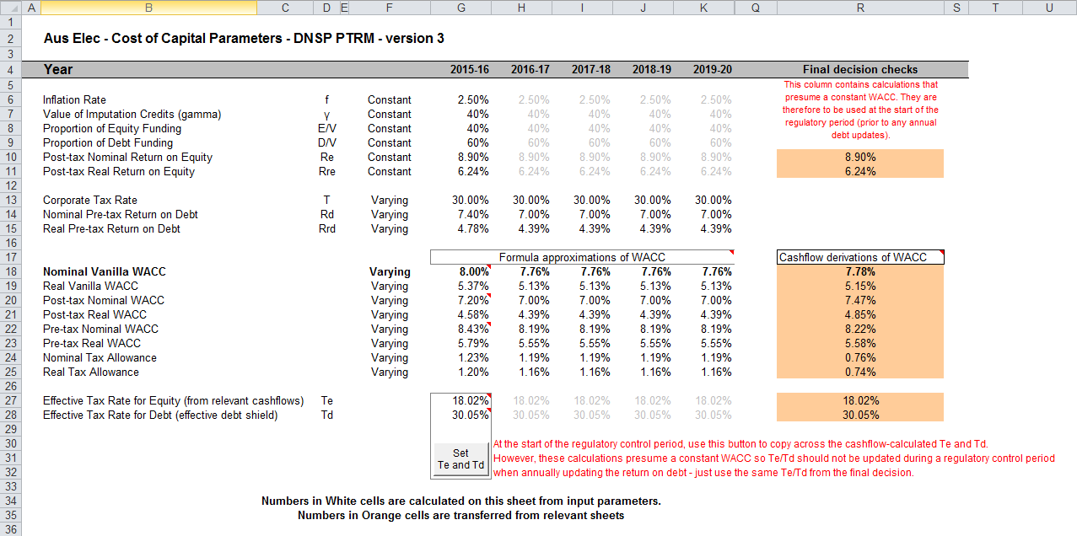

## Assets sheet

1. The Assets sheet calculates the value of the RAB for each regulatory year over the next regulatory control period in real (start of year one) and nominal dollar terms. It also calculates both regulatory and tax depreciation. The Assets sheet displays 55 years of data to allow estimation of the effective tax rate.
2. Figure 7 provides an example of the Assets sheet.

Figure 7 Assets sheet

1. 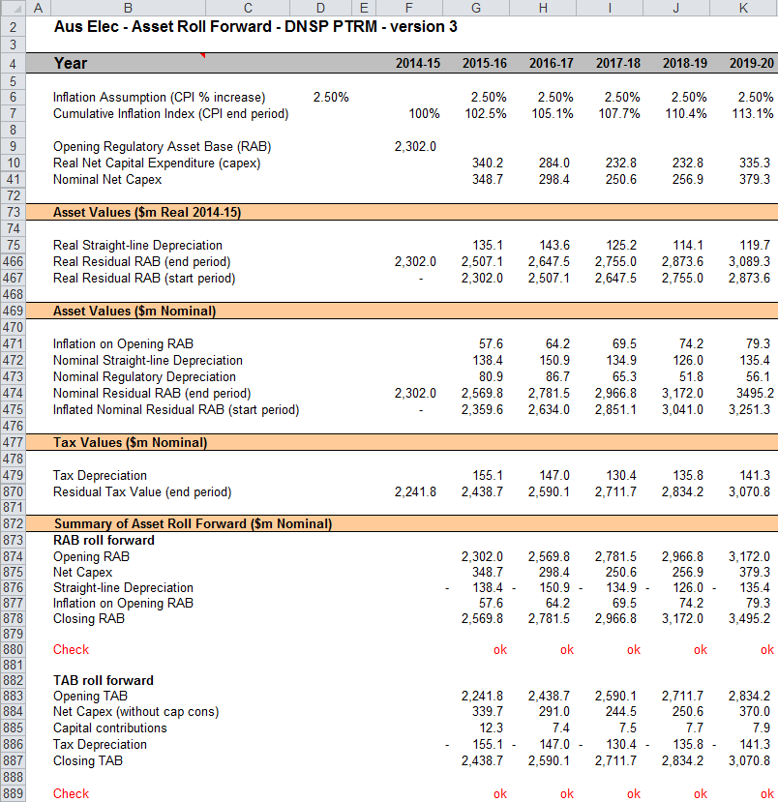

### Rolling forward the RAB and depreciation

1. For consistency, depreciation in a period must equal the difference between the asset value at the start and end of the period. Further, as depreciation is intended to represent the return of capital over the life of the asset, accumulated depreciation should not exceed the initial actual capital cost of the infrastructure.
2. The opening RAB (cell F9) and real forecast net capex values (rows 10 to 40) displayed in this sheet are sourced from the **PTRM** input sheet. Nominal forecast net capex values are displayed in rows 41 to 71. The modelling of capex in the PTRM is based on a full as-incurred approach. Under this approach the return on capital and the return of capital are calculated based on as-incurred forecast net capex.
3. Capex is assumed to be incurred evenly throughout the regulatory year and therefore a timing assumption is adopted that on average places capex half-way through the year. However, the PTRM calculates the return on capital based on the opening RAB for each regulatory year and capex is not added to the RAB until the end of the regulatory year in which the expenditure on the asset is incurred. To address this timing difference of modelling the real capex, a half-real vanilla WACC is provided (capitalised and recovered over the life of the assets) to compensate for the six-month period before capex is included in the RAB.[18] This is calculated using the specific half-real vanilla WACC applying to the year in which the expenditure is incurred.
4. Real asset values are displayed in rows 75 to 467. Real straight-line depreciation is calculated in rows 75 to 465. It uses the opening RAB, forecast capex values and asset lives from the **PTRM** input sheet. The individual depreciation profiles for each asset class can be viewed by expanding rows 76 to 465. The roll forward of the closing RAB in real dollar terms (start of year one) for each regulatory year is calculated in row 466.
5. Nominal asset values are displayed in rows 471 and 475. To compensate the DNSP for inflation, the residual value of the RAB at the end of each regulatory year is adjusted upwards for the amount of expected inflation in that regulatory year. This adjustment is calculated in row 471. The change in the nominal value of the RAB from regulatory year to year is calculated by adjusting the closing RAB (row 474) for forecast net capex and the regulatory depreciation allowance. Regulatory depreciation (row 473) is calculated as the nominal straight-line depreciation (row 472), less the inflation adjustment on the opening RAB (row 471).
6. Depreciation for tax purposes and the tax asset value over time is calculated in rows 479 to 870 and is based on the tax asset values, capex values and tax asset lives from the **PTRM** input sheet. Capex recognised for tax purposes is net of disposals but includes the value of customer contributions. The individual tax depreciation profiles for each asset class can be viewed by expanding rows 480 to 869. Tax depreciation is calculated separately because asset values and asset lives for tax purposes generally differ from those for regulatory purposes.
7. A summary of the roll forward of the RAB is set out in rows 874 to 878. A summary of the roll forward of the TAB is set out in rows 883 to 887.

## Analysis sheet

1. The Analysis sheet itemises the basic costs, or building blocks, of the DNSP, which are then added together to calculate the ARR. In other words, the Analysis sheet is where the data from the **PTRM** input sheet is combined with the calculations in the Assets and WACC sheets to estimate a DNSP’s revenue requirement. The Analysis sheet displays 55 years of data so that the effective tax rate can be estimated.
2. The Analysis sheet also includes an analysis of the forecast cash flows. This analysis provides rate of return measures estimated from forecast revenues and costs, including: expected pre and post-tax returns on equity, effective tax rates, the effective cost of debt and selected measures of the WACC.
3. Figure 8, Figure 9 and Figure 10 provide examples of the Analysis sheet.

Figure 8 Analysis sheet–first screenshot

1. 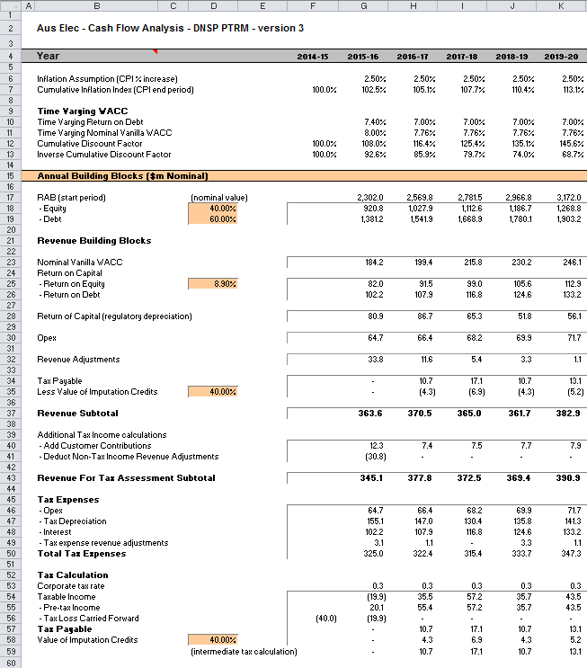

Figure 9 Analysis sheet–second screenshot

1. 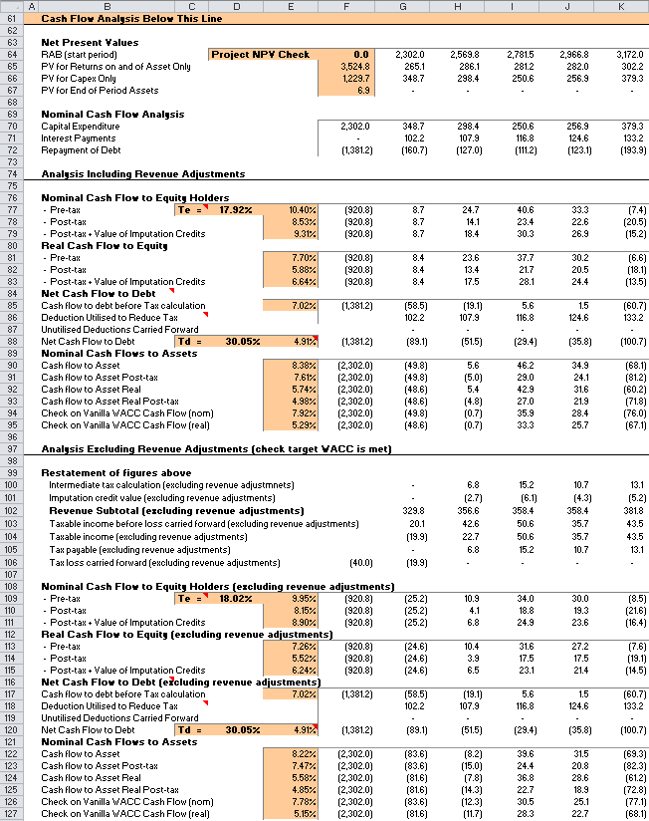

Figure 10 Analysis sheet — Third screenshot

1. 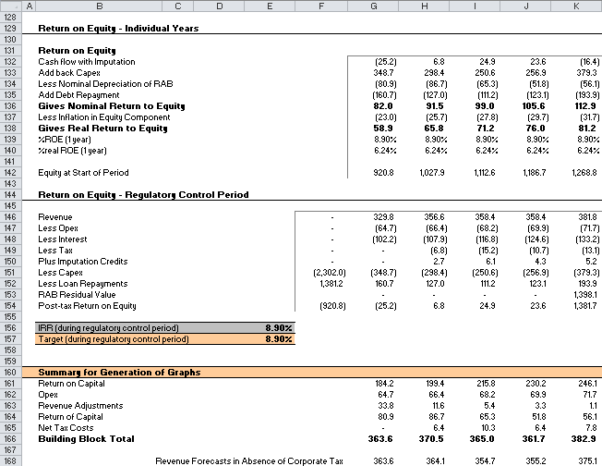

### Building block approach to deriving cash flows

1. Clause 6.4.3 requires the AER to apply the building block approach to assess the revenues required by a DNSP to recover the full cost of providing the regulated distribution (standard control) service. The revenue requirement includes a commercial return on its investment.
2. The key building blocks are:

* the return on capital (row 23) comprising:
* the post-tax return on equity (row 25)
* the return on debt (or the interest payments incurred) required to service borrowings (row 26)
* the regulatory depreciation or return of capital (row 28 )
* opex including carry-over amounts (row 30)
* revenue adjustments (row 32)
* net tax liabilities payable—the figure is net in the sense that it is the annual tax payable by the DNSP (row 34) less the value of imputation credits available to investing shareholders (row 35).

1. The costs are determined for each regulatory year of the next regulatory control period to derive the building block subtotal (row 37). There is an additional adjustment to reflect the taxation implications of additional revenues from customer contributions (row 40) and revenue adjustments for non-tax income revenue adjustments (row 41). Because the costs can fluctuate from year to year, the ARR (which includes the additional revenue adjustments) is smoothed over the next regulatory control period to give the expected revenue (see section 2.7).
2. As a result of the PTRM’s particular timing assumptions, i.e. all cash flows with the exception of capex are assumed to occur at the end of each regulatory year, there is no need to provide DNSPs an allowance for working capital in the modelling.[19]

### Taxation and related costs and benefits

1. Tax is payable on revenue less tax costs recognised by the ATO. Tax-deductible costs include interest or debt servicing, depreciation allowances, opex and tax expense revenue adjustments (rows 46 to 49).
2. Spreadsheet calculations
3. Tax payable by the DNSP for each regulatory year is calculated in rows 35 to 54, in three steps:
   1. Pre-tax income (row 55) is calculated as the revenue subtotal plus the customer contributions (row 40) less non-tax income revenue adjustments (row 41) less total tax expenses (row 50).
   2. Tax loss carried forward is calculated (row 56).
   3. Taxable income (row 54) is then the sum of the above.
4. The tax expenses (rows 46 to 49) used in calculating the pre-tax income for the regulatory year are the same as those in the building blocks (rows 26 to 32) with the exception of depreciation and revenue adjustments. In the case of the revenue building blocks, regulatory depreciation (row 28) is calculated based on the economic life of the asset (see rows 75 to 465 and 471 to 473 of the Assets sheet). Tax depreciation is generally based on a much shorter tax life or calculated in a different way (see rows 479 to 869 of the Assets sheet). For revenue adjustments, the tax implications of each individual adjustment are set on the **PTRM input** sheet. Those revenue adjustments which are treated as taxable income will add to pre-tax income (the net effect of rows 32 and 41). Similarly, those revenue adjustments which are treated as a tax expense will reduce pre-tax income (row 49). Where there are revenue adjustments that are taxable income but not a tax expense, the two effects will not be equal.
5. The tax payable is recognised as a building block cost and added to the revenue building blocks (row 34). Offsetting this tax cost is the benefit shareholders receive from imputation credits (gamma). This offsetting benefit is equal to gamma multiplied by the tax payable and is recorded in rows 35 and 58.

### Cash flow analysis

1. Calculations in the cash flow analysis section provide a comprehensive check on the validity of revenue determinations to ensure that the outcomes are consistent with the assumptions forming the basis of the building block approach. The Analysis sheet is designed to check the desired rate of return on equity that can be expected from the regulated revenue stream.
2. Net present values
3. The total returns on and of capital (comprising the RAB and capex) is calculated in row 65. The present value (PV) for these cash flows at the start of the first regulatory year of the next regulatory control period is calculated in cell F65. The PV for capex is calculated in cell F66 and the PV of the end of period assets is calculated in cell F67. The sum of the PV of the returns on and of the RAB and capex, less the residual value of assets is calculated in cell F64. This project net present value (NPV) for the RAB check cell should be equal to zero, which indicates that the asset is receiving the correct returns.
4. Rows 74 to 177 set out cash flow analysis including (rows 77 to 95) and excluding (rows 99 to 127) revenue adjustments. Cash flow analysis excluding revenue adjustments allows the user to ensure that the target rate of return is being met. Cash flow analysis including revenue adjustments can be used to identify the incremental effects of revenue adjustments, which will cause the return on equity outcome to differ from the base return on equity. To enable the analysis excluding revenue adjustments, several cash flows terms must be restated, including the tax payable calculation. This takes place in rows 99 to 106. Aside from the different base data (including or excluding revenue adjustments), the mechanics of the calculations in each section are identical, and so they are discussed together.
5. Net cash flows available to equity holders
6. Net nominal pre-tax cash flows to equity holders (row 77 and row 109) are represented by nominal revenues less:

* opex
* capex
* interest payments
* any repayment of debt in the period.

1. Net nominal post-tax cash flow to equity holders (row 78 and 110) is obtained by further deducting the tax expense of the business. Rows 79 and 111 add back the value of imputation credits to calculate the net post-tax benefits available to equity holders in a period.
2. The internal rate of return (IRR) of the net cash flows over the life of the assets is calculated in column E. The key IRR is the net post-tax returns to equity holders inclusive of imputation credits (re). The determined re should be validated by the estimated cash flows (rows 79 and 111).
3. The corresponding real cash flows and the respective IRRs are calculated in rows 81 to 83 and 113 to 115.
4. The difference in the IRR applying to pre-tax and post-tax cash flows to equity allows the effective rate of tax (Te = 1 – rpost/rpre) to be calculated (cells D77 and 109). This can then be used as an input to the formula-based WACC calculations.
5. It is important to note that the formula-based WACC calculations will only provide an approximation of the actual WACC outcomes implied by the cash flow calculations. In practice, Te is generally below the corporate tax rate for assets that can be depreciated at a faster rate for tax purposes.
6. Net cash flows necessary to service debt and the effective debt shield
7. The cost of debt is reduced by the value of the ‘debt shield’ (rows 86 and 118) in calculating tax liabilities. Where the interest expense in a regulatory year reduces taxable income by a corresponding amount, the net cost of debt for investors is reduced by the corporate tax rate.
8. However, where the taxable income is so low that the full interest deduction is not required to reduce tax liabilities to zero, the value of the debt shield benefit is deferred to the following regulatory year. This effect is analysed in rows 86 to 88 and rows 118 to 120. That part of interest expense used to defer tax is calculated in each regulatory year (rows 86 and 118) and the unused part carried forward is embodied in the tax loss carried forward calculation (rows 87 and 119). This allows the net cost to the firm of paying debt holders, after taking account of the tax concession, to be calculated.
9. The IRR calculation (cells E88 and E120) represents the effective cost of debt, which is generally well below the nominal cost of debt based on the current interest rates.
10. Nominal cash flows to assets and calculation of WACC estimates
11. The cash flows to the different sources of capital (debt and equity) have been presented above, but the cash flows to the assets as a whole are of interest since these aggregate numbers characterise the nature of the regulated business.
12. The IRRs from these cash flows are the WACC estimates expected from the application of the regulatory framework and have greater validity than any formula based approximations. The cash flow calculations from the section excluding revenue adjustments are then reported on the WACC sheet. These are the relevant IRRs for comparison against the formula-based approximations derived from the return on equity and return on debt inputs. It should be noted that the WACC outcomes are calculated for reporting purposes only. They are not required for setting revenues since the modelling already provides the requisite revenue forecasts.
13. Return on equity analysis
14. The next two sections demonstrate that the desired return on equity is being achieved in each year of the regulatory control period, and across the regulatory control period as a whole. In accordance with this aim, they use the cash flows after removal of revenue adjustments. In essence they expand on the calculations presented in row 111.
15. The first section (rows 131 to 140) demonstrates the return to equity holders on an annual basis. The second section (rows 146 to 157) demonstrates the return to equity holders across the entire regulatory control period.
16. Summary for generation of graphs
17. Rows 161 to 166 provide a summary table presenting total revenue components in accordance with the categories listed in the NER. These values are referred to in the **Chart 3–Building blocks** sheet.

## Forecast revenues sheet

1. The Forecast revenues sheet is relevant to the calculation of X factors under the WAPC control mechanism. Prices are sourced from the **PTRM** input sheet and escalated by forecast changes of the inflation rate and X factors from the X factors sheet to derive notional prices for each year of the regulatory control period. These prices are multiplied by the forecast quantity data from the **PTRM** input sheet to derive a notional forecast smoothed revenue amount in row 7, which is intended to equal (in NPV terms) the building block requirement in the X factors sheet.
2. The calculations in this sheet are automated and do not require inputs. The display of forecast, quantities and revenues has been split into two sections—years 1 to 5, and years 6 to 10. The grouping controls can be used to hide all columns relating to years 6 to 10 (for instance, if the regulatory control period is only 5 years long). This sheet is, however, based on a generic tariff structure and will require amendment by each DNSP to suit its own tariff schedules. DNSPs using the PTRM for forms of control other than a WAPC will not be required to use the Forecast revenues sheet. Pricing data in this sheet has no relationship with the information to be provided by DNSPs to the AER under clause 6.8.2(c)(4) or Part I of the NER.
3. Figure 11 and Figure 12 provide an example of the Forecast revenues sheet.

Figure 11 Forecast revenues sheet–first screenshot

1. 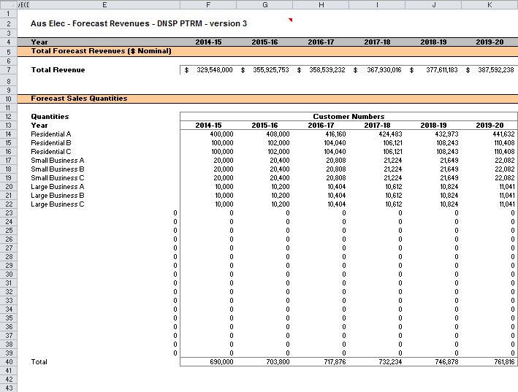

Figure 12 Forecast revenues sheet–second screenshot

1. 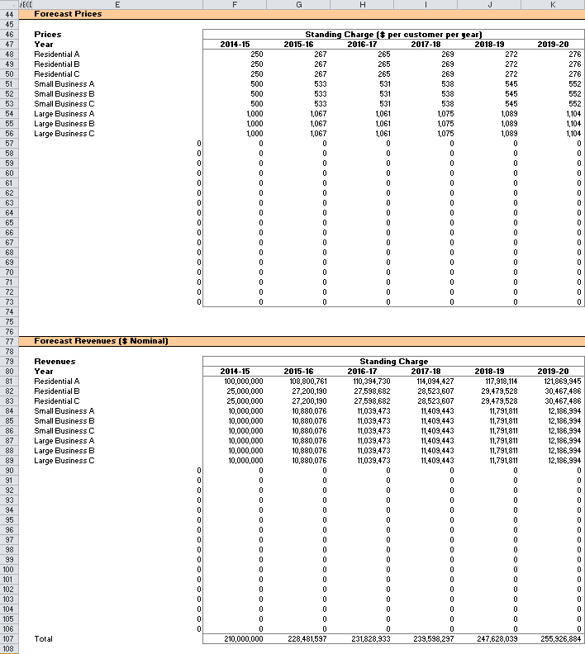

## X factors sheet

1. The X factors sheet reflects the requirements of clause 6.2.6 and 6.5.9 regarding the setting of X factors, namely, that they are to comprise part of the CPI–X constraint on direct control services, and that they must be set such that the following conditions are met:

* the ARR and forecast expected revenues are to be equal in NPV terms
* the value of expected revenue and the ARR in the final regulatory year of the period must be as close as reasonably possible.[20]

1. DNSPs must propose X factors in submitting a completed PTRM with its building block proposal in accordance with clause S6.1.3(6) of the NER. The AER will assess this in accordance with the provisions listed above, but may also consider other relevant factors such as price stability, cash-flow adequacy and longer term pricing goals.
2. The PTRM provides for X factor calculations (usually called 'smoothing') under three basic forms of control, namely a WAPC, revenue cap and revenue yield cap. Through these calculations the X factor is simply a price or revenue adjustment mechanism. It does not relate to actual productivity improvements in the operations of a DNSP. However, this does not mean that the AER ignores productivity improvements when assessing a DNSP’s building block proposal. Instead, the AER includes any expectation of productivity gains directly into the forecasts of costs.
3. When smoothing across the regulatory control period, it is necessary to iteratively update equity raising costs as well. This is because the estimate of equity raising costs is dependent on the smoothed revenue (expected revenue) profile, but in turn the expected revenue is dependent on the estimate of equity raising costs. Hence, there are a number of macros built into the PTRM which jointly smooth revenues while iteratively updating equity raising costs. It is possible to stop the automatic updating of equity raising costs using the drop down menu in cell H16.
4. Across each of the three forms of control (WAPC, revenue cap or revenue yield cap) there are two basic types of smoothing operation:

* Select the 'Apply default smoothing' button that changes all X factors. This default path first entails setting the expected revenue (calculated using the relevant form of control) for the first year equal to the ARR for that year (this will show as a change to the X factor in year 1, sometimes referred to as P0). Next, the macro calculates the single (constant) X factor which can be applied to all remaining years of the next regulatory control period so that the NPVs of smoothed revenue (expected revenue) and unsmoothed revenue (ARR) across the entire period are equal. Equity raising costs will be updated as well.
* Alternatively, it might be necessary (including during the annual debt update) to adjust the X factor for a specific year only. This type of smoothing changes just one X factor so that the NPVs of smoothed revenue (expected revenue) and unsmoothed revenue (ARR) across the regulatory control period are equal.

1. In both cases, equity raising costs will be iteratively updated while smoothing (unless this default option is turned off, as noted above).
2. The WACC (row 7), values of forecast inflation rates (row 10) and building block ARR (rows 30 to 35) are sourced from other sections of the model and are used for the calculations in all three forms of control. All NPV calculations in this sheet now reflect the time varying WACC (row 7) which arises as a result of the return on debt (potentially) varying each year. The cumulative discount rate is calculated in row 8. When the return on debt is updated within the regulatory control period, these discount rates will change as a result, and so too will the NPV of the ARR and expected revenue.[21]
3. The process for annually updating the return on debt is described further in chapter 3. There is a drop down menu in cell F21 which allows the user to input the year of the annual return on debt update. This drop down menu will not affect underlying calculations, but instead drives the presentation of content-sensitive help in this sheet (and in the **Input** sheet). Rows 23 to 26, 51, 67 and 87, will display caution notes/guidance based on logical tests of the PTRM.
4. X factors under a price cap
5. Under the WAPC form of control, row 47 provides the inputs for the profile of X factors. These are used along with the expected inflation rate to escalate prices in the **Forecast revenues** sheet and derive the forecast smoothed expected revenues which are listed in row 44. Revenue can be smoothed using the buttons at rows 49 to 50, either by applying the default smoothing approach (changing all X factors as described above) or changing a single specific year's X factor. Smoothing operations will equate the NPV of the forecast expected revenue (cell R44) and the NPV of the ARR (cell R39).
6. The difference between the values of the ARR and forecast expected revenue for the final year of the regulatory control period is listed in cells R41 (nominal dollars) and R42 (percentage of unsmoothed revenue).
7. X factors under a revenue cap
8. Under the revenue cap form of control, row 63 provides the inputs for the profile of X factors. These are used, along with the expected inflation rate, to derive the nominal smoothed expected revenue for each regulatory year of the regulatory control period in row 60. The value of the expected revenue is escalated directly by CPI–X. Revenue can be smoothed using the buttons at rows 65 to 66, either by applying the default smoothing approach (changing all X factors as described above) or changing a single specific year's X factor. Smoothing operations will equate the NPV of the forecast expected revenue (cell R60) and the NPV of the ARR (cell R55).
9. The difference between the values of the ARR and forecast expected revenue for the final year of the regulatory control period is listed in cells R57 (nominal dollars) and R58 (percentage of unsmoothed revenue).
10. X factors under a revenue yield
11. Under the revenue yield form of control, row 83 provides the inputs for the profile of X factors. These are used, along with the expected inflation rate, to derive a nominal revenue yield value for each regulatory year of the regulatory control period in row 78. The value of the revenue yield is multiplied by the forecast energy throughput to derive a nominal smoothed expected revenue for each regulatory year of the regulatory control period in row 80. Revenue can be smoothed using the buttons at row 85 to 86, either by applying the default smoothing approach (changing all X factors as described above) or changing a single specific year's X factor. Smoothing operations will equate the NPV of the forecast expected revenue (cell R80) and the NPV of the ARR (cell 71).
12. The difference between the values of the ARR and the forecast expected revenue is listed in cells R73 (nominal dollars) and R74 (percentage of unsmoothed revenue).
13. Figure 13 and Figure 14 provide examples of the X factors sheet.

Figure 13 X factors sheet–first screenshot

1. 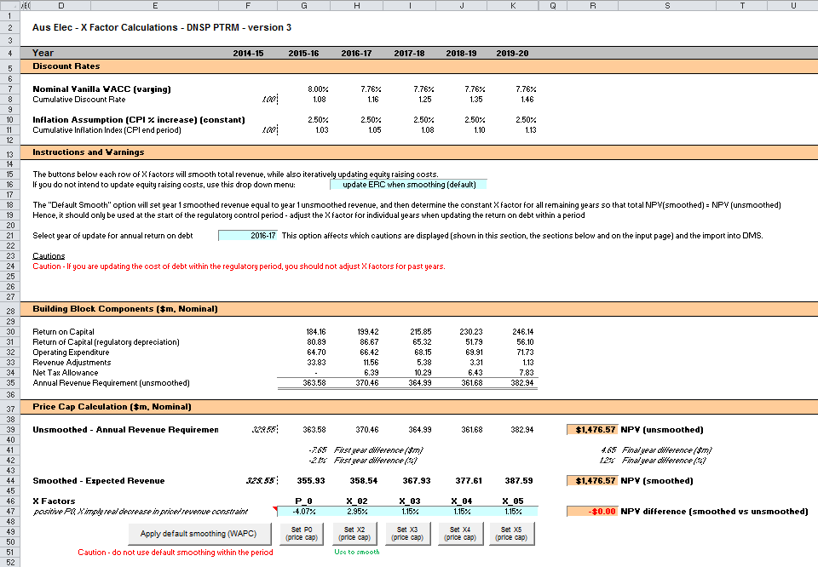

Figure 14 X factors sheet–second screenshot

1. 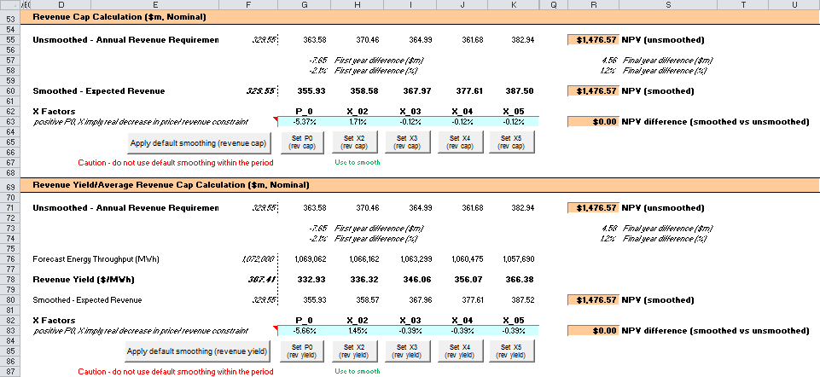

## Revenue summary sheet

1. The **Revenue summary** sheet outlines the various building blocks, the unsmoothed forecast revenues (or the ARR) and smoothed expected revenues for the next regulatory control period:

* rows 7 to 12 display the building blocks in nominal dollar terms
* rows 17 to 26 display a summary of smoothed revenue amounts in nominal dollar terms and X factors for the three forms of control
* rows 30 to 35 display the building blocks in real dollar terms (start of year one)
* rows 40 to 49 display a summary of smoothed revenue amounts in real dollar terms (start of year one) and X factors for the three forms of control.

1. The price path analysis section presents summary values for the forecast price path, which in broad terms is the forecast revenue divided by forecast demand:

* rows 53 and 78 display the DNSP’s forecast energy for the regulatory control period
* rows 56 to 74 use the expected revenues for the three forms of control to calculate indicative revenue and price paths in nominal dollar terms
* rows 81 to 99 use the expected revenues for the three forms of control and calculate indicative revenue and price paths in real dollar terms (start of year one).

1. The price path analysis differs slightly based on the form of control:

* Under a WAPC, the expected revenue in each year reflects the tariff breakdown (forecast quantities x prices) sourced from the **Forecast revenues** sheet. The starting point for the WAPC price path is an indicative price calculated as total revenue divided by forecast total energy demand.[22] To calculate the price path, this starting value is escalated each year of the regulatory control period using the CPI–X pricing formula. Hence, the X factors will align with the real change in this price path (row 85).
* Under a revenue cap, the expected revenue is directly targeted by the form of control and so the X factors will align with the real change in revenue (row 89). The expected revenue is divided by forecast total energy demand to produce the indicative price path. This also illustrates the extent to which the revenue cap will adjust prices in response to changes in (forecast) demand.
* Under a revenue yield cap, the revenue yield is directly targeted by the form of control and so the X factors will align with the real change in the price path (row 99). Hence, the price path is not just illustrative in this case, and is used to then derive the expected revenue (reversing the operation undertaken in the two other forms of control).

Under each form of control, calculations show the percentage change year-on-year (in both nominal and real terms) and the average yearly change across the regulatory control period.[23]

Figure 15 and Figure 16 provide examples of the **Revenue summary** sheet.

Figure 15 Revenue summary sheet–first screenshot

1. 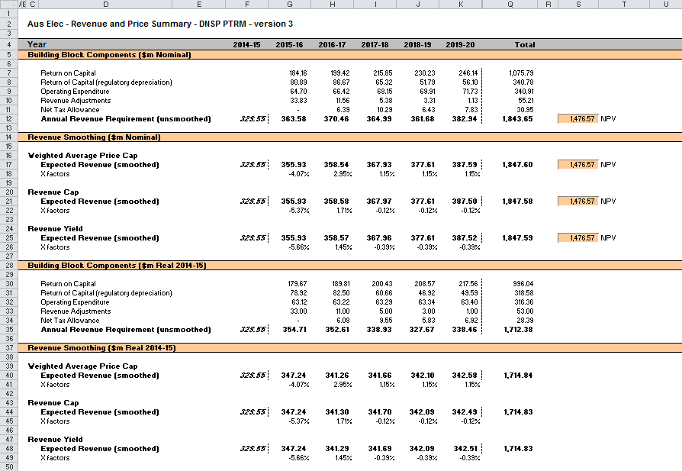

Figure 16 Revenue summary sheet–second screenshot

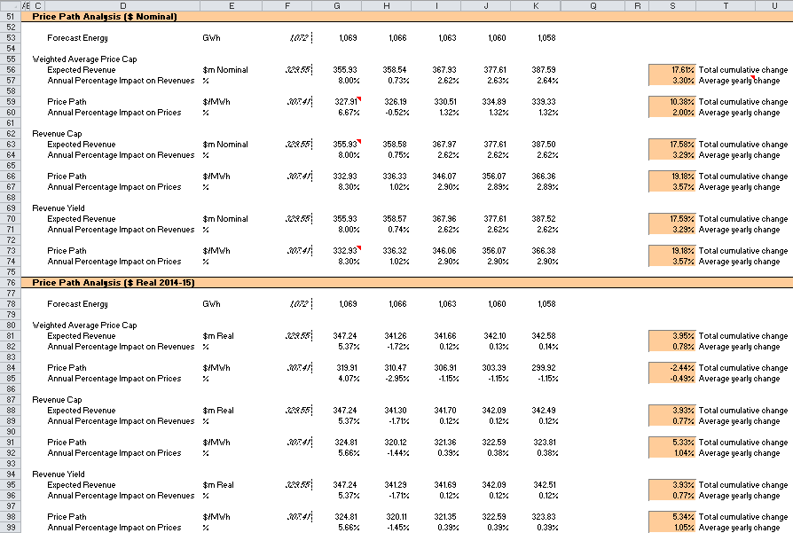

## Equity raising costs sheet

1. In raising new equity capital a business may incur costs such as legal fees, brokerage fees, marketing costs and other transaction costs. These are upfront expenses, with little or no ongoing costs over the life of the equity. While the majority of the equity a firm will raise is typically obtained at its inception, there may be points in the life of a firm—for example, during significant capital expansions—where it chooses additional external equity funding (instead of debt or internal funding) as a source of equity capital, and accordingly may incur equity raising costs.
2. The benchmark cash flow analysis applied by the AER to determine the extent to which equity raising associated with capex is required has been discussed in detail in previous electricity determinations.[24] Broadly, the analysis uses the PTRM cash flows to calculate the amount of retained earnings (taking account of cash flows such as revenue, opex, interest payment, tax payment dividends, and dividend reinvestment plans). The amount of retained earnings is deducted from the equity component of forecast capex (while maintaining the benchmark level of gearing) to determine any external equity requirement. The **Equity raising costs** sheet sets out the benchmark cash flow analysis.
3. The opening RAB and capex values (rows 7 and 8) are sourced from the **Assets** sheet. Based on this information the capex rate is calculated and displayed in row 9. The capex rate indicates the proportion of the capex relative to the opening RAB but does not affect the calculation of equity raising costs by itself.
4. The tax payable values (row 13) are sourced from the **Analysis** sheet and are used in combination with parameters (such as the corporate tax rate and imputation credit payout ratio) from the **PTRM input** sheet to calculate the dividends payable (row 14). A proportion of dividends that are paid out to investors are assumed to be reinvested in the business. The amount of dividends reinvested by investors is displayed at row 15 and is used in the benchmark cash flow analysis to determine retained cash flows.
5. The drop down menu in row 19 allows the selection of the form of control so that the smoothed revenue cash flows are sourced from the correct section of the **X factors** sheet. This drop down menu may be automatically updated when running a smoothing macro using the buttons in the **X factors** sheet. If the drop down option to 'update ERC when smoothing (default)' in the **X factors** sheet (cell H16) is selected, then running a smoothing macro will set the drop down menu in the **Equity raising costs** sheet (cell G19) to the relevant form of control (based on which smoothing button was pressed).[25]
6. The benchmark cash flow analysis set out in rows 21 to 36 are undertaken in nominal dollar terms and is used to determine the equity raising costs as follows:

* The revenues (row 21) sourced from the **X factors** sheet less expenses such as opex, interest payments, tax payable and other revenue adjustments (rows 22 to 25) sourced from the **Analysis** sheet provides the internal cash flow (row 26).
* The internal cash flow less dividends paid out to shareholders (row 27) provides the retained cash flow (row 28).
* The capex funding requirement (row 32) is sourced from row 8, adjusted to remove the gross-up for the WACC provided in the PTRM to account for the assumed timing of the incurrence of capex, which is not relevant for financing purposes. The debt component (row 33) represents the increase in debt funding and is sourced from the **Analysis** sheet, whereby to maintain the benchmark level of gearing, the level of debt must equal 60 per cent of the RAB rather than capex. The residual of capex funding requirement less the increase in debt funding gives the equity component (row 34), which represents the amount of capex that must be funded through retained earnings and then new equity.
* The equity component less retained cash flow (row 35), where it is insufficient, indicates the additional equity requirement (row 36).[26]

1. Rows 40 to 42 display the equity component, retained cash flow and additional equity requirement in real dollar terms (based on start of year one) by converting the nominal dollar equivalents set out in rows 34 to 36. Dividend reinvestment, also in real dollar terms, is displayed in row 44 by converting the nominal dollar equivalent as set out in row 15.
2. If the total equity requirement over the next regulatory control period is above zero, cell Q48 calculates the total dividend reinvestment plan requirement based on the total amount set out at Q44. The total external equity requirement over the next regulatory control period is calculated at cell Q49 by taking the difference between the total equity requirement and the total dividend reinvestment. Cell Q50 displays the sum of the total dividend reinvestment plan requirement and the total external equity requirement. This is the total equity requirement.
3. Based on the total amount of dividends reinvested (cell Q48) and the external equity requirement (cell Q49) the cost for each of these component (sourced from the **PTRM** **input** sheet) is calculated in cells Q52 and Q53 respectively. The sum of these components provides the total equity raising costs in real dollar terms (start of year one) and is displayed at cell Q54. A positive value for the total equity raising costs over the next regulatory control period indicates that the calculated benchmark equity raising costs should be allowed and recovered by the DNSPs.
4. The equity raising cost calculations must be performed iteratively because they are both an input to and an output from the building block calculation.[27] In other words, a change in the equity raising cost will change the ARR and expected revenue, which in turn changes the equity raising cost. Further, the equity raising cost calculation depends on both unsmoothed building block components (for instance, the outgoing cash flows each year) and the smoothed total revenue (for instance, the available revenue each year). Accordingly, changes to the smoothed revenue profile (the expected revenue) can change the required equity raising cost, starting the cycle again.
5. By default, the smoothing macros in the **X factors** sheet perform these iterative calculations for equity raising costs at the same time. However, this function can be disabled using the drop-down menu in cell H16 of the **X factors** sheet.
6. Figure 17 provides an example of the **Equity raising costs** sheet.

Figure 17 Equity raising costs sheet

1. 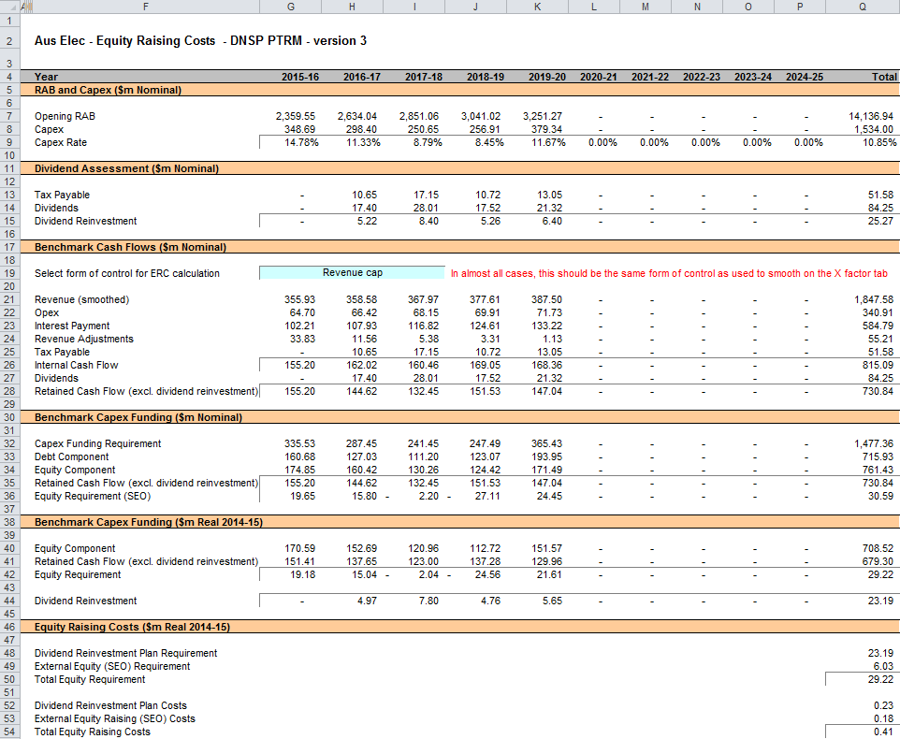

## Chart 1—Revenue sheet

1. The Chart 1–Revenue sheet displays charts for each form of control that incorporates the:

* nominal and real ARR
* nominal and real forecast expected revenues derived under the three forms of control.

1. This information is sourced from the Revenue summary sheet.
2. Figure 18 provides an example of the Chart 1–Revenue sheet.

Figure 18 Chart 1—Revenue sheet

1. 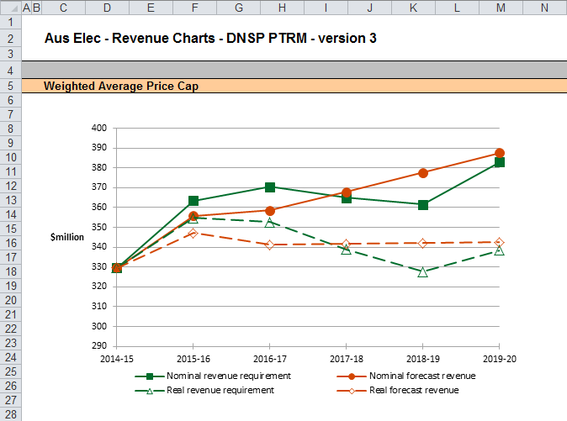

Note: This screenshot only shows an example chart for the weighted average price cap form of control. However, the Chart 1—Revenue sheet also includes similar charts for the revenue cap and revenue yield forms of control.

## Chart 2—Price path sheet

1. The Chart 2–Price path sheet displays charts for each form of control that incorporate the value of average prices (approximated by total revenues divided by total energy demand forecast, or the revenue yield value) in nominal and real dollar terms (start of year one). This information is sourced from the Revenue summary sheet.
2. Figure 19 provides an example of the Chart 2–Price path sheet.

Figure 19 Chart 2–Price path sheet

1. 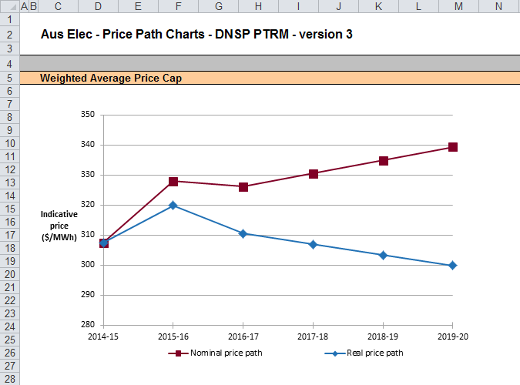

Note: This screenshot only shows an example chart for the weighted average price cap form of control. However, the Chart 2—Price path sheet also includes similar charts for the revenue cap and revenue yield forms of control.

## Chart 3—Building blocks sheet

1. The Chart 3–Building blocks sheet displays the various building block cost components making up the ARR:

* return on capital
* regulatory depreciation
* opex (excluding any carry-over amounts)
* net tax costs
* carry-over and other revenue adjustments.

1. This information is sourced from the Analysis sheet.
2. Figure 20 provides an example of the Chart 3–Building blocks sheet.

Figure 20 Chart 3–Building blocks sheet

1. 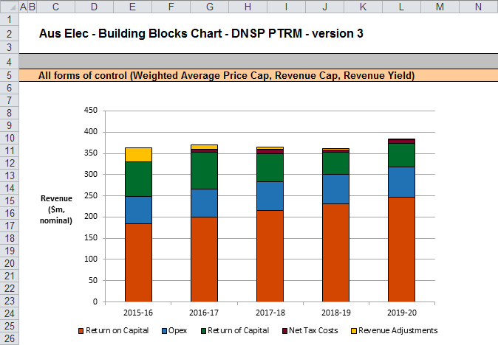

# Process for annual return on debt update

This section sets out the process to set X factors at the time of the final decision, and the default process for annual updates of the return on debt. Some aspects of this approach will be guided by policy decisions to be made during individual determinations. However, following the process set out below will likely result in the basis for calculations that is consistent with the requirements of clauses 6.5.2(h)–(l) of the NER.

## Setting X factors for the final decision before the start of the regulatory control period

* 1. Complete all inputs to the **PTRM** **input** sheet. This requires a trailing average portfolio return on debt value only in G210.[28] By default, the PTRM approach adopts the most recent trailing average portfolio return on debt that is entered, where there is no further forecast values entered for other years in the regulatory control period. Accordingly, it is not necessary to enter the return on debt for later years in the regulatory control period at this stage.[29]
  2. In the **X factors** sheet, ensure that the equity raising costs update option (cell H16) is set to ‘update ERC when smoothing (default)’. This will ensure the equity raising cost calculations are iteratively updated as part of setting the X factors.[30]
  3. In the **X factors** sheet, check that cell F21 is set to the first year of the next regulatory control period. This will ensure the correct checks and warnings operate for the model.
  4. In the **X factors** sheet, apply revenue smoothing in the section relating to the chosen form of control:
     1. If applying the default X factor path (year 1 ARR = year 1 expected revenue; X2=X3=X4=X5; NPV(ARR) = NPV(expected revenue)), press the button labelled 'Apply default smoothing (…)' where ‘(…)’ describes the relevant form of control (either WAPC, revenue cap or revenue yield).
     2. If applying an alternative smoothing path, in the section relating to your chosen form of control (WAPC, revenue cap or revenue yield), manually enter values for all X factors except one. Then press the relevant button to calculate the final remaining X factor (so that NPV(ARR) = NPV(expected revenue)). This final X factor can be any of the X factors in the regulatory control period (including the first year, which is labelled as 'P0' by convention instead of 'X1'). These buttons are located under the relevant X factors and are also labelled with the relevant form of control.
     3. In either case, it is necessary to consider the resulting difference between the final year ARR and expected revenue for the chosen form of control (shown in cells R41 and R42 for the WAPC; in cells R57 and R58 for the revenue cap; and cells R73 and R74 for the revenue yield). If this difference would not meet the requirements of NER clause 6.5.9(b)(2), return to step (b) and manually adjust one or more X factors again (ensuring that the final X factor adjustment uses the relevant button so as to jointly smooth the revenue and equity raising cost calculations).
  5. In the **WACC** sheet, press the 'Set Te and Td' button to copy the cash-flow derived effective tax rates for equity and debt from the **Analysis** sheet to the appropriate cells in the **WACC** sheet.

## Updating X factors to incorporate the annual update to the trailing average portfolio return on debt

* 1. In the **X factors** sheet, select the relevant year of update in cell F21.
  2. In the **PTRM** **input** sheet (row 210), enter the trailing average portfolio return on debt values up to and including the relevant year of update, consistent with that selected in cell F21 of the **X factors** sheet.[31] Caution notes will appear in rows 211 to 212 of the **PTRM** **input** sheet to show which inputs are necessary. No other inputs should be changed.
  3. In the **X factors** sheet, ensure the equity raising cost update option (cell H16) is set to 'update ERC when smoothing (default)'.
  4. In the **X factors** sheet, apply smoothing to recalculate the X factor by using the button for the relevant year as identified in step 1 and for the relevant form of control. The correct year for update will be identified by a caution note in the rows (rows 51, 67 and 87) under the smoothing X factor buttons for the three forms of control. Only the relevant form of control should be used. It is important that the X factors for past years in the regulatory control period are not altered, since these X factors reflect the revenue (and price) outcomes from those years. Further, the default approach is that only the X factor for the year of update should be altered (rather than multiple X factors, for this year and remaining years within the regulatory control period).[32] This means that the impact of increases/decrease in that year's return on debt will be fully reflected in price changes in that year. For example, under a revenue cap form of control, to re-smooth for a return on debt update in year 2 the button labelled 'Set X2 (rev cap)' would be used, and all other X factors as determined during the final decision process would remain unaltered.

1. The set of Microsoft Excel spreadsheets which constitute the PTRM were created in Microsoft Excel 2010. The AER recommends this or a later version of Microsoft Excel be used in applying these spreadsheets.
2. This requires the total smoothed and unsmoothed revenues to be equal in net present value (NPV) terms.
3. Note that this is an iterative process, because changing smoothed revenue alters equity raising costs, changing equity raising costs alters unsmoothed revenue, and changing unsmoothed revenue alters smoothed revenue.
4. For example, whether the PTRM relates to the Regulatory proposal, Draft decision, Revised regulatory proposal or Final decision.
5. The depreciation profiles would be subject to satisfying the requirements of clauses 6.5.5(b) and 6.5.3 of the NER.
6. Clause 6.8.1 of the NER sets out the requirements of the framework and approach applying to a determination.
7. The PTRM can be expanded to accommodate additional asset classes, when necessary.
8. The 30th asset class is designed to be used only with the 'Equity raising costs' asset class. Several defined name ranges use this asset class to implement the iterative equity raising cost update when smoothing total revenue.
9. Inputs for assets under construction will only be relevant for any DNSPs that previously recognised capex on an as-commissioned basis.
10. Generally these can be derived based on the weighted average remaining life of all individual assets in the class.
11. Row 70 (asset class 30) is designed to be used for equity raising costs only.
12. The button at the left of row 71 may be pressed to display/hide rows 41 to 70 (asset classes 1 to 30).
13. The PTRM templates include sample revenue adjustments line items, which should be treated as basic examples of the type of revenue adjustments (and tax treatments) that might be included. The examples should not be read as indicating the AER’s position on the tax implications of these particular revenue adjustments.
14. Clause 6.4.2(b)(1) of the NER requires the AER to specify in the PTRM a methodology that is likely to result in the best estimate of expected inflation. The AER uses an approach that calculates the geometric average based on the inflation forecasts for two years sourced from the latest available Reserve Bank of Australia’s (RBA’s) Statement of monetary policy and the mid-point of the RBA’s target inflation band for eight years (see AER, Final decision, TransGrid transmission determination 2009–10 to 2013–14, 28 April 2009, pp. 60–64).
15. AER, Better regulation: Rate of return guideline, December 2013.
16. These link to the cash-flow analysis excluding the effect of revenue adjustments, which is the relevant basis for checking that the target return on equity has been met.
17. See rows 24 to 27 in the Analysis sheet, which calculate the return on capital and provide a breakdown of the return on equity and return on debt.
18. The half-real vanilla WACC is calculated as the square root of (1 + real vanilla WACC) – 1 to account for the compounding effect on an annual rate.
19. The timing of the capex cash flow is assumed to be mid-year.
20. The AER in its regulatory determinations has considered a divergence of up to 3 per cent between the expected revenue and ARR for the final year of the regulatory control period to be reasonable if this can achieve smoother price changes for customers over the regulatory control period.
21. This is not the only change that flows from a change to the return on debt – the return on capital and return of capital building blocks will change, and therefore so will the tax building block.
22. This preserves comparability with the other two forms of control.
23. The average yearly change is calculated as the geometric mean (not the arithmetic mean), and therefore reflects the cumulative impact of year-on-year percentage changes across the regulatory control period. In other words, the value shown in column S (where labelled 'Average yearly change') is the percentage change that, if applied to every year in the regulatory control period, would arrive at the total cumulative change across the period.
24. AER, *Final decision, Powerlink transmission determination 2012–13 to 2016–17*, April 2012, pp. 145–147.
25. If the drop down menu to 'do NOT update ERC when smoothing' (**X factors** sheet, cell H16) is selected, then running a smoothing button will not change the equity raising cost form of control (**Equity raising cost** sheet, cell G19). This means that the form of control used to smooth the X factors and the form of control used to iteratively determine equity raising cost may not align.
26. Where there is sufficient retained cash flow to cover the equity component of capex, the amounts shown in row 36 would be negative.
27. This does not mean that the calculation method for the entire workbook needs to be set to manual or iterative (under Options -> Formulas -> Calculation options). The implementation in the PTRM is such that direct values are entered in the **PTRM** i**nput** sheet, so there is no circular reference, and the iterative updates are managed via macros when smoothing. Hence, the calculation option can be left as automatic, without iteration.
28. Also, the year-by-year tax rates (row 200) only require the first year (cell G200) to be entered; the PTRM will apply this tax rate to later years where there is no explicit tax rate entered.
29. The PTRM will use the return on debt for a given year if entered, so if forecasts were entered for later years in the regulatory control period (and these values differ from the year 1 return on debt), this will be reflected in the building block calculations. However, this is not intended to be the default operation of the PTRM. If a DNSP was to propose (at the time of making the final decision) return on debt forecasts for year 2 onwards this would need to be assessed as part of an individual determination.
30. The ‘do NOT update ERC when smoothing’ option can be selected for certain analysis that seeks to isolate the impact of equity raising cost from the revenue requirement.
31. By default, the PTRM will use the most recent return on debt value as the forecast for later years (where the return on debt is not yet known). Hence, at each annual update the forecast for the remaining years in the regulatory control period will be updated.
32. If a DNSP was to propose an alternative approach (for instance, where multiple X factors were changed in response to a given year's annual return on debt update) this would need to be assessed as part of an individual determination and approved as part of the final decision.