

Annual Benchmarking Report

Electricity distribution network service providers

November 2015

© Commonwealth of Australia 2015

This work is copyright. In addition to any use permitted under the Copyright Act 1968, all material contained within this work is provided under a Creative Commons Attributions 3.0 Australia licence, with the exception of:

* the Commonwealth Coat of Arms
* the ACCC and AER logos
* any illustration, diagram, photograph or graphic over which the Australian Competition and Consumer Commission does not hold copyright, but which may be part of or contained within this publication. The details of the relevant licence conditions are available on the Creative Commons website, as is the full legal code for the CC BY 3.0 AU licence.

Requests and inquiries concerning reproduction and rights should be addressed to the   
Director, Corporate Communications,   
Australian Competition and Consumer Commission,   
GPO Box 4141,   
Canberra ACT 2601   
or publishing.unit@accc.gov.au.

Inquiries about this publication should be addressed to:

Australian Energy Regulator  
GPO Box 520  
Melbourne Vic 3001

Tel: (03) 9290 1444  
Fax: (03) 9290 1457

Email: [AERInquiry@aer.gov.au](mailto:AERInquiry@aer.gov.au)  
AER Reference: D15/156976

Shortened forms

|  |  |
| --- | --- |
| Shortened form | Description |
| AEMC | Australian Energy Market Commission |
| AER | Australian Energy Regulator |
| ACT | ActewAGL |
| AGD | Ausgrid |
| AND | AusNet Services (distribution) |
| Capex | Capital expenditure |
| CIT | CitiPower |
| DNSP | Distribution network service provider |
| END | Endeavour Energy |
| ENX | Energex |
| ERG | Ergon Energy |
| ESS | Essential Energy |
| IEEE | Institute of Electrical and Electronics Engineers |
| JEN | Jemena Electricity Networks |
| MW | Megawatt |
| NEL | National Electricity Law |
| NEM | National Electricity Market |
| NER | National Electricity Rules |
| Opex | Operating expenditure |
| PCR | Powercor |
| RAB | Regulatory asset base |
| SAP | SA Power Networks |
| TND | TasNetworks (Distribution) |
| UED | United Energy Distribution |

Glossary

|  |  |
| --- | --- |
| Term | Description |
| Allocative efficiency | Allocative efficiency is achieved where resources used to produce a set of goods or services are allocated to their highest value uses (i.e., those that provide the greatest benefit relative to costs). In other words, goods and services are produced in the combination that consumers value the most. To achieve this, prices of the goods and services must reflect the productively efficient costs of providing those goods and services. |
| Dynamic efficiency | Dynamic efficiency reflects the need for industries to make timely changes to technology and products in response to changes in consumer tastes and in productive opportunity. Dynamic efficiency is achieved when a business is productively and allocatively efficient over time. |
| Inputs | Inputs are the resources DNSPs use to provide services. |
| LSE | Least squares econometrics. LSE is an econometric modelling technique that uses statistics to estimate the relationship between inputs and outputs. Because they are statistical models, LSE models allow for economies and diseconomies of scale and can distinguish between random variations in the data and systematic differences between DNSPs. |
| MPFP | Multilateral partial factor productivity. MPFP is a PIN technique that measures the relationship between total output and one input. |
| MTFP | Multilateral total factor productivity. MTFP is a PIN technique that measures the relationship between total output and total input. |
| Network services opex | Opex for network services excludes amounts associated with metering, customer connections, street lighting, ancillary services and solar feed-in tariff payments. |
| OEFs | Operating environment factors. OEFs are factors beyond a DNSP’s control that can affect its costs and benchmarking performance. |
| Outputs | Outputs are quantitative or qualitative measures that represent the services DNSPs provide. |
| PIN | Productivity index number. PIN techniques determine the relationship between inputs and outputs using an index. |
| PPI | Partial performance indicator. PPIs are simple techniques that measure the relationship between one input and one output. |
| Productive efficiency | Productive efficiency is achieved when a business produces its goods and/or services at the least possible cost. To achieve this, the business must be technically efficient (produce the most output possible from the combination of inputs used) while also selecting the lowest cost combination of inputs given prevailing input prices. |
| Ratcheted maximum demand | Ratcheted maximum demand is the highest value of maximum demand for each DNSP, observed in the time period up to the year in question. It recognises capacity that has been used to satisfy demand and gives the DNSP credit for this capacity in subsequent years, even though annual maximum demand may be lower in subsequent years. |
| SFA | Stochastic frontier analysis. SFA is an econometric modelling technique that uses statistics to estimate the relationship between inputs and outputs. Like LSE models, SFA models allow for economies and diseconomies of scale and directly estimates efficiency for each DNSP. |

Contents

Shortened forms i

Glossary ii

Contents iii

Overview iv

1 Introduction 1

2 Approach 4

3 Multilateral total factor productivity results 7

4 Results from supporting techniques 11

5 Conclusions 16

Appendices 17

A References and further reading 18

B Inputs and outputs 19

C Additional PPIs 25

D Map of the National Electricity Market 28

E List of submissions 29

Overview

The AER regulates all electricity networks in the National Electricity Market (NEM). We set network prices so that energy consumers pay no more than necessary for the safe and reliable delivery of electricity services. Benchmarking underpins this by enabling us, at an overall level, to identify the relative efficiency of electricity networks, and to track changes in efficiency over time.

This is the second annual benchmarking report. The benchmarking models presented in this report are the culmination of a substantial work program that commenced in 2012 after changes to the electricity rules removed impediments to the use of benchmarking in making regulatory determinations. For this program, we worked with leading economic experts and consulted extensively with the distribution network service providers (DNSPs) and electricity consumers to establish benchmarking data requirements, model specifications and a guideline setting out how benchmarking would be used in determinations.

We consider that our benchmarking models are the most robust measures of overall efficiency available. At the same time, however, we recognise that there is no perfect benchmarking model, and have been cautious in our initial application of these results in recent distribution determinations. Benchmarking is a critical exercise in assessing the efficiency of the DNSPs’ regulatory proposals and we will continue to invest in refining our benchmarking techniques into the future.

This report uses a different format to our 2014 report, with less emphasis on technical detail. We have focused on an economic benchmarking technique—multilateral total factor productivity (MTFP)—as the primary technique to compare relative efficiency. MTFP is a sophisticated ‘top down’ technique that enables us to measure each DNSP’s overall efficiency at providing electricity services. In addition to MTFP, we present supporting techniques, including econometric opex modelling, which was not included in the 2014 report.

Key messages

Productivity across the industry has been declining over the past several years. This can be seen in Figure 1, which shows the combined industry inputs have increased at a greater rate than outputs since 2007.

Figure 1 MTFP input, output and TFP indices for all DNSPs, 2006–14



This can also be seen in Figure 2, which shows the MTFP score for most DNSPs is sloping downwards over the observation period.

Figure 2 Multilateral total factor productivity by DNSP for 2006–14



Productivity is declining because the resources used to maintain, replace and augment the networks are increasing at a greater rate than the demand for electricity network services (measured in terms of increases in customer numbers, line length, energy, and maximum demand).

For the majority of DNSPs, the declining productivity trend has continued in the twelve months between 2013 and 2014. However, some DNSPs have improved their productivity in recent years, including Energex, Ergon Energy and Essential Energy.

Figure 2 demonstrates that, over time, the field has started to narrow. In 2014, the four most productive DNSPs are CitiPower, United Energy, SA Power Networks and Jemena and the four least productive DNSPs are TasNetworks, ActewAGL, Essential Energy and Ausgrid. These DNSPs have consistently been among the best and worst performers, respectively, over the period. However, recent declines in productivity from SA Power Networks and AusNet Services, combined with improvements from Energex and Ergon Energy have resulted in the relative efficiency of eight of the 13 DNSPs being closer than ever before.

In addition to MTFP, this report presents several supporting metrics, which provide alternative measures of comparative performance. These metrics include partial productivity indices, econometric models and partial performance indicators. While, in some cases, the best and worst performers on a supporting metric rank similarly to those on MTFP, the supporting techniques do not measure overall efficiency. They either examine relative efficiency of total output to one input or provide a general indication of comparative performance. Therefore, the results of the supporting metrics will not be the same as they are for MTFP. The supporting metrics are, however, useful for assessing relative efficiency and we use all of them in our distribution determinations.

# Introduction

This annual benchmarking report informs consumers about the relative efficiency of network service providers. It is prepared to facilitate greater consumer engagement and participation in network revenue decisions.

## Who the report compares

The electricity industry in Australia is divided into four distinct parts, with a specific role for each stage of the supply chain—generation, transmission, distribution and retail.

Electricity generators are usually located near fuel sources, and often long distances from most electricity customers. The supply chain, therefore, requires networks to transport power from generators to customers:

* High voltage transmission lines transport electricity from generators to distribution networks in metropolitan and regional areas
* Distribution networks convert electricity from the high voltage transmission network into medium and low voltages and transport electricity from points along the transmission lines to residential and business customers.

This report focuses on the distribution sector. Thirteen DNSPs operate in the NEM. Appendix D presents a map of the NEM showing the service area for each DNSP.

Despite the existence of some differences between the operating environments of the DNSPs, they all supply electricity using the same technology and assets (such as poles and wires). This means they are natural comparators for benchmarking. Indeed, benchmarking the performance of electricity DNSPs is commonplace around the world. Appendix A contains (among other things) references for further reading on benchmarking electricity networks overseas.

## What the report measures

The core function of a DNSP is to provide consumers with access to electricity. This function must be undertaken in accordance with certain performance requirements, usually to achieve desired policy objectives including minimum service standards for delivering electricity safely and reliably.

The objective of this report is to benchmark the DNSPs to determine who provides electricity services, in accordance with their requirements, most efficiently. Several approaches to benchmarking exist, which may be broadly classified into ‘top down’ and ‘bottom up’ techniques. Top down techniques measure a business’s efficiency overall, which means they take into account efficiency trade-offs between components that make up the total.

Bottom up techniques, in contrast, separately examine the components that make up the total, often at a granular level. Components are then built up to form the total. In most cases, bottom up techniques are not effective at examining efficiency trade-offs between all of the different components of a DNSP’s operations.[1] They are also resource intensive. Most regulators overseas use top down economic benchmarking techniques rather than bottom up techniques.[2]

This report presents top down benchmarking techniques, using an inputs and outputs framework. Inputs are the resources a DNSP uses to provide services (such as capital and labour) and outputs are measures that represent those services (such as the number of customers and how much electricity they need). The fewer inputs a DNSP uses to provide outputs, the lower the cost of providing distribution services and, hence, the lower the price consumers pay for the services. The benchmarking techniques in this report examine the combination of inputs the DNSPs use to deliver their outputs.

Using the combination of resources to deliver outputs for the least possible cost is known as ‘productive efficiency’. Productive efficiency is one of the three components of economic efficiency (productive, allocative and dynamic efficiency[3]) which is achieved when inputs are optimally selected and used in order to deliver outputs that align with customer preferences.

This report examines the DNSPs’ productive efficiency in providing core network services. Measuring productive efficiency over time also provides an insight into the DNSPs’ dynamic efficiency.

## Reasons for measuring comparative performance

Comparative information on the performance of electricity DNSPs contributes to the wellbeing of all electricity consumers by encouraging improvements in the services they provide, particularly their cost effectiveness. This is important in an industry where the service providers are natural monopolies because they may not face the same pressures to operate efficiently as service providers in a competitive market. Consumers have limited means of gathering information about DNSP performance and very little opportunity to choose their DNSP or express their preferences by accessing services elsewhere.

Key reasons for reporting comparative performance information across jurisdictions are to:

* provide meaningful information to consumers and other stakeholders
* encourage participation and engagement in the AER’s regulatory processes
* identify high performing DNSPs
* enable DNSPs to learn from peers that are delivering their services more efficiently
* generate additional incentives for DNSPs to improve their efficiency.

In addition to being useful for stakeholders, the comparative performance information in this report is relevant to our distribution determinations. For example, we use all of the techniques as part of our toolkit for assessing the efficiency of DNSPs’ expenditure proposals.

# Approach

This report uses top down benchmarking techniques to measure each DNSP’s efficiency in delivering network services to consumers. In essence, we rank the DNSPs according to their relative efficiency, based on their costs of providing services in accordance with service standard obligations. We present three different types of techniques to do this, drawing on data provided by the DNSPs.

## Inputs and outputs

Inputs are the resources a DNSP uses to provide services. The two inputs we focus on are opex and capital stock (assets). DNSPs spend opex to operate and maintain their assets. DNSPs invest in capital to replace or upgrade their assets and to expand their network for growth in customers or to increase the amount of electricity they can deliver.

Outputs are quantitative and qualitative measures that represent the services the DNSPs provide. DNSPs provide customers with access to a safe and reliable supply of electricity, so the outputs we use in this report are customer numbers, circuit line length, maximum demand, energy delivered and reliability. We consider these measures capture the total output faced by DNSPs effectively because:

* the number and location of customers dictate where DNSPs must build their networks and the capacity and length of the lines required
* the network must be capable of delivering energy to customers when they need it, including at times when demand is at its greatest (maximum demand)
* DNSPs must provide their services in accordance with reliability standards and aim to minimise interruptions to electricity supply.

Since DNSPs use multiple inputs to provide multiple outputs to customers, it is necessary to aggregate them to produce an efficiency measure. Appendix A contains references for further reading on how Economic Insights, our benchmarking expert, chose the inputs and outputs and produced the aggregate efficiency measure. Appendix B provides detail about the inputs and outputs used in this report.

## Techniques

There are different types of top town benchmarking techniques. We present three types in this report:

* productivity index number (PIN) techniques
* econometric opex modelling
* partial performance indicators (PPIs).

These techniques each use different mathematical or econometric methods for relating outputs to inputs. Appendix A contains references to further reading on the PIN techniques and econometric opex modelling used in this report.

### Productivity index number techniques

PIN techniques use an index to determine the relationship between outputs and inputs. They measure productivity by constructing a ratio of inputs used for total output delivered. The PIN analysis used in this report includes:

* multilateral total factor productivity (MTFP) which relates total input to total output
* multilateral partial factor productivity (MPFP) which relates either opex or capital as inputs to total output.

The ‘multilateral’ method enables comparison of productivity levels and productivity trends. MTFP is the primary technique we use to compare relative efficiency in this report. We present the MTFP results in section 3. Section 4 contains the MPFP results.

### Econometric opex modelling

Econometric modelling techniques use statistics to estimate the relationship between outputs and inputs. The econometric techniques presented in this report model the relationship between opex (as the input) and total output, so they measure partial efficiency. Two types of econometric opex models are presented in this report—least squares econometrics (LSE) and stochastic frontier analysis (SFA). Section 4 contains the results.

### Partial performance indicators

PPIs are simple techniques that relate one input to one output (contrasting with the above economic benchmarking techniques that relate inputs to multiple outputs). In this report, the output chosen is customer numbers. Section 4 contains the PPI results. Appendix C presents additional PPIs, including some that use outputs other than customer numbers.

## Data

All techniques in this report use data provided by the DNSPs in response to our economic benchmarking regulatory information notices (EB RINs). The EB RINs require all DNSPs to provide consistent data that is verified by the DNSP’s chief executive officer and independently audited. This data has been subject to rigorous testing and validation by both Economic Insights and us.

For the econometric modelling techniques, we also rely on some overseas data. The data intensive nature of these techniques means that robust results cannot be produced with only the Australian DNSP data. As such, Economic Insights supplemented the Australian data with comparable data from Ontario and New Zealand. This significantly increases the size of the dataset, enabling robust estimation of the opex cost function. Importantly, the models control for international differences so they do not benchmark the Australian DNSPs against DNSPs in Ontario and New Zealand. Appendix A contains references to further reading on how Economic Insights incorporated overseas data into the econometric models.

## Differences in operating environments

When benchmarking, it is important to recognise that DNSPs operate in different environments. Certain factors arising from a DNSP’s operating environment are beyond its control. These factors, which we call ‘operating environment factors’ (OEFs) may influence a DNSP’s costs and, therefore, its benchmarking performance.

The economic benchmarking techniques presented in this report capture the key OEFs. For example:

* MTFP takes into account a DNSP’s assets, density factors and allows for different network structures in certain jurisdictions.
* the econometric models account for density factors and the proportion of each DNSP’s network that is underground.

However, not all OEFs can be captured in the models. In our recent determinations for the NSW, ACT and QLD DNSPs, we conducted a separate assessment of OEFs and made ex post adjustments to account for them. However, it would not be practical to make ex post adjustments to account for the differences between all operating environments relative to each other for the purposes of this report.

# Multilateral total factor productivity results

This section presents the benchmarking results for MTFP, the primary technique used to measure overall relative efficiency. Results are presented over a nine year period, from 2006 to 2014.

The output specification used in this analysis comprises energy delivered, customer numbers, circuit length, ratcheted maximum demand[4] and reliability. Reliability is measured as the number of customer minutes off supply. It is a negative output because a decrease in supply interruptions is equivalent to an increase in output. The input specification is both opex and capital.

Opex is the observed opex spent on network services. Capital is split into overhead distribution (low and medium voltage) lines, overhead subtransmission (high voltage) lines, underground distribution cables, underground subtransmission cables and transformers and other capital. It is necessary for the MTFP input specification to distinguish between subtransmission and lower voltage lines and cables because generally, subtransmission contributes to the majority of a DNSP’s network capacity (measured in MVA multiplied by kilometres) but only a small proportion of asset values and annual user costs.

Further detail about the MTFP input and output specifications can be found in the Economic Insights publications referred to in Appendix A. Figure 3 displays the output and input indices and the resultant TFP index at the industry level (all DNSPs).

Figure 3 MTFP input, output and TFP indices for all DNSPs, 2006–14

Figure 3 shows that since 2007, inputs have increased at a greater rate than outputs. In other words, DNSPs have been spending resources (opex and capital) at a greater rate than the key factors that drive the supply of electricity distribution services. This indicates productivity declining across the whole sector. With the exception of 2013, which showed minimal positive productivity growth, there has been negative productivity growth each year. There are several reasons for this:

* most outputs have increased moderately or remained relatively flat in recent years
* jurisdictional regulatory requirements have required some DNSPs to spend more resources (that is, increasing input) but without a corresponding increasing output
* some DNSPs are not using their resources as efficiently as other DNSPs.

Two pertinent examples of jurisdictional obligations increasing inputs during the period are the bushfire mitigation requirements in Victoria (following the Victorian Bushfires Royal Commission, or VBRC) and the Ministerial reliability requirements in NSW. In both cases, significant asset replacement and upgrades were required.

Following the VBRC, for example, certain overhead lines were deemed unsafe and the DNSPs were required replacement them with safer types of line. This resulted in increased expenditure on assets (an input) but no increase in line length (an output). Similarly, the VBRC requirements also resulted in DNSPs spending increased opex for vegetation clearance purposes, with no change in output.

Figure 4 presents the MTFP results for each DNSP. The decline in productivity over the period can be observed for all DNSPs except Ergon Energy. Ergon Energy’s productivity has recently improved following a relatively flat period. Essential Energy’s productivity has also improved in the last two years. For both these DNSPs, however, despite recent improvements, their performance is still well below most of their peers.

Figure 4 Multilateral total factor productivity by DNSP for 2006–14



CitiPower, United Energy, SA Power Networks and Jemena are the best performers over the entire period because their MTFP scores are the highest. For 2014, the results show that, relative to the base observation (ActewAGL’s 2006 score), CitiPower produced more than 50% higher outputs per input. The other three top performers produced between 30% and 40% higher outputs per input. In contrast, ActewAGL, Ausgrid, Essential Energy and TasNetworks produce less than 1 output per input, relative to the base observation.

TasNetworks, however, could be considered an outlier compared to its peers in terms of system structure, which influences its MTFP score to some extent. Compared to other DNSPs, TasNetworks operates substantially less high voltage subtransmission assets and has a comparatively high proportion of lower voltage lines. Therefore, Economic Insights advises that some caution is required in interpreting TasNetworks’ MTFP score, given its comparatively unusual system structure. The Economic Insights memorandum referred to in Appendix A contains further detail on TasNetworks’ system structure.

## Observations for 2013–14

A requirement of the annual benchmarking report is to present each DNSP’s relative efficiency over a twelve month period. This section compares each DNSP’s MTFP performance in 2014. It also compares each DNSP’s average performance over the 2006–14 period because one off factors in a particular year can influence the results. It is, therefore, important to look at performance over a longer period of time. Table 1 ranks each DNSP according to its period-average MTFP score and its 2014 score.

Table 1 DNSP MTFP rankings for 2014 and period-average

|  |  |  |  |  |  |
| --- | --- | --- | --- | --- | --- |
| DNSP | Average Rank | 2014 Rank | Average Score | 2014 Score | 2014 % change |
| CitiPower | 1 | 1 | 1.711 | 1.555 | -2.4% |
| SA Power Networks | 2 | 3 | 1.521 | 1.322 | -4.3% |
| United Energy | 3 | 2 | 1.484 | 1.366 | -2.5% |
| Jemena | 4 | 4 | 1.382 | 1.302 | -0.8% |
| **Powercor** | **5** | 6 | 1.280 | 1.173 | -0.6% |
| Energex | 6 | 5 | 1.262 | 1.196 | 2.5% |
| AusNet Services | 7 | 8 | 1.234 | 1.093 | -4.6% |
| Endeavour Energy | 8 | 7 | 1.223 | 1.135 | -2.9% |
| Ergon Energy | 9 | 9 | 0.992 | 1.073 | 1.4% |
| Ausgrid | 10 | 11 | 0.986 | 0.926 | -5.8% |
| **Essential Energy** | **11** | 10 | 0.977 | 0.928 | 8.5% |
| ActewAGL | 12 | 13 | 0.952 | 0.845 | -6.0% |
| TasNetworks | 13 | 12 | 0.942 | 0.863 | -3.8% |

The rankings in this table are indicative only because, as outlined in section 2.4, there may be other operating environment variables not captured in the MTFP model.

Table 1 also shows the percentage change in score between 2013 and 2014. The last column in Table 1 shows the only DNSPs who have improved their productivity between 2013 and 2014 are Energex, Ergon Energy, and Essential Energy. Both Ergon Energy and Essential Energy have improved their performance for the second consecutive year.

All other DNSPs’ MTFP performance decreased in 2014. ActewAGL had the largest decrease in productivity, with a decrease of 6%. However, SA Power Networks (‑4.3%), AusNet Services (-4.6%), Ausgrid (-5.8%) and TasNetworks (-3.8%) all exhibited significant reductions in productivity.

# Results from supporting techniques

For the purposes of this report, the techniques presented in this section support the MTFP results because they either measure relative efficiency of one input (MPFP, econometric models) or provide a general indication of comparative performance (PPIs). They are, however, useful for assessing relative efficiency and we use all of them in our distribution determinations.

## Multilateral partial factor productivity

The MPFP techniques use the same output specification (energy delivered, customer numbers, circuit length, ratcheted maximum demand and reliability) but examine the productivity of either opex or capital in isolation (rather than both). This is why they are ‘partial’ factor productivity metrics.

Figure 5 displays capital MPFP for all DNSPs over the 2006–14 period. The input specification is the same as the capital index in the MTFP model so it simultaneously considers the productivity of each DNSP’s use of overhead lines and underground cables (split into distribution and subtransmission voltages) and transformers and other capital.

Figure 5 Capital partial factor productivity for 2006–14



Figure 5 shows that the capital productivity for all DNSPs except for Essential Energy has declined between 2013 and 2014. There is a general downward trend in capital productivity, but for several DNSPs, the rate of capital productivity decline is more modest than observed for MTFP in Figure 4.

Figure 6 displays opex MPFP for all DNSPs over the same period. It demonstrates a significant decline in productivity over the period for some DNSPs, including CitiPower and SA Power Networks. Ergon Energy, on the other hand, has improved since the beginning of the period.

Figure 6 Opex partial factor productivity for 2006–14



The ranking of the DNSPs changes somewhat under the two MPFP results, which reflects differing input combinations. Powercor and TasNetworks are two pertinent examples. Both DNSPs perform relatively poorly on capital MPFP but are among the top five performers for opex MPFP. This suggests they are more efficient with their use of opex than with capital.

CitiPower and United Energy are solid performers on the opex and the capital MPFP measures. Essential Energy has improved its performance on both measures but remains below most of its peers in 2014. On opex MPFP in particular, however, the field has narrowed significantly in the last two years due to improvements from Essential Energy, Ergon Energy and Energex. ActewAGL is showing no sign of improvement on opex MPFP, with it exhibiting a decline in 2014 but its performance on capex MPFP is slightly more favourable.

## Econometric opex modelling

This section presents the results of the three econometric models developed by Economic Insights:

* Cobb-Douglas stochastic frontier analysis (SFA)
* Translog least squares econometrics (LSE)
* Cobb-Douglas LSE.

These models measure the efficiency of opex only and were developed for assessing the efficiency of DNSPs’ opex proposals in recent distribution determinations. Each model uses the same specification. It compares opex as the input to multiple outputs (customer numbers, circuit length and ratcheted maximum demand). This output specification differs from that used in MTFP and MPFP because it does not include energy delivered or reliability. However, the econometric model specification includes the proportion of network underground as an operating environment factor.

Where each model differs is its functional form or estimation method. Cobb-Douglas and translog are different functional forms. SFA and LSE are different estimation methods. Figure 7 presents the results from the three econometric models and the opex MPFP model from the previous section.

Figure 7 Econometric modelling and opex MPFP results (2006–14 average)



The results in Figure 7 are the average efficiency scores for the 2006–14 period. A score of 1.0 is the highest possible score. CitiPower, Powercor, SA Power Networks and United Energy have the highest efficiency scores on the majority of metrics. ActewAGL, Ausgrid, and Ergon Energy have the lowest scores.

Figure 7 demonstrates comparable results for each model, despite their differing functional forms and estimation methods. In particular, the similarity in results between the opex MPFP model and the econometric models is noteworthy. Opex MPFP is a PIN technique that uses Australian data only whereas (as discussed in section 2.3) the three econometric models use Australian data and overseas data.

Economic Insights observes that the econometric modelling results for the period up to 2014 are very close to the results for the period up to 2013. The stability of the results when an additional 68 observations are added provides us with further confidence in the models.

In recent distribution determinations, we have used the Cobb-Douglas SFA model as our preferred technique for forming a view about efficient total opex. When we do this, we make three adjustments to the above ‘raw’ score of the DNSP we are assessing:

* apply an adjustment for OEFs that are beyond the DNSP’s control and not already accounted for in the model
* compare the DNSP’s efficiency score to a target efficiency score (previously we have used the top quartile of possible scores) to provide an error margin for potential data or modelling issues
* conduct a ‘roll forward’ process to transform the average efficiency results to an opex amount for a particular year.

Appendix A contains references to determinations where we have used the Cobb-Douglas SFA model to form a view on efficient total opex.

## Partial performance indicators

This section presents one PPI using total user cost (the sum of opex and asset costs) as inputs. The output measure for each metric is customer numbers. Customer numbers are arguably the most significant output DNSPs face because the number of customers connected to the network drives the demand and the infrastructure required to meet that demand. Appendix C presents additional PPIs, including metrics that use alternative output measures.

On “per customer” metrics an apparent disadvantage exists for large rural DNSPs. The longer and sparser a DNSP’s network, the more assets it must operate and maintain *per customer* because despite the few customers in a sparse area, assets are required to connect them to the network. More assets per customer results in higher opex per customer. Accordingly, when comparing DNSPs on per customer PPIs, the general rule is that a given DNSP typically show higher costs than any peers of higher customer density (to the right on the x-axis).

All the PPIs in this report measure average costs over a five year period (from 2010 to 2014). We use an average to mitigate the effect of one-off changes in opex or assets in a particular year. Five years is the length of a typical regulatory period.

### Total user cost per customer

Figure 8 shows total user cost per customer on the vertical axis and customer density on the horizontal axis. Under this measure the Victorian and South Australian DNSPs appear the most productive in their combined use of opex and assets. They have the lowest ratio of cost to customers, despite their differing customer densities, of between approximately $500 and $700 per customer.

Ergon Energy and Essential Energy have the highest cost per customer. While this may be partially explained by their low customer density, they nevertheless spent approximately double the cost per customer than many DNSPs, including SA Power Networks and Powercor, who also are rural networks. Ausgrid, ActewAGL, Endeavour Energy, Energex, TasNetworks and AusNet Services are expected to position lower on the chart than SA Power Networks and Powercor, due to their comparatively higher customer densities.

Figure 8 Total cost per customer against customer density (2010–14 average)

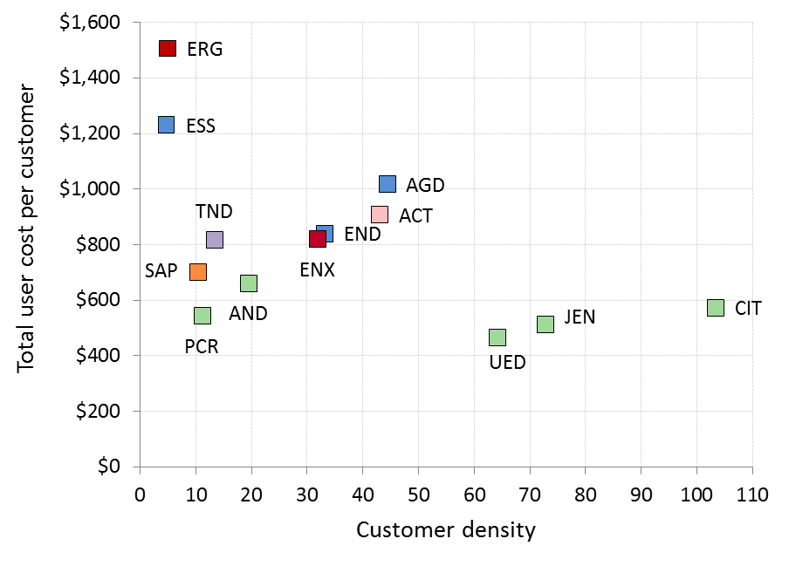

# Conclusions

Productivity across the industry has been declining over the past several years. It is declining because the resources used to maintain, replace and augment the networks are increasing at a greater rate than the demand for electricity network services (measured in terms of increases in customer numbers, line length, energy, and maximum demand).

For the majority of DNSPs, the declining productivity trend has continued in the twelve months between 2013 and 2014. However, some DNSPs have improved their productivity in recent years. As a result, the field has started to narrow. Recent declines in productivity from SA Power Networks and AusNet Services, combined with improvements from Energex and Ergon Energy have resulted in the relative efficiency of eight of the 13 DNSPs being closer than ever before.

The supporting metrics (opex and capital MPFP, the econometric models and the total cost PPI) provide alternative measures of comparative performance. While, in some cases, the best and worst performers on a supporting metric rank similarly to those on MTFP, the supporting techniques do not measure overall efficiency. MPFP and the econometric models examine relative efficiency of total output to one input and PPIs examine the relationship between only one input and one output. Therefore, the results of the supporting metrics, while useful for assessing relative efficiency, will not be the same as they are for MTFP.

Appendices

1. References and further reading

This benchmarking report is informed by several sources. These include ACCC/AER research and expert advice provided by Economic Insights. We retained Economic Insights to assist us with the economic benchmarking relied on in this report and in recent distribution determinations. References to relevant distribution determinations are also included below.

Economic Insights publications

The following publications explain in detail how Economic Insights developed and applied the economic benchmarking techniques used by the AER.

* Economic Insights, Memorandum – DNSP MTFP and Opex Cost Function Results, 13 November 2015
* Economic Insights, Economic Benchmarking Assessment of Operating Expenditure for NSW and ACT Electricity DNSPs, 17 November 2014 ([link](https://www.aer.gov.au/system/files/Economic%20Insights%20%E2%80%93%20%20Economic%20benchmarking%20assessment%20of%20operating%20expenditure%20for%20NSW%20and%20ACT%20Electricity%20DNSPs%20%E2%80%93%2017%20November%202014_1.PDF)).
* Economic Insights, Response to Consultants’ Reports on Economic Benchmarking of Electricity DNSPs, 22 April 2015 ([link](https://www.aer.gov.au/system/files/Economic%20Insights%20-%20Response%20to%20consultants%20%20reports%20on%20AER%20economic%20benchmarking%20-%20April%202015_1.PDF)).

ACCC/AER publications

These publications provide a comprehensive overview of the benchmarking approaches used by overseas regulators.

* ACCC/AER, Benchmarking Opex and Capex in Energy Networks – Working Paper no. 6, May 2012 ([link](https://www.accc.gov.au/system/files/Working%20paper%20no.%206%20%20-%20Benchmarking%20energy%20networks.pdf)).
* ACCC/AER, Regulatory Practices in Other Countries – Benchmarking opex and capex in energy networks, May 2012 ([link](https://www.accc.gov.au/system/files/Regulatory%20practices%20in%20other%20countries%20-%20Benchmarking%20opex%20and%20capex%20in%20energy%20networks.pdf)).
* WIK Consult, Cost Benchmarking in Energy Regulation in European Countries, December 2011 ([link](https://www.accc.gov.au/system/files/Cost%20benchmarking%20in%20energy%20regulation%20in%20European%20countries%20-%20WIK-Consult.pdf)).

AER distribution determinations

In each of the following determinations, the AER applied economic benchmarking to determine efficient total forecast opex.

* AER, Final decision, Endeavour Energy distribution determination 2015–16 to 2018–19, Attachment 7 – Operating Expenditure, April 2015 ([link](https://www.aer.gov.au/system/files/AER%20-%20Final%20decision%20Endeavour%20Energy%20distribution%20determination%20-%20Attachment%207%20-%20Operating%20expenditure%20-%20April%202015.pdf)).
* AER, Draft decision, Endeavour Energy distribution determination 2015–16 to 2018–19, Attachment 7 – Operating Expenditure, November 2014 ([link](https://www.aer.gov.au/system/files/AER%20%E2%80%93%20Draft%20decision%20Endeavour%20Energy%20distribution%20determination%20%E2%80%93%20Attachment%207%20%E2%80%93%20%20Operating%20expenditure%20%E2%80%93%20November%202014.pdf)).
* AER, Preliminary decision, Energex determination 2015–16 to 2019–20, Attachment 7 – Operating Expenditure, April 2015 ([link](https://www.aer.gov.au/system/files/AER%20-%20Preliminary%20decision%20Energex%20distribution%20determination%20-%20Attachment%207%20-%20Opex%20-%20April%202015.pdf)).
* AER, Preliminary decision, Ergon Energy determination 2015–16 to 2019–20, Attachment 7 – Operating Expenditure, April 2015 ([link](https://www.aer.gov.au/system/files/AER%20-%20Preliminary%20decision%20Ergon%20Energy%20-%20Attachment%207%20-%20Opex%20-%20April%202015_0.pdf)).

1. Inputs and outputs

This appendix contains further information on the outputs and inputs used in the benchmarking techniques. The November 2014 Economic Insights report referenced in Appendix A explains and justifies the input and output specifications used in this report.

* 1. Outputs

The techniques in the report measure output using some or all of customer numbers, line length, maximum demand, energy throughput and reliability.

* + 1. Customer numbers

The primary function of a distribution network is providing its customers with access to electricity. Regardless of how much electricity a customer consumes, infrastructure is required to connect every customer to the network. The number of customers, therefore, reflects a significant driver of the services a DNSP provides. We measure the number of customers as the number of active connections on a network, represented by each energised national metering identifier.

Figure 9 shows the average customer numbers of each DNSP over the five year period from 2010 to 2014.

Figure Five year average customer numbers by DNSP (2010–14)



* + 1. Line length

Line length reflects the distances over which DNSPs deliver electricity to their customers. To provide their customers with access to electricity, DNSPs must transport electricity from the transmission network to their customers' premises. DNSPs will typically operate networks that transport electricity over thousands of kilometres.

In this report, line length is measured in terms of the length of 'circuit' or the length of 'route’. Route length is the distance between a DNSP’s poles. Circuit length is the length of lines in service, where a double circuit line counts as twice the length. Circuit and route length can differ because distributors may run multiple lines on the same route.

In economic benchmarking metrics, we use circuit length because, in addition to measuring network size, it also approximates the line length dimension of system capacity. System capacity represents the amount of network a DNSP must install and maintain to supply consumers with the quantity of electricity demanded at the places where they are located. Figure 10 shows each DNSP’s circuit length, on average, over the five years from 2010 to 2014.

Figure 10 Five year average circuit length by DNSP (2010–14)



For PPI metrics, we use route length because we are interested in network size as a means of calculating customer density (measured as customers per km of line length). For this purpose, route length is a measure of a DNSP’s physical network footprint because it does not count multiple circuits on the same route. Figure 11 demonstrates that, for all DNSPs, route length is shorter than circuit length but there is no change in DNSP ranking between the two line length measures.

Figure 11 Five year average route line length by DNSP (2010–14)



* + 1. Maximum demand and energy throughput

DNSPs are required to meet and manage the demand of their customers. This means that they must build and operate their networks with sufficient capacity to meet the expected peak demand for electricity. Maximum demand is a measure of the overall peak in demand experienced by the network. The maximum demand measure we use is non-coincident summated raw system annual maximum demand, at the transmission connection point.

The economic benchmarking techniques use 'ratcheted' maximum demand as an output rather than observed maximum demand. Ratcheted maximum demand is the highest value of peak demand observed in the time period up to the year in question for each DNSP. It thus recognises capacity that has actually been used to satisfy demand and gives the DNSP credit for this capacity in subsequent years, even though annual peak demand may be lower in subsequent years.

Energy throughput is a measure of the amount of electricity that DNSPs deliver to their customers. While energy throughput is not considered a driver of costs (distribution networks are typically engineered to manage maximum demand rather than throughput) energy throughput reflects a service provided directly to customers.

An alternative approach to measuring a distributor's service in meeting the demand of its customers at times of peak demand is to measure system capacity. In this report we do not use this measure because it can potentially advantage large DNSPs on certain metrics. The November 2014 Economic Insights report referenced in Appendix A discusses this in further detail.

Table 2 presents maximum demand and energy delivered for each of the DNSPs, on average, for the five years between 2010 and 2014.

Table 2 Maximum demand and energy throughput (2010–14 average)

|  |  |  |
| --- | --- | --- |
|  | Maximum demand (MW) | Energy throughput (MWh) |
| ActewAGL (ACT) | 662 | 2,886,234 |
| Ausgrid (AGD) | 5,998 | 28,461,862 |
| AusNet Services (AND) | 1,879 | 7,616,404 |
| CitiPower (CIT) | 1,414 | 6,060,130 |
| Endeavour Energy (END) | 3,731 | 16,611,104 |
| Energex (ENX) | 4,837 | 21,350,013 |
| Ergon Energy (ERG) | 3,148 | 13,677,436 |
| Essential Energy (ESS) | 2,625 | 12,044,212 |
| Jemena (JEN) | 979 | 4,323,904 |
| Powercor (PCR) | 2,416 | 10,556,286 |
| SA Power Networks (SAP) | 2,982 | 11,078,469 |
| TasNetworks (TND) | 1,062 | 4,333,489 |
| United Energy (UED) | 2,002 | 7,971,804 |

* + 1. Reliability

Another dimension of the outputs of DNSPs is the reliability of their electricity supply. This is commonly measured as the average number of minutes off supply per customer (per annum) or the average number of interruptions per customer. Figure 12 presents the average number of minutes off supply per customer, excluding the effects of major events, planned outages and transmission outages.

Figure 12 Average minutes off supply per customer (2010–2014)

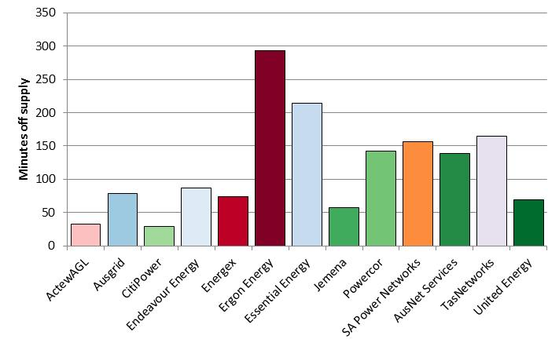

Figure 13 presents the average number of interruptions to supply per customer, excluding the effects of major events, planned outages and transmission outages. There are other measurements of reliability but the frequency and duration of interruptions to supply per customer are the IEEE standard measures for DNSPs.

Figure 13 Average number of interruptions per customer (2010–2014)



* 1. Inputs

The inputs used in this report are assets and opex. DNSPs use a mix of assets and opex to deliver services. Electricity transmission assets can provide useful service over several decades. However, benchmarking studies typically focus on a shorter period of time.

For our MTFP analysis we use physical measures of capital inputs. Using physical values for inputs has the advantage of best reflecting the physical depreciation profile of DNSP assets. Our MTFP analysis uses five physical measures of capital inputs: the capacity of transformers, overhead lines above 33kV, overhead lines below 33kV, underground cables above 33kV and underground cables below 33kV. The MTFP analysis also uses constant dollar opex as an input. The November 2014 Economic Insights report referred to in Appendix A provides further detail on the capital inputs for MTFP.

For the purpose of PPI analysis we use the real price value of the regulatory asset base (referred to as 'asset cost') as the proxy for assets.

Asset cost is the sum of annual depreciation and return on investment. This measure has the advantage of reflecting the total cost of assets for which customers are billed on an annual basis, using the average return on capital over the period. This accounts for variations in the return on capital across DNSPs and over time.

Table 3 presents measures of the cost of network inputs relevant to opex and assets for all DNSPs. We have presented the average annual network costs over five years in this table to moderate the effect of any one-off fluctuations in cost.

Table 3 Average annual costs for network inputs for 2010–14 ($m, 2014)

|  |  |  |  |  |
| --- | --- | --- | --- | --- |
|  | Opex | RAB | Depreciation | Asset cost |
| ActewAGL (ACT) | 73.92 | 764.91 | 40.14 | 82.73 |
| Ausgrid (AGD) | 558.69 | 12,202.29 | 412.88 | 1092.35 |
| AusNet Services (AND) | 171.94 | 2,590.48 | 124.85 | 269.10 |
| CitiPower (CIT) | 53.09 | 1,226.32 | 61.08 | 129.36 |
| Endeavour Energy (END) | 248.62 | 4,906.24 | 241.11 | 514.31 |
| Energex (ENX) | 363.36 | 7,514.82 | 318.73 | 737.18 |
| Ergon Energy (ERG) | 339.93 | 7,097.87 | 318.59 | 713.83 |
| Essential Energy (ESS) | 402.59 | 5,959.63 | 298.50 | 630.36 |
| Jemena (JEN) | 69.22 | 805.72 | 47.94 | 92.80 |
| Powercor (PCR) | 169.59 | 2,203.42 | 111.26 | 233.95 |
| SA Power Networks (SAP) | 213.10 | 3,228.91 | 197.58 | 377.37 |
| TasNetworks (TND) | 81.31 | 1,357.12 | 69.33 | 144.90 |
| United Energy (UED) | 123.11 | 1,613.36 | 88.62 | 178.46 |

Note: Data for the Victorian distributors is for calendar years whereas the data for the other DNSPs is for financial years. RAB values are the average of opening and closing values.

1. Additional PPIs

In this appendix we present some PPIs using alternative output measures (customers, maximum demand and line length).

Figure 14 is a ‘per customer’ reliability metric. It compares the total cost per customer against unplanned minutes off supply per customer. In doing so, it excludes the effect of large, abnormal outage events (known as major event days, or MEDs). MEDs can be unforeseeable, uncontrollable and may affect measured performance.

Figure 14 Total cost per customer ($2014) against unplanned minutes off supply per customer (excluding MEDs, average 2010–14)

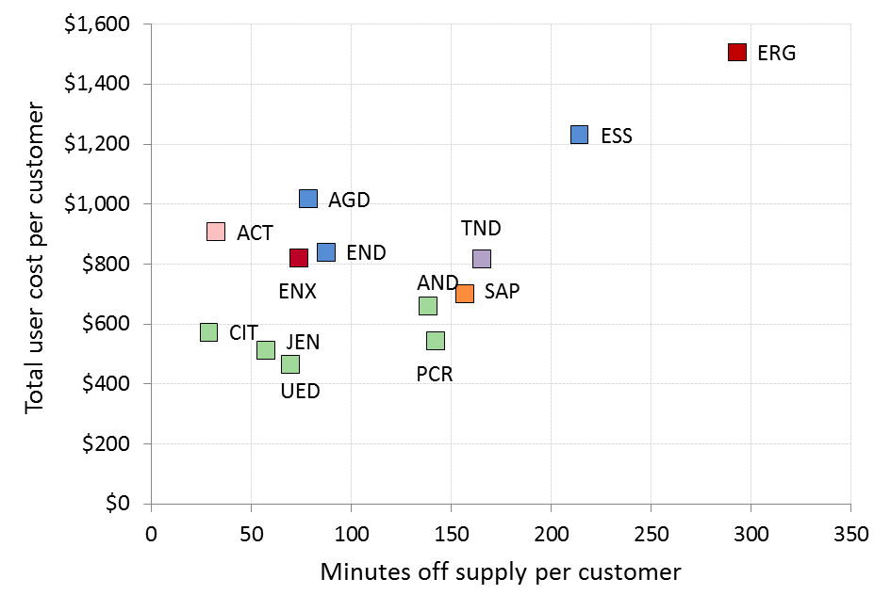

The Victorian and South Australian DNSPs have the lowest cost per customer on this metric. We would expect those DNSPs with greater route line lengths (such as Essential Energy and Ergon Energy) to incur higher minutes off supply per customer, as they need to travel further distances when responding to outages. Ergon Energy's minutes off supply (and its costs), however, are much greater than that of its peers, including Powercor, AusNet Services and SA Power Networks, who also operate rural networks.

Figure 15 shows total cost using MW of maximum demand as the output measure. Maximum demand is a driver of assets because DNSPs install assets to maintain the demand for electricity at peak times. Maximum demand is also an indirect driver of opex because the assets installed to meet demand will ultimately require maintenance (opex).

Figure 15 Total cost per MW of maximum demand ($2014) against customer density (average 2010–14)

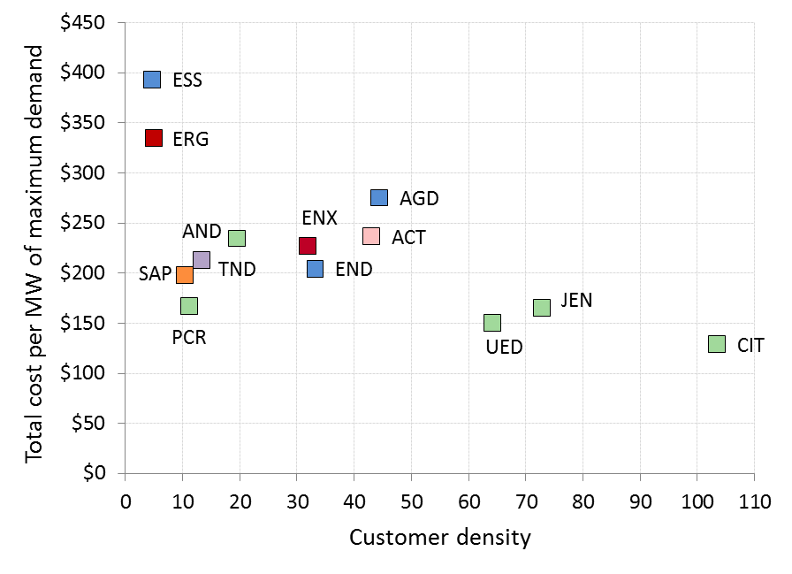

The spread of results on this metric is narrower than for some other metrics. For example, ActewAGL, TasNetworks, Endeavour Energy and Energex spend comparable amounts to AusNet Services and SA Power Networks.

Figure 16 presents total cost per km of line length against customer density. We would expect a strong positive relationship between these two variables because both user cost per km and customer density are normalised by line length.

Figure 16 Total cost per km of route line length ($2014) against customer density (average 2010–2014)

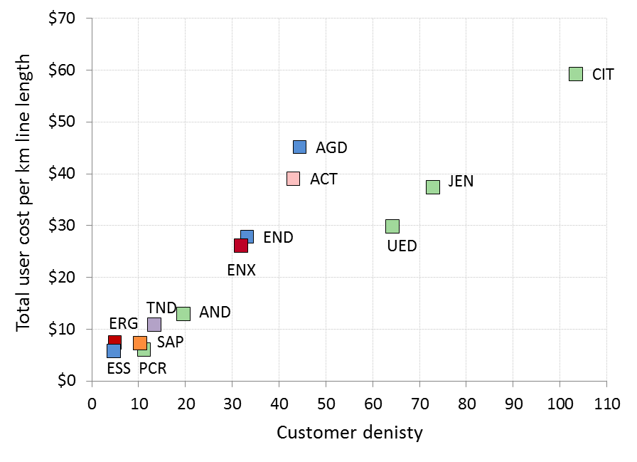

Figure 16 shows this is the case. However, Ausgrid and ActewAGL spend more per km than Jemena and United Energy, who both have a higher customer density. Endeavour Energy and Energex have similar costs to United Energy. Similarly, Ergon Energy and Essential Energy have comparable costs per kilometre to SA Power Networks and Powercor, despite their lower customer density. We would expect each of these NSW, ACT and QLD DNSPs to have lower costs on this metric than their peers with higher customer density.

1. Map of the National Electricity Market

This benchmarking report examines the efficiency of the 13 DNSPs in the National Electricity Market (NEM). The NEM connects electricity generators and customers from Queensland through to New South Wales, the Australian Capital Territory, Victoria, South Australia and Tasmania. Figure 17 illustrates the network areas for which the DNSPs are responsible.

Figure Electricity distribution networks within the NEM

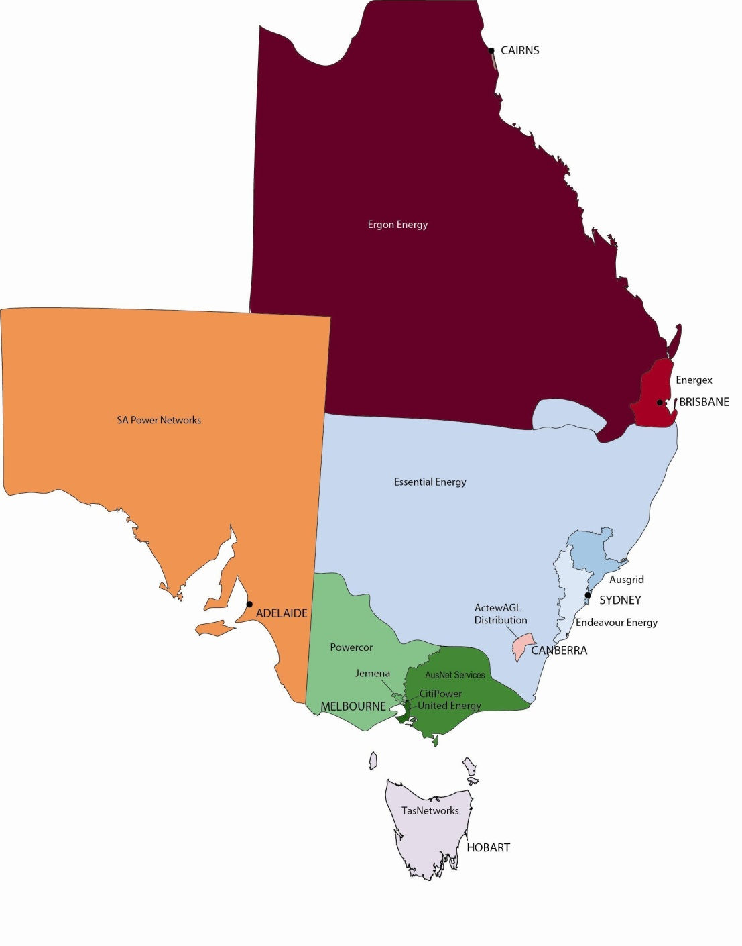

1. List of submissions

We sought comment from DNSPs on a draft version of this report. We received submissions from:

* ActewAGL
* AusNet Services
* CitiPower and Powercor
* Energex
* Ergon Energy
* Jemena
* Networks NSW
* SA Power Networks
* TasNetworks.

All submissions are available on our website.

1. This is particularly the case with opex. However, it is should be recognised that for capex, in some cases, a bottom up assessment is useful in circumstances where a discrete number of projects to be undertaken can be clearly identified.
2. Bottom up techniques are not commonly used. One example, however, is in Spain where the regulator constructs a network reference model. This model designs large scale electricity distribution networks optimally, considering all technical features imposed on the actual distribution networks. The WIK Consult report referenced in Appendix A provides more detail on the Spanish bottom up model.
3. Refer to glossary for definitions.
4. ‘Ratcheted’ maximum demand is the highest value of maximum demand for each DNSP, observed in the time period up to the year in question. It recognises capacity that has been used to satisfy demand and gives the DNSP credit for this capacity in subsequent years, even though annual maximum demand may be lower in subsequent years.