**Submission to the Australian Energy Regulator**

***Qld Electricity Distribution Regulatory Proposals 2015-16 to 2019-20***

**January, 2015**

**Cotton Australia**

Cotton Australia is the key representative body for the Australian cotton growing industry. It helps the industry to work together to be world competitive and sustainable, and also tell the good news about the industry’s achievements. Cotton Australia determines and drives the industry’s strategic direction, retaining its strong focus on R&D, promoting the value of the industry, reporting on its environmental credibility, and implementing policy objectives in consultation with its stakeholders.

Cotton Australia works to ensure an environment conducive to efficient and sustainable cotton production. It has a key role in Best Management Practices (myBMP), an environmental management program for growers. This work has seen a significant improvement in the environmental performance of the industry, with huge improvements in water use efficiency, significant reductions in pesticide use, and millions of dollars invested into R&D.

The Australian cotton industry directly employs thousands of Australian’s and this year will contribute approximately $.5 billion to the Queensland economy, and approximately $1.5 billion to the Australian economy.

Cotton Australia welcomes the opportunity to provide this submission to the Australian Energy Regulator (AER) on the *Qld Electricity Distribution Regulatory Proposals 2015-16 to 2019-20.*

Cotton Australia is a member of a number of organisations that will also be lodging submissions including National Irrigators Council (NIC), Queensland Farmers Federation (QFF), Energy Users Association of Australia (EUAA), and is part of the Alliance of Electricity Consumers.

Cotton Australia has reviewed submissions being submitted by the above organisations, and endorses them. While Cotton Australia is confident that this submission will reflect the views contained in the submissions lodged by the above organisations, if there is any divergence of views expressed then Cotton Australia’s position is the one outlined in this paper.

For further information on this submission please contact Cotton Australia’s Queensland Policy Manager Michael Murray – 0427 707 868 or [michaelm@cotton.org.au](mailto:michaelm@cotton.org.au) .

**General Comments**

Queensland cotton growers have faced extremely large increases in electricity prices over the last decade. Prices have skyrocketed far in excess of inflation, with a very large part of these increases attributed to surging network charges.

The following graph shows an Emerald (QLD) irrigator’s bill from the year 2000, based on set consumption, with the actual tariff applied each year. Over this period the bill has increased from approximately $10,000 to $35,000 or a 350% increase in prices. During this same period the cumulative inflation rate in Australia was approximately 45% or 2.9% per annum.[1]

**Figure 1 – Growth in an Irrigator’s Bill**

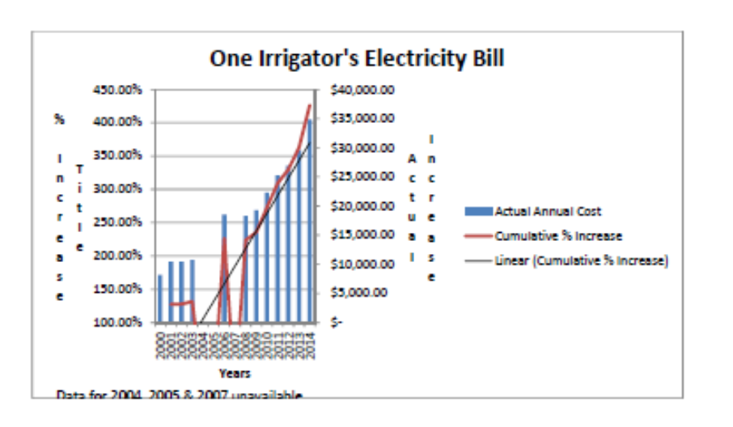

The impost of rising electricity costs is also demonstrated in the following graph prepared by Cotton Australia which shows the annual increases in Tariff 11 (T11) and Tariff 62 (T62), compared to inflation over the past eight years. Tariff 11 is the primary residential tariff.

It should be noted that over this period T62, a popular Tariff for irrigators has increased 82%, while CPI rose just 21%.

**Figure 2 – Tariff Increase vs Inflation**

[2]

It is because of these massive changes and the implications of electricity pricing on our growers, that electricity pricing has become a major policy priority for Cotton Australia over the past 5 years.

Cotton Australia has actively engaged in the Queensland Competition Authority (QCA) Retail Electricity Price Determinations for a number of years, has lodged submissions to the current AER regulatory determination for Essential Energy in NSW, is participating in the current Senate Inquiry into Network Charges, lodged submissions to the recent Australian Government Energy White Paper and participated in a number of electricity related processes.

In regards to the current AER Queensland regulatory determination process, Cotton Australia would like to advise the AER that while all of Queensland’s cotton growers operate in the Ergon Network area, the nature of Queensland electricity pricing means that our growers have a very real interest in the efficiency and final determination that is applied to Energex.

As noted on pg 9 of the AER Issues paper, the majority of Ergon customers pay the same tariffs as Energex customers, although this does not apply to customers whose usage exceeds 100MW/annum.

Therefore Cotton Australia has an interest in ensuring that both Ergon and Energex are as efficient as possible, and deliver significant reductions in network charges during the coming Determination period.

As pointed out earlier, Cotton Australia through various memberships and alliances has had input into numerous submissions made to this stage of the Determination process. Some of these submissions contain a reasonably high level of detail. As such, it is not the intention of Cotton Australia to provide detailed commentary on both the Ergon and Energex proposals.

Cotton Australia would like to acknowledge the AER on its efforts to-date with this Determination to consult with stakeholders, and in particular would like to congratulate it on the formation and funding of the Consumer Challenge Panel (CCP).

The CCP represents a significant step forward. Organisations such as Cotton Australia have limited resources and do not have the time or the technical expertise to delve deeply into much of the data that the Networks provide the AER, and certainly cannot compete in terms of the dollars the network companies spend in preparing their submissions. The CCP provides an opportunity to address that imbalance to some degree.

However, it is also critically important that the AER is resourced in a manner that allows it to test many of the claims made by the network companies.

The history of recent Determinations is that they have all accepted inflated growth in demand figures, and this to a large part has been responsible for high levels of capital expenditure. We, and the community at large, have very justifiable concerns about the “gold-plating” of assets, and we must have confidence that the AER has the technical ability and commitment to properly determine what is prudent and efficient expenditure.

**Specific Comments**

***Capital Expenditure***

Cotton Australia notes that both Ergon and Energex are proposing modest reductions in capital expenditure during this regulatory period, 18% and 33% respectively.

However, this must be viewed with regards to the very high levels of CAPEX that have been allowed over the past few Determinations.

Increases in required reliability standards, and unfulfilled optimistic peak demand forecasts fuelled high levels of CAPEX. Not only is there a compelling case for significant reductions in CAPEX, but it also must be realised that this massive historical over-expenditure now forms part of the RAB, and contributes significantly to higher prices.

Cotton Australia acknowledges that in some areas Ergon still has Peak Demand issues, but overall as demonstrated in the following graphs system utilisation is falling.

**Figures 3 & 4 – System Utilisation**



[3]

So while Ergon may be able to make a case for further augmentation in very specific areas, there is no wholesale need for further augmentation. Where augmentation maybe justified, Cotton Australia strongly believes that AER must test Ergon and Energex claims, and ensure that alternative solutions such as Demand Management programs or local peaking generation options have been fully considered.

Cotton Australia also notes that both providers have made claim for considerable expenditure for replacement CAPEX.

Over the years there has been a considerable trend upwards in Replacement CAPEX, and by analysing the following graph on the age of Energex assets, there is a strong case that it should have peaked as there is now a very consistent trend downwards on the average life of assets. The networks cannot argue that they need to spend more due to an aging assets base.

**Figure 5 – Average Life of Assets**



[4]

***Regulatory Asset Base***

While Cotton Australia understands that the RAB is determined by set rules, and the AER must accept the resulting calculation, it is extremely concerned about the constant growth in the RAB, and the consequential growth in revenue that is driven through the combination of the RAB and the WACC. Cotton Australia believes that the AER has a responsibility to comment on the way the RAB is calculated, and provide recommendations for change.

In particular, as stated above, the acceptance of overly optimistic demand forecasts in previous determinations, fed unjustifiable capital expenditure. Earlier graphs have demonstrated both networks have consistently and significantly falling system utilisation performance. Capital has been spent and not utilised.

It is completely unfair that the consumer should have to bear the risk for this imprudent and inefficient expenditure. There is an urgent need for a review of the asset base, with particular emphasis on the treatment of “un-utilised” or “under-utilised” assets.

Cotton Australia also struggles to understand the justification for allowing an annual adjustment for CPI on the RAB. While the principle would apply across all assets, it appears likely that a long-life assets such as a pole may still have a value assigned to it that is close to its original cost, at the end of its life, because the average CPI rate is likely to be similar or greater than the annual depreciation rate for such an asset.

The extent of the growing RAB problem is well-illustrated in Figures 9 & 10 of the AER Issue paper, reproduced below.

**Figure 6 - Energex – regulatory asset base (RAB) values ($nominal)**

[5]

**Figure 7 -Ergon Energy – regulatory asset base (RAB) values ($nominal)**



[6]

It is clear from the above graphs that unless the growth in the RAB is curtailed, a key component of the revenue calculation will continue to grow, even when capital investments eases. This process provides no comfort to consumers, and is a clear example of perverse outcomes that occur with monopolistic providers.

***Operating Expenditure***

Cotton Australia notes that both Energex and Ergon have proposed modest reductions in operational expenditure, however the AER benchmarking process shows that both organisations in general and Ergon in particular perform well below their peers.

The networks need to be driven to implement a “root and branch” reform of their operating practices and systems.

Cotton Australia notes the significant reductions in operating expenditure that the AER has proposed in draft Determinations for organisations such as Essential in NSW, and cannot see why similar reductions should not be placed upon Ergon and Energex.

It is extremely difficult for organisations such as Cotton Australia to point to specific areas of operational costs savings.

However, a pricing model that does not force efficiencies onto monopolistic organisations will always result in high and inefficient operational costs. It is therefore important that the AER proposes significant reductions, which put the network operating costs in line with the best of their peers.

It is only when the challenge is laid in front of Ergon and Energex that the breadth of savings that are possible will be achieved.

***Rate of Return***

As mentioned throughout this submission Cotton Australia is acutely aware of the role played by the WACC in determining the total Revenue allowance for network companies.

Cotton Australia contends that the WACC applied in the previous Determination was not only patently too high, but its setting at the level of 9.72% provided hundreds of millions of dollars of windfall gain to the network companies. This is due to expected high interest rates predicted following the GFC failing to eventuate in both the short to medium term.

Therefore, there is a strong argument that the WACC for this current Determination should be set somewhat lower than what it might otherwise be determined to be, to allow some recovery of this over payment.

Cotton Australia does not have the in-depth economic expertise to determine a WACC, but makes the following comments for the AER to give regards to:

* Cotton Australia understands that the CCP believes that the draft WACC applied to Essential and other recent Determinations is still too high, and a WACC in the 6-7% range would fall within the application of the AER’s WACC setting Guidelines.
* Compared to many businesses, the networks are very low risk business, and therefore a lower WACC would be appropriate.
* Shifts in Australian interest rates since the setting of the last Determination would suggest a minimum reduction of three percentage points from the last Determination (see Figure 8).

**Figure 8 – Australian cash rate**

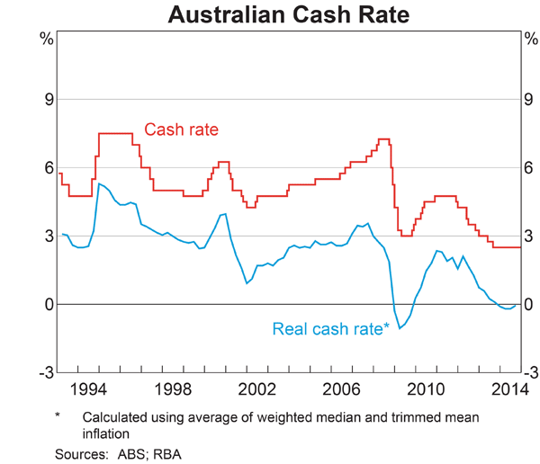

**[7]**

***Taxation Allowances***

Cotton Australia calls on the AER to closely examine the way it determines allowances for taxation equivalents and the like.

Cotton Australia understands that there is significant evidence that the allowance has far exceed actual tax paid by privatised networks. This suggests that their maybe a systemic overestimation.

***Consumer engagement***

Cotton Australia would give Ergon and Energex a pass mark for Consumer Engagement. We believe that have made an effort, but the reality is that given the timeframes, the complexities of their businesses, limited resources in organisations like ours, it is extremely difficult to get a full appreciations of their business.

***Final comments***

The bottom line is that irrigators and cotton growers, and indeed all users of electricity are sick and tired of paying inflated prices for electricity.

The networks are established businesses, and while Cotton Australia well understands that cost increases almost never track directly with inflation, the huge disparity between electricity cost increases since 2000 and inflation point to an absolutely fundamental flaw in pricing of electricity and network services.

It is time for the AER to draw a line in the sand, and force a significant downward reset in electricity network revenues and therefore pricing.

1. Source Cotton Australia
2. Source Cotton Australia
3. Hugh Grant – AER CCP
4. Source Hugh Grant – AER CCP
5. AER Issue Paper Pg 19
6. AER Issue Paper – Pg 20
7. Source Reserve Bank of Australia