Eastern 2014 Pre-Reinforce Knox

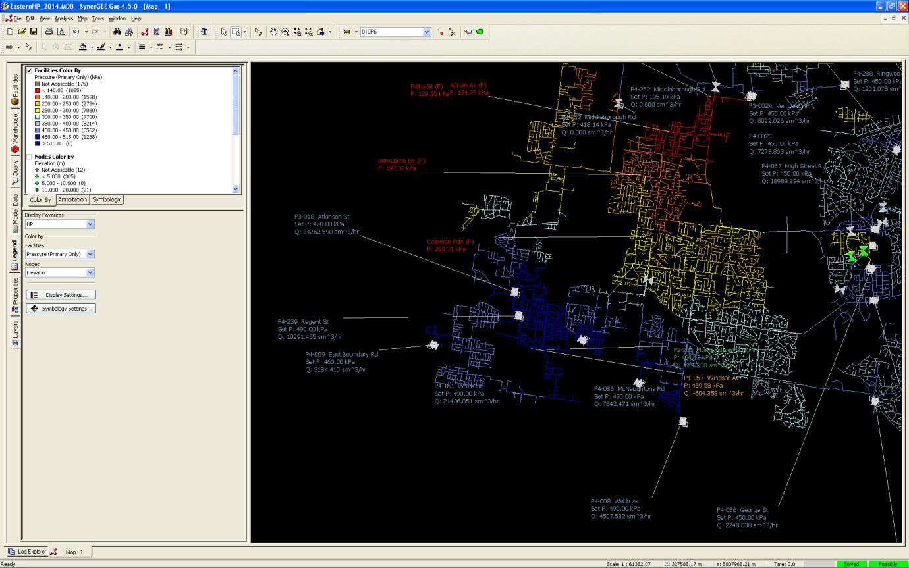

Eastern 2014 Pre-Reinforce Ringwood

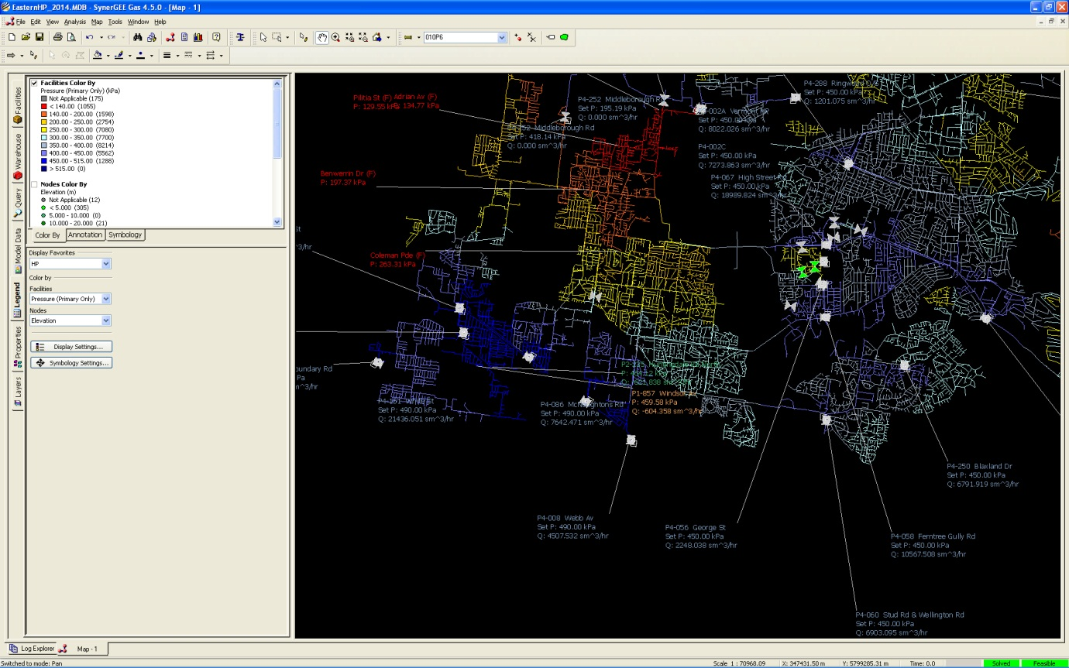

Eastern 2014 Post Ringwood

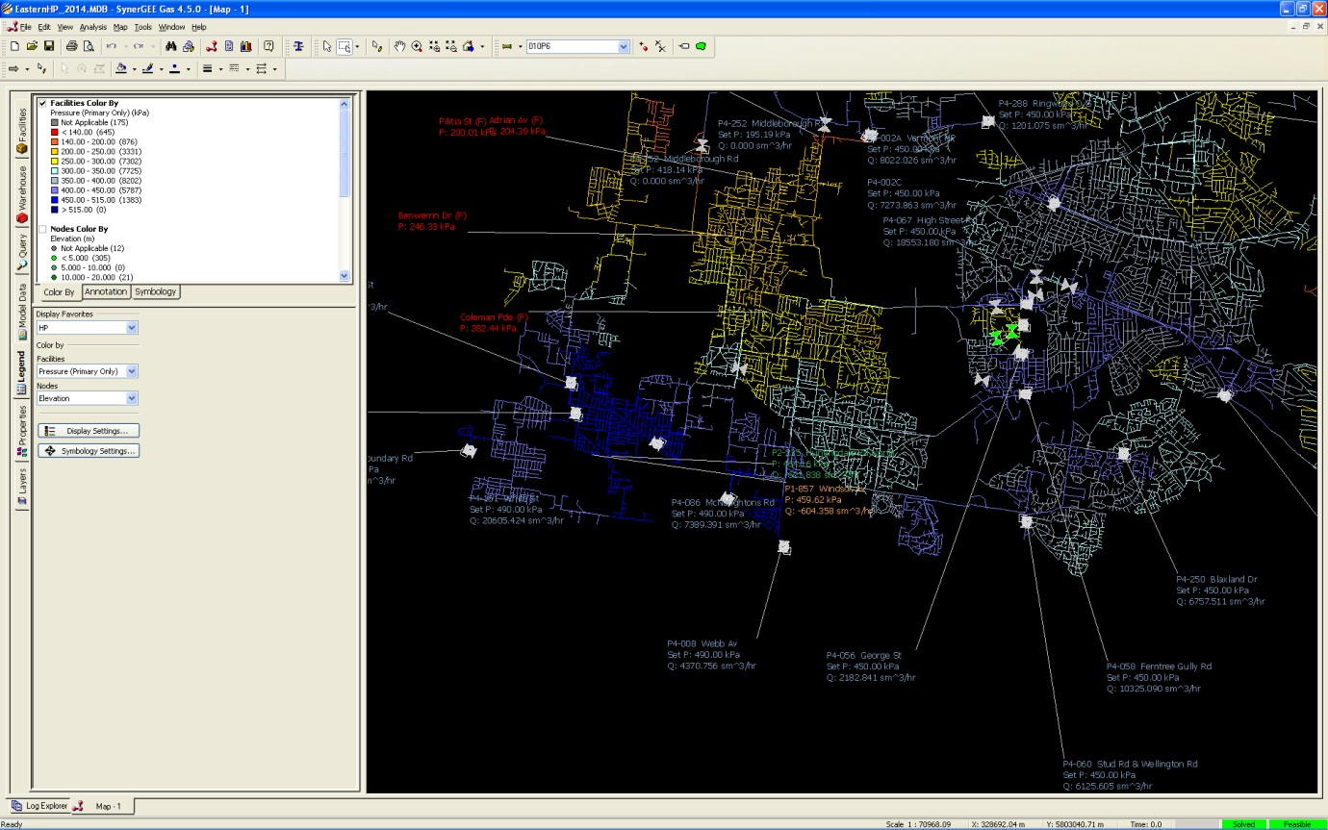

Central HP 2014 Pre-Reinf South Melbourne

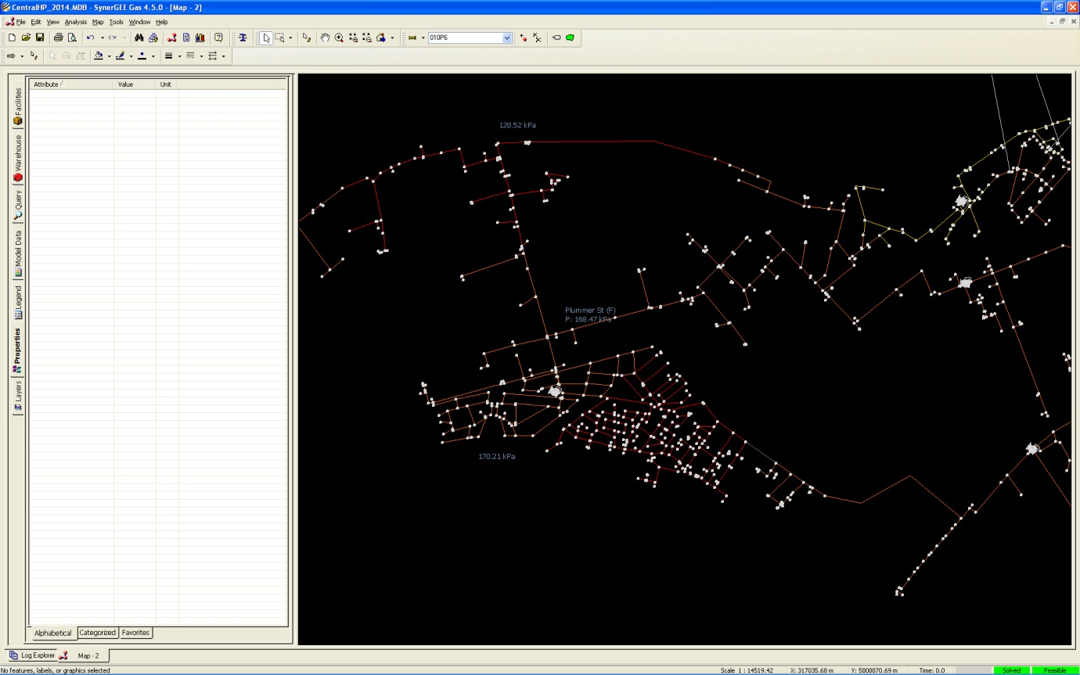

Eastern HP 2015 Pre-Reinforce Knox

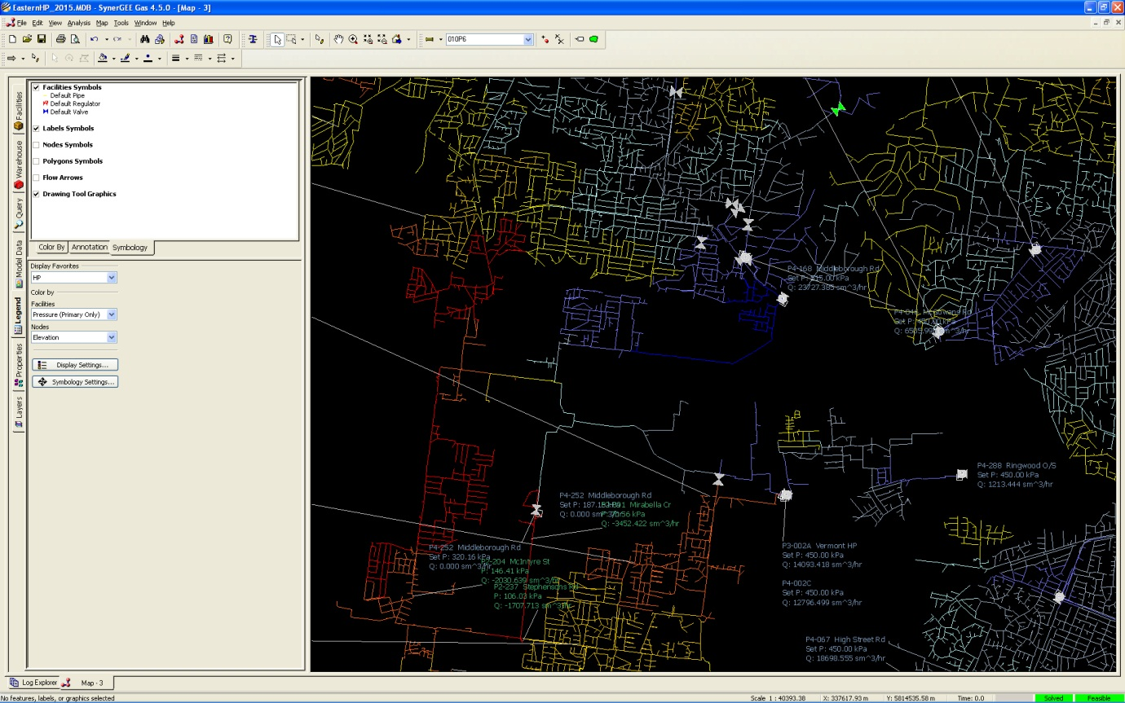

Eastern HP 2015 Pre-Reinf Nunawading

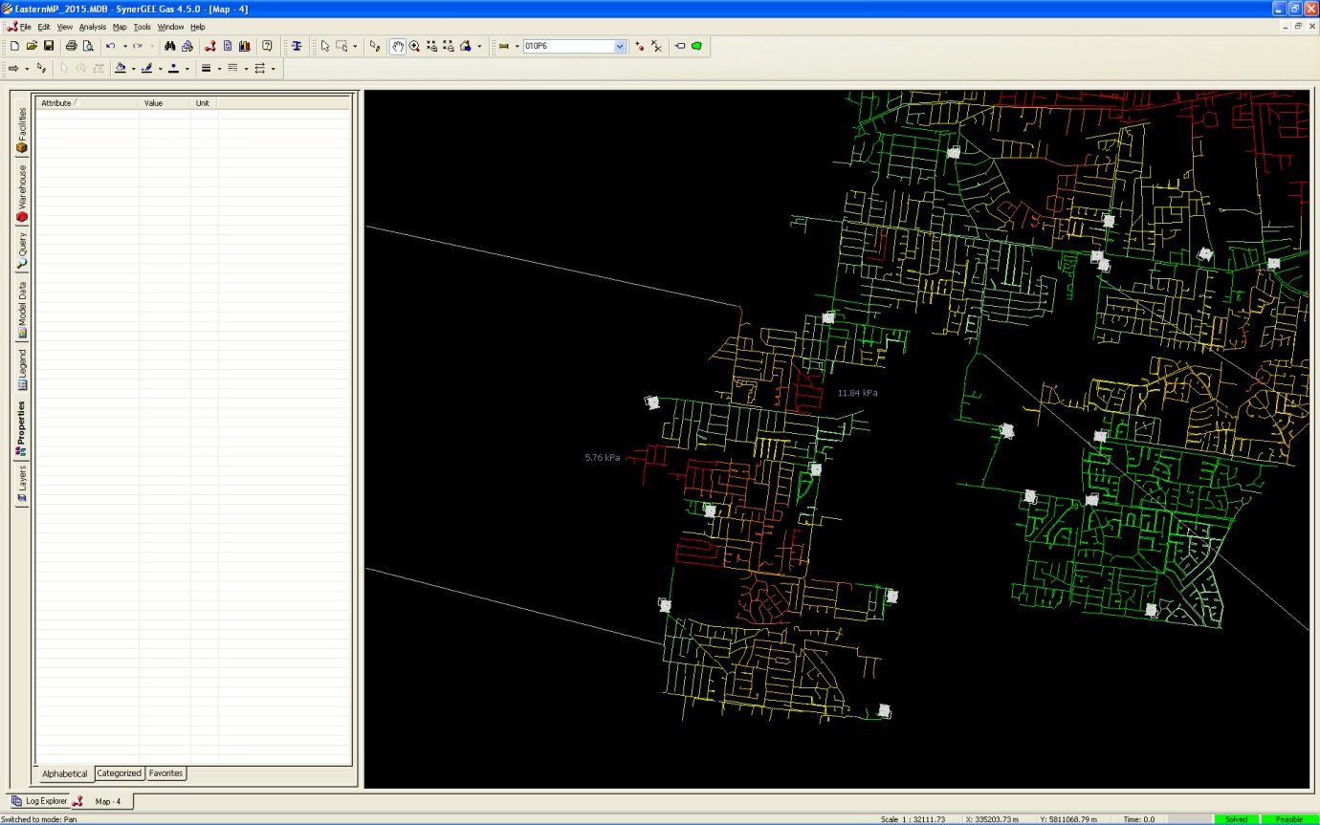

**General**

Multinet’s expenditure in the previous period accepted by the AER is $45.2m (p32 part 2). Multinet’s forecast for 2012 for augmentation is $11.7m compared to the AER accepted figure of $5.2m. Taking this into account Multinet’s actual expenditure for augmentation in the previous period is $51.7m. Multinet submitted a forecast for augmentation of $35.1m for the 2013 – 17 access arrangement period and the AER draft decision cut this by 79% to $7.4m.

Augmentation capital is driven by peak load growth which is relatively consistent within the Multinet territory. Expenditure from year to year is variable depending on the timing of particular projects; however over the medium term the average tends to be relatively consistent. To expect that Multinet can move from a previous spend of $51.7m to $7.4m whilst sustaining similar load growth is beyond credibility. If this decision is to stand and Multinet restricted augmentation capital to this level then the AER can expect that very significant capacity related supply interruptions will be experienced over a wide range of the Multinet territory over the 2013 – 2017 period and potentially for several years into the next period. The reason for the AER rejecting the vast majority of augmentation projects seems to be based on the AER consultant’s narrow view that each project has to be considered on an individual basis and interrelationships with other projects, supplied and supplying networks and adjacent network impacts can be ignored. Although the impact of these factors is complex and difficult to describe, completely discounting them will have drastic adverse effects on the reliability of the Multinet network. Many questions were received from the AER’s consultant asking what “business cases” had been approved for augmentation projects.

It should be noted that forecasting augmentation projects with accuracy is increasingly difficult as the forecast period extends beyond the next two years. Too many variables exist to be able to justify forecast projects in year 5 with more than a low to moderate degree of certainty. Based on the AER’s approach in the draft decision this means that a forecast of zero is the appropriate forecast where a moderate degree of uncertainty exists or projects cannot be justified to “business case” standards. Although we acknowledge an increasing degree of uncertainty as time proceeds within the forecast period around specific projects, this is not to say that no augmentation will be required in the later years of the forecast period. Even though uncertainty exists and is acknowledged for specific projects we know that augmentation will be required in the latter years. Hence a forecast of zero cannot be said to be the best forecast in the circumstances.

**Approach**

The collective capital expenditure items presented in the Multinet submission provide the most cost effective expenditure program and profile when a timeline of 5 to 10 years is considered. Consequently, when assessing the effects of an individual reinforcement item in a particular year it may appear to either under or over reinforce a particular network in the shorter term. The alternative approach favoured by the AER’s consultant requires the promotion of reinforcements based on modelling of discreet networks in isolation. This approach would equate to a significantly larger program scope, estimated at more than double that proposed in this submission.

The optimal expenditure program is the result of countering a multiplicity of network changes in the form of: imposed forecast load growth; network load transfers post MP – HP up-rating and LP-HP upgrading; network re-segregations and the interactive impacts of each reinforcement item itself with others in ‘network proximity’ to it. The cases where this complexity is most apparent are those in which, post reinforcement outcomes across multiple networks need to be interpreted to appreciate the overall net benefit. Hence, assessment of post reinforcement models, at times show that one or more networks suffer a loss in capacity, but to a lesser aggregate extent than the dominant benefit(s) of one or more networks, ensuring an overall positive reinforcement outcome.

E.g “Nunawading MP – HP 2014” is an MP – HP up-rating/replacement scope which reinforces the depleted MP network by ‘elimination’ of MP main, i.e. a transfer of mains and consumers to the HP network from the MP network is achieved. However, this scope also significantly reinforces all three of the Oakleigh, Vermont and Knox HP networks through the inclusion of corresponding amounts of additional mains, formerly in the MP network, subsequently operating at HP in those networks. Consequently, it can often be the case, the aggregate benefits of the expenditure associated with any single item is not easily discerned from point state depictions of one or other network in isolation.

It should be noted the year forming part of the models’ names as provided, do not at times align with the calendar year of the expenditure. This has arisen from the need to include impacts of anticipated load transfer of the ensuing winter year load for which the project in question is an essential precedent e.g a 2014 item referring to a Post 2015 model to appreciate the benefits of the augmentation works.

**Planning Criteria and current state of networks**

The Multinet Network Planning Criteria is to plan capacity only for a mildly cold day (1 in 2 year), ie a day of coldness that could on average be expected to occur every two years. Obviously Multinet’s system will experience many instances of weather colder than this standard and without some additional buffer; capacity related outages would be a regular occurrence. The additional buffer is provided by applying the planning criteria while setting the outlet pressure of high-pressure field regulators at 450 kPa. The high-pressure field regulators can in fact be set as high as 490 kPa which provides some extra capacity. During weather colder than the “1 in 2 year” standard, the outlet pressures are adjusted higher to cope with the additional load. This additional buffer gives an overall Planning Criteria equivalent to about a 1 in 10 year event (when outlet pressure of high-pressure field regulators are set at their maximum of 490 kPa) which is more consistent with societal expectations of reliability from utility services.

See below extract of the Multinet Planning Criteria (a copy was provided as an appendix to the Capital Growth Plan):

***Weather Standard***

*The level of coldness benchmark for which the networks are assessed is a day of 4.8oC Effective Temperature which has been statistically shown to equate to the level of coldness expected to be experienced once every two years. The standard is therefore sometimes referred to as a ‘one in two, day’ (1:2, Day).*

*This standard ‘Effective Temperature’ takes into account sun hours, wind speed, ambient temperature and seasonal usage patterns.*

***Operating Pressure Standard***

*Network supply (operating) pressures are set to their scheduled ‘Normal Maximum Operating Pressures’.*

*These are typically as follows for the various pressure categories:*

*Low Pressure: 2.5 kPa*

*Medium Pressure: 60 kPa*

*High Pressure 450 kPa*

*Sub transmission 840 kPa*

*Transmission 2760 kPa*

*Statistically days colder than those corresponding to a 1:2 day will occur. The corresponding level of gas load is met by utilising a ‘failsafe setting’ function on SCADA controlled regulators.*

In many instances where augmentation has been proposed (and rejected in the AER draft decision), outlet pressures of many of the high-pressure field regulators supplying the subject areas have already been set higher that the 450kPa specified in the Planning Criteria. This means that the networks supplied by these networks already have insufficient capacity to cope with a 1 in 10 year cold day, ie some component of the buffer has been used up to satisfy load growth. Where this has occurred the individual high-pressure field regulators have been listed together with their current settings for each relevant project below:

**AER rejected augmentation capital expenditure ($'000, 2012)**

|  |
| --- |
| **2013 Knox HP (MP to HP) $1,850k** |
| AER comment: |

*Information shows fringes pressure above regulatory minimum so no demonstrated need for augmentation.*

Multinet response:

Further to the strategic benefits contained in the opportunity brief, the proposed works assist in the removal of deteriorated main in the MP system and avoids the need for MP reinforcements. These works also enable a reduction in operating pressure to 450kPa to meet the Design Standard “System Minimum Pressure” for HP networks of 140 kPa when supplied at 450 kPa from the regulated sources on a 1:2 year level of coldness event.

See the attached modelling diagram: EasternHP_2014_Pre-Reinforcement_Knox.jpg This shows the network operating at well above 450kPa.

These reinforcements in the form of MP upgrading anticipate load growth in the coming years for which reinforcement would be required.

6 of 9 high-pressure field regulators currently operate above 450kPa (see yellow highlighting).

|  |  |  |  |
| --- | --- | --- | --- |
| **Knox HP (VC)**  **H02** |  | **PRESSURE [kPa]**  **01.Oct – 14.May** | **PRESSURE [kPa]**  **15.May – 30.Sep** |
| George St | P4-056 | MTL 450 (Failsafe 440) | MTL 490 (Failsafe 515) |
| Webb Av | P4-008 | MTL 450 (Failsafe 440) | MTL 490 (Failsafe 515+) |
| McNaughtons Rd | P4-086 | MTL 450 (Failsafe 440) | MTL 490 (Failsafe 515) |
| White St | P4-161 | MTL 450 (Failsafe 440) | MTL 490 (Failsafe 515) |
| Stud Rd & Wellington Rd | P4-060 | MTL 450 (Failsafe 440) | MTL 470 (Failsafe 490) |
| Ferntree Gully Rd | P4-058 | MTL 450 (Failsafe 440) | MTL 450 (Failsafe 470) |
| High St Rd | P4-067 | MTL 450 (Failsafe 440) | MTL 450 (Failsafe 440)  -ve 50kPa Bias |
| Blaxland Dr | P4-250 | MTL 450 (Failsafe 440) | MTL 470 (Failsafe 490) |
| Boronia Rd | P4-053 | MTL 450 (Failsafe 440) | MTL 450 (Failsafe 440) |

In addition 6 of 9 high-pressure field regulators have a single-run design capacity below 70% of required winter throughput (i.e. dual-run SCADA-based operation cloaks this significant deficiency.) See Blue Highlights in the above table.

The absence of pipe work of sufficient capacity to carry an increased biased load out from any such regulator is a weak link which is partially addressed with these reinforcements.

Consequences:

To not undertake this work would equate to accepting high-levels of supply capacity risk, the consequences being:

* escalation of outages and poor supply in both the MP and HP networks (>100 in year 2014 and increasing).
* Inadequate pipework downstream of significant supply regulators to ensure a measure of biasing can be undertaken when necessary.
* Continued operation at >450kPa for HP and a need for elevating MP supply at many sources from 60kPa to 70kPa with the consequential risk associated to this.

This project includes transfer of load to Mulgrave HP. See Mulgrave HP below:

|  |
| --- |
| **2013 Mulgrave HP $331k** |
| *AER comment:*  *No expenditure was proposed for this project.* |

Multinet response:

Akin to the reinforcement above, this enables Knox HP to be operated at closer to 450kPa supply pressure.

The principal aim is to transfer load to Mulgrave HP from Knox HP.

Placing the former AFL park area load onto the Mulgrave system and reinforcing it to support the load is is cost effective and strategically prudent. Load is also transferred away from the inner ring main.

Refer to:

EasternHP_2014_Pre_Reinforcement_Ringwood.jpg, Pilita Av- Red Area <140 kPa

EasternHP_2014_Post_Ringwood.jpg, Pilita Av 200 kPa.

Consequences of not proceeding: See Knox above.

|  |
| --- |
| **2013 Tooronga HP Darling Rd Outlet Grid (#1) $1,251k** |
| AER comment:  *Pre-solution pressure at Kilby Rd regulator is 133kpa and at Wilsmere Rd regulator is 135kpa. Post solution pressure is the same. Hence the effectiveness of the proposed augmentation is not demonstrated.* |

Multinet response:

Refer Central HP- Pre/Post – 2014_ Tooronga HP

This is the first section of four sections of an extensive progressive reinforcement. This first section benefits the network locally; however, the significant pressure restoration at the northern fringe will not be achieved until all 4 sections are constructed and commissioned.

These sections correspond to “Tooronga HP Darling Rd Outlet Grids 1 to 4”. It is noted that the AER has approved stage 4 of this reinforcement but not stages 1 to 3. The AER position does not make sense.

Most importantly the load growth over consecutive years with the corresponding complete reinforcement is a better indicator of the final outcome.

It is assessed to be cost ineffective over the longer term to construct a lesser than 300 mm mains over such extensive difficult routes that would require duplication at a later date. Consequently capacity is inevitably surplus over intervening particular years.

Current operation above 450kPa. As shown in the previously provided screenshot, McKinley Av regulator at 517.4kPa and Ewart St at 461.4kPa (failing to hold 490kPa on account of depleted regulator capacity).

|  |  |  |  |
| --- | --- | --- | --- |
| **Tooronga HP (SC)**  **H43** |  | Note: Now topped-up by the one-way valve from Doncaster HP in Doncaster Rd. | |
|  |  | PRESSURE [kPa]  01.Oct – 14.May | PRESSURE [kPa]  15.May – 30.Sep |
| McIllwrick St | P4-280 | 350 (High Setting 420) | 460 (High Setting 470) |
| Ewart St (840kPa) | P4-113 | 360 (High Setting 430)  See also Moorabbin HP |  |
| Ewart St (2760kPa) | P4-100 | 340 (High Setting 420) | 450 (High Setting 515) |
| McKinley Av (840kPa) | P3-008 | 350 (High Setting 410) | 455 (High Setting 470) |

This elongated network is very sensitive to small changes in supply pressures. Note that point state modelling demonstrates a static condition. Many models with incremental load and supply pressure changes would be needed to provide an indication of network sensitivity.

Consequences:

An escalation of outages and poor supply occurrences in the HP network (>1350 in year 2014 and increasing by year if at 450kPa operating pressure).

Introduction of a new source at Darling Rd (2012/13) requires large diameter outlet mains to distribute gas long distances northwardly (approximately 12km) across this very elongated network.

In the absence of these mains, inadequate pipe work downstream of this new significant supply regulator is available to ensure a measure of biasing can be undertaken when necessary.

Provision of additional high pressure network capacity in anticipation of replacement upgrading and load transfers in future years is imperative.

If a complete program is not achievable in which it is envisaged accomplishment of the entire scope comprised of a new supply source and four staged grid constructions, or if the program were to be extended over a period greater than the manageable concentrated period of four years as submitted, acceptance of year by year escalation of widespread poor supply and outages occurrences must be expected.

**2013 Queens Wharf Rd 1050kPa CTS & PRS $1,200k**

|  |
| --- |
| AER comment:  *No information is provided on the pre and post regulator pressures so the proposed augmentation has not been justified.* |

Multinet response:

This is a new supply point into the current 840 kPa network to ensure capacity / fringe integrity rather than more augmentation via the construction of 840 kPa network ‘duplication. Without further investment on upstream network capacity it is anticipated the current 840 kPa network cannot be increased to an MAOP of 1050 kPa within the 2013-18 period. This renders the need for an extra network supply point more urgent to enable 450 kPa outlet pressures to be reliably maintained with reduced inlet pressures. Alternatively, less cost effectively: Existing supply point augmentations for regulators and CTS’s, plus additional outlet mains augmentations of several kilometres, would be required.

This need for this additional supply point or alternative ‘duplication’ of 840 kPa network is exacerbated by the capacity limitation of the Aughtie Dr Supply point regulators. See Below.

|  |  |
| --- | --- |
| **2013 Aughtie Dr CTS & PRS Augmentation $650k** |  |
| AER comment:  *Pre-solution pressure at Boral is 123.8kpa and at Kraft Foods is 138.0kpa. Post solution pressure at Boral is 127kpa and at Kraft Foods is 140kpa. Hence the effectiveness of the proposed augmentation is not demonstrated.* | |

Multinet response:

The AER comment above refers to the downstream South Melbourne/Southbank HP network rather than the issues directly influencing Aughtie Drive.

The drivers described above for Q.W.R also apply to this claim for Aughtie Drive.

We are also most concerned with added forecast flow tripping over the Ultrasonic meter into non registration > 120% levels, especially when biasing load away from Dandenong to avoid BOC letdown gas lockout. It is clear the CTS will need augmentation. Considering the minimum obligation pressure AEMO quote as permissible rather than the typically experienced inlet pressure, the CTS would need to have been upgraded over ten years ago.

This is demonstrated when comparing the actual data in the graph below of 2011 throughput and inlet pressure May – Sept 2012 to the capacity of the meter.

Peak Flow (Green) 120,000+ Sm3/h

Minimum Inlet Pressure (Blue) 2350 kPa

AEMO / APA GASnet Minimum Obligation Pressure 1800 kPa

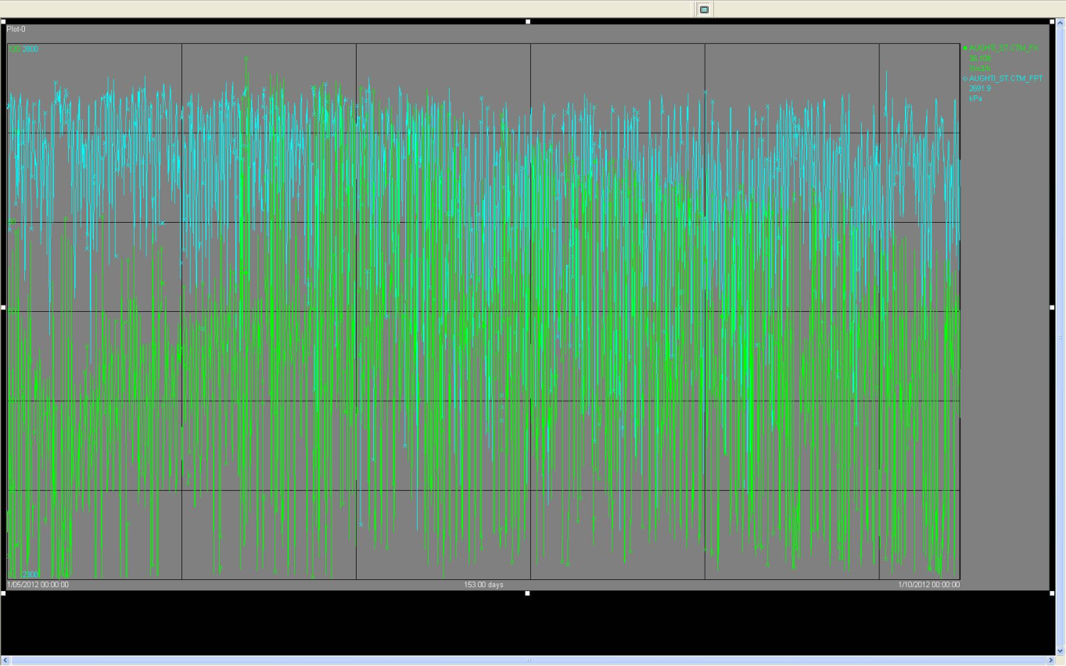

See page 30 in the APA GASnet Metering Report 2011 for Multinet Gas supplied transfer points for the meter capacity characteristic.

Note: The APA GASnet report contains significantly lower flow data, pre-biasing of flow to Aughtie Drive, pre-840 kPa operation for 2010 throughputs.

The extensive amount of peak flow values above 70,000 Sm3/h is evident in this older 2010 data. The regulators at single run operation cannot do more than 70% of unbiased peak flow (least taxing, no biasing to Augthie Drive case from DTS or Highett). This has been worsening significantly in recent years, the reinforcement imperative escalating post experiencing a protracted ESV involved delay in increasing the current 840 kPa MAOP operating limit to 1050 kPa. The ability to increase the MAOP from 840 kPa has been limited by the DTS source outlet pressure limit of 680 kPa.

Valve reconfiguration enabling isolation of DTS from the 450 mm to Augtie Drive from DTS is being undertaken. The elimination of this inflexibility will counter the constraint represented by the BOC injection pressure of letdown gas from the “BOC gas pressure driven electrical generator”.

Consequences:

Failure of one regulator sleeve would result in a required flow of 120,000 Sm3/h to be restricted to approximately 70,000 Sm3/h with significantly reduced outlet pressure from 840 kPa to an anticipated pressure <700 kPa. Large numbers of widespread consumers downstream of regulators supplied by the 840 kPa network would consequently experience Poor and No Gas Supply occurrences. Estimate : 2,000 consumers.

**2013 Moorabbin HP $421k**

|  |
| --- |
| AER comment:  *As part of the central HP network (as per Aughtie Dr) the effectiveness of the proposed augmentation is not demonstrated.* |

Multinet response:

The screenshots provided corresponding to “Pre/Post Central HP 2015”, demonstrate pressures improved significantly. See legend on the left of the screenshot. Pressure improvement by 100kPa+, from ~140kPa (red).

The mains upgrading program for this area makes it prudent to bridge this incomplete grid with large diameter in anticipation of load increase and redistribution in the ensuing years.

Consequences:

Poor supply outcomes are envisaged in this area of the network without this reinforcement commencing in 2015.

|  |  |  |  |
| --- | --- | --- | --- |
| **2013 South Melbourne HP (Port Melbourne MP to HP) $1,556k**   |  | | --- | | AER comment:  *No information is provided on the pre and post regulator pressures so the proposed augmentation has not been justified.* |   Multinet response:  The Port Melbourne MP network experiences sub 15 kPa System Minimum Pressures. This is below the minimum standard required for MP networks to maintain supply. The upgrade serves to alleviate the MP network and simultaneously reinforces the South Melbourne HP network into which the up-rated/upgraded mains at HP will be incorporated.  The models provided had not shown the impact of native growth on the HP network in the absence of the upgrade benefits.  Attached is another model, “Central HP Pre Reinforcement_Sth. Melb_2014” in which the HP network is loaded without the upgrade (mains disabled) augmentation benefit, making apparent the sub-standard 140 kPa areas.  As depicted in the provided screenshots, load would be transferred from the MP system supplied out of the South Melbourne Outstation (MAOP 840 kPa inlet) onto Albert Rd HP regulator which supplies an additional 200Sm3/h.  This large diameter HP grid and numerous 63P8 interconnections and replacements are necessary for the accomplishment of the upgrade which can only occur cost-effectively if undertaken as one project.  Consequences:  Ongoing operational risk and supply risk of aged MP and LP mains that would otherwise be decommissioned.  Inability to connect large apartment complex loads to HP avoiding increased reliance on LP and MP with greater rework cost associated with deferment of same to HP for their decommissioning.  **2013 Nunawading MP (Various MP to HP) $1,121k**   |  | | --- | | AER comment:  *No information is provided on the pre and post regulator pressures so the proposed augmentation has not been justified.* |   Multinet response:  The expansive Nunawading MP network is progressively taxed by increasingly large apartment style point loads. It is economically marginal to effect connections to the MP network when compared to the numerous benefits of HP expansion, replacement and improved HP network interconnection benefits that arise. Universally the provision of greater than 1.1 kPa and smaller less capital intensive infrastructure renders such a strategy invariably superior.  The benefits of this augmentation are essentially twofold. The reinforcement of both the Oakleigh and Vermont HP networks.  See “Eastern HP Pre Reinforcement_Knox_ HP_ 2015” (Red indicating less than 140 kPa) and  The reinforcement of Nunawading MP.  See Attached: “ Eastern MP Pre Reinforcement_Nunawading MP_ 2014”. (Red indicating <15 kPa)  Consequences:  This MP area has several pockets of marginal pressure well below system minimum pressure of 15kPa (<5kPa measured). No domestic connections can be afforded greater than 1.1 kPa metering pressure. |  |

Increased financial CAPEX demand i.e. up-rating to HP rather than reinforcing at MP is favourably cost effective. The financial benefit can often be shown to exist over a short term period of as low as 5yrs, even down to 3 years if known moderate gas load applications are coincident with intended upgrade areas.

The introduction of HP enables interconnection to existing HP emanating from Ringwood O/S into areas tenuously supplied by expansive 63mm mains. The longer term strategy for the broader area compels a progressive construction of HP mains consistent with reinforcement need north and west of Ringwood O/S.

Up-rating by utilizing a large percentage of existing MP mains in this area most effectively accomplishes the necessary long-term strategy.

|  |  |  |  |
| --- | --- | --- | --- |
| **2013/14 Ringwood HP $1,090k** | |  | |
| AER comment:  *There is conflicting pressure information between the Network Performance Report and the modelling results. The forecast of the requirement for the augmentation has therefore not been arrived at on a reasonable basis.* | |

Multinet response:

The network report data preceded the complete strategic program of reinforcements developed for the 5 year GAAR period. Rather than in isolated network assessment terms to which the earlier data corresponded to, the model data pictorially provided better reflects the expected outcomes corresponding to an implementation of the submission items collectively.

These large scale complex works achieve several things:

Re-segregation of Doncaster HP by transferring significant large mains (and associated load) off the Inner Ring Main and Doncaster to the more capacity depleted westerly network of Ringwood HP. This scope ‘transfers load south’ along the Inner Ring Main and adds longevity to the Doncaster network by provision of bolstered capacity and to regulator for their given capacities through retardation of TP inlet pressure degradation.

Ringwood HP is intended to be supported by the very much underutilised Hedge End Rd regulator that currently supports Vermont HP and would be divided ‘in two’. This offsets regulator augmentation.

The initial widespread multi-faceted benefits are not quantifiable by inference from short term changes pictorially represented at localised fringe locations. This project redefines the operation of several networks on various levels

Consequences:

Longer term financial impact if alternative short term, year by year reinforcement strategies are adopted. e.g. Adopting an alternative plan would converge on an earlier eventual need to duplicate the Ringwood to Lilydale TP 250mm bottle neck for increased TP inlet pressures at regulators connected to it and to effect a reinforcement of the 450 mm Inner Ring main.

**2014 Tooronga HP Darling Rd Outlet Grid (#2) $1,544k**

|  |
| --- |
| AER comment:  *Pre-solution pressure at Freshwater Pl is 153.8kpa and at Wood St is 155.0kpa. Post solution pressure at Freshwater Pl is 154.5kpa and at Wood St is 204.0kpa. Pressures exceed 140kpa regulatory minimum hence there is no justification for the augmentation.* |

Multinet response:

See Tooronga HP Darling Rd Outlet Grid (#1).

Consequences:

See Tooronga HP Darling Rd Outlet Grid (#1).

**2014 Nunawading MP – HP $666k**

|  |
| --- |
| AER comment:  *No information is provided on the pre and post regulator pressures so the proposed augmentation has not been justified.* |

Multinet response:

See Attached: “Eastern MP Pre-Nunawading MP 2015”.

The MAOP of this sparse and badly interconnected system has been progressively increased to the point where it now operates at 80kPa from several of the 30 supply regulators during winter periods. It is no longer considered a viable option to continue with further incremental MAOP increases across the network. Mains deterioration and dust fouling issues have increased significantly indicative of the need to replace the MP mains causing the problem.

Cost effective pressure up-rating compared with ad hoc replacement and increased MAOP is the sole viable economically prudent option.

Pockets of pressure pictorially visible at below 15 kPa in several areas is evidentiary of an extensive reinforcement program that would be needed to augment the MP network in numerous locations

Consequences:

See Nunawading MP (Various MP to HP)

**2014 Regent St CTS Augmentation M017 $500k**

|  |
| --- |
| AER comment:  *There is conflicting pressure information between the Network Performance Report and the modelling results. The forecast of the requirement for the augmentation has therefore not been arrived at on a reasonable basis* |

Multinet response:

Models provided do not demonstrate the Regent St Peak Flow.

See APA “Metering Strategy Plan 2011”. Capacity used graph exceeding 100% without 2012 load increase or network change impacts

The aggregate impacts of the network changes promoted heavily taxes the Oakleigh HP network for which Regent St is the Principal supply, this together with the APA assessment of the current state of this CTS, are collectively and severally compelling evidence that this site is over taxed at this time. Technically it should be augmented immediately.

|  |
| --- |
| **2014 Ringwood HP (Croydon Rd) $183k** |
| AER comment:  *There is conflicting pressure information between the Network Performance Report and the modelling results. The forecast of the requirement for the augmentation has therefore not been arrived at on a reasonable basis* |

Multinet response:

The network report data preceded the complete strategic program of reinforcements developed for the 5 year GAAR period. Rather than in isolated network assessment terms to which the earlier data corresponded to, the model data pictorially provided better reflects the expected outcomes corresponding to an implementation of the submission items collectively.

See “Eastern HP 2014 Pre-Reinforcement Ringwood”

The fringe pressure at the Floods Rd RTU fringe is demonstrably highly sensitive and is regularly below 140kPa.

Consequences:

Poor Supply and no Gas outages are anticipated without a degree of reinforcement to the benefit of this area. It is not possible to stage the construction of this interconnecting large diameter main. Deferment by another year is tantamount to acceptance of outages in the worst parts of this network.

**2014 Moorabbin HP (Bentleigh) $1,346k**

|  |
| --- |
| AER comment:  *Pre-solution pressure at St Ninians Ct is 132.5kpa. Post solution does not show a reading for St Ninians Ct so no justification is provided for the augmentation.* |

Multinet response:

See “Central HP 2014 Pre-Reinforcement Moorabbin”

The pressure at St Ninians Ct of 132.5kPa is not indicative of the area for which reinforcement is promoted. The area north of St Ninians Ct is the area of greatest concern for which this reinforcement has been identified as necessary.

See Moorabbin HP above.

Consequences:

See Moorabbin HP above.

**2015 Tooronga HP Darling Rd Outlet Grid (#3) $1,019k**

|  |
| --- |
| AER comment:  *Pre-solution pressure is not less than 140kpa. Post solution the pressure drops in Willsmere Rd and Kilby Rd compared with pre-solution pressures. Hence there is no justification for the project.* |

Multinet response:

It is imperative that Tooronga HP Darling Rd Outlet Grids (#1, #2, and #3 ) and the Darling Rd Regulator projects are in place ahead of Grid #4 that has been seen as justified

See Tooronga HP Darling Rd Outlet Grid (#1).

Consequences:

See Tooronga HP Darling Rd Outlet Grid (#1).

**2015 Oakleigh HP Grid $1,407k**

|  |
| --- |
| AER comment:  *Pre-solution Oakleigh does not show any fringe pressures below 140kPa. The minimum pressure at Pilitia St is 186kPa and post solution is the same. As the proposed augmentation has made no difference it is not justified.* |

Multinet response:

The pictorial representation of modelling of the Oakleigh HP network within Eastern HP does not include the anticipated load of LP upgrading in ensuing years.

In anticipation of the impacts of the longer term strategy that is promoted, consistent with the complete program of works, it is necessary to construct these large scale, large diameter mains in difficult to construct areas ahead of the year that load increases and capacity taxing transfers are to occur.

In cases where the LP area is supplied from the same network via existing large diameter mains at various points, the initial upgrading process often unbalances the pre-existing condition. The most optimal process of LP –HP upgrading from the null lines between LP sources is first upgraded working back towards the LPDR’s. This strategy being the most cost effective to avoid LP capacity disruption and short term; LPDR constructions, or HP re-supply/upgrade of LPDR sources.

The most cost effective manner in which adequate HP capacity can be made available to LP upgrade areas is often, as in this case, the earlier provision of large scale capacity that serves to reinforce the HP network as an additional benefit to the primary requirement of enabling upgrading.

This grid construction is consistent with the long term Master Grid Plan that is adhered to for the final ‘backbone’ of large diameter mains that would support a network that is almost entirely HP network.

Consequences:

An inability to embark on the LP-HP upgrading program as necessary.

A need to reinforce the HP network less cost effectively. HP reinforcement would then take place in a separate rather than combined strategic manner, hence this mutual exclusivity would manifest a significant cost when compared to a combined strategy with its higher benefits through a more holistic LP and MP, to HP upgrade plan.

Less cost effective connection of small and large consumers to capacity depleted and difficult to augment LP and MP networks requiring larger dedicated infrastructure (services and service regulators).

**2016 Sherbrooke HP $1,363k**

|  |
| --- |
| AER comment:  *Pre-solution fringe pressure in Joy Ave is 89.6kpa and Range Rd is 171.6kpa. No other pressure is less than 140kpa. Post solution the pressure in Joy Ave is 137.3kpa and Range Rd is 208.9kpa. This does not change from the Olinda North pressures. Hence this shows that the Olinda North augmentation is sufficient. There is no justification for the proposed augmentation.* |

Multinet response:

Olinda North and South are completely separate. This is an Olinda South’ reinforcement. Models are consolidated but not necessarily interacting.

Pre-reinforcement pressure at Joy Av is 89.57kPa. Post-reinforcement pressure at Joy Av is 137.27kPa. According to this model, this proposed reinforcement is borderline adequate at best.

Supply regulator pressures are above 450 kPa and it is therefore considered that this should be regarded as a first step to establishing an adequately supported reliable network.

The area within proximity of Joy Av currently suffers from severely low pressure (e.g. 0kPa). Reinforcement in excess of what is proposed should be technically promoted, however the next plausible reinforcement is of significant cost. Consequently, on balance it has been assessed that it could be sensibly deferred to the subsequent year.

Consequences:

Extensive areas of poor Supply and No gas occurrences in the areas of Mt Evelyn, Kalorama, Mt Dandenong and Silvan

**2016/17 Olinda South HP $2,066k**

|  |
| --- |
| AER comment:  *As for Sherbrooke HP, the pre-solution fringe pressure in Joy Ave is 89.6kpa and Range Rd is 171.6kpa. No other pressure is less than 140kpa. Post solution the pressure in Joy Ave is 137.3kpa and Range Rd is 208.9kpa. This does not change from the Olinda North pressures. Hence this shows that the Olinda North augmentation is sufficient. There is no justification for the proposed augmentation.* |

Multinet response:

As above.

Consequences:

As above.

**2017 Tooronga HP $1,800k**

|  |
| --- |
| AER comment:  *Pre-solution pressure in Wood St is 125.4kpa, in Willsmere Rd is 88.8kpa and in Kilby Rd is 85.3kpa. Post solution the pressure in Wood St is 124.2kpa, in Willsmere Rd is 87.3kpa and in Kilby Rd is 83.8kpa. Hence there is no justification for the augmentation* |

Multinet response:

In the case of this project and the following three projects it has not been possible to quantify with a high level of confidence a narrow band of likely load increases that would be imposed on, and network changes impacting the networks at that time.

The outlined requirement ensure adequate reinforcement provision made to accommodate the load increases and for the accompanying network changes.

Based on past network specific response to load growth via historical and forecast pressure deterioration and load forecasts, an amount of reinforcement capable of meeting the expected impacts has been submitted.

As is the case with Oakleigh HP it is not possible to proceed with extensive LP – HP upgrading in the absence of large scale provision of redistributed capacity in the affected upstream HP network.

Furthermore, the pressures shown in the modelling results provided do not reflect the outcome when additional load corresponding to the years ahead are applied, for which this reinforcement is a necessary precursor.

Consequences:

Limitations on LP-HP upgrading

Less cost effective separate HP reinforcements would need to be undertaken for maintenance of system minimum requirement pressures at network fringes

**2017 Knox HP $1,521k**

|  |
| --- |
| AER comment:  *Cost build up not provided so the AER was unable to assess.* |

Multinet response:

See Tooronga HP above

**2017 Mulgrave HP $1,500k**

|  |
| --- |
| AER comment:  *Cost build up not provided so the AER was unable to assess.* |

Multinet response:

See Tooronga HP above

Consequences:

Inadequate capacity to meet system minimum fringe pressure requirement in one or more areas of the network. ( i.e <140 kPa when operating an 450 kPa on a 1:2 yr, coldness level event).

**2017 Moorabbin HP $1,900k**

|  |
| --- |
| AER comment:  *Cost build up not provided so the AER was unable to assess.* |

Multinet response:

See Tooronga HP above

Consequences:

Inadequate capacity to meet system minimum fringe pressure requirement in one or more areas of the network. ( i.e <140 kPa when operating an 450 kPa on a 1:2 yr, coldness level event).