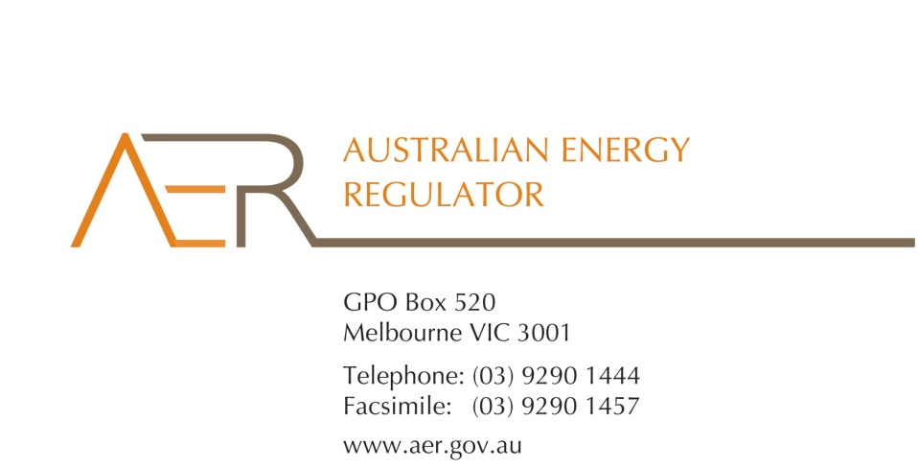

21 January 2016

Phil Richardson

A/General Manager

Energy Consumer and Pricing

Department of Energy and Water Supply

**By email:** [consultation@dews.qld.gov.au](mailto:consultation@dews.qld.gov.au)

Dear Mr Richardson

##### Access of on-supply Customers to Energy Rebates and EWOQ

The Australian Energy Regulator (AER) welcomes the opportunity to provide the attached submission to the consultation on the Regulatory Impact Statement-for this review.

Our submission clarifies the position of ‘on-suppliers’ (or ‘on-sellers’) under the National Energy Retail Law and provides the AER’s views on the proposed options for improved access to energy rebates and the Queensland ombudsman scheme for customers of on-suppliers.

Should you have any questions, please feel free to contact the Retail Markets branch General Manager, Sarah Proudfoot, on (03) 9290 6965.

Yours sincerely

Sarah Proudfoot

General Manager, Retail Markets

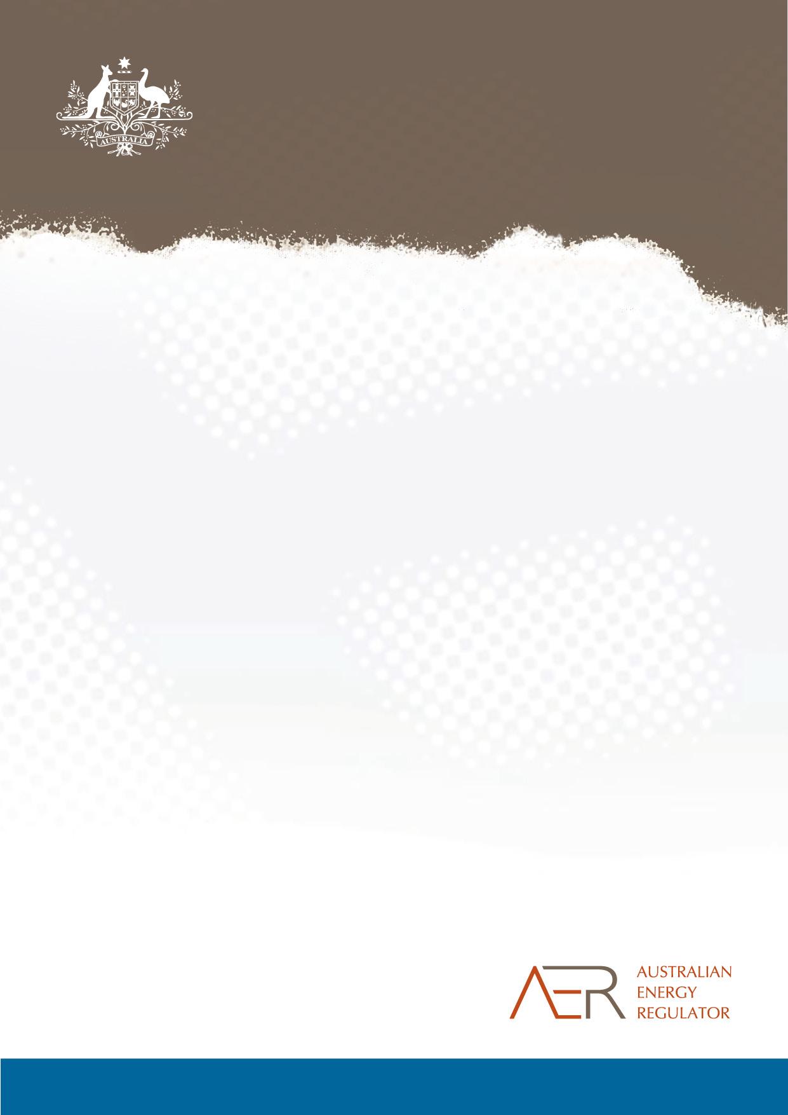

Review of on-supply customer access to energy rebates and the Energy and Water Ombudsman Queensland

AER Submission on Consultation Regulatory Impact Statement

**January 2016**

1. Introduction

The Australian Energy Regulator (AER) welcomes the opportunity to provide a submission in response to the Consultation Regulatory Impact Statement in relation to on-supply customer access to energy rebates and the Energy and Water Ombudsman Queensland (EWOQ).

The AER is Australia’s national energy market regulator and an independent decision making body. Our functions, which mostly relate to energy markets in eastern and southern Australia, include promoting compliance with, and enforcing, the National Energy Retail Law (Retail Law) and National Energy Retail Rules (Retail Rules).

The Retail Law commenced in Queensland on 1 July 2015. It requires that anyone selling energy to a person for premises must either hold a retailer authorisation or be exempt from that requirement in accordance with the exempt selling framework (as prescribed in the [Retail Exempt Selling Guideline](http://www.aer.gov.au/retail-markets/retail-guidelines/retail-exempt-selling-guideline-april-2015)).

Under the Retail Law, entities engaged in the sale of energy are either authorised retailers or exempt sellers. Authorised retailers are not required to be registered wholesale market participants and so in some cases may purchase from another retailer and then on-sell to their customers. Exempt sellers may also (and in the cases of registrable classes in particular generally do) on-sell energy to their customers. The key sale relationship – and the relationship to which rights attach- under the Retail Law is that between the authorised/exempt entity and their customer.

The term ‘on-supplier’ or ‘on-supply’ is not defined in the Retail Law. It is however defined under section 20 of the *Electricity Act 1994* (Qld).[1] For the purposes of an energy seller’s obligations under the Retail Law the AER refers to ‘authorised retailers’ or ‘exempt sellers,’ noting either party may be engaged in on-selling or ‘on-supply’ arrangements.

We encourage any moves to improve the protections for customers in on-supply arrangements and support the Queensland government’s consultation on two key issues, access to energy concessions and to dispute resolution mechanisms. Our submission focuses on the principles we consider important in determining the appropriate response for each issue. The first part of the submission deals with the issue of improving access to energy rebates and concessions. As we are still considering our position in relation to exempt sellers’ obligation to claim rebates on behalf of their customers[2] , our submission does not endorse a particular option.

In the second part of the submission, we set out the principles we consider important to improve access to dispute resolution services and specifically those of the jurisdictional ombudsmen. We support access for all small‘on-supply’ customers to dispute resolution and specifically, the services of the EWOQ.

1. Exempt (on-supply) customer access to energy rebates

One of the principles underlying the Retail Law exemptions framework is that, to the extent possible, exempt customers are entitled to the same protections as retail market customers of the same customer category. Specifically, section 114(1)(c) of the Retail Law states that ‘exempt customers should, as far as practicable, not be denied customer protections afforded to retail customers under this Law and the Rules’.

We consider that eligible customers should have access to energy rebates and concessions to which they are entitled and in a timely manner. This does not always happen in Queensland at present. We note many customers affected by these arrangements are vulnerable customers for whom energy rebates can have marked impacts on household budgets.

Condition 12 currently provides that an exempt seller must use their best endeavours to claim an energy rebate or concession where government or non-government energy rebate or concession can only be claimed by an exempt seller. Our draft Guideline includes a proposed amendment to condition 12(2) to remove the requirement that exempt sellers use their best endeavours to claim rebates and concessions for eligible customers and instead impose a mandatory obligation on those sellers to claim the rebates/concessions on behalf of customers. We have consulted on the draft Guideline and are currently finalising our position on the relevant issues.

The Queensland Government, like all other Retail Law jurisdictions, provides a range of rebates and concessions to assist vulnerable customers with their energy bills. These rebates and concessions are aimed at relieving costs associated with energy consumption. Delivery of the Queensland government’s electricity and gas rebates to residential customers occurs via energy retailers, who assess rebate applications and apply the rebates to eligible customers’ accounts. In the case of exempt customers, the exempt seller (such as the body corporate or park operator) has to claim an exempt customer’s rebate as the customer cannot claim it directly.

Although residential exempt customers may meet the eligibility criteria for the Queensland Government’s energy rebates, it is not mandatory that exempt sellers administer rebates on behalf of their eligible residential customers, and some exempt sellers are choosing not to do so. This means their customers may be missing out on savings of around 20 per cent of an average electricity bill (as the current rebate for electricity is $320.97 per year). This issue is long-standing and existed prior to the commencement of Retail Law on 1 July 2015. The proposed change to Condition 12 of the draft Guideline would impose a general obligation under the exemption framework but would not be linked directly to the administration of the rebate and concession schemes which are state and territory based entitlements.

We agree with the position put forward in the RIS that the current position in Queensland needs improvement. The RIS has identified that a number of exempt sellers are not processing eligible customers’ rebates and AER stakeholder feedback and complaints since 1 July 2015 support this view. Even where exempt sellers claim rebates on behalf of exempt customers there are lengthy delays in delivery of the rebates to customers who are vulnerable and for whom the rebate can make a material difference. During recent consultation forum on our draft Guideline, stakeholders noted delays in the delivery of rebates of up to six months, depending on how frequently the retailer that supplies energy to the exempt seller or on-supplier processed the rebates at its end.[3]

The main benefits of Option 3 (direct delivery of rebates to customers) are that it removes the necessity for the exempt seller to claim the rebate on behalf of the customer and allows customers to obtain their rebates more efficiently and quickly. While this position has been adopted by other jurisdictions, notably NSW and SA, DEWS does not recommend Option 3 due to high administrative costs.

We are still finalising our position on access to rebates under the Draft Guideline. While our proposed position for improving access under the draft Guideline aligns with Option 1 under the RIS, we note that Options 3 and 1 are not mutually exclusive and, should Queensland adopt Option 3, a decision by the AER to require exempt sellers to collect rebates on behalf of customers who cannot do so would not conflict with, or undermine, the Queensland position.

1. Access to EWOQ

In Queensland, the relevant statute explicitly excludes small customers of on-suppliers from accessing the dispute resolution services of the energy ombudsman. This is in contrast to the position in NSW but similar to other Retail Law jurisdictions. A number of consumer groups have advocated that EWOQ extend its membership to include small ‘on-supply’ customers.

The Retail Law requires that authorised retailers are members of, or subject to, energy ombudsman schemes for each jurisdiction in which they market or sell energy to small customers. The Retail Law does not (and cannot) require exempt sellers to be members of an ombudsman scheme. However the exemptions framework should, to the extent possible, provide exempt customers with the same protections as retail market customer such as access to dispute resolution options. The general conditions of exemption in the Exempt Selling guideline require exempt sellers to inform customers of their rights to access dispute resolution processes and also require them to make “reasonable endeavours” to resolve the dispute.[4]

Each jurisdiction sets the limits of membership or participation in the relevant energy (and water) ombudsman scheme. Following the introduction of full retail contestability in the retail electricity market on 1 July 2007, EWOQ was established under the *Energy and Water Ombudsman Act 2006* (Qld) (the EWO Act) to assist residential and small business energy customers to resolve energy disputes. In Queensland, as in other jurisdictions (with the exception of NSW), the scheme is limited to members who are authorised retailers. In the case of EWOQ further limitations are placed on membership eligibility as the scheme excludes on-suppliers for the purposes of the *Electricity Act 1994* (Qld). This means that even if a retailer holds a retailer authorisation it may not be eligible to participate in EWOQ because it otherwise meets the definition of ‘on-supplier’.

Under the Retail Law, and specifically the Exempt Selling guideline, an exempt seller is required to inform exempt customers about the exempt customer’s rights in relation to dispute resolution including the exempt person’s procedures for handling disputes and any right the exempt customer has to access the energy Ombudsman scheme or any other relevant external dispute resolution body (Condition 2(1)(c)). With the exception of NSW, exempt customers must rely on the exempt sellers’ own dispute resolution processes, and other relevant dispute resolution bodies (which vary according to the customer type and jurisdiction, for example, tenancies tribunals, administrative tribunal, tenants’ unions and small business commissioners).

We support any move to provide exempt customers with access to effective dispute resolution and consider amendments to the EWO Act to allow access by small on-supply customers would achieve this for both exempt customers and customers of authorised on-seller retailers. We note that in many circumstances, the relationship between an on-supplier and their customer is multi-faceted (eg may also be landlord and tenant) and as such is weighted heavily in favour of the on-supplier. This highlights the importance of access to an impartial and effective dispute resolution service for on-supply customers.

We are concerned that Option 2 will leave the customers of on-suppliers with limited dispute resolution options which the RIS identifies results in exempt customers largely bearing the cost of resolving their disputes.

1. An on-supplier is defined in section 20 of the Electricity Act 1994 (Qld) to be (a) is the owner or occupier of premises or has the right to use premises; and (b) supplies electricity for use in the premises.
2. As part of our consultation on the draft Exempt Selling Guideline released in September 2015 (draft Guideline).
3. [AER Minutes from stakeholder forum, 20 October 2015](http://www.aer.gov.au/system/files/Minutes%20from%20stakeholder%20forum.pdf), p.3
4. Condition 15 of the general conditions, Exempt Selling Guideline