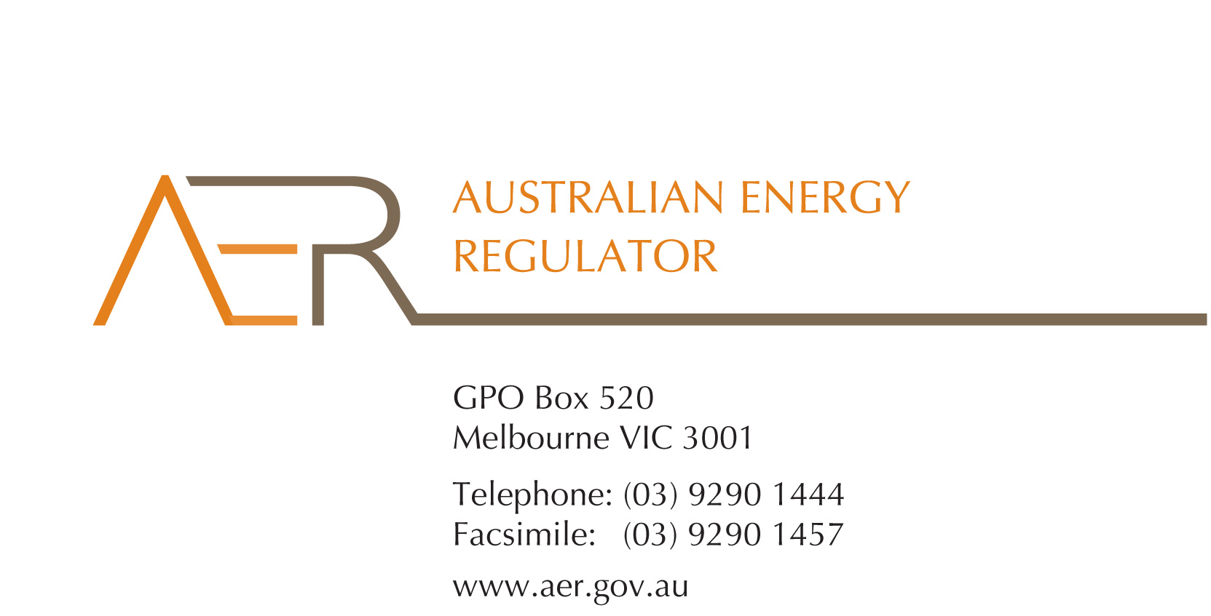

Our Ref: 41662

Contact Officer: David Chan

1. Contact Phone: 03 9290 1446

21 July 2014

Mr Paul Smith

Chief Executive

Australian Energy Market Commission

PO Box A2449

Sydney South

NSW 1235

Dear Mr Smith

**AER comments on Consultation Paper: National Electricity Amendment (Connecting Embedded Generators Under Chapter 5A) Rule 2014 (ERC0158)**

1. Reference is made to the above consultation paper.
2. We do not have any particularly significant issues to raise. However, we would like to comment on the rule change proponent’s proposal to broaden the definition of a relevant dispute to include “the requirements of chapter 5A and any material produced by a DNSP in consequence of chapter 5A”.[1]
3. We suggest that the key to reduce disputes and to improve the connection negotiation process is to increase the level of clarity regarding the requirements on DNSPs and embedded generator proponents in relation to the process for connection. In particular, the rules should specify what minimum technical information a DNSP must provide to a proponent in order for the latter to meet quality of supply standards, and within more clearly defined timeframe. As well, the rules can specify prescribed time frames, such as DNSPs responding within number of business days to compliant information requests by proponents.
4. The rule change proponent’s concern is that the current Chapter 5A dispute resolution process is too narrow and excludes aspects of the negotiation process that may be subject to disagreement.[2]
5. We do not consider that the level of disagreement between embedded generator proponents and DNSPs would be reduced by broadening the definition of what is a relevant dispute. We consider that our current distribution network access (connection) dispute resolution and related compliance role is adequate.
6. The current framework can deal with various types of disputes, including procedural aspects around the timing and quality of information required to be provided by DNSPs. If necessary, the AER can exercise its compliance powers where DNSP’s are not responding appropriately to connection requests. Having said that, clarifying DNSPs obligations in relation to connection requests in the Rules, such as in terms of the timing and nature of information to be provided, as noted above, would facilitate the more timely resolution of any complaints or disputes about these matters.
7. Both chapter 5A and Part 10 of the *National Electricity Law* provide a range of options for us to resolve disputes, including requiring the parties to mediate, conciliate or engage in another alternative dispute resolution process. It is important that the AER continues to have a full range of possible options available to it to resolve disputes. As we noted in our submission to the AEMC’s First Interim Report on Transmission Frameworks Review in January 2012, we consider that for complex disputes, it is important that there is flexibility in how such disputes should be handled, such as through alternative dispute mechanisms.
8. We therefore consider the current framework is sufficient for this purpose. Also relevant is that any changes to the rules which impose new administrative burdens on participants or the regulator need to be considered in terms of the higher costs being justified by additional benefits. In our view, no case has been made in this regard.
9. Finally, we think some clarifying amendments on the inter-linkages between chapter 5A disputes and the dispute resolution framework under Part L of chapter 6 would be desirable. In particular, by clarifying that the Part L framework also applies to any disputes under Chapter 5A. This would be desirable as connection services, which are dealt with under Chapter 5A, are normally classified as regulated distribution services under chapter 6 (typically as direct control services).
10. We would be please to discuss these matters further with AEMC staff. If AEMC staff would like to discuss any aspect of this letter, please contact David Chan, Director, Networks on (03) 9290 1446.

Yours sincerely

Chris Pattas

General Manager, Networks

1. AEMC consultation paper, p28
2. Ibid