

Customer consultation paper

AER draft decisions on   
access arrangements for Victorian gas transmission and distribution businesses 2013–17

October 2012

© Commonwealth of Australia 2012

This work is copyright. Apart from any use permitted by the Copyright Act 1968, no part may be reproduced without permission of the Australian Competition and Consumer Commission. Requests and inquiries concerning reproduction and rights should be addressed to the Director Publishing, Australian Competition and Consumer Commission, GPO Box 3131, Canberra ACT 2601.

Brief overview

This paper aims to assist customers and customer representative groups to understand our recent draft decisions on prices for gas transmission and distribution services in Victoria. It provides background on our role in relation to gas networks, our approach to assessing transmission and distribution charges and key outcomes in the draft decisions.

Our aim is that this paper will enable customers to better understand our processes. We hope this will facilitate greater customer engagement. In particular, interested stakeholders are invited to make written submissions by 7 January 2013.

Submissions should be sent electronically to [VicGAAR@aer.gov.au](mailto:VicGAAR@aer.gov.au) and addressed to the attention of Sebastian Roberts, General Manager, 2012 Victorian Gas Access Arrangement Review, Australian Energy Regulator.

A number of issues and trade-offs are discussed in this paper and in the draft decisions. While this paper does not raise specific questions for customers, we hope that it highlights some of the key issues and trade-offs that are most relevant to customers. Customers may wish to address these and other issues in any submissions they make to the process.

In terms of timing, the review commenced in March 2012 and final decisions are due in March 2013. See table 1 for a list of key dates.

Table 1 Key dates for the review of Victorian gas transmission and distribution businesses

|  |  |
| --- | --- |
| **Key stages in the decision making process** | **Scheduled date** |
| Business proposals submitted | 30 March 2012 (published 2 May 2012) |
| AER draft decisions released | 10 September 2012 for APA GasNet and SP AusNet  21 September 2012 for Multinet and Envestra |
| Revised proposals to be submitted | 9 November 2012 |
| Submissions on revised proposal due | 7 January 2013 |
| Release of AER final decision | March 2013 |

1. Purpose and context

The Australian Energy Regulator (AER) recently released draft decisions on access arrangements for Victorian gas transmission and distribution businesses for the 2013–17 period. Among other things, access arrangements set the conditions, including tariffs or prices paid for the transportation of gas to gas customers.

This document aims to make our draft decisions more accessible to consumers with the ultimate objective of encouraging better customer engagement. It provides background and context to our recent draft decisions. In particular, it:

* provides an overview of the Victorian gas industry
* describes our role in regulating gas transmission and distribution tariffs (prices) in Victoria
* describes our approach to assessing the proposals made by gas transmission and distribution businesses for use of their pipeline services
* explains the legal and economic framework we use to determine how much revenue the businesses need and the prices they can charge their customers
* highlights key issues in the draft decisions.

In addition, this document provides an overview of the next steps for our review of Victorian transmission and distribution businesses and how consumers can be part of this process.

* 1. Importance of customer engagement

The overarching objective of gas regulation is given by the National Gas Objective. The National Gas Objective is ‘to promote efficient investment in, and efficient operation and use of, natural gas services for the long term interests of consumers of natural gas with respect to price, quality, safety, reliability and security of supply of natural gas’.

In line with this objective, understanding consumer interests is central to our role in regulating gas transmission and distribution.

Our documents can at times be complex and difficult to understand for customers and they may find it difficult to engage with us through our usual processes.

This document is written with consumers in mind. We would like to promote a better understanding and engagement from consumers in relation to our role in regulating gas transmission and distribution businesses. Through this we hope to better understand the needs and preferences of consumers so that we can better consider these when we make our decisions in relation to gas transmission and distribution.

More customer engagement benefits customers. While customers do not directly deal with gas transmission and distribution businesses, they do ultimately bear the costs of these services. To the extent that customers can provide information that will help us in assessing businesses’ proposals, this could ultimately benefit customers where the result is lower prices for gas transmission and distribution, or improved services.

* 1. Where to find the draft decisions and other related material

This document should be read in conjunction with the AER’s draft decisions and other supporting material:

* The AER draft decisions, business proposals and other supporting material can be found on the AER’s website:
* APA GasNet: <http://www.aer.gov.au/node/13556>
* Envestra: <http://www.aer.gov.au/node/14473>
* SP AusNet: <http://www.aer.gov.au/node/4810>
* Multinet: <http://www.aer.gov.au/node/4799>
* The National Gas Law (NGL) can be found on the following website: <http://www.austlii.edu.au/au/legis/sa/consol_act/ngaa2008294/sch1.html>
* The National Gas Rules (NGR) can be found on the Australian Energy Market Commission’s website: <http://www.aemc.gov.au/gas/national-gas-rules/current-rules.html>

This consultation paper is not a substitute for the AER’s draft decisions. It is designed to help customers to understand the AER’s decisions to allow for increased consultation.

* 1. How to use this document

We have tried to make this paper accessible to a wide ranging customer audience. However, we understand that parts of the paper are still complex. In particular, chapter 4 is more technical than other chapters as it discusses the ‘building block’ approach.

To account for different levels of knowledge we have layered the paper to allow readers to be more selective in what they read. If a section is too complex for some readers, they may wish to skip over that section. While those readers will miss some of the detail by doing this, they will still be able to engage in some of the higher level issues involved in our assessment of gas transmission and distribution charges.

We have included the more complex and technical discussions as these are important to understand if you wish to get into the detail of our draft decisions. We know from reading submissions from customer representative groups that some of these stakeholders already have a good understanding of our approach. For these stakeholders we expect that most of this paper will be relatively easy to understand, and we hope that the paper helps to further clarify and enhance the understanding of these stakeholders.

In particular, in undertaking our assessment we often have to consider various trade-offs such as price and service. For example, a business might propose to increase prices so as to improve the reliability of services in certain areas. In this case our job is to assess whether enhanced reliability is required and whether the costs associated with this are justified (as these will flow through to prices). While reading this paper we encourage you to consider these trade-offs and to consider our approach to assessing these trade-offs. We welcome your views on these and other issues.

1. AER review of prices for Victorian gas pipelines

Access arrangements set the conditions and importantly, the default prices (referred to as ‘tariffs’) that retailers and other third parties pay for transmission and distribution services.[1] These prices will ultimately be paid by customers, including households, through gas bills.

Victorian gas transmission and distribution service providers APA GasNet, Envestra, SP AusNet and Multinet submitted their access arrangement proposals to the AER in March this year. We issued our draft decisions on these proposals in September 2012. Before we make any final decisions, businesses are given the opportunity to submit revised proposals in early November 2012.

Interested parties are invited to make submissions in response to draft decisions and revised proposals by 7 January 2013. Further information, including copies of our draft decisions, can be found at <http://www.aer.gov.au/node/478>

We then assess the revised proposals and any submissions and make a final decision on conditions and prices. The final decisions will be made in March 2013.

This paper provides background information on the gas industry in Victoria, our role and key parts of our recent draft decisions on gas access arrangements in Victoria. The paper also outlines the next steps for the Victorian gas review and how customers can engage in this process.

* 1. The Victorian gas industry

The Victorian gas market is made up of four parts:

* A wholesale market in which gas producers[2] and storage providers[3] sell bulk quantities of gas to energy retailers and other large gas users.
* Transmission service providers (such as APA GasNet) that own and operate the high pressure pipeline networks that transport gas from gas production fields to major demand centres.
* Distribution service providers (such as Envestra, Multinet and SP AusNet) that own and operate pipeline networks that transport gas from the major demand centres to the end consumer.[4]
* A retail market in which retailers[5] enter into contracts with gas producers and transmission and distribution service providers to provide gas to end consumers. Consumers are able to choose which retailer they buy their gas from.

Of these, the wholesale and retail markets are largely competitive and do not need significant economic regulation. However, transmission and distribution pipeline networks are natural monopolies involving large capital and operating expenses and regulation is necessary to ensure that customers do not pay unnecessarily high charges or receive poor service levels.

* 1. Regulation of gas transmission and distribution

The AER is responsible for the economic regulation of gas pipelines in all Australian states and territories except Western Australia. The National Gas Law and National Gas Rules set out the regulatory framework. Various levels of regulation apply to particular pipelines and services, based on the level of competition and the importance of the pipeline or service.

In Victoria, there is one transmission service provider (APA GasNet) and three distribution service providers (Envestra, SP AusNet and Multinet) (see box 2.1). These businesses are subject to full regulation by the AER.

Full regulation requires a pipeline provider to periodically (usually every five years) submit an access arrangement to the AER for approval. We assess the amount of money the pipeline provider needs to cover its efficient costs and earn a commercial return on the capital it uses to provide pipeline services. We then decide the ‘reference tariffs’ or prices that will be charged for using the pipeline. More on our approach to assessing access arrangements is in chapter 3 below.

* 1. What is an access arrangement and AER price review?

An access arrangement sets out the conditions under which third parties (such as gas retailers) can use a pipeline.[6] This includes the prices that retailers and other parties pay for gas transmission and distribution services. These prices are ultimately paid by consumers through their gas bills.

Gas distribution and transmission networks that are subject to full regulation by the AER have to submit an access arrangement proposal to us for approval. The process that we follow to assess and approve (or not approve) an access arrangement is often called a price review.

The AER’s draft decision indicates whether we are prepared to approve the access arrangement proposal as submitted. If not, the draft decision indicates what amendments are required in order to make the proposal acceptable to us. Gas businesses may then submit a revised access arrangement proposal to us for assessment prior to our final decision.

Box 2.1 Transmission and distribution service providers in Victoria

|  |
| --- |
| **Map of gas pipeline networks in Victoria**    The big pipes—transmission  APA GasNet is the Victorian transmission service provider. It transports gas to more than 1.4 million residential consumers and 43 000 industrial and commercial users throughout Victoria. Its network is linked to Esso’s Longford gas treatment plant in south east Victoria (which processes gas from offshore Bass Strait gas fields), the Otway Basin gas field in south west Victoria and underground storage in south west Victoria.  Smaller pipes—distribution  Distribution service providers in Victoria include Envestra, SP AusNet and Multinet.  Envestra's Victorian gas network serves the northern, outer eastern and southern areas of Melbourne, Mornington Peninsula, rural communities in northern, eastern and north-eastern Victoria, and south-eastern rural townships in Gippsland. It comprises around 9900 kilometres of mains delivering gas to around 575 000 customers.  SP AusNet's gas distribution network delivers gas to approximately 605 000 customers across central and western Victoria. The network spans approximately 9400 kilometres across an area of 60 000 square kilometres.  Multinet distributes gas to more than 665 000 customers throughout the South and East areas of metropolitan Melbourne, Yarra Ranges and South Gippsland Towns. Multinet’s network covers an area of 1790 square kilometres. |

* 1. Impact on customers

Demand for pipeline services is driven by demand for gas by commercial businesses, residential customers and small businesses. However, residential customers and small businesses are not likely to seek access to transmission or distribution pipelines. This is done on their behalf by the relevant retailer.

This is not to say that access arrangements have no impact on customers. Through gas bills, consumers ultimately pay for transmission and distribution services. This cost is borne first by retailers but then passed through to consumers. In Victoria:

* transmission charges make up approximately 8 per cent of an average residential customer's gas bill[7]
* distribution charges make up approximately a third of an average residential customer's gas bill.[8]

In this way, a significant proportion of an average residential customer's gas bill is directly related to the charges paid for the transmission and distribution of gas. For this reason it is important that charges recover only the ‘efficient’ costs of operating the pipeline network. That is, the minimum costs required to deliver the appropriate level of pipeline service without compromising on the safety and reliability of the service. This is why the AER assesses the costs and charges proposed by transmission and distribution companies.[9]

1. What does the AER consider in assessing an access arrangement?

The AER’s draft decisions for the 2013–17 access arrangements were made in accordance with the relevant sections of the National Gas Law and National Gas Rules. In forming our draft decisions, we considered:

* businesses' access arrangement proposals and other supporting information provided by the businesses; we undertook our own analysis to verify this information
* submissions from interested parties, including retailers and end users of gas
* views expressed by stakeholders at various meetings
* expert advice or analysis commissioned by us and others on certain aspects of the businesses' access arrangement proposals.

The AER’s draft decisions include draft decisions on tariffs for regulated pipeline services and non-tariff terms and conditions for reference and ancillary services.

* 1. Transmission and distribution tariffs

To determine tariffs, we first assessed the total revenue the service provider needs to provide an efficient and appropriate level of transmission or distribution services. Total revenue should be sufficient to ensure the business can cover the efficient costs it incurs in providing pipeline services. These costs include capital costs such as for pipes and buildings, and operating costs such as for labour (discussed more below and in chapter 4). In assessing these costs, we consider whether these reflect the costs that would be incurred by a prudent service provider acting efficiently to achieve the lowest sustainable cost of providing services.

In assessing and determining a business’ total revenue, we use a ‘building block’ approach (explained below). These ‘building blocks’ summed together basically give the required revenue. However, the components of the building block are interlinked and in assessing total revenue we also have to consider these interlinkages. In particular, capital and operating expenditure are often interlinked.

Operating expenditure (opex) is sometimes incurred as a result of a new capital project being undertaken. For example, a new IT project may require opex to fund new staff to manage some ongoing aspect of the IT project. If we consider that the IT project is not justified, this could also result in a reduction to opex (where that opex was only going to be incurred because of the IT project).

Similarly, capital expenditure (capex) and the capital base can’t be considered in isolation. We use our assessment of future capex to forecast the future capital base and the costs associated with financing that capital base. These interlinkages are discussed more in the AER’s draft decisions. Opex, capex and the capital base are discussed more in chapter 4 below.

There are also certain requirements that apply to forecasts and estimates provided by each business as part of its proposal. In particular, any forecasts or estimates must be arrived at on a reasonable basis and be the best possible in the circumstances.

Building block approach to determining revenue

The building block components comprise:

* A return on the projected capital base incorporating:
* The capital base—our assessment of the value of the business’ capital assets needed to provide pipeline services (e.g. gas pipelines, IT systems and plant and equipment).
* Capital expenditure (capex)—how much we believe the business will need to spend on new assets during the upcoming access arrangement period.
* A rate of return or return on investment—what we consider the businesses need to finance their capital assets, such as paying interest on loans.
* Regulatory depreciation of the projected capital base—that is, an allowance we give to the businesses to compensate for the falling value of their assets over time.
* Operating expenditure (opex)—how much we will allow for operating, maintenance and other non-capital costs incurred in providing pipeline services.
* Rewards and penalties resulting from an incentive mechanism[10]—incentive mechanisms allow service providers to benefit from some of the savings they make when they are efficient and deliver a project or outcome at a lower cost than forecast.
* Corporate income tax.

Each of these ‘building blocks’ are discussed in more detail in the following chapter (chapter 4).

Use of demand forecasts to derive tariffs

Once we have assessed a business’ total revenue needs, we then look at demand forecasts. Demand forecasts are used to estimate how much gas will be consumed by each customer type over the access arrangement period. As well as providing information on how much opex and capex is required over the upcoming access arrangement period, demand forecasts are used to determine the prices charged for services.

Distribution and transmission networks have largely fixed costs. That is, the costs of providing pipeline services do not vary much with the amount of gas transported. Because of this changes in demand can have a relatively large impact on the overall level of tariffs. For example, if gas demand has fallen, the largely fixed network costs will have to be spread across a smaller quantity of ‘sales’. In this case prices could rise even if total revenue has fallen. This differs from the case in other more competitive markets where price usually changes with demand.

Other factors to consider in setting tariffs

The access arrangement also details:

* Tariff or price setting—that is, how tariffs for reference services are allocated between different user groups and how costs are shared between services.
* The tariff variation mechanism—this is a process for changing charges for each year of the access arrangement period. It also provides a process for changing charges when certain pre-specified conditions arise. For example, when a business has to spend money for costs that it did not expect to incur, the tariff variation mechanism provides for these costs to be passed onto customers through higher charges when appropriate. See box 3.1 for more on how price changes are managed through the tariff variation mechanism.

Box 3.1 The tariff variation mechanism and price stability

|  |
| --- |
| As part of the tariff variation mechanism there is a limit on the amount that prices can increase by between years. This is called the rebalancing constraint.  Regulators like us generally assume that consumers value relatively stable energy prices. Stable prices allow for easier management of the household budget. If prices are completely stable, consumers can put aside the same amount of their income each bill period and know that this will cover the bill. Even if energy bills are going up, limiting the amount that prices can increase by can allow for a more gradual adjustment to higher prices. This gives consumers more time to either increase the amount of money they put aside for energy bills or to use less energy so that they can pay the higher prices.  For this reason, the rebalancing constraint is usually set so that prices are relatively stable over the period. However, if price variability is restricted within an access arrangement period, this could potentially lead to greater price variability from one access period to the next. This could happen if there is a large change in revenue required by the business between the two periods. With only small changes in prices allowed within the period, larger price adjustments would be required from the end of one period to the start of the next period. A less binding rebalancing constraint could reduce the change between periods, but this could lead to greater increases within the period. This is one of the trade-offs that we consider in assessing gas businesses’ proposals. We welcome your views on this issue. |

* 1. Non-tariff terms and conditions

Non-tariff terms and conditions essentially define the commercial relationship between the network service provider and pipeline users. In considering businesses' proposals, the AER assesses whether the proposed terms and conditions are consistent with the National Gas Objective (NGO). Although parties can agree on terms and conditions that are different to those set out in an access arrangement, the AER's approved terms and conditions can act as a starting point for negotiations.

As residential customers do not directly access transmission or distribution services themselves (this is done on their behalf by their retailer), the non-tariff terms and conditions are less relevant for residential consumers. However, non-tariff terms and conditions do affect the type of service that is provided to residential customers and which party provides the service.

A national framework governing the relationship between customers, retailers and gas distribution businesses has been developed (the National Energy Customer Framework), but has not yet commenced in Victoria. The timing for its introduction lies with the Victorian government.

The framework sets out a number of obligations that retailers and gas distribution businesses have to their customers (including residential customers), and to each other in the shared provision of services to those customers. These obligations cover areas such as contracts for small customers, connections, disconnection, interruption to supply and billing.

The national framework may affect some of the terms and conditions in businesses’ access arrangements. For this reason it is important to ensure that the terms and conditions that we approve now will be compatible with the national framework once it begins in Victoria. We therefore require that any terms or conditions put forward by the businesses that we find are inconsistent with the framework will cease to operate once the framework commences in Victoria.

1. The building block approach

As mentioned in the previous section, we use the building block approach to determine how much revenue a business requires to cover its efficient costs (see figure 4.1).

* + - 1. Building block approach

|  |
| --- |
|  |

This section provides more detail on each of the building blocks shown above. This provides background for the following section which looks at our draft decisions on some of the key building blocks.

This section is by nature more technical than the other sections. If you are not seeking to understand our approach to applying the building block model, you can skip ahead to chapter 5, which looks at key aspects of our draft decisions.

* 1. Return on capital

The capital cost block is made up of a return on, and return of, capital. This section discusses the return on capital. The return of capital is discussed in the following section (section 4.3).

The return on capital is calculated by multiplying the capital base[11] by the rate of return, with capital expenditure used as an input to determine the projected capital base. Hence, the return on capital building block comprises:

* capital expenditure
* the capital base
* a rate of return.

These are discussed below.

Capital expenditure

Forecast capital expenditure (or capex) is a forecast of the cost of new assets that are likely to be constructed by a network business during an access arrangement period for the efficient operation of its network.

Capex is broken down into several categories:

* augmentation capex—assets that expand the capacity of the network or provide connections to new customers
* refurbishment and upgrade capex—used to replace or upgrade aging, obsolete or inefficient assets
* non-network capex—including IT, plant and equipment, motor vehicles and buildings.

Factors that influence the required level of capex include the age and condition of existing assets, expected changes in the number of customers connected to the network, expected changes in the demand profile of customers, and general ‘stay in business’ requirements of the business.

We assess the capex proposals of gas network businesses to determine whether they meet the criteria set out in the National Gas Rules. These criteria essentially ensure that the capex is necessary, efficient and has a positive economic value. In addition, we have to be satisfied that the methodology and data underlying any forecast or estimate is reasonable and the best forecast or estimate in the circumstances.

Capital base

The capital base is the value of a business’ capital assets on which it can earn a rate of return (discussed below). Businesses generally have to borrow—for example, from banks, from issuing corporate debt, and from equity investors—to finance their capital expenditure.

In order to pay back the ‘loan’ the business then needs to earn a return on its capital expenditure—that is, its capital base—in order to be able to cover the ‘interest’ on the loan. In this way we need to calculate each business’ capital base in order to determine the amount on which each business can earn a rate of return. Items that form a business’ capital base include gas pipelines, customer connections, IT systems, plant and equipment, motor vehicles and buildings.

As part of our draft decisions, we were required to determine each business’ capital base for both the current access arrangement period (i.e. 2008–12) and for the upcoming access arrangement period (i.e. 2013–17).

Assessing a business’ capital base for the current period involves a decision about whether the money the business spent on new assets in that period was efficient. In particular, the AER considers whether the capex would have been undertaken by an efficient service provider in providing reference services. For example, for capex to be included in the capital base we should be satisfied that it was incurred in relation to the provision of pipeline services.

As the assessment relies on a decision about capex actually incurred in the past, it can only relate to past years where there is data on actual capex. This means we cannot yet assess actual capex for 2012 as it is still a forecast for the remainder of the year. Instead, the capital base for 2012 is a forecast. Similarly, in 2007, when the access arrangement for the 2008–12 period was being assessed, data on actual capex for 2007 was incomplete and hence, the capital base for 2007 was forecast rather than actual.

In updating the capital base for the 2008–12 period, the AER’s assessment therefore covers the period 2007–11. Capex that meets the necessary requirements is included in the capital base and is called conforming capex.

Once conforming capex is determined, the closing value[12] of the capital base is determined for each year by taking the closing value from the previous year and:

* adding any conforming capex undertaken in that year[13]
* subtracting allowed depreciation, any capital contributions from customers or government, any redundant assets and any disposal of assets
* multiplying by the change in the consumer price index for the previous year to index the capital base for actual inflation.[14]

Rolling forward the forecast capital base for the 2012–17 period involves a similar process. Estimates of forecast depreciation, capex, disposals and inflation are taken from our draft decision in respect of these cost categories. In particular, forecast capex is added to the capital base, while forecast depreciation and disposals are removed from the capital base. Forecast inflation is used to index the resulting capital base.

Rate of return

A business’ return on capital building block is calculated by multiplying the rate of return with the value of the business’ capital base. The rate of return relates to the cost of financing capital assets, such as providing a return on equity and paying interest on loans, as discussed above. The rate of return is to be in line with prevailing conditions in the market for such funds and the risks faced by the business in providing gas pipeline services.[15]

In forming our draft decisions, we consider an extensive range of material on the rate of return including businesses’ proposals, submissions from users, advice from academic experts, and information available from the Reserve Bank of Australia or the Commonwealth Treasury.

There are a number of methodologies that can be used to calculate the rate of return. In our recent draft decisions we used the ‘nominal vanilla’ weighted average cost of capital (WACC).[16] This was also adopted by the businesses for the current review process. The main differences in approach between us and the businesses were to do with the sources of data used for the various inputs to the WACC calculation.

While differences in the rate of return determined by us and that proposed by businesses might appear small (a percentage or two), this can actually have a big impact on revenues. This is because these businesses have very large capital bases. These large capital bases reflect the fact that these businesses have networks that span large areas of Victoria and hence, are worth a substantial amount of money.

As the rate of return is multiplied by the capital base to determine the return on capital, even a small change in the rate of return can have a big impact on the return on capital. This in turn can have a large impact on a business’ revenue. It is for this reason that the rate of return is a major focus of our assessment and is of significant interest to businesses. Given the potential impact on revenue and tariffs, businesses often seek to have our rate of return decision reviewed.

* 1. Return of capital—depreciation

The return of capital (or depreciation) is the second element of the capital cost building block and is discussed in this section.

Depreciation represents the amount of the original capital expenditure (as opposed to the interest on the capital) that a business pays back to its investors each year. To use a loan analogy, where the return on capital represents the amount of interest a borrower needs to pay back on the loan, the return of capital, or depreciation, represents the repayment of the principal (the cost of the capital expenditure).

Capital costs are generally large and ‘lumpy’ in that there can be large variations between years. Instead of having to pay the full amount of capex back to investors in the year that it is incurred, depreciation allows the cost of the capital asset to be spread over the useful life of the asset. This in turn leads to a smoother revenue requirement and smoother prices. Over an asset’s life, the total of the depreciation amounts will equal the capital cost of the asset.

In assessing a business’ proposed depreciation, we must ensure that the depreciation schedule is designed:

* so that reference tariffs will vary, over time, in a way that promotes efficient growth in the market for reference services[17]
* so that each asset or group of assets is depreciated over the economic life of that asset or group of assets[18]
* so as to allow, as far as reasonably practicable, for adjustment reflecting changes in the expected economic life of a particular asset, or a particular group of assets[19]
* so that an asset is depreciated only once (subject to the rules about capital redundancy)[20]
* so as to allow for the service provider's reasonable needs for cash flow to meet financing, non-capital and other costs.[21]

In general, an approach whereby an asset is depreciated by the same amount for each year of its remaining asset life would be expected to meet these criteria. In particular, it should provide a steady revenue stream to the business and should not lead to large price variability.

* 1. Operating expenditure

Operating expenditure (or opex) is the operating, maintenance and other non-capital costs needed to deliver pipeline services.[22] Opex includes labour costs and other non-capital costs associated with providing pipeline services.

We are required to assess each business’ forecast opex to decide whether it complies with the National Gas Law and National Gas Rules. In particular opex must be efficient. To test this, we ask whether a prudent and efficient service provider[23] would seek to incur the same opex. In addition, opex forecasts must be arrived at on a reasonable basis and represent the best forecast or estimate possible in the circumstances.[24]

We generally use a base year approach to forecasting opex. This generally involves using the most recent year for which there is data available on actual opex (2011 for the recent draft decisions) to set the base year.[25] This base year estimate is then adjusted to account for:

* Any changes in costs that result from:
* real cost escalation—that is, an estimate of the expected cost change of key factor inputs such as labour and materials costs[26]
* output growth—that is, any expected change in the demand for pipeline services (for example, a change in customer numbers).
* Any other circumstance, requirement or project that will require the business to undertake expenditure that is not incorporated in the base year; these are called step changes and are a key driver of opex changes. Step changes are discussed in more detail in the next chapter.
  1. Incentive mechanism

Incentive mechanisms offer businesses incentives to provide their pipeline services at the lowest cost. If a business provides its pipeline services at a lower cost than forecast, the business is allowed to ‘keep the difference’ for five years. That is, any underspend is added to the business’ revenue and carried forward for five years. Conversely, if a business overspends, it will be penalised for this for five years.

In making its draft decisions, we are required to ensure that any bonuses or penalties from the operation of the incentive mechanism in the previous period are properly reflected in the business’ total revenue requirement. We are also required to consider whether to allow any of the incentive mechanisms proposed by each business for the 2013–17 period. These are approved where we consider they would encourage efficiency in the provision of pipeline services, and where they were consistent with the revenue and pricing principles.[27]

* 1. Tax

Like most other companies, gas network businesses have to pay tax on their income. The estimated cost of corporate income tax is one of the building blocks used to determine total revenue. We use the post-tax revenue model (PTRM) to produce an estimate of the taxable income that would be earned by an efficient company operating each business’ network. This approach involves the use of benchmark assumptions.

For the recent draft decisions we modelled each business’ tax expenses over the access arrangement period using a benchmark 60 per cent gearing—that is, 60 per cent debt and 40 per cent equity. Tax depreciation was calculated using a separate value of the tax asset base. All tax expenses were offset against the service provider's forecast revenue to estimate the taxable income. The statutory income tax rate of 30 per cent was then applied to the estimated taxable income to arrive at a notional amount of tax payable. We then apply a discount to this to account for the assumed utilisation of imputation credits, which has a value of 0.25. This amount is then included as a separate building block in determining each business’ total revenue.[28]

1. Key aspects of the AER’s draft decisions

This section summarises key parts of our draft decisions on the Victorian transmission and distribution service providers' access arrangements.

* 1. Key differences between draft decisions and businesses’ proposals

In general, the key differences between the businesses’ proposals and our draft decisions were for capex, the rate of return and opex. Also, we did not accept APA GasNet’s proposal for depreciation. These changes are discussed below.

Capital expenditure

We did not accept all of the capex proposed by the businesses. The businesses' proposals included higher amounts of forecast capex than had been undertaken historically. Reasons for this included:

* network expansion or improvements
* increasing labour and materials costs
* replacement of ageing infrastructure, including pipelines.

In general, we only accept capex proposals where they are in line with what an efficient and prudent service provider would undertake. Where the businesses’ proposals did not demonstrate the need for the expenditure or justify the amount of expenditure, we did not accept the proposal. In these cases our draft decisions included revised capex forecasts.

For example, our draft decisions for the distribution businesses included revisions to capex for mains replacement. Distribution mains are the pipes that convey gas to service pipes at each end user point—that is, each house or business. Mains replacement projects generally relate to the replacement of ageing distribution mains. Some proposed mains replacement projects were not demonstrated to be necessary in the 2013–17 period and hence, were not approved by us. In other cases, such as for the replacement of low pressure pipes with high pressure pipes, the scale of the projects was not justified. In this case we approved a reduced scale of works. We also allowed businesses to apply for increased capex funding if the scale of works needs to be increased during the period.

In the case of the transmission operator, APA GasNet, we did not approve a number of major capex projects that APA GasNet proposed. These were not approved as we did not consider that APA GasNet had justified these projects as being necessary for the   
2013–17 period. An example of one of these projects is provided in box 5.1.

Box 5.1 The Western Outer Ring Main (WORM) project

|  |
| --- |
| APA GasNet proposed capex for the WORM project to enhance security of supply for domestic customers in the event of a major gas plant outage at Longford.  The WORM project has three stages; the first of which (the Sunbury loop) will be completed by the end of 2012. APA GasNet proposed to undertake stages two and three of the WORM project in the 2013–17 period, involving:   * laying 49.3 km of 500 mm pipeline from Wollert to Rockbank via Kalkallo * installing an additional compressor at Wollert Compressor Station B to allow compression from the Pakenham–Wollert pipeline to the new WORM pipeline * installing a new interconnecting pressure reduction station at Wollert, connecting the Brooklyn–Lara Pipeline to the Pakenham–Wollert pipeline.   APA GasNet proposed to complete the WORM project in 2013 and 2014 at a total cost of $93.4 million ($2012). APA GasNet submitted that the WORM project is justified as being necessary to maintain the integrity of services and to avoid other 'stay in business' capital expenditure that would otherwise be required at a number of sites.  Our draft decision concluded that the purported security of supply benefits provided by the WORM project were not supported by APA GasNet’s proposal. Despite the merits of the proposal, the investment is not required in the 2013–17 period. In addition, demand projections provided by the Australian Energy Market Operator (AEMO) suggest the project will not be required to cater for growing demand in the next 5 years. We considered that, for the 2013–17 period, the project would not be undertaken by a prudent service provider, and was not consistent with achieving the lowest sustainable cost of providing services. Hence, we did not approve this component of capex. |

For all businesses, our draft decisions reduced forecast capex and this had a consequent impact on revenue (see table 5.1).

* + - * 1. Our draft decision and business proposal for capital expenditure   
           ($ nominal)

|  |  |  |  |  |
| --- | --- | --- | --- | --- |
|  | APA GasNet | Envestra Victoriaa | SP AusNet | Multinet |
| AER draft decision | $167 million | $354 million | $452 million | $195 million |
| Business proposal | $394 million | $872 million | $578 million | $410 million |
| Difference (per cent) | -58% | -59% | -22% | -53% |
| Impact on revenue | $78 million | -$93 million | -$22 million | -$43 million |
| Impact on revenue (per cent) | -10% | -8% | -2% | -4% |

Source: AER analysis.

Notes: (a) The AER’s draft decision also included its Envestra Albury business. For simplicity only Envestra Victoria has been included in this table.

Rate of return

The AER’s draft decision was to set the rate of return at 7.16 per cent rather than the 9.06 per cent proposed by the businesses.

In many cases the businesses proposed an approach that used long term historical data to set the rate of return. This led to a higher rate of return than an approach that relied more on current market data. As the rate of return should reflect current market conditions, we consider that use of current market data is preferable.

This revision led to a drop in forecast revenue compared to that proposed by the businesses (see table 5.2).

* + - * 1. Revenue impact of our draft decision on the rate of return

|  |  |  |  |  |
| --- | --- | --- | --- | --- |
|  | APA GasNet | Envestra Victoriaa | SP AusNet | Multinet |
| Impact on revenue ($ nominal) | -$90 million | -$171 million | -$165 million | -$130 million |
| Impact on revenue (per cent) | -12% | -14% | -14% | -11% |

Source: AER analysis.

Notes: (a) The AER’s draft decision also included its Envestra Albury business. For simplicity only Envestra Victoria has been included in this table.

Operating expenditure

In general, our draft decisions on opex bring forecasts for each of the businesses to levels more in line with historic levels of opex undertaken by the businesses.

As discussed, we generally use a base year approach to forecast opex. All businesses except for Multinet applied this same methodology. While we accepted some of the ‘step changes’ proposed by the other three businesses, we did not accept proposed step changes where we did not agree that an increase in opex was warranted. See box 5.2 for more on our approach to assessing step changes. In addition, we also revised the labour and materials cost escalators for most businesses.

Multinet proposed an alternative ‘bottom-up’ approach to estimating opex. This approach was not based on historic opex. Instead it involved identifying what categories of opex would be required for each year in the upcoming period, estimating how much opex would be required in each category for each year, and summing these together to get a total opex forecast. Multinet argued that historic opex could not be used as it had undergone a business restructure.

We did not accept Multinet’s proposed approach to forecasting opex as it did not meet the relevant requirements of the National Gas Rules. We applied our usual base year approach to forecast Multinet’s opex, consistent with the approach used for other businesses. We consider that our base year approach is appropriate even if a business’ circumstances have changed. A business can propose step changes to account for any changes to its business that will affect its opex requirements going forward.

Box 5.2 AER assessment of step changes

|  |
| --- |
| Step changes allow for additional funding where a business faces a new requirement or change in circumstance requiring additional expenditure that was not accounted for in the base year. Examples of step changes include new safety regulations requiring additional opex on an ongoing basis and opex related to a new capital project.  In assessing proposed step changes we considered whether these were consistent with that which would be incurred by a prudent service provider acting efficiently, in accordance with accepted good industry practice, to achieve the lowest sustainable cost of delivering pipeline services. Where we considered proposed step changes meet this requirement an incremental increase in base year opex was included in total forecast opex.  In general, we consider an increase in opex is not consistent with the above requirement where the additional opex relates to a regulatory requirement or industry standard that has not changed since the previous period. In such cases, a prudent service provider would already be incurring this as part of its base opex. That is, the opex it incurs each year to stay in business and comply with the relevant laws and regulations.  Our assessment of proposed step changes also recognises that a service provider's opex program is not exactly the same from year to year. For example, some of the expenditure will be ongoing while some will be related to one-off occurrences. When forecasting opex we do not seek to estimate all one-off expenditure incurred in the base year. In this way, the base year inevitably includes some opex that will not be undertaken in other years.  Given this, we do not automatically consider a step change is required solely because a program of expenditure was not undertaken in the base year but needs to be undertaken in the upcoming access arrangement period. Instead, we consider on a case-by-case basis whether base year opex would be likely to be sufficient to fund the proposed program of opex or whether a step up in opex is required. |

See table 5.3 for our draft decisions on opex compared to each businesses’ proposal on opex and the resulting impact on revenues.

* + - * 1. Our draft decision and business proposal for operating expenditure (including incentive carryover) ($ nominal)

|  |  |  |  |  |
| --- | --- | --- | --- | --- |
|  | APA GasNet | Envestra Victoriaa | SP AusNet | Multinet |
| AER draft decision | $150 million | $307 million | $281 million | $274 million |
| Business proposal | $198 million | $411 million | $319 million | $391 million |
| Difference (per cent) | -24% | -26% | -12% | -30% |
| Impact on revenue | -$48 million | -$105 million | -$38 million | $114 million |
| Impact on revenue (per cent) | -6% | -9% | -3% | -10% |

Source: AER analysis.

Notes: (a) The AER’s draft decision also included its Envestra Albury business. For simplicity only Envestra Victoria has been included in this table.

Depreciation

We did not approve APA GasNet’s depreciation approach. APA GasNet proposed to change its depreciation approach to one that brings forward APA GasNet’s cash flows by requiring customers to pay a greater proportion of an asset's costs earlier in its life. We considered that this approach would not meet the requirement of promoting efficient growth of the market for reference services.

In particular, we were concerned with the potential for unnecessarily high prices in the short to medium term. We were also concerned that APA GasNet’s proposed approach could create incentives for unintended outcomes. It could potentially lead to inefficient asset utilisation and the inefficient management of assets. There appeared to be no offsetting benefits to users arising from the proposed approach that could be considered to be in customers’ long-term interests.

In addition, changes to other building block components of APA GasNet's proposal (including the capital base and capex) impact on the proposed regulatory depreciation allowance. Our draft decision was to allow forecast regulatory depreciation allowance of $56 million ($ nominal)—a reduction of 64 per cent of APA GasNet's proposed total regulatory depreciation allowance. This reduced APA GasNet’s total revenue requirement by $102 million or by 13 per cent.

* 1. Overall impact on revenues

Our draft decisions on revenue as compared to the businesses' proposed revenue forecast is shown in table 5.4.

* + - * 1. Impact of our draft decision and business proposal on forecast revenue ($ nominal)

|  |  |  |  |  |
| --- | --- | --- | --- | --- |
|  | APA GasNet | Envestra Victoriaa | SP AusNet | Multinet |
| AER draft decision | $464 million | $854 million | $928 million | $782 million |
| Business proposal | $766 million | $1 221 million | $1 181 million | $1 145 million |
| Difference | -$302 million | -$354 million | -$253 million | -$363 million |
| Difference (per cent) | -39% | -29% | -21% | -32% |

Source: AER analysis.

Notes: (a) The AER’s draft decision also included its Envestra Albury business. For simplicity only Envestra Victoria has been included in this table.

* 1. Impact on regulated tariffs

As can be seen in table 5.5, our draft decisions led to lower forecast revenues than those proposed by the businesses. This has resulted in lower reference tariffs for pipeline services, compared with the tariffs proposed by the businesses (see table 5.5). Further, for all businesses except Envestra Victoria, tariffs would actually decrease slightly compared with tariffs for the 2008–12 period.

* + - * 1. Impact of our draft decision on reference tariffs (per cent)

|  |  |  |  |  |
| --- | --- | --- | --- | --- |
|  | APA GasNet | Envestra Victoriaa | SP AusNet | Multinet |
| AER draft decision effect on average annual bill compared with 2008–12 period average bill | -19% | 17% | -7% | -14% |
| Average difference between AER draft decision and business proposal on reference tariffs | -34% | -29% | -23% | -34% |

Source: AER analysis.

Notes: (a) The AER’s draft decision also included its Envestra Albury business. For simplicity only Envestra Victoria has been included in this table.

Figures 5.2, 5.3, 5.4 and 5.5 show reference tariffs for each of the businesses for the last five years and the next five years (as proposed by each of the businesses and as a result of our draft decision).

* + - 1. APA GasNet reference tariffs

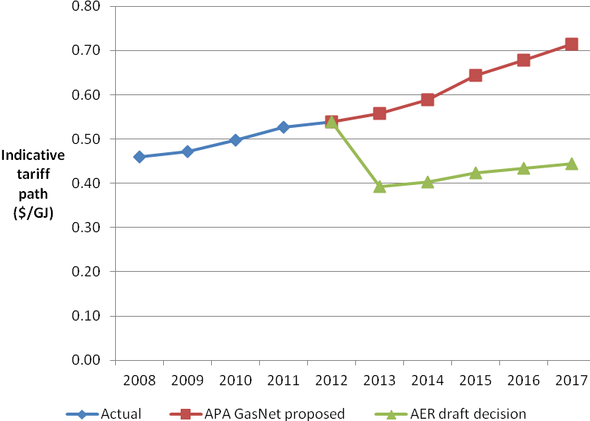

* + - 1. Envestra Victoria reference tariffs

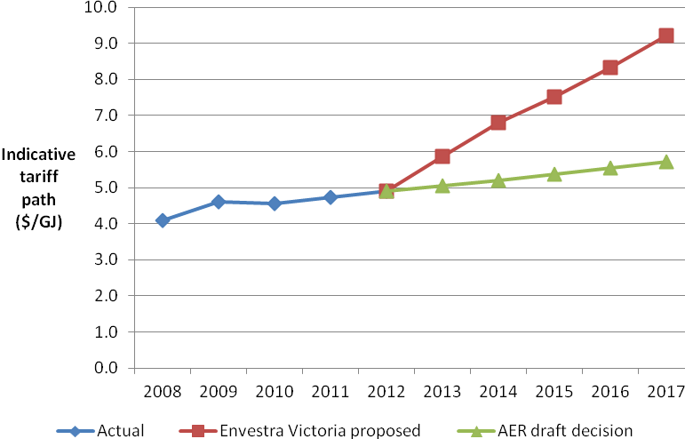

* + - 1. SP AusNet reference tariffs

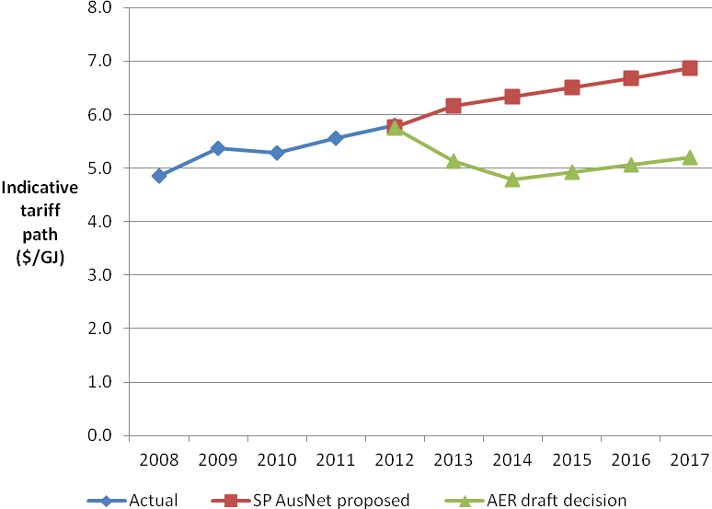

* + - 1. Multinet reference tariffs

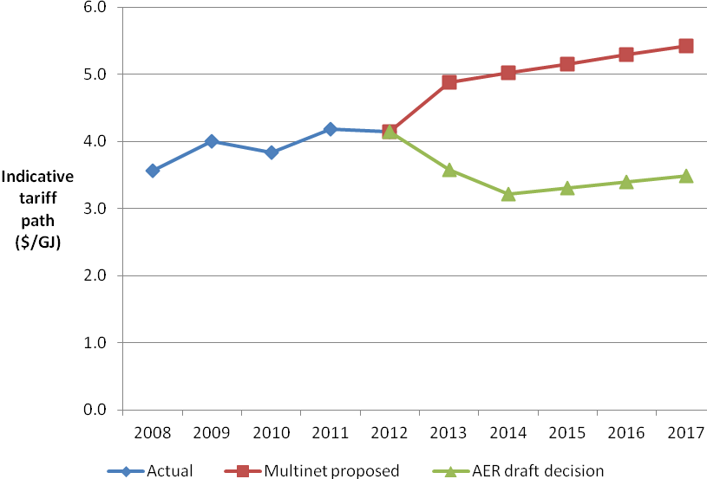

* 1. Impact on an average residential gas bill

For all businesses except Envestra Victoria, our draft decisions would result in lower tariffs both compared with current tariffs and the businesses’ proposed tariffs. All other things being equal, if retailers pass these lower tariffs on to end consumers, gas bills would go down. However, whether consumers actually get a real decrease in their bill will depend on various things including what happens to the wholesale price of gas.

In the case of Envestra Victoria, tariffs are likely to increase marginally as a result of our draft decision, compared with current levels. While this could result in small bill increases, any bill increase will be lower than those from Envestra Victoria’s proposal.

Table 5.6 estimates the impact on an average residential bill if retailers pass onto residential consumers the whole decrease or increase in reference tariffs. This has been calculated with reference to current residential bills. The table shows that the estimated impact of our decision on an average residential bill varies by business. For all businesses, the impact of our draft decision on an average bill is more favourable for customers than what would have resulted if the businesses' proposals were accepted in full.

* + - * 1. Impact of our draft decision and business proposal on an average residential bill ($ nominal)

|  |  |  |  |  |
| --- | --- | --- | --- | --- |
|  | APA GasNet | Envestra Victoriaa | SP AusNet | Multinet |
| Average residential bill | $1 154 | $1 132 | $1 018 | $1 050 |
| AER draft decision effect on annual bill | -$4 | $7 | -$9 | -$8 |
| Business proposal effect on annual bill | $6 | $57 | $13 | $18 |

Source: AER analysis.

Notes: (a) The AER’s draft decision also included its Envestra Albury business. For simplicity only Envestra Victoria has been included in this table.

1. Next steps

Victorian transmission and distribution businesses are currently considering our draft decisions. These businesses are required to submit revised proposals by 9 November 2012.

Interested parties are invited to make submissions to our review. The deadline for submissions is 7 January 2013. This allows interested parties time to consider both our draft decisions and the businesses’ revised proposals before making submissions. In making a submission, consumer groups are encouraged to address the issues that have the most impact on consumers. These may relate to the overall impact on bills or the importance of price stability, for example.

Submissions should be sent electronically to [VicGAAR@aer.gov.au](mailto:VicGAAR@aer.gov.au) and addressed to the attention of Sebastian Roberts, General Manager, 2012 Victorian Gas Access Arrangement Review, Australian Energy Regulator.

A summary of the key dates for the 2013–17 Victorian gas providers’ price review is provided in table 6.1 below.

* + - * 1. Scheduled dates for key stages in the decision making process

|  |  |
| --- | --- |
| **Key stages in the decision making process** | **Scheduled date** |
| AER received business proposals | 30 March 2012 |
| Business proposals published | 2 May 2012 |
| Industry workshop on terms and conditions | 18 May 2012 |
| AER draft decision released | 10 September 2012 for APA GasNet and SP AusNet  21 September 2012 for Multinet and Envestra |
| Revised proposals to be submitted | 9 November 2012 |
| Submissions on revised proposal due | 7 January 2013 |
| Release of AER final decision | March 2013 |

1. Providers of gas distribution services typically negotiate contracts to sell pipeline services to customers such as energy retailers. Section 322 of the National Gas Law (NGL) provides that contracts between service providers and users may differ from those approved by the AER as part of an access arrangement review. In the event of a dispute, however, a user or prospective user may request dispute resolution by the AER under Chapter 6, Part 3 of the NGL. In the event that the AER makes an access determination in order to resolve the dispute, it must give effect to the access arrangement: s. 189.
2. Gas producers include Exxon Mobil, BHP Billiton, Origin Energy and Santos.
3. Gas storage operators include APA GasNet Australia and TRUenergy Gas Storage.
4. End consumers include residential homes, offices and other businesses.
5. Victorian retail companies include AGL Sales, Origin Energy, Sun Retail, Red Energy, Australian Power & Gas, Santos Direct, Victoria Electricity, Energy Australia and Simply Energy.
6. However, under s. 322 of the NGL a service provider may enter into an agreement for access that differs from the applicable access arrangement.
7. See the AER’s draft decision for APA GasNet for more on how this percentage was determined.
8. The actual percentage varies slightly across the three distribution business. See the AER’s draft decisions for more on how these percentages were calculated.
9. Our assessment considers whether the costs being recovered through charges are what we believe an efficient service provider should incur in operating its pipeline services.
10. This may relate to operating expenditure and/or capital expenditure depending on the incentive mechanism.
11. This is the value of the business’ existing assets.
12. The closing value is the value of a business’ capital base on the last day of the relevant calendar year (i.e. 31 December of each year).
13. The value of any redundant assets that were reused during the year are also added on.
14. This has little overall impact on the revenue allowance provided a ‘real’ cost of capital is used.
15. NGR, r. 87.
16. The vanilla post tax WACC is the return to investors after company tax (including imputation benefits) has been accounted for. This WACC formulation has been consistently used by the AER in its regulatory decisions.
17. NGR, r. 89(1)(a).
18. NGR, r. 89(1)(b).
19. NGR, r. 89(1)(c).
20. NGR, r. 89(1)(d).
21. NGR, r. 89(1)(e).
22. NGR, r. 69.
23. That is, whether a prudent service provider acting efficiently, in accordance with accepted good industry practice, to achieve the lowest sustainable cost of delivering pipeline services, would have incurred the opex.
24. NGR, r. 74.
25. This is chosen as it is thought to provide the most accurate estimate of a business’ opex requirements into the future.
26. Due to market forces, these costs may not increase at the same rate as inflation.
27. NGR, r. 98.
28. NGR, r. 76(c).