

Gas market significant price variation report

7 July 2014, Brisbane STTM

© Commonwealth of Australia 2014

This work is copyright. Apart from any use permitted by the Copyright Act 1968, no part may be reproduced without permission of the Australian Competition and Consumer Commission. Requests and inquiries concerning reproduction and rights should be addressed to the Director Publishing, Australian Competition and Consumer Commission, GPO Box 3131, Canberra ACT 2601.

Inquiries about this document should be addressed to:

1. Australian Energy Regulator
2. GPO Box 520
3. Melbourne Vic 3001
4. Tel: (03) 9290 1444
5. Fax: (03) 9290 1457
6. Email: [AERInquiry@aer.gov.au](mailto:AERInquiry@aer.gov.au)

AER reference: 51673 -D13/134960

1. Contents

Contents 3

1 Background 4

1.1 The AER's reporting role 4

1.2 Brisbane Hub 4

2 Brisbane Hub - 7 July 2014 gas day 5

3. Conclusion 9

# Background

## The AER's reporting role

This Significant Price Variation (SPV) report is published by the AER in accordance with the requirements under rule 498(1)(b) of Part 20 of the National Gas Rules (Gas Rules).[1] In accordance with rule 498(2), the AER published the [Short Term Trading Market **(STTM)** SPV Guideline](http://www.aer.gov.au/node/18400) on 21 December 2012. The guideline sets out a number of thresholds that determine whether or not an SPV has occurred. The AER is required to prepare a report when one of these defined events occurs.

Relevant to this report, a SPV includes circumstances where the difference between the D-2 provisional price and the ex ante price is greater than $7/GJ. On 7 July 2014, the difference between the D-2 provisional price and the D-1 ex ante price was $7.15/GJ in the Brisbane STTM gas hub **(Brisbane hub)**.

## Brisbane Hub

The Brisbane hub commenced operation on 1 December 2011. The hub provides a market-based mechanism to deliver wholesale balancing gas to and from Brisbane via the Roma to Brisbane Pipeline **(RBP)**. Users participate in the Brisbane hub, by submitting bids or offers for the purchase or supply of gas.

As shown in Figure 1 below major gas users in the hub include the Swanbank Power Station and two industrial users - Incitec Pivot and BP (Bulwar Refinery).[2] Users also regularly submit bids to withdraw gas from the hub such as for the use of power stations located along the RBP. Gas supplied is understood to largely originate from the Queensland coal seam gas facilities in the Roma region.[3] In contrast to the Adelaide and Sydney hubs, which are serviced by two main pipelines, the Brisbane hub relies on gas delivered by the RBP. Accordingly, gas can only be scheduled by AEMO up to the capacity of the RBP as determined by APA, the pipeline operator.[4]

The Roma Brisbane Pipeline, connected facilities and the Brisbane hub 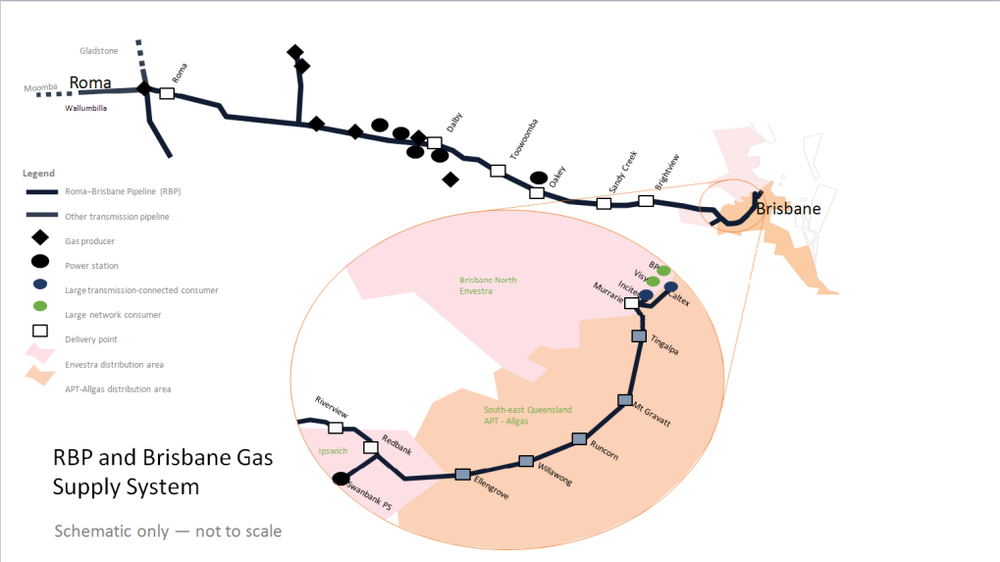

# Brisbane Hub - 7 July 2014 gas day

Thecapacity to deliver gas to the Brisbane hub was reduced by APA in late June to 186 TJ[5]. This impacted on how much gas could be scheduled to the Brisbane hub.

APA advised that on 25 June 2014 a defect was identified in the RBP 10” pipeline downstream of Toowoomba. The affected section of the RBP 10” pipeline was isolated and, as at 21 September 2014, remains isolated reducing capacity to the Brisbane STTM Hub to 186 TJ/d. APA continues to work on the section of the 10” pipeline and investigations have identified issues that will require rectification prior to the section of pipeline being reinstated. APA is investigating a range of solutions. At this stage it is expected that capacity will remain at the current reduced level for the immediate future.

Reduced pipeline capacity limiting scheduled deliveries to the Brisbane STTM hub



As shown in figure 2 above, up to and including 7 July (circled) there were a number of days where the lower RBP capacity prevented the scheduling of further offers to match bids in merit order for the Brisbane hub[6]. Market rules do not allow volumes of gas to be scheduled to the Brisbane hub beyond the physical capacity of the pipeline even if there are parties willing to buy more gas. Notably, since 7 July, this capacity limit has not influenced scheduling because of a reduction in demand.

As shown in figure 3, for 7 July across the three schedules:

* 186 TJ of offers were scheduled to meet price taker bids (uncontrollable demand) of around 156 TJ and around 30 TJ of controllable withdrawal bids.
* With the capacity constraint, there was about 6 TJ TJ of gas which could not be scheduled despite there being bids to take gas priced above offers to supply gas.

**Figure 3: 7 July - Capacity, demand and pricing information**

|  |  |  |  |  |  |  |  |
| --- | --- | --- | --- | --- | --- | --- | --- |
| 1. Schedule | 1. Capacity & Scheduled Offers (TJ) | 1. Scheduled Demand (TJ) | 1. Scheduled Controllable demand (TJ) | 1. Marginal offer (MO) price at 186 TJ ($/GJ) | | 1. Marginal bid (MB) price at 186 TJ ($/GJ) | 1. Quantity of unscheduled / unmatched gas between MO and MB price (TJ) |
| 1. D-3 | 1. 186 | 1. 155.9 | 1. 30.1 | 1. **$2.01** | 1. **$9.85** | | 1. **7.0** |
| 1. D-2 | 1. 186 | 1. 155.6 | 1. 30.4 | 1. **$1.77** | 1. **$9.85** | | 1. **6.7** |
| 1. D-1 | 1. 186 | 1. 155.6 | 1. 30.4 | 1. **$2.28** | 1. **$2.70** | | 1. **6.6** |

Figure 4 highlights how the reduced capacity contributed to higher provisional prices for the D‑3 and D-2 schedules than otherwise would have occurred absent the constraint. With the capacity limit restricting additional volumes from being scheduled, $9.85/GJ bids set the D-3 and D-2 provisional prices. For the D-1 schedule, however, 4.9 TJ of gas was rebid from $9.85/GJ down to a lower bid price. Following this rebid (and reoffers), the resulting ex ante price was set at the price of the last partially cleared bid of $2.70/GJ. This led to a change between the D‑2 and D‑1 price of $7.15/GJ triggering this price event report.

**Figure 4: Reduced pipeline capacity affecting deliveries and prices on 7 July\***



*Not all offers and bids shown

**Rebidding**

A rebid by Stanwell for the D-1 schedule was influential in the fall in the ex ante price. This rebid led to a significant fall in the marginal bid price at the pipeline capacity limit. Other participants did not significantly change their backhaul bid prices. Stanwell has noted to the AER that it changed its bids (and offers) for the D-1 schedule in response to a potential exposure to capacity payments (discussed below) for as available gas quantities it had scheduled based on the D-2 provisional schedule.

Figure 5: Change in controllable withdrawal bid quantity/price between schedules



**Capacity prices and payments**

The reduction in capacity on the RBP led to a number of capacity constraint prices (CCPs)[7] over a number of gas days including 7 July. As shown in figure 6, for the provisional schedules there were relatively high CCPs due to the large area of separation between the low priced offers and high priced bids. However, the capacity price decreased to $0.42/GJ for the ex ante schedule due to rebids.

Figure 6: Reduced pipeline capacity affecting capacity prices on 7 July

The CCP forms part of a mechanism used to compensate shippers with firm transportation rights when two conditions are met. Firstly, quantities of firm gas are unscheduled because of a constraint and secondly non-firm or as available gas quantities are scheduled (ahead of this firm gas).

Stanwell’s rebidding noted above reduced its exposure to high CCPs it may otherwise have had to pay to firm shippers at a relatively high CCP because in the provisional schedules it had “as available” gas scheduled ahead of firm shippers.

# 3. Conclusion

Gas can only be scheduled to Brisbane up to the capacity of the RBP determined by APA. As a result of a constraint on 7 July, pipeline capacity was insufficient to service all demand including controllable withdrawal bids.

A quantity of controllable withdrawal bids at prices higher than the capacity constrained market clearing price was not scheduled. This is in line with market rules which do not allow forward haul gas to be scheduled beyond the pipeline operator capacity of the pipeline.

For the ex-ante schedule, the fall in price appears to have been a response to a high provisional market price given capacity constraints, leading to rebidding which reduced the D-1 ex-ante price. Based on information provided to the AER, the $7.15/GJ fall in price for this gas day appears to indicate a rational response to an identified potential high price and high market exposure for some participants. It appears consistent with the price discovery process facilitated by provisional schedules and final schedules where participants can refine their trading based on material changes in the market.

1. Under Rule 490(1)(a), the AER is to monitor that trading participants activity meet obligations under Part 20 of the Gas Rules.
2. Users also include retailers such as AGL and Origin who sell gas to residential customers in Brisbane.
3. Based on flows on the natural gas services bulletin board, there is no gas flowing east from gas facilities to the south at Moomba. www.gasbb.com.au
4. Rule 405 of the Gas Rules
5. Previous pipeline capacity for Brisbane STTM hub gas deliveries on the RBP had been 206.3 TJ since mid-May.
6. Other days where the capacity constraint prevented the further scheduling of offers/bids in provisional or final schedules were 1,2,3,8 July. On these days, however, there were not significant differences between D-2 prices and D-1 ex ante prices. For these days, the impact on prices of the capacity constraint on D-2 and D-1 ex ante prices was less because the unscheduled bids were priced much lower than the unscheduled bid price of $9.85/GJ on 7 July.
7. The capacity pricing mechanism was triggered in Brisbane on three occasions during the previous week (1, 2 and 3 July 2014).