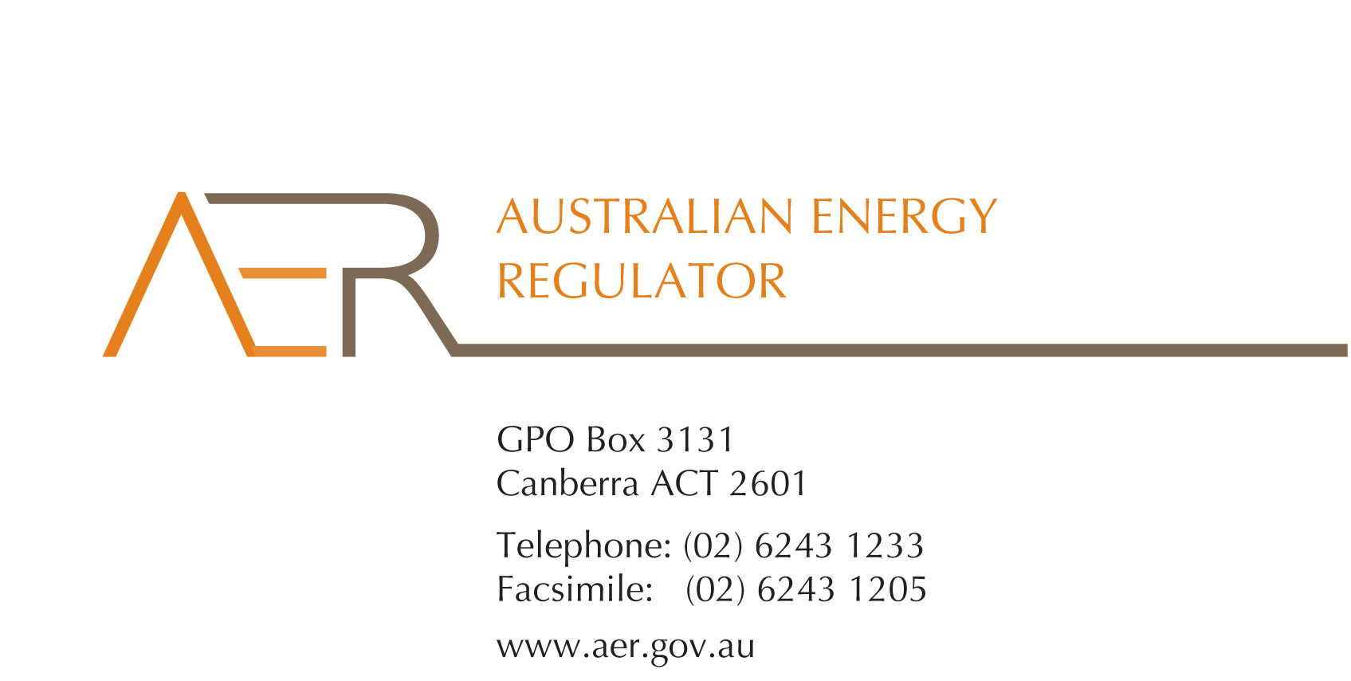

Our Ref: TRACKIT 50305
Contact Officer: Tanja Warre
Contact Phone: 02 6243 1103

22 January 2013

Dear Sir/Madam

Expression of Interest: AER Customer Reference Group

We are pleased to call for expressions of interest to join the AER’s new Customer Reference Group (CRG).
As you may be aware, the National Electricity Rules for setting charges for use of energy network services were substantially amended in late 2012. In light of these and other rule changes including those arising from the AEMC Power of Choice review, the AER has commenced the ‘Better Regulation’ Program. A significant part of this program is to develop Guidelines setting out our proposed approach in application of the revised rules. The National Electricity Objective includes a focus on the long term interests of consumers and the AER is very keen for customers and their representatives to participate in the development of the Guidelines. However the AER also recognises the complexity of the topics and the limits on resources available to representative groups.
Therefore, the AER is establishing the CRG to facilitate customer representative groups’ input into the Guideline development process.
The purpose of the CRG is to ensure that customer perspectives are considered throughout this process. The AER will provide briefings on key issues and the CRG will enable participation with others in considering proposals. The role of CRG members will be to consult with their stakeholders on key issues relating to the Guidelines and to report back to the AER. Notably, contributions of the CRG will be taken as submissions and considered by the AER in its decision making processes to complement the standard workshop and consultation process.
We appreciate the volume of matters for consideration and the limited resources of many customer representative groups. The AER considers the CRG will provide a mechanism for coordinated and informed input from a wider cross-section of customer groups. It is anticipated the CRG will run from February through to December 2013, when the ‘Better Regulation’ project is complete.
We anticipate:
- monthly CRG meetings to be held by video conference from AER offices (located in all State capitals)
- CRG sub-groups. These groups will consist of 3-5 CRG members to provide detailed input on nominated Guidelines. In this way, some may focus on particular topics, but all topics will be addressed by the CRG.
The proposed responsibilities and meeting requirements of CRG members are outlined in the draft CRG Statement of objectives and functions included below. We anticipate that the Group’s first meeting will be held on 7 February 2013 from 12.30 – 3.00pm. Meetings are then scheduled for 7 March, 18 April, 2 May and 6 June 2013. Further meetings may be scheduled after this time in consultation with CRG members.
As outlined earlier, in addition to the monthly CRG meetings where high level discussions will occur, we are seeking nominations from CRG members to provide more detailed input into selected work streams (refer to dot point 2). Further details on this proposal are set out in the draft CRG Statement of objectives and functions. A summary of each of the Guidelines is also attached following this letter.
Please provide the completed expression of interest form with the name and contact details of your organisation’s representative and the nominated work streams of interest (if applicable) by 5.00pm Monday 28 January 2013. We will advise successful applicants by Thursday 31 January 2013 and will provide further details on upcoming meetings. Please do not hesitate to contact Tanja Warre at tanja.warre@aer.gov.au or (02) 6243 1103 for any enquiries or questions about the CRG and its operation.
Yours sincerely

Andrew Reeves
Chairman
Australian Energy Regulator
‘Better regulation’ work stream overview

- Expenditure forecast assessment guideline

These guidelines will describe the techniques and associated data requirements of the AER’s approach to determining efficient expenditure allowances in accordance with the objectives, criteria and factors in the Rules. The techniques used and data collected under the guidelines will also form the basis of our annual benchmarking reports.
In developing the guidelines we will be looking to improve our approach to expenditure assessment and become better equipped to challenge the proposals put to us by regulated businesses. In consultation with customers we will be moving towards a framework which involves greater use of benchmarking techniques both at aggregated and disaggregated levels of analysis.
- Rate of return guideline

This guideline will set out how the AER intends to apply the new rules framework to set rates of return for network businesses that meet the long term interest of customers. This will involve setting out high level regulatory principles that will guide our assessment of methodologies, data sources and models to determine returns on equity and debt that make up the overall rate of return.
Consultation with customers who have an interest in energy regulation will be undertaken to filter priority issues for further detailed examination.
- Expenditure incentives guideline

The Rules require the AER to develop Capital Expenditure Incentive Guidelines. These guidelines will set out how we intend to apply improved incentives for electricity network businesses to incur efficient capital expenditure so that only investment that is necessary to provide a reliable network is funded by consumers.
In addition, we will be reviewing the incentives for efficient operating expenditure. In particular, we will consider whether revisions are required to the current efficiency benefit sharing scheme that applies to network businesses are necessary in the context of our approach to expenditure assessments of network businesses.
- Shared asset guideline

This guideline will establish the AER’s approach to shared assets, allowing electricity customers to benefit from unregulated revenue streams from services provided by regulated assets.
- Confidentiality guideline

This guideline will set out how the AER will consider confidential information for regulatory determinations. The Guideline will cover the types of information that is considered confidential and the process for disclosure to ensure more information is available for stakeholders to engage in the regulatory determination process.
- Network service provider customer engagement guideline

This guideline will set out how the AER expects network service providers to engage with customers and respond to issues raised in preparing regulatory proposals.
- Power of Choice implementation

The AEMC has been undertaking a number of reviews into how the National Electricity Market can better support efficient demand-side participation. The AEMC completed its Power of Choice review in November 2012 and is soon to complete its review of energy market arrangements for electric and natural gas vehicles. These reviews propose a number of recommendations to the Standing Council on Energy and Resources on required changes to the Rules and broader market reforms. The rule change assessment and public consultation processes will occur in 2013. It is likely that the AER will have a role in implementing a number of these reforms. This role is likely to involve:
- reviewing incentives for distributors to engage with the demand-side;
- reviewing arrangements pertaining to distribution tariff reviews; and,
- possible amendments to the AER’s retail guidelines.

To: Tanja Warre
Director, AER
tanja.warre@aer.gov.au

Response: Expression of interest to join AER Customer Reference Group

Thank you for considering our invitation to join the AER Customer Reference Group.

Please complete this form and return it to Tanja Warre at the above email address by 5.00pm Monday 28 January 2013.

If you wish to nominate to be a member of one of the AER’s smaller CRG working groups to provide more detailed input into particular Guidelines, please list these below in the ‘nominated work streams’.

Organisation
Address
Representative’s name
Direct telephone
Mobile
Email
Nominated work streams

Please contact Tanja Warre at the above email or on (02) 6243 1103 for any enquiries.

Membership is aimed at customer representative groups. Regulated businesses and other interest groups have the opportunity to participate in the Better Regulation Project workgroups.

