Better Regulation Update – October 2013

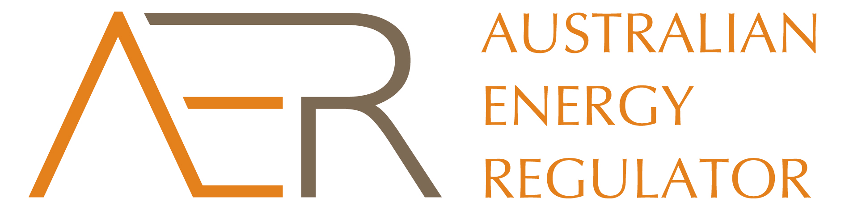

#### Recap

##### September & October

* **Expenditure assessment:** held stakeholder six workshops in September and bilateral meetings with stakeholders; submissions closed on 20 September.
* **Expenditure incentives:** held bilateral meetings with stakeholders; submissions closed on 20 September.
* **Confidentiality:** held bilateral meetings with stakeholders; submissions closed on 20 September.
* Consumer reference group: held CRG meeting on 17 October.
* Rate of return**:** held forum on 2 October; released issues paper on equity beta on 11 October.

#### Upcoming

##### October & November

* Rate of return**:** submissions on issues paper on equity beta close 28 October.
* Consumer engagement: publish final guidelineend October.
* Shared assets:publishfinal guideline in November.
* **Expenditure assessments:** publish final guideline on 29 November.
* **Expenditure incentives:** publish final guideline on 29 November.
* **Confidentiality:** publish final guideline on 29 November.

1. Consultation on the majority of our guidelines has ended and we are working towards the end of the Better Regulation program. The last part of our consultation is the issues paper on equity beta for the rate of return guideline. We are requesting written submissions by close of business Monday 28 October. More information and the paper are available on the rate of return webpage at <http://www.aer.gov.au/node/18859>.
2. We will publish our final consumer engagement guideline at the end of October, which is the subject of this month’s spotlight. We will publish our shared assets guideline in November and the final guidelines for expenditure assessment, expenditure incentives and confidentiality on 29 November.

#### Spotlight: stakeholder engagement in energy regulation

1. Our consumer engagement guideline will assist network businesses to engage systematically, consistently and strategically with consumers on significant issues. This will better align the provision of energy services with the long term interests of consumers. The consumer engagement guideline will support greater transparency and accountability for network businesses. Businesses will need to demonstrate they have listened to consumers, heard what has been said and that this is reflected in their spending proposals.
2. Meanwhile, we have sought to be more innovative in the way we engage with stakeholders in the Better Regulation program. Traditionally we developed guidelines by publishing papers, holding one-shot public forums and taking written submissions. Instead, for Better Regulation we hosted more and varied types of forums for stakeholders to voice their views. From larger public forums, to targeted workshops and the consumer reference group. We’ve also sought to communicate better through our newsletters, whole-of-program updates and factsheets. Our new engagement approach has added significant value to the Better Regulation guideline development process.

While we will publish the consumer engagement guideline for network businesses in October, we are also releasing our own framework for how we as a regulator will engage. The AER Stakeholder Engagement Framework sets out principles for us to transparently and consistently consider our stakeholders’ interests. It commits us to timely and clear communication, transparency, inclusiveness and accessibility. It establishes what energy consumers and other stakeholders can expect when they engage with us. A final Framework, incorporating the views of stakeholders, will be available on our website by 31 October at <http://www.aer.gov.au/node/21247>.