Better Regulation Update – November 2013

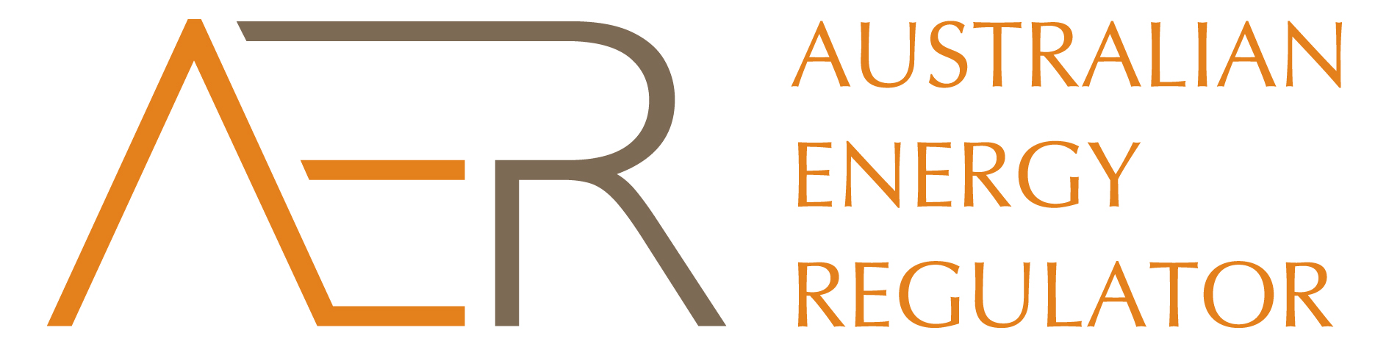

#### Recap

##### October & November

* **Rate of return:** held stakeholder forum and published issues paper on equity beta for consultation.
* Consumer reference group: held CRG meeting on 17 October.
* **Consumer engagement:** publishedfinal 6 November.
* **Confidentiality:** publishedfinal guideline 19 November.

#### Upcoming

##### November & December

* Rate of return**:** publish final guideline in mid-December.
* Shared assets:publishfinal guideline on 29 November.
* **Expenditure assessments:** publish final guideline on 29 November.
* **Expenditure incentives:** publish final guideline on 29 November.

1. This is our final newsletter update for the Better Regulation program. We would like to thank all stakeholders for their active involvement in the large amount of work done this year on reforming network regulation.
2. We published our final consumer engagement guideline for network service providers on 6 November, and our final confidentiality guideline on 19 November. We will publish the final expenditure assessment, expenditure incentives and shared assets guidelines on 29 November. We expect to publish the final rate of return guideline in mid-December. The impact of our guidelines is the subject of this month’s spotlight.
3. We will be publishing two more documents to round out the Better Regulation program. The first will be a report on the consumer reference group. It will feature our summary of how the group worked and assessment of how effective it was. The second will be the last in our series of policy notes which explain the reform package as a whole. It will follow on from *Better Regulation: an integrated package* and the *Better Regulation: reform package update*. These documents will all be available on our website.

#### Spotlight: Applying Better Regulation

1. The Better Regulation guidelines will apply to network businesses at their next determination. Network prices will first begin to be affected by our new approach in NSW and the ACT. Determinations for these businesses will commence in early 2014 and be finalised in 2015. Following NSW and the ACT, we will implement the Better Regulation reforms in Queensland, SA and then Victoria. All energy networks will be subject to the new approach by 2018.
2. Some of our reforms are already having an effect before our next determinations. We are already collecting data from network businesses to support our new forecasting and benchmarking techniques. For the majority of businesses from next year onwards any capital investments they make will be subject to our ex post review process.
3. Network businesses can also begin using our consumer engagement guideline from now to enhance their consultation. We also expect businesses to follow the new Regulatory Investment Test for Distribution. Our decision making will also become more transparent as our new confidential information process applies from now.