**UNITED ENERGY REVISED REGULATORY PROPOSAL – JAN 2016**

**Attachments not published on AER website**

United Energy provided further supporting information which we have not published on our website due to the number of documents. However, if you wish to obtain a copy of this material, please email VICElectricity2016@aer.gov.au.

The public documents submitted by United Energy but not published on our website are listed below:

**RRP 8-13 Detailed WACC supporting documents – Frontier**

Beta report – references used

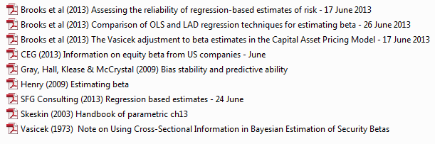

Equity report – references used

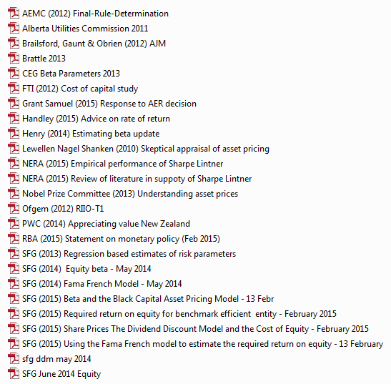

Gamma report – references used

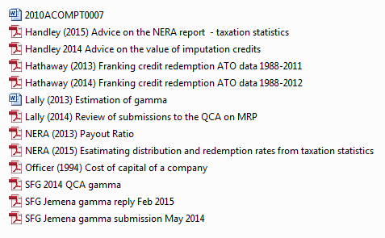

Yo yo report – references used

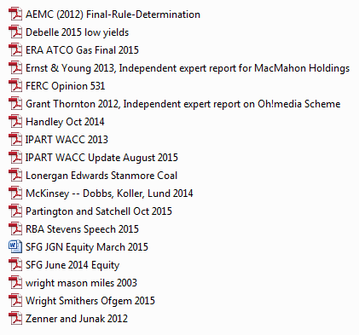

**RRP 8-14 Houston Kemp WACC supporting documents**

