

FINAL DECISION

TasNetworks distribution determination

2017−18 to 2018−19

Attachment 1 – Annual revenue requirement

April 2017

© Commonwealth of Australia 2017

This work is copyright. In addition to any use permitted under the Copyright Act 1968, all material contained within this work is provided under a Creative Commons Attributions 3.0 Australia licence, with the exception of:

* the Commonwealth Coat of Arms
* the ACCC and AER logos
* any illustration, diagram, photograph or graphic over which the Australian Competition and Consumer Commission does not hold copyright, but which may be part of or contained within this publication. The details of the relevant licence conditions are available on the Creative Commons website, as is the full legal code for the CC BY 3.0 AU licence.

Requests and inquiries concerning reproduction and rights should be addressed to the:

Director, Corporate Communications  
Australian Competition and Consumer Commission   
GPO Box 4141, Canberra ACT 2601

or publishing.unit@accc.gov.au.

Inquiries about this publication should be addressed to:

Australian Energy Regulator  
GPO Box 520  
Melbourne Vic 3001

Tel: 1300 585 165

Email: [AERInquiry@aer.gov.au](mailto:AERInquiry@aer.gov.au)

1. Note
2. This attachment forms part of the AER's final decision on TasNetworks' distribution determination for 2017–19. It should be read with all other parts of the final decision.

This final decision consists of an Overview and 8 attachments. As many issues were settled at the draft decision stage or required only minor updates we have not prepared final decision attachments for:

* Regulatory asset base
* Regulatory depreciation
* Capital expenditure
* Operating expenditure
* Corporate income tax
* Capital expenditure sharing scheme
* Service target performance incentive scheme
* Demand management incentive scheme
* Classification of services
* Pass through events
* Connection policy.

1. The AER's final decision on these matters is set out in the Overview. For ease of reference the remaining attachments have been numbered consistently with the attachment numbering in our draft decision.
2. The final decision therefore includes the following documents:
3. Overview
4. Attachment 1 – Annual revenue requirement
5. Attachment 3 – Rate of return
6. Attachment 4 – Value of imputation credits
7. Attachment 9 – Efficiency benefit sharing scheme
8. Attachment 14 – Control mechanisms
9. Attachment 16 – Alternative control services
10. Attachment 17 – Negotiated services framework and criteria

Attachment 19 – Tariff structure statement

1. Contents

Note 1-2

Contents 1-3

Shortened forms 1-4

1 Annual revenue requirement 1-6

1.1 Final decision 1-6

1.2 TasNetworks' revised proposal 1-8

1.3 Assessment approach 1-9

1.4 Reasons for final decision 1-9

1.4.1 Revenue smoothing 1-10

1.4.2 Shared assets 1-11

1.4.3 Indicative average distribution price impact 1-12

1.4.4 Expected impact of decision on electricity bills 1-14

1. Shortened forms

| Shortened form | Extended form |
| --- | --- |
| 1. AARR | 1. aggregate annual revenue requirement |
| 1. AEMC | 1. Australian Energy Market Commission |
| 1. AEMO | 1. Australian Energy Market Operator |
| 1. AER | 1. Australian Energy Regulator |
| 1. ASRR | 1. annual service revenue requirement |
| 1. augex | 1. augmentation expenditure |
| 1. capex | 1. capital expenditure |
| 1. CCP | 1. Consumer Challenge Panel |
| 1. CESS | 1. capital expenditure sharing scheme |
| 1. CPI | 1. consumer price index |
| 1. DMIA | 1. demand management innovation allowance |
| 1. DRP | 1. debt risk premium |
| 1. EBSS | 1. efficiency benefit sharing scheme |
| 1. ERP | 1. equity risk premium |
| 1. MAR | 1. maximum allowed revenue |
| 1. MRP | 1. market risk premium |
| 1. NEL | 1. national electricity law |
| 1. NEM | 1. national electricity market |
| 1. NEO | 1. national electricity objective |
| 1. NER | 1. national electricity rules |
| 1. NSP | 1. network service provider |
| 1. NTSC | 1. negotiated transmission service criteria |
| 1. opex | 1. operating expenditure |
| 1. PPI | 1. partial performance indicators |
| 1. PTRM | 1. post-tax revenue model |
| 1. RAB | 1. regulatory asset base |
| 1. RBA | 1. Reserve Bank of Australia |
| 1. repex | 1. replacement expenditure |
| 1. RFM | 1. roll forward model |
| 1. RIN | 1. regulatory information notice |
| 1. RPP | 1. revenue and pricing principles |
| 1. SLCAPM | 1. Sharpe-Lintner capital asset pricing model |
| 1. STPIS | 1. service target performance incentive scheme |
| 1. TNSP | 1. transmission network service provider |
| 1. TUoS | 1. transmission use of system |
| 1. WACC | 1. weighted average cost of capital |

# Annual revenue requirement

1. The annual revenue requirement (ARR) is the sum of the various building block costs for each year of the regulatory control period before smoothing. The ARRs are smoothed across the period to reduce fluctuations between years and to determine expected revenues for each year. The expected revenues are the amounts that TasNetworks will target for annual pricing purposes and recover from customers for the provision of standard control services for each year of the regulatory control period. This attachment sets out our final decision on TasNetworks' ARRs and expected revenues for the 2017–19 regulatory control period.

## Final decision

We do not accept TasNetworks' revised proposed total revenue requirement of $458.8 million ($ nominal, unsmoothed) over the 2017–19 regulatory control period. This is because we have not accepted the building block costs in TasNetworks' revised proposal. We determine a total revenue requirement of $478.0 million ($ nominal, unsmoothed) for TasNetworks for the 2017–19 regulatory control period, reflecting our final decision on the various building block costs. This is an increase of $19.2 million ($ nominal) or 4.2 per cent to TasNetworks' revised proposal.

As a result of our smoothing of the ARRs, our final decision on the annual expected revenue and X factor for each regulatory year of the 2017–19 regulatory control period is set out in Table 1.1. Our final decision is to approve total expected revenues of $477.3 million ($ nominal, smoothed) for the 2017–19 regulatory control period.

1. Figure 1.1 shows the difference between TasNetworks' revised proposal and our final decision.
2. Table 1.1 shows our final decision on the building block costs, the ARR, annual expected revenue and X factor for each year of the 2017–19 regulatory control period.
3. Figure 1.1 AER's final decision on TasNetworks' revenue for the 2017–19 regulatory control period ($million, nominal)

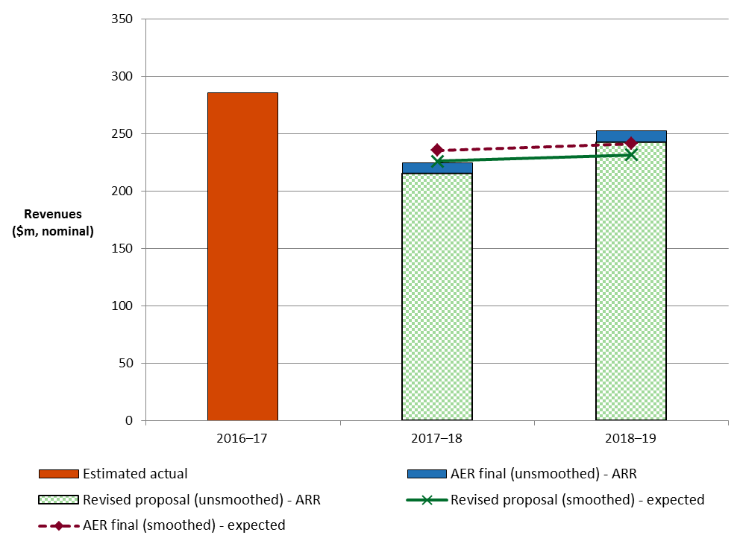

Source: TasNetworks, Revised regulatory proposal, RTN006–PTRM, December 2016; AER analysis.

Table 1.1 AER's final decision on TasNetworks' revenues for the   
2017–19 regulatory control period ($million, nominal)

|  |  |  |  |
| --- | --- | --- | --- |
|  | 2017–18 | 2018–19 | Total |
| Return on capital | 97.2 | 101.9 | 199.1 |
| Regulatory depreciationa | 38.2 | 57.6 | 95.8 |
| Operating expenditureb | 68.3 | 68.4 | 136.7 |
| Revenue adjustmentsc | 12.5 | 12.8 | 25.4 |
| Net tax allowance | 8.9 | 12.2 | 21.0 |
| Annual revenue requirement (unsmoothed) | 225.0 | 252.9 | 478.0 |
| **Annual expected revenue (smoothed)** | **235.8** | **241.6** | **477.3** |
| X factor | n/ad | 0.00%e | n/a |

Source: AER analysis.

(a) Regulatory depreciation is straight-line depreciation net of the inflation indexation on the opening RAB.

(b) Operating expenditure includes debt raising costs.

(c) Revenue adjustments include the efficiency benefit sharing scheme (EBSS) carry-overs and demand management incentive scheme (DMIS) allowance.

(d) TasNetworks is not required to apply an X factor for 2017–18 because we set the expected revenue for 2017–18 in this decision. The expected revenue for 2017–18 is $235.8 million ($nominal). This is around 19.5 per cent lower than the estimated revenue for 2016–17 in real terms, or around 17.6 per cent lower in nominal terms.

(e) The X factor for 2018–19 will be revised to reflect the annual return on debt update. Under the CPI–X framework, the X factor measures the real rate of change in annual expected revenue from one year to the next. A negative X factor represents a real increase in revenue. Conversely, a positive X factor represents a real decrease in revenue.

## TasNetworks' revised proposal

1. TasNetworks' revised proposal included a total expected revenue of $458.2 million ($ nominal, smoothed) for the 2017–19 regulatory control period.
2. Table 1.2 shows TasNetworks' revised proposed building block costs, the ARR, expected revenue and X factor for each year of the 2017–19 regulatory control period.

Table 1.2 TasNetworks' revised proposed revenues for the 2017–19 regulatory control period ($million, nominal)

|  |  |  |  |
| --- | --- | --- | --- |
|  | 2017–18 | 2018–19 | Total |
| Return on capital | 88.8 | 93.0 | 181.8 |
| Regulatory depreciationa | 38.4 | 57.8 | 96.2 |
| Operating expenditureb | 68.3 | 68.4 | 136.7 |
| Revenue adjustmentsc | 12.6 | 12.9 | 25.6 |
| Net tax allowance | 7.7 | 10.9 | 18.6 |
| Annual revenue requirement (unsmoothed) | 215.7 | 243.0 | 458.8 |
| **Annual expected revenue (smoothed)** | **226.3** | **231.9** | **458.2** |
| X factor | 22.76% | 0.00% | n/a |

Source: TasNetworks, Revised regulatory proposal, RTN006–PTRM, December 2016.

(a) Regulatory depreciation is straight-line depreciation net of the inflation indexation on the opening RAB.

(b) Operating expenditure includes debt raising costs.

(c) Revenue adjustments include EBSS carry-overs and DMIS allowance.

## Assessment approach

We have not changed our assessment approach for the ARR from our draft decision. Section 1.3 of our draft decision details that approach.[1]

## Reasons for final decision

For this final decision, we determine a total revenue requirement of $478.0 million ($ nominal, unsmoothed) for TasNetworks over the 2017–19 regulatory control period. This is $19.2 million ($ nominal) or 4.2 per cent more than TasNetworks' revised proposal. This reflects the impact of our final decision on the return on capital, regulatory depreciation, EBSS and corporate income tax building block costs.

Figure 1.2 shows the difference between TasNetworks' revised proposed ARRs and our final decision, as well as our draft decision and TasNetworks’ initial proposal.

Figure 1.2 AER's draft and final decisions, and TasNetworks' initial and revised proposed annual revenue requirement ($million, nominal)

1. 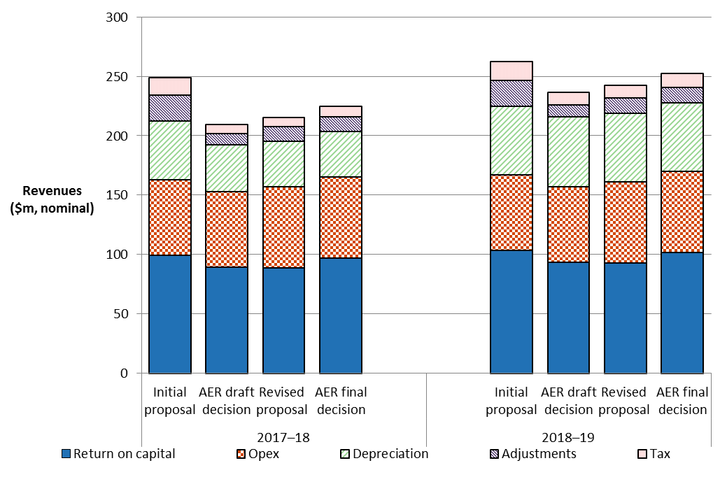

Source: TasNetworks, Revised regulatory proposal, RTN006–PTRM, December 2016.

AER analysis.

Note: Revenue adjustments include EBSS carry-overs and DMIS allowance. Opex includes debt raising costs.

The most significant changes to TasNetworks' revised proposal include:

* an increase in the return on capital allowance of 9.5 per cent (sections 3.1 and 3.2 of the Overview)
* a reduction in the regulatory depreciation allowance of 0.4 per cent (section 3.4 of the Overview)
* an increase in the cost of corporate income tax allowance of 13.3 per cent (section 3.7 of the Overview)
* a reduction in the EBSS carryover amounts from the 2012–17 regulatory control period of 0.8 per cent (section 4.3 of the Overview).

### Revenue smoothing

We have taken into account the building block costs determined in this decision when smoothing the expected revenues for TasNetworks over the 2017–19 regulatory control period. We consider that our profile of X factors results in an expected revenue in the last year of the regulatory control period that is as close as reasonably possible to the ARR for that year.[2]

TasNetworks' 2017–19 regulatory control period is shorter than the usual five year period. To smooth the revenue reductions over this shorter period, we have allowed the difference between smoothed and unsmoothed revenues in the last year of the 2017–19 regulatory control period to diverge more than would be usual. This approach smooths the revenues by allowing for a more gradual path for lower revenues over the 2017–19 regulatory control period.

Based on the X factors we have determined for TasNetworks, the difference between the expected revenue and ARR for 2018–19 is 4.5 per cent. While we consider this divergence is larger than usual, it avoids the situation of a large price decrease in 2017–18 followed by a large price increase in 2018–19.

### Shared assets

Our final decision is to not apply a shared asset revenue adjustment to TasNetworks' total revenue requirement because the materiality threshold is not met in any year of the 2017–19 regulatory control period.

1. Distributors, such as TasNetworks, may use assets to provide both the standard control services we regulate and other unregulated services. These assets are called 'shared assets'.[3] Of the unregulated revenues a distributor earns from shared assets, 10 per cent will be used to reduce the distributor's prices for standard control services.[4]
2. Shared asset revenue reductions are subject to a materiality threshold. Unregulated use of shared assets is material when a distributor's unregulated revenues from shared assets in a specific regulatory year are expected to be greater than one per cent of its total expected revenue for that regulatory year.[5]

In our draft decision, we considered TasNetworks' forecast unregulated revenues from shared assets for the 2017–19 regulatory control period to be reasonable because they were comparable with its historical unregulated revenues from shared assets. Based on the expected revenues determined in this final decision, we estimate that the unregulated revenues will be 0.3 per cent of the expected revenues in each year of the 2017–19 regulatory control period. Hence, the materiality threshold of one per cent is not met in any year of the 2017–19 regulatory control period and we do not apply a shared asset revenue adjustment.

1. We note unregulated revenues from shared assets may in future become material. We will monitor TasNetworks' shared asset unregulated revenues for future regulatory control periods.

### Indicative average distribution price impact

1. Our final decision on TasNetworks' expected revenues ultimately affects the prices consumers pay for electricity. There are several steps required in translating our revenue decision to a price impact.
2. We regulate TasNetworks' standard control services under a revenue cap form of control. This means our final decision on TasNetworks' expected revenues do not directly translate to price impacts. This is because TasNetworks' revenue is fixed under the revenue cap form of control, so changes in the consumption of electricity will affect the prices ultimately charged to consumers. We are not required to establish the distribution prices for TasNetworks as part of this determination. However, we will assess TasNetworks' annual pricing proposals before the commencement of each regulatory year within the 2017–19 regulatory control period. In each assessment we will administer the pricing requirements set in this distribution determination.
3. For this final decision, we have estimated some indicative average distribution price impacts flowing from our determination on the expected revenues for TasNetworks over the 2017–19 regulatory control period. In this section, our estimates only relate to standard control services (that is, the core electricity distribution charges), not alternative control services (such as metering charges). These indicative price impacts assume that actual energy consumption across the 2017–19 regulatory control period matches TasNetworks' forecast energy consumption, which we have adopted for this final decision.
4. Figure 1.3 shows TasNetworks' indicative price path based on the expected revenues established in our final decision compared to its revised proposed revenue requirement. The indicative price path is estimated using the approved expected revenue as determined in this final decision and dividing by TasNetworks' forecast energy consumption for each year of the 2017–19 regulatory control period. For presentation purposes, the prices are scaled so that the price index begins at 1.00 in 2016–17. The index provides a simple overall measure of the relative movement in expected distribution prices over the 2017–19 regulatory control period.

Figure 1.3 AER's final decision and TasNetworks' revised proposed indicative price path (nominal price index)

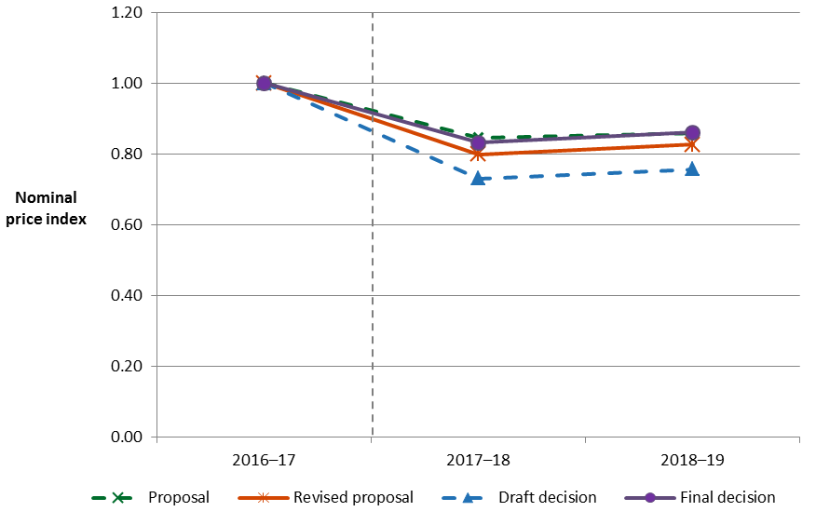

Source: AER analysis.

Notes: The nominal price index is constructed by dividing expected revenue for standard control services by forecast energy consumption for each year of the regulatory control period, then scaling relative to the base year (2016–17).

We estimate that our final decision on TasNetworks' annual expected revenue will result in a decrease to average distribution charges by about 7.2 per cent per annum over the 2017–19 regulatory control period in nominal terms.[6] This compares to the nominal average decrease of approximately 9.1 per cent per annum proposed by TasNetworks over the 2017–19 regulatory control period.[7] These high-level estimates reflect the aggregate change across the entire network and do not reflect the particular tariff components for specific end users.

1. Table 1.3 displays the comparison of the revenue and price impacts of TasNetworks' revised proposal and our final decision.

Table 1.3 Comparison of revenue and price impacts of TasNetworks' revised proposal and the AER's final decision

|  |  |  |  |
| --- | --- | --- | --- |
|  | 2016–17 | 2017–18 | 2018–19 |
| **AER final decision** |  |  |  |
| Revenue ($m, nominal) | 286.0 | 235.8 | 241.6 |
| Price path (nominal index)a | 1.00 | 0.83 | 0.86 |
| Revenue (change %) |  | –17.6% | 2.4% |
| Price path (change %) |  | –16.8% | 3.5% |
| **TasNetworks revised proposal** |  |  |  |
| Revenue ($m, nominal) | 286.0 | 226.3 | 231.9 |
| Price path (nominal index)a | 1.00 | 0.80 | 0.83 |
| Revenue (change %) |  | –20.9% | 2.5% |
| Price path (change %) |  | –20.2% | 3.5% |

Source: AER analysis.

(a) The nominal index is constructed by dividing expected revenue for standard control services by forecast energy consumption for each year of the regulatory control period, then scaling relative to the base year (2016–17).

### Expected impact of decision on electricity bills

1. The annual electricity bill for customers in Tasmania will reflect the combined cost of all the electricity supply chain components—wholesale energy generation, transmission, distribution, metering, and retail costs. This final decision primarily relates to the distribution charges for standard control services, which represent approximately 41 per cent on average for Tasmanian customers.[8]
2. In this section, we estimate the expected bill impact by varying the distribution charges in accordance with our final decision, while holding all other components—including the metering component—constant. This approach isolates the effect of our final decision on the core distribution charges, and does not imply that other components will remain unchanged across the regulatory control period. We note that in its recent electricity price trends report for Tasmania, the AEMC has indicated that wholesale costs are expected to rise, based on the expected trend in Victoria following the closure of Hazelwood power station.[9] However, as discussed below we expect the decreasing distribution network charges flowing from this final decision will offset some of the increases from other components of the overall bill.

Based on this approach in our final decision, we expect that the distribution component of the average annual residential electricity bills in Tasmania to decrease over the 2017–19 regulatory control period. The distribution component of the average annual residential electricity bill in 2018–19 is expected to reduce by about $110 ($ nominal) below the 2016–17 level. This equates to a 5.7 per cent decrease in the average customer’s total bill over 2 years.

By comparison, had we accepted TasNetworks' revised proposal, the expected distribution component of the average annual residential electricity bill in 2018–19 would reduce by about $137 ($ nominal) below the 2016–17 level. This equates to a 7.1 per cent decrease in the average customer’s total bill over 2 years.

1. Our estimate of the potential impact our final decision will have for TasNetworks' residential customers is based on an annual electricity usage of around 8550 kWh per annum for a residential customer in Tasmania.[10] Therefore, customers with different usage will experience different changes in their bills. We also note that there are other factors, such as metering costs, transmission network costs, wholesale and retail costs, which affect electricity bills.

Similarly, for an average small business customer in Tasmania that uses approximately 10250 kWh of electricity per annum,[11] our final decision for TasNetworks is expected to lead to lower average annual electricity bills. The distribution component of the average annual small business electricity bill in 2018–19 is expected to reduce by about $184 ($ nominal) below the 2016–17 level. This equates to a 5.7 per cent decrease in the average customer’s total bill over 2 years.

By comparison, had we accepted TasNetworks' revised proposal, the expected distribution component of the average annual residential electricity bill in 2018–19 would reduce by about $230 ($ nominal) below the 2016–17 level. This equates to a 7.1 per cent decrease in the average customer’s total bill over 2 years.

Table 1.4 shows the estimated annual average impact of our final decision for the 2017–19 regulatory control period and TasNetworks' revised proposal on the average residential and small business customers' annual electricity bills. As explained above, these bill impact estimates are indicative only, and individual customers’ actual bills will depend on their usage patterns and the structure of their tariffs.

Table 1.4 Estimated impact of TasNetworks' revised proposal and the AER's final decision on annual electricity bills for the 2017–19 regulatory control period ($ nominal)

|  |  |  |  |
| --- | --- | --- | --- |
|  | 2016–17 | 2017–18 | 2018–19 |
| **AER final decision** |  |  |  |
| Residential annual bill | 1920a | 1787 | 1810 |
| Annual changec |  | –133 (–6.9 %) | 23 (1.3%) |
| Small business annual bill | 3229b | 3006 | 3045 |
| Annual changec |  | –223 (–6.9%) | 38 (1.3%) |
| **TasNetworks revised proposal** |  |  |  |
| Residential annual bill | 1920a | 1761 | 1783 |
| Annual changec |  | –159 (–8.3%) | 22 (1.3%) |
| Small business annual bill | 3229b | 2962 | 2999 |
| Annual changec |  | –268 (–8.3%) | 37 (1.3%) |

Source: AER analysis; AEMC, Final report: 2016 Residential Electricity Price Trends, 14 December 2016, p. 160; AER, [Energy made easy website](http://www.energymadeeasy.gov.au/); OTTER, Information paper: Typical electricity customers, May 2014.

(a) Annual bill for 2016–17 is sourced from AEMC's 2016 residential electricity price trends report and reflects an annual consumption of 8550kWh for a residential customer in Tasmania.

(c) Annual bill for 2016–17 is sourced from the AER's Energy Made Easy website and reflects an average annual consumption of 10252kWh for small business customers using tariff 22 in Tasmania.

(b) Annual change amounts and percentages are indicative. They are derived by varying the distribution component of 2016–17 bill amounts in proportion to yearly expected revenue divided by forecast energy as proposed by TasNetworks. Actual bill impacts will vary depending on electricity consumption and tariff class.

1. AER, Draft decision TasNetworks distribution determination - Attachment 1 - Annual revenue requirement, September 2016, pp. 8–10.
2. NER, cl. 6.5.9(b)(2).
3. NER, cl. 6.4.4.
4. AER, Shared asset guideline, November 2013.
5. AER, Shared asset guideline, November 2013, p. 8.
6. This amount reflects an expected inflation rate of 2.45 per cent per annum as determined in this final decision. In real terms we estimate average distribution charges to decline by 9.4 per cent per annum, compared to a decrease of 11.3 per cent proposed by TasNetworks in its revised regulatory proposal.
7. This amount reflects an expected inflation rate of 2.45 per cent per annum as proposed by TasNetworks in its revised regulatory proposal.
8. AEMC, Final report: 2016 Residential Electricity Price Trends, 14 December 2016, p. 160; AER analysis.
9. AEMC, Final report: 2016 Residential Electricity Price Trends, 14 December 2016, p. 162.
10. AEMC, Final report: 2016 Residential Electricity Price Trends, 14 December 2016, p. 158.
11. This reflects the average annual consumption for small business customers using tariff 22 in Tasmania. OTTER, Information paper: Typical electricity customers, May 2014, p. 7.