

Issues Paper

Victorian electricity distribution pricing review, 2016 to 2020

June 2015

© Commonwealth of Australia 2015

This work is copyright. In addition to any use permitted under the Copyright Act 1968, all material contained within this work is provided under a Creative Commons Attributions 3.0 Australia licence, with the exception of:

* the Commonwealth Coat of Arms
* the ACCC and AER logos
* any illustration, diagram, photograph or graphic over which the Australian Competition and Consumer Commission does not hold copyright, but which may be part of or contained within this publication. The details of the relevant licence conditions are available on the Creative Commons website, as is the full legal code for the CC BY 3.0 AU licence.

Requests and inquiries concerning reproduction and rights should be addressed to the   
Director, Corporate Communications,   
Australian Competition and Consumer Commission,   
GPO Box 4141,   
Canberra ACT 2601   
or publishing.unit@accc.gov.au.

Inquiries about this publication should be addressed to:

Australian Energy Regulator  
GPO Box 520  
Melbourne Vic 3001

Tel: (03) 9290 1444  
Fax: (03) 9290 1457

Email: [AERInquiry@aer.gov.au](mailto:AERInquiry@aer.gov.au)

Contents

1 Introduction 1

Request for submissions 3

2 Our initial observations 4

3 Demand and services 8

3.1 Quantity of services provided 8

3.1.1 Customer numbers 8

3.1.2 Peak demand 9

3.1.3 Energy distributed 12

3.2 Quality of services provided 14

3.2.1 Reliability of service 15

4 Capital expenditure 17

4.1 The capital expenditure proposals 18

4.2 Key drivers of the distributors' capital expenditure proposals 22

4.2.1 Asset renewal/replacement 22

4.2.2 Responding to growth 23

4.2.3 Non-network expenditure 24

4.3 Regulatory asset base proposals 28

5 Operating expenditure 32

5.1 How do we assess operating expenditure 32

5.2 Operating expenditure proposed by the businesses 34

5.2.1 AusNet Services' operating expenditure proposal 34

5.2.2 CitiPower's operating expenditure proposal 36

5.2.3 Jemena's operating expenditure proposal 37

5.2.4 Powercor's operating expenditure proposal 39

5.2.5 United Energy's operating expenditure proposal 40

5.3 Opex efficiency 42

6 Rate of return 44

6.1 Distributors' proposed overall rate of return 45

6.2 Return on equity 47

6.3 Return on debt 50

6.3.1 Implementation issues 50

6.3.2 Transition issues 52

6.4 Value of imputation credits 53

7 Consumer engagement 55

7.1 Consumer engagement reported by the businesses 56

7.1.1 CitiPower and Powercor 57

7.1.2 AusNet Services 59

7.1.3 Jemena 60

7.1.4 United Energy 61

7.2 Public lighting 62

# Introduction

Victorian households and businesses consume electricity, which is supplied through a network of 'poles and wires'. The electricity network in Victoria is commonly divided into two parts:

* transmission network, which carries electricity from the large generators to the major load centres
* distribution network, which carries electricity from the points of connection with the transmission network to virtually every building, house and apartment in Victoria.

In Victoria, the electricity distribution network is owned by five private businesses—AusNet Services, CitiPower, Powercor, Jemena and United Energy. They design, build, operate and maintain the distribution networks for electricity consumers.

The network charges do not appear directly on most customers’ electricity bills, which are sent by the retail businesses. Nevertheless, these charges are important as they account for a significant component of each customer's final bill.

We, the Australian Energy Regulator (AER), regulate the revenues of the network businesses by setting the annual revenue requirement they may recover from customers. Other components of consumer bills include the cost of generation, transmission network charges, and retailer costs. We do not set retail prices.

We are just starting the process of reviewing regulatory proposals for the Victorian distribution network, which cover the next five years (2016 to 2020). This involves examining the businesses' proposals to make sure they recover no more than necessary for the delivery of safe and reliable electricity services.

Our decision on the revenue the businesses are allowed to receive will directly impact on the prices they charge. Separate to this process, we also have a role in approving the structure of prices the businesses propose and ensuring that these prices comply with the regulatory requirements.

The purpose of this Issues Paper is to help consumers and other stakeholders understand the businesses' proposals and compare them against each other. For more information on our process for reviewing electricity distribution pricing proposals, see our recent Consumer Guide to this review, which is also available on our website.

Consumers can get involved in our Victorian electricity distribution pricing review in a number of ways. We will host public forums during which consumers can ask us and the distribution businesses questions. Consumers can make submissions on the businesses' proposals and our preliminary determinations (see details below). We have also established a consultative group to inform key stakeholders on the proposals and to make it easier for consumer representatives to provide input into our decisions.

As part of our 'Better Regulation Program' and to ensure that consumers have a say in our decision making process, we established the Consumer Challenge Panel to challenge the way we work with consumers, and to help ensure we have a good understanding of the things that matter to consumers. Panel members will present their views and analysis at our public forums and consultative group meetings, which will help inform consumer views.

In terms of timing, the review commenced in April 2015 with the businesses submitting their proposals, and final decisions are due to be released in late April 2016. Table 1.1 lists the key dates of the review.

Table 1.1 Key dates for the Victorian electricity distribution pricing review

|  |  |
| --- | --- |
| Task | Date |
| Businesses submit regulatory proposals to AER | 30 April 2015 |
| AER to release Issues Paper | 9 June 2015 |
| AER to hold public forum | 22 June 2015 |
| Submissions on regulatory proposals due | 13 July 2015 |
| AER to make preliminary determinations | 21 October 2015 |
| AER to hold conference to explain preliminary determinations | Mid-November 2015 |
| Submissions on preliminary determinations due | 6 January 2016 |
| Businesses to submit revised regulatory proposals to AER | 6 January 2016 |
| Further submissions due, including on revised proposals* | 4 February 2016 |
| AER to make final determinations | 29 April 2016 |

Our preliminary determinations—to be released on 21 October 2015—will take effect at the commencement of the regulatory control period on 1 January 2016. As required by the 'transitional arrangements' in the National Electricity Rules (rules the AER is required to implement regulating transmission and distribution businesses in Australia), we will then revoke the preliminary determinations and make final determinations by 29 April 2016. This means that the network prices which take effect on 1 January 2016 will be based on our preliminary determinations, but our final determinations will take effect on 1 January 2017. Any necessary changes for 2016 will be reflected in the revenues and prices we approve for 2017 and the remaining years of the regulatory period.

The National Electricity Rules, under transitional provisions, do not provide for consultation on the Victorian distribution businesses' revised proposals. Nevertheless, we will give third party stakeholders an opportunity to comment on these revised proposals. In addition, we will allow for further submissions from all stakeholders, including the distribution businesses, on the submissions made by third party stakeholders to the preliminary determinations. This additional round of consultation is not another opportunity for stakeholders to comment on our preliminary determinations.

Request for submissions

Energy consumers and other interested parties are invited to make submissions on the Victorian distribution regulatory proposals by **Monday 13 July 2015**. The proposals are available on the AER’s website [www.aer.gov.au](http://www.aer.gov.au)

We will consider and respond to submissions in our preliminary determinations in late April 2015.

We prefer that all submissions are in Microsoft Word or another text readable document format. Submissions on any of the Victorian regulatory proposals should be sent to: [VICElectricity2016@aer.gov.au](mailto:VICElectricity2016@aer.gov.au)

Alternatively, submissions can be sent to:

Mr Chris Pattas  
General Manager  
Australian Energy Regulator  
GPO Box 520  
Melbourne Vic 3001

We prefer that all submissions be publicly available to facilitate an informed and transparent consultative process. Submissions will be treated as public documents unless otherwise requested. Parties wishing to submit confidential information should:

* clearly identify the information that is the subject of the confidentiality claim
* provide a non-confidential version of the submission in a form suitable for publication.

All non-confidential submissions will be placed on our website. For further information regarding our use and disclosure of information provided to us, see the ACCC/AER Information Policy (October 2008), which is available on our website.

If interested parties have any enquires about this Issues Paper, or about lodging submissions, please send an email to: [VICElectricity2016@aer.gov.au](mailto:VICElectricity2016@aer.gov.au)

# Our initial observations

The proposals ask for a combined revenue allowance of $11.7 billion over the 2016 to 2020 period, which would amount to a $2.2 billion increase in revenue allowed from 2011–15. Figures 2.1 to 2.5 show the revenue is increasing at a moderate rate for most distribution businesses in 2016–20.

Figure 2.1 AusNet – proposed total revenue (2015)



Source: Historical actual revenue from AusNet Service's economic benchmarking RINs and reset RIN. AusNet Service's proposed revenues are from its submitted PTRM.

Figure 2.2 CitiPower – proposed total revenue (2015)



Source: Historical actual revenue from CitiPower's economic benchmarking RINs and reset RIN. CitiPower's proposed revenues are from its submitted PTRM.

Figure 2.3 Jemena – proposed total revenue (2015)



Source: Historical actual revenue from Jemena’s economic benchmarking RINs and reset RINJemena’s proposed revenues are from its submitted PTRM.

Figure 2.4 Powercor – proposed total revenue (2015)



Source: Historical actual revenue from Powercor’s economic benchmarking RINs and reset RIN. Powercor’s proposed revenues are from its submitted PTRM.

Figure 2.5 United Energy – proposed total revenue (2015)



Source: Historical actual revenue from United Energy’s economic benchmarking RINs and reset RIN. United Energy’s proposed revenues are from its submitted PTRM.

The proposed revenue allowances translate to network price increases roughly in line with the forecast Consumer Price Index (CPI) over the next five years. In real terms, for the next five years on average, the core network component of residential consumers’ electricity bills could change by:

* AusNet Services – $7 increase
* CitiPower – $2 increase
* Jemena – $2 decrease
* Powercor – $0 (no change)
* United Energy – $4 increase

The core network component refers to 'standard control services'—as distinct from alternative control services. Alternative control services include metering, among other things.

We will assess the Victorian distribution businesses' proposals to determine whether we can accept them under the Rules. We will consider the current operating environment, which has changed since we made their last set of determinations five years ago, including:

* the cost of infrastructure financing has fallen substantially
* less onerous network security and reliability standards
* more onerous safety obligations, especially bushfire safety
* demand for electricity has been flat or declining across the National Electricity Market.

While we welcome submissions on any aspect of the businesses' proposals, we are particularly interested in submissions on the following areas:

* The distributors have forecast growth in services—particularly peak demand—which exceeds the forecasts produced by the Australian Energy Market Operator (AEMO). We will explore the reasons for this difference.
* The distributors have forecast increases in capital expenditure that they attribute to factors including urban growth, asset age and condition, and greatly enhanced fire safety programs—which have been mandated by the Victorian Government. This is despite lower demand in the current period. We will examine the impact of the enhanced Victorian standards for network construction and on the need for increased network expenditure generally.
* The distributors forecast increases in opex despite relatively limited growth in service volumes. We will examine the drivers of the increases in opex, including 'step changes', and the impact of service classification (especially for metering) and changes in capitalisation policy.
* The distributors are seeking a return on equity which is materially higher than the return on equity used in recent AER decisions for New South Wales, Queensland and South Australian distribution, for example. We will consider the rationale submitted by the distributors to assess whether or not their proposals comply with the requirements of the Rules.
* The distributors have reported a higher level of customer engagement activities than in the past. We will explore the effectiveness of their consumer engagement and how such engagement has influenced their regulatory proposals.

# Demand and services

This section looks at the businesses' proposals regarding the range and the quantity and quality of regulated services they will provide, which provides important context to the capex and opex proposals discussed in sections 4 and 5.

Not all of the services provided by distribution businesses are regulated and therefore within the subject of this review. During 2014 the AER carried out a process that, amongst other things, determined which of the Victorian businesses' services should be subject to regulation and the form of regulation which should be applied. Interested parties can read more about this in the Final Framework and Approach for the Victorian Electricity Distributors, published on our website on 24 October 2014.

## Quantity of services provided

Broad indicators of output of the Victorian distribution businesses include:

* number of customers
* peak demand at different locations in the network
* total volume of electricity carried over the network.

### Customer numbers

All of the distribution businesses provided either actual customer numbers or forecast growth in customer numbers over the next regulatory period.

Table 3.1 compares the forecast customer numbers for each distributor with the historic rate of growth in customer numbers over the previous two regulatory periods. The businesses' proposed growth in customer numbers is broadly in-line with recent historic growth rates, with the exception of CitiPower and Jemena. These two businesses forecast faster growth in customer numbers than has occurred in previous regulatory periods.[1]

Table 3.1 Historic and forecast growth in customer numbers

|  |  |  |  |  |  |  |  |
| --- | --- | --- | --- | --- | --- | --- | --- |
| Distributor | 2006–2010 | 2010–2014 | 2016 | 2017 | 2018 | 2019 | 2020 |
| AusNet Services | 1.62% | 1.50% | NA | 1.61% | 1.57% | 1.49% | 1.46% |
| CitiPower | 1.26% | 1.25% | 2.00% | 1.60% | 1.60% | 1.60% | 1.60% |
| Jemena | 1.37% | 0.71% | NA | 1.24% | 1.24% | 1.25% | 1.25% |
| Powercor | 1.88% | 1.70% | 1.70% | 1.80% | 1.80% | 1.80% | 1.80% |
| United Energy | 0.85% | 0.96% | 1.00% | 1.00% | 1.10% | 1.00% | 1.00% |

Source: AER, Historic data is compound annual growth rate of actual customer numbers reported for RIN purposes; CitiPower, PowerCor, United Energy: forecast growth rates as reported in regulatory proposals; AusNet Services and Jemena: forecast growth in customer numbers inferred from forecast customer numbers reported in regulatory proposals.

We welcome submissions on forecast growth in customer numbers, especially where the businesses forecast higher growth compared to trends in the historical data and in the wider-National Electricity Market.

### Peak demand

Another key driver of the cost of providing distribution network services is the maximum flow of electricity, which must be accommodated at each point on the network. The larger the peak flow on a given part of that network, the larger the capacity of network assets must be at that location.

The businesses submitted forecasts of the total peak demand. In addition, AEMO prepares forecasts of the peak demand. AEMO is the transmission planner in Victoria.

Figure 3.1 shows the AEMO forecasts for peak demand for the Victorian region as a whole. As can be seen, AEMO forecasts essentially no growth in peak demand for the next ten years. The 10 per cent Probability of Exceedance (POE)[2] maximum demand is forecast to drop at 1.1 per cent in the short term and then to grow at 0.1 per cent in the longer term. This is a shift downwards from the 2013 forecast, which forecast growth in peak demand of 1.2 per cent in the short-term and 0.8 per cent in the longer term. The peak demand is also forecast to shift later in the day due to the effect of solar PV.

Figure 3.1 2014 NEFR operational summer maximum demand forecasts (10-year outlook – MW)

Source: AEMO, National Electricity Forecasting Report 2014.

Figure 3.2 shows historic actual non-coincident summer peak demand (measured at transmission connection points) and the AEMO POE10 forecast, for each of the distributors.[3] AEMO forecasts very little growth in peak demand. The highest peak demand growth is forecast for CitiPower's network (0.4 per cent per annum), while the lowest peak demand forecast growth is on AusNet Services' network (a fall of 0.15 per cent per annum).

Figure 3.2 Historic and Forecast Peak Demand by Distributor

Source: AER analysis using AEMO data on transmission connection point forecasts.

We can compare these forecasts by AEMO with the forecast in peak demand growth proposed by the distributors, as set out in table 3.2. The distributors forecast higher growth in peak demand than AEMO.

We welcome submissions on forecast peak demand, especially where the businesses forecast higher peak demand compared to AEMO's forecasts.

Table .2 Forecast growth in peak demand (Summer, POE10)[4]

|  |  |  |  |
| --- | --- | --- | --- |
| Distributor | Period | Regulatory Proposal Forecasts | AEMO forecast |
| AusNet Services | 2015–2020 | 1.07% | –0.09% |
| CitiPower | 2015–2024 | 2.38% | 0.40% |
| Jemena | 2015–2024 | 1.46% | –0.10% |
| Powercor | 2015–2024 | 3.54% | 0.27% |
| United Energy | 2015–2024 | 2.05% | 0.14% |

Source: AusNet Services Regulatory Proposal, p. 80; CitiPower, Appendix C, p. 13; Jemena, Attachment 3-5, p. 8, Powercor, Appendix C, p. 16; United Energy, Regulatory Proposal, p. 30. AER analysis based on AEMO Transmission Connection Point forecasts. The figures show the compound annual growth rate.

All of the businesses commented on the differences between their own forecasts and AEMO's forecasts of peak demand. They identify differences in forecasts for:

* uptake of solar PV and in the assessment of the extent to which solar PV take-up will affect peak demand
* rate of investment in energy efficiency and the impact of that investment on peak demand
* rate of take-up of electric vehicles
* macro-economic factors such as economic growth, population growth, etc.

Notably, growth in peak demand will depend, amongst other things, on the tariff structures chosen by the network businesses. These may change substantially during the next regulatory period. For example, Jemena is proposing to introduce a 'maximum demand charge' for all residential and small business customers. It could be expected that this new tariff structure, if it is passed through to end-customers, may have the effect of moderating further growth in peak demand.[5]

We welcome submissions on the differences in the assumptions adopted by AEMO and the network businesses in forecasting peak demand.[6]

### Energy distributed

Over the last decade, the total volume of energy consumed in Victoria has remained essentially flat. AEMO forecasts no growth in energy demand for the next ten years. AEMO forecasts of energy consumption for the Victorian region are set out in figure 3.3, which shows three scenarios: a 'high', 'medium' and 'low' growth scenario. The variation between the high and low scenarios is substantial, reflecting current uncertainty about the future growth of demand for network services.[7] AEMO has recently revised downwards its forecasts of future demand. (Figure 3.3 highlights greater household energy efficiency over time.)

Figure 3.3 Historic and Forecast Annual Energy Consumption for Victoria

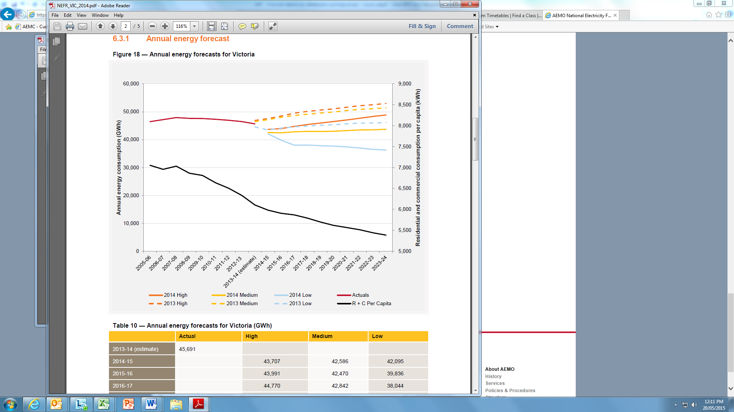

Source: AEMO. * R + C stands for residential and commercial, which is shown on a per capita basis.

Table 3.3 compares the historic growth of energy distributed in Victoria with the forecasts proposed by each distributor. Most of the distributors are forecasting faster rates of growth in the future than has occurred in the past. CitiPower forecasts substantially higher growth in energy delivered in the future compared to the previous regulatory period. Only AusNet Services is forecasting lower demand in the future compared to the past.

Table 3.3 Historic and forecast growth rate of annual energy consumption by distributor

|  |  |  |
| --- | --- | --- |
| Distributor | Historic energy growth 2006-2013 | Forecast energy growth 2016-2020 |
| AusNet Services | 0.20% | –0.08% |
| CitiPower | 0.02% | 2.16% |
| Jemena | –0.08% | 1.20% |
| PowerCor | 0.56% | 1.38% |
| United Energy | –0.11% | 0.51% |

Source: AER analysis of distributor proposals.

Several of the distributors noted the difficulty of forecasting future demand for electricity, due to uncertainty over:

* rate of take-up of electric vehicles
* extent of continuing investment in solar PV
* impact of customers switching from gas to electricity in response to higher gas prices
* changes in tariff structures
* impact of new technologies, such as domestic electricity storage facilities, further developments in solar PV or other renewables, and the take-up of smart appliances or smart thermostats.

The uncertainty in future demand for electricity will have several implications for this review. In particular, it will have implications for the risks faced by the businesses, the nature and amount of capital expenditure required and, to an extent, the level of operating expenditure.

In the next regulatory period the Victorian distributors will be regulated under a revenue cap framework. The revenue cap framework partially insulates the businesses from the risk of changes in demand. If there is a fall in demand for some services, leading to a fall in revenue in a given regulatory year, under the revenue cap framework, the businesses are allowed to increase their prices to earn more revenue in the next regulatory year. Similarly, if there is an increase in demand, leading to an increase in revenue in a given regulatory year, the businesses must reduce their prices in the following regulatory year. The revenue cap partially insulates the distributors from volume risk by passing that risk on to customers.

## Quality of services provided

The quality of an electricity distribution service has three main dimensions:

* physical (electrical) service quality—that is, the physical quality of the electricity delivered (the consistency of the voltage and the reliability of supply)
* customer service—that is, the responsiveness of the business to its customers, such as responding to customer requests for connection, energisation/de-energisation, or re-routing of poles and wires, communication with customers about planned and unplanned outages, and telephone answering times
* assets-and-environment—that is, the safety and visual amenity of the physical assets (poles, wires, transformers), including bush-fire risk, undergrounding and vegetation management decisions.

In the case of the Victorian electricity distribution sector, many aspects of the overall service quality are specified in rules and regulations by the Victorian Government and its agencies. However, other aspects of service quality—particularly service reliability—are not specified in legislation and are subject to incentive schemes administered by the AER.[8]

For most customers, the most important dimension of service quality is reliability of supply. The quality of service for electricity distribution business is typically measured using aggregate measures of the overall frequency and duration of outages, such as the SAIDI (System Average Interruption Duration Index) and SAIFI (System Average Interruption Frequency Index) measures.

### Reliability of service

When making decisions about new investments to improve reliability, the Victorian distributors have chosen to use what is known as a 'probabilistic planning approach'.[9] Under this approach the distributors estimate the economic benefits of the improvement in reliability and weigh that against the cost.

To assess the economic benefits of a reliability improvement, the distributors must place a value on the economic harm suffered by customers when they lose supply. The economic cost to customers from the loss of electricity supply is known as the Value of Customer Reliability (VCR).

AEMO produces estimates of the value of customer reliability for different classes of customers in different regions. The distributors have generally chosen to use the Value of Customer Reliability estimated by AEMO.

AEMO has recently reduced its estimates of the value of customer reliability for different customer classes.[10] Other things equal, this will reduce the net economic benefit of different investment projects—reducing the amount of investment in reliability needed, and leading to a decline in reliability overall. This observation was reflected in several of the regulatory proposals and is discussed at length in AusNet Services' proposal:

In previous regulatory reviews, asset replacement programs were developed based on a 'maintain case'; that is, the program was based on the level of replacement required to maintain existing levels of reliability. Due to a recent reduction in the official Value of Customer Reliability (VCR) measure, it may be economically efficient for a DNSP to adopt a slower rate of asset replacement because customers are willing to accept a lower level of supply.[11]

AusNet Services expects that the annual average outage duration will increase by 3 minutes from the current average of 150 minutes over the next regulatory period.[12]

It is worth noting that the Victorian Electricity Distribution Code[13] sets out special arrangements which apply to electricity supply to Melbourne's CBD. In its regulatory proposal Citipower discusses the steps it has taken to upgrade the 66 kV network which supplies the Melbourne CBD to the 'N-1' standard.[14]

United Energy notes that the reduction in the level of the VCR may conflict with the obligation in clause 6.5.7(a) of the Rules to maintain current levels of reliability.[15] United Energy proposes to achieve the requirements of the Rules while maintaining consistency with AEMO's survey results on the VCR by using the following approach. For decisions involving augmentation or replacement of power transformers, United Energy proposes to use a value of the VCR which corresponds to customer's willingness to pay for reliability on hot summer days. This is because transformers are more likely to fail on hot summer days when demand is high and external temperatures are high. For all other assets United Energy proposes to use the standard AEMO headline VCR results which are calculated as an average across all sectors and all seasons.

We welcome submission on the impact of changes in the VCR and whether the businesses should target a lower level of service reliability. For example, does United Energy above approach more accurately reflect customers' average willingness to pay for reliability by taking into account the time at which outages are likely to occur?

# Capital expenditure

Capex refers to the capital expenditure incurred in the provision of network services. The most significant elements of total capex are generally network augmentation expenditure (augex), asset replacement expenditure (repex) and connections. Non-network expenditure is also a significant aspect of the Victorian proposals.

Capex is added to the RAB and so forms part of the capital costs of the building blocks used to determine a distributor’s total revenue requirement. Under the rules, we must accept a distributor's proposed forecasts of total capex if we are satisfied they reasonably reflect the capital expenditure criteria (capex criteria) set out in the Rules. The capex criteria relate to the efficient costs incurred by a prudent operator in light of realistic demand forecasts and cost inputs. We must have regard to the capex factors in the rules when making that decision.[16] The approach we will adopt to assess the services providers' forecasts of total capex is outlined in our expenditure forecast assessment guideline.

Over the next five years, the Victorian businesses have all proposed higher capex forecasts. As set out in table 4.1, these forecast increases range from a low of 2 per cent for AusNet Services to a high of 32 per cent for Powercor. These forecasts reflect lower forecast expenditure on augmentation by AusNet Services and United Energy but higher forecasts for augmentation by CitiPower, Jemena and Powercor. At the same time, expenditure on aged asset replacement is expected to rise for all five distributors. Asset replacement is an increasing proportion of all the distributors' capex proposals.

Powercor anticipates a substantial increase in expenditure relating to customer connections (30 per cent). The other four distributors also propose increased connection expenditure but to a lesser degree than Powercor. The development of new housing estates in designated growth areas in Victoria is suggested as a driver of these increases. Also, some of this change is attributed to changes in the service classifications that are to apply for the first time to some connection services in Victoria. This involves a shift between categories of expenditure, rather than being entirely new expenditure.

AusNet Services and Powercor have both proposed capital expenditure to fund bushfire safety works. Jemena and United Energy have also proposed bushfire safety works, although to a lesser degree than AusNet Services and Powercor. Powercor and AusNet Services have taken different approaches to funding potential new bushfire safety obligations which are currently being developed by the Victorian Government. These obligations will be unique to Victoria when they are implemented later in 2015. Powercor has included forecasts of its future requirements as contingent projects in anticipation of regulatory changes planned by the Victorian Government. AusNet Services instead has addressed these costs as a pass through event when the regulations are introduced. These differences should to be taken into account when comparing their proposals given that they operate under the same legislation.

Non-network expenditure relates to the cost of supporting infrastructure, notably IT systems, plant and equipment and depots.

## The capital expenditure proposals

Table 4.1 summarises forecast standard control services capex proposed by each of the Victorian businesses.

Table . Victorian distributor capital expenditure proposals

|  |  |  |
| --- | --- | --- |
| Distributor | 2016–20 total capex proposal ($million, 2015) | Change from 2011–15 total actual capex (per cent) |
| AusNet Services | 1 964 | 2 |
| CitiPower | 850 | 17 |
| Jemena | 841 | 19 |
| Powercor | 2 331 | 32 |
| United Energy | 1 195 | 14 |

Source: Actual total capex is drawn from the distributors' submitted Roll Forward Models (RFM). Proposed capex is drawn from the "assets" sheet of the distributors' submitted PTRM. We have drawn the capex amounts shown in this table from the distributors' submitted financial models, rather than from their written regulatory proposals.

AusNet Services proposes a relatively flat capex over the next five years. Replacement expenditure, which includes safety obligations and programs to reduce bushfire risk, make up the largest component of proposed capital expenditure (46 per cent). Augmentation, the capital required to expand network capacity, at 16 per cent makes up a smaller portion of the overall proposed capital expenditure.

For CitiPower, the largest category of proposed capital expenditure is expected to continue to be related to new customer connections (33 per cent).[17] Proposed replacement expenditure accounts for around 26 per cent of capital expenditure. Augmentation, Bushfire related expenditure, IT and non-network expenditure together are around one third of the total forecast for capital expenditure.

For Jemena, the largest category of capital expenditure is forecast to be replacement expenditure (27 per cent). Connections expenditure is forecast to be around 20 per cent of forecast future expenditure whilst augmentation at 17 per cent makes up a smaller portion.

For Powercor, the largest category of forecast capital expenditure is expected to be replacement expenditure at 33 per cent. New customer connections is forecast to be the second largest category, accounting for around 30 per cent of capital expenditure. Powercor has also proposed three contingent processes, which, if triggered, would account for $375 million ($nominal) of capex. These contingent projects relate to prospective regulatory changes for bushfire safety initiatives and potential changes in Powercor's responsibilities for private overhead electric lines.

For United Energy, the largest category of proposed capital expenditure is expected to be replacement expenditure at 49 per cent. New customer connections is expected to be the second largest category, accounting for around 21 per cent of proposed capital expenditure. Augmentation at 14 per cent makes up a portion of the overall proposed capital expenditure which is the lowest of all the distributors.

Figures 4.1 to 4.5 compare the distributors’ forecasts with their 2011–15 capex allowances and actual outcomes.

Four of the distributors significantly over spent their capex allowances in the 2011–15 period. Only CitiPower spent less than what the AER allowed for in their 2011-2015 determination. This means that their opening RABs for the 2016–20 regulatory control period are higher than anticipated. This higher actual spending compared to the allowances we approved reflects a number of factors, including lower than forecast peak demand but offset by higher than expected costs and revised safety and reliability standards.[18]

Figure .1 AusNet Services – capital expenditure

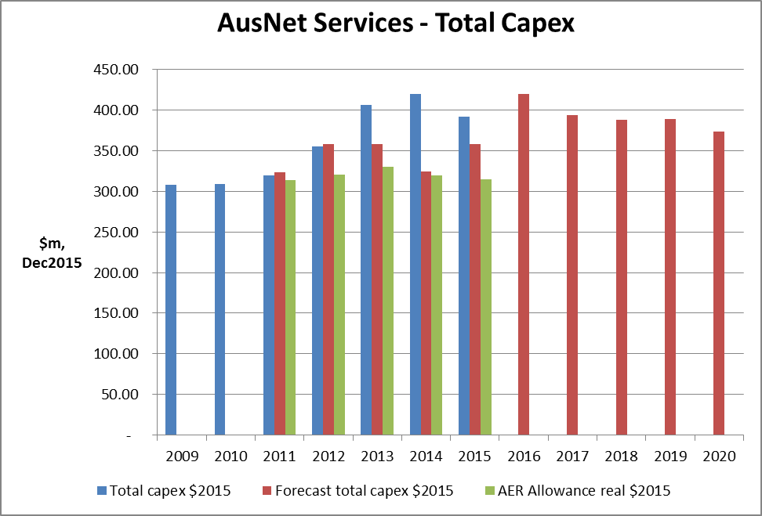

Source: Distributor regulatory proposal and RINs.

Figure .2 CitiPower – capital expenditure

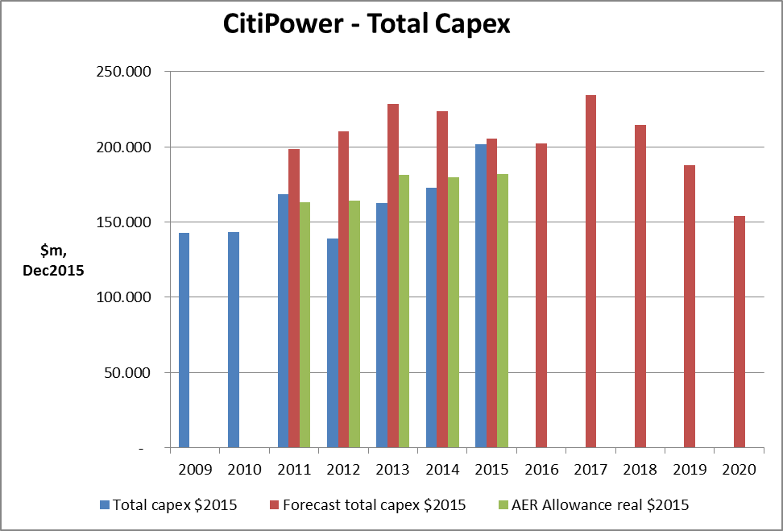

Source: Distributor regulatory proposal and RINs.

Figure .3 Jemena – capital expenditure

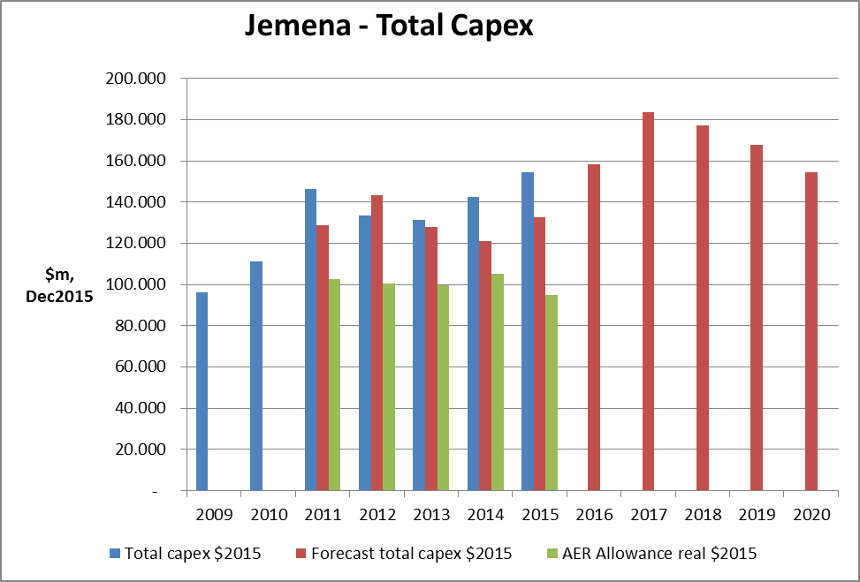

Source: Distributor regulatory proposal and RINs.

Figure .4 Powercor – capital expenditure

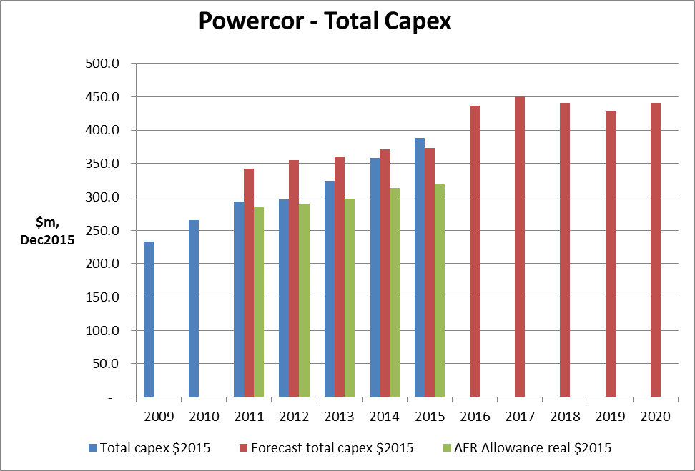

Source: Distributor regulatory proposal and RINs.

Figure .5 United Energy – capital expenditure

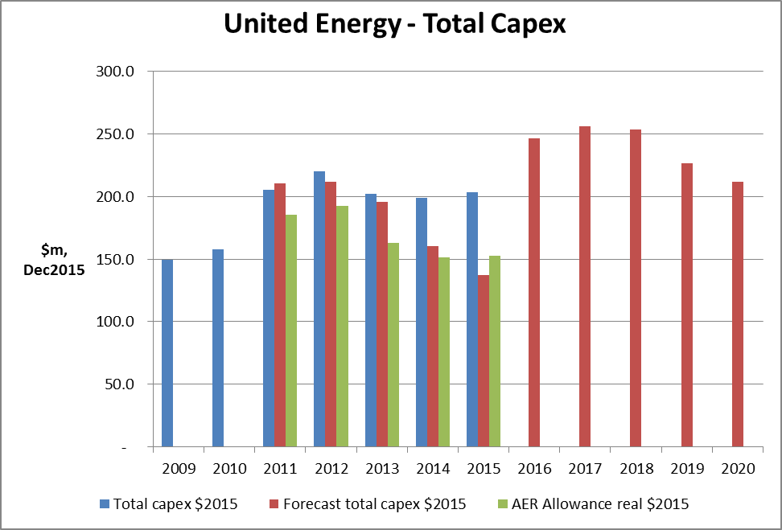

Source: Distributor regulatory proposal and RINs.

## Key drivers of the distributors' capital expenditure proposals

The Victorian distributors' capex proposals largely cover augmentation, replacement and bushfire safety. Also of note is the non-network expenditure of all the distributors.

### Asset renewal/replacement

The businesses submit that the current network is ageing. Our general expectation is that repex levels should remain relatively constant over time. This is because the application of financial and asset management techniques can even out fluctuations in replacement rates of aging assets. We consider an important factor in controlling asset maintenance costs is the use of condition based assessment techniques when managing deteriorating assets.

We note that a particular driver of replacement expenditure in Victoria is initiatives being undertaken to implement the findings of the Victorian Bushfire Royal Commission, which examined the safety of electricity networks following the bushfires in 2009. The Royal Commission made a number of recommendations that affect the design and construction of the Victorian electricity distribution networks, particularly in areas of high bushfire risk. As a consequence, there have been a number of network design changes mandated by the Victorian Government which are unique to Victoria and which directly affect replacement expenditure costs. Steps are also underway for Victoria to complete the implementation of further recommendations, which would also impact future network design and replacement costs.

Do stakeholders consider the cost of improving the fire safety of the Victorian electricity distribution network is reasonable, given it is expected to be a significant factor in the increase in replacement expenditure?

Table 4.2 summarises the total replacement expenditure (repex) forecast proposed by each of the distributors for the 2016–20 period.

Table .2 Victorian distributor replacement capital expenditure proposals

|  |  |  |  |
| --- | --- | --- | --- |
| Distributor | 2016–20 repex ($million, 2015) | Proportion of total capex (per cent) | Change from actual repex in 2011–15 period |
| AusNet Services | 901 | 46 | 214 |
| CitiPower | 260 | 26 | 107 |
| Jemena | 224 | 27 | 61 |
| Powercor | 722 | 33 | 279 |
| United Energy | 585 | 49 | 179 |

Source: Distributor regulatory proposals and RINs.

### Responding to growth

The distributors have to augment the shared network to ensure that there is sufficient capacity to meet forecast future demand from new and existing customers.

As shown in section 3, maximum demand has been relatively flat over the 2011–15 regulatory period, and is not expected to grow significantly across Victoria over the 2016-20 regulatory period. However, there is forecast growth in certain regions of Victoria, such as the west and south-west of Melbourne. This is reflected in a significant increase in augmentation capex proposed by Powercor.

Table 4.3 summarises the total augmentation expenditure (augex) forecast by the distributors for the 2015–20 period.

Table .3 Victorian distributor augmentation capital expenditure proposals

|  |  |  |  |
| --- | --- | --- | --- |
| Distributor | 2016–20 augex ($million, 2015) | Proportion of total capex (per cent) | Change from actual augex in 2011–15 period |
| AusNet Services | 314 | 16 | -146 |
| CitiPower | 203 | 20 | 17 |
| Jemena | 141 | 17 | 26 |
| Powercor | 362 | 16 | 145 |
| United Energy | 167 | 14 | -16 |

Source: Distributor regulatory proposals and RINs.

New customers connecting to the grid only pay a portion of the full cost of their connection. The remainder is shared with all existing customers. This amount is forecast in the distributors' proposals and is identified as 'connections' capex. Connections capex generally comprises a larger proportion of the total capex forecasts than augmentation capex. This is driven by forecast increases in construction activity in new developments and redevelopments across Victoria. Similar to augmentation capex, Power also proposes significant increases in connections capex to meet forecast network growth in western Victoria and connecting major new industrial customers and generators

Table 4.4 summarise the total connections capex forecast by the distributors for the 2016-20 period.

Table .4 Victorian distributor connections capital expenditure proposals

|  |  |  |  |
| --- | --- | --- | --- |
| Distributor | 2016–20 augex ($million, 2015) | Proportion of total capex (per cent) | Change from actual connections in 2011–15 period |
| AusNet Services | 368 | 19 | 29 |
| CitiPower | 332 | 33 | 40 |
| Jemena | 170 | 20 | 15 |
| Powercor | 649 | 30 | 149 |
| United Energy | 249 | 21 | 30 |

Source: Distributor regulatory proposals and RINs.

### Non-network expenditure

The distributors have also proposed material amounts of non-network related capex in the 2016–20 period. Table 4.5 summarises the total non-network expenditure forecast by the distributors for the 2016–20 period.

Table .5 Victorian distributor non-network capital expenditure proposals

|  |  |  |  |
| --- | --- | --- | --- |
| Distributor | 2016–20 non-network ($million, 2015) | Proportion of total capex (per cent) | Change from actual non-network in 2011–15 period |
| AusNet Services | 209 | 11 | -16 |
| CitiPower | 104 | 10 | 50 |
| Jemena | 137 | 20 | -1 |
| Powercor | 262 | 12 | 72 |
| United Energy | 194 | 16 | 21 |

Source: Distributor regulatory proposals and RINs.

Figures 4.6 to 4.10 below show for each distributor their proposed repex, augex, connections and non-network spending compared to their actual spending in the 2009–15 period. The columns to the right of the figures beginning with 2016 are the distributors' forecast proposals for the 2016–20 period.

Figure .6 AusNet – capital expenditure components ($million, 2015)

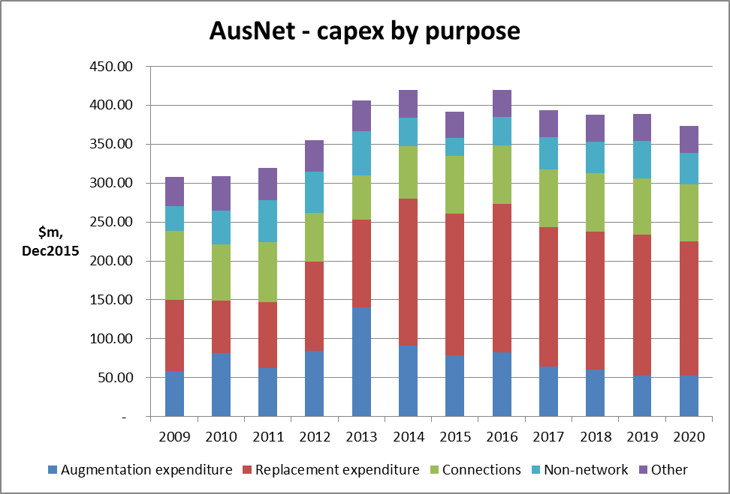

Source: Distributor regulatory proposals and RINs.

Figure .7 CitiPower – capital expenditure components ($million, 2015)

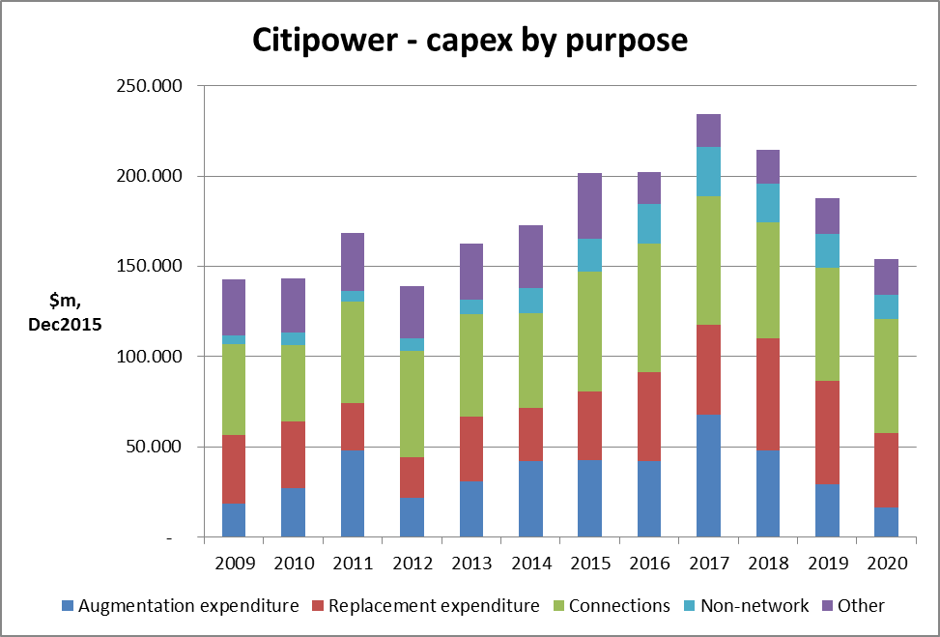

Source: Distributor regulatory proposals and RINs.

Figure .8 Jemena – capital expenditure components ($million, 2015)

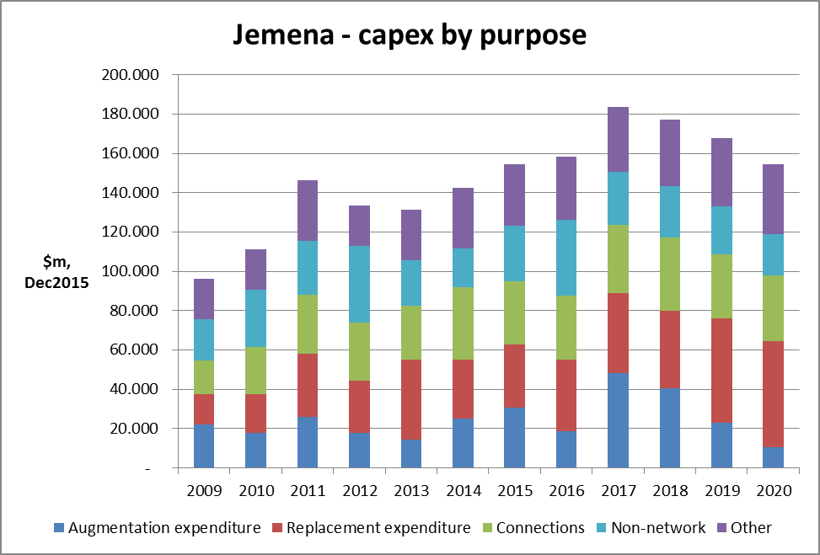

Source: Distributor regulatory proposals and RINs.

Figure .9 Powercor – capital expenditure components ($million, 2015)

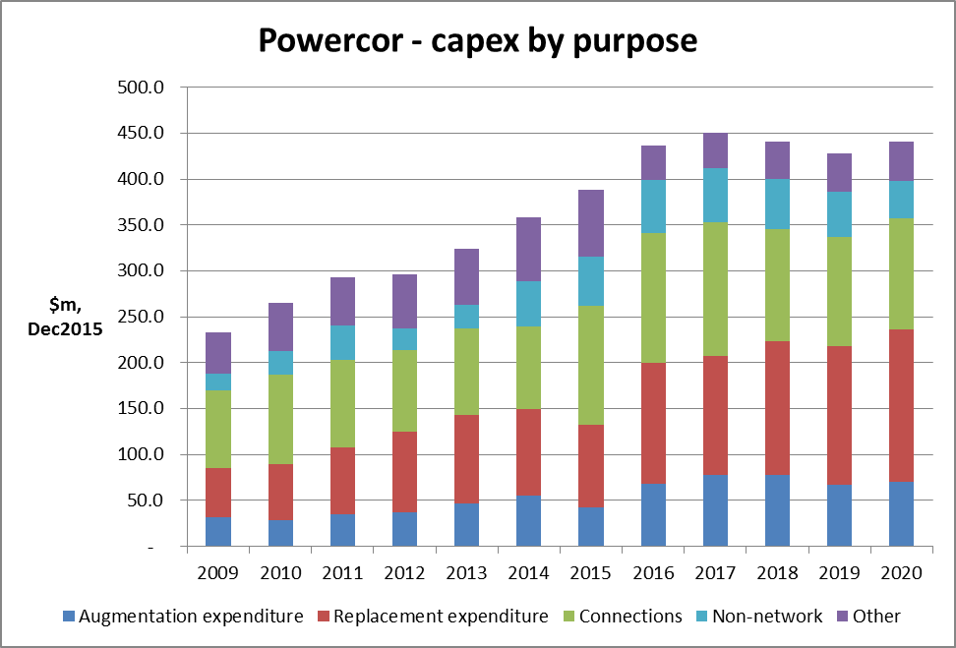

Source: Distributor regulatory proposals and RINs.

Figure .10 United Energy – capital expenditure ($million, 2015)

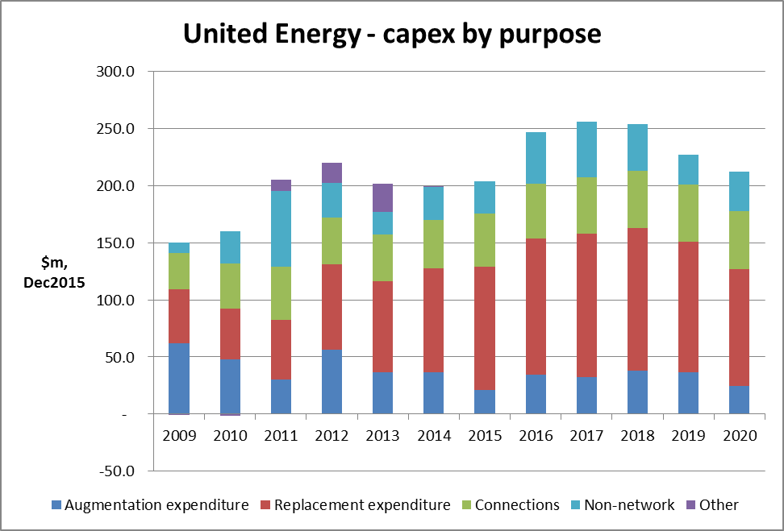

Source: Distributor regulatory proposals and RINs.

In figure 4.6 we can see AusNet Service has forecast higher levels of repex (31 per cent) but lower levels of augex (-32 per cent) across the forecast period compared to the current period. In figure 4.7 we can see CitiPower has proposed higher augex (9 per cent) and higher repex (70 per cent) with a significant spike in augex in 2017, though a long term trend is much less apparent. From figure 4.8 it is evident that Jemena also has sought increased repex (37 per cent) but their augex (23 per cent) trend remains positive. A similar outcome is evident for Powercor in figure 4.9, increased repex (63 per cent) but their augex trend (67 per cent) also remains positive. In figure 4.10 we can see that United Energy has a significant increase in repex (44 per cent), and a fall in augex (-9 per cent).

We welcome submissions on whether these changes in the businesses' spending profile are justified? In particular, are the large increases in replacement expenditure justified by current experience of reliability outcomes for customers? Are the increases in augmentation cost reasonable, especially when the forecast increases in demand are also considered?

Demand management refers to any strategy to mitigate growth in consumption volumes or peak demand. Demand management can have positive economic impacts by encouraging more efficient use of existing network assets, resulting in lower prices for network users, reduced risk of stranded network assets and benefits for the environment. Demand management is an integral part of good asset management for network businesses.

In some circumstances, demand management can provide efficient alternatives to network investments, by deferring the need for augmentations to relieve network constraints. Costs of network augmentation projects can be significantly greater than the costs of conducting demand management projects to defer an augmentation project. Deferral of network investment may result in efficiency benefits, as the same level of reliability and service is provided by a smaller, better utilised network.

Network owners can undertake demand management through a range of mechanisms. These include incentives for consumers to change their demand patterns, operational efficiency programs, load control technologies, or alternative sources of supply (such as distributed or embedded generation and energy storage).

AusNet Services, Jemena and United have each submitted that their demand management programs over the 2011–15 period have been successful in achieving their respective objectives for the allowance. AusNet Services, CitiPower, Jemena, Powercor and United Energy have each submitted a further demand management program for the 2016–20 period. CitiPower and Powercor also submit that the current allowance has been inadequate. They propose that the scheme be amended to permit the allowance to be increased above the capped amount. Expenditure above the cap would be subject to pre-approval by the AER of the excess amount.

## Regulatory asset base proposals

A distributors' regulated asset base (RAB) is the outcome of its cumulative capex spending. All five Victorian electricity distributors have proposed higher capex spending in the 2016–20 period than in the 2011–15 period. Similarly, a number of the businesses have proposed increases in their repex compared to historical levels. Their RABs are proposed to continue to grow (see figures 4.11–15). Assets purchased or constructed by the distributors will earn a rate of return until their value depreciates over their economic life.

Figure .11 AusNet Services – regulatory asset base (RAB) values ($2015)

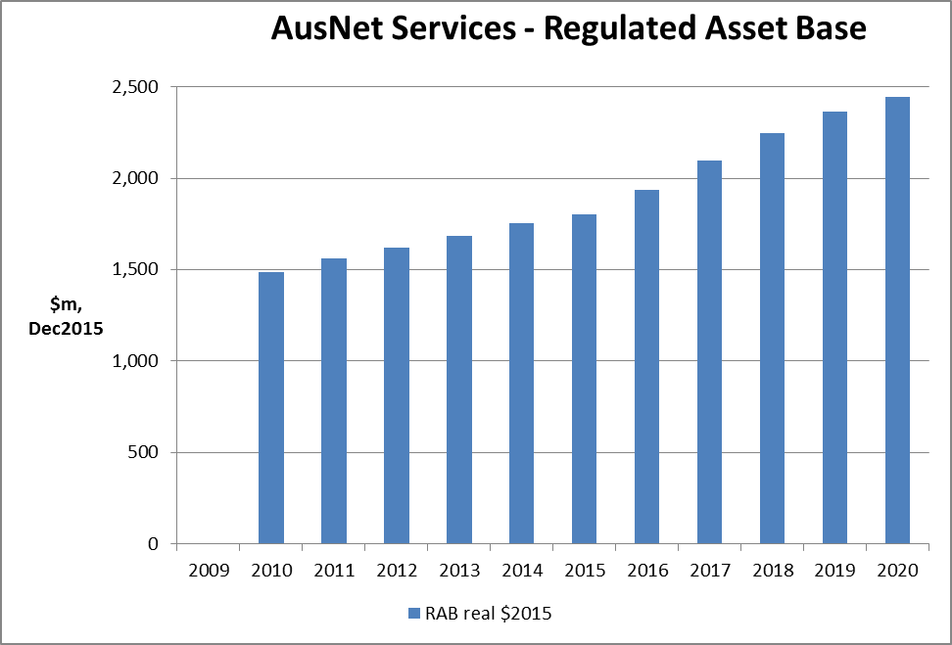

Source: Distributor regulatory proposals and RINs.

Figure .12 CitiPower – regulatory asset base (RAB) values ($2015)

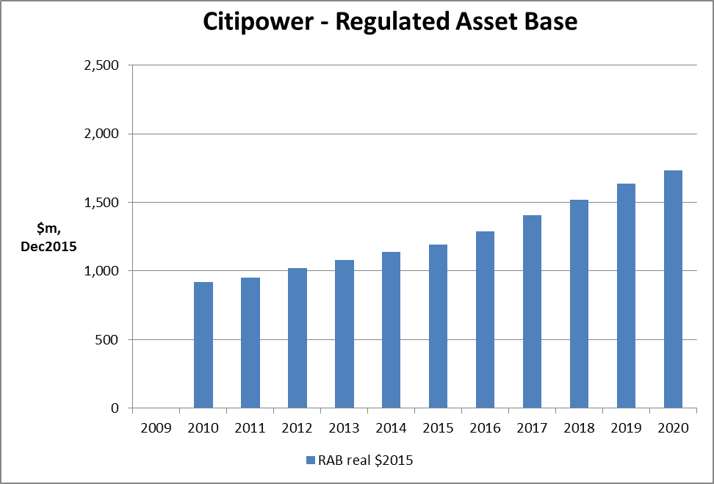

Source: Distributor regulatory proposals and RINs

Figure .13 Jemena – regulatory asset base (RAB) values ($2015)

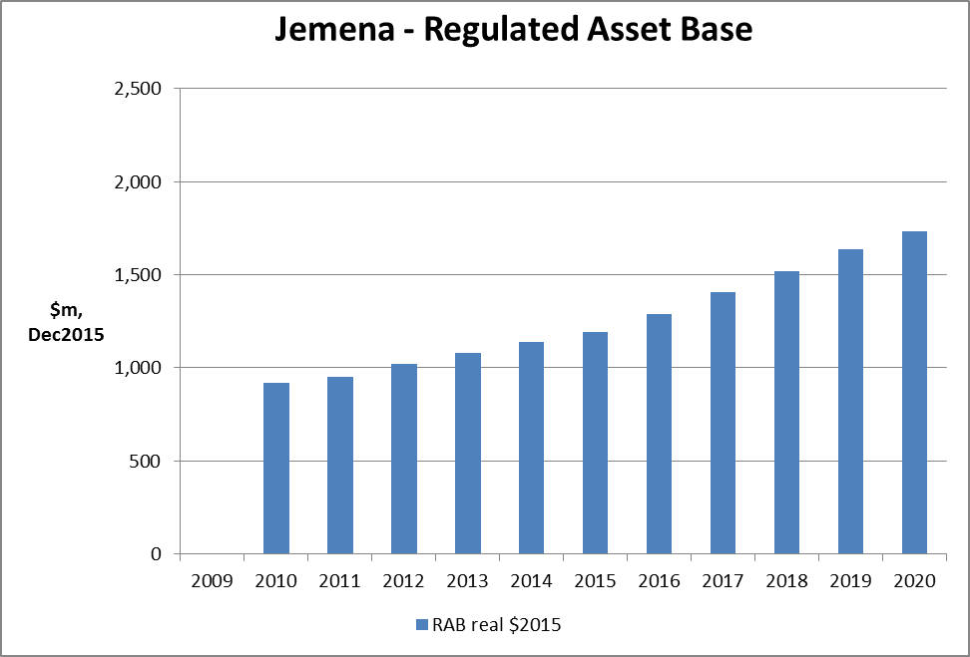

Source: Distributor regulatory proposals and RINs.

Figure .14 Powercor – regulatory asset base (RAB) values ($2015)

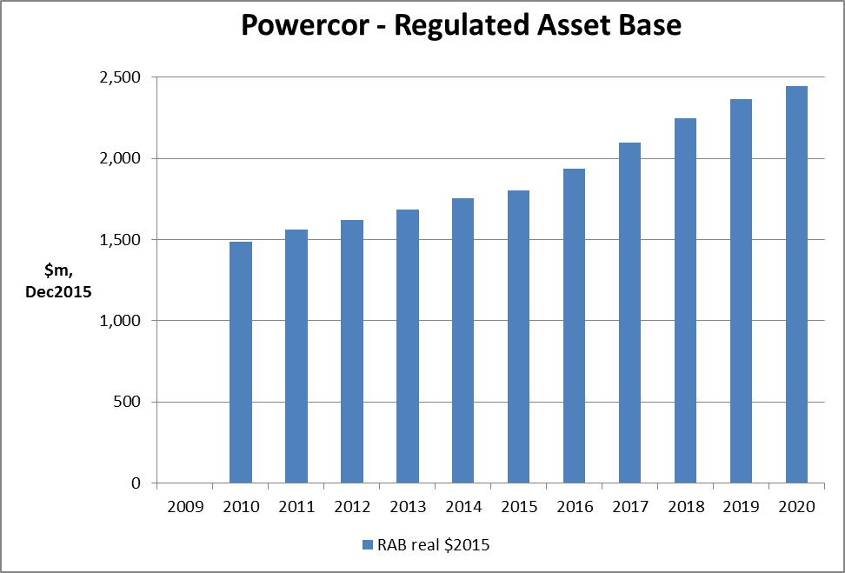

Source: Distributor regulatory proposals and RINs.

Figure .15 United Energy – regulatory asset base (RAB) values ($2015)

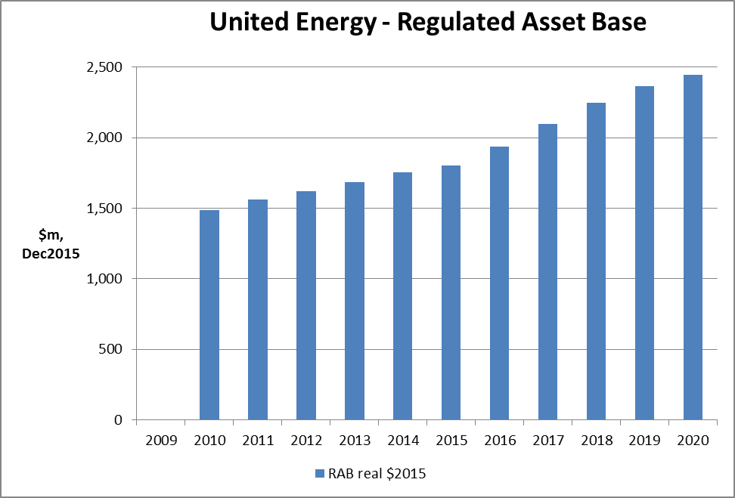

Source: Distributor regulatory proposals and RINs.

# Operating expenditure

Opex refers to the operating, maintenance and other non-capital expenditure incurred in the provision of network services. It includes labour costs and other non-capital costs that a prudent service provider is likely to require during the 2016–20 period for the efficient operation of its network.

Opex is one of the building blocks used to determine the service providers' total revenue requirement. Under the rules, we must accept a service providers' forecast of total opex if we are satisfied it reasonably reflects the opex criteria.[19] The opex criteria relate to the efficient costs incurred by a prudent operator in light of realistic expectations of the demand forecast and cost inputs.. We must have regard to the opex factors when assessing the distributor's forecast opex.[20]

Under the Rules, if we are not satisfied a service providers' opex proposal reasonably reflects the opex criteria, we must not accept it.[21] We must estimate the total required opex that, in our view, reasonably reflects the opex criteria taking into account the opex factors.

## How do we assess operating expenditure

We have outlined our approach to assessing the service providers' forecasts of total opex in our expenditure forecast assessment guideline.[22]

Our approach is to compare the service provider's total forecast opex with an alternative estimate that we develop and that reasonably reflects the opex criteria.[23] By doing this we form a view on whether we are satisfied that the service provider's proposed total forecast opex reasonably reflects the opex criteria. If we conclude the proposal does not reasonably reflect the opex criteria, we use our estimate as a substitute forecast.

Our estimate is unlikely to exactly match the service provider's forecast because they may not adopt the same forecasting method. However, if the service provider's inputs and assumptions are reasonable, its method should produce a forecast consistent with our estimate.

If a service provider's total forecast opex is materially different to our estimate and we find there is no satisfactory explanation for this difference, we may form the view that the service provider's forecast does not reasonably reflect the opex criteria. Conversely, if our estimate demonstrates that the service provider's forecast reasonably reflects the expenditure criteria, we will accept the forecast.[24]

Our approach to forming an alternative estimate of opex involves five key steps:

1. We typically use the service provider's reported opex in a single year as the starting point for our assessment. We call this the base year. While categories of opex can vary from year to year, total opex is relatively recurrent. We typically choose a recent year for our assessment.

2. We assess whether opex the service provider incurred in the base year reasonably reflects the opex criteria. We have a number of techniques including economic benchmarking to do this. We adjust base year expenditure to ensure it reflects the opex criteria if necessary.

3. As the opex of an efficient service provider tends to change over time due to changes in prices, output and productivity we trend our estimate of base opex forward over the regulatory control period to take account of these changes. We refer to this as the rate of change.

4. We then adjust base year expenditure to account for any forecast cost changes over the regulatory control period that would meet the opex criteria that are not otherwise captured in base opex or rate of change. This may be due to new regulatory obligations in the forecast period and efficient capex/opex trade-offs. We call these step changes.

5. Finally we add any additional opex components which we forecast using an alternative approach. For instance, we forecast debt raising costs based on the costs incurred by a benchmark efficient service provider.

Each of the Victorian service providers stated that they adopted a forecasting method largely consistent with this approach.[25]

In our assessment of the proposed opex forecasts we do not 'accept' or 'reject' components of the total opex forecast. We assess the components of the proposed opex forecasts to determine how we should treat the relevant driver of opex change in our alternative forecast. We then accept or reject the total opex forecast proposed. We may accept the total opex forecast even though we have forecast different price, output or productivity growth or step changes.

We note that a significant driver of the Victorian service providers proposed increase in opex is the reclassification of expenditure as standard control opex. We will assess whether the proposed expenditure should be classified as opex. For example, the distribution businesses have reclassified at least some ongoing costs associated with the AMI 'smart meter' program under standard control services, although our Framework and Approach paper classified AMI as an alternative control service. AMI services were previously regulated under an Order in Council.[26]

If it should be classified standard control opex, we will then assess whether the proposed expenditure is required for total opex to meet the opex criteria. For example, because this expenditure was not subject to the EBSS in the 2011–15 regulatory control period, we must assess the efficiency of the proposed expenditure.

## Operating expenditure proposed by the businesses

The five Victorian electricity distributors propose a combined $4.4 billion of operating expenditure over the 2016–20 regulatory period.

### AusNet Services' operating expenditure proposal

AusNet Services proposed total operating expenditure of $1256.4 million (real 2015) for the 2016–20 regulatory control period. This is 35 per cent more than AusNet Services' actual and estimated[27] opex for the 2011–15 regulatory control period (figure 5.1).

Figure 5.1 AusNet Services – operating expenditure ($million, 2015)



Source: Historical opex amounts are from AusNet Services' submitted annual regulatory information notices (RINs). Forecast opex amounts are from AusNet Services' submitted PTRM. The historical opex allowance is from the Tribunal varied PTRM for the 2011–15 period. * Excludes movements in provisions.

The key drivers of the proposed increase in opex were:

* service classification change:[28] AusNet Services included expenditure for the 2016–20 regulatory control period that was not previously classified as standard control services opex. Specifically AusNet Services proposed the following as standard control services opex:
* The cost of a large network support contract, previously recovered through an adjustment to the tariffs during the annual tariff setting process. AusNet Services stated these costs would decline in real terms over the 2016–20 regulatory control period.

Accounting for these costs as a standard control service increases the overall opex by $132.8 million (real 2015) of AusNet Services' opex forecast for the 2016–20 regulatory control period.

* category specific forecasts:[29] AusNet Services' adopted category specific forecasts to forecast what it called 'other costs', which account for $116.8 million (real 2015) of its opex forecast for the 2016–20 regulatory control period. These represent category specific forecasts for::
* insurance, $62.2 million (real 2015)
* self insurance losses, $16.6 million (real 2015)
* GSL payments, $28.0 million (real 2015)
* DMIA expenditure, $10.0 million (real 2015)

AusNet Services' expenditure for these categories in the base year (2014) was $18.6 million (real 2015). Consequently, AusNet Services' category specific forecasts for these categories are $23.9 million (real 2015) above the base year level of expenditure.

* price growth: AusNet Services forecasted price growth of $49.2 million (real 2015) for the 2016–20 regulatory control period. It used wage price growth forecasts from its consultant, CIE, to forecast labour price growth.
* output growth: AusNet Services stated that it adopted our approach to forecasting output growth. It stated it used the forecast increase in customer numbers (with a weight of 67.6 per cent), circuit length (10.7 per cent) and ratcheted maximum demand (21.7 per cent) to forecast output change due to output growth. This increased its opex forecast for the 2016–20 regulatory control period by $39.4 million (real 2015).
* productivity growth: AusNet Services forecast no productivity change in the 2016–20 regulatory control period.

We welcome submissions on the key drivers of AusNet Services' forecast opex. For example: should part of AusNet Services' AMI opex be included in its forecast of standard control services opex? Which price measures should be used to forecast price growth and how should they be weighted? Is there evidence that indicates the Victorian distribution businesses should improve productivity over the 2016–20 period?

### CitiPower's operating expenditure proposal

CitiPower proposed total operating expenditure of $501.0 million (real 2015) for the 2016–20 regulatory control period. This is 75 per cent more than CitiPower's actual and estimated[30] opex for the 2011–15 regulatory control period, although this is largely driven by changes to capitalisation policy (figure 5.2).

Figure 5.2 CitiPower – operating expenditure ($million, 2015)



Source: Historical opex amounts are from CitiPower's submitted annual regulatory information notices (RINs). Forecast opex amounts are from CitiPower's submitted PTRM. The historical opex allowance is from the Tribunal varied PTRM for the 2011–15 period. * Excludes movements in provisions.

The key drivers of the proposed increase in opex were:

* change in overhead capitalisation policy: CitiPower's new cost allocation method (CAM) accounts for $94.8 million of its opex forecast for the 2016–20 regulatory control period. The main change to the CAM is that CitiPower will now expense indirect corporate overheads. CitiPower stated that the implementation of the new CAM has not changed the combined total of its capex and opex forecasts for standard control services.
* output growth: CitiPower used the average output growth from four different econometric models to forecast output growth. This increased its opex forecast for the 2016–20 regulatory control period by $35.3 million (real 2015).
* price growth: CitiPower used an historic average of the change in EBA rate to forecast internal labour price growth. It used the forecast change in the wage price index for the Victorian construction sector to forecast the change in contract costs. It weighted these forecast price changes based on its actual expenditure in the base year (2104). Overall, CitiPower forecast labour price growth would increase its opex by $30.2 million (real 2015) for the 2016–20 regulatory control period.
* service reclassification: CitiPower changed the allocation of expenditure for supply abolishment, category RIN alignment and reclassification of IT metering to standard control services opex. This service classification change accounts for $19.5 million (real 2015) of CitiPower's opex forecast for the 2016–20 regulatory control period.
* step changes: CitiPower included seven step changes in its opex forecast. These step changes increased its opex forecast for the 2016–20 regulatory control period by $18.3 million (real 2015).
* productivity growth: CitiPower forecast no productivity change in the 2016–20 regulatory control period.

We welcome submissions on the key drivers of CitiPower's forecast opex. For example: should part of CitiPower's AMI opex be included in its forecast of standard control services opex? Which price measures should be used to forecast price growth and how should they be weighted? Is there evidence that indicates the Victorian distribution businesses should improve productivity over the 2016–20 period?

### Jemena's operating expenditure proposal

Jemena's proposed total operating expenditure of $499.0 million (real 2015) for the 2016–20 regulatory control period. This is 31 per cent more than Jemena's actual and estimated[31] opex for the 2011–15 regulatory control period, although this is largely driven by changes to service classifications (figure 5.3).

Figure 5.3 Jemena – operating expenditure ($million, 2015)



Source: Historical opex amounts are from Jemena's submitted annual regulatory information notices (RINs). Forecast opex amounts are from Jemena's submitted PTRM. The historical opex allowance is from the Tribunal varied PTRM for the 2011–15 period. * Excludes movements in provisions.

The key drivers of the proposed increase in opex were:

* service classification change: Jemena changed the allocation of expenditure for supply abolishment and some advanced metering infrastructure to standard control services opex. This service reclassification accounts for $63.9 million (real 2015) of Jemena's opex forecast for the 2016–20 regulatory control period.
* output growth: Jemena forecast overall output growth of 2.24 per cent per year based on the forecast growth in the number of assets and customers. This increased its opex forecast for the 2016–20 regulatory control period by $36.3 million (real 2015).
* step changes: Jemena included 12 step changes, which account for $30.3 million (real 2015) of Jemena's opex forecast for the 2016–20 regulatory control period. Jemena stated that six of the proposed step changes worth, $16.9 million (real 2015), were required to meet regulatory obligations. It stated two step changes, worth $2.9 million (real 2015), were capex/opex trade-offs.
* price growth: Jemena identified three different cost types: internal labour, contracted services and materials. It applied weightings based on historic data to price change forecasts prepared for it by BIS Shrapnel. Overall, Jemena forecast that price growth would increase opex for the 2016–20 regulatory control period by $11.6 million (real 2015).
* productivity growth: Jemena applied expected productivity improvements, averaging 4.5 per cent over the 2016–20 regulatory control period. This reduced its opex forecast by $12.5 million (real 2015).

We welcome submissions on the key drivers of Jemena's forecast opex. For example: should part of Jemena’s AMI opex be included in its forecast of standard control services opex? Which price measures should be used to forecast price growth and how should they be weighted? Is there evidence that indicates Jemena should improve productivity by more or less than the proposed 4.5 per cent over the 2016–20 period?

### Powercor's operating expenditure proposal

Powercor proposed total operating expenditure of $1330.7 million (real 2015) for the 2016–20 regulatory control period. This is 44.0 per cent more than Powercor's actual and estimated[32] opex for the 2011–15 regulatory control period, although this is largely driven by changes to service classifications (figure 5.4).

Figure 5.4 Powercor – operating expenditure ($million, 2015)



Source: Historical opex amounts are from Powercor's submitted annual regulatory information notices (RINs). Forecast opex amounts are from Powercor's submitted PTRM. The historical opex allowance is from the Tribunal varied PTRM for the 2011–15 period. * Excludes movements in provisions.

The key drivers of the proposed increase in opex were:

* change in overhead capitalisation policy: Powercor's new cost allocation method (CAM) accounts for $173.4 million of its opex forecast for the 2016–20 regulatory control period. The main change to the CAM is that Powercor will now expense indirect corporate overheads. Powercor stated that the implementation of the new CAM has not changed the combined total of its capex and opex forecasts for standard control services.
* output growth: Powercor used the average output growth from four different econometric models to forecast output growth. This increased its opex forecast for the 2016–20 regulatory control period by $82.8 million (real 2015).
* price growth: Powercor used an historic average of the change in EBA rate to forecast internal labour price growth. It used the forecast change in the wage price index for the Victorian construction sector to forecast the change in contract costs. It weighted these forecast price changes based on its actual expenditure in the base year (2104). Overall, Powercor forecast labour price growth would increase its opex by $76.7 million (real 2015) for the 2016–20 regulatory control period.
* service classification change: Powercor changed the allocation of expenditure for supply abolishment, category RIN alignment and reclassification of IT metering to standard control services opex. This service classification change accounts for $43.3 million (real 2015) of Powercor's opex forecast for the 2016–20 regulatory control period.
* step changes: Powercor included five step changes in its opex forecast. These step changes increased its opex forecast for the 2016–20 regulatory control period by $16.5 million (real 2015).
* productivity growth: Powercor forecast no productivity change in the 2016–20 regulatory control period.

We welcome submissions on the key drivers of Powercor's forecast opex. For example: should part of Powercor's AMI opex be included in its forecast of standard control services opex? Which price measures should be used to forecast price growth and how should they be weighted? Is there evidence that indicates the Victorian distribution businesses should improve productivity over the 2016–20 period?

### United Energy's operating expenditure proposal

United Energy proposed total operating expenditure of $800.4 million (real 2015) for the 2016–20 regulatory control period. This is 25 per cent more than United Energy's actual and estimated[33] opex for the 2011–15 regulatory control period, although this is largely driven by changes to service classifications (figure 5.5).

Figure 5.5 United Energy – operating expenditure ($million, 2015)



Source: Historical opex amounts are from United Energy's submitted annual regulatory information notices (RINs). Forecast opex amounts are from United Energy's submitted PTRM. The historical opex allowance is from the Tribunal varied PTRM for the 2011–15 period. * Excludes movements in provisions.

The key drivers of the proposed increase in opex were:

* base year adjustments: United Energy made a number of adjustments to its reported expenditure for 2014, which it used as its base year to forecast opex, including:
* adding $18.9 million for AMI expenditure that will be regulated as a standard control services in the 2016–20 regulatory control period
* removing its actual 2014 guaranteed service level (GSL) payments of $1.15 million
* removing its demand management incentive scheme expenditure of $0.7 million
* removing $1.5 million of costs for preparing its regulatory proposal for the 2016–20 regulatory control period because they are non-recurrent in nature
* adding $0.8 million in efficient incremental costs associated with the 2015 regulatory year, which will be recurrent in the forthcoming regulatory period.

United Energy's base year adjustments increased its opex forecast for the 2016–20 regulatory control period by $81.6 million (real 2015).

* step changes: United Energy included 19 step changes for events or obligations that it considered would cause it to incur additional opex in the 2016–20 regulatory control period. It grouped these step changes into five groups:
* new regulatory obligations, $22.3 million (real 2015)
* customer response/initiated expenditure, $10.3 million (real 2015)
* existing regulatory obligations—recurrent but non-annual, $12.0 million (real 2015)
* changes in the external environment, $6.3 million (real 2015)
* capex-opex trade-offs, $2.4 million (real 2015)

United Energy's forecast step changes increased its opex forecast for the 2016–20 regulatory control period by $53.8 million (real 2015).

United Energy also forecast that output growth would increase its opex forecast for the 2016–20 regulatory control period by $8.1 million (real 2015) and price growth would increase it by $7.0 million (real 2015). It forecast no productivity change in the 2016–20 regulatory control period.

We welcome submissions on the key drivers of United Energy's forecast opex. For example: should part of United Energy's AMI opex be included in its forecast of standard control services opex? Which price measures should be used to forecast price growth and how should they be weighted? Is there evidence that indicates the Victorian distribution businesses should improve productivity over the 2016–20 period?

## Opex efficiency

An important part of our assessment of opex forecasts is to assess whether opex the service provider incurred in the base year reasonably reflects the opex criteria. We have a number of techniques including economic benchmarking to do this.

Figure 5.6 shows efficiency measures that relate the services delivered by distribution networks to the costs they incur in providing those services.[34] These are opex specific benchmarks for distribution businesses.[35] A higher index number equates to a more efficient distributor relative to its peers. Such results can be found in the AER's annual benchmarking report, which is available on our website.

Figure 5.6 NEM service provider's average opex efficiency scores 2006 to 2013

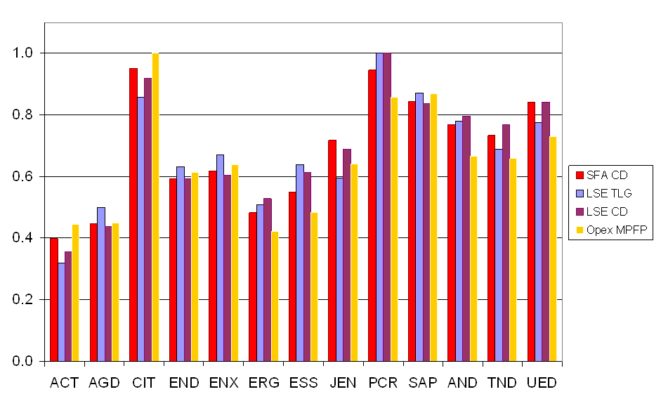

Source: Economic Insights, Economic Benchmarking Assessment of Operating Expenditure for NSW and ACT Electricity DNSPs, 17 November 2014, p. 46.

Note: ACT=ActewAGL, AGD=AusGrid, CIT=CitiPower, END=Endeavour Energy, ENX=Energex, ERG=Ergon Energy, ESS=Essential Energy, JEN=Jemena, PCR=Powercor, SAP=SA Power Networks, AND=AusNet Services, TND=TasNetworks, UED=United Energy.

The 2014 benchmarking results suggest the Victorian services providers are among the most efficient service providers in the NEM, although Jemena is just outside of the 'efficiency frontier'. This suggests that the Victorian businesses are largely responsive to the incentives of the regulatory regime. If we find we can rely on the businesses' revealed (past actual) costs for base opex, we will focus more on whether the proposed step changes and other proposed increases reasonably reflect the opex criteria.

We welcome submissions on the relative efficiency of the Victorian distribution businesses, including for opex, capex and total expenditure.

# Rate of return

The allowed rate of return is one of the most important determinants of each firm’s overall revenue allowance. In the building block model, the rate of return affects the annual revenue allowance through the building block known as the return on capital. The return on capital is equal to the allowed rate of return multiplied by the size of the regulatory asset base.

Because electricity distribution networks are capital-intensive businesses, the return on capital component can be quite large. During the forthcoming regulatory period, the Victorian businesses have forecast return on capital payments between 40 and 45 per cent of their total revenue allowance.

The allowed rate of return is similar to the interest rate on a loan. Like other interest rates, the rate of return that is appropriate for a network business will depend on both economy-wide factors, such as prevailing conditions in the economy, and firm-specific factors, such as the nature of the risks faced by the firm.

It is important to ensure that the allowed rate of return is set at an appropriate level. If the allowed rate of return is set too low the firm will not be able to attract sufficient capital to fund new investment. In the long run the quality of services the businesses are able to offer may suffer and the businesses may become insolvent. If the allowed rate of return is set too high, consumers would pay more than necessary for the electricity distribution service. According to the rules, the allowed rate of return for a distribution business must be commensurate with the efficient financing costs of a benchmark efficient entity with a similar degree of risk rather than using actual costs of the businesses.

Commercial enterprises raise funds from investors in two main ways: by issuing debt (e.g., by borrowing from banks), and by issuing equity (i.e., shares, which are often traded on the stock market). Rather than estimate the allowed rate of return for the business as a whole, it is usual regulatory practice to estimate the rate of return on debt and rate of return on equity separately. The rate of return or 'cost of capital' for the business as a whole is then calculated as the weighted average of the cost of capital for debt and the cost of capital for equity.

In this weighted average the weighting on the cost of capital for debt is equal to the share of the debt in the total value of the firm. The weighting on the cost of capital for equity is equal to the share of the equity in the total value of the firm. The weighted average cost of capital for the firm as a whole is often abbreviated as 'WACC'.

It is useful to keep in mind that the rate of return or cost of capital that is appropriate for a given stream of cash flows depends on the precise nature of the cash flows. In the previous paragraph we noted that the appropriate cost of capital for debt payments is different from the cost of capital for payments to equity. In addition, the cost of capital will be different if the cash-flows are fixed in “nominal” terms (that is, a fixed amount, paid in the money-of-the-day) or fixed in “real” terms (that is, an amount which varies directly in line with inflation). In addition, the cost of capital will be different for cash-flows which are before tax has been paid, called “pre-tax”, or for cash-flows which are after tax, called “post-tax”. The rules require the AER to use a nominal post-tax framework.

In December 2013 the AER published a guideline that sets out our intended approach for determining the rate of return.[36] The guideline is not binding, but if we or the distributors seek to depart from it the rules require that we must set out reasons for doing so. As we will see below, in many respects the Victorian distributors have used methods other than those set out in the rate of return guideline to develop their proposed rates of return. While we consider the guideline sets out an appropriate approach, we do not wish to preclude stakeholder submissions proposing alternative approaches to both the guideline and the distributors' proposals.

As explained further in the rate of return guideline, for regulatory purposes, we assume a benchmark firm with 60 per cent of its total value in debt and 40 per cent in equity. In reality, each of the distributors may finance themselves using a greater or lesser ratio of debt and equity. However, we consider that the 60:40 ratio reflects a prudent financing approach by a typical network firm. The use of a benchmark rather than the actual value for the gearing ratio means that each distributor retains an incentive to finance its activities as efficiently as possible.

## Distributors' proposed overall rate of return

Table 6.1 below summarises the distributors' proposed rates of return for the first year of the 2016–20 regulatory period. The first row shows the WACC proposed by the Victorian electricity distributors. The following rows show the distributors' proposed values for the return on equity and the return on debt that, when combined, make up the WACC. All of the businesses proposed to use the 60:40 gearing ratio (that is 60 per cent of the firm’s value is debt, and 40 per cent is equity). The overall WACC is therefore equal to 60 per cent of the return on debt plus 40 per cent of the return on equity.

As can be seen, the WACC proposals of these businesses are similar, around 7.20 per cent. The proposed return on equity and return on debt for United Energy is slightly higher than the others which results in a slightly higher WACC (7.38 per cent).

Table 6.1 Victorian Electricity Distributors' proposed rates of return

|  |  |  |  |  |  |
| --- | --- | --- | --- | --- | --- |
|  | AusNet Services | CitiPower | Jemena | Powercor | United Energy |
| Overall WACC (per cent) | 7.19 | 7.20 | 7.18 | 7.20 | 7.38 |
| Return on equity (post-tax nominal) (per cent) | 9.90 | 9.90 | 9.87 | 9.90 | 9.95 |
| Return on debt (pre-tax nominal) (per cent) | 5.39 | 5.39 | 5.39 | 5.39 | 5.67 |

Source: Regulatory proposals.

The return on debt set out in the table above will only apply in the first year of the regulatory period (2016). As discussed further below, each of the distributors has proposed to annually update the return on debt. This approach is consistent with the guideline.

By way of comparison, table 6.2 sets out recent AER WACC decisions.

Table 6.2 Rates of return in recent AER decisions

|  |  |  |  |  |  |
| --- | --- | --- | --- | --- | --- |
|  | Ausgrid | Endeavour Energy | Essential Energy | ActewAGL | TasNetworks |
| Overall WACC (per cent) | 6.68 | 6.68 | 6.68 | 6.39 | 6.37 |
| Return on equity (post-tax nominal) (per cent) | 7.10 | 7.10 | 7.10 | 7.10 | 7.10 |
| Return on debt (pre-tax nominal) (per cent) | 6.40 | 6.40 | 6.40 | 5.91 | 5.88 |

Source: See relevant AER determinations.

In the previous regulatory period (2011–15) the return on equity allowed to the Victorian businesses was around 10.3 per cent, while the return on debt was around 8.8 per cent. This resulted in an allowed WACC of around 9.40 per cent (9.95 per cent for Jemena and 9.65 per cent for AusNet Services). The primary explanation for the higher rates of return allowed in the previous regulatory decision was the higher market-wide interest rates prevailing at the time. The investment environment has improved since our last determinations for the businesses. Interest rates and perceptions of economy wide risk have eased. In recent years interest rates on government bonds have dropped to near record lows.

At the same time, the Victorian electricity distributors submit that they are facing new risks, such as technological change which is driving down the cost of battery storage and solar PV.[37] They submit that it may shortly become economic for some customers to seek to disconnect from the grid entirely. According to the Victorian distribution businesses, therefore, electricity network businesses are facing new risks which were not present in the past. The interaction between this uncertainty in future demand and the revenue cap framework was discussed briefly in section 3.1.3.

We welcome comments on how these risks should be considered in estimating the rate of return. Further, how should the changing environment affect demand, capex and depreciation?

## Return on equity

The Victorian distributors have proposed a return on equity of around 9.90 per cent. The businesses have estimated this return using a methodology which is different from that set out in the rate of return guideline. The primary differences from the guideline are set out in the table below.

Perhaps the most important difference in the approach proposed by the Victorian distributors is the extent to which different models are used to estimate the appropriate return on equity. The AER and the regulated businesses agree that there are a range of models which can be used to derive estimates of the return on equity. These models include the Sharpe-Lintner CAPM (SL-CAPM), the Black CAPM model, the Fama-French model, and the Dividend Growth Model. The Victorian electricity distribution businesses submit that the required return on equity should be estimated using each of these models separately, with the results combined in a weighted average. In contrast, the AER in the rate of return guideline proposes what is referred to as the 'foundation model' approach. That approach adopts the Sharpe-Lintner CAPM as the primary model with the other models (the Black CAPM and the DGM) used to provide input and inform the interpretation of the SL-CAPM.[38]

Each of the Victorian electricity distribution businesses rejected the foundation model approach, arguing instead for an approach which gives weighting to all of the four models. Relying on a report by SFG Consulting, the businesses set out proposed estimates of the return on equity using each of these four models.[39] The businesses differed slightly in their approach to combining these four estimates into a single weighted average. Four of the businesses took the advice of SFG Consulting regarding the weighting of the four approaches, placing the greatest weight on the Fama French model. Jemena proposed instead to weight each of the four approaches equally (i.e., to take the simple average) on the basis that there is no clear basis to distinguish one method or model over the others”.

The estimated rate of return under each of the four models, and the proposed weighting of these estimates is set out in table 6.3.

Table 6.3 Victorian Electricity Distributors' proposed rates of return

|  |  |  |  |
| --- | --- | --- | --- |
|  | Estimated return on equity ( per cent) | Weighting (except Jemena) ( per cent) | Weighting (Jemena) ( per cent) |
| SL-CAPM | 9.32 | 12.5 | 25.0 |
| Black CAPM | 9.93 | 25.0 | 25.0 |
| Fama French Model | 9.93 | 37.5 | 25.0 |
| DGM | 10.32 | 25.0 | 25.0 |
| Resulting Estimated Return on Equity ( per cent) |  | 9.95 | 9.87 |

Source: Regulatory Proposals.

In contrast, in our recent draft and final decisions, the AER gave primary weight to SL-CAPM. According to the SL-CAPM, the required return on equity is estimated as the sum of two terms:

* The 'risk-free rate' which is the rate of return on certain government bonds of an appropriate tenor[40]
* The 'equity risk premium' which is the product of the equity beta for each distributor and the market risk premium (MRP).

Relying on report by SFG Consulting, the Victorian electricity distribution businesses submitted that the risk-free rate (averaged over a 20-business-day-period in January 2015), was 2.64 per cent, and the appropriate market risk premium was 8.17 per cent. SFG propose an SL-CAPM equity beta of 0.82, resulting in an estimate of the return on equity using the SL-CAPM model of 9.32 per cent.

Several businesses also proposed that, if the SL-CAPM is to be relied on as the primary model, the correct approach would be to derive an estimate of the equity beta using all four of the models discussed above. The average of the estimate of the equity beta implied by each of the four models is 0.89 which would result in a return on equity of 9.91 per cent.

In contrast, in recent decisions for NSW electricity distributors, the AER has estimated a risk-free rate of 2.55 per cent, a market risk premium of 6.5 per cent, and an equity beta of 0.7, resulting in an overall estimate of the return on equity of 7.1 per cent.

Table 6.4 summarises the similarities and differences between the guidelines, the AER recent decisions, and the Victorian distributors' proposals.

Table 6.4 Comparison of WACC outcomes

|  |  |  |  |
| --- | --- | --- | --- |
| Issue | AER guideline | Recent AER decisions | Distributor proposals |
| Models to be used in estimating return on equity | Primary weight given to SL-CAPM, informed by results of Black CAPM and Dividend Growth Model. Fama French model not used | Followed the principles set out in the guidelines | The Fama French model provides valuable insights and corrects for well-documented biases, and therefore should be used |
| Regard to financial models | SL-CAPM is used as the primary or foundation model, with other models yielding insight and information in a secondary role | Followed the principles set out in the guidelines | All four models should be used, with the return on equity a weighted average of the estimates arising from each model |
| SL-CAPM: Risk-free rate | Risk-free rate should be yield on government bonds with a 10-year term, averaged over a 20-business-day-period | Followed the principles set out in the guidelines | Agree |
| SL-CAPM: Equity beta | Estimated using a set of energy firms comparable to the benchmark efficient entity resulting in beta of 0.7 | Followed the principles set out in the guidelines. Beta of 0.7 | Beta should be at least 0.82 using a broader sample of domestic and international firms |
| SL-CAPM: Market Risk Premium | AER will estimate a range for the MRP and then select a point within that range taking into account different sources of evidence | MRP of 6.5 per cent | MRP of 8.17 per cent, derived by synthesising a number of differently sourced estimates (i.e., taking a weighted average).[41] |

Source: AER.

All of the parameters of the SL-CAPM—especially the appropriate equity beta and market risk premium—remain highly contentious and are covered in detail in the regulatory proposals. In regard to estimating the equity beta, the key issue is the identity of comparable listed companies. There are technical questions about the methodological choices made in estimating equity beta. In regard to estimating the market risk premium, the key issue is what weight to give to different sources of information. There are also more technical questions about what Dividend Growth Model should be used and the treatment of imputation credits in the estimation of the market risk premium.

## Return on debt

The AER rate of return guideline sets out a new methodology for the estimation of the return on debt. This methodology departed from previous practice in two key respects:

* First, the AER proposed to estimate the return on debt by gradually transitioning from the current “on-the-day” approach to a “trailing average” approach. The on-the-day approach resets the return on debt allowed based on prevailing interest rates around the start of the regulatory period. Under the trailing average approach the return on debt is estimated as the simple average of the historic rate of return on ten-year debt during a period in time in each of the last ten years.
* Second, the AER proposed to allow the return on debt to vary from year to year during the regulatory period.

The Victorian distributors have all proposed to adopt this trailing average approach, with certain variations. The variations relate to, first, the details of the implementation of the trailing average approach, and second, the details of the procedure to be followed during the transition to the new approach.

### Implementation issues

The AER guideline proposes that the return on debt is estimated using a simple average of the historic return on ten-year debt during the averaging period. This estimate of the return on debt is updated each year during the regulatory period. However, many additional details must also be determined, including: the credit rating of the relevant debt, the averaging period, the data source, and the timing of the process by which the updated return on debt is reflected in updated prices.

In regard to credit rating, the guideline proposes a benchmark credit rating of BBB+, based on the median credit rating for a sample of Australian utilities. Each of the distributors has departed from the guideline in proposing a benchmark credit rating of BBB. It is not clear what impact (if any) the proposed change in credit rating would have – the two possible data series' providers (the RBA and Bloomberg) both publish broad BBB rated data series.

In regard to data source, the guideline proposed to use the published yields from an independent third party data service provider. In the recent AER determinations, we decided to use a simple average of:

* the RBA data series (specifically, the RBA broad-BBB rated 10 year curve)
* the Bloomberg BVAL data series (specifically, the Bloomberg broad-BBB rated 10 year BVAL curve, where available, and otherwise the Bloomberg BBB rated 5 year or 7 year BVAL curve).

In additions we decided to make certain adjustments to the RBA and BVAL data series where necessary.[42] These adjustments were to match the return on debt from the data series with the benchmark 10 year debt term, to enable the data series to be implemented over the service providers' averaging periods, and to enable the change in revenue resulting from the annual debt update to occur via the automatic application of a formula that is specified in the determination, consistent with the rules.

The Victorian distributors have proposed a variation on this approach. Specifically, the distributors have proposed to use:

* For the first averaging period, a process that selects the data series (RBA or Bloomberg) which best fits the observed bond data for future averaging periods
* For subsequent averaging periods, the averaging approach proposed by the AER unless there is a material (60 basis point) departure between the estimates from the two sources, in which case the “best fit” process in the first bullet point is used to select the best estimate.

In regard to averaging period, in our guideline we proposed to allow the distributors to confidentially propose averaging periods for each year in the future before the start of the regulatory period. In their submissions some distributors have proposed that they should only be required to submit the averaging period for the first year of the regulatory period at this time. The averaging period in future years should be specified in advance during the regulatory period itself.

Finally, in regard to how the time-varying return on debt is reflected in the annual revenue allowance, the guideline proposed that the averaging period should be 'as close as practical to the commencement of each regulatory year'. In the recent determinations we decided that the averaging period must end at least 25 business days before the annual pricing proposals are submitted, to give us 15 days in which to prepare the updates to the building block model (in particular, the X factor).

In their submissions the distributors have proposed a somewhat different approach. They propose that the return on debt be estimated as close as possible to the regulatory year to which it applies, but that any adjustment to tariffs not be made until the following year. The distributors argue that this provides them sufficient time to engage with retailers and other stakeholders on the annual tariff proposal before the update is reflected in tariffs.

|  |  |  |  |
| --- | --- | --- | --- |
| Issue | AER guideline | Recent AER decisions | Distributor proposals |
| Methodology for estimating the return on debt | Use of a simple average of ten years of return on ten-year debt. Return on debt updated each year of the regulatory period | Followed the principles set out in the guidelines | Agree |
| Benchmark credit rating | Estimated using a credit rating of BBB+ or equivalent or the closest approximation | Followed the principles set out in the guidelines | Estimated using a credit rating of BBB |
| Data source | Published yields from independent third-party service provider | Average of RBA BBB-rated ten-year curve and Bloomberg BBB-rated 10-year BVAL curve | Use of “best fit” curve in the first year, and the average approach in subsequent years unless there is a material difference, in which case use “best fit” approach |
| Averaging period | The averaging period for each year of the regulatory period should be nominated in advance by each distributor, as close as practical to the commencement of each regulatory year | Followed the principles set out in the guidelines | Averaging periods should be nominated in advance but only the first averaging period should be nominated before for regulatory period |
| Timing of debt updates | Averaging period should be as close as practical to the commencement of each regulatory year, but process not specified | Averaging period must end at least 25 businesses days before distributors must submit pricing proposals | Introduce a one-year lag between estimating return on debt and impact on tariffs, to allow time for consultation |

Source: AER.

### Transition issues

As we noted earlier, the AER guideline proposes, and the businesses have accepted, that the return on debt should be estimated using a trailing average approach. This contrasts with the previous approach, under which the return on debt was estimated as the return on ten-year debt at one point in time close to the start of the new regulatory period.

This raises the question of how to transition from the previous approach to the new approach. In the AER guideline we proposed a transitional arrangement involving a staged or staggered approach. For the Victoria distributors this transitional arrangement would operate as follows: In the first year of the regulatory period (2016), the return on debt would be set equal to the ten-year debt at a point in time in late 2015 (as it was in the previous regulatory period). In the second year of the regulatory period (2017), the return on debt would be set equal to 90 per cent of this 2016 figure plus 10 per cent of the return on ten-year debt prevailing in 2017. In the third year (2018), the return on debt would be set equal to 80 per cent of the 2016 figure, 10 per cent of the 2017 figure, and 10 per cent of the new return on ten-year debt in 2018. This process would continue for ten years until the transition to the new approach is complete.

The distributors have proposed an alternative transition to the new approach for setting the return on debt. The businesses argue that if a network business wanted to reduce its exposure to interest rate risk during the transition period it should follow a particular hedging strategy. Specifically it should, at the start of the regulatory period, adopt a policy of hedging ten per cent of its current debt for one year, ten per cent for two years, ten per cent for three years and so on.

The distributors propose to estimate the different term rates (the one-year rate, the two-year rate and so on) using the rate on swaps of different terms. In addition, they propose to add to this a risk premium reflecting the historic average risk premium for corporate debt over swap rates. This risk premium is calculated as the average of the difference between the return on ten-year BBB bonds and the swap rate. They also add a premium of 23 basis points for the transactions costs of entering into the hedging arrangement.

## Value of imputation credits

In the building block model an allowance is made for the estimated tax paid by the benchmark firm. In Australia companies typically pay tax at the rate of 30 per cent on their profit. However, under the Australian taxation system, investors can receive an 'imputation credit' for income tax paid at the company level. For investors that meet certain eligibility criteria, this credit can be used to offset their tax liabilities. If the amount of imputation credits received exceeds an investor’s tax liability, that investor can receive a cash refund for the balance. Imputation credits are a benefit to investors in addition to any cash dividend or capital gains from owning shares.

The rules recognise that a service provider's allowed revenue does not need to include the value of imputation credits. Under the rules, service providers are to recover revenue that compensates them for their efficient costs in providing regulated services. This includes, among other things, a return to be provided to investors (return on equity) that is required to promote efficient levels of investment. The more that imputation credits are valuable, the less return that investors require from dividends and capital gains. However, the estimation of the return on equity does not take imputation credits into account. Therefore, an adjustment for the value of imputation credits is required. This adjustment could take the form of a decrease in the estimated return on equity itself. An alternative but equivalent form of adjustment, which is employed by the rules, is via the revenue granted to a service provider to cover its expected tax liability. Specifically, the rules require that the estimated cost of corporate income tax be determined in accordance with a formula that reduces the estimated cost of corporate tax by the 'value of imputation credits' (represented by the Greek letter, $γ$, 'gamma'). This form of adjustment recognises that it is the payment of corporate tax which is the source of the imputation credit return to investors.

The rate of return guideline proposes that the value of imputation credits would be estimated as a market-wide parameter, rather than estimating this on an industry or business specific basis. Under the guideline, it would be determined as the product of:

* a distribution rate (referred to in our guideline as the 'payout ratio'), which represents the proportion of imputation credits generated by the benchmark entity that is distributed to investors
* a utilisation rate, which is the extent to which investors can use the imputation credits they receive to reduce their tax or to get a refund.

In the guideline, our assessment of this evidence produced an estimate of 0.7 for the utilisation rate and 0.7 for the distribution rate. The guideline therefore proposed an estimate of 0.5. However, in the recent NSW determinations we re-examined the evidence and clarified our understanding of the utilisation rate as the utilisation value to investors in the market per dollar of imputation credits distributed. This re-examination, in addition to new evidence and advice considered since the guideline, led us to depart from the 0.5 value of imputation credits we proposed in the guideline. Instead, we chose a value for imputation credits of 0.4 from within a range of 0.3 to 0.5.

In their submissions the Victorian distributors have proposed a value of imputation credits of 0.25. This value is determined as the product of:

* a distribution rate of 0.7, consistent with our guideline
* a utilisation rate of 0.35.

The use of a gamma value of 0.25 rather than 0.4 has the effect of increasing the revenue allowance of the distributors by between 1.5 and 2 per cent.

# Consumer engagement

The Victorian distributors have submitted their consumer engagement strategies and descriptions of the feedback they received from consumers and other stakeholders.

Consumer engagement is an important issue for our distribution determination. The NER require network service providers to identify in their proposals how they engaged with consumers, and how consumers' concerns were addressed.[43]

Our expectations of network service providers, such as the Victorian distributors, are set out in a Consumer Engagement Guideline we published in December 2013.[44] The guideline centres on best practice principles to drive consumer engagement and a commitment from network service providers to continuously improve engagement across all business operations. The guideline is not prescriptive, rather it places the onus on network service providers to develop consumer engagement strategies and activities that best suit their business.

As required by the NER, we will have regard to the nature of consumer engagement undertaken and the outcomes of that engagement in considering the proposals put to us by network service providers.[45]

We will consider how the service provider:

* equipped consumers to participate in consultation
* made issues tangible to consumers
* obtained a cross-section of views
* considered and responded to consumer views.

The Consumer Challenge Panel (CCP) has previously given us advice on consumer engagement by network businesses.[46] The CCP states that 'effective consumer engagement must be a two way process, with consumers and groups representing consumers needing to be active collaborators in partnership with businesses.'[47] The CCP also emphasises that businesses that are committed to consumer engagement will be able to show intent in their actions and demonstrate that the outcomes of its consumer engagement have informed and been reflected in its regulatory proposal and ongoing business activities.[48]

We welcome comments from consumers who were part of a distributor's consultation activities and from consumers who did not participate in such activities.

We welcome submissions on whether the businesses have adopted practices set out in the Consumer Engagement Guideline to build genuine consumer engagement across all business activities. This is particularly with respect to accessibility of information, clarity of roles and objectives of engagement.

Is there evidence that the engagement process provided options and scenarios for service and price trade-offs? Were cost, price and quality of service information provided to those consumers participating in the consumer engagement process to inform those trade-offs? We will examine whether the businesses' proposals reflect the outcomes of their engagement process.

## Consumer engagement reported by the businesses

This section summarises the consumer engagement strategies and activities described by the Victorian distributors in their regulatory proposals. We consider this is a valuable resource for readers to get a sense of the distributors' consumer engagement approaches. However, we also encourage consumers to review the regulatory proposals' consumer engagement material and make submissions.

Table 7.1 categorises the type of engagement undertaken by the Victorian distributors in the lead up to submitting their proposals.

Table 7.1 Consumer engagement - comparative table

|  |  |  |  |  |  |
| --- | --- | --- | --- | --- | --- |
|  | AusNet | CitiPower | Powercor | Jemena | United Energy |
| Research and analysis of existing customer research | X | X | X | X | X |
| Telephone surveys | X |  |  |  | X |
| Online surveys |  | X | X | X |  |
| Forums (community, retailers or stakeholders, deliberative) | X | X | X | X |  |
| Meetings |  |  |  | X | X |
| Workshops | X |  |  | X | X |
| Focus groups | X | X | X | X | X |
| Interviews |  | X | X | X | X |
| Follow-up sessions | X |  |  |  |  |
| Community relations activities / shopping centre kiosks |  |  |  | X | X |
| Industry engagement | X |  |  |  |  |
| Asset tours |  | X | X |  |  |
| Website |  | X | X | X |  |
| Social media (Twitter / Facebook) |  | X | X |  |  |
| e-newsletters |  | X | X |  |  |
| Letters |  | X | X |  |  |
| Consultation paper and submissions |  | X | X |  |  |
| Customer consultative committee /  Customer council | X |  |  | X |  |
| Customer literacy programs |  |  |  |  | X |

Sources: AusNet Services, Citipower, Powercorp, United Energy and Jemena regulatory proposals.

The sections below describe how each business interpreted the outcomes of their consumer engagement and how their proposal responds to it.

### CitiPower and Powercor

CitiPower and Powercor summarised their customer feedback as follows:

* Customers want reliable supply for a reasonable price.
* They want efficient and targeted investment across the networks.
* They want the distributors to pay close attention to safety and maintenance and they support additional investment in activities that reduce risk of fire danger.
* They expect forward and proactive planning to ensure the resilience, capacity and capability of the networks.
* They say future needs are best met by a smart grid to enable choice and flexibility.
* They want greater access to readily understandable information about their electricity usage.[49]

At a high level, CitiPower and Powercor have responded to these preferences in their regulatory proposals, by stating:

* Powercor will underground powerlines in high-risk fire areas, as well as investing in other bushfire mitigation activities.[50]
* Powercor will enable the connection of several large wind farms in Western Victoria, as well as better controls so they can connect more rooftop solar panels.[51]
* CitiPower will invest in technology to connect more embedded generation, and work local government to introduce new types of energy efficient street lighting.[52]

In more detail in their capex proposals, CitiPower and Powercor have submitted that concerns raised by their stakeholders have influenced their capex proposals.

* In discussing forecast replacement capital expenditure, Powercor cited its customer research to understand customer views on the need to replace assets to maintain reliability. Powercor stated its customers expect the distributor to continue providing a reliable supply for a reasonable price, thus requiring regular maintenance.[53] Powercor has proposed a 58 per cent increase in repex compared to the previous regulatory period.[54]
* In proposing augmentation expenditure, Powercor cited its customers' views supporting the increase in capacity of its network to meet load growth.[55] Powercor has proposed a 93 per cent increase in augex compared to the previous regulatory period, particularly to meet local demand growth in the western suburbs of Melbourne and Geelong.[56]
* In discussing its proposed repex, CitiPower referred to its large customers' views on the importance of continuous, uninterrupted reliable supply of electricity.[57] CitiPower's forecast repex will increase by 74 per cent compared to the previous five-year period, largely driven by the age and condition of assets as stated by CitiPower.[58]
* On its connections and customer-driven works forecast, CitiPower referred to its large customers' main expectations and general customer satisfaction with the distributor's management of new connections. CitiPower has proposed a 14 per cent increase in this expenditure compared to the previous period, mainly due to new developments and redevelopments in its distribution area.[59]

We welcome comments on the consumer engagement conducted by Citipower and Powercor, particularly with respect to:

• whether Citipower and Powercor has articulated the outcomes of its consumer engagement and effectively summarised the views and concerns of its customers

• whether and how well Citipower and Powercor has considered and responded to its customers' views.

### AusNet Services

AusNet Services submits it found consumers want high levels of reliability and safety. With respect to the costs of mitigating bushfire risk, AusNet Services reported that its regional customers consider urban customers should contribute because they benefit from regional products and services such as agricultural output and tourism.[60] AusNet Services states that the findings from its engagement program have not been used to make expenditure decisions on a stand-alone basis, but rather, these insights have shaped and refined our plans.[61]

In response to stakeholder concerns AusNet Services stated:

* They have adopted a range of measures including cost pass throughs, continued investment in demand management, accelerated depreciation of the remaining asset value and a low augmentation expenditure[62]
* that its expenditure proposal is expected to lead to a slightly lower level of reliability[63]
* it has proposed expenditure that aims to reduce the risk of bushfires and electric shocks arising from its assets[64]
* that is has proposed to expand the allowance for investment in longer term research.[65]

We welcome comments on the consumer engagement conducted by AusNet Services, particularly with respect to:

• whether AusNet Services has articulated the outcomes of its consumer engagement and effectively summarised the views and concerns of its customers

• whether, and how well, AusNet Services has considered and responded to its customers' views.

### Jemena

Arising from its consumer engagement, Jemena submits its customers:

* want to be informed to make their own energy decisions and that they prioritise reliability and safety.[66]
* consider existing reliability levels are appropriate, although large commercial or industrial customers require specific service differentiation[67]
* want the business to continually improve service efficiency to keep prices low.
* are concerned some are struggling to pay for their energy services and require support.

Jemena contends that it took account of its customers' feedback in its decision making for its proposal.[68] Jemena states that its 2016 Plan includes the following responses to customer feedback:

* Maintaining current safety and service levels—expenditure will be targeted to ensure demand from new growth areas (such as Craigieburn and Sunbury, Victoria) and ageing assets (such as the oldest pole structures) in well-established areas do not compromise service levels.[69]
* Reducing average network prices—Jemena's proposal includes an 8.2 per cent decrease in average network prices over the five-year period (excluding the impact of inflation). This means the distribution network component of annual electricity bills of typical residential customers will fall over the five-year period, offsetting the impact of inflation.[70]
* Updating price components to encourage informed energy decision making—Jemena has introduced a new ' maximum demand charge'. This new charge means that over the next five years, how much the customer pays for using the network will depend on how and when the customer uses the network.[71]
* Providing assistance to vulnerable customers struggling to pay energy bills—Jemena will partner with a No Loan Interest Scheme to help these customers to replace inefficient appliances, trial 500 in-home energy displays, and provide targeted information about their energy usage and bills.[72]

We welcome comments on the consumer engagement conducted by Jemena, particularly with respect to:

• whether Jemena has articulated the outcomes of its consumer engagement and effectively summarised the views and concerns of its customers

• whether, and how well, Jemena has considered and responded to its customers' views.

### United Energy

United Energy submits it engaged a consultant to facilitate its consumer engagement activities, including conducting focus groups, workshops and surveys among its large and commercial customers and its Consumer Consultative Committee.

United Energy submits that the key findings from its consumer research are the following:

* Affordability is a key issue for its customers.
* Customers do not want to accept lower reliability in exchange for lower prices.
* Customers perceive electricity to be a basic utility. Electricity supply should be constant and of high quality, and customers do not see any reason to pay a premium for improved reliability.
* Customers want better communication about planned and unplanned interruptions.
* Customers generally want better and timely information and guidance to enable them to control their electricity consumption and bills.
* Customers are willing to respond to incentives to reduce their maximum demand, although this can be more difficult for business customers.
* Customers say United Energy is meeting customers’ expectations regarding the day-to-day issues of vegetation management, safety and aesthetics.[73]

United Energy summarised its response to customer feedback as reflected in its regulatory proposal:

* Affordability and communication—United Energy proposes to maintain reliability and cut its charges for a typical customer by approximately $70 in 2016.
* Better communication—United Energy proposes to invest in ICT solutions to provide better outage information, online customer claims and tracking tools and a self-service portal for new connections to streamline the process for customers, electricians and developers.
* Energy usage information—United Energy proposes to invest in its customer portal to give customers ready access to the information they need to make informed energy choices.
* Market transactions (feedback from retailers)—United Energy proposes to continue to invest in its ICT systems to improve the quality and reliability of market transactions and will also take advantage of the remote capabilities of AMI meters for transfer and re-energisation / de-energisation reads.
* Energy innovation (feedback from councils and some customer groups)—United Energy proposes to continue to pursue non-network solutions including demand-side initiatives and technology.
* Safety and environment—United Energy is proposing $3 million for a three-year trial of dedicated vegetation management crews to work with local councils in its area.
* Public lighting—United Energy submitted a negotiating framework with its regulatory proposal. United Energy submits that this framework is supported by the AER’s Victorian Framework and Approach paper, which approved splitting public lighting into two services: a regulated service applicable to services involving shared public lighting, and a negotiated service relating to dedicated public lighting.[74]

We welcome comments on the consumer engagement conducted by United Energy, particularly with respect to:

• whether United Energy has articulated the outcomes of its consumer engagement and effectively summarised the views and concerns of its customers

• whether, and how well, United Energy has considered and responded to its customers' views.

## Public lighting

The Victorian distribution businesses provide public lighting services (including street lighting) in their respective service areas, predominantly to local municipal councils but also to VicRoads. Public lighting is classified as an alternative control service. We regulate the rates that the companies can charge public lighting customers. The charges approved by us are for the operation, maintenance and replacement of the physical assets, such as poles and luminaires.

Over the course of the last few years, local councils expressed concerns in submissions and public forums about the prices they are paying for public lighting, and the level of transparency around how charges are calculated. Adherence by distributors to the service levels set out in the Public Lighting Code has also been mentioned.[75]

We note that the Victorian distribution businesses have now published their public lighting price (tariff) models, setting out how their public lighting prices are calculated. They have also included public lighting proposals in their regulatory proposals.

We encourage stakeholders to consider the public lighting related material provided by the distributors in their regulatory proposals and the published tariff models.

We are particularly interested in stakeholders’ views about the prospects for negotiating outcomes that are in both their and distributor’s interests, rather than relying on regulatory solutions for the setting of service levels and charges. Councils and their distributor are in a far better position than the regulator to decide how best to provide and receive the services. The AER can remain the final arbiter in case of dispute. It is our considered view that the main intractable issue is the charges but more specifically the input costs—luminaires, globes, poles, labour— used to derive charges.

We welcome comments on whether a negotiated outcome could work? What elements can/or should be negotiated? What specifically do customers want changed in the regime now?

1. In Jemena's regulatory proposal, attachment 3-3 forecasts growth in customer numbers of around 1.24% per annum. However chapter 7 (p. 76, para. 253) of their proposal refers to 'our forecast of 0.58% year-on-year growth in customer numbers'.
2. The 10 per cent POE corresponds to a peak demand level which occurs one year in ten. The 50 per cent POE corresponds to a peak demand level which occurs one year in two.
3. The forecast here is the sum of the (non-coincident) peak demands for each transmission connection point.
4. The AEMO forecasts are the sum of the AEMO Connection Point forecasts for each distributor and therefore reflect the growth in non-coincident peak demand. CitiPower and Powercor forecasts are for coincident peak demand. AusNet Services forecasts are for non-coincident peak demand. The regulatory proposals for Jemena and United Energy do not state whether the forecasts used for this table are coincident or non-coincident. We will seek to further clarify the extent to which differences in forecasts set out in this table reflect differences in the methodology.
5. A maximum demand charge has the effect of inducing each customer to reduce their consumption at the time of the customer's maximum demand during each billing period. If the maximum demand of enough customers occurs at the time of network peak demand, the impact of the maximum demand charge may be to reduce network peak demand.
6. AEMO forecasts of future demand can be found on the AEMO website: <http://www.aemo.com.au/Electricity/Planning/Forecasting/National-Electricity-Forecasting-Report> and <http://www.aemo.com.au/Electricity/Planning/Forecasting/AEMO-Transmission-Connection-Point-Forecasting/Transmission-Connection-Point-Forecasting-Report-for-Victoria> .
7. Speech by Andrew Reeves, former AER Chair, Perspectives on regulation in a changing environment: what does ‘success’ look like in energy regulation?, 6 August 2014.
8. Clauses 5.1 and 5.2 of the Victorian Electricity Distribution Code requires each Victorian distributor to publish targets for its reliability of supply and then to use best endeavours to meet those targets and otherwise to meet reasonable customer expectations.
9. See, for example, the description on p. 12 of CitiPower's 2014 Annual Planning Report.
10. AEMO, Value of Customer Reliability Review: Final Report, September 2014.
11. AusNet, Regulatory Proposal, p. 103.
12. AusNet, Regulatory Proposal, p. 105.
13. The Electricity Distribution Code can be found on the ESC website: <http://www.esc.vic.gov.au/Energy/Distribution/Electricity-Distribution-code/Electricity-Distribution-Code-May-2012>
14. The 'N-1' standard refers to a situation where the network is planned and operated in such a way that the loss of any one network element, even at the peak time on the network, will not result in any interruption in supply.
15. United Energy, Regulatory Proposal, p. 62.
16. If we are not satisfied a distributors' capex proposal reasonably reflects the capex criteria, we must not accept the forecast. In that case, we must estimate the total required capex that, in our view, does reasonably reflect the capex criteria taking into account the capex factors.
17. Connections expenditure as presented here is a gross amount. Customer contributions must be deducted to arrive at the net capex. Customer contributions are not added to the regulated asset base. Customer contributions reduce this expenditure to offset this amount.
18. For the Victorian distributors transitional rules based on version 58 of the NER apply. This means the review of capital overspending now present in rule S6.2.2A will not apply.
19. NER, cl. 6.5.6(c).
20. NER, cl. 6.5.6(e).
21. NER, cl. 6.5.6(d).
22. AER, Expenditure forecast assessment guideline, November 2013.
23. AER, Expenditure forecast assessment guideline, November 2013, p. 7.
24. NER, clause 6.5.6(c).
25. AusNet Services, Regulatory proposal, 30 April 2015, pp. 181–182; CitiPower, Regulatory proposal, 30 April 2015, p. 161; Jemena, Regulatory proposal, 30 April 2015, p. 82; Powercor, Regulatory proposal, 30 April 2015, p. 171; United Energy, Regulatory proposal, 30 April 2015, p. 89.
26. Order under Section 15A and Section 46D of the Electricity Industry Act 2000.
27. We only have an estimate of opex incurred for the last year of the 2011–15 regulatory control period at this time.
28. AusNet Services referred to these costs as 'cost roll ins'.
29. AusNet Services called these 'other costs'.
30. We only have an estimate of opex incurred for the last year of the 2011–15 regulatory control period at this time.
31. We only have an estimate of opex incurred for the last year of the 2011–15 regulatory control period at this time.
32. We only have an estimate of opex incurred for the last year of the 2011–15 regulatory control period at this time.
33. We only have an estimate of opex incurred for the last year of the 2011–-15 regulatory control period at this time.
34. The methodology and assumptions used to calculate these measures are set out in detail in our annual benchmarking report, and supporting report prepared by Economic Insights. These are available on our website [www.aer.gov.au](http://www.aer.gov.au)
35. The methods include a Cobb Douglas stochastic frontier analysis (SFA CD) opex cost function model, Cobb Douglas and translog least squares econometrics (LSE) opex cost function models and opex multilateral partial factor productivity (MPFP) indexes.
36. AER, Rate of return guideline, December 2013.
37. See, for example, Jemena submission, Attachment 9.2, chapter 2, 'The Changing Risk Profile for Electricity Distribution Businesses'.
38. In the guideline we expressed concern with the Fama-French model and proposed to give it little or no weight.
39. See, for example, Jemena submission, Attachment 9.2, chapter 3, 'Return on Equity'.
40. The tenor of a loan is the amount of time left for the repayment of the loan.
41. See, for example, AusNet Services, Regulatory proposal 2016–20, p. 329.
42. For the RBA curve, our decision was to interpolate the monthly data points to produce daily estimates, to extrapolate it to an effective term of 10 years, and to convert it to an effective annual rate. For the BVAL curve, our decision was to extrapolate it to 10 years (if using the 5 or 7 year curve) using the spread between the extrapolated RBA estimate (either 5 or 7) and 10 year curves, and to convert it to an effective annual rate.
43. NER, cll. 6.5.6(e)(5A) and 6.5.7(e)(5A).
44. AER, Consumer engagement guideline for network service providers, November 2013.
45. NER, 5.6.
46. CCP, Preliminary advice on the effectiveness of consumer engagement by network businesses, Jul 2014; CCP, Further advice on the effectiveness of consumer engagement by network businesses, October 2014.
47. CCP, Preliminary advice on the effectiveness of consumer engagement by network businesses, Jul 2014, p. 1.
48. CCP, Preliminary advice on the effectiveness of consumer engagement by network businesses, Jul 2014, p. 1.
49. CitiPower, Regulatory proposal, Appendix A - Our customer engagement, April 2015, pp. 47–50; Powercor, Regulatory proposal, Appendix A - Our customer engagement, April 2015, pp. 47–50.
50. Powercor, Regulatory proposal, April 2015, pp. 66–67; 141.
51. Powercor, Regulatory proposal, April 2015, pp. 67, 140, 152.
52. CitiPower, Regulatory proposal, April 2015, p. 10-11; Powercor, Regulatory proposal, April 2015, pp. 10–11.
53. Powercor, Regulatory proposal, Appendix E Capital expenditure, April 2015, pp. 19–20
54. Powercor, Regulatory proposal, Appendix E Capital expenditure, April 2015, p. 48.
55. Powercor, Regulatory proposal, Appendix E Capital expenditure, April 2015, pp. 61–62.
56. Powercor, Regulatory proposal, Appendix E Capital expenditure, April 2015, p. 81. The large increase includes a large one-off project.
57. CitiPower, Regulatory proposal, Appendix E Capital expenditure, April 2015, p. 19.
58. CitiPower, Regulatory proposal, Appendix E Capital expenditure, April 2015, p. 43.
59. CitiPower, Regulatory proposal, Appendix E Capital expenditure, April 2015, p. 113.
60. AusNet Services, Regulatory proposal, April 2015, p. 52.
61. AusNet Services, Regulatory proposal, April 2015, p. 31.
62. AusNet Services, Regulatory proposal, April 2015, pg. 452.
63. AusNet Services, An overview of our plans 2016 to 2020, April 2015, p. 14.
64. AusNet Services, An overview of our plans 2016 to 2020, April 2015, p. 14.
65. AusNet Services, An overview of our plans 2016 to 2020, April 2015, p. 14.
66. Jemena, Regulatory proposal, April 2015, p. 32.
67. Jemena, Regulatory proposal, Attachment 4–1 Our customer, stakeholder and community engagement, April 2015.
68. Jemena, Regulatory proposal, April 2015, p. 33.
69. Jemena's 2016 Plan: Consumer Overview, April 2015, p. 10, 13.
70. Jemena's 2016 Plan: Consumer Overview, April 2015, p. 16.
71. Jemena's 2016 Plan: Consumer Overview, April 2015, p. 18.
72. Jemena, Regulatory proposal, April 2015, p. 33.
73. United Energy, Regulatory proposal, April 2015, p. 22.
74. United Energy, Regulatory proposal, April 2015, p. 23. See also United Energy, Capex Overview Paper - Augmentation, April 2015, pp. 36–37, 54.
75. The Code was developed by the Essential; Services Commission of Victoria in the early 2000s following consultation between it, local councils and distributors. The AER now administers the Code but does not have the authority to change it. That role rests with the ESCV.