Final decision: TasNetworks (transmission) 2015–19



We have made a final decision on TasNetworks’ transmission determination. TasNetworks is the principal electricity transmission network service provider in Tasmania. Our final decision allows TasNetworks to recover $693.9 million ($ nominal) over the 2015-19 regulatory control period.[1]

Overview

The Australian Energy Regulator (AER) regulates TasNetworks by setting the maximum allowed revenue (MAR) it may recover from customers through transmission network charges.

We accepted TasNetworks’ proposal to recover $693.9 million ($nominal) over the 2015–19 regulatory control period.

The figure below shows our overall decision on TasNetworks’ total revenue allowance for each year of the final decision.

TasNetworks’ past total revenue, proposed total revenue and AER final decision revenue allowance ($ million, $2013–14)



The revenue we determine affects the transmission component of a customer’s electricity bill. Transmission charges make up about 15 per cent of the bill for a typical residential customer in Tasmania, but for large customers it can be more significant.

Other components in customer bills include the cost of generation, distribution network charges, and retailer costs. The AER does not set retail prices

**Estimated bill impact**

Under this decision, transmission charges (per MWh) should fall from $18.95/MWh in 2014-15 to $17.43/MWh in 2015-16. From there, we expect them to increase by 2-3 per cent per annum to reach around $17.85/MWh at the end of the period covered by this decision (2018-19).

Based on the lower transmission charges from our final decision passing through to customers, we would expect average annual electricity bills for residential customers to reduce by $24 (or 1 per cent), and for small business customers by $41 (or 1 per cent), in 2015–16. For the rest of the period we expect bills to remain relatively stable.

These are only estimates, and are based on the data we have about how much energy customers in Tasmania use. There are a number of other factors that also affect a customer’s electricity bill, such as the wholesale price of electricity. You can read more about what makes up the energy prices on customers’ bills on our website: <http://www.aer.gov.au/Consumers>.

**Key elements of our decision**

Our assessment of TasNetworks’ proposed revenue is based on a number of components. These include expenditure to maintain and operate the network, and the return to investors on their investment. Together, these determine the revenue TasNetworks may recover from its customers.

We discuss each of these below.

**Rate of return**

Significant investment is required to build a transmission network. The return TasNetworks must pay lenders and investors is referred to as the rate of return. Even a small difference in the rate of return can have a big impact on revenues.

Our final decision sets the allowed rate of return (or ‘cost of capital’) of 6.37 per cent for 2015–16. We will update the rate of return annually to reflect changes to the return on debt.

The investment environment has improved since our previous decision, which was made during the height of uncertainty surrounding the global financial crisis. This improved investment environment translates to lower financing costs necessary to attract efficient investment.

The lower rate of return in this decision will reduce TasNetworks’ average revenue compared to the past.

**Capital expenditure**

Capital expenditure (capex) refers to the cost of building new facilities or replacing existing infrastructure. Factors that influence the required level of capex include the age and condition of existing assets.

Capex is another key component of our final decision. We must be satisfied that the level of capex proposed by TasNetworks reflects the capex criteria: the costs that a prudent operator—with efficient costs and a realistic expectation of demand and cost inputs—would need to operate its network safely and comply with its obligations and service standards.

We accepted TasNetworks’ proposed forecast capex of $246.4 million ($2013-14) for the 2014-19 period.

TasNetworks’ forecast capex is a result of reduced augmentation expenditure due to slower demand growth, and the completion of significant asset renewal in the previous period. However, it includes forecast expenditure to replace ageing assets that would have otherwise been replaced as part of deferred augmentation projects. The forecast capex helps to maintain reliable electricity supply to TasNetworks’ customers.

**AER final decision compared to TasNetworks’ past and proposed capex ($million, 2013-14)**

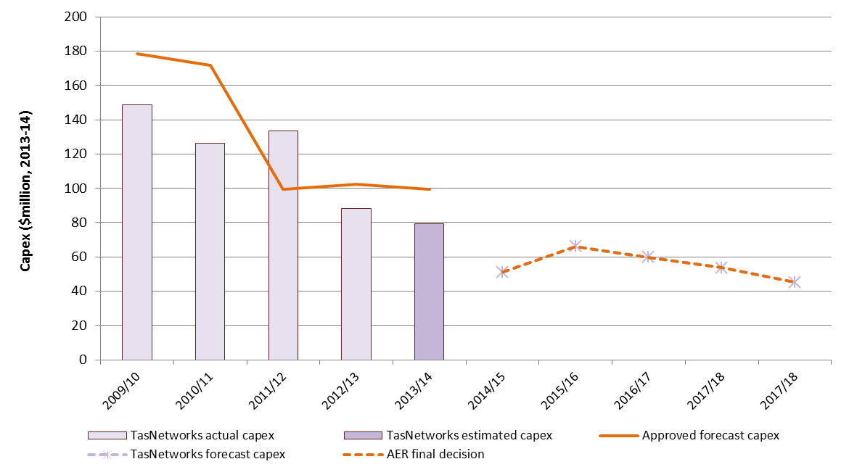

Operating expenditure

Operating expenditure (opex) includes forecast operating, maintenance and other non-capital costs incurred in the provision of transmission network services. It includes labour costs and other non-capital costs that TasNetworks is likely to require during the 2014–18 period for the efficient operation of its network.

We accepted TasNetworks’ proposed opex forecast of $218.3 million ($2013–14) for the 2014-19 period.

We must be satisfied that the level of opex reflects costs that a prudent operator—with efficient costs and a realistic expectation of demand and cost inputs—would need to operate its network safely and comply with its obligations and service standards.

TasNetworks’ proposed opex is around 12 per cent lower than actual opex in the previous period. The decrease is mainly due to the recent merger of the Transend transmission and Aurora distribution businesses. The combined entity, TasNetworks, is expected to incur more efficient costs by rationalising its functions and systems.

**AER final decision compared to TasNetworks’ past and proposed opex ($million, $2013-14)**

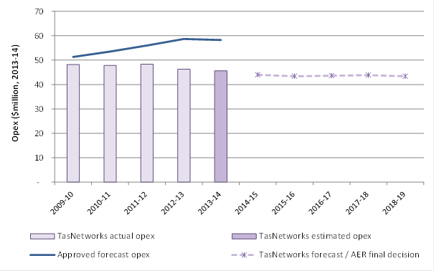

**$ million 2013-14**

**For more information:**

More information on our final decision is on our website: <http://www.aer.gov.au/node/23140>.

You can also read about our upcoming review of TasNetworks’ distribution network here: <http://www.aer.gov.au/node/30748>

1. In November 2012 major changes were introduced to the regulation of transmission service providers under the National Electricity Rules. TasNetwork’s transmission determination was due to commence on 1 July 2014, and apply for a period of five years. So that the new rules could be applied to this decision, transitional rules required two regulatory control periods: a transitional regulatory control period from 1 July 2014 to 30 June 2015; and a subsequent regulatory control period commencing 1 July 2015. We made a fast-tracked placeholder determination for 2014-15. That determination has been adjusted (or ‘trued up’) in this final decision. TasNetwork’s approved revenue for the combined 2014-19 period is $880.8 million ($nominal).