Final decision: Directlink (transmission) 2015-20



We have made a final decision on Directlink’s transmission determination. Dorectlink operates the high voltage interconnector that links the Queensland and New South Wales electricity transmission networks. Our final decision allows Directlink to recover $68.7 million ($nominal) from its customers over five years commencing 1 July 2015.

Overview

The Australian Energy Regulator (AER) regulates Directlink by setting the maximum allowed revenue (MAR) it may recover from customers.

Our final decision allows Directlink to recover $68.7 million ($nominal) from its customers over five years commencing 1 July 2015. If we had accepted Directlink’s proposal, it would have recovered $78.5 million ($nominal) over the 2015-20 regulatory control period. Our final decision is for 12.5 per cent less revenue than Directlink’s proposal.

The figure below shows the difference between Directlink’s proposed revenue, and what we have allowed for each year of the final decision.

Directlink's past total revenue, proposed total revenue and AER final decision revenue allowance ($ million, 2014–15)



The revenue we determine affects the transmission component of a customer’s electricity bill. Transmission charges make up about 7 per cent of the bill for a typical residential customer in NSW but for large customers it can be more significant.

Other components in consumer bills include the cost of generation, distribution network charges, and retailer costs. The AER does not set retail prices.

**Estimated bill impact**

Directlink's transmission charges are recovered by TransGrid as the coordinating transmission service provider for NSW.

Based on the lower transmission charges from our final decision passing through to customers, we expect average annual electricity bills for residential customers to reduce by $22-$25 (or 1 per cent) in 2015–16 and remain relatively stable over the rest of the period covered by this decision.

For small business customers, we estimate reductions of $34 to $41 (or 1 per cent) in 2015-16 and relatively stable bills over the rest of the period covered by this decision.

These are only estimates, and are based on the data we have about how much energy customers in NSW use. There are a number of other factors that also affect a customer’s electricity bill, such as the wholesale price of electricity. You can read more about what makes up the energy prices on customers’ bills on our website: <http://www.aer.gov.au/Consumers>.

**Key elements of our decision**

Our assessment of Directlinks proposed revenue is based on a number of components. These include expenditure to maintain and operate the network, and the return to investors on their investment. Together, these determine the revenue Directlink may recover from its customers.

Our final decision on estimates of capital expenditure (capex) and operating expenditure (opex) includes most but not all of Directlink's proposed forecast capex and opex. The component of our final decision that has had the greatest impact on the total revenue allowance is rate of return. It is the rate of return that drives most of the revenue gap between us and Directlink and explains much of why we have approved less revenue for the 2015-20 period than Direclink has proposed.

We discuss each of these below.

**Rate of return**

Significant investment is required to build a transmission network. The return Directlink must pay lenders and investors is referred to as the rate of return. Even a small difference in the rate of return can have a big impact on revenues.

Our final decision sets the allowed rate of return (or ‘cost of capital’) at 5.45 per cent for 2015–16. We have not accepted Directlink's proposal for a rate of return of 6.17 per cent.[1]

The investment environment has improved since our previous decision, which was made during the height of uncertainty surrounding the global financial crisis. This improved investment environment translates to lower financing costs necessary to attract efficient investment. We consider that Directlink has sought a rate of return that is higher than necessary given the current investment environment.

In our final decision we did not accept the methodology proposed by Directlink to set its rate of return. Instead, we have used our methodology developed with extensive consultation during our Better Regulation program in 2013. We consider that our approach provides for a rate of return that better reflects the allowed rate of return objective.

**Capital expenditure**

Capex refers to the cost of building new facilities or replacing existing infrastructure. Factors that influence the required level of capex include the age and condition of existing assets.

Capex is another key component of our final decision. We must be satisfied that the level of capex proposed by Directlink reflects the capex criteria: the costs that a prudent operator—with efficient costs and a realistic expectation of demand and cost inputs—would need to operate its network safely and comply with its obligations and service standards. We did not accept Directlink’s proposed forecast capex of $37.06 million ($2014–15). Our final decision allows $26.86 million ($2014–15) or 27.5 per cent less than Directlink’s proposal.

**AER final decision compared to Directlink's past and revised proposed capex ($million, 2014-15)**

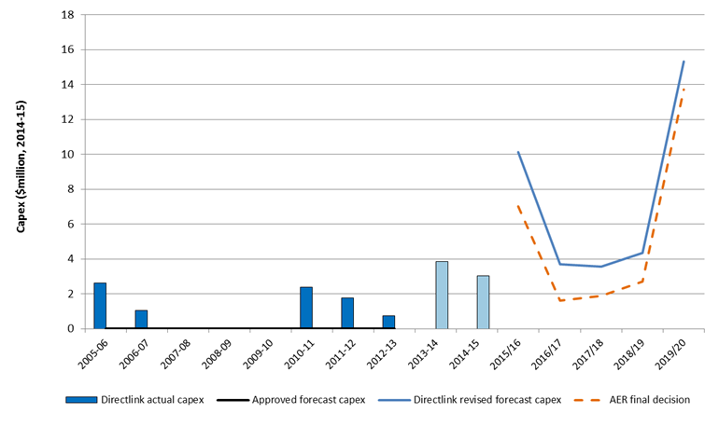

The key areas of difference between our substitute estimate and Directlink’s revised proposal are that our estimate includes adjustments to Directlink’s proposals for its fire suppression system, phase reactor cooling system and converter station roof repair, and reclassification of its proposed cable replacement program from capex to opex.

Operating expenditure

Opex includes forecast operating, maintenance and other non-capital costs incurred in the provision of transmission network services. It includes labour costs and other non-capital costs that Directlink is likely to require during the 2015–20 regulatory control period for the efficient operation of its network.

We estimate total forecast opex of $17.7 million ($2014–15) for the 2015–20 regulatory control period. This includes an allowance for Directlink's proposed cable replacement expenditure, which we consider Directlink had incorrectly classified as capex in its revised proposal. When these elements of Directlink's proposal are combined, our total forecast opex is 33.7 per cent less than proposed by Directlink.

**AER final decision compared to Directlink's past and revised proposed opex ($million, 2014-15)**

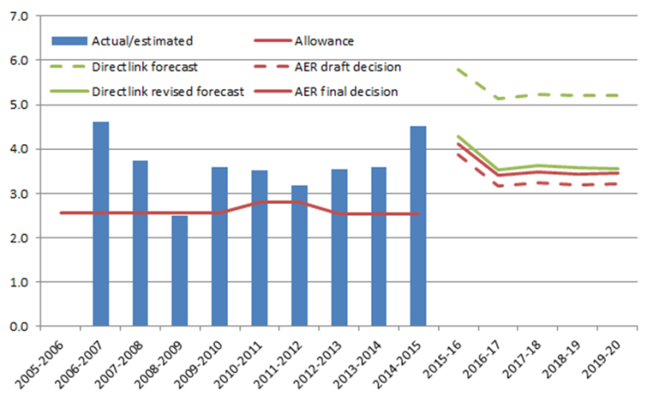

We must be satisfied that the level of opex reflects costs that a prudent operator—with efficient costs and a realistic expectation of demand and cost inputs—would need to operate its network safely and comply with its obligations and service standards.

The key areas of difference between our substitute estimate and Directlink’s revised proposal include lower forecast expenditure for the cable replacement program, and adjustments to forecast expenditure for insurance, commercial services, and APA Operations margin.

**For more information:**

More information on our final decision can be found on our website: <http://www.aer.gov.au/node/23143>.

1. The rate of return that Directlink included in its proposal is an indicative value. Its proposal includes provision for the AER to adjust this value based on updated information that was not available when Directlink submitted its revised proposal. More information on the rate of return can be found in our Rate of Return Fact Sheet.