We have made a final decision for SA Power Networks, the electricity distribution network operator in South Australia. Our final decision allows SA Power Networks to recover $3837.5 million ($nominal) from its customers over five years commencing 1 July 2015.

Final decision:

SA Power Networks (distribution) 2015–20



Overview

The Australian Energy Regulator (AER) regulates the revenues of SA Power Networks by setting the annual revenue requirement it may recover from customers.

Our final decision allows SA Power Networks to recover $3837.5 million ($nominal) from its customers over five years commencing 1 July 2015. If we had accepted SA Power Networks’ revised proposal, it would have recovered $4534.5 million ($nominal) over the 2015−20 regulatory control period. Our final decision is to accept 15.4 per cent less revenue than SA Power Networks’ revised proposal.

The figure below shows the difference between SA Power Networks’ revised proposed revenue and what we have allowed for each year of the final decision.

SA Power Network past and proposed total revenue and AER final decision revenue allowance ($ million, 2014–15)

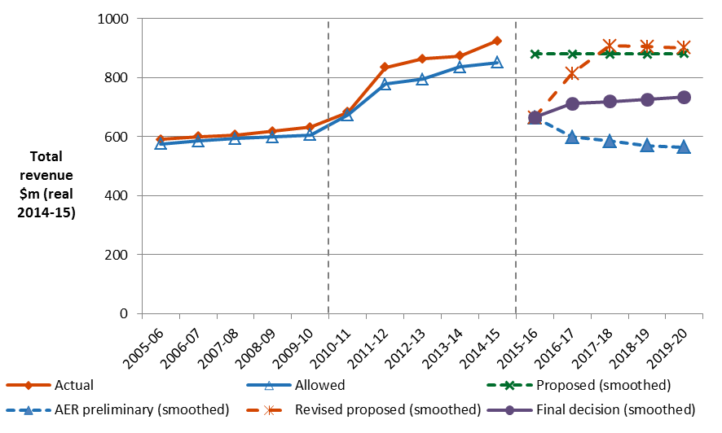

In April 2015, we published our preliminary decision for SA Power Networks, which took effect on 1 July 2015. Our preliminary decision formed the basis for approving prices for 1 July 2015 to 30 June 2016. Our final decision comes into effect from 1 July 2016. Our final decision incorporates a 'true-up' of SA Power Networks’ revenue for 2015─16 and spreads the adjustment over the remaining four years.

The revenue we determine affects the distribution component of a customer’s electricity bill. Distribution charges make up about 38 per cent of the bill of SA Power Networks’ typical residential customers.

Other components in customer bills include the cost of generation, transmission network charges and retailer costs. The AER does not set retail prices.

**Estimated impact on customer bills**

Typical electricity bills for residential and small business customers in South Australia will remain below the level experienced in 2014-15 for next five years. That is, if the distribution charges from our final decision are passed through to customers. We expect average annual electricity bills for residential customers that fell by $203 (or –10.1 per cent) in 2015–16 will rise by $45 (2.5 per cent) in 2016-17. Modest increases in bills of around 1 per cent are expected over the rest of the period covered by this decision.

For small business customers, typical bills decreased by $392 (or ─10.1 per cent) in 2015─16 and will rise by around 1 to 2 per cent each year, through to 2020.

These are only estimates, and are based on the data we have about how much energy customers in South Australia use. There are a number of other factors that also affect a customer’s electricity bill, such as the wholesale price of electricity. You can read more about what makes up the energy prices on customers’ bills on our website: <http://www.aer.gov.au/Consumers>.

Key elements of our decision

Our assessment of SA Power Networks’ revised proposed revenue is based on a number of components. These components include expenditure to maintain and operate the network, and the return to investors on their investment. Together, these determine the revenue SA Power Networks may recover from its customers.

Four components of our final decision drive most of the difference between SA Power Networks’ revised proposal and our final decision: rate of return, depreciation, operating expenditure (opex) and capital expenditure (capex). We discuss each of these below.

Rate of return

Significant investment is required to build a distribution network. The return SA Power Networks must pay lenders and investors is referred to as the rate of return. Even a small difference in the rate of return can have a big impact on revenues.

Our final decision sets the allowed rate of return (or ‘cost of capital’) at 6.17 per cent in 2015–16. We have not accepted SA Power Networks’ proposed rate of return of 7.09 per cent.

The investment environment has improved since our previous decision in 2010, which was made during the period of uncertainty surrounding the global financial crisis. This improvement translates to lower financing costs necessary to attract efficient investment.

The lower rate of return in this decision will reduce SA Power Networks’ average annual revenue requirement compared to the past.

Depreciation

Depreciation (or ‘return of capital’) is the allowance provided so capital investors recover their investment over the economic life of the asset. The effect of changes in depreciation is to move forward or backward in time when SA Power Networks receives its depreciation allowance.

Our final decision is to reduce SA Power Networks’ proposed depreciation allowance for the 2015–20 regulatory control period by $122.2 million ($nominal) to $917.2 million ($nominal). This is 11.8 per cent less than SA Power Networks’ proposed depreciation allowance. We have accepted SA Power Network’s’ revised approach to the calculation of depreciation. This new, more detailed approach provides a higher allowance for depreciation than in our preliminary decision.

Operating expenditure

Opex includes forecast operating, maintenance and other non-capital costs that SA Power Networks is likely to require during the 2015−20 regulatory control period for the efficient operation of its network.

Our final decision allows $1261.6 million ($2014–15). This is 11.9 per cent less than SA Power Networks’ revised proposal of $1432.1 million ($2014─15).

**AER final decision compared to SA Power Networks’ past and proposed opex ($million, 2014-15)**

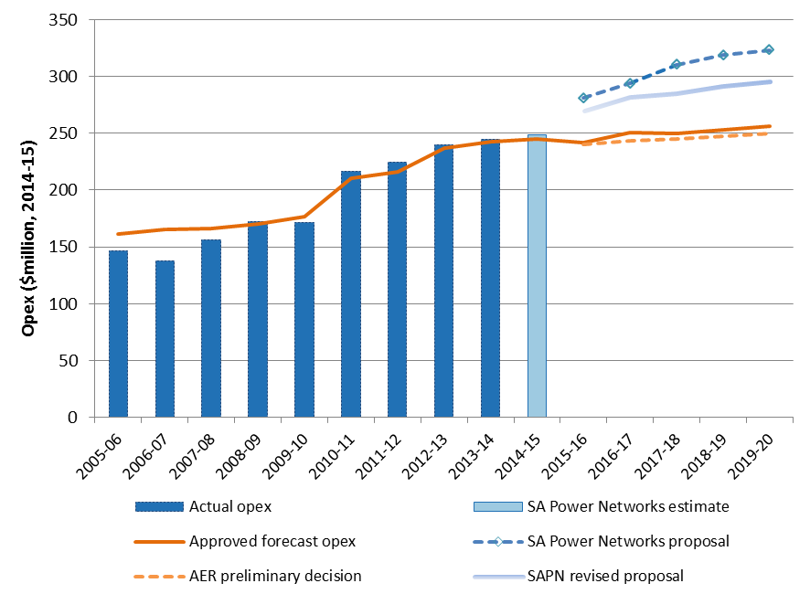



We must be satisfied that the level of opex reflects costs that a prudent operator—with efficient costs and a realistic expectation of demand and cost inputs—would need to operate its network safely and comply with its obligations and service standards.

We are not satisfied that SA Power Networks’ proposed forecast opex reasonably reflects the opex criteria. While we have accepted SA Power Networks’ base opex, we have not accepted several of its proposed opex step changes (which are increases in revenue for changed regulatory or environmental conditions). We consider SA Power Networks has not demonstrated that such revenue increases are necessary to provide safe and reliable distribution services.

**Capital expenditure**

Capex refers to the cost of building new assets or replacing existing infrastructure. Factors that influence the required level of capex include the age and condition of existing assets.

We must be satisfied that the level of capex proposed by SA Power Networks reflects the capex criteria: the costs that a prudent operator—with efficient costs and a realistic expectation of demand and input costs—would need to operate its network safely and comply with its obligations and service standards.

Under our final decision, SA Power Networks can recover $1845.8 million ($2014−15) for capex. This is 10.9 per cent lower than SA Power Networks’ proposed $2070.8 million ($2014─15).

The main driver for our substitute capex estimate is our assessment that SA Power Networks requires less funding for asset replacement, network augmentation and non–system capex than it proposed.

**AER final decision compared to SA Power Networks’ past and proposed capex ($million, 2014-15)**



**For more information:**

More information on our final decision can be found on our website: [www.aer.gov.au](http://www.aer.gov.au).