We have made a draft decision on the access arrangement for the Amadeus Gas Pipeline (AGP). APT Pipelines (NT) Pty Limited (APTNT) operates the AGP, which provides transmission services to customers in the Northern Territory. Our draft decision allows APTNT to recover $110.7 million ($nominal) from its customers over five years commencing 1 July 2016.

Draft decision:

Amadeus Gas Pipeline 2016–21



Overview

The Australian Energy Regulator (AER) approves access arrangements for the AGP and other major gas networks in eastern and southern Australia under the National Gas Law (NGL) and National Gas Rules (NGR).

Our draft decision allows APTNT to recover $110.7 million ($nominal) from users of the AGP over five years commencing 1 July 2016. If we had accepted APTNT’s proposal, it would have been permitted to recover $140.3 million ($nominal) over the 2016−21 access arrangement period. Our draft decision is for 21.1 per cent less revenue than APTNT’s proposal.

The figure below shows the difference between APTNT’s proposed revenue and our draft decision.

APTNT’s past and proposed total revenue and AER draft decision revenue allowance ($million, 2015–16)

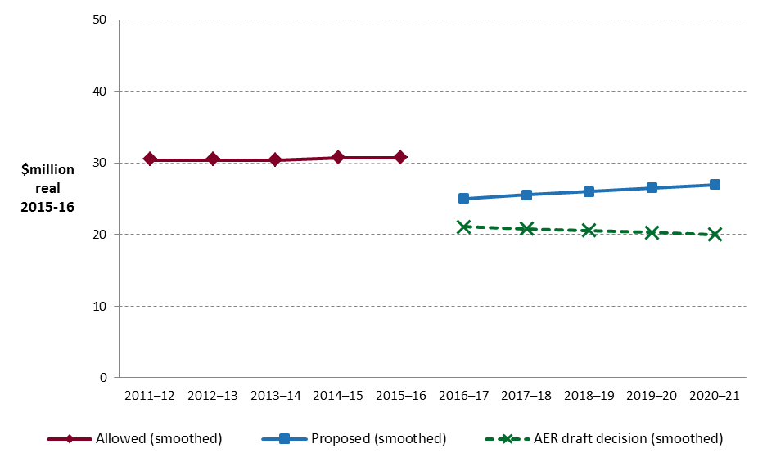

**Key elements of our decision**

Most Australian gas distribution networks are subject to full regulation, which required the service provider to submit an initial access arrangement to the regulator for approval, and revise it periodically. An access arrangement sets out the terms and conditions under which third parties can use a pipeline. It must specify at least one reference service likely to be sought by a significant part of the market, and a reference tariff for that service.

We based our assessment of APTNT’s proposed revenue on a number of components. These include expenditures to maintain and operate the network, and the return to shareholders on their investment. Together, these determine the revenue APTNT may recover from its customers.

We discuss each of these below.

**Rate of return**

Significant investment is required to build and maintain a gas transmission network. The return APTNT must pay lenders and investors is referred to as the rate of return. Even a small difference in the rate of return can have a big impact on revenues.

Our draft decision sets the allowed rate of return (or ‘cost of capital’) at 6.02 per cent for 2016. We have not accepted APTNT’s proposed 8.30 per cent.

The investment environment has improved since our previous decision, which was made during the period of uncertainty surrounding the global financial crisis. This improved investment environment translates to lower financing costs necessary to attract efficient investment. We consider that APTNT has sought a rate of return that is higher than necessary given the current investment environment.

We have not accepted the methodology proposed by APTNT to set its rate of return. Instead, we have used the methodology we developed through extensive consultation during our Better Regulation program in 2013. We consider that our approach provides for a rate of return that better reflects the allowed rate of return objective.

The lower rate of return in this decision will reduce APTNT’s average annual revenue requirement compared to the previous access arrangement period.

Operating expenditure

Opex includes forecast operating, maintenance and other non-capital costs incurred in the provision of gas distribution services. It includes labour and other non-capital costs that AGN is likely to require during the 2016−21 access arrangement period for the efficient operation of its network.

We must be satisfied that the level of opex reflects costs that would be incurred by a prudent service provider acting efficiently, in accordance with accepted good industry practice, to achieve the lowest sustainable cost of delivering pipeline services.

We have accepted APTNT’s total forecast opex of $62.8 million ($2015–16) for the 2016–21 access arrangement period.

**APTNT’s past and forecast opex ($million, 2015–16)**

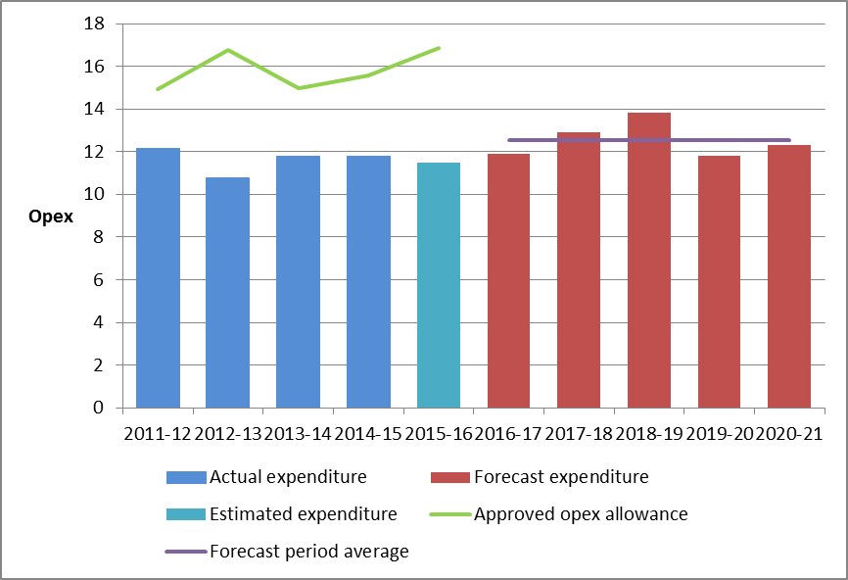

**Capital expenditure**

Capex refers to the cost of building new facilities or replacing existing infrastructure. Factors that influence our required level of capex include expected growth in the network, and the age and condition of existing assets.

We must be satisfied that the level of capex proposed by APTNT is justified, and reflects costs such as would be incurred by a prudent operator acting efficiently, in accordance with accepted good industry practice, to achieve the lowest sustainable cost of providing services.

We have estimated total forecast net capex of $26.5 million million ($2015–16) for APTNT’s 2016−21 access arrangement period. This is 11.4 per cent lower than the $29.9 million million APTNT proposed.

The key difference between our substitute capex forecast and APTNT’s proposal is lower expenditure on the Channel Island bridge project.

**AER draft decision compared to APTNT’s past and proposed capex ($million, 2015–16)**



**More information about our consultation process**

APTNT may submit a revised proposal in response to our draft decision by 6 January 2016. Stakeholders may make written submissions on our draft decision and APTNT’s revised proposal by 4 February 2016. Our final decision is due for release by the end of April 2016.

Our final decision will be issued in April 2016 and will take into account any new information filed by APTNT in its revised proposal, additional analysis and stakeholder submissions. To the extent that new information, analysis or submissions persuade us to depart from this draft decision, the final decision will deliver a different total revenue requirement, and therefore a different impact on reference tariffs.

More information on APTNT’s proposal, our draft decision and how to make a submission is on our website: [www.aer.gov.au](http://www.aer.gov.au).