We have made a draft decision for the Directlink interconnector, which connects the Queensland and New South Wales transmission networks. Our draft decision allows Directlink to recover $76.3 million ($nominal) from its customers over five years commencing 1 July 2015.

Draft decision:

Directlink (transmission) 2015–20



Overview

Directlink operates the high voltage interconnector that links the Queensland and New South Wales transmission networks. We, the Australian Energy Regulator (AER) regulate the revenues of Directlink and other TNSPs in eastern and southern Australia under the National Electricity Law (NEL) and National Electricity Rules (NER).

In June 2014 Directlink submitted its revenue proposal for the regulatory control period 1 July 2015 to 30 June 2020.

We regulate TNSPs by setting the maximum allowed revenue (MAR) they can recover from their customers. Our draft decision allows Directlink to recover $76.3 million ($ nominal) from its customers over the 2015-20 regulatory control period.

If we had accepted Directlink’s proposal, it would have recovered $99.3 million ($ nominal) over the 2015-20 regulatory control period. The difference between Directlink’s revenue from 2005-15, its proposed revenue, and what we have allowed in our draft decision are shown below.

Directlink's past total revenue, proposed total revenue and AER draft decision revenue allowance ($ million, 2014–15)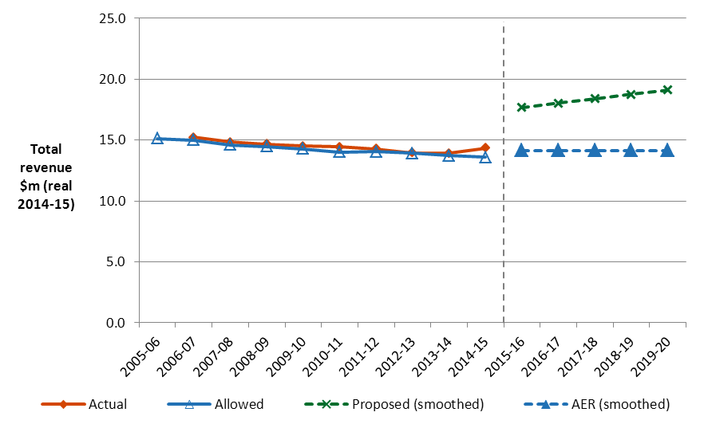

The revenue we determine affects the transmission component of a customer’s final bill. Generally, transmission charges make up about 7 per cent of a typical residential customer’s final bill in NSW but for other large customers it can be more significant. Other components in consumer bills include the cost of generation, distribution network charges, and retailer costs.

Directlink’s revenue is recovered as part of TransGrid’s transmission charges, which we also regulate. We released our draft decision on TransGrid’s revenue at the same time as our draft decision on Directlink.

Overall, based on estimated energy use, we expect the average residential customer’s annual bill to fall by $24 in 2015-16 in NSW.

**Our assessment**

In making our assessment, a TNSP first proposes its forecast revenue requirement. This is based on an estimate of a number of cost categories called ‘building blocks’.

Together, the building blocks add to the MAR Directlink can earn through transmission charges levied on customers. In this way, it should recover no more than the efficient cost of providing transmission services to its customers.

**Draft decision: Building blocks 2015-20 ($ nominal)**



We also apply our service target performance incentive scheme (STPIS) to incentivise TNSPs to maintain and improve service levels.

**Capital expenditure**

We did not accept Directlink’s proposed forecast capital expenditure (capex) of $35.2 million ($2014–15). We estimated a substitute forecast of $25.6 million ($2014–15).

Capex refers to the cost of building new facilities or replacing existing infrastructure. Factors that influence the required level of capex include the age and condition of existing assets.

**AER draft decision compared to Directlink's past and proposed capex ($million, 2014-15)**



Directlink’s forecast capex includes expenditure Directlink will need to maintain its assets over the next five years. This helps to maintain reliable electricity supply to customers in New South Wales and Queensland.

Our draft decision also sets stricter performance targets for Directlink for 2015-20, which take into account the increase in its capex allowance and our expected improved performance.

Operating expenditure

We did not accept Directlink’s proposed $26.5 million   
($2013–14) operating expenditure (opex) forecast. We instead estimated a substitute of $16.7 million ($2013–14).



Opex refers to the non-capital cost of running a business. It includes controllable and non-controllable costs.

Directlink proposed significant increases in its opex compared to its actual opex in the current period. Instead, our draft decision proposes forecast opex more in line with its actual expenditure to date.

Our Efficiency Benefit Sharing Scheme (EBSS) will apply to Directlink for the first time in the 2015-20 regulatory control period. The EBSS encourages TNSPs to become more efficient, by allowing them to keep any difference between their approved opex forecast and their actual opex. At the same time, if a TNSP overspends its allowed opex, it cannot recover this from customers.

**AER draft decision compared to Directlink's past and proposed opex ($million, 2014-15)**

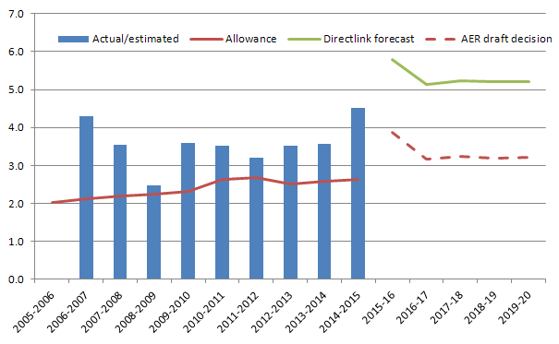

**$ million 2013-14**

**Rate of return**

Our final decision sets the allowed rate of return (or ‘cost of capital’) at 6.80 per cent. In comparison, it was 8.32 per cent during the previous regulatory control period.

The investment environment has improved since our previous decision. The lower rate of return in this decision will reduce Directlink’s average annual revenue requirements compared to the past. This should help reduce electricity prices for consumers in the forthcoming regulatory control period.

Significant investment is required to build a transmission interconnector. The return Directlink must pay lenders and investors is referred to as the rate of return. Even a small difference in the rate of return can have a big impact on revenues.

**More information about our consultation process**

Directlink may submit a revised proposal in response to our draft decision, no later than 13 January 2015. Stakeholders will also be able to make submissions on our draft decision and Directlink’s revised proposal, by 6 February 2015.

More information on Directlink’s proposal, our draft decision, and how to make a submission is on our website: [www.aer.gov.au](http://www.aer.gov.au).