

DRAFT DECISION

AusNet Services transmission determination

2017–18 to 2021–22

Attachment 12 – Pricing methodology

July 2016

© Commonwealth of Australia 2015

This work is copyright. In addition to any use permitted under the Copyright Act 1968, all material contained within this work is provided under a Creative Commons Attributions 3.0 Australia licence, with the exception of:

* the Commonwealth Coat of Arms
* the ACCC and AER logos
* any illustration, diagram, photograph or graphic over which the Australian Competition and Consumer Commission does not hold copyright, but which may be part of or contained within this publication. The details of the relevant licence conditions are available on the Creative Commons website, as is the full legal code for the CC BY 3.0 AU licence.

Requests and inquiries concerning reproduction and rights should be addressed to the:

Director, Corporate Communications  
Australian Competition and Consumer Commission   
GPO Box 4141, Canberra ACT 2601

or publishing.unit@accc.gov.au.

Inquiries about this publication should be addressed to:

Australian Energy Regulator  
GPO Box 520  
Melbourne Vic 3001

Tel: 1300 585 165  
Email: [AERInquiry@aer.gov.au](mailto:AERInquiry@aer.gov.au)

AER reference: 53444

1. Note
2. This attachment forms part of the AER's draft decision on AusNet Services’ revenue proposal 2017–22. It should be read with other parts of the draft decision.
3. The draft decision includes the following documents:
4. Overview
5. Attachment 1 – maximum allowed revenue
6. Attachment 2 – regulatory asset base
7. Attachment 3 – rate of return
8. Attachment 4 – value of imputation credits
9. Attachment 5 – regulatory depreciation
10. Attachment 6 – capital expenditure
11. Attachment 7 – operating expenditure
12. Attachment 8 – corporate income tax
13. Attachment 9 – efficiency benefit sharing scheme
14. Attachment 10 – capital expenditure sharing scheme
15. Attachment 11 – service target performance incentive scheme
16. Attachment 12 – pricing methodology
17. Attachment 13 – pass through events

Attachment 14 – negotiated services

1. Contents

Note 12-2

Contents 12-3

Shortened forms 12-4

12 Pricing methodology 12-6

12.1 Draft decision 12-6

12.2 AusNet Services’ proposal 12-7

12.3 AER’s assessment approach 12-7

12.4 Reasons for draft decision 12-9

12.4.1 Assessment against the pricing principles 12-9

Calculation and allocation of annual revenue 12-9

Allocation of annual service revenue to network connection points 12-10

Development of price structure 12-11

12.4.2 Assessment against the pricing methodology guidelines 12-12

1. Shortened forms

| 1. Shortened form | 1. Extended form |
| --- | --- |
| 1. AARR | 1. aggregate annual revenue requirement |
| 1. AEMC | 1. Australian Energy Market Commission |
| 1. AEMO | 1. Australian Energy Market Operator |
| 1. AER | 1. Australian Energy Regulator |
| 1. ASRR | 1. annual service revenue requirement |
| 1. augex | 1. augmentation expenditure |
| 1. capex | 1. capital expenditure |
| 1. CCP | 1. Consumer Challenge Panel |
| 1. CESS | 1. capital expenditure sharing scheme |
| 1. CPI | 1. consumer price index |
| 1. DRP | 1. debt risk premium |
| 1. EBSS | 1. efficiency benefit sharing scheme |
| 1. ERP | 1. equity risk premium |
| 1. MAR | 1. maximum allowed revenue |
| 1. MRP | 1. market risk premium |
| 1. NEL | 1. national electricity law |
| 1. NEM | 1. national electricity market |
| 1. NEO | 1. national electricity objective |
| 1. NER | 1. national electricity rules |
| 1. NSP | 1. network service provider |
| 1. NTSC | 1. negotiated transmission service criteria |
| 1. opex | 1. operating expenditure |
| 1. PPI | 1. partial performance indicators |
| 1. PTRM | 1. post-tax revenue model |
| 1. RAB | 1. regulatory asset base |
| 1. RBA | 1. Reserve Bank of Australia |
| 1. repex | 1. replacement expenditure |
| 1. RFM | 1. roll forward model |
| 1. RIN | 1. regulatory information notice |
| 1. RPP | 1. revenue and pricing principles |
| 1. SLCAPM | 1. Sharpe-Lintner capital asset pricing model |
| 1. STPIS | 1. service target performance incentive scheme |
| 1. TNSP | 1. transmission network service provider |
| 1. TUoS | 1. transmission use of system |
| 1. WACC | 1. weighted average cost of capital |

# Pricing methodology

This attachment is our draft decision on AusNet Services' proposed pricing methodology for the 2017–22 regulatory control period.

A pricing methodology must be specified as part of our transmission determination[1] and answers the question ‘who should pay how much'[2] in order for a transmission business to recover its efficient costs. To do this, the National Electricity Rules (NER) sets out that it must provide a 'methodology, formula, process or approach'[3] that when applied:

* allocates the aggregate annual revenue requirement to the categories of prescribed transmission services provided by the transmission business[4]
* provides the manner and sequence of adjustments to the annual service revenue requirement[5] and allocates that requirement to transmission connection points[6]
* determines the structure of prices that a transmission business may charge for each category of prescribed transmission services.[7]

AusNet Services' proposed pricing methodology addresses only the pricing matters for which it has responsibility.[8] These are prescribed entry and exit services. In Victoria, the pricing of all other prescribed transmission services is the responsibility of the Australian Energy Market Operator (AEMO).[9] AEMO is also the co-ordinating network service provider in Victoria. It is therefore responsible for allocating the aggregate annual revenue requirement (AARR) for all transmission businesses in the region including AusNet Services.[10]

## Draft decision

We approve AusNet Services' proposed pricing methodology for the 2017–22 regulatory control period. As required, the proposed methodology gives effect to the pricing principles in the NER and complies with the requirements of the pricing methodology guidelines.[11]

## AusNet Services’ proposal

On 30 October 2015, AusNet Services submitted its proposed pricing methodology.

AusNet Services stated that its proposal is 'identical to that approved for the current regulatory control period'.[12] That is, AusNet Services is not proposing to introduce any new or amended pricing arrangements in the 2017–22 regulatory control period.

When considering its proposed pricing methodology, AusNet Services stated that it is important to note that the transmission arrangements in Victoria differ from those in other states.[13] Under these arrangements, AusNet Services owns and operates the majority of the declared shared transmission network. But, unlike other similar network operators in the National Electricity Market (NEM), AusNet Services does not have pricing responsibility for all transmission services in the region. Given this, AusNet Services proposed its pricing methodology should address only the pricing matters for which it has responsibility. These are prescribed entry services and prescribed exit services. This is the same approach which was taken with respect to AusNet Services' approved 2014–17 pricing methodology.

## AER’s assessment approach

We must approve a proposed pricing methodology if satisfied that it:

* gives effect to, and complies with, the pricing principles for prescribed transmission services[14]
* complies with the information requirements of the pricing method guidelines.[15]

In making our assessment, we agree the transmission arrangements in Victoria need to be considered. In Victoria, ownership and planning of the electricity transmission network is split. Ownership rests with the declared transmission system operators (DTSOs). Of these, AusNet Services is the largest.[16] Planning is the responsibility of AEMO. Its objective as a planner is to ensure that the transmission network operates within the security and performance obligations set out in schedules 5.1a and 5.1 of the NER. AEMO bases its investment decisions on cost benefit analysis and considers the long term interests of electricity consumers.[17]

In addition to its role as planner, AEMO is responsible for managing certain services in Victoria. Prescribed transmission services consist of four types. Figure 12.1 shows each of these and the delineation between the services AusNet Services and AEMO manage. AusNet Services manages connection services. As mentioned, these are prescribed entry services and prescribed exit services. AEMO is responsible for shared transmission services, namely TUOS services and common transmission services. Prescribed TUOS services provide different benefits to transmission customers depending on their location within the transmission system.[18] Prescribed common transmission services provide equivalent benefits to all transmission customers without any differentiation based on their location.[19]

Figure . Transmission pricing responsibilities in Victoria

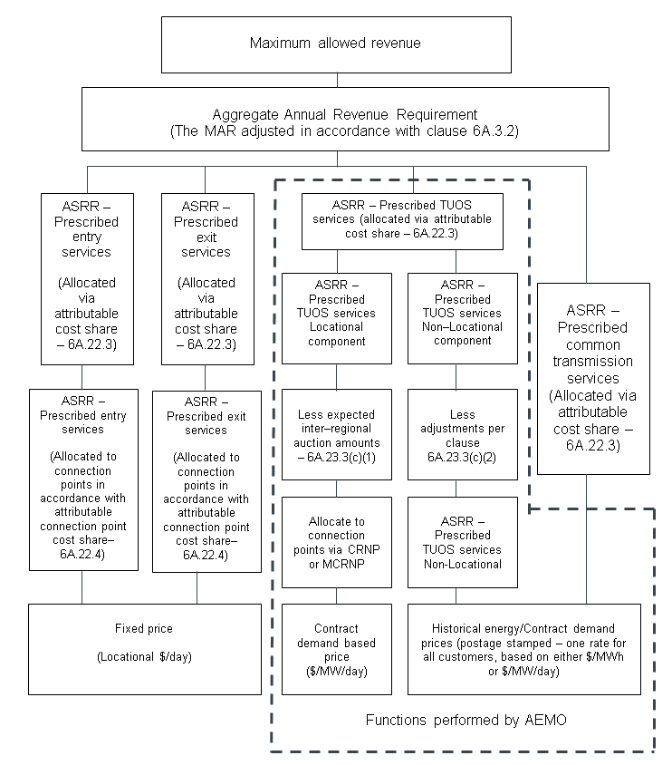

Source: AER analysis; AusNet Services, Revenue proposal, Appendix 14A: Pricing methodology, October 2015, p. 17.

1. The transmission arrangements in Victoria affect AusNet Services' pricing responsibilities. AusNet Services has pricing responsibility for prescribed entry services and prescribed exit services only. Taking this into account we determined that AusNet Services proposed pricing methodology could be approved if it only addressed those connection services. This is consistent with our assessment of AusNet Services current 2014–17 pricing methodology. The services for which AusNet Services does not have pricing responsibility—TUOS services and common transmission services—are addressed by AEMO's 2014–19 pricing methodology.[20]

## Reasons for draft decision

We accept AusNet Services proposed pricing methodology. It is the same pricing methodology we approved for AusNet Services' 2014–17 regulatory control period. We also determine that AusNet Services' proposal meets each of the pricing principles and pricing methodology guidelines requirements that are relevant to its responsibility for connection services.

### Assessment against the pricing principles

In considering AusNet Services' proposed pricing methodology against the requirements of the pricing principles, we addressed only those principles that are relevant to its transmission pricing responsibilities. We consider this approach is appropriate, because the pricing principles are intended to provide scope for TNSPs to develop pricing arrangements that address their operating circumstances.[21]

Calculation and allocation of annual revenue

We assessed how AusNet Services' proposed pricing methodology calculates and allocates its aggregate annual revenue requirement (AARR). The AARR is derived from an adjustment made to the maximum allowed revenue (MAR) that we approve in AusNet Services' transmission determination. That adjustment must accord with the method prescribed under clause 6A.3.2 of the NER. Table 12.1 summarises our assessment in which we found that AusNet Services' proposal satisfactorily addresses the pricing principles.

Table . AER's assessment of AusNet Services' proposed calculation and allocation of the AARR

|  |  |
| --- | --- |
| NER requirements | AER assessment |
| Requirement for the AARR to be calculated as defined in the NER—clause 6A.22.1 | Clause 3 of AusNet Services' proposed pricing methodology satisfies this requirement. |
| Requirement for the AARR to be allocated to each category of prescribed transmission services in accordance with the attributable cost share for each such category of service—clause 6A.22.2 | Clause 4.1 and appendix B of AusNet Services' proposed pricing methodology satisfies this requirement. |
| Requirement for every portion of the AARR to be allocated and for the same portion of AARR to be allocated more than once—clause 6A.23.2(c) | Clause 4.1 and appendix B of AusNet Services' proposed pricing methodology satisfies this requirement. |
| Subject to clause 11.6.11 of the NER, requirement for adjusting the attributable cost share and priority ordering approach to asset costs that would otherwise be attributed to the provision of more than one other category of prescribed transmission service—clause 6A.23.2(d) | Clause 4.2 and appendix B of AusNet Services' proposed pricing methodology satisfies this requirement. |

Source: AER analysis.

Allocation of annual service revenue to network connection points

We assessed how AusNet Services' proposed pricing methodology allocates the annual service revenue requirement (ASRR). The ASRR is derived from allocating a transmission business's AARR to each category of prescribed transmission services in accordance with each category's attributable cost share.[22] Table 12.2 summarises our assessment which found that AusNet Services' proposal satisfactorily addresses the pricing principles.

Table . AER's assessment of AusNet Services' proposed allocation of the ASRR

|  |  |
| --- | --- |
| NER requirements | AER assessment |
| Requirement for the whole ASRR for prescribed entry services to be allocated to transmission network connection points in accordance with the attributable connection point cost share for prescribed entry services that are provided by the TNSP at that connection point—clause 6A.23.3(i) | Clause 5.1 of AusNet Services' proposed pricing methodology satisfies this requirement. |
| Requirement for the whole ASRR prescribed exit services to be allocated to transmission network connection points in accordance with the attributable connection point cost share for prescribed exit services that are provided by the TNSP at that connection point—clause 6A.23.3(j) | Clause 5.1 of AusNet Services' proposed pricing methodology satisfies this requirement. |
| Requirement for the ASRR to be allocated for prescribed TUOS services locational components and pre-adjusted non locational components—clause 6A.23.3(a) | Not addressed, since AEMO (not AusNet Services) is responsible for the pricing of prescribed TUOS services. |
| Requirement for the recovery of the ASRR for prescribed common transmission services and the operating and maintenance costs incurred in the provision of those services to be recovered through prices charged to transmission customers and network service provider transmission connection points set in accordance with price structure principles set out in clause 6A.23.4—clause 6A.23.3(h) | Not addressed, since AEMO (not AusNet Services) is responsible for the pricing of prescribed common transmission services. |

Source: AER analysis.

Development of price structure

AusNet Services' proposed pricing methodology must develop different prices for recovering the ASRR. We are satisfied that this requirement is met. Table 12.3 summarises our assessment against the pricing principles.

Table . AER's assessment of AusNet Services' proposed pricing structure

|  |  |
| --- | --- |
| NER requirements | AER assessment |
| Requirement for separate prices for each category of prescribed transmission services—clause 6A.23.4(a) | Clause 6 of AusNet Services' proposed pricing methodology satisfies this requirement for prescribed entry and prescribed exit services. |
| Requirement for fixed annual amount prices for prescribed entry and exit services—clause 6A.23.4(g) | Clause 6 of AusNet Services' proposed pricing methodology satisfies this requirement. |
| Requirement for postage stamped prices for prescribed common transmission services—clause 6A.23.4(f) | Not addressed, since AEMO (not AusNet Services) is responsible for the pricing of prescribed common transmission services. |
| Requirement for prices for locational component of prescribed TUOS services to be based on demand at times of greatest use of the transmission network and for which network investment is most likely to be contemplated—clause 6A.23.4(b)(1) | Not addressed, since AEMO (not AusNet Services) is responsible for the pricing of prescribed TUOS services. |
| Requirement for prices for the locational component of the ASRR for prescribed TUOS services not to change by more than 2 per cent per year compared with the load weighted average price for this component for the relevant region—clauses 6A.23.4– 6A.23.4(b)(2) | Not addressed, since AEMO (not AusNet Services) is responsible for the pricing of prescribed TUOS services. |
| Requirement for prices for the adjusted non-locational component of prescribed TUOS services to be on a postage stamped basis—clause 6A.23.4(e) | Not addressed, since AEMO (not AusNet Services) is responsible for the pricing of prescribed TUOS services. |

Source: AER analysis.

### Assessment against the pricing methodology guidelines

We are satisfied AusNet Services' proposed pricing method complies with the information requirements of the pricing method guidelines. Features of the proposal that reflect the guideline requirements include:

* acknowledging AEMO is the coordinating network service in Victoria[23]
* using the priority ordering approach under clause 6A.23.3(d) of the NER to implement priority ordering[24]
* describing how asset costs that may be attributable to both prescribed entry services and prescribed exit services will be allocated at a connection point[25]
* describing billing arrangements as in clause 6A.27 of the NER[26]
* describing prudential requirements as in clause 6A.28 of the NER[27]
* including hypothetical examples[28]
* describing how AusNet Services' intends to monitor and develop records of its compliance with its approved pricing methodology.[29]

1. NER, cl. 6A.2.2(4).
2. AEMC, Rule determination: National Electricity Amendment (Pricing of Prescribed Transmission Services) Rule 2006 No. 22, 21 December 2006, p. 1.
3. NER, cl. 6A.24.1(b).
4. NER, cl. 6A.24.1(b)(1).
5. NER, cl. 6A.24.1(b)(2).
6. NER, cl. 6A.24.1(b)(3).
7. NER, cl. 6A.24.1(b)(4).
8. AusNet Services, Revenue proposal, Appendix 14A: Pricing methodology, October 2015, p. 4.
9. AusNet Services, Revenue proposal, Appendix 14A: Pricing methodology, October 2015, p. 4.
10. AusNet Services, Revenue proposal, Appendix 14A: Pricing methodology, October 2015, p. 4.
11. NER, cl. 6A.24.1(c).
12. AusNet Services, Revenue proposal, Appendix 14A: Pricing methodology, October 2015, p. 4.
13. AusNet Services, Revenue proposal, Appendix 14A: Pricing methodology, October 2015, p. 4.
14. NER, clause 6A.24.1(c)(1).
15. NER, clause 6A.24.1(c)(2).
16. Other DTSOs in Victoria include: Rowville Transmission Facility Pty Ltd; Transmission Operations Australia Pty Ltd; NSW Electricity Network Operations Pty Ltd; Transmission Operations Australia 2 Pty Ltd.
17. National Electricity Law, section 50F.
18. NER, Chapter 10.
19. NER, Chapter 10.
20. AEMO, Approved pricing methodology (2014–19), April 2014
21. AEMC, Rule Determination: National Electricity Amendment (Pricing of Prescribed Transmission Services) Rule 2006 No. 22, 21 December 2006, pp. 27–8.
22. NER, clause 6A.22.3.
23. AusNet Services, Revenue proposal, Appendix 14A: Pricing methodology, October 2015, clause 1.
24. AusNet Services, Revenue proposal, Appendix 14A: Pricing methodology, October 2015, clause 4.1.
25. AusNet Services, Revenue proposal, Appendix 14A: Pricing methodology, October 2015, clause 5.
26. AusNet Services, Revenue proposal, Appendix 14A: Pricing methodology, October 2015, clause 7.
27. AusNet Services, Revenue proposal, Appendix 14A: Pricing methodology, October 2015, clause 8.
28. AusNet Services, Revenue proposal, Appendix 14A: Pricing methodology, October 2015, Appendix B.
29. AusNet Services, Revenue proposal, Appendix 14A: Pricing methodology, October 2015, clause 7.1.