Draft decision:

TasNetworks electricity distribution 2017–19



Overview

The Australian Energy Regulator (AER) regulates the revenues of TasNetworks by setting the annual revenue it may recover from its customers.

Our draft decision allows TasNetworks to recover $446.6 million ($nominal) from its customers over two years commencing 1 July 2017. If we had accepted TasNetworks’ proposal, it would have been permitted to recover $511.9 million ($nominal) over the 2017−19 regulatory control period.

In coming to our draft decision we have accepted large parts of TasNetworks’ regulatory proposal, including its capital and operating expenditure forecasts.

The figure below shows the difference between TasNetworks’ proposed revenue, and what we have allowed for each year of the regulatory period.

TasNetworks’ past and proposed total revenue and AER draft decision revenue allowance ($million, 2016–17)

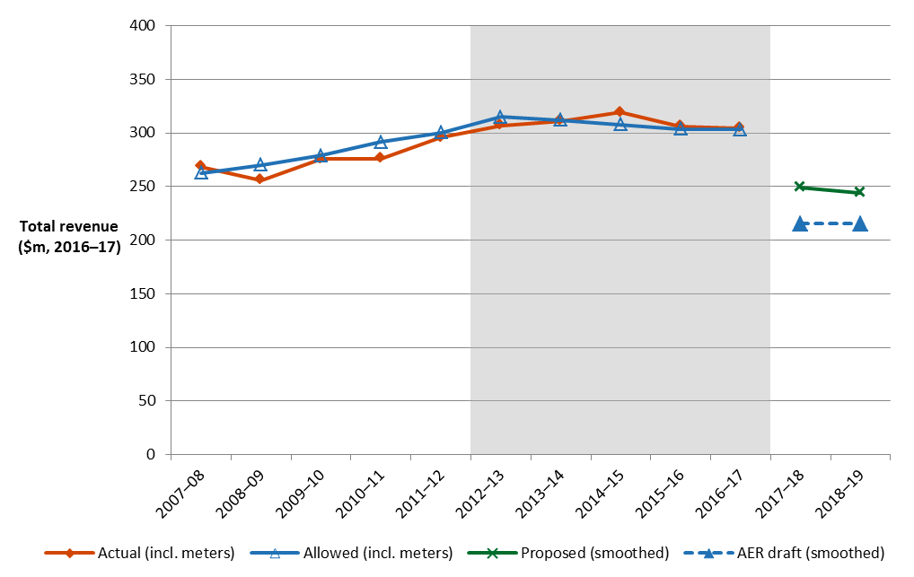

The revenue we determine affects the distribution component of a customer’s electricity bill. Distribution charges may make up approximately 38 per cent of the bill for one of Tasmania’s typical residential customers.

Other components of customer bills include the cost of generation, transmission, and retailer costs. The AER regulates the transmission and distribution components only, it does not influence the cost of generation or set retail prices.



**Estimated impact on customer bills**

As a result of the reductions proposed in our draft decision, we expect that the distribution component of the average annual residential electricity bill in 2018–19 would reduce by about $163 below the 2016–17 level. We also expect the distribution component of the average annual small business electricity bill in 2018–19 would reduce by about $299 below the 2016–17 level.

These are only estimates, and are based on the data we have about how much energy customers in Tasmania use. There are a number of other factors that also affect a customers electricity bill, such as the wholesale price of electricity. You can read more about what makes up the energy process on customers’ bills on our website: http://www.aer.gov.au/consumers.

**Key elements of our decision**

We based our assessment of TasNetworks’ proposed revenue on a number of components. These include expenditures to maintain and operate the network, and the return to shareholders on their investment. Together, these determine the revenue that TasNetworks may recover from its customers.

Three components of our draft decision drive most of the difference between TasNetworks’ proposed revenue and our draft decision: rate of return, gamma and adjustments to the operation of the efficiency benefit sharing scheme.

We discuss each of these below.

**Rate of return**

Significant investment is required to build a transmission network. The return TasNetworks must pay lenders and investors is referred to as the rate of return. Even a small difference in the rate of return can have a big impact on revenues.

We set out our approach to determining the rate of return in the Rate of Return Guideline (Guideline) we published in December 2013. In its proposal, TasNetworks proposed to use the methodology set out in our Guideline. We have accepted the approach proposed by TasNetworks for calculating the rate of return, however, this approach requires us to consider prevailing market conditions.

Prevailing market conditions for debt and equity are subject to change and heavily influence the rate of return. Financial market conditions have changed since TasNetworks submitted its proposal. Interest rates are lower, meaning that the cost of debt and the returns required to attract equity are lower. These factors result in a rate of return lower than TasNetworks proposed in its draft decision.

Our draft decision is for a rate of return of 5.48 per cent (for 2017–18). This compares with TasNetworks' proposed 6.04 per cent in its regulatory proposal. This difference is due to movements in market rates for the risk free rate and return on debt since TasNetworks submitted its proposal.

In our final decision we will update the rate of return again, having regard to the prevailing market conditions at the time we make our final decision and by reference to the averaging periods that TasNetworks nominated in its proposal.

Gamma

Under the Australian imputation tax system, investors can receive an imputation credit for income tax paid at the company level. These are received after company income tax is paid, but before personal income tax is paid. For eligible investors, this credit offsets their Australian income tax liabilities. If the amount of imputation credits received exceeds an investor's tax liability, that investor can receive a cash refund for the balance. Imputation credits are therefore valuable to investors and are a benefit to investors in addition to any cash dividend or capital gains they receive from owning shares.

However, the estimation of the return on equity does not take imputation credits into account. Therefore, an adjustment for the value of imputation credits is required. This adjustment could take the form of a decrease in the estimated return on equity itself. An alternative but equivalent form of adjustment, which is employed under the NER, is via the revenue granted to a service provider to cover its expected tax liability.

Specifically, the NER requires that the estimated cost of corporate income tax be determined in accordance with a formula that reduces the estimated cost of corporate tax by the 'value of imputation credits' (represented by the Greek letter, γ, 'gamma'). This form of adjustment recognises that it is the payment of corporate tax which is the source of the imputation credit return to investors.

We do not accept TasNetworks' proposed value of imputation credits (or gamma) of 0.25. Instead, we adopt a value of imputation credits of 0.4. We consider that the use of a value for imputation credits of 0.4 will result in equity investors in the benchmark efficient entity receiving an ex ante total return (inclusive of the value of imputation credits) commensurate with the efficient equity financing costs of a benchmark efficient entity.

**Efficiency benefit sharing scheme**

The efficiency benefit sharing scheme (EBSS) provides an additional incentive for service providers to pursue efficiency improvements in operating expenditure (opex).

We have determined an EBSS carryover amount of $18.1 million ($2016–17) from the application of the EBSS during the 2012–17 regulatory control period. This is $23.0 million ($2016–17) less than TasNetworks' proposal. The primary reason for this difference is that TasNetworks' EBSS calculations assume year 4 (2015–16) is used as the base year to forecast opex. However, TasNetworks used year 3 (2014–15) to forecast opex. This inconsistency would effectively reward TasNetworks twice for incremental efficiency gains made in 2015–16: once through the EBSS carryovers and a second time because they are not reflected in its opex forecast.

**More information about our consultation process**

TasNetworks may submit a revised proposal in response to our draft decision by 1 December 2016. Stakeholders may make written submissions on our draft decision by the same date, 1 December 2016. Stakeholders may also file submissions on TasNetworks’ revised proposal by  
23 December 2016. Our final decision is due for release by 30 April 2017.

More information on TasNetworks’ proposal, our draft decision and how to make a submission is on our website: [www.aer.gov.au](http://www.aer.gov.au).