

DRAFT DECISION

TasNetworks distribution determination

2017−18 to 2018−19

Attachment 1 – Annual revenue requirement

September 2016

© Commonwealth of Australia 2016

This work is copyright. In addition to any use permitted under the Copyright Act 1968, all material contained within this work is provided under a Creative Commons Attributions 3.0 Australia licence, with the exception of:

* the Commonwealth Coat of Arms
* the ACCC and AER logos
* any illustration, diagram, photograph or graphic over which the Australian Competition and Consumer Commission does not hold copyright, but which may be part of or contained within this publication. The details of the relevant licence conditions are available on the Creative Commons website, as is the full legal code for the CC BY 3.0 AU licence.

Requests and inquiries concerning reproduction and rights should be addressed to the:

Director, Corporate Communications  
Australian Competition and Consumer Commission   
GPO Box 4141, Canberra ACT 2601

or publishing.unit@accc.gov.au.

Inquiries about this publication should be addressed to:

Australian Energy Regulator  
GPO Box 520  
Melbourne Vic 3001

Tel: 1300 585 165

Email: [AERInquiry@aer.gov.au](mailto:AERInquiry@aer.gov.au)

1. Note
2. This attachment forms part of the AER's draft decision on TasNetworks' distribution determination for 2017–19. It should be read with all other parts of the draft decision.
3. The draft decision includes the following documents:
4. Overview
5. Attachment 1 – Annual revenue requirement
6. Attachment 2 – Regulatory asset base
7. Attachment 3 – Rate of return
8. Attachment 4 – Value of imputation credits
9. Attachment 5 – Regulatory depreciation
10. Attachment 6 – Capital expenditure
11. Attachment 7 – Operating expenditure
12. Attachment 8 – Corporate income tax
13. Attachment 9 – Efficiency benefit sharing scheme
14. Attachment 10 – Capital expenditure sharing scheme
15. Attachment 11 – Service target performance incentive scheme
16. Attachment 12 – Demand management incentive scheme
17. Attachment 13 – Classification of services
18. Attachment 14 – Control mechanisms
19. Attachment 15 – Pass through events
20. Attachment 16 – Alternative control services
21. Attachment 17 – Negotiated services framework and criteria
22. Attachment 18 – Connection policy
23. Attachment 19 - Tariff structure statement

1. Contents

Note 1-2

Contents 1-3

Shortened forms 1-4

1 Annual revenue requirement 1-6

1.1 Draft decision 1-6

1.2 TasNetworks' proposal 1-8

1.3 AER's assessment approach 1-8

1.3.1 The building block costs 1-9

1.4 Reasons for draft decision 1-10

1.4.1 Revenue smoothing 1-11

1.4.2 Shared assets 1-12

1.4.3 Indicative average distribution price impact 1-12

1.4.4 Expected impact of decision on electricity bills 1-15

1. Shortened forms

| Shortened form | Extended form |
| --- | --- |
| AEMC | Australian Energy Market Commission |
| AEMO | Australian Energy Market Operator |
| AER | Australian Energy Regulator |
| augex | augmentation expenditure |
| capex | capital expenditure |
| CCP | Consumer Challenge Panel |
| CESS | capital expenditure sharing scheme |
| CPI | consumer price index |
| DRP | debt risk premium |
| DMIA | demand management innovation allowance |
| DMIS | demand management incentive scheme |
| distributor | distribution network service provider |
| DUoS | distribution use of system |
| EBSS | efficiency benefit sharing scheme |
| ERP | equity risk premium |
| Expenditure Assessment Guideline | Expenditure Forecast Assessment Guideline for Electricity Distribution |
| F&A | framework and approach |
| MRP | market risk premium |
| NEL | national electricity law |
| NEM | national electricity market |
| NEO | national electricity objective |
| NER | national electricity rules |
| NSP | network service provider |
| opex | operating expenditure |
| PPI | partial performance indicators |
| PTRM | post-tax revenue model |
| RAB | regulatory asset base |
| RBA | Reserve Bank of Australia |
| repex | replacement expenditure |
| RFM | roll forward model |
| RIN | regulatory information notice |
| RPP | revenue and pricing principles |
| SAIDI | system average interruption duration index |
| SAIFI | system average interruption frequency index |
| SLCAPM | Sharpe-Lintner capital asset pricing model |
| STPIS | service target performance incentive scheme |
| WACC | weighted average cost of capital |

# Annual revenue requirement

1. The annual revenue requirement (ARR) is the sum of the various building block costs for each year of the regulatory control period before smoothing. The ARRs are smoothed across the period to reduce fluctuations between years and to determine expected revenues for each year. The expected revenues are the amounts that TasNetworks will target for annual pricing purposes and recover from customers for the provision of standard control services for each year of the regulatory control period. This attachment sets out our draft decision on TasNetworks' ARRs and expected revenues for the 2017–19 regulatory control period.

## Draft decision

We do not accept TasNetworks' proposed total revenue requirement of $512.3 million ($ nominal) over the 2017–19 regulatory control period. This is because we have not accepted the building block costs in TasNetworks' proposal. We determine a total revenue requirement of $447.2 million ($ nominal) for TasNetworks for the 2017–19 regulatory control period, reflecting our draft decision on the various building block costs. This is a reduction of $65.1 million ($ nominal) or 12.7 per cent to TasNetworks' proposal.

As a result of our smoothing of the ARRs, our draft decision on the annual expected revenue and X factor for each regulatory year of the 2017–19 regulatory control period is set out in table 1.1. Our draft decision is to approve total expected revenues (smoothed) of $446.6 million ($ nominal) for the 2017–19 regulatory control period.

1. Figure 1.1 shows the difference between TasNetworks' proposal and our draft decision.
2. Table 1.1 shows our draft decision on the building block costs, the ARR, annual expected revenue and X factor for each year of the 2017–19 regulatory control period.

Figure 1.1 AER's draft decision on TasNetworks' revenue for the 2017–19 regulatory control period ($million, nominal)

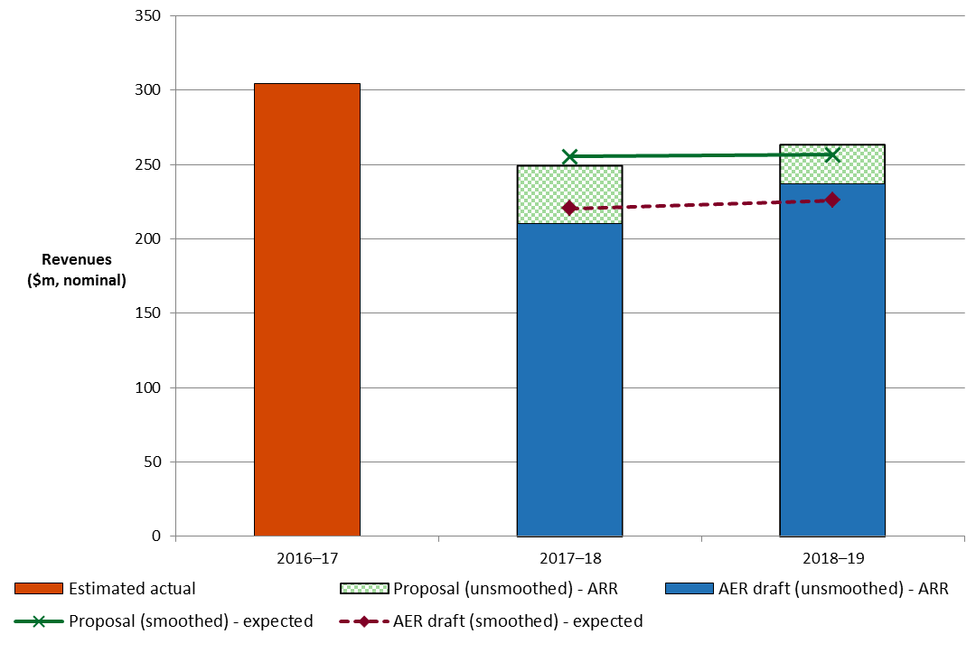

Source: TasNetworks, Regulatory proposal, TN059–PTRM, January 2016.

AER analysis.

Table 1.1 AER's draft decision on TasNetworks' revenues for the   
2017–19 regulatory control period ($million, nominal)

|  |  |  |  |
| --- | --- | --- | --- |
|  | 2017–18 | 2018–19 | Total |
| Return on capital | 89.2 | 93.4 | 182.6 |
| Regulatory depreciation | 39.6 | 59.0 | 98.6 |
| Operating expenditurea | 63.8 | 63.8 | 127.6 |
| Revenue adjustmentsb | 9.7 | 9.9 | 19.6 |
| Net tax allowance | 7.8 | 11.0 | 18.7 |
| Annual revenue requirement (unsmoothed) | 210.0 | 237.1 | 447.2 |
| **Annual expected revenue (smoothed)** | **220.6** | **226.0** | **446.6** |
| X factorc | 24.72% | 0.00% | n/a |

Source: AER analysis.

(a) Operating expenditure includes debt raising costs.

(b) Revenue adjustments include the efficiency benefit sharing scheme (EBSS) carry-overs and demand management incentive scheme (DMIS) allowance.

(c) The X factor for 2018–19 will be revised to reflect the annual return on debt update. Under the CPI–X framework, the X factor measures the real rate of change in annual expected revenue from one year to the next. A negative X factor represents a real increase in revenue. Conversely, a positive X factor represents a real decrease in revenue.

## TasNetworks' proposal

1. TasNetworks proposed a total revenue requirement of $511.9 million ($ nominal) for the 2017–19 regulatory control period. Table 1.2 shows TasNetworks' proposed building block costs, the ARR, expected revenue and X factor for each year of the 2017–19 regulatory control period.

Table 1.2 TasNetworks' proposed revenues for the 2017–19 regulatory control period ($million, nominal)

|  |  |  |  |
| --- | --- | --- | --- |
|  | 2017–18 | 2018–19 | Total |
| Return on capital | 99.5 | 103.5 | 202.9 |
| Regulatory depreciation | 49.6 | 57.6 | 107.2 |
| Operating expenditurea | 63.8 | 63.9 | 127.7 |
| Revenue adjustmentsb | 21.5 | 22.0 | 43.5 |
| Net tax allowance | 15.0 | 15.9 | 30.9 |
| Annual revenue requirement (unsmoothed) | 249.4 | 262.9 | 512.3 |
| **Annual expected revenue (smoothed)** | **255.4** | **256.5** | **511.9** |
| X factor | 12.9% | 2.0% | n/a |

Source: TasNetworks, Regulatory proposal, TN059–PTRM, January 2016.

(a) Operating expenditure includes debt raising costs.

(b) Revenue adjustments include EBSS carry-overs and DMIS allowance.

## AER's assessment approach

In this section, we describe the approach used to determine the ARR and expected revenue for TasNetworks for each year of the 2017–19 regulatory control period.[1]

In this determination we first calculate ARRs for each year of the 2017–19 regulatory control period. To do this we consider the various costs facing the distributor and the trade-offs and interactions between these costs, service quality and across years. This reflects the AER's holistic assessment of the distributor's proposal.

The ARR for each year is the sum of the building block costs. These building block costs are set out in section 1.3.1. The AER's post-tax revenue model (PTRM) brings together these building block costs and calculates the resulting ARRs.

We understand the trade-offs that occur between building block costs and test the sensitivity of these costs to their various driver elements. These trade-offs are discussed in the interrelationships section of the various attachments to this draft decision and are reflected in the calculations made in the PTRM developed by the AER.[2] Such understanding allows the AER to exercise judgement in determining the final inputs into the PTRM and the ARRs that result from this modelling.

Having determined the total revenue requirement for the 2017–19 regulatory control period, the ARRs for each regulatory year are smoothed across the 2017–19 regulatory control period. This is to reduce revenue variations between years and to come up with the expected revenue for each year. This is done through the determination of the X factors.[3] The X factor must equalise (in net present value terms) the total expected revenues to be earned by the distributor with the total revenue requirement for the 2017–19 regulatory control period.[4] The X factor must usually minimise, as far as reasonably possible, the variance between the expected revenue and ARR for the last regulatory year of the period.[5] We therefore consider a divergence of up to 3 per cent between the expected revenue and ARR for the last year of the regulatory control period is reasonable, if this can promote smoother price changes over the regulatory control period.

1. The building block costs (and the elements that drive those costs) used to determine the unsmoothed ARR are set out below.

### The building block costs

1. The efficient costs to be recovered by a distributor can be thought of as being made up of various building block costs. Our draft decision assesses each of the building block costs and the elements that drive these costs. The building block costs are approved reflecting trade-offs and interactions between the cost elements, service quality and across years.
2. Table 1.3 shows the building block costs that form the ARR for each year and where discussion on the elements that drive these costs can be found within this draft decision.

Table 1.3 Building block costs

|  |  |
| --- | --- |
| Building block costs | Attachments where elements are discussed |
| Return on capital | Regulatory asset base (attachment 2)  Capex (attachment 6)  Rate of return (attachment 3) |
| Regulatory depreciation (return of capital) | Regulatory asset base (attachment 2)  Capex (attachment 6)  Rate of return (attachment 3) |
| Operating expenditure (opex) | Opex (attachment 7) |
| Efficiency benefits/penalties | Efficiency benefit sharing scheme (attachment 9) |
| Estimated cost of corporate tax | Corporate income tax (attachment 8)  Value of imputation credits (attachment 4) |
| Adjustment for shared assets | Annual revenue requirement (attachment 1) |
| Demand management innovation allowance | Demand management incentive scheme (attachment 12) |

## Reasons for draft decision

For this draft decision, we determine a total revenue requirement of $447.2 million ($ nominal) for TasNetworks over the 2017–19 regulatory control period. This is $65.1 million ($ nominal) or 12.7 per cent below TasNetworks' proposal. This reflects the impact of our draft decision on the various building block costs. Figure 1.2 shows the difference between TasNetworks' proposed ARRs and our draft decision.

The most significant changes to TasNetworks' proposal include:

* a reduction in the return on capital allowance of 10.0 per cent (attachments 2 and 3)
* a reduction in the cost of corporate income tax allowance of 39.3 per cent (attachment 8)
* a reduction in the EBSS carryover amounts from the 2012–17 regulatory control period of 55.0 per cent (attachment 9).

Figure 1.2 AER's draft decision and TasNetworks' proposed annual revenue requirement ($million, nominal)

1. 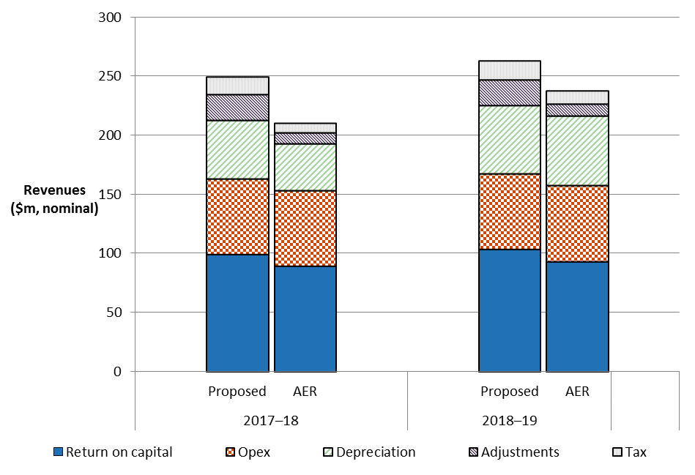

Source: TasNetworks, Regulatory proposal, TN059–PTRM, January 2016.

AER analysis.

Note: Revenue adjustments include EBSS carry-overs and DMIS allowance. Opex includes debt raising costs.

### Revenue smoothing

We have taken into account the building block costs determined in this decision when smoothing the expected revenues for TasNetworks over the 2017–19 regulatory control period. We consider that our profile of X factors results in an expected revenue in the last year of the regulatory control period that is as close as reasonably possible to the ARR for that year.[6]

TasNetworks' 2017–19 regulatory control period is shorter than the usual five year period. To smooth the revenue reductions over this shorter period, we have allowed the difference between smoothed and unsmoothed revenues in the last year of the 2017–19 regulatory control period to diverge more than would be usual. This approach smooths the revenues by allowing for a more gradual path for lower revenues over the 2017–19 regulatory control period.

Based on the X factors we have determined for TasNetworks, the difference between the expected revenue and ARR for 2018–19 is 4.7 per cent. While we consider this divergence is larger than usual, it avoids the situation of a large price decrease in 2017–18 followed by a large price increase in 2018–19.

### Shared assets

1. Distributors, such as TasNetworks, may use assets to provide both the standard control services we regulate and other unregulated services. These assets are called 'shared assets'.[7] Of the unregulated revenues a distributor earns from shared assets, 10 per cent will be used to reduce the distributor's prices for standard control services.[8]
2. Shared asset revenue reductions are subject to a materiality threshold. Unregulated use of shared assets is material when a distributor's unregulated revenues from shared assets in a specific regulatory year are expected to be greater than 1 per cent of its total expected revenue for that regulatory year.[9]

TasNetworks submitted that its total revenue requirement is not subject to a shared asset adjustment because its expected annual unregulated revenue from shared assets does not exceed the AER's materiality threshold.[10]

We consider TasNetworks' forecast unregulated revenues from shared assets for the 2017–19 regulatory control period are reasonable because they are comparable with its historical unregulated revenues from shared assets. However, TasNetworks' forecast unregulated revenues must be compared to the regulated revenues we determine, rather than those proposed by TasNetworks. Our draft decision sets lower expected revenues than TasNetworks' proposal, so we estimate that the unregulated revenues will be between 0.2 and 0.3 per cent of its expected revenues in each year of the 2017–19 regulatory control period. Hence, the materiality threshold is not met in any year of the 2017–19 regulatory control period and we do not apply a shared asset revenue adjustment.

1. We note unregulated revenues from shared assets may in future become material.[11] We will monitor TasNetworks' shared asset unregulated revenues for future regulatory control periods.

### Indicative average distribution price impact

1. Our draft decision on TasNetworks' expected revenues ultimately affects the prices consumers pay for electricity. There are several steps required in translating our revenue decision to a price impact.
2. We regulate TasNetworks' standard control services under a revenue cap form of control. This means our draft decision on TasNetworks' expected revenues do not directly translate to price impacts. This is because TasNetworks' revenue is fixed under the revenue cap form of control, so changes in the consumption of electricity will affect the prices ultimately charged to consumers. We are not required to establish the distribution prices for TasNetworks as part of this determination. However, we will assess TasNetworks' annual pricing proposals before the commencement of each regulatory year within the 2017–19 regulatory control period. In each assessment we will administer the pricing requirements set in this distribution determination.
3. For this draft decision, we have estimated some indicative average distribution price impacts flowing from our determination on the expected revenues for TasNetworks over the 2017–19 regulatory control period. In this section, our estimates only relate to standard control services (that is, the core electricity distribution charges), not alternative control services (such as metering charges). These indicative price impacts assume that actual energy consumption across the 2017–19 regulatory control period matches TasNetworks' forecast energy consumption, which we have adopted for this draft decision.
4. Figure 1.3 shows TasNetworks' indicative price path based on the expected revenues established in our draft decision compared to its proposed revenue requirement. The indicative price path is estimated using the approved expected revenue and dividing by forecast energy consumption for each year of the 2017–19 regulatory control period. For presentation purposes, the prices are scaled so that the price index begins at 1.00 in 2016–17. The index provides a simple overall measure of the relative movement in expected distribution prices over the 2017–19 regulatory control period.

Figure .3 AER's draft decision and TasNetworks' proposed indicative price path (nominal price index)



Source: AER analysis.

Notes: The nominal price index is constructed by dividing expected revenue for standard control services by forecast energy consumption for each year of the regulatory control period, then scaling relative to the base year (2016–17).

We estimate that our draft decision on TasNetworks' annual expected revenue will result in a decrease to average distribution charges by about 13.1 per cent per annum over the 2017–19 regulatory control period in nominal terms.[12] This compares to the nominal average decrease of approximately 7.4 per cent per annum proposed by TasNetworks over the 2017–19 regulatory control period.[13] These high-level estimates reflect the aggregate change across the entire network and do not reflect the particular tariff components for specific end users.

1. Table 1.4 displays the comparison of the revenue and price impacts of TasNetworks' proposal and our draft decision.

Table .4 Comparison of revenue and price impacts of TasNetworks' proposal and the AER's draft decision

|  |  |  |  |
| --- | --- | --- | --- |
|  | 2016–17 | 2017–18 | 2018–19 |
| **AER draft decision** |  |  |  |
| Revenue ($m, nominal) | 304.7 | 220.6 | 226.0 |
| Price path (nominal index)a | 1.00 | 0.73 | 0.76 |
| Revenue (change %) |  | –27.6% | 2.5% |
| Price path (change %) |  | –27.0% | 3.5% |
| **TasNetworks proposal** |  |  |  |
| Revenue ($m, nominal) | 304.7 | 255.4 | 256.5 |
| Price path (nominal index)a | 1.00 | 0.85 | 0.86 |
| Revenue (change %) |  | –16.2% | 0.4% |
| Price path (change %) |  | –15.5% | 1.5% |

Source: AER analysis.

(a) The nominal index is constructed by dividing expected revenue for standard control services by forecast energy consumption for each year of the regulatory control period, then scaling relative to the base year (2016–17).

### Expected impact of decision on electricity bills

1. The annual electricity bill for customers in Tasmania will reflect the combined cost of all the electricity supply chain components—wholesale energy generation, transmission, distribution, metering, and retail costs. This draft decision primarily relates to the distribution charges for standard control services, which represent approximately 38 per cent on average for these customers.[14]
2. In this section, we estimate the expected bill impact by varying the distribution charges in accordance with our draft decision, while holding all other components—including the metering component—constant. This approach isolates the effect of our draft decision on the core distribution charges, and does not imply that other components will remain unchanged across the regulatory control period.

Based on this approach, we expect that our draft decision will reduce the average annual electricity bills for residential customers in Tasmania. The distribution component of the average annual residential electricity bill in 2018–19 is expected to reduce by about $163 or 9.3 per cent ($ nominal) below the 2016–17 level. By comparison, had we accepted TasNetworks' proposal, the expected distribution component of the average annual residential electricity bill in 2018–19 would reduce by about $95 or 5.4 per cent ($ nominal) below the 2016–17 level.

1. Our estimate of the potential impact our draft decision will have for TasNetworks' residential customers is based on an average annual electricity usage of around 6800 kWh per annum for a residential customer in Tasmania.[15] Therefore customers with different usage will experience different changes in their bills. We also note that there are other factors, such as metering costs, transmission network costs, wholesale and retail costs, which affect electricity bills.

Similarly, for an average small business customer in Tasmania that uses approximately 10250 kWh of electricity per annum,[16] our draft decision for TasNetworks is expected to lead to lower average annual electricity bills. The distribution component of the average annual small business electricity bill in 2018–19 is expected to reduce by about $299 or 9.3 per cent ($ nominal) below the 2016–17 level. By comparison, had we accepted TasNetworks' proposal, the expected distribution component of the average annual residential electricity bill in 2018–19 would reduce by about $174 or 5.4 per cent ($ nominal) below the 2016–17 level.

Table 1.5 shows the estimated annual average impact of our draft decision for the 2017–19 regulatory control period and TasNetworks' proposal on the average residential and small business customers' annual electricity bills. As explained above, these bill impact estimates are indicative only, and individual customers’ actual bills will depend on their usage patterns and the structure of their tariffs.

Table . Estimated impact of TasNetworks' proposal and the AER's draft decision on annual electricity bills for the 2017–19 regulatory control period ($ nominal)

|  |  |  |  |
| --- | --- | --- | --- |
|  | 2016–17 | 2017–18 | 2018–19 |
| **AER draft decision** |  |  |  |
| Residential annual bill | 1763a | 1582 | 1600 |
| Annual changec |  | –181 (–10.2%) | 17 (1.1%) |
| Small business annual bill | 3225b | 2894 | 2926 |
| Annual changec |  | –331 (–10.2%) | 31 (1.1%) |
| **TasNetworks proposal** |  |  |  |
| Residential annual bill | 1763a | 1659 | 1668 |
| Annual changec |  | –104 (–5.9%) | 8 (0.5%) |
| Small business annual bill | 3225b | 3036 | 3051 |
| Annual changec |  | –190 (–5.9%) | 15 (0.5%) |

Source: AER analysis; AER, [Energy made easy website](https://www.energymadeeasy.gov.au/); OTTER, Information paper: Typical electricity customers, May 2014.

(a) Annual bill for 2016–17 is sourced from the AER's Energy Made Easy website and reflects the average consumption of 6819kWh for residential customers using tariffs 31 (3771kWh) and 41 (3048 kWh) in Tasmania (postcode 7000).

(b) Annual bill for 2016–17 is sourced from the AER's Energy Made Easy website and reflects the average consumption of 10258kWh for small business customers using tariff 22 in Tasmania (postcode 7000).

(c) Annual change amounts and percentages are indicative. They are derived by varying the distribution component of 2016–17 bill amounts in proportion to yearly expected revenue divided by forecast energy as proposed by TasNetworks. Actual bill impacts will vary depending on electricity consumption and tariff class.

1. NER, cll. 6.3.2(a)(1) and 6.5.9(b)(2).
2. There are trade-offs that are not modelled in the PTRM but are reflected in the inputs to the PTRM. For example, service quality is not explicitly modelled in the PTRM, but the trade-offs between service quality and price are reflected in the forecast capex and opex inputs to the model. Other trade-offs are obvious from the calculations in the PTRM. For example, while someone may expect a lower regulatory asset base to also lower revenues, the PTRM shows that this will not occur if the reduction in the regulatory asset base is due solely to an increase in the depreciation rate. In such circumstances, revenues increase as the increased depreciation allowance more than offsets the reduction in the return on capital caused by the lower regulatory asset base.
3. NER, cl. 6.5.9(a).
4. NER, cl. 6.5.9(3)(i). The X factors represent the real revenue path over the 2017–19 regulatory control period under the CPI–X framework.
5. NER, cl. 6.5.9(b)(2).
6. NER, cl. 6.5.9(b)(2).
7. NER, cl. 6.4.4.
8. AER, Shared asset guideline, November 2013.
9. AER, Shared asset guideline, November 2013, p. 8.
10. TasNetworks, Regulatory proposal, January 2016, p. 129.
11. We will reassess the materiality of the forecast shared asset unregulated revenues for our final decision.
12. This amount reflects an expected inflation rate of 2.45 per cent per annum as determined in this draft decision. In real terms we estimate average distribution charges to decline by 15.1 per cent per annum, compared to a decrease of 9.6 per cent proposed by TasNetworks.
13. This amount reflects an expected inflation rate of 2.50 per cent per annum as proposed by TasNetworks.
14. TasNetworks, Reset RIN template, TN069, January 2016.
15. This reflects the average annual consumption for residential customers using tariffs 31 and 41 in Tasmania. OTTER, Information paper: Typical electricity customers, May 2014, p. 13.
16. This reflects the average annual consumption for small business customers using tariff 22 in Tasmania. OTTER, Information paper: Typical electricity customers, May 2014, p. 7.