

Consumer guide to Victorian electricity distribution pricing review, 2016–20

May 2015

Contents

Brief overview 1

Why this review is important 3

Victorian electricity distribution 5

You can have a say 8

Basics of the building block model 10

Broader industry context 17

Conclusion 20

Brief overview

Victorian households and businesses consume electricity, which is supplied through a network of 'poles and wires'. The electricity network in Victoria is commonly divided into two parts:

* transmission network, which carries electricity from the large generators to the major load centres
* distribution network, which carries electricity from the points of connection with the transmission network to virtually every building, house and apartment in Victoria.

In Victoria, the electricity distribution network is owned by five private businesses—AusNet Services, CitiPower, Powercor, Jemena and United Energy. They design, build, operate and maintain the distribution networks for electricity consumers.

The network charges do not appear directly on most customers’ electricity bills, which are sent by your retailer. Nevertheless, these charges are important as they account for a significant component of each customer’s final bill.

We regulate the revenues of the network businesses by setting the annual revenue requirement they may recover from customers. We do not set retail prices.

We are just starting the process of reviewing regulatory proposals for the Victorian distribution network, which cover the next five years (2016 to 2020). This involves examining the businesses' proposals to make sure they recover no more than necessary for the delivery of safe and reliable electricity services.

We are looking for ways to improve how we communicate our regulatory processes and decisions. We consider it is important that consumers and other stakeholders can easily access information about what is happening in the Australian energy industry. This helps consumers participate in our process—a process that ultimately has a significant impact on consumers' electricity bills.

We hope this paper facilitates greater consumer engagement and gives you a better understanding of our process for reviewing electricity distribution revenue proposals. It is important that you are able to have an opportunity to influence our review, as well as the distribution businesses' decisions making.

You can get involved in our Victorian electricity distribution pricing review in a number of ways. We will host public forums during which you can ask us and the distribution businesses questions. You can make submissions on the businesses' proposals and our preliminary determinations. We will continue to engage throughout the process as we develop our thinking on the businesses' proposals.

We have also established a consultative group to inform key stakeholders, develop their understanding of our regulatory processes, and to make it easier for consumer representatives to provide input into our decisions. We will offer training on the 'building block model', which is a key feature of our decisions.

To ensure that consumers have a say in our decision making process, we established the Consumer Challenge Panel to challenge the way we work with consumers and to help ensure we have a good understanding of the things that matter to consumers. Panel members will present their views and analysis at our public forums and consultative group meetings, which will help inform consumer views.

In terms of timing, the review commenced in May 2015 and final decisions are due to be released in late April 2016. The table below lists the key dates of the review.

Key dates for the Victorian electricity distribution pricing review

|  |  |
| --- | --- |
| Task | Date |
| Businesses submit regulatory proposals to AER | 30 April 2015 |
| AER to release issues paper | 9 June 2015 |
| AER to hold public forum | 22 June 2015 |
| Submissions on regulatory proposals due | 13 July 2015 |
| AER to make preliminary determinations | 21 October 2015 |
| AER to hold conference to explain preliminary determinations | Mid-November 2015 |
| Submissions on preliminary determinations due | 6 January 2016 |
| Businesses to submit revised regulatory proposals to AER | 6 January 2016 |
| Further submissions due, including on revised proposals* | 4 February 2016 |
| AER to make final determinations | 29 April 2016 |

Our preliminary determinations—to be released on 21 October 2015—will take effect at the commencement of the regulatory control period on 1 January 2016. As required by the 'transitional arrangements' in the National Electricity Rules (rules the AER is required to implement regulating transmission and distribution businesses in Australia), we will then revoke the preliminary determinations and make final determinations by 29 April 2016. This means that the network prices which take effect on 1 January 2016 will be based on our preliminary determinations, but our final determinations will take effect on 1 January 2017. Any necessary changes for 2016 will be reflected in the revenues and prices we approve for 2017 and the remaining years of the regulatory period.

The National Electricity Rules, under transitional provisions, do not provide for consultation on the Victorian distribution businesses' revised proposals. Nevertheless, we will give third party stakeholders an opportunity to comment on these revised proposals. In addition, we will allow for further submissions from all stakeholders, including the distribution businesses, on the submissions made by third party stakeholders to the preliminary determinations. This additional round of consultation is not another opportunity for stakeholders to comment on our preliminary determinations.

Why this review is important

Electricity networks provide a means of transporting power from generators to customers. Transmission networks transport power over long distances, linking generators with load centres. Distribution networks transport electricity from points along the transmission network, and criss-cross urban and regional areas to provide electricity to customers.

Distribution services are a big part of your electricity bill

A typical residential electricity bill is made up of network charges (distribution and transmission), a charge for the generation cost of electricity and a retail component.

In Victoria, electricity distribution charges make up around 40 per cent of the final bill. So, when consumers flick a switch and power comes on in their home, a big part of the cost of this service is the distribution 'poles and wires'.

Why we regulate network prices

The Australian Energy Regulator (AER) sets the maximum revenues that electricity networks can recover from customers. We are an independent statutory authority. Our powers and functions are set out in the National Electricity Law and the National Electricity Rules.

Network services are monopolies with little scope in any given location for competition. Left unchecked, monopoly businesses do not have an incentive to set prices at an efficient level because there is no competitive discipline on their decisions. They do not need to consider how and whether or not rivals will respond to their prices as they seek to attract and retain customers.

Without regulation, the resulting market power would typically lead to prices being higher than necessary and probably insufficient investment and reliability. Accordingly, we regulate the revenues and other aspects of the network services to ensure that customers pay no more than necessary for safe, secure, and reliable electricity networks.

We do not set network prices directly. Instead we set the maximum revenue that the businesses are allowed to recover each year. In addition, we approve the methodology that the businesses use to convert that revenue into prices. The businesses retain some flexibility in how they structure their prices, provided they comply with the rules. Each year we will check to make sure that the actual prices chosen by the businesses comply with the agreed methodology and the overall revenue cap.

More on the rules

The National Electricity Law lays the foundation for the regulatory framework governing electricity networks. In particular, it sets out the National Electricity Objective: to promote efficient investment in, and operation of, electricity services for the long term interest of consumers. It also sets out 'revenue and pricing principles', including that network businesses should have a reasonable opportunity to recover at least efficient costs.

Regulated electricity network businesses must periodically apply to the AER to assess their forecast expenditure and revenue requirements (typically, every five years). Chapters 6 and 6A of the National Electricity Rules set out the framework that we must apply in undertaking this role for distribution and transmission networks respectively.

The regime is designed to include incentives for the businesses to operate efficiently. We are required to forecast and lock-in at the start of each five-year regulatory period a level of revenue that an efficient and prudent business would require.

What we mean by 'incentive regulation'

Given the businesses actually run the distribution networks, they have a much better understanding of their underlying costs than us. Incentive regulation is used to partially overcome this 'information asymmetry'. We apply incentive-based regulation across all energy networks we regulate. This is a fundamental aspect of the regime:

Set out in Chapter 6 of the NER, the incentive regulation framework is designed to encourage distribution businesses to spend efficiently and to share the benefits of efficiency gains with consumers. Specifically, it is designed to encourage distribution businesses to make efficient decisions on when and what type of expenditure to incur in order to meet their network reliability, safety, security and quality requirements. (Australian Energy Market Commission, 2015)

Broadly speaking, incentive regulation is designed to align the commercial goals of the business to the goals of society or, in the case of energy regulation, the National Electricity Objective. It relies on the principle that the network businesses’ objective is to maximise profits. Businesses that are able to improve their efficiency are rewarded with higher profits for a period of time. Businesses that allow their efficiency to deteriorate earn lower-than-expected profits.

Victorian electricity distribution

The electricity industry in Victoria is divided into four distinct parts, with a specific role for each stage of the supply chain—generation, transmission, distribution and retail.

Electricity generators are the power stations that generate electricity, produced from either fossil fuels, such as coal and gas, or renewable energy sources, such as wind, water or the sun.

Electricity is transported via the high voltage transmission network from power stations to major distribution points (terminal stations) via large tower structures.

Electricity distributors convert electricity from the transmission network into medium and low voltages and deliver that electricity to homes and businesses across Victoria. Each of Victoria’s five distributors serves a different geographic area of Victoria.

Electricity is bought in bulk from generators by electricity retailers who sell it to electricity consumers. They work with the local distributor to have electricity delivered to customers along the wires in the street—either overground (on poles) or underground (through pipes and ducts). The primary relationship between a customer and the electricity network is managed by the retailer. These are the businesses that send and manage electricity bills. Customers can choose from a number of electricity retailers in Victoria. We do not directly regulate the electricity retailers in Victoria.[1]

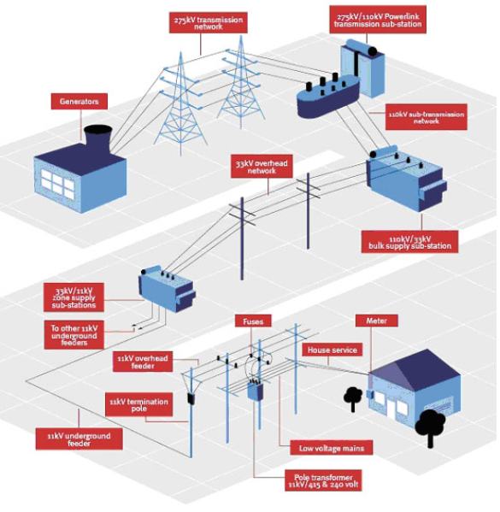

Source: Queensland Government, Department of Energy and Water Supply, available at: <https://www.dews.qld.gov.au/__data/assets/image/0007/42568/transmission.jpg> (9 June 2015).

Some basic facts about the five electricity distribution businesses in Victoria are provided in the table below for context.

|  |  |  |  |  |  |
| --- | --- | --- | --- | --- | --- |
| Network business | Region | Customer numbers | Length of lines (km) | Electricity delivered (GWH) | Maximum demand (MW) |
| AusNet Services | Eastern Victoria | 681 000 | 44 000 | 7 500 | 1 900 |
| CitiPower | Melbourne's inner suburbs | 323 000 | 4 300 | 6 000 | 1 500 |
| Powercor | Central and Western Victoria; Western suburbs of Melbourne | 754 000 | 74 000 | 11 000 | 2 400 |
| Jemena | Northwest Melbourne | 319 000 | 6 100 | 4 300 | 1 000 |
| United Energy | East and South-East Melbourne; Mornington Peninsula | 657 000 | 13 000 | 7 900 | 2 100 |

Source: AER, State of the Energy Market, 2014.

The following map shows the geographic reach of each of these networks. Importantly, AusNet Services and Powercor predominantly serve rural and regional Victoria, whereas Jemena, United Energy and CitiPower predominantly serve urban customers.  
  
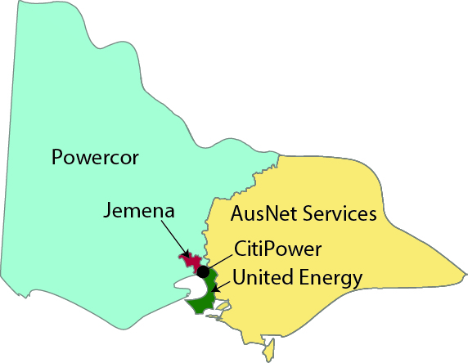

Each of these distribution businesses owns and maintains a large number of assets including:

* wires (conductors) of different sizes, thicknesses and different heights, some of which will be above ground (on poles) and some of which may be below ground
* poles of different sizes, heights and thicknesses, and underground cables
* transformers of various sizes and capacities
* switching equipment
* signalling, monitoring and control equipment, together with IT systems
* vehicles, buildings, storage facilities, depots and so on.

Our determinations directly affect the prices the businesses can charge for most, but not all network services. The Rules allow us to determine the level of regulatory control appropriate for different services. Where there is considerable scope to take advantage of market power, our regulation is more prescriptive. Where there is some prospect of competition, the Rules allow the regulation to be less prescriptive. The type of regulation that we have decided to apply is set out in our Framework and Approach decision.[2]

You can have a say

It is important for us to gain consumer perspectives and observations to help us understand if a regulatory proposal is consistent with the long term interests of consumers of electricity.[3] Consumer involvement is critical if the regulatory regime is to be focused on promoting consumers’ interests. It is also important in ensuring spending proposals are efficient and reflect the needs and priorities of the Australian community.

Further, transparency and accountability are core values of the AER. We want to inform consumers about our regulatory processes and decisions. To ensure effective engagement we aim to continue to be transparent in our communication and decision making.

If consumers are aware of and understand our reasons for our regulatory decisions, we are more likely to be able to make decisions in the consumers’ best interests, consistent with the needs of consumers, and in accordance with the law.

Where to start?

In forming our decisions, we must consider:

* businesses' regulatory proposals and other supporting information provided by the businesses
* submissions from interested parties, including retailers and end users of gas
* views expressed by stakeholders at various meetings
* expert advice on aspects of the businesses' regulatory proposals, including advice from expert consultants commissioned by us
* our annual benchmarking reports, which examine the relative efficiency of the distribution and transmission electricity network service providers
* the National Electricity Rules and Law.

In making our decisions we must, of course, comply with the Rules and the Law. To an extent, the Rules limit our discretion as to how we assess the businesses' proposals—such as the processes we must follow, the standards of assessment to use, and the factors we must take into account. Submissions from consumers are more helpful to us if they focus on areas of the proposals where we have discretion within the framework of the Rules.

Our decisions will reference our Better Regulation guidelines (available on the AER's website), which set out why we approach things the way we do. For example, they provide a simple explanation for why we prefer one form of incentive regulation over other approaches. We also set out the legal and economic basis for our approach. The guidelines provide a degree of predictability to all stakeholders—including the businesses and their investors—as to how we will approach the reset decisions.

So, to inform our assessment of the regulatory proposals submitted by the distribution businesses, it is helpful for stakeholders to engage with the above material. Of course, some of this material is extremely complicated.

We are here to help

To help you understand the businesses' proposals and compare them against each other, we have published an Issues Paper, which is available on the AER's website. There will also be public forums and consultative group meetings you can attend to ask questions. We will offer training on the 'building block model', which you can sign up for.

But please note it is not just about the technical analysis of the regulatory proposals. While we welcome such submissions, we want to give consumers a say on whether the Victorian distribution businesses' proposed price changes, and elements within their proposals, seem reasonable or not.

We are flexible in how we receive these views. Consumers can provide input into our decisions just by attending our meetings and forums—you do not necessarily need to provide written submissions. We will reflect the views we receive in our regulatory decisions. The Consumer Challenge Panel also helps us understand the range of consumer views that are put to us.

How to contact us

You can email us: [VICElectricity2016@aer.gov.au](mailto:VICElectricity2016@aer.gov.au)

You can contact the AER General Manager in charge of the Victorian review, Chris Pattas: [Chris.Pattas@aer.gov.au](mailto:Chris.Pattas@aer.gov.au)

You can contact the AER Director in charge of coordinating the review, Anthony Bell: [Anthony.Bell@aer.gov.au](mailto:Anthony.Bell@aer.gov.au)

If you have come this far …

The building block model is fundamental to our decisions. We use it to determine how much revenue a business requires to cover its 'efficient costs', as required under the National Electricity Rules. The building block model is a key input into the decision as to how much revenue to allow the regulated firms to recover.

The next section is designed to help your understanding of our approach to applying the building block model. It is by nature a technical discussion. We have tried to make this section accessible to a wide ranging consumer audience.

For those that are newer to the sector, further background information is provided on both how distribution networks fit into the overall electricity industry, and broader industry developments affecting this review.

We note that in recent years demand for electricity from the grid has been flat or even declining. This may have an impact on the expenditure requirements of the network businesses. We expect that consumers will have a keen interest in the businesses forecasts of the volumes of services that will need to be provided in the next five years.

One of the key issues that the AER must address is the balance between the cost of the services provided and reliability, quality and security. Typically, the higher the levels of reliability, quality and security, the higher the cost—all other things being equal. So we need to input from consumers to help us determine the correct balance between these competing aspects.

Basics of the building block model

The AER uses a tool known as the 'building block model' to help set the annual revenue allowance of a regulated firm. It allows us to spread the capital expenditure of the firm over time in such a way that the regulated firm receives a reasonable assurance that it will be able to pay back its lenders, with interest, and provide its investors with a reasonable return on their investment—given the relative risk of the businesses compared to other investments.

At the outset it is useful to define more formally some of the important terms. We can divide the costs or the expenditure of each distribution business into two categories:

1. The on-going or recurring expenditure which the firm incurs every year, such as its labour costs, the costs of the maintenance teams and resources, or the cost of head office. These expenditures are typically referred to as operating expenditure or 'opex'.
2. The expenditure on large capital projects in new assets, or the replacement of existing assets. These expenditures are typically referred to as capital expenditure or 'capex'.

A key difference between operating expenditure and capital expenditure is that capex tends to be large and variable over time, and is associated with the creation of assets which last many years. It is not usual practice to seek to recover all of the costs of capital expenditure in the year in which the capex is incurred. Rather, it is common to spread these costs over time.

The Regulatory Asset Base

The building block model operates by keeping track of the amount that the regulated firm owes to its lenders and investors. This amount is known as the Regulatory Asset Base or 'RAB'. The Regulatory Asset Base is just like the balance on a mortgage, or on a credit card.

Each year the Regulatory Asset Base is updated. In general terms we can think of the updating of the RAB as follows:

* Each year, any new capital expenditure is added to the RAB. This new capital expenditure is like any new borrowings on your mortgage, or any new charges on your credit card.
* In addition, any repayments of principal are subtracted from the RAB. In the building block model the repayments of principal are called 'depreciation'. This term is a little misleading, since it doesn't refer to any actual wear-and-tear on the assets—it is purely the repayment of the amount borrowed. This is just like the repayments of principal on your mortgage or the repayments of the borrowings on your credit card.

In the regulatory framework for electricity network businesses the RAB is also adjusted by the inflation rate each year.[4]

Capital expenditure

We noted above that each year the regulatory asset base is updated by adding in any new capital expenditure carried out by the regulated firm during the year.

The AER reviews the capital expenditure proposals of the regulated businesses to ensure that the expenditure is prudent and justified.

Capex is broken down into several categories:

* augmentation capex—assets that expand the capacity of the network or provide connections to new customers
* refurbishment and upgrade capex—used to replace or upgrade aging, obsolete or inefficient assets
* non-network capex—including IT, plant and equipment, motor vehicles and buildings.

Factors that influence the required level of capex include the age and condition of existing assets, expected changes in the number of customers and loads connected to the network, expected changes in the demand profile of customers, and general ‘stay in business’ requirements of the business.

We assess the capex proposals of electricity network businesses to determine whether they meet the criteria set out in the National Electricity Rules. These criteria essentially ensure that only capex which is necessary, efficient and has a positive economic value should be allowed. In addition, we have to be satisfied that the methodology and data underlying any forecast or estimate is reasonable and the best forecast or estimate in the circumstances.

In addition, in the future the AER will be able to assess whether or not the capital expenditure that was actually incurred in the previous period was necessary and efficient. In addition, if the distribution business has overspent its forecast allowance in the previous period, the AER will be able to reduce the amount of expenditure that is rolled into the regulatory asset base at the start of the next period.

The revenue equation

Under the building block model, the allowed revenue in any one year is the sum of the operating expenditure for that year and a contribution to the costs of capital investment made in the past, plus some other terms which are discussed further below. The contribution to the costs of capital investments is the sum of what is known as the 'return on capital' and the 'return of capital'.

The return on capital is analogous to the interest payments on a mortgage or credit card debt. The return on capital can be thought of as equal to the interest rate multiplied by the outstanding balance on the loan. In the regulatory context the return on capital is equal to the regulatory-allowed cost of capital multiplied by the regulatory asset base.

The return of capital is analogous to the repayments of principal on a mortgage or credit card debt. As noted above, in the regulatory context these repayments of principal are known as depreciation.

In addition, the total revenue allowance of each regulated firm includes a couple more terms, including compensation for the tax paid by the regulated firm, and any incentive payments (rewards for pursuing efficiency or service quality). As discussed further below, if the network businesses allow service quality to slip, they may incur a penalty. Conversely, they may receive a bonus in the form of higher profits for, say, improving their productive efficiency.

To summarise, under the building block model, the total allowed revenue is the sum of the following terms:

* operating expenditure for that year
* return on capital, equal to the cost of capital multiplied by the regulatory asset base
* return of capital, also known as depreciation
* an allowance for the forecast tax paid by the firm
* any incentive payments (such as carry-overs in the Efficiency Benefit Sharing Scheme from the previous period).

The total revenue allowance is illustrated in the figure below. Each of these revenue categories is described in more detail below.

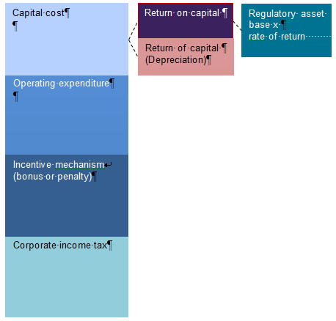

The next figure provides a typical breakdown of each of these components, in percentage terms, for the previous Victorian electricity distribution pricing decisions.

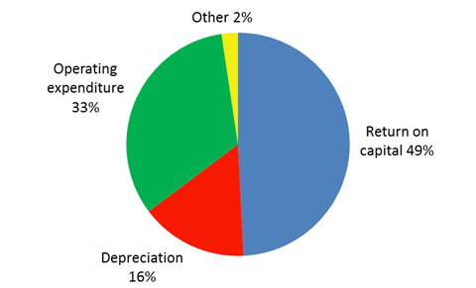

Return on capital

The return on capital is calculated by multiplying the regulatory asset base by the regulatory cost of capital. The cost of capital is also sometimes referred to as the rate of return (the equivalent of the interest rate).

The allowed cost of capital or rate of return is required by the National Electricity Rules to be in line with prevailing conditions in the market taking into account the risks faced by the businesses in providing electricity distribution services. In making a determination on the cost of capital, the AER will take into account an extensive range of material including businesses’ proposals, submissions from various stakeholders, advice from academic experts, information available from the Reserve Bank of Australia or the Commonwealth Treasury, and other independent sources of financial information.

There are a number of methodologies that can be used to estimate the rate of return. In past decisions the AER has used the ‘nominal vanilla’ weighted average cost of capital (WACC).

Electricity network businesses tend to be very capital intensive. This means that the return on capital tends to be a large proportion (as much as half) of the total revenue allowance. Even apparently small changes in the allowed cost of capital (such as change of one percentage point) can have a big impact on revenues. It is for this reason that the rate of return is a major focus of our assessment and is of significant interest to businesses and other stakeholders.

Regulated network businesses are generally regarded as 'low risk' businesses because they benefit from a consistent regulatory environment that protects their assets and revenues—compared to unregulated businesses operating in competitive markets.

Return of capital—depreciation

The return of capital (or depreciation) is the amount of the original capital expenditure (as opposed to the interest on the capital) that a business pays back to its investors each year. To use the loan analogy mentioned earlier, where the return on capital represents the amount of interest a borrower needs to pay back on the loan, the return of capital, or depreciation, represents the repayment of the principal (the cost of the capital expenditure).

As mentioned earlier, capital costs are generally large and ‘lumpy’ in that there can be large variations between years. Instead of having to pay the full amount of capex back to investors in the year that it is incurred, depreciation allows the cost of the capital asset to be spread over the useful life of the asset (which can be 30–70 years). This in turn contributes to a smoother revenue requirement and smoother prices over time. Over an asset’s life, the total of the depreciation amounts will equal the original capital cost of the asset.

In assessing a business’ proposed depreciation, we must ensure that the depreciation schedule is designed so that:

* the depreciation profile for a set of assets reflects the nature of the assets including the economic life of those assets
* the sum of the depreciation associated with an asset is equal to the original cost of the asset
* the economic life of assets and the depreciation methods and rates used to calculate depreciation are consistent with the previous regulatory decision.

Operating expenditure

Operating expenditure (referred to as 'opex') is the on-going recurring costs associated with the provision of electricity network services. Opex is sometimes defined as the operating, maintenance and other non-capital costs needed to deliver network services. Opex includes labour costs (which are often a significant component of opex) and other non-capital costs associated with providing electricity network services. Typical opex categories include network maintenance, vegetation management, emergency response, the network control room, fleet and property management costs, billing and revenue collection, customer services, insurance, IT support, and corporate overhead.

We are required to assess each business’ forecast opex to decide whether it complies with the National Electricity Rules. In particular opex must be no larger than is necessary for prudent and efficient service provider to provide the same volume of services. In addition, opex forecasts must be arrived at on a reasonable basis and represent the best forecast or estimate possible in the circumstances.

We generally use a base year approach to forecasting opex. This involves using the most recent year for which there is data available on actual opex (probably 2013 for this review) to set the base year. The base year costs are then assessed to determine if they reflect broadly efficient costs. In other revenue determinations benchmarking tools have been used to compare the opex outcomes across different network businesses.

If the base year costs are not reasonable, we may replace those costs with estimates of more efficient costs, before proceeding to assess the proposed forecast operating costs. Such adjustments have been made in recent revenue determinations in other jurisdictions. However, our experience with benchmarking suggests that the Victorian distribution businesses are reasonably efficient.

This base year estimate (or the AER's adjustment) is then adjusted to account for:

* any changes in costs that result from:
* real cost escalation—that is, an estimate of the expected change in the price of key factor inputs such as labour and materials costs
* output growth—that is, any expected change in the demand for network services (for example, a change in customer numbers)
* productivity growth—that is, changes in the ability of firms to convert inputs into outputs
* any other circumstance, requirement or project that will require the business to undertake expenditure that is not incorporated in the base year; these are called step changes and are a key driver of opex changes.

Incentive mechanisms

In addition to the 'base' revenue provided by the building block model, incentive regulation sets up a system of financial rewards or penalties. These can reward the network businesses for taking actions which are in the interests of consumers, such as improving their productivity or service quality, but also can penalise the network businesses for taking actions which reduce productivity or service quality. Incentive regulation is designed to align the commercial goals of the business to the long term interests of consumers.

As we mentioned earlier, amongst other things, incentive mechanisms offer businesses incentives to provide network services at the lowest cost. If a business provides its network services at a lower cost than forecast, the business is allowed to 'keep the difference' for five years. That is, any underspend is added to the business’ revenue and carried forward for five years. Conversely, if a business overspends, it will be penalised for this for five years.

There are several incentive mechanisms which operate in the electricity distribution network sector. Each of these has its own acronym and operates in its own way. These incentive mechanisms are as follows:

* Efficiency Benefit Sharing Scheme (EBSS). The objective of the EBSS is to ensure that businesses have a roughly constant incentive to make productivity improvements over time. In the absence of the EBSS, network businesses that make an opex saving towards the end of the regulatory period would keep the benefits of that saving for only a short period of time, whereas opex savings made at the beginning of the regulatory period can be kept for the full five years. As a result there could be a tendency for network businesses to make more effort to reduce opex at the beginning of the regulatory period, and to make little or no effort towards the end of the period. The EBSS seeks to offset this tendency so that, in principle, the network businesses have smooth incentives for making cost savings over time.
* Capital Expenditure Sharing Scheme (CESS). As with the EBSS, the objective of the CESS is to ensure that businesses have roughly constant incentives to economise on capital expenditure over time. In the past there was a concern that network businesses would face little incentive to economise towards the end of the regulatory period. The CESS seeks to offset this tendency, so that network businesses have smooth incentives to make cost savings over time.

An additional incentive mechanism is the Service Target Performance Incentive Scheme (STPIS). This scheme rewards distribution businesses for improving their service quality relative to a benchmark based on historic averages. Service quality is measured using measures of reliability, such as measures of the duration or frequency of outages experienced by customers. Payments from this scheme are not part of the building block model calculations. Rather, they are part of annual pricing reviews within the regulatory period.

In making preliminary determinations, we are required to ensure that any bonuses or penalties from the operation of the incentive mechanism in the previous period are properly reflected in the business’ total revenue requirement. We are also required to consider whether to allow any of the incentive mechanisms proposed by each business for the next regulatory period. These are approved where we consider they would encourage efficiency in the provision of network services, and where they were consistent with the revenue and pricing principles.

Tax

Like most other companies, electricity network businesses have to pay tax on their income. The estimated cost of corporate income tax is one of the building blocks used to determine total revenue. We use the post-tax revenue model (PTRM) to produce an estimate of the taxable income that would be earned by an efficient company operating each business’ network. This approach involves the use of benchmark assumptions.

We model each business' tax interest expense over the regulatory control period using a benchmark 60 per cent gearing—that is, 60 per cent debt and 40 per cent equity. Tax depreciation is also an expense for tax purposes and is calculated using a separate value of the tax asset base. All tax expenses are offset against the business' forecast revenue to estimate the taxable income. The statutory income tax rate of 30 per cent is then applied to the estimated taxable income to arrive at a notional amount of tax payable. We then apply a discount to this to account for the assumed utilisation of imputation credits, which has a value of 0.4 as determined in our recent regulatory decisions. This amount is then included as a separate building block in determining each business’ total revenue.

Broader industry context

As background to the Victorian electricity distribution pricing review, it is important to understand a bit about the electricity industry, and some of the sector-wide pressures and developments.

How distribution networks fit in to the overall electricity industry

Electricity is produced in a range of large and small generating units. Many of the larger generating units are located hundreds of kilometres from where electricity is consumed. To transport the electricity long distances the electricity is injected into the high voltage transmission network. This network carries the power closer to consumers where it is handed off to the lower voltage distribution networks. The distribution networks, in turn, carry the electrical power from the transmission network down every street to virtually every large and small enterprise, building, hospital, school, house and apartment in Victoria.

However, consumers do not usually deal directly with large generators, or with the transmission and distribution networks. Instead, consumers enter in an electricity supply contract with a retailer. The retailer enters into contracts with generators on their behalf, and pays the transmission and distribution charges. Retailers provide various services. In addition to a billing service, retailers provide an 'insurance' service, insulating customers from the volatile wholesale electricity prices. Some retailers also provide a service of directly controlling customer's devices and appliances, in order to lower the customer's overall electricity bill.

Around the world, experience has shown that, to get the best outcome for consumers, it is generally preferable to rely on competition and market forces wherever possible, and to limit price control intervention to those sectors which cannot sustain competition. In the electricity industry in Australia, as in many other countries, there is active competition between large generators operating in the wholesale market. In addition, there is competition between retailers serving small customers. These markets are not subject to price controls in Victoria and are generally subject to a lighter-handed form of regulation. As Victoria is not part of the National Energy Customer Framework, the oversight of the retail sector in Victoria is still the responsibility of the Essential Services Commission.

However the transmission and distribution networks are for the most part 'natural monopolies' and competition is not feasible. These markets are subject to price control regulation by the AER. It is the regulation of the distribution networks which is the focus of this review.

It is important to recognise that this price review does not directly determine the prices that end-customers will be charged for electricity. The price an end-customer is charged will depend on factors such as (a) the price for electricity in the wholesale market, which is determined by competition between generators; (b) the regulated price for the use of the transmission network; (c) the regulated price for the use of the distribution network; and (d) retail charges, which will depend on the level of competition in the retail market, and the services provided by the retailer to the end-customer.

This price review determines the price paid for the use of the distribution networks in Victoria, which is one of the largest component of the average retail tariff, as illustrated in the diagram below (data for 2014–15). The outcome of this review could potentially have a significant impact on Victorian retail tariffs.

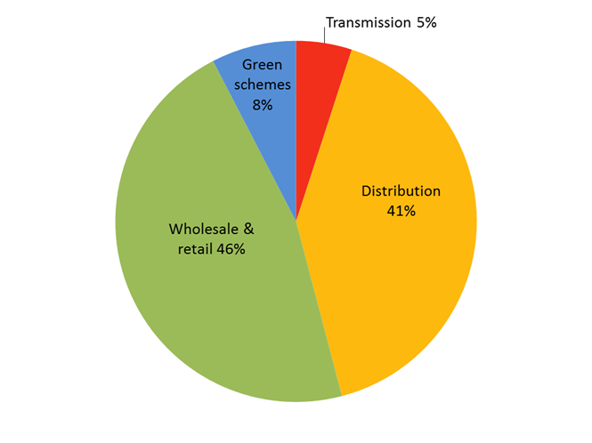

Source: AEMC, 2014 Residential Electricity Price Trends, 2014.

For more information on the electricity industry in Australia and in Victoria see AEMO guide to the NEM and AER State of the Energy Market (the 2014 edition is available at [www.aer.gov.au/node/29358](http://www.aer.gov.au/node/29358)).

Recent developments affecting this review

It is widely recognised that the electricity industry is undergoing a period of change. Historically, due to the limitations of each customer's electricity meter, it was not possible to charge a different price for electricity at different times of the day. However, the Victorian Government mandated for 'smart meters' to be installed in most homes in Victoria.[5] This opens up the potential for different ways of charging for electricity, and the potential to deliver better outcomes for consumers overall.

In addition, in the last few years a number of other developments are putting increasing pressure on network businesses. These developments include:

* changes to the way the networks are managed to limit the risk of bushfires[6]
* the rapid expansion of generation at the location of the customer, especially rooftop solar Photo-Voltaic (PV) generation
* air-conditioning load, which is continuing to impact demand for the network at peak times on hot days in summer
* shift to energy-efficient light bulbs and appliances
* community desire to keep network costs down.

In addition, other developments on the horizon are starting to be felt and may become more important during this regulatory period, such as an increased take-up of plug-in electric vehicles, and the reducing cost of battery storage.

With these market developments it is becoming increasingly important to ensure that distribution networks prices are set correctly, so that customers make efficient decisions regarding how they use appliances such as air-conditioning units or when they charge or discharge their electric vehicles. The level and structure of distribution prices can also affect the decision by customers to invest in one technology compared to another—or the decision to connect to or disconnect from the grid. The structure of distribution network prices is becoming an increasingly debated question around the world.

In addition, in recent years another concern has arisen. Overall demand for electricity from the grid has been declining. There are a number of reasons for this decline. It is due to in part to broader macroeconomic factors, such as the decline of manufacturing industry in Australia and a shift towards service industries. But it is also due, in part to factors such as the increasing investment in energy efficiency and local generation, such as solar PV.

Historically, the charge for the use of the distribution network depended on the volume of electricity each customer consumed. Other things equal, this implies that as demand for electricity declines, the revenue received by the distribution businesses also declines, leading to a potential shortfall in revenue. Distribution businesses have historically been allowed to make up for any shortfall in revenue by increasing their charges. But this has raised concerns that it might push more customers to install local generation or to disconnect from the network entirely. Many commentators in Australia have argued for a change in the structure of network tariffs to overcome this problem.

As part of this review process, each network business will have to set out how they proposed to structure their network charges in a document known as the Tariff Structure Statement. These issues of efficient pricing and ensuring adequate revenue will likely arise as important considerations in the AER's process for approving Tariff Structure Statements. This process—which is separate to but will operate in parallel with this revenue review—starts in late September 2015. We will consult with consumers and work with our consultative group members and the CCP.

This pricing review process focuses on the distribution businesses in Victoria. In recent months the AER has made decisions over the allowed revenue for distribution businesses in New South Wales, Queensland, South Australia and the ACT. Many of the issues raised in this review will have been raised in those other reviews. However, there will also be differences. Recent work by the AER comparing the efficiency of the network businesses across Australia shows that the Victorian distribution businesses tend to be more efficient than their counterparts in the other states. We will examine the businesses' regulatory proposals carefully to ensure that consumers are paying the least amount for safe and reliable services that they value.

## Conclusion

We hope that this guide will facilitate greater consumer engagement in this reset process. The revenue allowance determined through this process will affect virtually every Victorian resident. Your input into this process will help to ensure that the outcome is in the long term interests of consumers of electricity—consistent with the National Electricity Objective.

1. The Essential Services Commission of Victoria retains some responsibility for oversight of electricity retailing in Victoria.
2. AER, Final Framework and Approach for the Victorian Electricity Distributors, 24 October 2014.
3. This is part of the National Electricity Objective, which is to: 'promote efficient investment in, and efficient operation and use of, electricity services for the long term interests of consumers of electricity with respect to - (a) price, quality, safety, reliability and security of supply of electricity; and (b) the reliability, safety and security of the national electricity system'.
4. This feature doesn't have much impact on the overall framework as long as the 'real' rather than 'nominal' cost of capital is used in the calculation of the return on capital in the building block model (discussed below). The main effect of this inflation scaling is to change the allocation of inflation risk.
5. For more information see: [www.smartmeters.vic.gov.au](http://www.smartmeters.vic.gov.au)
6. Following the Black Saturday bushfires in 2009 a Victorian Bushfire Royal Commission (VBRC) made 67 recommendations. The Victorian Government is committed to implementing all the recommendations. The VBRC made eight recommendations for changed approaches to electrical safety that directly impact safety costs in Victoria. These have been progressively implemented by amendments to the electrical safety regime in Victoria. A key change initial in 2009 was to make having and implementing an Electricity Safety Management Scheme (ESMS) compulsory for all distributors. Previously it was voluntary. These schemes are regulated by Energy Safe Victoria.