

**Consultation paper**

**Alternative approach to the recovery of the residual metering capital costs through an alternative control services annual charge**

**March 2015**

© Commonwealth of Australia 2015

This work is copyright. In addition to any use permitted under the Copyright Act 1968, all material contained within this work is provided under a Creative Commons Attributions 3.0 Australia licence, with the exception of:

* the Commonwealth Coat of Arms
* the ACCC and AER logos
* any illustration, diagram, photograph or graphic over which the Australian Competition and Consumer Commission does not hold copyright, but which may be part of or contained within this publication. The details of the relevant licence conditions are available on the Creative Commons website, as is the full legal code for the CC BY 3.0 AU licence.

Requests and inquiries concerning reproduction and rights should be addressed to the Director, Corporate Communications,  
Australian Competition and Consumer Commission,   
GPO Box 4141, Canberra ACT 2601  
or publishing.unit@accc.gov.au.

Inquiries about this publication should be addressed to:

Australian Energy Regulator  
GPO Box 520  
Melbourne Vic 3001

Tel: (03) 9290 1444  
Fax: (03) 9290 1457

Email: [AERInquiry@aer.gov.au](mailto:AERInquiry@aer.gov.au)

1. Request for submissions

Interested parties are invited to make written submissions regarding the distributors' regulatory proposals to us, the Australian Energy Regulator (AER), by the close of business, Friday 27 March 2015.

We prefer that all submissions sent in an electronic format are in Microsoft Word or other text readable document form. Submissions should be sent electronically to:

* [NSWACTelectricity@aer.gov.au](mailto:NSWACTelectricity@aer.gov.au) (regardless of whether submission pertains to decisions in NSW, ACT, South Australia or Queensland).

Alternatively, submissions can be sent to:

Mr Chris Pattas

General Manager

Australian Energy Regulator

GPO Box 520

Melbourne Vic 3001

Email: [AERInquiry@aer.gov.au](mailto:AERInquiry@aer.gov.au)

We prefer that all submissions be publicly available to facilitate an informed and transparent consultative process. Submissions will be treated as public documents unless otherwise requested. Parties wishing to submit confidential information are requested to:

* clearly identify the information that is the subject of the confidentiality claim
* provide a non-confidential version of the submission in a form suitable for publication.

All non-confidential submissions will be placed on our website at [www.aer.gov.au](http://www.aer.gov.au). For further information regarding our use and disclosure of information provided to us, see the ACCC/AER Information Policy, October 2008 available on our website.

Enquires about this paper, or about lodging submissions, should be directed to our Network Investment and Pricing branch on 08 8213 3458.

1. **Purpose**

To seek stakeholder submissions on an alternative approach to recovering the residual metering capital costs through an alternative control services (ACS) annual charge that would occur when a customer moves to another service provider.

Submissions on the alternative approach outlined in this paper will be considered in making the NSW/ACT final decisions and the preliminary decisions for Qld/SA.

Given the limited nature of the issue and the time available to finalise the decisions, we are seeking submissions by **close of business, Friday, 27 March 2015**.

* 1. **Background**

### NSW/ACT Draft decision

In our draft decision, we proposed an alternative approach to exit fees due to our primary concern that a large exit fee would create a barrier to entry into a contestable metering market following the AEMC's rule change.

Our alternative was to define a standard control service (SCS) that would cover the residual capital costs of a meter when a customer transferred to another provider. That is, when a customer leaves, the capital cost to the service provider (the residual cost of the meter) would be added to the SCS regulatory asset base (RAB).[1] We proposed to make adjustments to the SCS RAB to account for actual churn for each year, subject to a two year lag to allow time to obtain data on actuals.

We included a b-factor in the SCS control mechanism formula[2]. This was intended to allow additional revenue, on top of the annual revenue requirement, to start recovering residual metering capital costs that have been added to the SCS RAB through network tariffs within the regulatory period.

We recognised the risk that if many customers churn in the same year, the impact on network tariffs may be large. On this basis, we introduced a tolerance limit. If the residual metering capital cost recovery component of the b-factor for year t:[3]

* is less than two per cent of the annual revenue requirement, then the whole amount would be cleared within one regulatory year.
* is greater than two per cent of the annual revenue requirement, then the under/over recovery will be recovered in the remainder of the regulatory control period. [4]

### NSW and ACT revised proposals

ActewAGL disagreed with our draft decision to classify the recovery of residual type 5 and 6 metering capital costs as a standard control service[5]. There were numerous reasons stated, but on our understanding, a primary objection is that our approach is legally impermissible because amongst other things, assets cannot be added to the SCS RAB during a regulatory control period.

The NSW distributors accepted our position to recover the residual metering capital costs as a standard control service.[6] However, the NSW and ACT distributors did not accept the tolerance limit for the b-factor adjustment. Ausgrid argued the tolerance limit should be applied only to the DUoS unders and overs account, not to the b-factor.[7] Essential Energy, Endeavour Energy and ActewAGL were concerned it would not allow them to recover their costs if they exceeded the 2 per cent tolerance limit.[8]

* 1. **Discussion**

We accept the concerns expressed by ActewAGL and the NSW distribution business, regarding the b-factor adjustment in the draft decision:

* the mechanism adopted to add the residual metering capital value on an annual basis to the SCS RAB is not appropriate under the National Electricity Rules (NER)[9]; and
* the concern that revenue recovery may not be allowed into the next regulatory period if the tolerance limits bind. Revenue recovery for the network businesses was a key consideration and it was not our intention that the proposed approach in the draft decision would undermine this.

Therefore, our draft decision to make annual adjustments to the SCS RAB requires an alternative approach.

### Proposed alternative

We are proposing to recover the residual meter capital cost through an annual metering charge that applies to all customers in respect of a service classified as ACS, rather than a SCS. It would be implemented through having two annual ACS charges, corresponding to two services under this category.

The first annual charge is an avoidable charge that applies if the customer has a current regulated meter. This incorporates the ongoing costs associated with the regulated metering base. If a customer churns to an unregulated metering provider, they will no longer pay this charge as they no longer use these meters. The second annual charge is an unavoidable charge that applies to both current and churned metering customers. These costs would include the residual or undepreciated capital costs of type 5 and 6 meters. The unavoidable residual component of this charge would continue to apply in respect of the relevant alternative control service until fully depreciated.

There are two ways of how this approach could be implemented as shown in the diagrams below. Both versions remove the need for a lump sum exit fee, which was also a feature of our previous position in the NSW/ACT draft decision. The total annual metering charge is the same in each option, however, where they differ relates to the metering asset base (MAB) recovery.

Option 1, the whole MAB is recovered through the unavoidable annual charge. There is no MAB recovery in the avoidable charge.

Option 2, MAB recovery is also a component of the avoidable charge, at least in part. Only the portion of the MAB that risks becoming stranded when a customer churns is recovered through the unavoidable charge.

We also intend to maintain our NSW/ACT draft decision that new/upgraded meters will be charged upfront to the customer, rather than through annual charges. New/upgraded capital costs are not shown in the annual charge diagrams below.

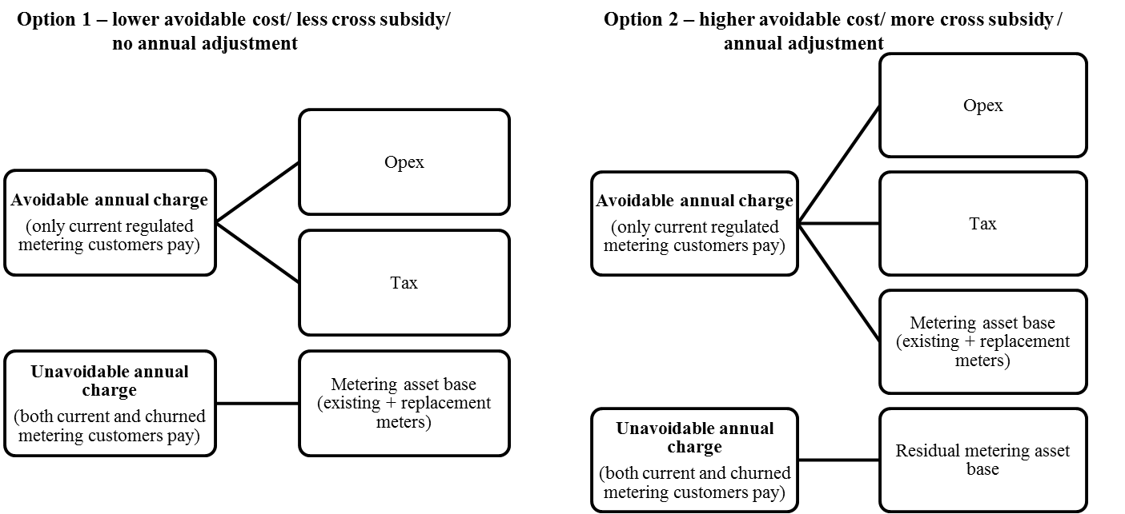

These approaches are both largely similar to our approach in the NSW/ACT draft decision that we consider achieve our desired outcomes:

* It ensures that the businesses recover the cost of their sunk investments
* The exit fee is significantly reduced to promote competition. This is consistent with stakeholders support for the current approach
* The residual component will be recovered from all customers as is the case if it was recovered through DUoS charges.

We consider that either approach reduces the downside reflected in comments received from distribution businesses in relation to customers taking up new meters from competitive suppliers. There is no longer the potential cash flow, revenue recovery and legal risks created by defining the service as a standard control service and having the residual component recovered at the end of the period.

There are three key implications:

* administrative impact
  + Option 1 is administratively simpler. The unavoidable charge can be set at the beginning of the regulatory period based on existing meters and forecast replacement capex, and does not require annual adjustment as this calculation is not contingent on actual churn.
  + Option 2 is administratively more complex. Only residual metering capital costs are recovered through the unavoidable annual charge. Therefore, the unavoidable annual charge will have to be annually adjusted because residual metering capital costs can only be calculated once actual churn is known.
* cross subsidy
  + Option 1 involves less cross subsidy between (churn) customers who decide to take up new meters and those who remain on regulated meters. Metering customers all contribute the same amount to MAB (residual) recovery, regardless of whether they churn or not.
  + Option 2 has more cross subsidy towards churned customers because customers who remain on the regulated metering service pay existing MAB recovery through their avoidable annual charge, but then also some portion of the residual metering capital costs through the unavoidable metering charge. Or to put this another way, churned customers will be able to avoid more of the residual metering costs than under option 1.

We have a strong preference for Option 1 because it reduces the cross subsidy to those who remain with regulated meters. Option 1 more closely aligns with our objectives in the NSW/ACT draft decision by:

* ensuring that all customers contribute the same amount to the residual meter recovery
* providing an appropriate cost recovery that minimises undue distortion in prices. An artificially high avoidable annual charge in these circumstances is not considered an appropriate cost recovery in the interest of consumers.

However, we are seeking stakeholder comments on both Options 1 and 2.

Either approach will require the classification of new alternative control services that were not included in the framework and approach paper. The framework and approach paper did not specifically deal with the classification of exit fees. We would need to classify services to be able to control the costs of those services in the way outlined in this paper. The draft decision for NSW/ACT acknowledged that there were unforeseen circumstances making a new classification appropriate. Similarly, the same rationale is present for the final decision, albeit that we are now recommending that new services be classified as ACS rather than SCS. We are confident that the service can be defined as an alternative control service for the purpose of the NSW/ACT final decision and the Qld/SA preliminary decision.

To enable the classification of the service, we propose to define two separate alternative control services connected with the transfer of a customer to a new meter provider. These services will be:

* Types 5 and 6 meter transfer service, comprised of the services required to complete a customer initiated switch (meter transfer) from a DNSP provided type 5 or 6 meter to a new provider, but not including the associated administrative tasks of updating records and processing information.
* An administration service associated with a customer initiated switch (meter transfer) from a DNSP provided type 5 or 6 meter, comprising updating records and processing information.

We propose to define and classify the above two services consistently for each distributor.

### Networks NSW – Modelling

In order to provide context around the options for the recovery of the residual meter capital costs, we requested that Network NSW provide us with worked examples and pricing outcomes for competitive metering take-up. We received a number of examples and pricing outcomes for Ausgrid, based on a variety of assumptions and take up rates of competitive meters.

The table below is for illustrative purposes only and provides a comparison of the effect on the annual charge components for options 1 and 2.

|  |  |  |  |  |  |  |
| --- | --- | --- | --- | --- | --- | --- |
|  | Option 1 | | Option 2 | | *Difference between*  *options 1 and 2* | |
|  | Avoidable annual charge | Unavoidable annual charge | Avoidable annual charge | Unavoidable annual charge | *Difference in avoidable annual charge* | *Difference in unavoidable charge* |
| 1% annual churn | $25.00 | $20.00 | $45.25 | $0.20 | *$20.25* | *$19.80* |
| 10% annual churn | $25.00 | $20.00 | $47.72 | $2.00 | *$22.72* | *$18.00* |
| 25% annual churn | $25.00 | $20.00 | $52.92 | $5.00 | *$27.92* | *$15.00* |

This table is based on Ausgrid’s modelling for option 1 and 2. The actual numbers are likely to differ across businesses depending on the size of their respective metering asset bases.

A regulated metering customer pays two regulated annual charges; the avoidable and unavoidable annual charge. When a metering customer switches to a competitive metering provider, they continue to pay one regulated annual charge (the unavoidable annual charge). This information has been provided to us on a best effort basis in a limited timeframe. It is provided for illustrative purposes only and should not be relied upon as representing a final calculation of the actual charges. We have not sought to outline or test the veracity of the key assumptions underlying the above comparisons.

1. Residual costs – Ausgrid draft decision, Alternative control services Attachment 16, pp. 67-72.
2. B-factor – Ausgrid draft decision, Control mechanism Attachment 14, pp 16-17.
3. Tolerance limit – Ausgrid draft decision, Control mechanism Attachment 14, p. 16.
4. Although not our intention, we recognise this wording from the draft decision suggests that recovery may not be allowed into the next regulatory control period.
5. ActewAGL Revised Regulatory Proposal – section 14.3.3 ‘Overview’ pp. 650-657.
6. Ausgrid, Revised Regulatory Proposal, Attachment 8.04, p. 15.

   Endeavour Energy, Revised Regulatory Proposal, p. 234.

   Essential Energy, Revised Regulatory Proposal, p. 250.
7. Ausgrid, Revised Regulatory Proposal, Attachment 9.01, p. 5.
8. Endeavour Energy, Revised Regulatory Proposal, p. 234.

   Essential Energy, Revised Regulatory Proposal, p. 250.

   ActewAGL, Revised Regulatory Proposal, p. 657.
9. During the regulatory period, in accordance with clause S6.2.3 of the NER, the SCS RAB is rolled forward during each year based on approved forecast capex and the RAB is updated for actual capex only at the end of the regulatory period, as set out in clause S6.2.1 of the NER.