

Better Regulation: an integrated package
Promoting efficient investment in the interests of all energy consumers

May 2013

Contents
Contents 2
1 Introduction 3
1.1 Background to the AER's Better Regulation program 3
1.2 What is the Better Regulation program? 3
1.3 What are the aims of the Better Regulation program? 3
1.1 How this document can help you 4
1.4 How are we consulting? 4
1.5 More information on the Better Regulation program 4
2 An integrated package 5
2.1 Our guidelines 5
2.2 Active consumers 8
2.3 Bringing it all together 9
A The regulatory process 10
A.1 Who is the AER and what is our role? 10
A.2 A simple model of network regulation 10
A.3 Building Blocks 11

Introduction

Background to the AER's Better Regulation program
The Australian Energy Regulator (AER) started the Better Regulation program to bring together several areas of our work this year. We are Australia’s independent national energy market regulator. Electricity network businesses provide an essential service valued by the Australian community. Our role as an economic regulator is to promote the national electricity objective. Our goal is to encourage efficiency in electricity networks in the long term interests of consumers.
National Electricity Objective
The objective of this Law is to promote efficient investment in, and efficient operation and use of, electricity services for the long term interests of consumers of electricity with respect to—
(a) price, quality, safety, reliability and security of supply of electricity; and
(b) the reliability, safety and security of the national electricity system.
A major part of our work is regulating energy networks which transport energy to consumers (electricity poles and wires and gas pipelines). Last year there were important changes affecting our role in regulation to the electricity and gas rules announced by the Australian Energy Market Commission on 29 November 2012, and energy market reforms announced by the Prime Minister on 7 December 2012.

What is the Better Regulation program?
The Better Regulation program draws together our work developing our own regulatory processes and systems with the important reforms above. The program encompasses several of our workstreams which together form an integrated package of changes to the way we approach network regulation under the new regulatory framework.
The Better Regulation program involves us:
- conducting extensive consultation on the creation of seven new guidelines outlining our approach to receiving and assessing network business' expenditure proposals and determining electricity network revenues and prices, including a new common rate of return framework for electricity distribution, electricity transmission and gas
- establishing a consumer reference group specially for our guideline development work to help consumers engage across the broad spectrum of issues we are considering
- establishing an ongoing Consumer Challenge Panel from 1 July 2013, to ensure our network regulatory determinations properly incorporate consumers’ interests
- improving our internal technical expertise and systems, and our engagement and communication with all our stakeholders.

What are the aims of the Better Regulation program?
The Better Regulation program aims to deliver an improved regulatory framework focused on the long term interests of electricity consumers. We will deliver this through our new guidelines, the consumer challenge panel, better internal expertise and systems, and improved engagement and communication.
We want to provide businesses with the right rewards (and penalties) to make efficient investment and expenditure decisions. We will develop benchmarking techniques to assess proposals from businesses, and to compare their performance to one another. Benchmarking may play a greater role in determining forecasts where incentives do not appear effective enough. We will set out how we will determine a rate of return that meets the new overarching objective. We will engage better with consumers, and encourage businesses to do the same.
The Better Regulation program will help us establish a transparent regulatory platform going forward to ensure customers pay no more than necessary for a safe and reliable supply of energy.

How this document can help you
The bulk of our work in the Better Regulation program involves developing new guidelines that we will apply when making revenue determinations for regulated energy network businesses. We will release several draft guidelines by 9 August 2013 and other significant materials leading up to this.
This document is intended to provide information and assist you in your involvement in the Better Regulation program. This document explains what our workstreams are and how we see the different workstreams interacting together.

How are we consulting?
Meaningful consultation is central to the Better Regulation program and, in particular, our development of the new guidelines. We appreciate the time and effort that stakeholders are committing to the development of the new guidelines. For us to deliver a high quality product, we need high levels of engagement from all stakeholders, particularly consumers and network businesses. We are continually reviewing and refining how we consult and engage. We appreciate there is a balance between ensuring all voices are clearly heard and asking for too much from stakeholders. We remain open to hearing suggestions on how we could improve our processes.
Our consultation strategy includes forming working groups for each workstream. Membership is open to all stakeholders. An AER board member normally chairs the key working group meetings.
We have established a Consumer Reference Group to help facilitate consumer input across the workstreams. While consumer representatives participate directly in the working groups, we have also set up a separate forum where consumers can share their ideas collectively, prior to having input in specific working groups.

More information on the Better Regulation program
For more information or to get involved in the consultation processes that we are running on each of these workstreams, please see our website http://www.aer.gov.au/node/18824. The Better Regulation web page has our monthly newsletter updates, links to the pages for each workstream, and a full up-to-date calendar of events

An integrated package
The Better Regulation program is aimed at improving the regulatory process. For those readers not familiar with the regulatory process, appendix 1 includes a stylised explanation of the regulatory process and the elements of a decision. As shown in the diagram below, this process starts with planning. In this step the businesses forecast growth on their networks and assess the age and condition of assets. They consider their service and reliability obligations and analyse how changing demand will impact on the need for new solutions, such as alternatives to building a bigger network. Together with forecasts of the cost of funds for capital expenditure and operating expenditure, their ongoing analysis forms the basis of the regulatory proposals businesses eventually put to the regulator.
Importantly, rather than being a once-in-five-year event, our aim is for the Better Regulation program to enhance the ongoing nature of the regulatory process.
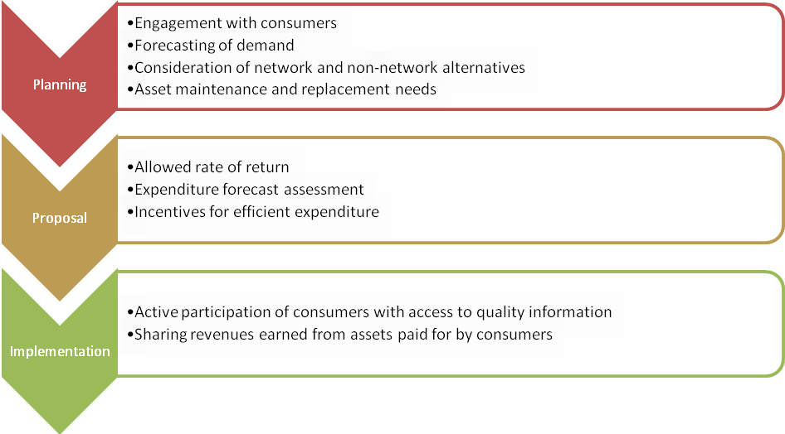

Our guidelines

Engagement with consumers
Regulatory determinations begin with network companies planning their expenditure for the next five years. This includes assessing how they will continue to serve existing consumers, maintain reliable systems and meet new consumer demand.
The revised electricity rules create a higher expectation of network businesses to consult effectively with consumers during this planning phase. This includes businesses being more transparent and accountable to consumers in developing their proposals. As the regulator, we must then have regard to this consultation when assessing businesses expenditure proposals. This links how well network companies conduct their consultation directly to the expenditure forecast assessment process. While not required by the rules, we think we should set out how we will assess the effectiveness of business' consumer engagement. We will do this by publishing the service provider consumer engagement guideline.
We have conducted a stocktake of business' and consumers' existing consumer engagement processes. We are also researching other sectors along with international comparisons. We will use all this to develop principles of ‘best practice’ consumer engagement for further consultation. Our aim is to finalise this guideline around the time we release the other draft guidelines. This will enable network companies to have regard to the consumer engagement guideline when formulating their proposals due in May 2014.

Consideration of non-network alternatives
When network businesses plan they can consider network solutions on the same footing as non-network solutions like embedded generation or demand side management. In this way, they can aim to find the most efficient solution to consumers needs.
Our Power of Choice Implementation workstream tackles this consideration on multiple fronts. First, the workstream is developing the first Regulatory Investment Test for Distribution. When a network company identifies a need for a network upgrade, the Regulatory Investment Test for Distribution requires them to conduct a rigorous planning and consultation process. Second, this workstream will also consider amendments to our existing demand management and embedded generation connection incentives schemes and pricing principles. These schemes provide a financial incentive for network companies to pursue cost-effective non-network solutions.
This workstream will also implement reforms from upcoming rule changes stemming from the Australian Energy Market Commission’s recommendations in its Power of Choice review. While the exact scope and timing of the rule changes is uncertain, our role is likely to involve:
- reviewing incentives for distributors to improve demand-side participation
- reviewing arrangements pertaining to distribution tariff reviews
- considering possible amendments to the AER’s retail guidelines.

Allowed rate of return
The allowed rate of return has a very significant impact on the overall regulatory determination. It has implications for the performance of incentive schemes and a big impact on final prices. Depending on the rate determined it can contribute about 40 per cent of the final revenue allowance and therefore the network charges customers pay.
The allowed rate of return is the estimate of the appropriate cost of capital expenditure for the business. A good estimate of the rate of return is necessary to promote efficient prices in the long-term interests of consumers. Efficiency is promoted when revenues align with costs. The cost of capital is one component of these costs. If the allowed rate of return is higher than the cost of capital then revenues are not aligned with costs, and customers will pay excessive prices. Further, businesses may seek to over-invest in network solutions. This may conflict with the demand management schemes discussed above and the broader expenditure incentives discussed below, which aim to encourage efficient levels of expenditure.
If the allowed rate of return is lower than the cost of capital, again, revenues are not aligned with costs. In this case, network companies may seek to defer or refuse to undertake expenditure. This could lead to a decline in the service and reliability outcomes for consumers. Our rate of return workstream will develop a new guideline setting out our approach to the methodologies we will use to establish a rate of return that meets a new 'rate of return' objective. Introduced as part of the reforms to the electricity and gas rules, the new objective is for the overall rate of return to correspond to the efficient financing costs of a benchmark efficient business.
The main issues we are exploring are the methods, approaches, and market data for estimating return on equity and return on debt, to meet the overall rate of return objective.

Expenditure forecast assessment
The new rules contemplate an increased role for economic forecasting and assessment tools in the regulatory process. This means developing techniques to improve our approach to forecasting how much needs to be spent and becoming better equipped to challenge the proposals put to us by regulated networks. Our expenditure forecast assessment workstream is developing these tools in consultation with stakeholders. These include new benchmarking and trend techniques, as well as improving on existing techniques. We are also considering the data requirements of each technique. Importantly, we will use these techniques to both test the expenditure proposals from each business at the time of price/revenue determinations, and to compare the relative performance of each business in our annual performance and benchmarking reports.
The setting of expenditure allowances has complex interactions with the expenditure incentives (see section below) and is the subject of ongoing consultation with stakeholders. Our preference is to rely on the incentive framework to encourage businesses to spend only what is efficient. We would then use the information about their actual spend when we forecast the amount they need for the future. We can do this for recurrent, (typically operating) expenditures. We are considering how benchmarking will play a role in this, for example, how we might use benchmarking to test whether actual expenditures are efficient. For businesses that appear less efficient than their counterparts in similar conditions, benchmarking may play a greater role in determining their forecasts. The method we use to set forecast allowances is a key factor when considering the strength of the incentive framework.
Given the inter-linkages between benchmarking and the incentive framework, we held a joint workshop between the two workstreams in late April.

Incentives for efficient expenditure
We consider incentive mechanisms are the most effective way to support efficient spending by network businesses. The new rules allow us to implement a capital expenditure incentive scheme to help encourage network businesses to only spend efficient levels of capital, and to share the benefits of efficiencies with consumers.
As above, there are clear linkages and dependencies between how expenditure forecasts are set and the incentive mechanisms used. Noting these dependencies, we will also review whether changes are needed to the efficiency benefit sharing scheme for operating expenditure so it complements both the capital expenditure sharing scheme and our expenditure forecasting approach.
Where a network business spends more than the forecast in the determination, the new rules allow us to review the efficiency of the business' overspend. Previously, if the network business spent more on capital than forecast, all of that new capital was added to the regulatory asset base. This was regardless of its efficiency, and provided a return for the business for the remaining life of the asset. We had no ability to review the prudency or efficiency of this expenditure.

Provision of information to stakeholders
Given the increased focus on consumer involvement in the determination process, it is important consumers have access to high quality information. In the past stakeholders had, on occasion, been denied an opportunity to comment on significant portions of revenue proposals because of confidentiality claims by network businesses. We accept there is material contained in revenue proposals that is confidential. For example, network businesses often source material through competitive tender and information that may indicate what the business was expecting from that tender would compromise that process. However, businesses have often claimed that large amounts of information they provide is confidential. This included information that other network businesses in the same situation did not claim was confidential.
To assist us with dealing with confidentiality claims, the revised rules allow us to pre-determine categories of information that may be confidential in businesses expenditure proposals. This guideline will also set out our revised approach to managing confidentiality claims. This will help us manage confidentiality more efficiently so we can make more information available for public scrutiny, while protecting genuinely confidential information.

Sharing revenues earned from assets paid for by consumers
The new rules allow us to specify how businesses and consumers can share the benefits of additional revenues businesses earn from assets already funded by consumers. An example of such assets are power poles in the community. All electricity consumers generally pay for power poles. The value of power poles is included in the regulatory asset base of a network business and they earn a return on it. If the network business charges another utility for use of a power pole, for example the National Broadband Network, it will now share the revenue it earns from this with consumers. This promotes the long-term interests of consumers and means consumers should pay no more than necessary for a reliable and safe supply of electricity.

Active consumers
Enhanced consumer involvement is a cornerstone of Better Regulation. In developing our guidelines this year we established a consumer reference group (CRG) to make it easier for consumer representatives to have input without necessarily writing formal submissions. CRG members are able to distil key issues and information to constituents for consideration, consult and report back to the AER. This will provide a mechanism for co-ordinated and informed input from a cross-section of consumer groups. The CRG will also give guidance on where consumer representative groups can invest their limited resources to most effectively contribute to future regulatory processes.
Beyond developing our guidelines this year, to bolster consumer involvement in the future we sought funding from the Australian Government to establish a Consumer Challenge Panel.
The objective of the Panel is to assist the AER to make better network regulatory determinations through advising us on issues that are important to consumers for each determination. Establishing the Panel will enhance consumer input into some of the more complex, technical issues we consider during determinations. Panel members will be appointed by 1 July 2013.
The roles of the Panel will include:
- advising the AER on whether network businesses’ proposals are justified in terms of the services to be delivered to consumers; whether those services are acceptable to, valued by, and in the long term interests of consumers
- advising the AER on the effectiveness of network businesses’ engagement activities with their consumers and how this engagement has informed, and been reflected in, the development of their proposals
- providing advice on consumer perspectives to other organisations when requested (such as SCER, AEMC)
- liaising with other consumer advocacy and consumer representative organisations to ensure it can provide an effective consumer focus to our work.
Beyond the Panel, the new rules enhance future consumer engagement by providing more time in the regulatory process for stakeholders to prepare submissions and put their views forward. There will also be more consumer-focused written documents and our new benchmarking reports will allow consumers to assess how their network business is performing compared to others.

Bringing it all together
The Better Regulation program will provide integrated guidelines, processes and engagement tools to:
- encourage network businesses to develop proposals that meet the needs of the communities they serve
- encourage and assist consumers to participate in network determination processes
- help the community understand the processes we will use to make decisions that affect them.
We will have guidelines on 'best practice' consultation and schemes to promote businesses considering and investing in cost-effective non-network solutions. We will have in place an incentive framework to encourage businesses to invest in and run their business efficiently. Before a business' proposal comes to us, we will have outlined our preferred approach to forecasting the rate of return. When a business submits its expenditure proposal, we will have guidelines covering our approach to its assessment, and how we will determine the rewards and penalties under our incentive framework. Stakeholders will be able to assess more information than before as we use our new efficient process for assessing confidentiality claims. The new consumer challenge panel will serve the interests of consumers throughout determination processes. Finally, if network businesses earn additional revenue from assets funded by consumers, there will be a mechanism to share that revenue back with consumers.

The regulatory process

Who is the AER and what is our role?
The AER is Australia’s national energy market regulator and an independent statutory authority. Our functions are set out in national energy market legislation and rules, and mostly relate to energy markets in eastern and southern Australia. These functions include:
- regulating energy networks (electricity poles and wires and gas pipelines) which transport energy to customers, to ensure customers pay no more than necessary for a safe and reliable supply of energy
- monitoring wholesale electricity and gas markets to ensure suppliers comply with the legislation and rules, and taking enforcement action where necessary
- publishing information on energy markets, including our annual State of the Energy Market Report and more detailed market and compliance reporting, to assist participants and the wider community
- assisting the Australian Competition and Consumer Commission with energy-related issues arising under the Competition and Consumer Act, including enforcement, mergers and authorisations.

A simple model of network regulation
To describe how the Better Regulation program works as an integrated package, it is useful to start with a simple model of the regulatory process.
As in the stylised diagram below, the process starts with a network company planning the expenditure it will require to meet its service and reliability obligations for the next five years. It then puts this proposal to us. We then assess their proposal against various criteria. Essentially what we are looking for is whether the network company has correctly identified what it is required to do and whether the proposed solutions are efficient.
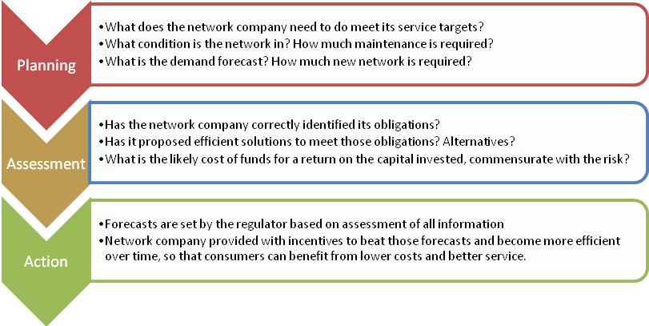
The electricity law and rules set out the regulatory framework for the national electricity market. Regulated network businesses must periodically apply to the AER to assess their revenue. Typically, this happens every five years. The application is known as a revenue proposal and starts a process often referred to as a regulatory reset (or simply a 'reset') and results in us making a final revenue determination (or simply a 'determination').

Building Blocks
Our final determination ultimately provides the network company with a maximum amount that it can recover from its customers over the next five years. This revenue is the summation of several constituent decisions, or building blocks as shown in the figure below.
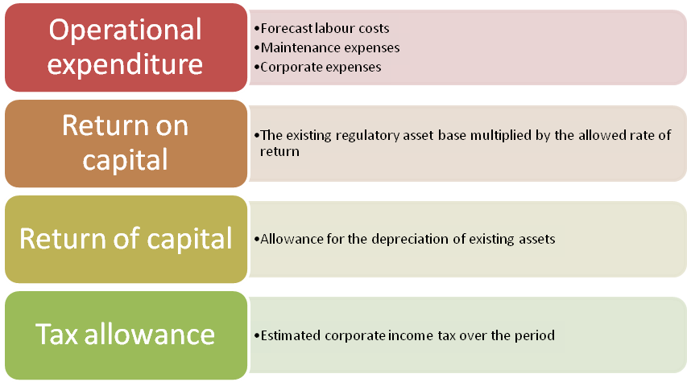
The electricity rules require us to divide our determinations into these building blocks. The sum of each building block is equal to the regulated revenue of a network business and, together, they cover the costs of providing regulated services.

Some network companies have regulatory periods of a different length, but most are five years.
Chapter 6 of the electricity rules contains the timelines and processes for the regulation of electricity distribution network businesses (chapter 6A for transmission network businesses).

