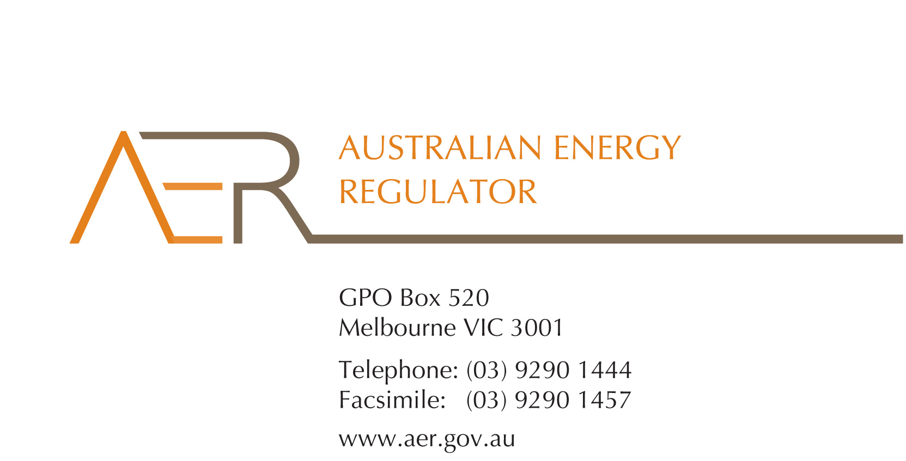

Our Ref: 53659

Your Ref:

Contact Officer: Naomi Feast

Contact Phone: (03) 9290 6930

21 February 2014

Mr Jonathon Ruddick

Tindo Asset Management

6 – 8 Second Avenue

Mawson Lakes SA 5095

Dear Mr Ruddick

**Tindo Asset Management Pty Ltd** **application for an individual exemption from the requirement to hold an electricity retailer authorisation**

I refer to your application of 14 January 2014 for an individual exemption in accordance with s 110 of the *National Energy Retail Law* (*Retail Law*) by Tindo Asset Management Pty Ltd (Tindo Solar) (ACN 163 311 457).

I am writing to inform you that the Australian Energy Regulator (AER) has decided to grant Tindo Asset Management’s application for an individual exemption in accordance with s 110 of the *Retail Law*.

In accordance with the *National Electricity Retail Rules* (*Retail Rules*), the AER has published the application on its website, and sought submissions from interested parties.[1] No submissions specific to Tindo’s application were received, however, one standing objection to all SPPA individual exemptions was received.

The AER has also considered the policy principles relating to exempt selling, in s 114 of the *Retail Law*, being:

1. regulatory arrangements for exempt sellers should not unnecessarily diverge from those applying to retailers,
2. exempt customers, should, as far as practicable, be afforded the right to a choice of retailer in the same way comparable retail customers in the same jurisdiction have that right,
3. exempt customers, should, as far as practicable, not be denied customer protections afforded to retail customers under this Law and Rules.

In making its decision the AER is also guided by the objective of the *Retail Law*,[2] the exempt seller factors,[3] and the customer related factors.[4] The AER’s decision is also informed by the assessment approach outlined in the *Exempt Selling Guideline*.[5]

On 21 February 2014, the AER considered Tindo Asset Management’s application for an individual exemption, taking into account the matters above.

The AER is satisfied that Tindo Asset Management should be exempt from the requirement to hold a national retailer authorisation. This individual exemption is subject to acceptance of the conditions set out at Schedule 1 to this letter.

Please be aware that the AER may vary conditions attached to an individual exemption at any time in accordance with r 158 of the *Retail Rules*.

Tindo Asset Management must advise the AER in writing, by **25 March 2014,** whether it accepts these conditions.

If you have any further queries, or would like to discuss this further, please contact Naomi Feast on 03 9290 69630.

Yours sincerely

Andrew Reeves

Chairman

**Schedule 1: Instrument of exemption**

**INDIVIDUAL EXEMPTION FROM THE REQUIREMENT TO HOLD A RETAIL AUTHORISATION**

The Australian Energy Regulator on 21 February 2014, decided pursuant to section 110 of the *National Energy Retail Law*, to grant Tindo Asset Management Pty Ltd (also trading as Tindo Solar) (ACN 163 311 457) (the exempt person) an exemption from the requirement to hold a retailer authorisation under section 88 of the *National Energy Retail Law*, subject to the following conditions.

**Condition 1 - Information provision**

The exempt seller must provide the customer in writing a plain English notice explaining that the contract is covered by the *Australian Consumer Law* (as set out in schedule 2 of the *Competition and Consumer Act* 2010) and is separate to the customer’s contract with their retailer and distributor which are covered under the *National Energy Retail Law*.

1. *Retail Rules*, r 155(3), 156.
2. The objective of the *Retail Law* is to ‘promote efficient investment in and efficient operation and use of energy services for the long term interests of energy consumers with respect to price, quality, safety, reliability and security of supply of energy’: *Retail Law*, s 13.
3. *Retail Law*, s 115.
4. *Retail Law*, s 116.
5. *AER (Retail) Exempt Selling Guideline - Version 2* (July 2013).