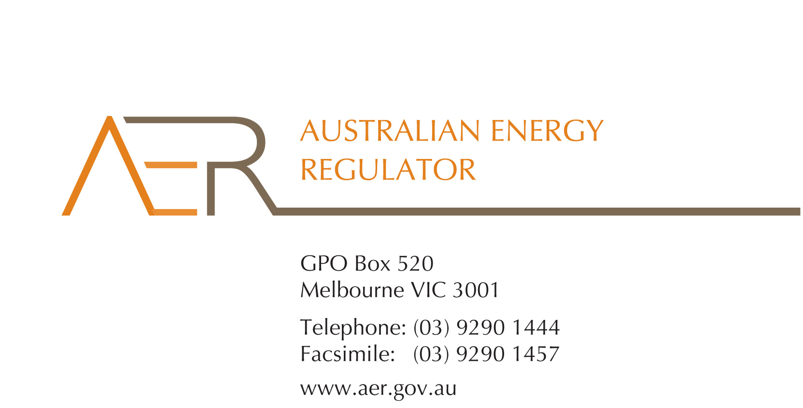

Our Ref: 53310

Your Ref:

Contact Officer: Naomi Feast

Contact Phone: (03) 9290 6930

21 February 2014

David Jones

Angeleno Group

2 Illawarra Street

Mosman NSW 2088

Australia

Dear Mr Jones

**Australian Clean Energy Finance Fund (ACEFF)** **application for an individual exemption from the requirement to hold an electricity retailer authorisation**

I refer to your application of 16 December 2013 for an individual exemption in accordance with s 110 of the *National Energy Retail Law* (*Retail Law*) by Australian Clean Energy Finance Fund (ACEFF) (ABN 291 670 433 98).

I am writing to inform you that the Australian Energy Regulator (AER) has decided to grant ACEFF’s application for an individual exemption in accordance with s 110 of the *Retail Law*.

In accordance with the *National Electricity Retail Rules* (*Retail Rules*), the AER has published the application on its website, and sought submissions from interested parties.[1] The AER received one submission in response to ACEFF’s application, and has also received a standing objection to all SPPA individual exemptions.

The AER has also considered the policy principles relating to exempt selling, in s 114 of the *Retail Law*, being:

1. regulatory arrangements for exempt sellers should not unnecessarily diverge from those applying to retailers,
2. exempt customers, should, as far as practicable, be afforded the right to a choice of retailer in the same way comparable retail customers in the same jurisdiction have that right,
3. exempt customers, should, as far as practicable, not be denied customer protections afforded to retail customers under this Law and Rules.

In making its decision the AER is also guided by the objective of the *Retail Law*,[2] the exempt seller factors,[3] and the customer related factors.[4] The AER’s decision is also informed by the assessment approach outlined in the *Exempt Selling Guideline*.[5]

On 21 February 2014, the AER considered ACEFF’s application for an individual exemption, taking into account the matters above.

The AER is satisfied that ACEFF should be exempt from the requirement to hold a national retailer authorisation. This individual exemption is subject to acceptance of the conditions set out at Schedule 1 to this letter.

Please be aware that the AER may vary conditions attached to an individual exemption at any time in accordance with r 158 of the *Retail Rules*.

ACEFF must advise the AER in writing, by **25 March 2014,** whether it accepts these conditions.

If you have any further queries, or would like to discuss this further, please contact Naomi Feast on 03 9290 69630.

Yours sincerely

Andrew Reeves

Chairman

Australian Energy Regulator

**Schedule 1: Instrument of exemption**

**INDIVIDUAL EXEMPTION FROM THE REQUIREMENT TO HOLD A RETAIL AUTHORISATION**

The Australian Energy Regulator on 21 February 2014, decided pursuant to section 110 of the *National Energy Retail Law*, to grant the Australian Clean Energy Finance Fund (ABN: 291 670 433 98) (the exempt person) an exemption from the requirement to hold a retailer authorisation under section 88 of the *National Energy Retail Law*, subject to the following conditions.

**Condition 1 - Information provision**

The exempt seller must provide the customer in writing a plain English notice explaining that the contract is covered by the *Australian Consumer Law* (as set out in schedule 2 of the *Competition and Consumer Act 2010*) and is separate to the customer’s contract with their retailer and distributor which are covered under the *National Energy Retail Law*.

1. *Retail Rules*, r 155(3), 156.
2. The objective of the *Retail Law* is to ‘promote efficient investment in and efficient operation and use of energy services for the long term interests of energy consumers with respect to price, quality, safety, reliability and security of supply of energy’: *Retail Law*, s 13.
3. *Retail Law*, s 115.
4. *Retail Law*, s 116.
5. *AER (Retail) Exempt Selling Guideline - Version 2* (July 2013).