# 

**7–13 December 2014**

**Weekly Gas Market Report**



**Weekly summary**

Prices in all markets remained low relative to the previous financial year to date averages. However the percentage change from the previous week varied between each market significantly.

The lowest average daily price for the week was in Brisbane, at $1.65/GJ. Despite this, the price was 194 per cent higher than the previous week (0.56/GJ). Prices in Brisbane have been volatile recently. This may be due in part to the Queensland LNG projects coming on line with impacts on ramp up gas for the domestic market.

Trade at the Wallumbilla hub continued to increase, with around 238 TJ in overall gas volume traded. Average traded prices this week doubled from the previous week to around $2/GJ.

**Long term statistics and explanatory material**

The AER has published an [explanatory note](http://www.aer.gov.au/node/451) to assist with interpreting the data presented in its weekly gas market reports. The AER also publish a range of [longer term statistics](http://www.aer.gov.au/node/456) on the performance of the gas sector including gas prices, production, pipeline flows and consumer demand.

**Market overview**

Figure 1 sets out the average daily prices ($/GJ) in the Victorian Declared Wholesale Market **(VGM or Victorian gas market)** and for the Sydney **(SYD)**, Adelaide **(ADL)** and Brisbane **(BRI)** Short Term Trading Market hubs **(STTM)** for the current week compared to historical averages.

Average daily prices – all markets ($/GJ)[1]

|  |  |  |  |  |
| --- | --- | --- | --- | --- |
|  | **Victoria** | **Sydney** | **Adelaide** | **Brisbane** |
| 07 Dec - 13 Dec 2014 | 3.79 | 2.28 | 3.75 | 1.65 |
| % change from previous week | 13 | 11 | -2 | 194 |
| 14-15 financial YTD | 3.47 | 3.12 | 3.51 | 1.76 |
| % change from previous financial YTD | -13 | -26 | -23 | -68 |

Figure 2 compares average weekly gas prices, ancillary market payments and scheduled injections against historical averages for the Victorian gas market.

Victorian gas market

|  |  |  |  |
| --- | --- | --- | --- |
|  | **Price ($/GJ)** | **Ancillary payments ($000)\*** | **BOD forecast demand quantity (TJ)** |
| 07 Dec - 13 Dec 2014 | 3.79 | - | 339 |
| % change from previous week | 13 | - | 4 |
| 14-15 financial YTD | 3.47 | - | 619 |
| % change from previous financial YTD | -13 | - | -1 |

* Note: only positive ancillary payments, reflecting system constraints will be shown here.

More detailed analysis on the VGM is provided in section 1.

Figures 3 to 5 show average ex ante and ex post gas prices, Market Operator Service **(MOS)** balancing gas service payments together with the related daily demand quantities against historical averages for the Sydney, Adelaide and Brisbane STTM hubs, respectively.

Sydney STTM

|  |  |  |  |  |  |
| --- | --- | --- | --- | --- | --- |
|  | **Ex ante price ($/GJ)** | **Ex post price ($/GJ)** | **MOS payments ($000)** | **Ex ante quantity (TJ)** | **Ex post quantity (TJ)** |
| 07 Dec - 13 Dec 2014 | 2.28 | 2.17 | 13.85 | 262 | 257 |
| % change from previous week | 11 | 18 | 30 | 9 | 10 |
| 14-15 financial YTD | 3.12 | 3.18 | 14.57 | 264 | 267 |
| % change from previous financial YTD | -26 | -22 | 29 | 4 | 7 |

Adelaide STTM

|  |  |  |  |  |  |
| --- | --- | --- | --- | --- | --- |
|  | **Ex ante price ($/GJ)** | **Ex post price ($/GJ)** | **MOS payments ($000)** | **Ex ante quantity (TJ)** | **Ex post quantity (TJ)** |
| 07 Dec - 13 Dec 2014 | 3.75 | 3.69 | 2.99 | 40 | 40 |
| % change from previous week | -2 | -5 | -41 | -21 | -24 |
| 14-15 financial YTD | 3.51 | 3.48 | 12.06 | 69 | 69 |
| % change from previous financial YTD | -23 | -25 | -23 | -7 | -8 |

Brisbane STTM

|  |  |  |  |  |  |
| --- | --- | --- | --- | --- | --- |
|  | **Ex ante price ($/GJ)** | **Ex post price ($/GJ)** | **MOS payments ($000)** | **Ex ante quantity (TJ)** | **Ex post quantity (TJ)** |
| 07 Dec - 13 Dec 2014 | 1.65 | 1.80 | 2.08 | 116 | 120 |
| % change from previous week | 194 | 222 | 82 | -8 | -6 |
| 14-15 financial YTD | 1.76 | 1.55 | 1.21 | 157 | 156 |
| % change from previous financial YTD | -68 | -72 | -23 | 6 | 5 |

More detailed analysis of the STTM hubs is found in sections 2 to 4.

Section 5 provides analysis on production and pipeline flows on the National Gas Bulletin Board **(Bulletin Board)**, as well as gas powered generation **(GPG)** volumes in each state, and section 6 provides information on the gas supply hub at Wallumbilla.

Significant Market Events or Issues this week

A large proportion of gas priced at the floor in Sydney (relative to demand) saw the price set at $0.90/GJ on Sunday, much lower than the other prices in Sydney during the following days.

There were capacity constraint prices[2] on the Moomba to Sydney Pipeline (the MSP, which services the Sydney hub) on 8, 11, and 12 December. While there was no non-firm (as available) gas scheduled for the 8 December gas day, as available gas was cleared in the ex ante schedule on 11 and 12 December leading to some capacity payments. The volumes and capacity prices for 11 and 12 December were around 13 TJ and 10.7 TJ priced at $1.11/GJ and $1.0487/GJ respectively.



1. Victorian Declared Wholesale Market

**7-13 December 2014**

**Detailed Market Figures**

In the Victorian gas market, gas is priced five times daily at 6 am, 10 am, 2 pm, 6 pm and 10 pm. However, the volume weighted gas price on a gas day tends towards the 6 am price which is the schedule at which most gas is traded.

The main drivers of price are demand forecasts together with bids to inject or withdraw gas from the market. For each of the five gas day pricing schedules, figures 1.1 to 1.4 below show the daily prices, demand forecasts[3], and injection/withdrawal bids.[4] Figure 1.5 provides information on which system injection points were used to deliver gas, in turn indicating the location and relative quantity of gas bids cleared through the market. Gas is priced five times daily (at 6 am, 10 am, 2 pm, 6 pm and 10 pm) when the first schedule and four reschedules apply, while the last 8‑hour schedule has been separated into two 4‑hour blocks for a consistent comparison with other scheduled injection volumes. The main drivers of price are demand forecasts and gas bids.[5]

Prices by schedule



Demand forecasts



Injection bids by price bands



Withdrawal bids by price bands



Metered Injections by System Injection Point



1. Sydney STTM

In each STTM hub, gas is priced once before each gas day (the ex ante price) and once after the gas day (the ex post price). The main drivers of ex ante and ex post prices are demand forecasts, together with participant offers and offers to inject or bids to withdraw gas traded through the hub.[6] Prices before and after the gas day may also vary depending on how much gas is scheduled before the gas day (setting the ex ante price) and how much gas is consumed in the hub on a gas day (setting the ex post price).

Market Operator Service balancing gas (MOS) payments arise because the amount of gas nominated on pipelines for delivery on a gas day will either exceed or fall short, by some amount, of the amount of gas consumed in the hub. In such circumstances, MOS payments are made to participants for providing a service to park gas on a pipeline or to loan gas from a pipeline to the hub.[7]

Figures 2.1 and 2.2 show daily prices, demand, offers and bids. Figures 2.3 and 2.4 show gas scheduled and allocated on pipelines, indicating the location and relative quantity of gas offers across pipelines and also the amount of MOS allocated for each pipeline.

SYD STTM daily ex ante and ex post prices and quantities

|  |  |  |  |  |  |  |  |
| --- | --- | --- | --- | --- | --- | --- | --- |
|  | **Sun** | **Mon** | **Tue** | **Wed** | **Thu** | **Fri** | **Sat** |
| Ex ante price ($/GJ) | 0.90 | 1.93 | 2.43 | 2.50 | 2.85 | 2.79 | 2.59 |
| Ex ante quantity (TJ) | 258 | 267 | 276 | 271 | 271 | 262 | 226 |
| Ex post price ($/GJ) | 0.10 | 1.73 | 2.43 | 2.50 | 2.79 | 2.86 | 2.79 |
| Ex Post quantity (TJ) | 245 | 261 | 274 | 264 | 265 | 263 | 230 |

Figure 2.2 (a): Daily hub offers in price bands ($/GJ) Figure 2.2 (b): Daily hub bids in price bands ($/GJ)



SYD net scheduled and allocated gas volumes (excluding MOS) by STTM facility



Figure 2.4 (a): SYD STTM MOS allocations (TJ) Figure 2.4 (b): Service payments and commodity payments/charges ($000)



1. Adelaide STTM

The Adelaide STTM hub functions in the same way as the Sydney STTM hub. The same data that was presented for the Sydney hub is presented for the Adelaide hub in the figures below.

ADL STTM daily ex ante and ex post prices and quantities

|  |  |  |  |  |  |  |  |
| --- | --- | --- | --- | --- | --- | --- | --- |
|  | **Sun** | **Mon** | **Tue** | **Wed** | **Thu** | **Fri** | **Sat** |
| Ex ante price ($/GJ) | 3.47 | 3.89 | 3.91 | 3.47 | 3.72 | 3.89 | 3.89 |
| Ex ante quantity (TJ) | 46 | 44 | 43 | 39 | 43 | 40 | 24 |
| Ex post price ($/GJ) | 3.47 | 3.71 | 3.91 | 3.71 | 3.72 | 3.45 | 3.89 |
| Ex Post quantity (TJ) | 40 | 44 | 43 | 42 | 44 | 39 | 26 |

Figure 3.2 (a): Daily hub offers in price bands ($/GJ) Figure 3.2 (b): Daily hub bids in price bands ($/GJ)



ADL net scheduled and allocated gas volumes (excluding MOS) by STTM facility



Figure 3.4 (a): ADL STTM MOS allocations (TJ) Figure 3.4 (b): Service payments and commodity payments/charges ($000)



1. Brisbane STTM

The Brisbane STTM hub functions in the same way as the Sydney STTM hub. The same data that was presented for the Sydney hub is presented for the Brisbane hub in the figures below.

BRI STTM daily ex ante and ex post prices and quantities

|  |  |  |  |  |  |  |  |
| --- | --- | --- | --- | --- | --- | --- | --- |
|  | **Sun** | **Mon** | **Tue** | **Wed** | **Thu** | **Fri** | **Sat** |
| Ex ante price ($/GJ) | 0.71 | 1.01 | 2.99 | 2.07 | 1.50 | 1.63 | 1.63 |
| Ex ante quantity (TJ) | 113 | 118 | 112 | 118 | 122 | 114 | 113 |
| Ex post price ($/GJ) | 0.71 | 1.10 | 2.99 | 2.07 | 1.93 | 2.18 | 1.63 |
| Ex Post quantity (TJ) | 112 | 125 | 115 | 121 | 127 | 121 | 117 |

Figure 4.2 (a): Daily hub offers in price bands ($/GJ) Figure 4.2 (b): Daily hub bids in price bands ($/GJ)



BRI net scheduled and allocated gas volumes (excluding MOS) by STTM facility



Figure 4.4 (a): BRI STTM MOS allocations (TJ) Figure 4.4 (b): Service payments and commodity payments/charges ($000)



1. National Gas Bulletin Board

Figure 5.1 shows average daily actual flows for the current week in the aqua boxes[8] from the Bulletin Board (changes from the previous week’s average are shown in brackets). Gas powered generation (GPG) gas usage is also shown in each region in the aqua boxes. In the orange boxes average daily scheduled volumes and prices[9] for each gas market are provided.

Gas market data ($/GJ, TJ); Production, Consumption and Pipeline flows (TJ)

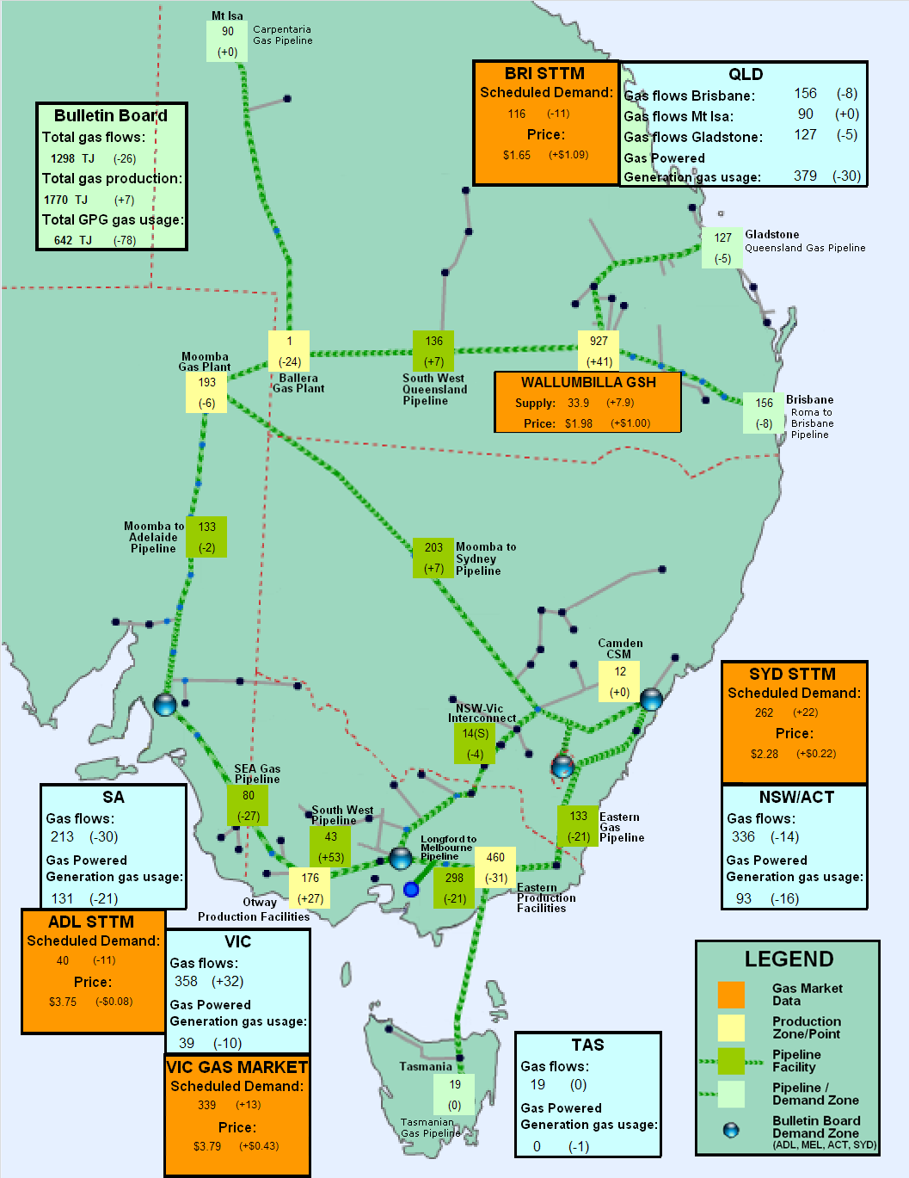

1. Gas Supply Hub

The Gas Supply Hub **(GSH)** was established for the trading of gas at Wallumbilla because it is located in close proximity to significant gas supply sources and demand locations and is a major transit point between Queensland and the gas markets on Australia’s east coast. The GSH is a voluntary market[10] for the supply of gas traded between separate participants, with products listed for sale and purchase at delivery points on three major connecting pipelines at Wallumbilla – the Queensland Gas Pipeline (QGP), the South West Queensland Pipeline (SWQP) and the Roma to Brisbane Pipeline (RBP). There are separate products for each pipeline (each pipeline is considered a trading location, and each has a number of delivery points) and delivery period (daily, day-ahead, balance-of-day and weekly).

Trade at the Wallumbilla hub increased again this week. Overall the volume traded was 238 TJ (an increase of 56 TJ from the previous week and a new record high volume traded in the hub[11]). Volume weighted prices on both the Roma to Brisbane pipeline and the South West Queensland pipeline (SWQP) were just under $2/GJ. Over 80 per cent of volume traded was on the SWQP and there were no weekly product trades.

Figure 6.1 shows volumes traded[12] on each gas day and trading day from 7 to 13 December.

Volume Traded (by Gas Day and by Trading Day)



1. The weighted average daily imbalance price applies for Victoria.
2. Capacity prices occur due to a capacity restriction on a pipeline which results in more expensive gas needing to be sourced from a different pipeline out of merit order. The Capacity Constraint Price forms part of a mechanism used to compensate shippers with firm transportation rights when as available (non-firm) gas is scheduled (with the volume of displaced gas charged at the capacity price). Routine maintenance has led to reduced capacity on the MSP since the end of September and is expected to be complete in April 2015.
3. These are Market Participants’ aggregate demand forecasts adjusted for any override as applied by AEMO from time to time. The main driver of the amount of gas scheduled on a gas day are these forecasts which are forecasts that cannot respond to price or in other words is gas delivered regardless of the price.
4. The price might also be affected by transmission or production (contractual) constraints limiting how much gas can be delivered from a locale or System Injection Point (SIP) from time to time.
5. The price might also be affected by transmission or production (contractual) constraints limiting how much gas can be delivered from a locale or SIP from time to time.
6. The main driver of the amount of gas scheduled on a gas day is the ‘price-taker’ bid, which is forecast hub demand that cannot respond to price and which must be delivered, regardless of the price.
7. MOS service payments involve a payment for a MOS increase service when the actual quantity delivered exceeds final gas nominations for delivery to a hub, and a payment for a MOS decrease service when the actual quantity delivered is less than final nominations. As well as a MOS ‘service’ payment, as shown in figure 2.4, MOS providers are paid for or pay for the quantity of MOS sold into the market or bought from the market (MOS ‘commodity’ payments/charges).
8. Regional Gas Flows: **SA** = MAP + SEAGAS, **VIC** = SWP + LMP – negative(NSW-VIC),

   **NSW/ACT** = EGP + MSP, **TAS** = TGP, **QLD (Brisbane)** = RBP, **QLD (Mt Isa)** = CGP, **QLD (Gladstone)** = QGP

   GPG volumes include gas usage that may not show up on Bulletin Board pipeline flows.

   From October 2014, production flows reported for the Roma region include quantities of gas for LNG export trains.
9. Wallumbilla supply is the average daily volume of gas ‘traded’, while price is a volume weighted average.
10. Market trade is facilitated through an electronic trading platform, with standardised terms and conditions and a market settlement facility for the short-term trading of physical gas and related products. The market is designed to complement existing bilateral gas supply arrangements and gas transportation agreements, through the placement of anonymous offers (to sell) or bids (to buy) at specified quantity and price increments, which are automatically matched on the exchange to form transactions.
11. The previous record volume traded over a week was just over 186.7 TJ for the week ending 6 September 2014.
12. Volumes shown for weekly products include the ‘daily’ volume for each relevant ‘gas day’, and the ‘weekly’ volume for each relevant ‘trading day’.