
18 – 24 August 2013
Weekly Gas Market Report
Weekly summary
Average prices in all markets increased from the previous week, driven by increases in demand compared to the previous week in all regions except Brisbane. The largest price increase of 16 per cent was recorded in Sydney but prices remained below $6/GJ in all regions.
Long term statistics and explanatory material
The AER has published an explanatory note to assist with interpreting the data presented in its weekly gas market reports. The AER also publish a range of longer term statistics on the performance of the gas sector including gas prices, production, pipeline flows and consumer demand.
Market overview
Figure 1 sets out the average daily prices ($/GJ) in the Victorian Declared Wholesale Market (VGM or Victorian gas market) and for the Sydney (SYD), Adelaide (ADL) and Brisbane (BRI) Short Term Trading Market hubs (STTM) for the current week compared to historical averages.
              - Average daily prices – all markets ($/GJ)
 | Victoria | Sydney | Adelaide | Brisbane
18 Aug - 24 Aug 2013 | 4.36 | 4.90 | 5.36 | 5.85
% change from previous week | 4 | 16 | 6 | 8
13-14 financial YTD | 4.41 | 4.93 | 5.33 | 5.88
% change from previous financial YTD | -19 | -28 | -17 | 6
Figure 2 compares average weekly gas prices, ancillary market payments and scheduled injections against historical averages for the Vic gas market.
              - Victorian gas market
 | Price ($/GJ) | Ancillary payments ($000)* | BOD forecast demand quantity (TJ)
18 Aug - 24 Aug 2013 | 4.36 | - | 907
% change from previous week | 4 | - | 10
13-14 financial YTD | 4.41 | - | 887
% change from previous financial YTD | -19 | - | -5
* Note: only positive ancillary payments, reflecting system constraints will be shown here
More detailed analysis on the Victorian declared wholesale market is provided in Section 1.
Figures 3 to 5 show average ex ante and ex post gas prices, MOS balancing gas service payments together with the related daily demand quantities against historical averages for the Sydney, Adelaide and Brisbane wholesale gas markets, respectively.

              - Sydney STTM
 | Ex ante price ($/GJ) | Ex post price ($/GJ) | MOS payments ($000) | Ex ante quantity (TJ) | Ex post quantity (TJ)
18 Aug - 24 Aug 2013 | 4.90 | 4.68 | 8.05 | 294 | 291
% change from previous week | 16 | 19 | -40 | 5 | 7
13-14 financial YTD | 4.93 | 4.79 | 10.97 | 291 | 287
% change from previous financial YTD | -28 | -39 | -26 | -3 | -6

              - Adelaide STTM
 | Ex ante price ($/GJ) | Ex post price ($/GJ) | MOS payments ($000) | Ex ante quantity (TJ) | Ex post quantity (TJ)
18 Aug - 24 Aug 2013 | 5.36 | 5.85 | 7.15 | 92 | 97
% change from previous week | 6 | 14 | -16 | 4 | 9
13-14 financial YTD | 5.33 | 5.50 | 23.61 | 92 | 95
% change from previous financial YTD | -17 | -16 | 183 | -1 | 2

              - Brisbane STTM
 | Ex ante price ($/GJ) | Ex post price ($/GJ) | MOS payments ($000) | Ex ante quantity (TJ) | Ex post quantity (TJ)
18 Aug - 24 Aug 2013 | 5.85 | 5.73 | 1.13 | 157 | 156
% change from previous week | 8 | 1 | -27 | -2 | -3
13-14 financial YTD | 5.88 | 5.89 | 1.71 | 153 | 152
% change from previous financial YTD | 6 | 10 | -55 | 0 | 1
More detailed analysis of the STTM hubs is found in sections 2 to 4.
Section 5 provides analysis on production and pipeline flows on the National Gas Bulletin Board, as well as gas-powered generation volumes in each state.
Significant Market Events or Issues this week
Nothing to report.
1 Victorian Declared Wholesale Market
18 – 24 August 2013

Detailed Market Analysis
In the Victorian Gas Market gas is priced five times daily at 6 am, 10 am, 2 pm, 6 pm and 10 pm. However, the volume weighted gas price on a gas day tends towards the 6 am price which is the schedule at which most gas is traded.
The main drivers of price are demand forecasts together with bids to inject or withdraw gas from the market. For each of the five gas day pricing schedules, figures 1.1 to 1.4 below show the daily prices, demand forecasts, and injection/withdrawal bids. Figure 1.5 provides information on which system injection points were used to deliver gas, in turn indicating the location and relative quantity of gas bids cleared through the market. Gas is priced five times daily (at 6 am, 10 am, 2 pm, 6 pm and 10 pm) when the first schedule and four reschedules apply, while the last 8-hour schedule has been separated into two 4-hour blocks for a consistent comparison with other scheduled injection volumes. The main drivers of price are demand forecasts and gas bids.
          - Prices by schedule
          - Demand forecasts
          - Injection bids by price bands
          - Withdrawal bids by price bands
          - Metered Injections by System Injection Point

- Sydney STTM
In each STTM hub, gas is priced once before each gas day (the ex ante price) and once after the gas day (the ex post price). The main drivers of ex ante and ex post prices are demand forecasts, together with participant offers and offers to inject or bids to withdraw gas traded through the hub. Prices before and after the gas day may also vary depending on how much gas is scheduled before the gas day (setting the ex ante price) and how much gas is consumed in the hub on a gas day (setting the ex post price).
Market Operator Service balancing gas (MOS) payments arise because the amount of gas nominated on pipelines for delivery on a gas day will either exceed or fall short, by some amount, of the amount of gas consumed in the hub. In such circumstances, MOS payments are made to participants for providing a service to park gas on a pipeline or to loan gas from a pipeline to the hub.
Figures 2.1 and 2.2 show daily prices, demand, offers and bids. Figures 2.3 and 2.4 show gas scheduled and allocated on pipelines, indicating the location and relative quantity of gas offers across pipelines and also the amount of MOS allocated for each pipeline.

          - SYD STTM daily ex ante and ex post prices and quantities
 | Sun | Mon | Tue | Wed | Thu | Fri | Sat
Ex ante price ($/GJ) | 4.38 | 4.99 | 5.55 | 4.85 | 4.85 | 4.85 | 4.85
Ex ante quantity (TJ) | 243 | 301 | 326 | 326 | 324 | 296 | 246
Ex post price ($/GJ) | 4.65 | 4.99 | 4.95 | 4.66 | 4.85 | 4.69 | 4.00
Ex Post quantity (TJ) | 243 | 304 | 325 | 323 | 318 | 287 | 235

Figure 2.2 (a) Daily hub offers in price bands ($/GJ) Figure 2.2(b): Daily hub bids in price bands ($/GJ)
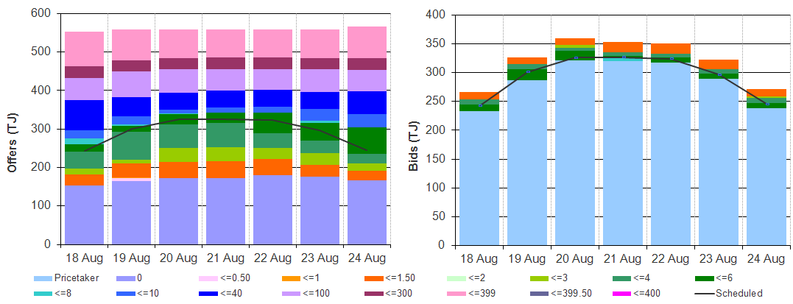
          - SYD STTM ex ante scheduled and allocated gas volumes by STTM facility

Figure 2.4 (a) SYD STTM MOS allocations (TJ) Figure 2.4 (b): Service payments and commodity ` payments/charges ($000)

- Adelaide STTM
The Adelaide STTM hub functions in the same way as the Sydney STTM hub. The same data that was presented for the Sydney hub is presented for the Adelaide hub in the figures below.
          - ADL STTM daily ex ante and ex post prices and quantities
 | Sun | Mon | Tue | Wed | Thu | Fri | Sat
Ex ante price ($/GJ) | 5.06 | 5.06 | 5.80 | 5.80 | 5.70 | 5.06 | 5.06
Ex ante quantity (TJ) | 82 | 100 | 98 | 97 | 94 | 90 | 82
Ex post price ($/GJ) | 5.80 | 5.88 | 5.80 | 6.00 | 6.00 | 5.75 | 5.70
Ex Post quantity (TJ) | 86 | 109 | 99 | 105 | 101 | 95 | 86

Figure 3.2 (a) Daily hub offers in price bands ($/GJ) Figure 3.2(b): Daily hub bids in price bands ($/GJ)
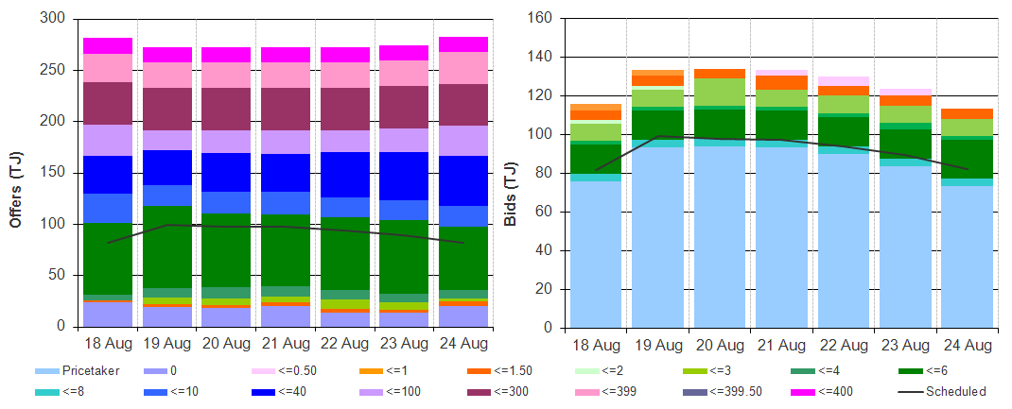
          - ADL STTM ex ante scheduled and allocated gas volumes by STTM facility

Figure 3.4 (a) ADL STTM MOS allocations (TJ) Figure 3.4 (b): Service payments and commodity ` payments/charges ($000)
- Brisbane STTM
The Brisbane STTM hub functions in the same way as the Sydney STTM hub. The same data that was presented for the Sydney hub is presented for the Brisbane hub in the figures below.
          - BRI STTM daily ex ante and ex post prices and quantities
 | Sun | Mon | Tue | Wed | Thu | Fri | Sat
Ex ante price ($/GJ) | 5.12 | 5.23 | 6.25 | 5.28 | 6.42 | 6.29 | 6.38
Ex ante quantity (TJ) | 148 | 164 | 162 | 161 | 162 | 156 | 144
Ex post price ($/GJ) | 5.12 | 5.08 | 5.76 | 6.25 | 6.42 | 6.29 | 5.17
Ex Post quantity (TJ) | 148 | 158 | 162 | 163 | 163 | 155 | 143

Figure 4.2 (a) Daily hub offers in price bands ($/GJ) Figure 4.2(b): Daily hub bids in price bands ($/GJ)
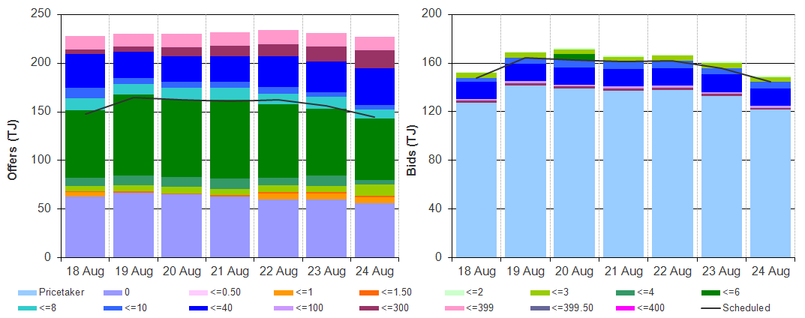
          - BRI STTM ex ante scheduled and allocated gas volumes by STTM facility

Figure 4.4 (a) BRI STTM MOS allocations (TJ) Figure 4.4 (b): Service payments and commodity ` payments/charges ($000)
- National Gas Bulletin Board
Figure 5.1 shows average daily actual flows for the current week in the aqua boxes from the Bulletin Board (changes from the previous week’s average are shown in brackets). Gas-powered generation (GPG) gas usage is also shown in each region in the aqua boxes. In the orange boxes average daily scheduled volumes and prices for each gas market are provided.
          - Gas market data ($/GJ, TJ); Production, Consumption and Pipeline flows (TJ)
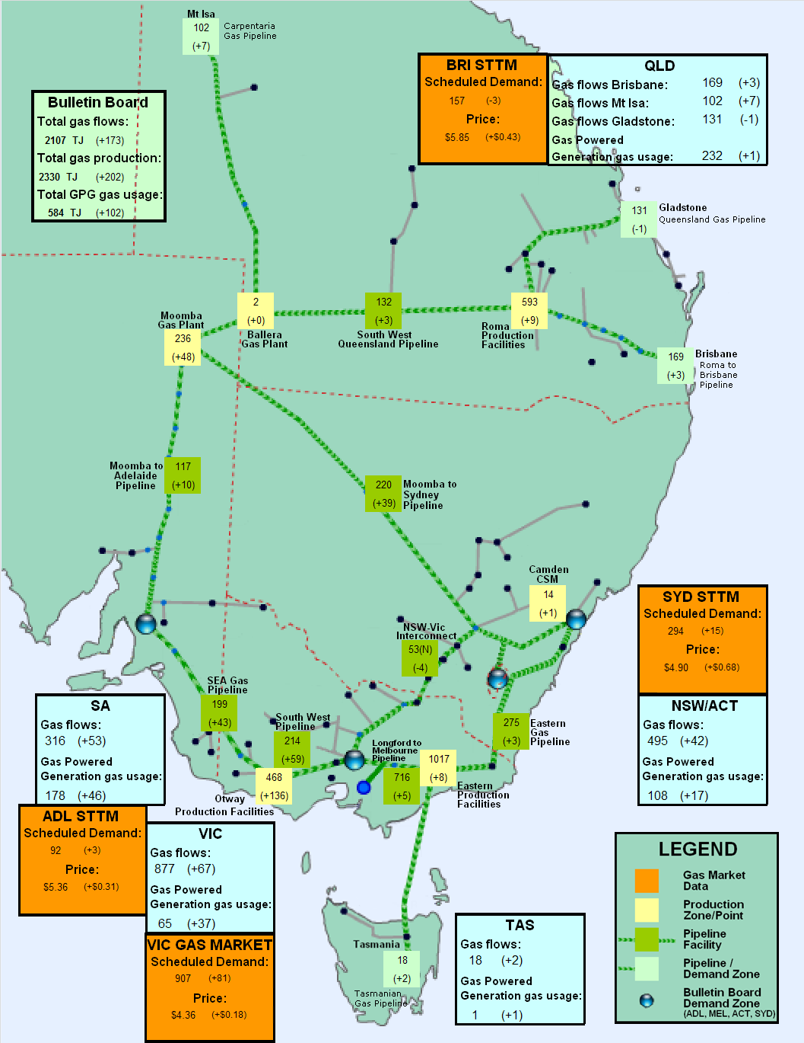

The weighted average daily imbalance price applies for Victoria.
These are Market Participants’ aggregate demand forecasts adjusted for any override as applied by AEMO from time to time. The main driver of the amount of gas scheduled on a gas day are these forecasts which are forecasts that cannot respond to price or in other words is gas delivered regardless of the price.
The price might also be affected by transmission or production (contractual) constraints limiting how much gas can be delivered from a locale or System Injection Point (SIP) from time to time.
The price might also be affected by transmission or production (contractual) constraints limiting how much gas can be delivered from a locale or SIP from time to time.
The main driver of the amount of gas scheduled on a gas day is the ‘price-taker’ bid, which is forecast hub demand that cannot respond to price and which must be delivered, regardless of the price.
MOS service payments involve a payment for a MOS increase service when the actual quantity delivered exceeds final gas nominations for delivery to a hub, and a payment for a MOS decrease service when the actual quantity delivered is less than final nominations. As well as a MOS service payment, as shown in figure 2.4, MOS providers are paid for or pay for the quantity of MOS sold into the market or bought from the market.
Regional Gas Flows: SA = MAP + SEAGAS, VIC = SWP + LMP – negative(NSW-VIC), NSW/ACT = EGP + MSP, TAS = TGP, QLD (Brisbane) = RBP, QLD (Mt Isa) = CGP, QLD (Gladstone) = QGP GPG volumes include gas usage that may not show up on Bulletin Board pipeline flows.

